|  |  |
| --- | --- |
| Government of Kenya | Brands of the World™ | Download vector logos and  logotypes | **MINISTRY OF ENERGY**  **Nairobi**  Republic of Kenya |

|  |  |
| --- | --- |
| The World Bank Logo | evolution history and meaning, PNG | **Investment Project Financing Kenya: Off-grid Solar Access Project for Underserved Counties (P160009)** |

Environmental & Social Impact Assessment, Social Assessment and Vulnerable & Marginalized Groups

**KENYA OFF-GRID SOLAR ACCESS PROJECT (KOSAP) FOR UNDERSERVED COUNTIES**

**Component 1: Mini grids for Community Facilities, Enterprises, and Households**

**Comprehensive Project Report (CPR) FOR THE PROPOSED SAROHINDI MINI OFF-GRID SOLAR PROJECT IN MANDERA COUNTY**

|  |  |  |  |  |  |
| --- | --- | --- | --- | --- | --- |
|  | **Date: December, 2021** | | | |  |
|  |  |  |  |  | |

# CERTIFICATION

This Comprehensive Project Report (CPR) has been prepared by ESIA /EA Lead Experts Mr. Ibrahim Adan Reg. No. 1608 Commissioned by a firm of experts, **Centric Africa and Norken International.** The report has been written with diligence in accordance with the World Bank Operational Procedures OP, Environmental Safeguards Standards (ESS), the EMCA 1999 *(Amended, 2015)* and the Environmental and Social Impact Assessment and Audit Regulations, 2003 to bring out the true nature of the intended development**.** The report was prepared based on the information provided by various stakeholders and village elders at Sarohindi in Mandera County as well as from primary and secondary sources. It is therefore issued without any prejudice.

We, the undersigned, certify that the particulars in this CPR are correct and righteous to the best of our knowledge.

**PROPONENT:**

**Mr. Rodney I. Sultani**

**Project Coordinator, KOSAP**

**Ministry of Energy and Petroleum,**

**P.O. Box 30582-00100,**

**Kawi House, Nairobi, Kenya**.

Signature: ________________________ Date: **­­______________________**

**ESIA/EA FIRM OF EXPERTS:**





Signature: ________________________ Date: **­­______________________**

**Isaiah Kegora**

**NEMA Expert (Reg. No. 1893).**

***For Norken (I) Ltd & Centric Africa Ltd***

# ACKNOWLEDGEMENT

The ESIA/Audit Experts are grateful to the project proponent for commissioning this Environment Social Impact Assessment. We would like to acknowledge with great appreciation Sarohindi community members who were involved in public participation and consultation process, for their cooperation throughout the exercise. I further acknowledge the support, either direct or indirect, from the various parties who assisted the ESIA/EA experts’ team towards the successful completion of this ESIA report. They include environmental experts from Centric Africa Limited and Norken International Limited. We wish to thank the community leaders that supported the organization of community members during public participation and stakeholder consultation.

Finally, the consultant wishes to acknowledge and appreciate the efforts and inputs by MOEP, the Implementing Agencies (KPLC and REREC), and the World Bank Group teams in reviewing this report to the required standards.

# LIST OF ACRONYMS

|  |  |
| --- | --- |
| CBO | Community Based Organization |
| CDI | County Development Index |
| CGRC | County Grievance Redress Committees |
| CoC | Code of Conduct. |
| Covid 19, | Coronus Virus Diseases 2019 |
| CPR | Comprehensive Project Report |
| CPS | Country Partnerships Strategy |
| CRA | Commission on Revenue Allocation |
| DOSHS | Directorate of Occupational Safety and Health Services |
| ECD | Early Childhood Development |
| EHS | Environmental and Health Standards |
| EMCA | Environment Management Coordination Act |
| EPRA | Energy and Petroleum Regulatory Authority |
| EPT: | Energy and Petroleum Tribunal |
| ESI | Electricity Supply Industry |
| ESIA | Environmental and Social Impact Assessment |
| ESM | Environmental and Social Management |
| ESMP | Environmental and Social Management Plan |
| FGD | Focus Group Discussions |
| GBV | Gender Based Violence |
| GDC | Geothermal Development Company |
| HIV/STD | Human Immune Deficiency syndromes/Sexually transmitted diseases |
| IA | Impact Assessment |
| KETRACO: | The Kenya Electricity Transmission Company |
| KII | Key Informant Interview |
| KOSAP | Kenya Off-Grid Solar Access Project |
| KPLC | Kenya Power and Lighting Company |
| LEP | Labor & Employment Plan |
| LGRC | Locational Grievance Redress Committees |
| MoE | Ministry of Energy |
| NEMA | National Environmental management Authority |
| NGOs | Non-Government organizations |
| NGRC | National Grievances Redress Committee |
| NLC | National Lands commission |
| OP | Operation procedures |
| OP/BP | Operational Procedures/bank policy |
| PLWDs | People living with disabilities |
| REREC | Rural Electrification and Renewable Energy Corporation |
| SA | Social Assessment |
| SEA/SH | Sexually Exploitation Activity/Sexual Harassment |
| TSC | Teachers Service Commission |
| VMGs | Vulnerable and Marginalized Groups |
| WB | World Bank |

# TABLE OF CONTENTS

CERTIFICATION ii

ACKNOWLEDGEMENT iii

LIST OF ACRONYMS iv

TABLE OF CONTENTS v

LIST OF TABLES x

LIST OF PLATES xi

LIST OF FIGURES xii

EXECUTIVE SUMMARY 1

1 INTRODUCTION 11

1.1 Context 11

1.2 Project Justification 12

1.3 Institutional and Implementation Arrangements 13

1.4 Project Overview 13

1.5 Purpose and Scope of Work 14

1.6 ESIA Approach 15

1.7 ESIA Methodology 18

1.7.1.1 Screening Methodology 19

1.7.1.2 Kick-off Meeting 19

1.7.1.3 Desk based review and baseline assessment 19

1.7.1.4 Project Description 19

1.8 ESIA Procedure 22

1.9 Limitations 22

1.10 Layout of the Report 22

1.11 Target Group for the ESIA Report 23

2 PROJECT DESCRIPTION 25

2.1 Introduction 25

2.2 Project Location 26

2.3 Project site setting 27

2.4 Description of Project Facilities, Components and Activities 28

2.4.1.1 PV Hybrid Mini-Grid Sizing 28

2.4.1.2 Transformers 29

2.4.1.3 Solar PV modules 29

2.4.1.4 Charge Controllers 29

2.4.1.4.1 Solar batteries 29

2.4.1.4.2 Inverters 29

2.4.1.5 Distribution lines 29

2.4.2.1 Land Tenure 30

2.4.2.2 Compensation Details 30

2.5 Resource Requirement 34

2.5.2.1 Construction Phase 34

2.5.2.2 Operation Phase 34

2.5.3.1 Construction Phase 35

2.5.3.2 Operation Phase 35

2.5.5.1 Construction Phase 35

2.5.5.2 Operation Phase 35

2.5.6.1 Natural Disasters 36

2.5.6.2 Malicious Damage or Theft 36

2.5.6.3 Hazard Risk Assessment 36

2.6 Land Requirement and Procurement Process 37

2.6.1.1 Land Tenure 37

2.6.1.2 Compensation Details 38

3 ANALYSIS OF PROJECT ALTERNATIVES 38

3.1 Consideration of Project Alternatives 38

3.2 Relocation Option 39

3.3 Zero or No Project Alternative 39

3.4 Alternative Sources of Energy 40

3.5 Analysis of Alternative Construction Materials and Technology 41

3.6 Solid Waste Management Alternatives 41

3.7 Alternative Solar Mini-Grid Site 41

4 RELEVANT LEGISLATIVE AND REGULATORY FRAMEWORKS 43

4.1 Introduction 43

4.2 Environmental Policy Framework 43

4.3 Institutional, Regulatory and Legal Framework 43

4.4 Kenya Policy Provisions 45

4.5 National Legal Framework 51

4.6 Relevant statutes 53

4.7 World Bank Environment and Social Safeguards Policies 77

4.8 Environmental and Social Management Framework (ESMF) for KOSAP 78

4.9 Resettlement Policy Framework (RPF) for KOSAP 78

4.10 Vulnerable and marginalized Groups Framework (VMGF) for KOSAP 79

4.11 Comparison between the World Bank and Kenyan Laws to this Project 79

5 BASELINE SETTINGS -ENVIRONMENT, ECOLOGY AND SOCIAL ASPECTS 81

5.1 Introduction 81

5.2 Environment Baseline 81

5.3 Ecological Conditions 82

5.4 Socio-Economic Environment 82

5.5 Land Use 84

5.6 Social and Physical Infrastructure 85

6 Stakeholder Engagement 87

6.1 Introduction 87

6.2 Legal requirement for stakeholder engagement 87

6.3 Objectives Public Participation 88

6.4 Stakeholder Consultation and Disclosure Requirement for the Project 88

6.5 Stakeholder Characterization and Identification 88

6.6 Summary of Community Consultation Meeting Leading to Land Identification and GRC Constitution (Screening Level) 90

6.7 Key Feedback of Further Stakeholder Consultation Process Carried out During ESIA 93

6.7.7.1 Adult to youth Representation 96

6.7.7.2 Gender Representation 96

6.7.7.3 Heads of Households 96

6.7.8.1 Female Stakeholders’ Consultation and Participation 97

6.7.8.2 Male Stakeholders’ Consultation and Participation 101

6.7.8.3 Youth Stakeholders’ Consultation and Participation 105

6.7.8.4 Vulnerable and marginalized group (VMG) 106

6.7.8.5 Education Stakeholders’ Consultation and Participation (KI) 107

6.8 Stakeholder Engagement and Grievance Management Post ESIA 108

7 GRIEVANCE REDRESS MECHANISM 110

7.1 Introduction 110

7.2 Grievance Mechanism 110

7.3 National Grievances Redress Committee (NGRC) 111

7.4 County Grievance Redress Committees (CGRC) 111

7.5 Locational Grievance Redress Committee (LGRC) 112

8 IMPACT ASSESSMENT AND MITIGATION MEASURES 115

8.1 Introduction 115

8.2 Impact Assessment Methodology 115

8.3 Defining Impact 115

8.4 Assessment of Significance 115

8.5 Magnitude of Impact 117

8.6 Sensitivity of Resources and Receptors 118

8.7 Likelihood 118

8.8 Definition of mitigation measures 118

8.9 Assessing residual impacts 119

8.10 Negative Impacts during Pre-construction Phase 123

8.11 Negative Impacts During Construction Phase 123

8.12 Negative impacts during Operation phase of the project 137

8.13 Negative impacts during decommissioning phase 144

8.14 Social Protection 146

8.15 Social Inclusion 146

9 ENVIRONMENTAL AND SOCIAL MANAGEMENT PLAN (ESMP) 148

9.1 Introduction 148

9.2 Monitoring 148

9.3 Plan Monitoring 149

9.4 Environmental and Social Monitoring by Contractors 149

10 IMPACT SUMMARY AND CONCLUSION 199

10.1 Introduction 199

10.2 Impacts Requiring Detailed Assessment 199

10.3 Conclusion 199

11 APPENDICES 200

1. Minutes of ESIA Consultation Meeting 201

2. ESIA List of Attendance 206

3. Minutes of land acquisition meetings 216

4. List of attendance minutes of land acquisition 225

5. Land Identification Form 231

6. Abbreviated Resettlement Action Plan (A-RAP) 236

7. Firm and Lead Expert EIA Practicing Licenses 242

# LIST OF TABLES

Table 1: Summary of Pre- Construction Impacts 7

Table 2: Summary of Construction and Decommissioning Phases Impacts 7

Table 3: Summary of Operation Phase Impacts 8

Table 4: Structure of the ESIA Report 22

Table 5: Component of the proposed Solar Mini-grid 25

Table 6. ESI and their roles 46

Table 7. Administrative stakeholders and their roles 50

Table 8. National Policy Framework 52

Table 9: World Bank Environmental Social Safeguards Standards 62

Table 10: Comparison between the WB safeguard policies and the Kenya Legislation 65

Table 11: Demographic profile of Sarohindi 68

Table 12: Identified Stakeholders 74

Table 13: Stakeholder Significance and Engagement Requirement 74

Table 14: GRC committee members 77

Table 15: The consultative meeting had a wide representation 82

Table 16. categories of significance 101

Table 17. Overall Significance Criteria for Environmental Impacts 102

Table 18. Explanation of Terms Used for Likelihood of Occurrence 103

Table 19: Environmental and Social Management Plan (ESMP) 136

Table 23: Institutional Framework and Compliance/ Implementation of the ESIA/ESMP 158

# LIST OF PLATES

Plate 1: Proposed project area 14

Plate 2: Proposed site for the project 36

Plate 3: A Lady Stakeholder member reporting the extra project (in kind compensation) to forum after community deliberations. 37

Plate 4:Photo showing residential houses to the west that will be connected with electricity 70

Plate 5: Project information posted at the chiefs Office and being read by members of the public. 78

Plate 6: Members of public being sensitized on the project implications by ESIA Consultants. 79

Plate 7: On-going community deliberation process. 81

Plate 8. Female FGD participants at Sarohindi. 83

Plate 9: Male FGD at Sarohindi 89

Plate 10: Youth FGD at Sarohindi 90

Plate 11: KII Education Sarohindi. 93

# LIST OF FIGURES

Figure 1. Location of the proposed site. 5

Figure 2: Proposed site in Sarohindi village 14

Figure 3: Summary of ESIA procedure 22

Figure 4. An aerial view of the propose site adjacent to Sarohindi mini grid 26

Figure 5: Sketch map of Sarohindi proposed site 27

Figure 6 28

Figure 7: KOSAP Grievance Redress Mechanism 99

# EXECUTIVE SUMMARY

**E.1 Context Setting**

The Ministry of Energy (MOE) hereinafter refer to as proponent is implementing the Kenya Off-Grid Solar Access Project (KOSAP) in 14 underserved counties in Kenya. The aim of the project is to provide clean and modern energy services through off-grid solar solutions. The Proponent is coordinating the implementation of the project through the implementing agencies; Kenya Power (KP) and the Rural Electrification and Renewable Emergency Corporation (REREC). The project is funded by the World Bank Group with $150 million and a $5 million grant from the Carbon Initiative for Development. The goal of the project is to bring electricity to around 250,000 households, 476 community facilities, and 380 boreholes in the target counties, benefiting low-income groups. It also includes the sale and installation of 150,000 efficient cook stoves. The project focuses on marginalized areas based on the County Development Index (CDI) and aims to address infrastructure deficits, lack of access to roads, electricity, water, and social services in these underserved counties. To ensure sustainability, the project relies on public funding, local community participation, and the institutional capacity of KP, REREC, and the MOE.

The KOSAP consists of four main components. The first component focuses on the implementation of mini-grids to provide electricity to community facilities, enterprises, and households in areas where mini-grids are the most cost-effective option. The second component aims to electrify households through standalone solar systems in areas without load clusters where standalone systems are the best technical and financial solution. The third component supports the electrification of public institutions and community facilities using standalone solar systems. It also includes the installation of solar PV-powered water pumps for consumptive purposes. Lastly, the fourth component, provides funding for implementation support, technical assistance, and capacity building activities to ensure the sustainability and impact assessment of the interventions carried out under the other components of KOSAP.

In Mandera County, one of the target counties, the Proponent is proposing to develop 27 No. mini grid facilities including Sarohindi Mini Grid discussed in this report. In order to adhere to both national and donor requirements, the Proponent engaged the services to the consortium of Norken International Limited and Centric Africa Limited to undertake the ESIA. The ESIA has been conducted following the requirements outlined in the Environmental Management and Coordination Act (EMCA) 1999 and its amendments, as well as international environmental and social policies such as the World Bank's OP 4.01 on environmental assessment.

**E.2 -Project Categorization and Justification**

In the World Bank context, there have been several projects supported by the organization that aim to provide electricity to communities located far from the national grid. These projects utilize off-grid approaches, meaning they are independent of a national or regional grid. The experience gained from these projects provides valuable guidance for designing sustainable off-grid electrification initiatives, particularly those targeting dispersed and economically disadvantaged communities. The Sarohindi proposed site aligns with this category of projects that the World Bank has been involved in.

In the Kenyan context, the Environmental Management and Coordination Act (EMCA) of 1999, as amended in April 2019 through Legal Notice No. 31, classifies solar power farms and plants as medium risk projects. This categorization provides a framework for assessing and managing the potential environmental and social impacts associated with such projects. By categorizing the Sarohindi site as a solar power facility, it falls within the medium risk project category as per the Kenyan legislative framework.

**E-3 Approach and Methodology**

The Environmental and Social Impact Assessment (ESIA) for the proposed project followed a structured process, beginning with kick-off meetings and online discussions involving the Proponent, Implementing agencies, and the World Bank Environmental and Social Safeguard Team. These consultations were instrumental in establishing the project's scope, deliverables, timeline, and methodology. Subsequently, screening and scoping exercises were conducted to evaluate potential social and environmental risks. A thorough desk-based review was also undertaken to assess existing project documentation, legal requirements, and relevant plans.

The study employed a comprehensive approach to gather primary and secondary data for the project. Both qualitative and quantitative methods were utilized, with secondary data obtained through literature reviews. Primary data collection involved various techniques, including physical observations, Photography, interviews, and stakeholder consultations. This comprehensive approach enabled a comprehensive examination of the project's environmental and social aspects, ensuring a holistic understanding of its potential impacts.

The study further involved the identification and assessment of potential impacts throughout the project's life cycle. Key areas of evaluation included land use, water resources, biodiversity, air quality, noise levels, community health and safety, and socio-economic conditions. To mitigate adverse effects, the study developed environmental and social management and monitoring plan, aiming to address both positive and negative impacts that may arise from the project. These measures aimed to ensure the project's sustainability and enhance its overall environmental and social performance.

**E-4 Legislative Regulatory Framework**

The evaluation, planning, and implementation of the proposed project is guided by the World Bank's Environmental and Social Framework, the national legislative framework, and the project's safeguard instruments. These measures aim to ensure environmental sustainability, protect the rights and needs of indigenous peoples and marginalized groups, and minimize adverse impacts through effective management and mitigation measures.

The Government of Kenya established the Environmental Management and Coordination Act (EMCA) in 1999, providing a legal framework for environmental management. EMCA takes precedence over other sectoral laws related to the environment. In 2013, the government formulated a national Environmental Policy with the goal of promoting sustainable management and use of the environment.

Collaboration and consultation among government agencies and stakeholders are essential for coordinating environmental management effectively. Key institutions in Kenya responsible for environmental issues include the National Environment Management Authority (NEMA), County Environment Committees, National Environmental Complaints Committee, National Environment Action Plan Committee, Standards and Enforcement Review Committee, National Environment Tribunal, and National Environment Council (NEC).

The project also adheres to the World Bank Safeguard Policies, which aim to improve decision-making processes, promote sustainable project options, and involve affected people in consultations. The applicable operational policies for this project include Environment Assessment, Natural Habitats, Indigenous Peoples, and Involuntary Resettlement. The Environmental and Social Impact Assessment (ESIA) considers these policies and addresses potential environmental and social concerns.

Additionally, the ESIA references other Safeguard Instruments prepared under the Kenya Off-Grid Solar Access Project (KOSAP), including the Environmental and Social Management Framework (ESMF), Resettlement Policy Framework (RPF), and Vulnerable and Marginalized Groups Framework (VMGF). These instruments provide procedures and guidelines for assessing and managing environmental and social aspects specific to the proposed subprojects under KOSAP.

**E.5 -Environmental Settings**

The proposed project site is in Sarohindi village, Arabia sub county in Mandera County. The nearest major town is Mandera town approximately 33km from the site. Sarohindi village has a population of approximately 1800 people with about 231 households. The gender ratio is currently estimated at about 40% male and 60% female. The inhabitants are mainly pastoralists keeping livestock such as camels, cattle, goats, sheep, and donkeys. However, low scale subsistence crop farming is practiced during rainy seasons as the village is near a dry river bed. Crops grown include sorghum maize and beans.

The project site has a few drought tolerant plant species. The area is characterized by sandy clay soils and is normally dusty during the dry seasons while muddy during the wet seasons. Prevailing strong winds are experienced at the proposed site due to minimal vegetation. The sunshine in the county is 12hours while Average UV index is 10. The annual average temperature is approximately 320Celcius.

Sarohindi has drought tolerant flora tree species with the vegetation in the County generally being Acacia and Commiphora species which are used for fuel wood, carving, livestock fodder and in charcoal production. The vegetation density is estimated to be 300-500 bushes per hectare. However, this varies from locality to locality based on the individual land holders where significant degradation has been done by livestock grazing and farming in particular along Daua River. The estimated bush coverage is between 30% - 50% of the area. Predominant bush species are Acacia and Commiphora types including; Acacia gerradii, Acacia Tortilis, Terminalia Brownii among others.

The Fauna: Mixes of both predatory and herbivorous animals are found within the area. This includes Hyena, Lions, Zebras, Warthogs, Cheetahs, Gazelles, Antelopes, Dikdik, Baboons among others. No detailed wildlife including birdlife count and diversity assessment was conducted. Density of game is low with concentration along the seasonal Dawa River and dry river beds bushes with few or minimal in open grassland. Wildlife hunting has been significant over the years with proliferation of small arms in the area from across the Somalia border decimating the wildlife in the area.

The area’s ecological conditions are influenced by the soil type, altitude, vegetation, rainfall pattern and human activities. As is the rest of the county, Sarohindi is a semi-arid area falling in the ecological zone V-VI. The rainfall pattern is bi-modals with annual rainfall ranging between 190mm and 277mm and is usually characterized by poor distribution especially the long rains. The rainfall is usually erratic and short making it unfavorable for vegetation growth.

Air quality in the area is pristine with particulate matter from dust emissions the main concern predominantly in areas with low grass/vegetation cover, such as heavily bush encroached areas resulting from transportation vehicles, motor bikes, donkey carts etc.

The village, like the larger County, is mainly covered by Precambrian basement system rocks, which weather into soils of variable depth and texture and are rich in ferromagnesian minerals with a deep red color. Soils range from red sandy soils to the western side of the village along the dry riverbed or lagha, loamy sand soils and patches of black cotton soils to the eastern and northern side that are characterized by poor drainage, cracks and high rate of expansion making farming less productive. Daua River shoreline has saline alluvial soils of moderate to high fertility. Most hills are covered by shallow and stony soils unsuitable for crop farming. Generally, soils are of low fertility and prone to erosion due to tendency to form surface capping. Soils are variable in depth and have stony surfaces. There are small pockets of black cotton soils (vertisols) in the County along the border with Ethiopia. The soil fertility ranges from low to moderate with low organic matter content.

**E.6 Project Overview**

The proposed Project site is located over unregistered community land measuring approximately 1.214 hectares in Sarohindi, in Sarohindi village, Arabia Ward, Arabia Subcounty, Mandera County at GPS coordinates (3.88N, 41.55E) as shown in the map below.The proposed project site is 33 km west of Mandera town. The Sarohindi market is locate in Mandera East Sub County, Mandera East Constituency, Libehiya ward, Sarohindi location and Sarohindi Sub location. Sarohindi market has a population of approximately 3000 with about 250 households with over 155 potential customers. The Sarohindi area is dominated with Somalis of Murule tribe. Islam is a dominated religion in the area.

No objections were raised by the community in regard to transferring land to Kenya Power and Lighting Company (KPLC) for management of the solar mini-grid. An abbreviated Resettlement Action Plan (A-RAP) outlining the principles and procedures for land acquisition and compensation is annexed to this ESIA

Figure 1. Location of the proposed site.

The project consists of two main components: Hybrid Mini-Grids and power line reticulation lines. The Hybrid Mini-Grids will combine solar panels and diesel power generation. These energy sources will be integrated through a centralized photovoltaic plant connected to a 3-phase AC busbar line. The configuration is designed to prioritize direct supply from the solar generator during daylight hours, reducing reliance on battery storage. The battery storage will primarily be used when solar generation is low, or demand is high. The construction of power line reticulation lines will ensure the efficient distribution of electricity to residential, commercial, and other consumers, ensuring a reliable and efficient power supply.

To develop the Mini Grid, approximately 1.214 hectares of land will be compulsorily acquired by the Proponent from the community through National Land Commission (NLC). This land is part of the community's designated public purposes area. The Proponent engaged with the community during the land acquisition process, and there were no objections to transferring the 1.214 hectares of land to Kenya Power and Lighting Company (KPLC) for the management of the solar mini grid. In accordance with the World Bank's Operation Procedure 4.12 on Involuntary Resettlement, an abbreviated Resettlement Action Plan (A-RAP) was prepared, outlining the principles and procedures for land acquisition and compensation. This plan is annexed to the project report.

**E.7 Project Alternatives**

Solar energy is identified as a non-polluting and site-specific option, and the proposed site for Sharohindi mini-grid is chosen as the most suitable location for the mini-grid based on factors such as sunlight availability and the community's lack of grid connectivity. The use of wind power, thermal power, fossil fuels, and power import from neighbouring countries are considered as alternative methods of power generation but are found to have limitations or environmental concerns. Solar energy is favoured due to its low production costs, versatility, clean nature, and economic savings. The "No Project" alternative is deemed unfavourable as it would maintain the current lack of electricity access and hinder socio-economic development. The project will be constructed using modern materials and technology, with a focus on public health, safety, security, and environmental requirements. The technology will involve a Battery Energy Storage System.

**E.8 Stakeholder Engagement**

It is important to highlight that two forms of stakeholder engagement were carried out for the project. The first form as noted earlier, focused on the acquisition of land for the project and involved the Proponent and the implementing agency in Kenya Power Ltd. The second form of engagement was conducted specifically for the Environmental and Social Impact Assessment (ESIA) study.

For the ESIA study, various methods were employed to engage stakeholders, taking into consideration their different categories. Face-to-face discussions were held with government officials and key stakeholders, while separate focused group discussions were conducted with men, women, and youth. Additionally, a public baraza or meeting was organized to allow community members to participate.

During the ESIA stakeholder engagement public meeting, which took place on November 23rd, 2021, a total of 86 stakeholders attended. The meeting provided an opportunity to discuss project details, including the preliminary design, positive and negative impacts, and mitigation measures. Stakeholders were encouraged to share their views and provide feedback on the project.

Some of the concerns raised by stakeholders included whether connections will be done grass thatched houses and there will be compensation for any loss from the project. The study team addressed these concerns by assuring stakeholders that the grass thatched houses will be connected and any loss from the project activities will be compensated. They also stated that additional projects would be undertaken for the community as compensation, based on their priorities. In addition, public facilities such as schools, health centres, police stations and boreholes would be connected to the electricity supply.

**E.9 Potential Impacts and Mitigation Measures**

The Environmental and Social Impact Assessment (ESIA) for the proposed Solar Mini-grid project has identified both positive and negative impacts across its different phases: pre-construction, construction, operation, and decommissioning. In the construction phase, positive impacts include local employment opportunities, boosting local businesses, and sourcing materials locally. During the operation phase, positive impacts encompass reliable power supply, economic improvement, education, health benefits, improved living standards, and enhanced security and communication. Similarly, the decommissioning phase offers positive impacts such as local employment and sourcing.

On the negative side, the pre-construction phase involves minor impacts like land acquisition, while the construction phase encompasses various minor to moderate impacts such as vegetation clearance, soil erosion, dust emissions, and occupational health and safety concerns. Challenges related to stakeholder engagement, labour influx, child labour, and exclusion of vulnerable individuals are also anticipated. In the operation phase, negative impacts include waste generation, increased oil consumption, fire outbreaks, occupational health and safety concerns, and inadequate stakeholder engagement. Issues of exclusion, inadequate grievance management, and public health concerns may arise as well.

During the decommissioning phase, negative impacts primarily relate to solid waste generation, noise and vibration, and challenges in stakeholder engagement, labour influx, child labour, gender-based violence, and exclusion of vulnerable individuals and households.

Tables 1, 2 and 3 below present summaries of anticipated impacts and their corresponding levels of significance, both pre- and post-mitigation

Table 1: Summary of Pre- Construction Impacts

| **Impact** | **Significance of Impact (Pre-Mitigation)** | **Residual Impacts (Post-Mitigation)** |
| --- | --- | --- |
| Land acquisition | Minor | Negligible |
| Way leaves | Minor | Negligible |
| Stakeholder identification and consultations | Major | Minor |

Table 2: Summary of Construction and Decommissioning Phases Impacts

| **Impact** | **Pre-construction** | **Construction phase** | **Decommissioning phase** |
| --- | --- | --- | --- |
| Impacts on Local Economy and Employment | Not Applicable | Positive | Positive |
| Change in land use | Not Applicable | Moderate | Positive |
| Site rehabilitation | Not Applicable | Not Applicable | Positive |
| Topography | Not Applicable | Minor | Not Applicable |
| Soil environment | Not Applicable | Minor | Minor |
| Air Quality | Not Applicable | Moderate | Moderate |
| Ambient noise | Not Applicable | Minor | Minor |
| Visual intrusion and change in landscape | Not Applicable | Minor | Positive |
| Waste generation and soil contamination | Not Applicable | Minor | Minor |
| Impact on water environment | Not Applicable | Minor | Not Applicable |
| Impacts from hazardous materials | Not Applicable | Minor | Not Applicable |
| Fire hazards | Not Applicable | Moderate | Minor |
| Impacts of construction material sourcing | Not Applicable | Moderate | Not Applicable |
| Energy consumption | Not Applicable | Negligible | Not Applicable |
| Occupational safety and health | Not Applicable | Moderate | Moderate |
| Community safety and health | Not Applicable | Moderate | Moderate |
| Labour influx | Not Applicable | Minor | Minor |
| Child labour | Not Applicable | Minor | Negligible |
| Cultural heritage | Not Applicable | Minor | Not Applicable |
| Gender based violence, SEA and SH | Not Applicable | Minor | Minor |
| Exclusion of VMGs, Vulnerable individuals and households | Not Applicable | Major | Major |
| Risk of communicable diseases | Not Applicable | Minor | Minor |
| Increased water demand |  | Negligible | Negligible |
| Forced labour |  | Minor | Negligible |

Table 3: Summary of Operation Phase Impacts

| **Impact** | **Significance Of Impact (Pre-Mitigation)** | **Residual Impacts (Post-Mitigation)** |
| --- | --- | --- |
| Impact On Economy and Employment | Positive | Positive |
| Quality, reliable power supply | Positive | Positive |
| Reduction of pollution associated with thermal power generation, kerosine and wood fuel usage | Positive | Positive |
| Education | Positive | Positive |
| Health benefits | Positive | Positive |
| Improved standard of living | Positive | Positive |
| Security | Positive | Positive |
| Communication | Positive | Positive |
| Soil environment | Minor | Negligible |
| Waste generation and management | Minor | Negligible |
| Water environment | Negligible | Negligible |
| Landscape and visual impacts | Minor | Negligible |
| Increased oil consumption | Minor | Negligible |
| Increased storm water flow | Minor | Negligible |
| Fire outbreaks | Moderate | Minor |
| Water demand | Negligible | Negligible |
| Sanitary waste | Negligible | Negligible |
| Flooding | Negligible | Negligible |
| Noise and Vibration | Negligible | Negligible |
| Electric and magnetic fields (EMFs) | Negligible | Negligible |
| Dust Emission | Negligible | Negligible |
| Vehicle Exhaust emission | Minor | Negligible |
| Collision and electrical hazards from distribution infrastructure | Minor | Negligible |
| Occupational safety and health | Moderate | Minor |
| Community safety and health | Moderate | Minor |
| Gender based violence, SEA and SH | Minor | Negligible |
| Exclusion of VMGs, Vulnerable individuals and households | Major | Minor |
| Risk of communicable diseases | Minor | Negligible |
| Shocks and electrocution to the beneficiaries | Moderate | Minor |
| Risks related to poor and inadequate stakeholder engagement (conflict) | Minor | Negligible |

**E.10. Summary of environmental and social Management and Monitoring Plans**

A comprehensive set of mitigation measures in the form of an Environmental and Social Management and Monitoring Plan (ESMMP) have been prepared for the project. The ESMMP serves as a comprehensive framework for the integrated management of all environmental and social impacts throughout the project's lifecycle. It has been prepared to ensure that the social and environmental impacts and risks identified during the Environmental and Social Impact Assessment (ESIA) process are appropriately managed during the construction, operations, and decommissioning phases of the project. It specifies the mitigation and management measures that the project proponent and contractor are committed to implementing and outlines how organizational capacity and resources will be mobilized to achieve these measures. The ESMMP also ensures compliance with the relevant laws, regulations within Kenya, as well as the environmental and social sustainability requirements of the World Bank's Operational Policies (OPs).

These measures emphasize a proactive approach, prioritizing prevention rather than reaction. They encompass various aspects such as proper waste handling and disposal to prevent pollution, engaging stakeholders to address grievances, providing personal protective equipment (PPE) for workers, ensuring adequate supervision, and emphasizing good workmanship from the contractor. Specific plans are also outlined to address specific issues that may arise. The ESMMP also highlights environmental performance indicators that should be regularly monitored. Monitoring serves as a means to detect and draw attention to any changes or problems in environmental quality. It involves continuous or periodic reviews of the ESMMP implementation progress, allowing for adjustments and improvements as necessary.

While accommodating the recommended mitigation measures to the extent practical and economically viable, the project proponent and contractor should ensure that the measures do not compromise the economic viability of the project or have long-lasting adverse impacts on the environment.

For the mitigation measures to be successful, it is imperative that the Kenya Power and Lighting Company (KPLC) allocates sufficient resources for the implementation of the ESMMP. Adequate resources will enable the proper execution of the proposed measures and ensure their effectiveness in minimizing the identified negative impacts.

Following the project's commissioning, it is mandatory to conduct statutory Environmental and Safety Audits in accordance with national legal requirements. These audits serve to evaluate the environmental performance of the site operations and assess their compliance with the recommended mitigation measures.

**E.11 Conclusion**

Based on the assessment findings, the consultant concludes that there are no substantial reasons to hinder the proposed project from progressing to the next stage of planning and development. However, this progression is conditional upon the implementation of the recommended mitigations and the monitoring of potential environmental and socio-economic impacts as outlined in the ESMMP.

It is in the opinion of the Environmental expert that the anticipated negative impacts can readily and effectively be mitigated and on the whole the proposed project does not pose any significant threat to the Environment and may be licensed to proceed**.**

# INTRODUCTION

The Ministry of Energy (MOE) Kenya is coordinating the implementation of the Kenya Off-Grid Solar Access Project (KOSAP) to provide access to clean and modern energy services through off-grid solar to 14 underserved counties. Mandera county was identified as one of the underserved Counties and others include Mandera, Narok, Garissa, Tana River, Samburu, Isiolo, Marsabit, West Pokot, Turkana, Taita Taveta, Kwale, Kilifi and Lamu.

Driven by the imperative to provide equal opportunities across the entire Kenyan territory as key to achieving Kenya’s Vision 2030, and the National target of achieving universal access to electricity by 2020, the GoK now seeks to close the access gap by providing electricity services to remote, low density, and traditionally underserved areas of the country. The World Bank’s (WB) Country Partnerships Strategy (CPS) for Kenya (2014-18) also recognizes the access to basic electricity, as a key developmental issue. The Strategy sets at improving core infrastructure as one of the Projects the WB will be engaged in. It also emphasizes the importance of mobilizing concessional funding to expand the sector including electricity generation, transmission, and distribution to meet the Government’s economic growth targets.

K-OSAP directly promotes the achievement of these objectives by supporting the use of solar and clean cooking Solutions to drive electrification of households (including host communities), enterprises, community facilities, and water pumps in Mandera county as one of the counties in Kenya that have been defined as “marginalized areas” based on the County Development Index (CDI) by the Commission on Revenue Allocation (CRA). According to the CRA as the communities in the marginalized areas have been excluded from social and economic life of Kenya for different reasons” (CRA, 2013).

Mandera County and other identified underserved counties collectively represent 4.5% of the Country’s total land area and 2.2% of the Country’s population, including historically nomadic societies that even today continue to rely on pastoralism. Their population is highly dispersed, at a density four times lower than the national average. They present profound infrastructure deficits, including lack of access to roads, electricity, water, and social services. There is also significant insecurity in certain areas, giving rise to substantial numbers of displaced persons and livelihood adaptations that further undermine economic prosperity.

## Context

This ESIA report has been prepared based on Site visit baseline survey, desktop survey, documentation review, consultation with stakeholders and in accordance with Environmental Management and Coordination (Amendment) Act, 2015 and World Bank’s Environmental and Social Safeguards. The study has also assessed the requirement of the project with respect to the local and national regulations relevant to the project.

Norken International Limited in Joint Venture with Centric Africa Limited were appointed by Ministry of Energy to undertake consultancy services for the Environmental and Social Impact Assessment (ESIA), Social Assessment (SA) and Vulnerable and Marginalized Groups Plan (VMGP) as per the standard TOR and NEMA and WB ESS. As reported, land acquisition has not resulted in any economic or physical displacement and no resettlement is envisaged for the proposed project.

Due to the remoteness and sometimes dispersed nature of the target populations and considering the lifestyles and socio-economic status of those residing in underserved Counties, the Project is designed to address low affordability of the potential users, and sustainability of service provision. Therefore, sustainability of the proposed approach to energy access expansion beyond the Nationally owned power network is predicated on two primary factors - public funding, local community participation: and institutional capacity of Kenya Power and, Rural Electrification and Renewable Energy Corporation (REREC) and the Ministry of Energy (MOE) as the implementing agencies. The project components are:

* Component 1- US$40M: Mini-grids for Community Facilities, Enterprises, and Households -This component will support electrification of areas where electricity supply through mini-grids represents the least cost option from a country perspective.
* Component 2- US$48M: Stand-alone Solar Systems and Clean Cooking Solutions for Households; This component will support electrification of households using standalone solar systems in areas where load clusters do not exist, and the best technical and financial solution is standalone solar systems.
* Component 3- US$40M: Stand-alone Solar Systems and Solar Water Pumps for Community Facilities; This component will support electrification of public institutions and community facilities using standalone systems. This component will also support the installation of solar PV-powered water pumps for consumptive purposes.
* Component 4- US$22M: Implementation Support and Capacity Building; This component will finance various technical assistance and capacity building activities to ensure the sustainability and measure the impact of the interventions devised and implemented within the other components of K-OSAP.

The MOE provides overall coordination of the project as well as lead in the implementation of components 2 and 4. Components 1 and 3(a&b) will be implemented by the Kenya Power and Lighting Company (KPLC) and the Rural Electrification and Renewable Energy Corporation (REREC), respectively.

## Project Justification

The Kenya Off Grid Solar Access Project (KOSAP) intends to support the Government initiative of ensuring increased electricity access to Kenyans, particularly among the low- income groups in off- grid areas. This proposed project is in line with the commitment of the Government of Kenya to reach 100% electricity access by 2023 through grid extension, stand-alone individual plant and autonomous solar mini- grids. Kenya Power as the implementing agency aims to develop the solar/diesel mini- grids to electrify areas that are not economically feasible through national grid extension. The Sarohindi site was proposed as part of this project due to its isolated nature and the high cost of grid extension to the area.

## Institutional and Implementation Arrangements

The Ministry of Energy and Petroleum (MoEP) will provide overall coordination of the project and oversight during planning and implementation of the project. This will include overall coordination and oversight for safeguards due diligence, and implementation.

KPLC will be responsible for the implementation of the Solar Mini-grid during construction and implementation. In addition, KPLC will have overall responsibility for safeguards due diligence and implementation. The County Government of Mandera is also working in liaison with the Ministry of Energy in implementation of the project.

* + 1. **Objectives of the Study**

The main objective of this ESIA was to examine both positive and negative effects of the proposed solar Mini-grid on the people, their property and the environment and proposed measures to mitigate the negative impacts and enhance positive impacts during the construction, operation and decommissioning phases of the project.

Specific objectives of the study included;

* Present an outline of the project background,
* Establish the environmental baseline conditions of the project area and review all available information and data related to the project,
* Identify key areas for environmental, social, health and safety concerns as well as the anticipated impacts associated with the proposed project implementation and commissioning,
* Undertake public consultations with the potentially affected peoples and other interested parties
* Establish a comprehensive environmental management plan covering the construction, operation and decommissioning phases of the project,
* Preparation of a comprehensive Project Report in accordance with the local environmental legislation and submission to NEMA for further instructions and/or approval.

## Project Overview

The project is located 33 Km west of Mandera town in Sarohindi village in Arabia subcounty, Mandera County at coordinates (3.88N, 41.55E). The proposed solar mini grid will be located on a 1.214 hectares piece of land. The solar mini grid will contain Solar panels, batteries, inverter and a perimeter fence. The proposed site is vacant and open for community grazing. The proposed site is gentle hilly to the east however to the west it fairly flat hence making the site very conducive for the proposed project.

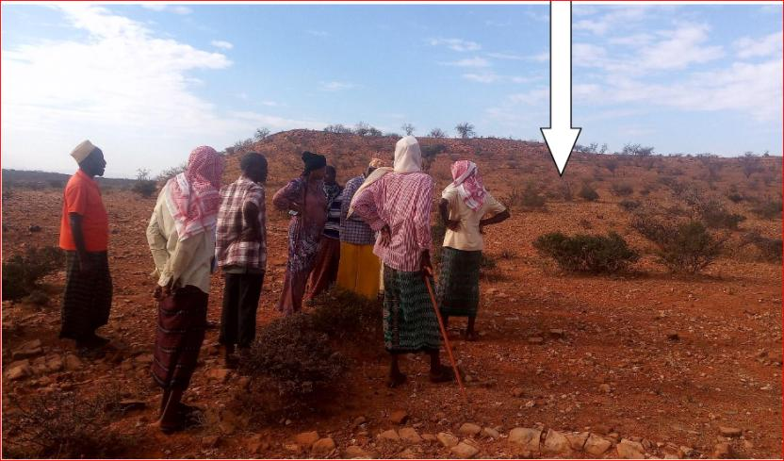

Plate 1: Proposed project area

## Purpose and Scope of Work

This report discusses the environmental and social baseline within which the proposed solar mini-grid power plant is commissioned and assesses the potential adverse and beneficial impacts that the project could have, along with suitable mitigation measures and an Environmental and Social Management Plan (ESMP) for the project. The report also evaluates the environmental and social risks associated with the project and implements mitigation measures to avoid adverse impacts for the remainder of the project’s life cycle. The project must comply with international standards (World Bank Environmental and Social Safeguards) along with applicable national, state, and local regulations.

## ESIA Approach

The approach chosen in undertaking this study was careful to consider EMCA, 1999, and its 2015 Amendment requirements, as well as the Environmental Impact Assessment and Audit Regulations, 2003. It involved largely an understanding of the project background, the preliminary designs and the implementation plan. The approach and methodology applied during the study enabled collection of both primary and secondary data. Qualitative and quantitative methods of data collection were employed. Secondary data was obtained through literature reviews while primary data was obtained through physical observations, photography, check lists, interviews and stakeholders’ consultation.

* + 1. **Key activities undertaken during the study included the following:**
* Physical inspections of the proposed project area
* Literature review of relevant documents
* Stakeholder consultations with different stakeholders and project affected persons and beneficiaries
* Gathering environmental and socio-economic data of the area by use of checklist
* Continuous discussions with the stakeholders and accessing other sources of information on the proposed project details, the site planning and implementation plan,
* Photography, and interviews with people in the immediate neighborhood.
* Evaluation of the activities around the site and the environmental setting of the wider area.
* Report writing and submission.

The initial stage of this assessment was project screening. Screening of the project sought to ascertain whether or not this project falls within a category that requires ESIA prior to commencement. Other considerations made during this stage included a preliminary assessment of the environmental sensitivity of the proposed project area/site. This screening indicated that the proposed solar Mini-grid is among the listed projects under Schedule 2 of EMCA, 1999 thus requires an ESIA study.

Project scoping was the next stage which was done to delineate project issues that required detailed analysis. This step involved collection of primary and secondary data through field visits and literature review respectively.

* + 1. **Desk study/literature review**

A critical literature review of secondary data was done to establish the following:

* Relevant legislations and institutional framework governing the proposed project
* Licenses and permits requirements and conditions;
* Baseline information of the project area
* Types of waste likely to be generated.

Documents relevant to the proposed development were reviewed. Some of the documents reviewed included Mandera County Integrated Development Plan 2018-2022, various Kenyan legal legislations, World Bank safeguard policies, project frameworks (ESMF, VGMF, and RPF), topographical maps, google earth/maps, Kenyan government publications among others.

* + 1. **Environmental, Socio-economic and Cultural Setting/Status**

To gain a better understanding of the environmental, socio-economic and cultural setting of the project site and its surrounding the ESIA team needed to gather primary data. This entailed collection of the data using various tools and methods. Interviews, discussions, photography and observations and checklists are some of the methods employed in gathering the data needed from different stakeholders.

* + 1. **Public Consultations**

Section 17 of the Environmental (Impact Assessment and Audit) Regulations of 2003, requires that all ESIA Studies undertake Public Consultation (PC) as part of the study. The aim of the PC is to ensure that all stakeholders interested in a proposed project such as project beneficiaries, government officers and the general public in the vicinity of the proposed project be identified and their opinion considered during project planning, design, construction, operation and decommissioning phases. Consequently, public consultations were carried out in the project area in a bid to inform the public and other interested parties on the proposed project and obtain their views on the same. The consultations also presented an opportunity for the community to raise issues and concerns pertaining to the project.

Public consultations were conducted through public barazas organized at appropriate locations near the proposed site for the Mini-grid. Key stakeholder’s views on the project were solicited through interviews and discussions with County officials, technical teams at Ministry of Energy and KPLC and also (KOSAP project implementation unit) officers.

* + - 1. **Stakeholder Identification and Mapping**

Stakeholder engagement and participation was carried out at different levels and with different stakeholders. Stakeholder’s identification and mapping was done based on the following criteria that affected/project beneficiaries and interested persons or parties. The stakeholders include;

* Beneficiaries of the proposed project who largely are the community members living within 3km radius of the proposed project
* Interested parties include
  + County government of Mandera has various departments including the office of the governor, land and environment, survey and public administration such as ward and village administrators. In addition is the county commissioner and officers under his administration such as chiefs.
  + Members of parliament and members of county assembly
    - 1. **Approach and Methodology used in Carrying Out the Public Participation**

Owing to the different categories of the stakeholders, the ESIA team opted to employ various methods in engaging them. The methods included; face to face discussions for the government officers, focused group discussions with the men, women and youth and a public baraza/meeting for the community members.

* + - 1. **Mobilization for the Community Meeting**

Prior to the community engagement meetings, a two weeks’ notice was done/issued to inform the community members of the meeting. This was done by the county renewable energy officer (CREO). The officer called the Chief of the area where the meeting was to take place and requested him to inform the people of the meeting in regard to KOSAP community engagement forums. The chief then informed the people about the meeting through an announcement by word of mouth given by the local leaders’ key among them was village administrator and village elders in Kabo village.

* + - 1. **Public Forum/Meeting**

The project team undertook community engagement forums with the target beneficiaries and the communities where the solar Mini-grids will be set. The main objective was to explain the project details including need for land identification and solicit broad community support and acceptability of the project. One open meeting with all the community members was held. The KOSAP team explained to the community members about the project and other related information as discussed in the minutes. The meeting was then opened up for a plenary session.

Community engagement proceedings and resolutions are presented in the form of minutes taken/written during the meetings. The meetings were well attended by all people including men, women, youth and persons with special needs.

* + - 1. **Focus Group Discussions**

After the meetings the community members were told of the need to have focus group discussions to discuss the project further and allow the different groups more opportunities to ask questions or give suggestions regarding the project. Therefore, three separate meetings for men, women and youth were held. In these meetings the message on the project was echoed again especially on benefits and impacts (both positive and Negative) of the project to the community, rights of the community and the need to have a grievance redress mechanism and committee with representation from all groups in the community.

* + - 1. **Key Informant Interviews**

Key Informants were identified both at the county and locational levels and they were interviewed to obtain baseline information in regard to the proposed project. The key informant interviews were from the education sector.

* + - 1. **Stakeholder Engagement Schedule**

The ESIA team identified four categories of stakeholders namely; government officials, opinion leaders at local level, elders and the general community. Stakeholder engagement began early in the planning phases of the project. A letter was written from the Ministry of Energy to the County commissioner informing them about the need to undertake public participation for the proposed project. Stakeholder consultations were undertaken twice on the 2nd November 2020 and 30th September 2021. During these meetings, project information in terms of preliminary design, positive impacts, negative impacts, mitigation measures among others were discussed with various stakeholders. The stakeholders gave their views in to the project

Interactive approach was adopted for the immediate neighborhood in discussing relevant information key among them being;

* Land use aspects,
* Neighborhood issues,
* Project acceptability,
* Social, cultural and economic aspects,
* Environmental Impacts
* Physical impacts,
* Biological impacts,
* Legal Compliance.
  + 1. **Sampling**
       1. **Soil Sampling and Analysis**

Soil sampling and testing was done for the purpose of soil quality control and identifying sources and effects of contamination of soil. Sampling was done manually within the boundaries of the proposed project site taking into consideration these guidelines:

* Remove superfluous soil covering/s (i.e., dense vegetation, gravel, concrete etc.), if present and place to one side.
* Use a clean implement (i.e., spade/shovel) and manually excavate a hole to a targeted depth of approximately 50 centimetres below ground level.
* Obtain a representative soil sample (500g) and transfer it in a well labelled air tight zip lock bag

## ESIA Methodology

The approach chosen in undertaking this study was careful to consider EMCA, 1999, and its 2015 Amendment requirements, as well as the Environmental Impact Assessment and Audit Regulations, 2003. It involved largely an understanding of the project background, the preliminary designs, and the implementation plan. The approach and methodology applied during the study enabled collection of both primary and secondary data. Qualitative and quantitative methods of data collection were employed. Secondary data was obtained through literature reviews while primary data was obtained through physical observations, Photography, check lists, interviews, and stakeholders’ consultation.

* + 1. **Screening and Scoping**

#### Screening Methodology

Evaluation of ESIA procedure has been undertaken as a fundamental procedure to implementation of the solar power mini-grid development project which is systematically mainstreamed into the project’s Cycle. World Bank Social safeguards underpin and demonstrate this commitment. The main aim of this is to enhance positive social opportunities and benefits as well as ensure that adverse social and environmental risks and impacts are avoided, minimized, and mitigated.

The below steps were followed: -

#### Kick-off Meeting

The Norken International and Centric team had a brief kick-off meeting with the Ministry of Energy on 12th July 2021 followed by subsequent online meetings and discussion on various aspects of the project up to 17th November 2021. The kick-off meeting in Mandera County involved meeting the County Commissioner and County Renewable and Principal Environment Officer among others. The meetings addressed varied deliverables and thresholds to be achieved and maintained during this assessment in terms of scope of work, deliverables, timeline, and the methodology. The communication and meetings were done both physically and virtual online where practicable.

#### Desk based review and baseline assessment

A comprehensive description of the KOSAP Component 1: project includes a desktop review of all the existing project documentation including the Project Appraisal Document and the four main safeguard framework documents prepared under KOSAP- these are Social Assessment, Vulnerable and Marginalized Group Framework, Resettlement Policy Framework and the Environmental and Social Management Framework.

#### Project Description

The consultant firm has concisely described the project location including its geographical, ecological and the general layout of associated infrastructure including maps at an appropriate scale where necessary. Location of all projects related development sites, including proximal offsite investments; general layout; flow diagrams/drawings of facilities/operation design basis, size, capacity, flow-through of unit operations, including pollution control technology included if any; pre-construction activities and construction activities; construction schedule; staffing size and support; facilities and services around; commissioning, operation and maintenance activities and plan

* + 1. **Baseline Condition**

This entails description and collection of relevant primary data within the project site’s bio-physical, socio-economic, and cultural profile with respect to the biodiversity profile, land use types, cultural heritage and practices, social and economic issues likely to be affected, expected project activities to be involved during the design, construction, and operation of the proposed facility. The information also includes description of the community social structure, employment and labor market, sources and distribution of income, cultural/religious sites and properties, vulnerable groups, and indigenous populations. This also covers description of the sites’ physical environment including their topography, land cover, geology, climate and meteorology, air quality and hydrology. This entails use of secondary data sources and for some specific environmental parameters the deployment of specialized equipment to measure and record the environmental readings as primary data for analysis and inclusion in the ESIA CPR report. The ecological and biophysical environment will focus on describing the *flora* and *fauna* resident in the Mandera county at the mini-grid site level. This will be based on ecological surveys, KPIs on local indigenous knowledge on historical and status of rare, endemic, and endangered plant and animal species known to occur in these localities. Vegetation assessment was done to gain an understanding of the mini-grid sites habitat type. This has provided for an in-depth description of existing land use types and their linked socio-economic activities.

* + 1. **Impact Assessment (IA) Prediction**

The anticipated impacts generated by the project and subsequent evaluation of their significance is provided by this report. A suite of field data collection methods was deployed including public forums discussions, Focus Group Discussions, Key Informant Interviews incorporating questionnaires for social risks assessment. Based on the outcome of the evaluation, the need for emphasis on critical areas was discussed. To accomplish this task an initial listing of the range of all issues and concerns identified during the study has been undertaken subsequently followed by analysis of the identified potential environmental and social impacts in terms of type (direct, indirect, cumulative, positive, negative), magnitude (local, widespread, random, severity) and duration (temporary, permanent, long term, short term). Consequently, an evaluation system will be used to categorize these impacts and evaluate them. This aided in determining the significance of the identified potential impacts in relation to established criteria or standards, geographic extent of effects, cumulative nature of the impact, community tolerance and preferences, etc. This culminated into the generation of a short list of the most critical issues in terms of environmental, ecological, and social impacts both positive and negative associated with the different phases of the project activities that are likely to affect the baseline environmental and social conditions presently occurring at the mini-grid sites.

Socio-cultural risks linked to Component 1 of KOSAP were identified during the assessment. These include, Labor influx, Gender Based Violence, Sexual Exploitation and Abuse, workplace Sexual Harassment, Spread of HIV/AIDS, STDs & other communicable diseases, Gender biases and inequality exclusion of vulnerable and marginalized groups (VMGs) and vulnerable individuals and households from accessing project decision making and governance structures, engagement processes, opportunities, and benefits. The vulnerable individuals and households will include the poor, elderly persons, PWDs, the sick, poor women, poor single mothers, child-headed households. The VMG’s include ethnic minority communities that are present in Sarohindi area.

The impacts and risks were identified in relation to free, prior, and informed comprehensive stakeholder consultations on land acquisition for construction of mini-grid, contractor’s facilities e.g., yard and workers camp site, way leave acquisition for the powerline distribution network; restricted access to grazing lands, water resources, soils and tree resources, economic/livelihoods displacement etc.

* + 1. **Environmental and Social Management Plan (ESMP)**

The ESMP as the implementation instrument of the ESIA has captured all the parameters that need to be monitored on a routine basis. The parameters as indicated in an Environmental and Social Management and Monitoring Plan (ESMMP) matrix, a detailed description of the implementation and monitoring program.

The ESMMP has a detailed arrangement of responsibilities for managing and monitoring the implementation of mitigation measures and the impacts of the project during construction, operation, and decommissioning. This includes: a description of monitoring methodology, specific operations, and features to be monitored, monitoring reporting relationships and arrangements to ensure that monitoring is effective. Simple and straightforward monitoring processes established for ease of implementation through the project cycle. This plan follows through a description of the impacts and areas affected, key mitigation measures, monitor-able indicators, timeframe, responsibilities, and budget implications.

The ESMP includes an implementation schedule and budget cost estimates for the mitigation measures both capital and recurrent costs estimate and the financing entity. It also describes institutional arrangements regarding the implementation of the ESMP among the implementing agencies, and the mini-grid contractor(s). This has specific responsibilities, procedures and resources required by each institutional actor engaged in implementing the ESMP.

The “Chance Find Procedures” has also been included in the ESMP as part of prevention and mitigation measures that will be implemented in the event physical cultural resources are encountered during subproject implementation.

The ESMP has a component on contracting management that will ensure the implementation of the ESMP by all contractors and subcontractors. A contracting mechanism is included in the ESMP to incentivize contractors and their subcontractors to comply with the ESMP or alternatively penalize them for failure to comply with the ESMP. It also includes contractor clauses that will cover worksite health and safety, the environmental and social management of construction sites; labor camps/out of area workers, HIV/AIDS, and other Sexually Transmitted Diseases (STDs), stakeholder engagement plans, grievance redress mechanism, child protection, gender equity and sexual harassment, labor rights and the employment of community members. The ESMP also has a budget to guide the contractor on resources required for the implementation and monitoring of the ESMP. Figure below is a summary of the methodology the firm will adopt in undertaking environmental and social impacts assessment for the proposed KOSAP project.

## ESIA Procedure

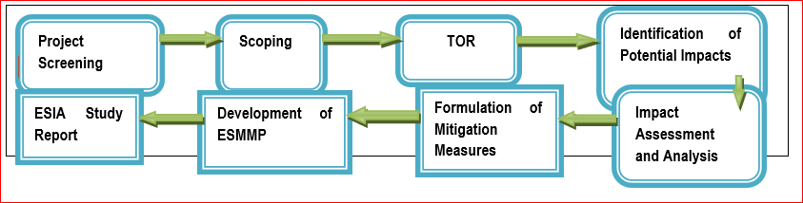

Figure 3: Summary of ESIA procedure

## Limitations

The limitations experienced during the study are illustrated below.

* The communication barrier with the community is not fully conversant with English or Kiswahili. This was mitigated through having a translator on the team and a part of the ESIA study teams were able to communicate with the participants.
* Due to drought that was being experienced the community members who participated in the public meetings were much fewer as most were engaged in tending to their livestock needs of water and pasture away from the village thus delaying in attending public participation meetings. This was mitigated by starting the meeting early enough when community members are available.
* Risk of being infected or transmitting COVID-19. The teams had to adopt preventive measures by wearing face masks and providing the community members with face masks and sanitizers during the public meetings and interactions. Community members were also guided on Covid -19 protocols on social distance requirements during the meeting.

## Layout of the Report

Table 4: Structure of the ESIA Report

|  |  |  |
| --- | --- | --- |
| **SECTION** | **TITLE** | **DESCRIPTION** |
| Section 1 | Introduction | (*This section*) Introduction to the Project and ESIA scope and methodology adopted. |
| Section 2 | Project Description | Technical description of the Project & related infrastructure and activities. |
| Section 3 | Applicable Legal and Regulatory Framework | Discusses the applicable environmental and social regulatory framework and its relevance for the Project. (The world bank safeguards and EMCA and environmental regulations) |
| Section 4 | Environmental, Ecology and Social Baseline | Outlines Environmental, Ecology and Social Baseline status in the study area of the Project |
| Section 5 | Stakeholder Engagement and Grievance Redress | Provides an overview of the stakeholder engagement activities undertaken during the ESIA, stakeholder categorization and profiling Additionally, it details the provision of Grievance Redress Mechanism for the project |
| Section 6 | Impact Assessment and Mitigation Measures | This section includes details of identified environmental impacts and associated risks due to Project activities, assessment of significance of impacts and presents mitigation measures for minimizing and /or offsetting adverse impacts identified. |
| Section 7 | Environmental and Social Management Plan | Outline of the ESMP considering identified impacts and planned mitigation measures and monitoring requirements. |
| Section 8 | Impact Summary and Conclusion | Summary of impacts identified for the Project and conclusion of the study. |

## Target Group for the ESIA Report

The ESIA Report has been prepared for use by different stakeholders to be involved in the construction and operation of the proposed Mini-Grids project. This report contains useful information on policies and procedures to be adhered to, implementation modalities, analysis of potential environmental and social impacts and suggested mitigation measures at various stages of project activities. The information will be useful in planning, implementation, management, and maintenance of the project.

In this regard, the report is useful to the following stakeholders:

* Engineers to be involved in preparation of designs and plans for the proposed solar Mini grid.
* Contractors to be engaged in the construction works for the project.
* MOE and other relevant government ministries and implementing agencies such as KPLC, REREC etc.
* County Government of Mandera,
* Funding agencies.
* Project affected persons and other stakeholders.
  1. **Assumptions**

The Experts made the following assumptions in preparing this ESIA

* All the technical data and information provided by the proponent, implementing and the specialists are accurate and up-to-date
* The design features will be put in place to minimize risks from external factors which could threaten the integrity of the facility which include: risks from landslides and other natural calamities; measures to minimize threats or damage from third parties e.g., terrorist attack
* The public involvement process has been sufficiently effective in identifying the critical issues that needed to be addressed
* The KPLC and the Contractor will implement the measures in the proposed ESMMP
* The KPLC will undertake monitoring to track the implementation of the ESMMP to ensure that management measures are effective to avoid, minimize and mitigate impacts and that corrective action will be undertaken to address shortcomings and/or non-performances.
  1. **Uncertainties in Compiling Information**

Uncertainty arises from a variety of aspects in any development, and for this particular study report has emanated from the following:

* The changes that may occur in baseline conditions, due to external factors over the lifetime of the project;
* Uncertainty related to Proponent’s policy initiatives that might influence the assessment of future baseline and post-development conditions;
* Uncertainty in design information which should be dealt with by the definition of design parameters for the development by the Contractor and Proponent;
* Uncertainty in relation to project planning and implementation as the detailed program and means of construction may be influenced by the choice of Contractor and the detailed design of the development; and
* Uncertainty in the understanding of who the VMGs are, and their population.

# PROJECT DESCRIPTION

## Introduction

This section provides a description of the project in terms of location, facilities and associated project infrastructure and activities during the project lifecycle and facilitates and identification of the potential impacts on resources and receptors that could result from project activities during the pre-construction, construction, operation, and decommissioning stages.

The components of the proposed solar mini grid are provided as follows.

Table 5: Component of the proposed Solar Mini-grid

| **S/NO.** | **PARTICULARS** | **DESCRIPTION** | |
| --- | --- | --- | --- |
| 1. | Project location | The project is located 33 KM west of Mandera town in Sarohindi village, Arabia sub county in Mandera County.  The proposed solar mini off-grid will be located on 1.214 hectares to the east of Sarohindi village.  The solar mini grid will contain Solar panels, batteries, invertors, perimeter fence and length of low voltage line. | |
| 2. | Proponent | Ministry of Energy | |
| 3. | Administrative location | Sarohindi, Arabia Subcounty, Mandera County | |
| 4. | Location Coordinates | 3.88N, 41.55E | 783856.02, 429299  783856.02, 429361.158  784051.331, 429361.158  784051.331, 429299 |
| 5. | Mini grid Capacity | - PV Array (DC-kW) of 56kw; 183kWh Battery  Peak demand (kW) 22.0 | |
| 6. | Mini grid Power | LV Circuit of 7km | |
| 7. | Climatic condition | Average Temperatures range from 32°C  The area receives an average of 277 mm of rainfall per year. The rainfall is usually erratic and short making it unfavorable for vegetation growth. There are two rainy seasons. short and long rains. The short rains are experienced between October to December and the long rains from March to May each year | |
| 8. | Average Elevation | 231m | |
| 9. | Site Conditions | The site is generally in an open area with minimal *fauna* and *flora*. | |
| 10. | Road Accessibility | murram road joining Mandera to Rhamu | |
| 11. | Nearest Airport | Mandera Airport at about 33 km | |
| 12. | River/canal/nallah/ pond present in project footprint | No rivers are present in the village | |
| 13. | Protected areas (National Park/ Sanctuary)/ Forest land within 10 kms | None | |
| 14. | Project Cost | 392,850 USD | |
| 15 | Potential Customers/Households | 231 | |
| 16 | Non-Residential Customers | 1. (Primary school; Community centre 2. ; Mosque) | |

## Project Location

The project site is in Sarohindi, Arabia South sub-county in Mandera County at coordinates (3.88N, 41.55E). The proposed mini grid will be constructed on approximately 1.214 hectares. The site soil is primarily loamy sandy with rocks within the area. The project site is approximately 33 Km west of Mandera town.

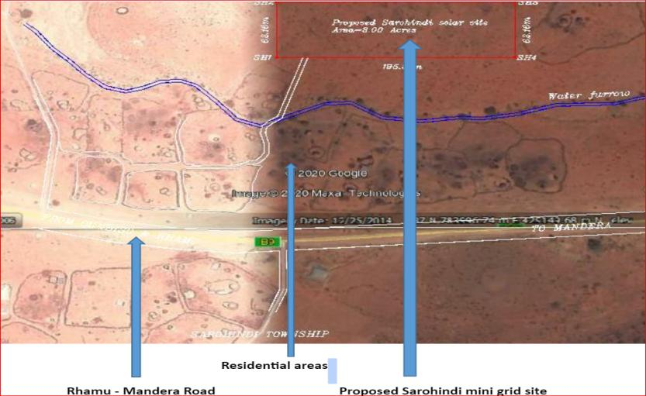

**Figure 4. An aerial view of the propose site adjacent to Sarohindi mini grid**

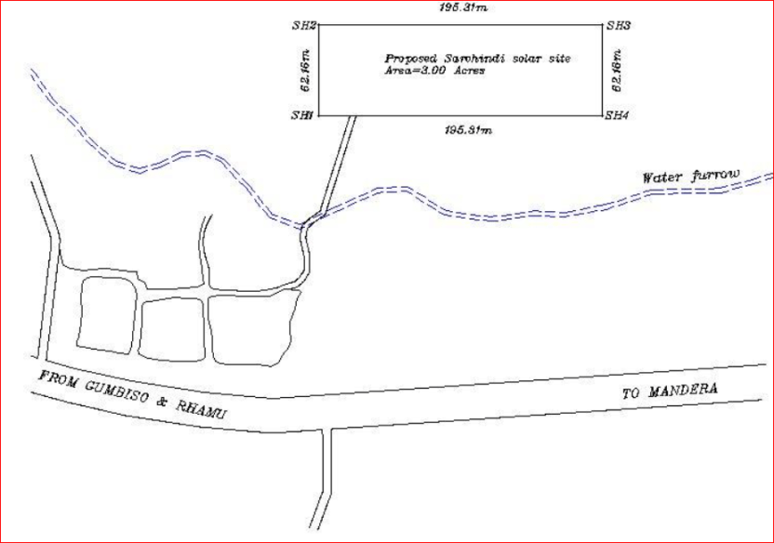

Figure 5: Sketch map of Sarohindi proposed site

## Project site setting

The proposed Sarohindi mini grid is in Arabia Subcounty, Mandera County. It falls under Lot 3 of cluster 3 which has a total of 113 mini-grids. Geographically, Sarohindi site falls on coordinates (3.88N, 41.55E). The proposed site has got loose red soils with some small rocks/stones. The proposed is open to the sky hence effective in the operation solar energy. The proposed site is vacant and free of disputes and/or encumbrances. Currently it’s being used as a grazing field for the community members.

Grievances in the community are addressed by through elders who are headed by one village elder in partnership local administration like senior chief and his assistant in the village. Grievances that cannot be solved by the elders are referred to the Subcounty administration including the Assistant County Administrator and other elders.

## Description of Project Facilities, Components and Activities

This project will entail generation of electricity from solar, distribution of power within nearly 6-kilometer radius using wooden or concrete poles and retailing the same to the community. The total length of LV distribution network will be 6km. The community members will pay a connection fee of KES. 1000 once they apply for electricity.

* + 1. **Nature of the Project**

The proposed project will be having two components in one that is a Hybrid Mini-Grids (PV- and Diesel) and construction of Power line reticulation lines. The following sections are explanations for each of the components that will be implemented;

#### PV Hybrid Mini-Grid Sizing

The power system has been sized based on the energy parameters. These are:

* The proposed Residential & Non-Residential Users available
* The PV Capacity in kilo Watt peak.
* The storage battery Capacity
* The Inverter capacity in (kW)

The system will be modular, so that it can be upgraded easily to meet future demand needs. The proposed power plant will be configured as AC coupled due to the significant portion of daytime loads that can be fed directly from the solar PV generator without intermediate battery storage. This will include:

* PV modules with PV inverters,
* Diesel Genset,
* Deep-cycle lead-acid electrochemical batteries with liquid electrolyte (largely used in off-grid applications thanks to its well proven technology at baseline costs compared with other types of batteries).

The proponent will be required to apply for a NEMA ESIA variation of the license, during the design changes over the project lifespan.

#### Transformers

Transformers change the AC voltage levels in a mini-grid network covering a large area. Step-up transformers increase the AC output voltage to transmit electricity more efficiently over a distance. Step-down transformers decrease the voltage from high- or medium-voltage transmission lines to 120 V or 220 V for residential use.

#### Solar PV modules

The project will use PV Array (DC-kW) 56 polycrystalline silicon modules with three strings connected in series. Each string will have five sets of panels connected in series, with output converged at the six-way combiners. The life expectancy of the PV modules is estimated at 25-30 years.

#### Charge Controllers

##### Solar batteries

The Battery Energy Storage System (BESS) will comprise of Lithium-ion Battery pack that conforms to IEC standards with warranty of 10 years, 3,000 cycles minimum. The Lithium-ion Battery Power Packs will be used to cater for required energy capacity, or equivalent as per approved design, minimum 80% DOD for Lithium-Ion. Batteries will be capable of at least C/4 charge and discharge rate. Batteries will be charged by Battery Inverter / Charger. The project will use 183kwh batteries.

##### Inverters

The Inverters shall be designed for continuous, reliable power supply as per specification and shall have internal protection arrangement against any sustained fault in the feeder line and against lightning strikes in the feeder line. The inverters shall be capable of complete automatic operation including wake-up, synchronization & shut down independently & automatically.

#### Distribution lines

Sarohindi site will have a distribution line circuit of 7 km in total spanning the village end to end with other properties as detailed below;

* LV circuit (km) - 7
* Demand (kVA) - 22
* PV Array (DC-kW) - 56
* Battery (kWh) - 183.

Supply of concrete poles for the distribution lines will be based on detailed survey and accessories like phase plates, circuit plates, number plates, danger plates, anti-climbing devices as per KPLC requirements/specifications. Erection of the Poles, fixing of insulator strings, stringing of conductor and earth wires along with all necessary line accessories and earthing’; will be as per KPLC requirements/specification. These specifications will be issued during the tendering processes and inspection and acceptance of the materials done during installation works.

* + 1. **Project Phases and Activities**

The main project activities include site clearance and leveling, civil works and construction of utilities and structures for the facilities, installation, and connection of the mini grid.

#### Land Tenure

The site for the proposed site is on communal land. The community has since allocated the land to the project proponent establishment of the proposed project. The allocation consent was minuted during the ESIA meetings in presence of Provincial Administration officers represented by the local chief and County Government representatives who are the trustees of the community Land as per Community Land Act 2016.

#### Compensation Details

Compensation for the land to be acquired for the proposed project will be in kind, the Proponent will undertake some projects for the community during the project construction phase. The community requested for construction of two number rooms that will be used as a dispensary since the village lacks one.

* + 1. **Construction Procedures**

All construction activities including ground preparation, earth moving, materials delivery, building, walling, roofing and the installation of amenities (power, water, communication equipment, etc.), fittings (doors, windows, safety provisions, etc.) will be carried out by competent personnel obtained through respectable contractors to ensure consistent high standard of finish and providing superb value for money.

* + 1. **Construction Contractor**

The construction contractor is responsible for building the physical infrastructure required for the mini-grid project. In this case, the infrastructure includes the installation of solar panels, battery storage systems, a diesel generator, inverters, and the low voltage power distribution network.

Their specific responsibilities will include site preparation, installation of solar panels, setting up the battery storage system, configuring the diesel generator, and laying down the distribution network.

The construction contractor will be responsible for ensuring that the components are installed correctly and meet the required standards for safety and performance. They may also manage the workforce, logistics, and project timeline to ensure that construction proceeds smoothly and is completed within the specified timeframe.

**Operation and Maintenance (O&M) Contractor**

The O&M contractor will be responsible for the ongoing operation and maintenance of the mini-grid system once it is operational. The construction contractor will also double up as the O&M contractor

In this project, their responsibilities include monitoring the performance of the solar panels, battery storage system, and the diesel generator to ensure the continuous and reliable supply of electricity to the consumers. The O&M contractor must carry out regular maintenance tasks, such as cleaning and servicing solar panels, inspecting and maintaining the battery energy storage system, and ensuring the diesel generator is in good working condition for backup power needs. They are responsible for addressing any technical issues or faults that may arise, as well as responding to consumer complaints and inquiries related to the electricity supply. The O&M contractor plays a crucial role in maximizing the system's efficiency and longevity by ensuring all components operate optimally.

The contractor will be required to have their own Environment, Health, and Safety (EHS) policy and an EHS officer on site. In the context of the mini-grid project, it will outline the contractor's dedication to upholding safety standards, minimizing environmental impact, and adhering to legal requirements. The presence of an EHS officer on site will be equally essential. Their role will be to oversee and manage all EHS concerns directly at the project location.

* + - 1. **Construction Activities Outline**

Construction activities will involve the following:

* The contractor shall perform site investigations in good time to ensure appropriate designs and construction is done on a sound engineering basis.
* Site preparation (ground ground-breaking, clearance of vegetation, preparation of a site office and stores, fencing to avoid intrusion),
* Disposal of any soil that could is not required, excavations/earth moving, filling and foundation laying,
* Procurement of construction materials and delivery of the same to the site,
* Storage and utilization of materials,
* Civil, mechanical, and electrical works,
* Building works, trampling and removal of construction wastes,
* Construction of fuel storage tank
* Installing of containerized generators
* Piping of fuel lines
* Cabling
* Installation of the Mini-grid
* Completion of the plant
* Post construction clean–up, restoration and landscaping of site
* Load testing
* Remedying of defects after functional tests
* Solid waste collection and commissioning of the plant.

During construction, the contractor shall observe safety and shall erect warning signs to warn of any potential hazards, ensure proper and efficient use of Personal Protective equipment (PPE) for all on site and observe safe work procedures.

* + - * 1. **Soil Excavation**

Soil will be excavated to pave way for the construction of the Solar Mini-grid. Soil excavation process shall be done with utmost care to ensure that the excavated soil is not improperly heaped or not carried away by any surface flows to any nearby surface waters causing siltation. The excavated soil will be used to backfill, and any remainder shall be disposed appropriately in accordance with the environmental management plan. Company safety and environmental policy and other established local environmental protection regulations/standards shall guide the contractor. This will include appropriate safety wear at all times and the contractor will appoint a safety officer on site during all construction activities.

* + - * 1. **Construction Supervision and Safety**

Throughout the construction phase, supervision shall be carried out by the KPLC to ensure:

* Workers use personal protective equipment (such as hand gloves, helmets, safety shoes ear muffs, overalls and dust coats) at all times as is appropriate
* Motorized equipment are checked to ensure that they are in good working condition, safe to use and produce minimal noise levels and reduced smoke emission.
* Provision of first aid kit and firefighting equipment (portable cylinders) and placement at strategic positions for access
* Proper disposal of waste material and toilet facilities are provided for construction workers
* Emergency response procedures are in place and all workers are aware of them like in case of fire.
* Any work involving deep excavations, elevated heights and lifting heavy loads, poses a number of risks to personnel. The contractor shall develop a worksite plan before commencement of each of the construction. This will ensure that personnel are equipped with the correct protective clothing and equipment and are ready to work safely while also safeguarding the environment.
* Workers shall be provided ablutions facilities and changing rooms.
  + - * 1. **Mini-grid Components**

The following components are planned to be constructed and operated on site. The same will need to undergo regular maintenance during the operation phase.

1. Technician Room
2. Battery Room
3. Generator Room
4. PV Array/Panels
5. Distribution network
6. Guard house
   * + 1. **Operation Phase Activities**

The Solar Mini-grid will be operated and maintained by the contractor for the first seven years and then handed over to KPLC engineers and operators. During the operation phase of the project, no unauthorized person shall access the Solar Mini-grid site. This is in line with company policy to ensure safety of staff and the public. Routine maintenance is to be done under supervision by authorized staff.

Throughout the project life, the KPLC shall adhere to all requirements of National Environmental Management Authority (NEMA) and any other applicable legislation regarding environmental and socio – economic impacts.

* + - 1. **Project’s Decommissioning Activities**

Kenya Power shall submit a decommissioning plan to NEMA in good time prior to decommissioning. The decommissioning plan should include a restoration plan.

At the decommissioning/demolition phase, the following activities will take place;

* Removal of Solar Mini-grid panels and Diesel Generator and their associated switching equipment
* Removal of electrical fittings, bus bars and steel poles/structures
* Demolish and carefully handle components that contain oil and fuels like the Diesel generators
* Ensure proper handling of the demolished materials and have an authorized and guided transportation and disposal away from human settlement, water bodies and wildlife conservation area in line with NEMA requirements for safe disposal
* Demolish and remove all the concrete works

The host environment should be rehabilitated and restored to its former state through:

* Approved and appropriate landscaping methodology.
* Planting of vegetation.
* Removal of any soils that may have been impacted by oils or fuels for offsite (away from the project area) remediation.

## Resource Requirement

* + 1. **Workforce Requirement**

Approximately 40 skilled, semi-skilled and unskilled Laborers will be required at the construction stage. During the operation phase, the following personnel will be required; 0ne operations and maintenance head, 2 engineers and 5 technicians as per KPLC plant operational human resources need assessment.

Approximately 5 unskilled workers will be involved during the operation phase of the project for grass cutting and module cleaning. Also, two trained security guards will be engaged at the operations phase.

The unskilled workers will largely be sourced from the immediate community while part of skilled workers will be sourced from the larger Mandera County community whose culture is similar to the local community. This is in part due to consideration for management of workers influx to minimize cultural insensitivities and minimize social vices attributable to foreign workers.

* + 1. **Water Requirement and Source**

#### Construction Phase

It has been estimated that approximately 50m3 of water will be required per day for civil works during the construction stage. Further, water will be required for workers at the project site as wholesome drinking water among other uses. However, this quantity of water requirement will vary depending upon the mobilization of construction workers at site. The water for the construction phase will be supplied by a water tanker from the area water vendors due to consideration for scarcity of water in the village. It is therefore important that the constructor does not compete with the immediate community for the commodity as this will adversely affect the commodity availability and its pricing.

#### Operation Phase

The water required during the operation phase of the project will be mainly for washing the face of the solar modules, Minimal water will be used for this purpose. Water requirements during the operational phase of the project will be met from the water vendors in the area. However, due to the scarcity of water especially during the drought seasons, it is imperative a borehole be sunk on the project to provide water needs for the facility and also support the community as part of the project’s corporate social investment.

Approximately, 10 employees (direct and contractual) will be working during the operation phase. For this workforce, approximately 10,000 Liters of water monthly will be required for domestic consumption.

* + 1. **Raw Material Requirement**

#### Construction Phase

The major raw materials required for the construction phase will be solar modules, batteries as power storage, fencing materials, construction materials like cement, sand, water and aggregate. The fencing materials and the construction materials will be sourced from the local hardware facilities.

#### Operation Phase

There will not be a major requirement of raw materials during the operation phase. Only maintenance spares in particular batteries which will require to be replaced between 3-5years after installation will be required at this phase. The replaced batteries will require storage and disposal as per EMCA, 1999, Waste Management Guidelines through registered waste handlers.

* + 1. **Power Requirement**

Power requirements during the construction phase will be met through Diesel Generators sets. The exact number of Diesel Generator sets to be used, as well as the quantity of fuel, will be ascertained once the project is in the implementation stage. Nonetheless, the generator sets are expected to meet the Noise Reduction Rules as per OSHA, 2012 guidelines.

* + 1. **Fire Safety and Security**

#### Construction Phase

Appropriate firefighting systems and equipment shall be provided throughout the construction period. The fire extinguishers will be well distributed according to the fire risks and will be available in areas such as the site office, security area, storage yard etc. A comprehensive emergency response plan with all the emergency numbers will be well displayed at the site and on the fence. A Safety officer will be appointed among the project supervision team to oversee safety management onsite and will have the overall responsibility for safe undertakings of the work.

#### Operation Phase

Suitable fire protection and fighting systems that will include portable fire extinguishers, automatic fire detection system through smoke and heat detectors, and alarms as a means of fire communication will be made available at the entire PV array area, inverter stations, main control room and switchyard.

The systems and equipment will align to the Kenyan Fire Reduction Rules of 2007. The Fire protection and fighting systems will be maintained and serviced after every 6 months to ensure their availability at all times.

* + 1. **Safety of the Facility**

As is with other projects, the proposed project is prone to both natural and man-made disasters. However, it is difficult to prevent the occurrence of natural disasters, but the consequences could be reduced by engineering measures. Man-made disasters on the other hand are preventable. The following safety concerns will be addressed in the proposed project.

#### Natural Disasters

In order to reduce the impacts of any potential natural disaster, the proposed project will be designed according to acceptable standards and code and shall be able to reasonably withstand any impacts which may arise as a result of the worst credible seismic event.

#### Malicious Damage or Theft

The proposed project could be prone to malicious damage such as terrorist attack or theft. To prevent the occurrence of such events, the following measures will be taken:

* Regular monitoring and inspection of the project and its associated infrastructure.
* 24-hour guard of the premises/office block

#### Hazard Risk Assessment

An emergency response procedure will be prepared by the KPLC and be communicated to the contractor. As a minimum requirement, the emergency management plan will cover the following aspects:

* Safety regulations
* Scope of the safety emergency plan
* Notification of local authorities
* Details of the proposed project
* Aim of the safety emergency plan
* Objectives of the study emergency plan
* Emergency arrangements, procedures and plans
* Roles and responsibilities in the event of an emergency
* Evacuation of people
* The role of local communities
* Regular testing of the safety emergency plan

The risk assessment will include as a minimum:

* + - A general process of the project being investigated
    - A description of the potential major incidents associated with that type of installation and the consequences of such incidents
    - An estimation of the probability of a major incident
    - A copy of the site emergency plan
    - An estimation of the damages in the case of an explosion or fire
    - An estimation of the effects of toxic gas releases.
    - The potential effect of an incident on the project or part thereof or an adjacent project or part thereof.
    - The potential effect of a major incident on any other installations, members of the public and residential areas.
    - Meteorological tendencies
    - The suitability of existing emergency procedures for the risks identified.
    - Any requirements laid down in the OSHA 2007 and EMCA 1999.
    - Recommendations regarding any organizational measures

## Land Requirement and Procurement Process

* + 1. **Land Requirement**

The land on which the proposed Sarohindi mini grid will be constructed covers a total 1.214 hectares in size. The site as depicted in the image below is situated to the East of Sarohindi village adjacent to other immediate land uses such as individual households. The site has scattered shrubs of acacia and various commiphora species.

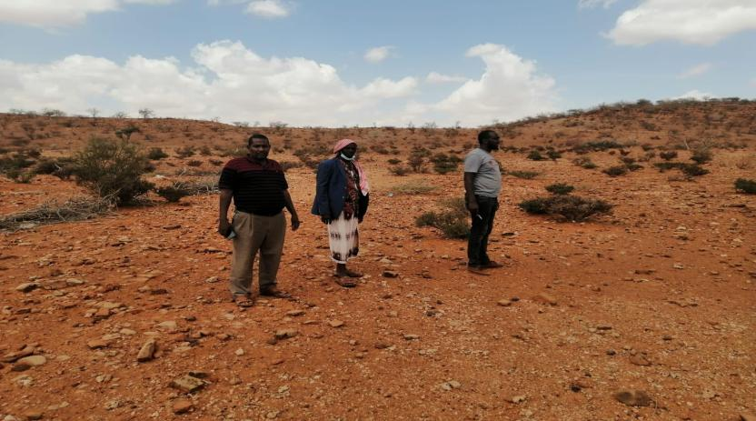

Plate 2: Proposed site for the project

#### Land Tenure

The entire county is categorized as community land held in trust on behalf of the community by the County Government. In Sarohindi, the site is a Communal land which the community has allocated for the public utility development and the consented documented by County administration and minuted as such.

#### Compensation Details

The proponents, due to the community’s land to be acquired for the project as part of in-kind compensation for the land, will fund a community project as an appreciation.

The community during deliberations considered various options but identified as a priority construction of 2No. rooms that will be used as a dispensary since the village lacks one.

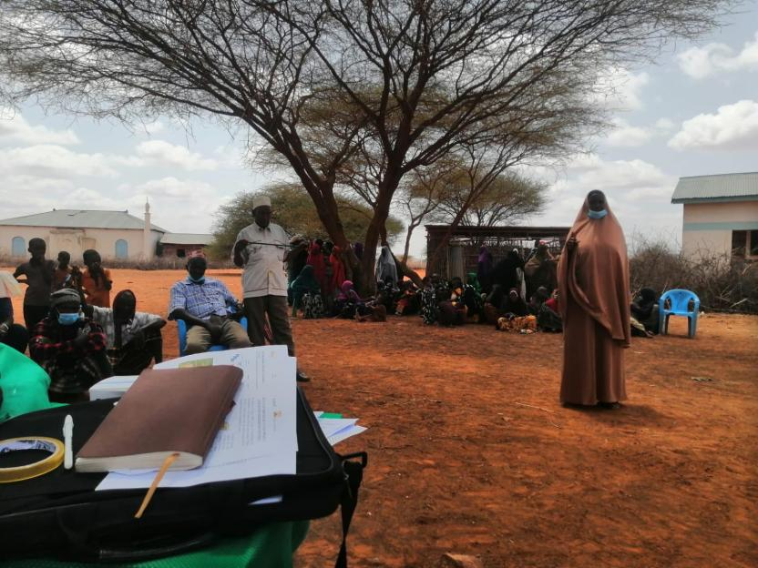

**Plate 3: A Lady Stakeholder member reporting the extra project (in kind compensation) to forum after community deliberations.**

# ANALYSIS OF PROJECT ALTERNATIVES

## Consideration of Project Alternatives

In this chapter, various alternatives available to the project are discussed. The alternatives are as follows; “no-go/do nothing” alternative, alternative construction materials and technology, the alternative Mini-grid site and alternative sources of energy identified during the ESIA process.

The identification and examination of alternatives is fundamental to environmental assessment. It provides decision-makers with information that enables them to properly consider optimal solutions to development proposals. Alternatives illustrate and contrast the environmental implications and consequences of different options available to achieve the same end. In this way, both the KPLC and the authorities who must consider granting the authorization, are put in a position where all involved are able to make informed choices or decisions.

This section analyses the project alternatives in terms of site, technology, and waste management options.

## Relocation Option

Relocation option to different sites is an option available before the project implementation. At present the project KPLC does not have alternative sites in the general direction of the proposed sites. This means that the project proponent has to look for the alternative lands. Looking for the lands to accommodate the scale and size of the proposed project and completing official transaction may take a long time although there is no guarantee that the land would be available.

This project is to improve electrification and accessibility to an already established market center. Several alternatives were considered to improve other areas, but this one was selected because it meets the electrification needs of the area.

In consideration of the above concerns and assessment of the current proposed sites, relocation of the projects is not a viable option.

## Zero or No Project Alternative

The No Project option in respect to the proposed project implies that the status quo is maintained. This option is the most suitable alternative from an extreme environmental perspective as it ensures non-interference with the existing conditions. This option will, however, involve several losses both to Sarohindi area and the community as a whole. The target beneficiaries will stay without electricity and the government objectives of bring electricity in order to open up the area and provide better public services will not be realized. The No Project Option is the least preferred from the socio-economic and partly environmental perspective due to the following factors:

* The socio-economic status of target communities the local economy would remain unchanged.
* Generation of employment opportunities through expansion of business activities that would have been spurred by availability of electric power will not occur.
* Opening up the area for investors will not occur.
* Health benefits that come with electricity will not be realized.
* The targeted consumers will forgo the desired electricity supply in the area.
* The country won’t meet its energy requirement.
* The objectives of the government’s efforts towards achieving Vision 2030 will not be realized.

From the analysis above, it becomes apparent that the no project alternative means no project to the local people and the Government of Kenya, and the benefits outlined above and other indirect benefits that would accrue from construction of the proposed project.

*It is thereby concluded that the ‘do-nothing’ option is not a good option economically and should therefore be discouraged and rejected. It is therefore imperative for KPLC to establish a new solar mini grid in the area and supply the community with clean energy*

## Alternative Sources of Energy

* + 1. **Thermal Power Generation**

Thermal power through installation of Diesel Gen Sets is an option which can be considered to provide power to Sarohindi project. This would need more than 250-300litres of Industrial Diesel Oil (IDO) is burnt daily to generate targeted 50kWp of electricity at Sarohindi. Thermal generation can also be fuelled using alternative fuels such as natural gas, bio diesel, industrial kerosene, heavy vehicle fuel, coal, and unleaded petrol. Thermal power generation has serious negative environmental impacts including generation hence the need for the KPLC to install the proposed solar power plant.

* + 1. **Hydro Electric Power – HEP**

This would mean exploring the possibility of extending the existing national grid to Sarohindi since there are no hydro facilities within the region to facilitate HEP generation. The proposed project is quite far from the national grid hence this is a costly venture and may take time before the residents need power for their livelihood.

* + 1. **Other Sources of Energy**

Wood fuel is the greatest source of Energy contributing to 80% of energy requirements in Africa. Over reliance on wood has led to deforestation, desertification, global warming, and climatic change among other socio – economic demerits. The Government of Kenya should look into the possibility of using nuclear energy to generate electricity. This is a long-term consideration and also has several deleterious effects to the environment and human health. Nuclear Waste disposal will also create a huge environmental challenge.

Based on this discussion the proposed solar Mini grid presents the most appropriate option of electrifying/ bringing power to Sarohindi in terms of technology, cost, and environmental considerations

## Analysis of Alternative Construction Materials and Technology

The proposed solar Mini grid will be constructed using modern, locally, and internationally accepted materials to achieve public health, safety, security, and environmental aesthetic requirements. Equipment that guarantees efficient use of locally available materials will be encouraged to ensure reliability in supply with minimum power loss and good design to allow efficient distribution of power in the area.

The support structures in the Solar Mini-grid can be wooden or steel. Because of its durability and strength, steel is the best choice, and all support structures will be steel. Perimeter fence can be a reinforced wire mesh fixed to support structures that can be wooden, concrete, or steel. Alternatively, a stone perimeter wall can be constructed, and this is the option of choice since it is more durable, offer better protection and requires less maintenance.

The design of the solar mini-grid will be easy to install and dismantle with minimum labour requirements and maintenance costs will be minimal. The process material that are input for the proposed project such as generator diesel fuel and oil and water for cooling the generator and for cleaning purposes are critical elements. There is no alternative for generator oil and water for standby generator cooling and for mini-grid facilities cleaning water. So, the task was to assess alternative water and Diesel generator oils and fuel sources for the project.

## Solid Waste Management Alternatives

A lot of solid wastes will be generated from the proposed project. An integrated solid waste management system is recommendable. First, the KPLC will give priority to reduction at source of the materials. This option will demand a solid waste management awareness program in the management and the staff. Recycling and reuse options of the waste will be the second alternative in priority. This will call for a source separation program to be put in place. The third priority in the hierarchy of options is combustion of the waste that is not recyclable. Finally, the KPLC will need to establish partnership with NEMA approved waste handlers for regular waste removal and disposal in an environmentally friendly manner. In this regard, a NEMA registered solid waste handler would have to be engaged. This is the most practical and feasible option for solid waste management.

## Alternative Solar Mini-Grid Site

In determining the most appropriate site for the establishment of the mini grid, several options were explored. Mini grid Sites under KOSAP were selected based on a number of factors as detailed below.

* Geophysical Factors-Proximity to Hills-Shade effect, Soil erosion, Drainage of the area, Flooding etc.
* Land identified is free from any dispute on ownership or any other encumbrances,
* Proximity to public utilities-Schools, Dispensaries, Places of worship and community settlements.
* No squatters, encroachers, or other claims to the land.
* The Size of the Mini grid to be constructed and the optimal coverage of a Mini grid in terms of the number of people to be reached.
* The Land identified should be on spaces set aside for public use within the community centres.

The land was identified by the beneficiary communities and confirmed by technical staff to be suitable for the sub-project and free from any environmental or health risks. The impacts on the Community will be marginal and will not result in displacement of households or cause loss of household’s incomes and livelihood.

The site identified was considered against the criteria highlighted above and was found suitable for Mini grid construction

# RELEVANT LEGISLATIVE AND REGULATORY FRAMEWORKS

## Introduction

This Chapter outlines the existing national and international environmental and social legislation, policies, and institutions applicable to energy generation that guide the development of the Project.

As Kenya is a signatory to various international conventions and laws, national projects need to be aligned with their requirements; relevant international conventions and laws are therefore presented in this chapter.

Finally, a summary of the World Bank (WB) Environmental and Social operational policies relevant to this Project are presented.

## Environmental Policy Framework

The Kenya government formulated a national Environmental policy in 2013 whose goal is better quality of life for present and future generations through sustainable management and use of the environment and natural resources.

According to the said policy Kenya has a wide variety of ecosystems namely mountains, forests, arid and semi-arid areas (ASALs), freshwater, wetlands, coastal and marine all offering many opportunities for sustainable human, social and economic development. These ecosystems are natural capitals which provide important services such as regulatory services, provision services, cultural services and supporting services implying that he survival and socio-economic wellbeing of Kenyans is ultimately intertwined with the environment.

The policy comes in handy as it provides a framework to guide the country’s efforts in addressing the ever-growing environmental issues and challenges such as: Environmental governance, Loss of biodiversity, valuation of environmental and natural resources, rehabilitation and restoration of environmentally degraded areas, urbanization, waste management and pollution, climate change, energy, security and disaster management, public participation, environmental education and awareness, data and information, poverty, chemicals management

One of the principles of the policy which this project must adhere to is that the right to development should be exercised taking into consideration sustainability, resource efficiency and economic, social, and environmental needs.

## Institutional, Regulatory and Legal Framework

The multi-faceted nature of the environment and the need to integrate environmental considerations in all development planning and activities calls for cooperation and consultation among responsible government agencies and stakeholders at all levels. At present there are several institutions and departments which deal with environmental issues in Kenya. Some of the key institutions include:

* + 1. **National Environment Management Authority (NEMA)**

The objective and purpose for which NEMA was established is to exercise general supervision and co-ordinate over all matters relating to the environment and to be the principal instrument of the government in the implementation of all policies relating to the environment. However, NEMA’s mandate is designated to the following committees:

* + 1. **County Environment Committees**

According to EMCA (Amendment), 2015, every governor shall, by notice in the Gazette, constitute a County Environment Committee (CEC) of the County. The County Environment Committees are responsible for the proper management of the environment, development of county strategic environmental action plan, every five years including implementation of the plans among others.

* + 1. **National Environmental Complaints Committee**

The Committee performs the following functions:

* Investigate any allegations or complaints against any person or against the authority in relation to the condition of the environment in Kenya and on its own motion, any suspected case of environmental degradation and to make a report of its findings together with its recommendations thereon to the Council.
* Prepare and submit to the Council periodic reports of its activities which shall form part of the annual report on the state of the environment under section 9 (3) and
* To perform such other functions and excise such powers as may be assigned to it by the Council.
  + 1. **National Environment Action Plan Committee**

This Committee is responsible for the development of a 5-year Environment Action Plan among other things. The National Environment Action Plan shall:

* Contain an analysis of the Natural Resources of Kenya with an indication as to any pattern of change in their distribution and quantity over time.
* Contain an analytical profile of the various uses and value of the natural resources incorporating considerations of intergenerational and intra-generational equity.
* Recommend appropriate legal and fiscal incentives that may be used to encourage the business community to incorporate environmental requirements into their planning and operational processes.
* Recommend methods for building national awareness through environmental education on the importance of sustainable use of the environment and natural resources for national development.
* Set out operational guidelines for the planning and management of the environment and natural resources.
* Identify actual or likely problems as may affect the natural resources and the broader environment context in which they exist.
* Identify and appraise trends in the development of urban and rural settlements, their impact on the environment, and strategies for the amelioration of their negative impacts.
* Propose guidelines for the integration of standards of environmental protection into development planning and management.
* Identify and recommend policy and legislative approaches for preventing, controlling, or mitigating specific as well as general diverse impacts on the environment.
* Prioritize areas of environmental research and outline methods of using such research findings.
* prejudice to the foregoing, be reviewed and modified from time to time to incorporate emerging knowledge and realities and.
* Be binding on all persons and all government departments, agencies, States Corporation, or other organ of government upon adoption by the national assembly.
  + 1. **Standards and Enforcement Review Committee**

This is a technical Committee responsible for environmental standards formulation methods of analysis, inspection, monitoring, and technical advice on necessary mitigation measures.

* + 1. **National Environment Tribunal**

This tribunal guides the handling of causes related to environmental offences in the Republic of Kenya.

* + 1. **National Environment Council (NEC)**

EMCA 1999 No. 8 part III section 4 outlines the establishment of the National Environment Council (NEC). NEC is responsible for policy formulation and directions for purposes of EMCA; set national goals and objectives and determines policies and priorities for the protection of the environment and promote co-operation among public departments, local authorities, private sector, non-governmental organizations, and such other organizations engaged in environmental protection programmes.

*The project proponent will adhere to any directive issued by the above institutions that are relevant to the project.*

## Kenya Policy Provisions

* + 1. **Kenya Energy Policy, 2014**

The Energy Policy sets out the national policies and strategies for the energy sector that align to the Constitution of Kenya and Kenya’s Vision 2030.

The Energy Policy envisages promoting an energy mix that includes solar energy at both the household/institutional levels as well as large-scale solar energy generation. The Government of Kenya has initiated and has been promoting programmes for the provision of electricity to institutions far from the grid through solar PV systems. The Government has also embarked on a programme to provide solar/diesel and solar/wind hybrid generation capacity to off-grid stations.

The Policy strategizes the need to:

* promote the widespread use of solar energy while enforcing existing regulations and standards.
* provide incentives to promote the local production and use of efficient solar systems.
* provide a framework for connecting electricity generated from solar energy to the national and isolated grids, through direct sale or net metering.
* promote the use of hybrid power generation systems involving solar and other energy sources; and
* facilitate the generation of electricity from solar energy by, among other things, funding, provision of land, fast-tracking issuance of permits and licenses, as well as acquisition of data and information to realize at least 100 MW from solar by 2017, 200 MW by 2022 and 500 MW by 2030.

The Kenya Electricity Supply Industry (ESI) is one of the sub-sectors in the energy sector which the Ministry of Energy and Petroleum oversees on behalf of the Government of Kenya (GoK). Under the Energy Act of 2006, the Ministry is responsible for formulation and articulation of policies to provide an enabling environment for operators and other stakeholders in the energy sector. Relevant stakeholders in the ESI are briefly described below.

Table 6. ESI and their roles

|  |  |
| --- | --- |
| Stakeholders | Role |
| Kenya Power Company | Responsible for distribution and retail supply of electrical energy to end users. Kenya Power purchases power in bulk from the Kenya Electricity Generating Company Limited (KenGen) and the Independent Power Producers (IPPs) through bilateral contracts or Power Purchase Agreements (PPAs) approved by the Energy Regulatory Commission (ERC) ([1]). |
| Kenya Electric Generating Company  (KENGEN) | It is the leading electric power generation company in the country. The company uses various sources of energy to generate electricity ranging from hydro, geothermal, thermal and wind |
| The Energy and Petroleum Regulatory Authority (EPRA) | Established by the Energy Act of 2019. The EPRA’s mandate extends beyond electricity and includes natural gas (including petroleum), renewables and all other forms of energy. The generation, transmission, distribution, supply, import and export of electricity can only be carried out by parties in possession of a license, or a permit issued by the EPRA. If the capacity involved is for own use and less than 1 MW, authorization is not required. Although the generated electricity is expected to be less than 1 MW (0.3 – 1 MW), the fact that the generated electricity is intended for use in a factory, The project requires a license from the EPRA to generate electricity as stipulated in the Energy Act, 2019. |
| Ministry of Energy and Petroleum | Aims to facilitate provision of clean, sustainable, affordable, reliable, and secure energy services for national development while protecting the environment. |
| The Rural Electrification and Renewable Energy Corporation (REREC): | Is established under Section 43 of the Energy Act, 2019 as a corporate body. The Corporation is the successor to the Rural Electrification Authority established under section 66 of the Energy Act No. 12 of 2006 (now repealed) and subject to this Act, all rights, duties, obligations, assets and liabilities of the Rural Electrification Authority existing at the commencement of this Act is to be automatically and fully transferred to the Corporation and any reference to the Rural Electrification Authority in any contract or document shall, for all purposes, be deemed to be a reference to the Corporation. |
| The Geothermal Development Company (GDC): | Is a 100% state-owned company, formed by the Government of Kenya as a Special Purpose Vehicle to fast track the development of geothermal resources in the country. The creation of GDC was based on the government’s policy on energy - Sessional paper No. 4 of 2004, and the energy Act No. 12 of 2006. |
| The Kenya Electricity Transmission Company (KETRACO): | Was incorporated on 2nd December 2008 and registered under the Companies Act, Cap 486 pursuant to Sessional paper No. 4 of 2004 on Energy. KETRACO’s mandate is to design, construct, operate and maintain new high voltage electricity transmission infrastructure that will form the backbone of the National Transmission Grid, in line with Kenya Vision 2030. |
| Energy and Petroleum Tribunal (EPT): | The tribunal is established under section 25 of The Energy Act, 2019. The tribunal is established for the purpose of hearing and determining disputes and appeals in accordance with The Energy Act, 2019 or any other written law. In relation to the proposed Project, any disputes or appeals if they arise will need to be addressed by the EPT. |

* + 1. **The Consultation of Kenya**

Environmental management and natural resources utilization are enshrined in the Kenya constitution 2010 under several articles. In article 69 of the Constitution of Kenya, 2010, the State clearly undertakes to carry out the following:

* Ensure sustainable exploitation, utilization, management and conservation of the environment and natural resources, and ensure the equitable sharing of the accruing benefits;
* Work to achieve and maintain a tree cover of at least ten per cent of the land area of Kenya;
* Protect and enhance intellectual property in, and indigenous knowledge of, biodiversity and the genetic resources of the communities;
* Encourage public participation in the management, protection and conservation of the environment;
* Protect genetic resources and biological diversity;
* Establish systems of environmental impact assessment, environmental audit and monitoring of the environment;
* Eliminate processes and activities that are likely to endanger the environment; and
* Utilize the environment and natural resources for the benefit of the people of Kenya.

The constitution in article 42 emphasizes the need for a clean and healthy environment through management of substances that may pollute the environment or cause harm to human health. The right to a clean environment is further enforced by article 70. Article 186 and the fourth schedule allocate functions of natural resources management and environmental protection to both the national and county governments.

The county government on the other hand shall Control air pollution, noise pollution and other public nuisances as stipulated in article 3 of the fourth schedule and in article 10, the county government shall implement specific national government policies on natural resources and environmental conservation.

Public participation is entrenched in several articles across the Kenya constitution 2010. Article 6 provided for devolution and access to services. Responsibilities in major decision-making process have been bestowed to the public (in the bill of rights, articles 118, 174, 196 and 201). The constitution further in article 21 section 3 requires safeguarding the rights and interests of marginalized groups for equity in public service provision. This can be effectively achieved through active involvement of such groups in decision making process at all levels. Hence need to involve the local people in the project area in studies, design and implementation of the proposed project facilities.

The principles of land policy that ensure land is held, used and managed in a manner that is equitable, efficient, productive and sustainable is set out in article 60 of the constitution. Proper land management by regulating the use of any land, or any interest in or right over any land, in the interest of defending, public safety, public order, public morality, public health, or land use planning is ensured by the constitution in article 66.

In regard to environmental protection and natural resources management, article 62 sub-article 1 stipulates what constitutes public land. Both the Land Act22 and the Land Registration Act23 refers to the definition given under the Constitution of Kenya (2010) to be the one to apply in each of the respective statutes. The public land areas are held by the national government in trust for the people of Kenya and shall be administered on their behalf by the National Land Commission as stated in article 62 sub-article 3. The land commission shall also monitor and have oversight responsibilities over land use planning throughout the country regardless of the classification as stated in article 67-2(h).

Private Land under Article 64, includes any land that is vested in a natural or artificial person, and any other land declared through an Act of Parliament. The Constitution 2010 has emphatically stated that: freehold land cannot be owned by a non- citizen of Kenya; and a leasehold interest of over 99 years cannot be held by a non-Kenyan citizen.

Article 63 of the constitution, Community land includes land currently under the Land (Group Representatives) Act; land currently classified as trust lands, community forests, land that is transferred to the community by any process of law, ancestral land and lands traditionally occupied by hunter-gather communities inter alia. Community land is a new category of land explicitly created by new constitution 2010. The term ―community‖ would require a legal definition to allow transfer of land that is currently forest, protected areas or other public land to such communities. Ethnicity may determine the community land however; Article 27 is prohibiting discrimination on the basis of ethnicity. Ancestral land too is not defined, nevertheless, it may be applied to any group or community which identifies itself as traditionally holding a specific area and which it has legal claim as its own.

*For the purposes of this project, the constitution of Kenya provides for sound environmental management and sustainability and therefore this study provides one of the tools through which this can be achieved*

* + 1. **Policy paper on Environment and Development (Sessional Paper No. 6 of 1999)**

The overall goal of this Sessional Paper is to ensure that environmental concerns are integrated into the national planning and management processes and provide guidelines for environmentally sustainable development. The objectives of the Paper are to conserve and manage the natural resources of Kenya including air, land, flora, and fauna and promote environmental conservation about soil fertility and conservation, biodiversity, to foster afforestation activities, and to protect water catchment areas. More importantly, the Policy emphasizes the enhancement of public awareness and appreciation of the essential linkages between development and environment, involving NGOs, private sector, and local communities in the management of natural resources and their living environment and ensures that an environmental impact assessment report is undertaken for all public and private projects and programmes.

*The proposed solar plant facility must ensure that it promotes this integrated approach to environmental management and development, without compromising the livelihoods of the local community.*

* + 1. **National Policy on Water Resources Management and Development, 1999**

While the National Policy on Water Resources Management and Development enhances a systematic development of water facilities in all sectors for promotion of the country’s socio-economic progress, it also recognizes the by-products of this process as wastewater. The Policy therefore calls for development of appropriate sanitation systems to protect people’s health and water resources from institutional pollution. This implies that industrial and business development activities should be accompanied by corresponding waste management systems to handle the wastewater and other waste emanating therefrom.

*During construction, water will be required for concrete works and during the operational period water supply may be necessary for cleaning the PV modules. Appropriate water treatment and waste handling must be incorporated into the Project design to be in alignment with this policy.*

* + 1. **Sessional Paper No. 10 of 2014 on the National Environmental Policy, 2014**

The overall goal of this Session Paper is to ensure better quality of life for present and future generations through sustainable management and use of the environment and natural resources. This Session Paper calls for the use of environmentally sound technologies based on the best available techniques and policies as a way of minimizing negative impacts to the environment.

Section 5.6 of this Session Paper focuses on infrastructure development and environment and makes explicit policy statements to ensure sustainable management and use of the environment and natural resources during the construction and operation of infrastructure developments. These policy statements require the commitment of the government to:

* Ensure Strategic Environmental Assessment (SEA), Environmental Impact Assessment, Social Impact Assessment and Public participation in the planning and approval of infrastructural projects.
* Develop and implement environmentally friendly national infrastructural development strategy and action plan.
* Ensure that periodic Environmental Audits are carried out for all infrastructural projects

*In line with the above policy statements, this ESIA has been conducted for the proposed solar project (including the associated infrastructure) to ensure that environmental and social issues are appropriately addressed.*

*Once approved by NEMA, the Project Proponent will also need to conduct periodic Environmental Audits to ensure continuous conformity with the overall goal of this Session Paper. In addition, this ESIA has considered analysis of alternatives including alternatives to technology to ensure that the best available and appropriate technology is used.*

## National Legal Framework

* + 1. **Administrative Framework**

In 2001, the Government established the administrative structures to implement the Environmental Management and Co-ordination Act of 1999 (EMCA). The main administrative structures are described in the following sections:

Table 7. Administrative stakeholders and their roles

|  |  |
| --- | --- |
| Stakeholders | Role |
| *NEC* | The **National Environmental Council** is responsible for policy formulation and directions for the purposes of EMCA. The Council also sets national goals and objectives and determines policies and priorities for the protection of the environment.  *The proponent should ensure that the project abides by the set goals and objectives of the Council*. |
| *NEMA* | The responsibility of NEMA is to exercise general supervision and coordination over all matters relating to the environment and to be the principal instrument of Government in the implementation of all policies relating to the environment.  *This ESIA has been prepared for submission to NEMA for review and approval prior to the commencement of the Project activities, in compliance with the EMCA.* |
| *PCC* | EMCA has also established a Public Complaints Committee, which provides the administrative mechanism for addressing environmental harm. The Committee has the mandate to investigate complaints relating to environmental damage and degradation. The members of the **Public Complaints Committee** include representatives from the Law Society of Kenya, NGOs, and the business community.  *The proponent should address all issues arising from the Project in accordance with the above requirements, including a clear policy of stakeholder engagement and feedback.* |
| *WRA* | The Water Resources Authority is responsible for regulation of water resources issues such as water allocation, source protection and conservation, water quality management and pollution control and international waters. One of its functions among others is to receive water permit applications for water abstraction, water use and recharge and determine issue, vary water permits; and enforce the conditions of those permits as well as formulate and enforce standards, procedures and Regulations for the management and use of water resources and flood mitigation.  *The project area experiences serious water scarcity. The proponent will have to purchase water for use during construction.* |
| ***The Energy and Petroleum Regulatory Authority (EPRA):*** | Established by the Energy Act of 2019. The EPRA’s mandate extends beyond electricity and includes natural gas (including petroleum), renewables and all other forms of energy. The generation, transmission, distribution, supply, import and export of electricity can only be carried out by parties in possession of a license or a permit issued by the EPRA. In the event that the capacity involved is for own use and less than 1 MW, authorization is not required. Although the generated electricity is expected to be less than 1 MW (0.3 – 1 MW), the fact that the generated electricity is intended for use in a factory and there is a possibility for connection to the national grid and sale of excess power to the government, the project requires a license from the EPRC to generate electricity as stipulated in the Energy Act, 2019.  The Energy and Petroleum Regulatory Authority (Authority) together with industry stakeholders have developed the Draft Energy (Mini-Grid) Regulations, 2021 (the ‘Regulations’). The Regulations have been developed within provisions 10, 11 and 208 of the Energy Act, 2019 (the ‘Act’) and shall constitute Regulations to the Act. The Regulations will amongst others, provide guidance to mini-grid developers and other stakeholders on the tariff approval and licensing requirements. This will be directly applicable to the Sarohindi site. |

## Relevant statutes

The current legal provisions for natural resource management in Kenya are contained in over seventy sector-specific statutes. For a long time, the country lacked an umbrella legislative guide for harmonious and holistic environmental management. As such, resources were managed sectoral in accordance with the statutes that were in place.

As these statutes were contradictory at times, in 1999, the Government of Kenya enacted the Environmental Management and Co-ordination Act (EMCA) which is an umbrella legal framework under which the environment is being managed. EMCA establishes the institutional framework under which environmental management is to be coordinated. EMCA prevails over all other Sectoral laws relating to the environment in cases of conflict or contradictions. It also grants the public a *locus standi* in matters of the environment.

Table 8. National Policy Framework

| **No** | **Legislation/**  **Guidelines** | **Description of the Legislation/Guideline** | **Relevance of the legislation/regulations in terms of license, permits, and other requirements** |
| --- | --- | --- | --- |
|  | **NATIONAL POLICY FRAMEWORK** | | |
|  | Vision 2030 | Kenya Vision 2030 is the current national blueprint for development from its inception in 2008 until the milestone year of 2030. This plan is the national long-term development policy that aims to transform Kenya into a newly industrialized, middle-income country by 2030. The Vision is comprised of three key pillars (economic, social, and political), two of which are projected to be positively affected by project implementation. | Under Vision 2030, Energy is identified as one of the key sectors that form the foundation for socio-political and economic growth. Promoting equal opportunities across the entire Kenyan territory and enhancing access to competitively priced, reliable, quality, safe and sustainable energy is essential to the achievement of this vision. |
|  | The Poverty Reduction Strategy Paper (PRSP) of 2001 | The PRSP has the twin objectives of poverty reduction and enhancing economic growth. The paper articulates Kenya ‘s commitment and approach to fighting poverty; with the basic rationale that the war against poverty cannot be won without the participation of the poor themselves. | * The proposed project aims at provision and access of renewable electricity geared towards improved economic performance and thus will contribute to poverty alleviation in the project area. |
|  | National Environmental Action Plan (NEAP) of 1994 | The NEAP for Kenya was prepared in mid 1990s. It was a deliberate policy whose main effort is to integrate environmental considerations into the country ‘s economic and social development. The integration process was to be achieved through multi-sectoral approach to develop a comprehensive framework to ensure that environmental management and the conservation of natural resources forms an integral part of societal decision-making. | * The NEMA does not approve a development project unless the impacts of the proposed project are evaluated and Enhancement Measures proposed for incorporation in the project ‘s development plan, which is in line with the requirements of the NEAP. * The project will be reviewed by NEMA for approval before implementation. |
|  | Environmental and Development Policy (Session Paper No.6 1999) | As a follow-up to the foregoing, the goal of this policy is to harmonize environmental and developmental goals so as to ensure sustainability. The paper provides comprehensive guidelines and strategies for government action regarding environment and development.  The Government will:   * Ensure Strategic Environment Assessment (SEA), Environmental Impact Assessment, Social Impact Assessment and Public participation in the planning and approval of infrastructural projects. * Develop and implement environmentally-friendly national infrastructural development strategy and action plan. * Ensure that periodic Environmental Audits are carried out for all infrastructural projects | The proponent:   * is undertaking an Environmental Impact Assessment, Social Impact Assessment and Public participation as part of the planning and approval of infrastructural projects. * Will ensure that periodic Environmental Audits are carried out for the project. |
|  | The National Energy and Petroleum Policy 2015 | The overall objective of the energy and petroleum policy is to ensure affordable, competitive, sustainable and reliable supply of energy to meet national and county development needs at least cost, while protecting and conserving the environment. This policy stipulates the transformation of the Rural Electrification Authority (REA) to Rural Electrification and Renewable Energy Corporation (REREC) to be the lead agency for development of renewable energy resources. | The policy is relevant to the project in the sense that the project will provide sustainable and reliable energy supply and measures will be put in place to protect and conserve the environment during its development. REREC will be in charge of the development of the minigrid and maintenance. |
|  | The Gender and Development Policy (Sessional paper no.2 2019) | The overall goal of this policy is to achieve gender equality by creating a just society where women, men, boys and girls have equal access to opportunities in the political, economic, cultural and social spheres of life.  The anticipated outcome of this policy as enshrined in the Constitution that aligns to the project include:  a) Equality and economic empowerment will be of both genders,  b) Women and men will have equality of opportunity to participate in decision making and to contribute to the political, social, economic and cultural development agenda;  c) Sexual and Gender based Violence will abate and men, women, boys and girls will live with dignity | * In the absence of appropriate measures, the project can exacerbate gender inequalities and sexual and gender based violence. In adherence to this policy, measures will be put in place to:   + ensure gender inclusivity in decision making, employment opportunity and access to the energy generated from the Mini-Grid   + mitigate social risks including sexual and gender based violence, and any form of discriminations |
|  | The HIV/ AIDS Policy 2009 | In summary, the policy aims at:  I. Establishing and promoting programmes to ensure non-discrimination and non- stigmatization of the infected;  ii. Contributing to national efforts to minimize the spread and mitigate against the impact of HIV and AIDS;  iii. Ensuring adequate allocation of resources to HIV and AIDS interventions; | * The proposed project is to be implemented in a rural setting at area. The area is not economically empowered hence few HIV/AIDS prevention resources are available. This policy shall provide a framework to both the project proponent and contractor to address issues related to HIV/AIDS during the entire project phase. |
| LAWS AND LEGISTLATIONS | | | |
|  | The Constitution of Kenya, 2010 | The Constitution of Kenya promulgated in 2010 is the supreme law of the republic and binds all persons and all State organs at all levels of government. The Constitution provides the broad framework regulating all existence and development aspects of interest to the people of Kenya, and along which all national and sectoral legislative documents are drawn. | The proposed project complies with the Constitution by proposing a structure in its ESIA on how to deal with Social, Health, safety and environmental issues for sustainable development. |
|  | ENVIRONMENTAL MANAGEMENT AND COORDINATION ACT, 1999 (AND THE AMENDMENTS OF 2015) | The EMCA is a framework environmental law in Kenya. This Act (assented to on January 14, 2000) provides a structured approach to environmental management in Kenya. With the EMCA coming into effect, the environmental provisions within the sectoral laws were not superseded; instead, the environmental provisions within those laws were reinforced to better manage Kenya’s ailing environment. | * The proposed project will be undertaken in accordance with relevant sections of the EMCA, specifically Clauses 58 – 63. These sections of the Act are operationalized by subsidiary legislation promulgated under the Act and specifically Legal Notice (L.N.) 101: Environment (Impact Assessment and Audit) Regulations, 2003. |
|  | L.N. 101: EIA/EA REGULATIONS, 2003 AND 2016 AMENDMENTS | These regulations provide the framework for undertaking EIAs and EAs in Kenya by NEMA licensed Lead Experts and Firms of Experts. An EIA or EA Study in Kenya is to be undertaken by a firm duly licensed by the National Environmental Management Authority (NEMA). The EIA/EA Regulations also provide information to project proponents on the requirements of either an EIA or EA as required by the EMCA. | * The proposed project is subject to relevant provisions of these regulations and subsequently, the ESIA has been undertaken in accordance with the requirements. |
|  | L.N. 120: WATER QUALITY REGULATIONS, 2006 | These regulation provides for the sustainable management of water used for various purposes in Kenya. For effluent discharges into the environment and aquatic environment, a Proponent needs to apply directly to the NEMA. For discharges into public sewers, a Proponent needs to apply for the license to the relevant county. The regulation contains discharge limits for various environmental parameters into public sewers and the environment. | * These regulations will apply to the proposed project during the construction and operational phases. The contractor will be required to properly manage the effluent from construction activities in accordance with the above regulations prior to discharge into the environment. |
|  | L.N. 121: WASTE MANAGEMENT REGULATIONS, 2006 | These regulations are comprehensive and cover the management of various kinds of waste in Kenya. Generally, it is a requirement under the regulations that a waste generator segregates waste (hazardous and non-hazardous) by type and then disposes the them in an environmentally acceptable manner. Under the regulation, it is a requirement that waste is transported using a vehicle that has an approved “Waste Transportation License” issued by NEMA. Wastes generated in Kenya must be disposed of in a licensed disposal facility. Such a facility will require annual environmental audits to be undertaken by NEMA registered Lead Experts.  The regulation requires that prior to generating any hazardous waste, a proponent shall undertake an EIA Study and seek approval from the NEMA. Labelling of hazardous wastes is mandatory under the regulation and the specific labelling requirements are provided in Rule 18. The treatment options for hazardous waste disposal provided in Rule 19 include incineration or any other option approved by the NEMA. | * During the construction and operation phases, the proposed project will generate various streams of wastes. For the most part, it is expected that the wastes will be non-hazardous in nature and can be disposed of in accordance with these regulations. |
|  | L.N. 61: NOISE AND EXCESSIVE VIBRATION CONTROL REGULATIONS, 2009 | The general prohibition of these regulations states that no person shall make or cause to be made any loud, unreasonable, unnecessary, or unusual noise which annoys, disturbs, injures, or endangers the comfort, repose, health, or safety of others and the environment.  The regulations further provide factors that will be considered in determining whether or not noise and vibration is loud, unreasonable, unnecessary, or unusual. | * Rules 13 and 14 of the regulations define the permissible noise levels for construction sites. These noise limits will be applicable to the proposed project. |
|  | LICENSES AND PERMITS REQUIRED UNDER THE EMCA | The subsidiary legislations under the EMCA are partially monitored through the use of permits and licenses. Subsequently all licenses and permits required during the construction phase shall be the responsibility of the individual contractors and their agents. During the operational phase, all permits and licenses required to operate the project will be the responsibility of the proponent. | The subsidiary legislations under the EMCA requires some or all the following types of permits to be available for inspection during the construction and operational phases of the project:   * Effluent Discharge License under Legal Notice 120: The Environment Management and Coordination (Water Quality) Regulations 2006; * Waste Transport License under Legal Notice 121: The Environment Management and Coordination (Waste Management) Regulations 2006 for disposal of all types of wastes; and * Noise Permit under Legal Notice 61: The Environment Management and Coordination (Noise and Excessive Vibration Control) Regulations, 2009. |
|  | OCCUPATIONAL HEALTH AND SAFETY ACT, 2007 | The Occupational Safety and Health Act (OSHA) was enacted to provide for the health, safety and welfare of persons employed in workplaces, and for matters incidental thereto and connected therewith.  Part II of the Act provides the General Duties to which the occupier must comply with respect to health and safety in the workplace. Such duties include undertaking safety and health (S&H) risk assessments, S&H audits, notification of accidents, injuries and dangerous occurrences. A number of sections under this part shall be applicable to the proposed project.  Part IV deals with the enforcement provisions that Directorate of Occupational Safety and Health Services (DOSHS) has under the Act. It discusses the instances when Improvement and Prohibition Notices can be issued as well as the powers of Occupational S&H officers. This part of the Act will be mandatory for the occupier to comply with for the proposed project.  Part V of the Act requires all workplaces to be registered with the DOSHS. This part will be applicable for the proposed project as the Occupier will have to apply for registration of their project with the DOSHS on completion of the construction phase and before the operational phase of the project.  Part VI of the Act lists the requirements for occupational health provisions which include cleanliness, ventilation, overcrowding, etc. This section of the Act will apply to the Occupier during the operational phase of the project.  Part VIII of the Act contains provisions for general safety of a workplace, especially fire safety. This part of the Act will apply to the proposed project during the design, construction, and operational phases.  Part X of the Act deals with the General Welfare conditions that must be present during the construction and operational phase of the project. Such conditions include first aid facilities, supply of drinking water, accommodation for clothing, ergonomics, etc. This part of the Act will apply to the proposed project during the construction and operational phases.  Part XI of the Act contains Special Provisions on the management of health, safety, and welfare. These include work permit systems, PPE requirements and medical surveillance. Some sections of this part of the Act will be applicable to the proposed project during the construction and operational phase.  Part XIII of the Act stipulates various fines and penalties associated with non-compliance with the Act. It includes those fines and penalties that are not included in other sections of the Act and will be important for the Occupier to read and understand the penalties for non-compliance with S&H provisions.  Part XIV of the Act is the last section of the Act and contains miscellaneous provisions which are not covered elsewhere in the Act. Some sections under this part of the Act will apply to the proposed project and it is in the interest of the occupier to read, understand, and ensure compliance. | The proposed project will be undertaken in compliance with the OSHA-2007 during the construction, design, and operational phases.  During the construction phase, the contractors will be required to fully comply with the requirements of Legal Notice 40 titled: Building Operations and Works of Engineering Construction Rules, 1984 (BOWEC). Each contractor will develop and implement a formal construction health and safety plan for the entire construction phase duration in alignment with the OSHA and international health and safety best practices. |
|  | L.N. 31: The Safety and Health Committee Rules, 2004 | These rules came into effect on April 28, 2004, and require that an Occupier formalize a S&H Committee if there is a minimum of 20 persons employed in the workplace. The size of the S&H Committee will depend on the number of workers employed at the place of work.  For the Proponent and Contractor, the OSHA and the S&H Committee Rules 2004 are important as they require compliance with the following measures:   * + Posting of an Abstract of the Factories and Other Places of Work Act in key sections of each area of the factory or other workplace;   + Provision of first aid boxes in accordance with Legal Notice No. 160 of 1977;   + Ensuring that there are an appropriate number of certified first aiders trained by an approved institution and that the certification of these first aiders is current;   + Provision of a General Register for recording, amongst other things, all incidents, accidents, and occupational injuries;   + Appointment of a S&H Committee made up of an equal number of members from management and workers based on the total number of employees in the workplace;   + Training of the S&H Committee in accordance with these rules; and   + Appointment of a S&H management representative for the Proponent. | The contractor will be required to constitute Health and Safety Committee to oversee safety and health at the construction site. The number of the committee members will be deducted by the number of staff hired by the contractor. The S&H Committee must meet at least quarterly, take minutes, circulate key action items on bulletin boards, and may be required to send a copy of the minutes to the DOSHS provincial office.  Appropriate record keeping including maintenance of all current certificates related to inspection of critical equipment such as cranes, air compressors, lifts, pulleys, etc. Such inspections need to be undertaken by an approved person registered by the Director of the DOSHS. |
|  | L.N. 24: Medical Examination Rules, 2005 | These rules provide for Occupiers to mandatorily undertake pre-employment, periodic, and termination medical evaluations of workers whose occupations are stipulated in the Eighth Schedule to the OSHA and the First Schedule to this Rules. Workers that fall under the above two schedules are required to undergo medical evaluations by a registered medical health practitioner duly registered by the DOSHS. | Some construction activities such as metal cutting and grinding, repair or maintenance of construction equipment could expose the construction workers during construction phase and operations and maintenance workers during operation phase to physical and chemical hazards The contractor should that the workers exposed to such hazards undergo requisite medical examinations as required by these rules |
|  | L.N. 25: Noise Prevention and Control Rules, 2005 | The rules set the permissible level for occupational noise in any workplace (which includes construction sites) as follows:  • 90 dB(A) over an 8-hour time weighted average (TWA) period over 24-hours; and  • 140 dB(A) peak sound level at any given time.  Additionally, the rules set permissible limits for community noise levels emanating from a workplace as follows:  • 50 dB(A) during the day; and  • 45 dB(A) at night.  The Proponent is to ensure that   * any equipment brought to the site for use shall be designed or have built-in noise reduction devices that do not exceed 90 dB(A). * those employees that may be exposed to continuous noise levels of 85 dB(A) are medically examined as indicated in Regulation 16. If found unfit, the occupational hearing loss to the worker will be compensated as an occupational disease. | It is expected that during the construction phase of the project, there may be plant equipment that exceeds the threshold levels of noise stipulated under the Rules. It will therefore be incumbent on the contractor and his or her sub-contractors to ensure that their equipment is serviced properly and/or use equipment that complies with the threshold noise values given above. Alternatively, each contractor will be required to develop and implement a written hearing conservation programme during the construction phase. |
|  | L.N. 59: Fire Risk Reduction Rules, 2007 | A number of sections of the rules apply to the proposed project as enumerated below.   * Regulation 5 requires Proponents to ensure that fire resistant materials are used for construction of new buildings. A number of minimum specifications of materials are provided in this rule. * Regulation 6 requires that all flammable materials be stored in appropriately designed receptacles. Some of the flammable materials anticipated at the project site including; fossil fuel using running construction equipment and vehicles (during construction phase) and stand by generator (operation phase) * Regulation 7 requires that all flammable storage tanks or flammable liquid containers be labelled with the words “Highly Flammable” in English or Swahili. It is therefore practical for the Proponent to use a system similar to the Hazardous Material Identification System of labelling their product containers. The regulation requires a Proponent to consult the product’s MSDS for appropriate labelling requirements. * Regulation 8(3) requires a Proponent to have a Spill Prevention, Control, and Countermeasures (SPCC) plan. This may be important if there will be chemicals stored in the refueling area at the construction site. * Regulation 16 requires Proponents to ensure that electrical equipment is installed in accordance with the respective hazardous area classification system. It is also a requirement that all electrical equipment is inspected every six months by a competent person and the Proponent is required to keep records of such inspections. * Regulation 22 provides a description of the functions of a fire-fighting team. * Regulation 23 requires Proponents to mandatorily undertake fire drills at least once a year. * Regulation 33 requires Proponents to have adequate fire water storage capacity. As a minimum this regulation requires Proponents to have at least 10 cubic meters of dedicated fire water storage capacity. * Regulation 34 requires Proponents to develop and implement a comprehensive written Fire Safety Policy. This policy should contain a Fire Safety Policy Statement signed by the CEO, a Fire Safety Policy Manual and a brief summary of the Fire Safety Policy of the company. * Regulation 35 requires a Proponent to notify the nearest Occupational S&H area office of a fire incident within 24 hours of its occurrence and a written report sent to the Director of DOSHS within 7 days. | The proponent is expected to comply with the requirements of L.N. 59: Fire Risk Reduction Rules, 2007 by   1. Carrying out, and record, a fire risk assessment identifying any possible dangers and risks. 2. Reducing, or where possible remove, the risk of fire and take precautions to deal with the remaining risks. 3. Putting in place protection measures if there are flammable or explosive materials used or stored on the premises. 4. Developing an emergency plan should a fire occur which includes evacuation procedures etc. |
|  | THE ENERGY ACT, 2019 | The Energy Act deals with all matters relating to all forms of energy including the generation, transmission, distribution, supply, and use of electrical energy, as well as the legal basis for establishing the systems associated with these purposes. The Energy Act also established Energy and Petroleum Regulatory Authority (EPRA) in place of the Energy Regulatory Commission (ERC), whose mandate is to regulate all functions and players in the energy sector. One of the duties of the EPRA is to ensure compliance with environmental, health, and safety standards in the energy sector, as empowered by Section 99 of the Energy Act, 2019. In this respect, the following environmental issues will be considered before approval is granted:   * The need to protect and manage the environment and conserve natural resources; and * The ability to operate in a manner designated to protect the health and safety of the project employees, the locals, and other potentially affected communities.   An ESIA approved by NEMA must support licensing and authorisation to generate and transmit electrical power.   * Part VI Section 121 (1a) stipulates that the EPRA shall, before issuing a license, take into account the impact of the undertaking on the social, cultural or recreational life of the community. * Part VI Section 121(1b) stipulates that the EPRA shall, before issuing a license, take into account the need to protect the environment and to conserve natural resources in accordance with the Environmental Management and Coordination Act. * Part VI Section 136 (1a) stipulates that it shall be the duty of a transmission licensee to operate, maintain (including repair and replace if necessary) and protect its transmission grid to ensure the adequate, economic, reliable and safe transmission of electricity; and | The proponent is in line with the Energy act regulations in the following ways;   * The proponent has identified an available site * alignment of the Mini-Grid Project to County development plans; * the Mini-Grid proponent has the technical and financial capability to conduct the project * The proponent has conducted the necessary engagement with the community. |
|  | THE ENERGY (SOLAR PHOTOVOLTAIC SYSTEMS) REGULATIONS, 2012 | These regulations shall apply to a solar PV system manufacturer, importer, vendor, technician, contractor, system owner, a solar PV system installation and consumer devices.  The Regulations prohibits any person from designing or installing any solar PV system unless he/she is licensed by EPRA. | The Regulations regulates, the design and installation of PV systems. The Proponent will ensure that persons engaged in the designing and installation of the Mini-Grid are licensed by EPRA |
|  | THE PUBLIC HEALTH ACT (CAP. 242) | The Act prohibits the project proponents from engaging in activities that cause environmental nuisance or those that cause danger, discomfort or annoyance to inhabitants or is hazardous to human and environmental health and safety. | The proponent will be in line with the regulations of this act and will ensure suppression of infectious diseases and maintain proper sanitation during all the phases of the project. |
|  | COMMUNITY LAND ACT, 2016 | This Act is critical for the proposed project is within community land. Section 6(1) of the Act provides that ‘county governments shall hold in trust all unregistered community land on behalf of the communities for which it is held’. Furthermore, Section 6(2) maintains that ‘the respective county government shall hold in trust for a community any monies payable as compensation for compulsory acquisition of any unregistered community land’. Therefore, the proposed road project can access land or water resources in community land that may be unregistered and pay compensation to the County Government which the law authorizes to hold such monies in trust for the communities.  Section 30(1) states that ‘Every member of the community has a right to equal benefit from community land’. Section 26(1) provides that ‘a community may set aside part of the registered community land for public purposes’ and Sub-section (2) holds that ‘where land is set aside for public purposes under Sub-section (1), the (Land) Commission shall gazette such parcel of land as public land’. This provisions offer a window for the proposed project to acquire land for project works legally for communities as necessary and to convert the same into public land. This is useful for the project as once done powerful groups will not have opportunity to exclude them on account of their socio - economic statuses. In any event, Section 35 holds that, ‘subject to any other law, natural resources found in community land shall be used and managed-  (a) Sustainably and productively;  (b) For the benefit of the whole community including future generations;  (c) With transparency and accountability; and  (d) On the basis of equitable sharing of accruing benefits’.  The concept of community land has been defined broadly enough to include VMGs. Women, children, old people and future generations have been thought of as beneficiaries and thus their rights secured in this Act | The proposed project site falls on unregistered community land set aside by the community for development projects. The community has since offered to the land in kind for project use. The establishment of the minigrid will convert communal land to industrial use for long term. Further, based on community need assessment the proponent will undertake in kind development project to support the community and they have requested for improved water supply and improvement of the existing medical facility.  The proponent should adhere to the provision of this legislation |
|  | HIV AIDS PREVENTION AND CONTROL (CAP 246A) | This Act is to promote public awareness about the causes, modes of transmission, consequences, means of prevention and control of HIV and AIDS. It also seeks to positively address and seek to address conditions that aggravate the spread of HIV infection. | Like other projects, the proposed project is expected to attract new people to the project area seeking employment. This can lead to increased transmission of HIV/AIDS and other sexually transmitted diseases (STDs) as they engage in sexual relationships amongst themselves and/or local community members. In line with the requirements of this Act, the Contractors will create awareness and sensitize the workers and other persons on the risks of infections to foster prevention and control. |
|  | THE PHYSICAL AND LAND USE PLANNING ACT, 2019 | This Act of Parliament makes provision for the planning, use, regulation and development of land and for connected purposes.  The objects of this Act related to the project include;  (a) the principles, procedures and standards for the preparation and implementation of physical and land use development plans at the national, county, urban, rural and cities level;  (b) the procedures and standards for development control and the regulation of physical planning and land use; (d) a framework for the co-ordination of physical and land use planning by county governments;  (c) a framework for equitable and sustainable use, planning and management of land; | The proposed site is not in contravention of any Zoning regulations. The project site is within unregistered community land; necessary county approvals will be sought by the proponent e.g. project design approval and change of use. The approvals shall be issued by the Physical planner in the department of Lands, Housing and Urban Development – NarokCounty. |
|  | The Sexual Offenses Act 2006 | This is a comprehensive law that criminalizes a wide range of behaviours including rape, sexual assault, defilement, compelled or induced indecent acts with child imbeciles or adults, gang rape, child pornography, child trafficking, child sex tourism, child prostitution, exploitation of prostitution, incest by male and female persons, sexual harassment, deliberate transmission of HIV or other life threatening sexually transmitted disease, stupefying with sexual intent, forced sexual acts for cultural or religious reasons among others. The Act also has orders for medical treatment for victims including free HIV prophylaxis, emergency pregnancy pill and counselling. The Act provides stiff penalties in which most of the crimes attract minimum of ten years’ imprisonment which can be enhanced to life imprisonment. | Implementation of a project creates changes in a community in which it is implemented and is has potential to can cause shifts in power dynamics between community members and within households. For instance, male jealousy is a key driver of Gender Based Violence (GBV) which can be triggered by labor influx on a project when workers are believed to be interacting with community women. Hence, abusive behavior can occur not only between project-related staff and those living in and around the project site, but also within the homes of those affected by the project. |
|  | The Children Act, 2012 | Part 2 of the Act denotes the rights of the children and their welfare shall be protected from child labor and armed conflict i.e. Every child shall be protected from economic exploitation and any work that is likely to be hazardous or to interfere with the child’s education, or to be harmful to the child’s health or physical, mental, spiritual, moral or social development.  The Act also notes that a shall be protected from sexual exploitation and use in prostitution, inducement or coercion to engage in any sexual activity, and exposure to obscene materials. | Sensitization to the community on the need to ensure the protection of children has been done and will continue throughout the project cycle. In addition, the contractor will sensitize workers against abuse and exploitation of children. |
|  | Persons with Disability Act, Chapter 133 | This Act provides for the protection of the rights of people with disabilities ensuring they are not marginalized and that they enjoy all the necessities of life without discrimination. The Act guarantees that (1) No person shall deny a person with a disability access to opportunities for suitable employment. (2) A qualified employee with a disability shall be subject to the same terms and conditions of employment and the same compensation, privileges, benefits, fringe benefits, incentives or allowances as qualified able-bodied employees. (3) An employee with a disability shall be entitled to exemption from tax on all income accruing from his employment. | The Act will be adhered to in order to ensure that persons with disability are included in all decision making that affects their lives. This will be monitored to make sure they are not excluded from project benefits and exposed to negative impact from the project that could adversely affect them. |
|  | Land value amendment Act 2019 | It aims at standardizing the value of land in Kenya for the primary purpose of enhancing efficiency and expediting the compulsory land acquisition process for public projects.  It introduces Section 107A into the Land Act, which provides the criteria for the valuation of freehold and community land that is the subject of compulsory acquisition. Community Land, like freehold land, shall be valued based on the criteria outlined in Section 107A and the Land Value Index which will be jointly developed by the national government and county government. Section 5 introduces a list of the forms in which compensation can be made. | Land in Sarohindi is community land. The project site land has been allocated by the community for the proposed mini-grid will be acquired for the project. The MOE will pay compensation in kind through implementation of projects in water, education and health sectors. The community will choose the project for purposes of compensation |
|  | Land Registration Act, 2012 | Section 27 (2) provides that a transfer without valuable consideration shall have the same effect as a transfer for valuable consideration when registered. | Once the KOSAP PIU finalizes stakeholder engagements in all the identified counties, the transfer process shall be commenced to ensure that the land  rights are secured. This gives the project the required land security to allow project implementation, which is in compliance with this legal requirement. |

## World Bank Environment and Social Safeguards Policies

The objective of the World Bank’s environmental and social safeguard policies is to prevent and mitigate undue harm to people and their environment in the development process. These policies provide guidelines for the bank and borrower staffs in the identification, preparation, and implementation of programs and projects. Safeguard policies have often provided a platform for the participation of stakeholders in project design and have been an important instrument for building ownership among local population.

The Safeguard Policies aims at improving decision making, to ensure that project options under consideration are sound and sustainable, and that potentially affected people have been properly consulted.

Table 9: World Bank Environmental Social Safeguards Standards

|  |  |  |  |
| --- | --- | --- | --- |
| **S.No.** | **Safeguard Policy** | **Objective** | **Applicability** |
|  | Environment Assessment (Operational Policy, OP/BP 4.01) | The objective of this policy is to ensure that Bank-financed projects are environmentally sound and sustainable, and that decision-making is improved through appropriate analysis of actions and of their likely environmental impacts. This policy is considered to be the umbrella policy for the Bank’s environmental ‘safeguard policies. | The policy is applicable to this project because there are environmental and social concerns associated with the construction and operation of the proposed project. In response, the KPLC has commissioned and Environmental impact assessment in order to identify and address the potential impacts to a level that is acceptable. |
|  | Natural Habitats (Operational Policy, OP/BP 4.04) | This policy recognizes that the conservation of natural habitats is essential to safeguard their unique biodiversity and to maintain environmental services and products for human society and for long-term sustainable development. The Bank therefore supports the protection, management, and restoration of natural habitats in its project financing, as well as policy dialogue and economic and sector work. The Bank supports, and expects borrowers to apply, a precautionary approach to natural resource management to ensure opportunities for environmentally sustainable development. Natural habitats are land and water areas where most of the original native plant and animal species are still present. Natural habitats comprise many types of terrestrial, freshwater, coastal, and marine ecosystems. They include areas lightly modified by human activities but retaining their ecological functions and most native species. | The proposed project will not significantly affect natural habitats due to its area of coverage. Additionally, caution will be taken to ensure minimum disruptions to habitats as guided by the ESMMP. |
|  | Indigenous Peoples (Operational Policy 4.10) | The objective of this policy is to (i) ensure that the development process fosters full respect for the dignity, human rights, and cultural uniqueness of indigenous peoples; (ii) ensure that adverse effects during the development process are avoided, or if not feasible, ensure that these are minimized, mitigated or compensated; and (iii) ensure that indigenous peoples receive culturally appropriate, gender and inter-generationally inclusive social and economic benefits. | The policy is applicable because the inhabitants of Sarohindi who are the Murulle are classified as a marginalized group in Kenya. The Murulle are the main inhabitants of Sarohindi and the sole beneficiaries of the proposed solar mini-grid project. Further the proponent will continue to engage the beneficiaries in a culturally appropriate way and allow for decision making in a free, prior, and informed consent manner throughout the phases of the project. |
|  | Involuntary Resettlement (Operational Policy, OP/BP 4.12) | The objective of this policy is to (i) avoid or minimize involuntary resettlement where feasible, exploring all viable alternative project designs; (ii) assist displaced persons in improving their former living standards, income earning capacity, and production levels, or at least in restoring them; (iii) encourage community participation in planning and implementing resettlement; and (iv) aid affected people regardless of the legality of land tenure. | The policy is applicable for the entire project because there is land acquisition for the Mini-grid, Wayleaves, contractor facilities and worker’s camps. |

## Environmental and Social Management Framework (ESMF) for KOSAP

An Environmental & Social Management Framework (ESMF) for KOSAP was prepared by the Environment & Social Unit, Safety, Health & Environment (SHE) Department of Kenya Power in liaison with REA (now REREC) and MoEP now (MOE). The purpose of the Environmental and Social Management Framework (ESMF) was to provide a procedure for environmental and social assessment of the proposed REA, KPLC and MoEP subprojects.

The framework was prepared because the geographic coverage for KOSAP was generally known but the exact locations for the sub projects had not been identified. The ESMF provides guidelines for MoEP, KPLC & REREC in determining the appropriate level of environmental and social assessment required for the sub-projects and in preparing the necessary environmental and social mitigation measures for these sub-projects.

*This ESIA report for Sarohindi Project Site is guided by this KOSAP ESMF.*

## Resettlement Policy Framework (RPF) for KOSAP

A resettlement policy framework report was prepared following the Kenyan laws and World Bank policy (O.P 4.12) on involuntary resettlement. The RPF states that K-OSAP component 1 (Mini-grids for Community Facilities, Enterprises, and Households) which involves installation of mini-grids will require land acquisition.

The Framework seeks to avoid, manage, and/or mitigate potential risks arising out of damage to assets, disruption to work, temporary negative impacts on livelihoods and/or in the unlikely case of displacement. The RPF proposes guidelines to develop a Resettlement Action Plan and proposes an implementation framework for RAP to mitigate such effects. The RPF states that involuntary resettlement and land acquisition will be avoided where feasible, or minimized or compensated where it cannot be eliminated. Where involuntary resettlement and land acquisition are unavoidable, resettlement and compensation activities will be conceived and executed as sustainable development programs, providing resources to give PAPs the opportunity to share project benefits.

*The Ministry of Energy has partnered with the community who are the owners of the land and the County government of* Mandera *in identifying land for the proposed project. The sub-project site will be acquired compulsorily by NLC, and in-kind compensation in form of priority community projects provided to affected communities. The A-RAP stipulates procedures and actions for acquiring land and compensating affected communities. The A-RAP also documents the land acquisition consultations undertaken with affected communities.*

## Vulnerable and marginalized Groups Framework (VMGF) for KOSAP

As noted above the KOSAP project triggered O.P 4.10 policy on Indigenous People and therefore a Vulnerable and Marginalized Groups Framework (VMGF) was prepared for use by the Ministry of Energy (MOE) and the implementing agencies KPLC and REREC and other stakeholders. The framework was prepared then because it was known that IPs are present in all the 14 target project counties. However, at that stage of project preparation, the exact sub-project sites were not yet identified and the exact impacts of the project on VMGs were not yet completely known. The VMGF describes the policy requirements and planning procedures used during the preparation and implementation of components, especially those identified as occurring in areas where VMGs are present.

The purpose of the VMGF is to guide management of issues related to Vulnerable and Marginalized Groups (VMGs) during the development and operation of proposed sub projects and to ensure effective mitigation of potentially adverse impacts while enhancing sharing of benefits.

The framework *requires that if a marginalized group is found within a community for the sub projects, then a Marginalized and Vulnerable Groups Plan be prepared depending on further assessments done during screening.*

*In regards to the Solar Mini-grid in Sarohindi, the policy is applicable because the main inhabitants of Sarohindi- who are mainly the Muralle community the Muralle community are classified as VMGs in Kenya. The ESIA did not identify any adverse impact on the Muralle community therefore, a separate Vulnerable and Marginalized Group Plan (VMGP) will not be required but the proponent will continue to engage the beneficiaries in a free, prior and informed. however, elements of the VMGP such as inclusion of Muralle in the stakeholder engagement process as well as representation on the locational grievance redress committee will be incorporated in the ESMP, to ensure that the Muralle access culturally appropriate project benefits and opportunities, in a gender sensitive and intergenerationally inclusive manner.*

## Comparison between the World Bank and Kenyan Laws to this Project

A comparison between the WB policies and the Kenyan law is presented in this section. The objective is to find out any gaps and propose a recommendation.

Table 10: Comparison between the WB safeguard policies and the Kenya Legislation

|  |  |  |  |
| --- | --- | --- | --- |
| **World Bank safeguard Policies** | **Kenyan laws** | **Comparison** | **Recommendation** |
| O.P 4.01 requires screening to determine level of environmental and social assessment to be done  An ESIA is prepared before project implementation | EMCA requires screening of project to determine level of environmental and social assessment to be done  An ESIA is required once determination is done | Similar both require screening | Screening has been done and the project is established as medium risk which requires and ESIA |
| ESIA is needed once determination had been established and should be prepared identifying all environmental and social impacts and mitigation measures proposed to address the impacts | ESIA is needed once determination had been established and should be prepared identifying all environmental and social impacts and mitigation measures proposed to address the impacts | Similar-both require ESIA depending on the project impacts | ESIA is prepared in line with EMCA /EIA regulations and refers to WB safeguard policies |
| O.P 4.12 Land Acquisition and Involuntary resettlement should be avoided wherever possible or minimized and exploring all alternatives | The Government and any other organization, The Government and any other organization shall prevent internal displacement linked to development projects to the extent possible by exploring other alternatives. | Displacement in projects should be avoided to the extent possible by exploring alternatives. | WB policy is more elaborate than the Kenyan Law. |
| O.P 4.10 on indigenous people seeks to promote the inclusion of these group in development project and especially through consultation to ensure they also share in the project benefits and ensure negative impacts do not disproportionately fall on them  The policy requires these groups to be consulted separately to enhance their participation | The COK 20.10 article 56 provides for the rights of marginalized communities and the importance of their input in decision making that regards them.  The National Gender and Equality Act and the Children’s Act and Persons with Disability Act seek to promote the inclusion of these persons in all issues as they are often overlooked and left out.  Emphasis is also on consulting with them | Similar-both seek to promote inclusion of these group so that they do can share the projects benefits and ensure that negative impacts of the project do not fall on them disproportionately  WB needs a social assessment to be conducted | WB policy more elaborate and the two are being used to compliment |
| Project affected persons should be meaningfully consulted and be given opportunities to participate in planning and implementing of projects and especially where there is resettlement | EMCA requires that the project owner seeks the views of the people who are affected and explain the project information to them and especially the impacts of project and also obtain their opinions or comments | Both are similar | Consultation has been done and will be progressed in line with the two WB policy and Kenya legislation |

# BASELINE SETTINGS -ENVIRONMENT, ECOLOGY AND SOCIAL ASPECTS

## Introduction

This chapter describes the existing bio-physical and socio-economic context of the proposed project area which acts as the basis for the identification and assessment of the potential environmental and social impacts of the proposed project. It provides both the project specific information of the project’s area of influence as well as the regional baseline information derived from secondary information.

## Environment Baseline

* + 1. **Geology and Soil**

Generally, the soils in most parts of the sub-county including those at the propose project site are considered to be fertile since they have not been exploited. There are a few areas with soil salinity and sodicity where arable crop production cannot be practiced. Presence of saline soils in most parts of the county greatly poses a challenge for crop farming. In sections of the proposed Mini grid sites are characterized by hilly elevation and rock outcrops, soil profiles with layers of loosely packed rocks suitable for construction works. Generally, from the geological formation, the soils within Mandera West and South Sub-County are mainly from sandy loam to sandy clay loams extending from 1.0 m up to 15 m and very small rock out crops in Elwak area.

* + 1. **Topography**

Sarohindi is a featureless plain and lies 400 meters above sea level and along latitude 3.82N and longitude 41.54E. The village is low lying, characterized by sparse vegetation with thorny shrubs of largely acacia family. Sarohindi has drought tolerant flora tree species with the vegetation in the County generally being Acacia and Commiphora species which are used for fuel wood, carving, livestock fodder and in charcoal production. The vegetation density is very sparse with estimates of between 300-500 bushes per hectare. However, this varies from locality to locality based on the individual land holders where significant degradation has been done by livestock grazing and farming in particular along Daua River. The estimated bush coverage is between 30% - 50% of the area. Predominant bush species are Acacia and Commiphora types including; Acacia gerradii, Acacia Tortilis, Terminalia Brownii and invasive Prosopis juliflora ‘mathenge’ coverage. The flat plains make drainage very poor, causing flash floods during heavy rain downpours. There is Daua River to the North of the village around 5km away and a dry riverbed with shallow wells for use during dry seasons by the community as a source of water.

* + 1. **Hydrogeology and Drainage**

In Mandera County, the notable hydrological features are the seasonal laghas, River Daua, many boreholes and water pans within the county. Most of the flowing water resources and laghas have a North Easterly directional flow into River Daua which flows eastwards to Somalia. During the rainy season, there are several seasonal swamps/temporary wetlands. These swamps and drainage serve as dry season grazing zones at the same time allow some cultivation for extended periods of time. During the rainy season water collects in the earth dams forming water points for the locals and their livestock. Percolation of water in the sandy flood plains and subsequent low evaporation rates provides water for the local communities during much part of the year.

* + 1. **Ground Water Development**

The ground water resources were majorly identified during the site assessment by means of observation and selected data hydrological model of the area. The site has a borehole indicating the presence of underground water. However, the water is slightly salty.

## Ecological Conditions

The project area encompasses low trees, grass, and shrubs. Mandera County is a semi-arid area falling in the ecological zone IV-VI. Zone V receives rainfall between 300-600mm annually, has low trees, grass, and shrubs. On the other hand, zone VI receives an annual rainfall of 200-400mm. The main economic activity practiced in the project area is livestock keeping and seasonal small scale rainfed farming. The project area is characterized with sparse vegetation mainly thorny shrubs and bushes along foots of isolated hills and invasive Juliflora Prosopis ‘mathenge’ trees along gullies.

* + 1. **Climatic Conditions**

The county experiences an annual average relative humidity of 61.8 percent. The county receives an average of 255 mm precipitation annually. The higher areas of Banisa and Gither receive higher rainfall of between 500mm and 700mm. The average temperature is 32°C. There are two rainy seasons’ i.e., short, and long rains. The short rains are expected between October to December and the long rains from March to May each year.

## Socio-Economic Environment

* + 1. **Community Profile**

Sarohindi village is in Arabia ward, Arabia sub county in Mandera County. It is located 33km from Mandera town. The main clans are the Murule clan. Islam is the dominant religion. The top community development priorities are 1st Health, 2nd electricity 3rd education in that order. The village has been in existence for 23 years officially per the area administrators following grant of locality. Houses in the community are thatched with a few are roofed by iron sheets. The community support mechanism includes Hunger safety net, emergency relief food/feed (for livestock and humans). Below is a summary of the demographic profile of Sarohindi.

Table 11: Demographic profile of Sarohindi

|  |  |
| --- | --- |
| **Attribute** | **Magnitude/Number** |
| Approx. population | 1800 |
| Households | 231 |
| Gender. | Male – 40%  Female – 60% |
| Ave. No. per household | 10 per household |
| Indigenous | Indigenous- 98%  Settlers – 2% |
| Vulnerable classes | Elderly, PLWDs, orphans, divorcees |
| Dominant ethnic group | Muralle |
| Primary religion | Islam |
| Other groups | None |
| Employment (formal/Informal) | Formal – Less than 6%  Informal – 94% |

* + 1. **Demographic Profile**

Sarohindi has a population of approximately 1800 and with about 231 households with an average of 7 people. The gender ratio is currently estimated to be about 40% male and 60% female.

* + 1. **Educational Infrastructure**

The village has only one primary school - Sarohindi Primary which is located within the village. Sarohindi primary has a total of 244 students: 165 boys and 79 girls with 5 teachers. This shows that girl child education is not a priority among the community with such low enrolment levels of below 35 percent yet there is a near equal gender parity in the wider population. The school currently doesn’t have a consistent supply of electricity with the installed solar system intermittent due to poor maintenance.

* + 1. **Occupation and Livelihood Profile**

Sarohindi community are mainly semi-sedentary pastoralists moving with livestock in search of pasture and water. Major livestock reared are camel, cattle, sheep, goats, donkey and chicken. The community majorly rely on livestock products for food at the household level and for income generation. Formal employment is <2% with teachers and provincial administration officers as those in formal employment. Other sources of income in the society include sale of wood fuel/charcoal and firewood, building materials in particular sand along the dry riverbeds, retail shops and food kiosks/eateries. Due to the aridity of the county, food production (crop growing) is limited and contributes little to food security. The community during severe droughts rely on the national and county government for livelihood support through food aid to supplement their resources.

* + 1. **Vulnerable Individuals and Households Groups**

According to the World Bank Document-Vulnerability: A View from Different disciplines by Jeffry Alwang and Paul B. Siegel, a vulnerable group is a population that has some specific characteristics that make it at higher risk of falling into poverty than the others.

The categories of vulnerable individuals and households’ groups as identified by the community at the project area are, the poor female headed households and persons living with disabilities (PLWD). At the time of assessment, the female headed households were about 15 and 1 PLWD.

The vulnerable households can hardly access the basic needs and most of them rely really on well-wishers within the community. The project should consider such households for electricity connection. Most of them cannot afford the one thousand shillings’ connection fees

* + 1. **Gender Based Vulnerability**

The society in the project area is characterized by a patriarchal family structure. Women continue to be rooted in traditional norms of social behaviour which include minimal participation in household or economic decision making, lesser economic freedom and limited opportunity to socialize with other females in the village. During the Focus Group Discussion with women, it was reported that men have more control over household resources such as land, assets and equipment. In a typical household, the head of the household is the eldest male member, while the decision-making authority is the man. In addition to this, men are responsible for ensuring the financial security of the family. The women on the other hand are responsible for household activities such as fetching water, cooking, cleaning, and taking care of the children. Female literacy was reported to be low among women over the age of 18 and higher among the younger girls.

* + 1. **Gender Based Violence**

Based on the Focus Group Discussion with women at *Sarohindi*, the only form of GBV common in the area is early marriages for the young girls. Other forms of GBV including the intimate partner violence and sexual exploitation and abuse are not common. The forms of GBV that may arise during project implementation include Sexual Harassment and Sexual Exploitation and Abuse. A SEA/SH Prevention and Response Action Plan needs to be prepared and implemented in all the phases of the project.

## Land Use

Land tenure in the area is mainly communal. The proposed site is currently used as the grazing field by community members. The site has few acacia trees, shrubs and withered grasslands. The site neighbours’ residential homesteads to the west and south. Much of the residential houses are concentrated on the west side of the proposed site. The proposed mini grid will have minimal negative impact to other existing land uses since the project will attract the installation of solar panel that will utilize the sun shine rays to produce electricity. Occasionally the diesel generator will be running to substitute the solar energy once the power demand is high. Other land uses in the neighbourhood include shopping centres, playing grounds, worship (mosque), school, social gatherings among others.

An abbreviated Resettlement Action Plan (A-RAP) outlining the principles and procedures for land acquisition and compensation is annexed to this ESIA. An A-RAP applies where affected persons are not physically displaced, and less than 10% of their productive assets are lost, or fewer than 200 people are displaced. In the case of KOSAP sub-projects, there is no physical displacement of affected persons, and the foreseen impacts on livelihoods such as grazing occasioned by mini-grid construction, wayleaves acquisition, and implementation of community projects are considered minor. A-RAPs will be implemented for sub-project sites on registered and unregistered community land/group ranches.

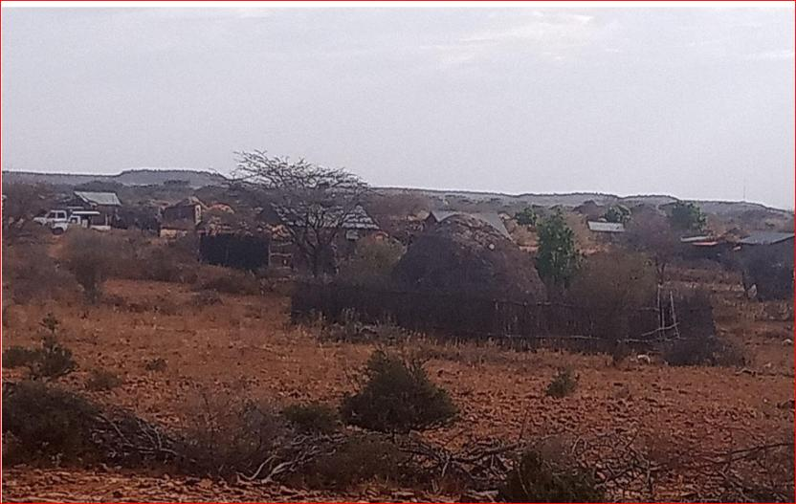

Plate 4:Photo showing residential houses to the west that will be connected with electricity

## Social and Physical Infrastructure

**Water**: The only sources of water in the village are 1No. borehole, shallow wells, and a water pan. Water from the borehole is however salty and requires treatment. During the dry seasons water tinkering is undertaken to supplement the various sources.

**Sanitation**: Open defecation (OP) is widely practiced in the village. There are however few private toilets in the school, some homes, chiefs’ offices and Mosque. Waste management is poor with burning in the dumpsite the main disposal method. However, waste is strewn all over from the poor disposal practice and lack of appropriate infrastructure.

**Road Network**: Roads connectivity within the area is also poor with dirt motorable roads connecting the village to Mandera. There was evidence of lack of maintenance of the existing motorable roads with significant potholes along the route. The main forms of transport within the area are Motor bikes, taxis and Matatus while donkeys and camels also provide alternative modes of transport for non-sedentary pastoralists. The village is off Mandera and Rhamu road.

**Mobile Network Coverage:** *Safaricom* is the only Network coverage within the village and majority of people have access to the internet services.

**Power/electricity:** - the community is not connected to the main grid or any standalone off-grid system. The population uses mainly portable solar piccos at the household levels for charging mobiles and lighting. Kerosene is also used for lighting homes. However, the local primary school has a solar system installed by the national government through Rural Electrification and Renewable Energy Corporation (REREC).

**Settlement Patterns:** - It was noted that most of the Mandera county neighbourhood settlements are scattered, linear and nucleated in nature. Nucleated refers to a pattern where there are a lot of buildings around a certain point for Mandera West and South sub-counties, there are schools, dispensaries, water pans, mosques and a shopping centre. KOSAP is targeting this area since it has a number of residents who are not served with electricity. It was observed that in most of the 12 proposed mini grids in Mandera South and West are mostly nucleated, linear and partially scattered hence taking up a rural setting.

# Stakeholder Engagement

## Introduction

Timely stakeholder analysis and engagement is key as it provides opportunities for stakeholders to make significant contribution to the project design and implementation which results in enhanced project acceptance among other benefits. Stakeholders in this project are individuals or groups who will be affected or are likely to be affected by the project (project affected parties) and those that have interest in the project (interested parties).

This section profiles the key stakeholders for the Sarohindi site solar project and assesses their potential concerns and levels of influence. The process of stakeholder engagement involved: -

1. stakeholder identification and analysis
2. stakeholders’ engagement planning
3. disclosure of information.
4. consultation with stakeholders
5. addressing and responding to grievances; and
6. reporting to stakeholders.

## Legal requirement for stakeholder engagement

The overall objective and the spirit of the Kenya constitution is to involve citizens in project formulation and implementation at the local level. This is enshrined in our constitution in Article 35 which provides that ‘every citizen has the right of access to information held by the state; and information held by another person and required for the exercise or protection of any right or fundamental freedom’.

Further public participation is an essential and legislative requirement for environmental authorization. The ESIA team undertook the stakeholder consultation (SC) for the proposed project in accordance with the requirements as stipulated in the EMCA, 1999 and its 2015 amendments and ESIA/EA Regulations 2003. The main purpose of public participation is to provide project information to stakeholders and allow them the opportunity to provide input and comment on the project, including issues and alternatives that are to be investigated, thereby facilitating informed decision-making.

Therefore, public participation was a key component of the ESIA of the proposed solar Mini-grid in *Sarohindi*. Project information was shared with different stakeholders mainly government officers and also community/project affected persons/beneficiaries. The positive and negative views of the stakeholders on the project were sought. The exercise was conducted through a public meeting/baraza, key informant interviews. In addition, gender and intergenerational dimensions of the community members were considered and three separate focus group discussions sessions were held with the men, women and the youth.

## Objectives Public Participation

1. To assess the level of stakeholder interest and support for the project
2. To enable stakeholder’s views to be considered in project design and implementation.
3. To establish and maintain constructive relationships and means for effective and inclusive engagement with project affected parties on issues that could affect them.
4. To ensure appropriate project information on environmental and social risks and impacts is disclosed to stakeholders in a timely and accessible matter.

The purpose of stakeholder engagement/participation is to identify stakeholders and to allow such parties the opportunity to provide input and comment on the project, including issues and alternatives that are to be investigated, thereby facilitating informed decision-making. Stakeholder participation involves both disseminating information about the project as well as gathering primary data from stakeholders regarding the project. Therefore, data collection was a key component of the EIA of the proposed project. The first source of information was literature review of project documents, site visit coupled with observations and discussion with the project engineers and other project officers. Further information and views on the project were also sought from other government officers at the county and from the target community.

Part of the key project information that was shared with the stakeholders to enable them to understand the project included positive and negative impacts of the project including potential opportunities. The information specifically focused on; the objective, nature and scale of the project, potential risks, and impacts of the project on local communities, mitigation measures to the negative impacts, need for future consultations and means of raising and addressing impacts.

## Stakeholder Consultation and Disclosure Requirement for the Project

The World Bank Environmental Social Safeguards 10 emphasizes on engagement in meaningful consultations with all stakeholders. The stakeholders with timely, relevant, understandable, and accessible information, and consult with them in a culturally appropriate manner, which is free of manipulation, interference, coercion, discrimination, and intimidation.

A documented record of stakeholder engagement, including a description of the stakeholders consulted, a summary of the feedback received, and a brief explanation of how the feedback was considered is in place.

## Stakeholder Characterization and Identification

A stakeholder is “a person, group, or organization that has a direct or indirect stake in a project/organization because it can affect or be affected by the Project/organization's actions, objectives, and policies” Stakeholders thus vary in terms of degree of interest, influence and control they have over the project.

Stakeholders are classified in the following two categories.

* **Primary Stakeholders**- Stakeholders who have a direct impact on or are directly impacted by the project.
* **Secondary Stakeholders**- Stakeholders who have an indirect impact or are indirectly impacted by the project.

In line with the nature of the project and its setting in Sarohindi, the stakeholders have been identified and listed in the table given below.

Table 12: Identified Stakeholders

|  |  |  |
| --- | --- | --- |
| **Stakeholder Groups** | **Primary Stakeholders** | **Secondary Stakeholders** |
| Community | Local Laborers  Landowners,  Business owners  Elders, women & youth groups.  VMG’s  Pastoralists  Local Community |  |
| Institutions | Faith Based Organizations -Mosques; Madrasas  Education institutions  Community Based organizations |  |
| Government Bodies |  | NEMA  County Government  sub county and local administration |

* + 1. **Stakeholder Mapping**

Stakeholder mapping” is a process of examining the relative influence that different individuals and groups have over a project as well as the influence of the project over them. The purpose of a stakeholder mapping is to:

* Identify each stakeholder group.
* Study their profile and the nature of the stakes.
* Understand each group’s specific issues, concerns as well as expectations from the project
* Gauge their influence on the Project.

The significance of a stakeholder group is categorized considering the magnitude of impact (type, extent, duration, scale, and frequency) or degree of influence (power and proximity) of a stakeholder group and urgency/likelihood of the impact/influence associated with the stakeholder group in the project context. The magnitude of stakeholder impact/influence is assessed taking the power/responsibility and proximity of the stakeholder group and the group is consequently categorized as negligible, small, medium, or large. The urgency or likelihood of the impact on/influence by the stakeholder is assessed on a scale of low, medium, and high. The overall significance of the stakeholder group is assessed as per the matrix provided in Table below.

Table 13: Stakeholder Significance and Engagement Requirement

|  |  |  |  |  |
| --- | --- | --- | --- | --- |
|  | | **Likelihood of Influence on/ by Stakeholder** | | |
| Low | Medium | High |
| Magnitude of impact | Negligible | Negligible | Negligible | Negligible |
| Small | Negligible | Minor | Moderate |
| Medium | Minor | Moderate | Major |
| Large | Moderate | Major | Major |

* + 1. **Stakeholder Analysis**

The table below has been used to classify the identified stakeholders (directly or indirectly impacting the project) in accordance with their levels of influence on the project. The influence and priority have both been primarily rated as:

* **High Influence**: This implies a high degree of influence of the stakeholder on the project in terms of participation and decision making or high priority to engage with the stakeholder.
* **Medium Influence**: Which implies a moderate level of influence and participation of the stakeholder in the project as well as a priority level to engage the stakeholder which is neither highly critical nor are insignificant in terms of influence; and
* **Low Influence**: This implies a low degree of influence of the stakeholder on the project in terms of participation and decision making or low priority to engage that stakeholder.

The intermediary categories of low to medium or medium to high primarily imply that their influence and importance could vary in that range subject to context specific conditions or also based on the responses of the project towards the community.

The coverage of stakeholders as stated above includes any person, group, institution, or organization that is likely to be impacted (directly or indirectly) or may have interest/influence over the project. Keeping this wide scope of inclusion in the stakeholder category and the long life of the project, it is difficult to identify all potential stakeholders and gauge their level of influence over the project at the outset of the project. Therefore, the project proponent is advised to consider this stakeholder mapping as a live document which should be revised in a timely manner to make it comprehensive for any given period.

## Summary of Community Consultation Meeting Leading to Land Identification and GRC Constitution (Screening Level)

Project: **Sarohindi Mini-grid Site**

Venue of meeting:

Date: **25th February 2020**

The meeting was called to order by the area chief at 2:20 pm, a word of prayer was offered by Maalim Abdi Bashir. The area chief welcomed the team from MoE, KPLC, REREC and Mandera county government in a special way, he further welcomed the community members present for attending the developmental meeting in the community. He further emphasized the importance of having electricity in their community since it will improve their standards. The chief further informed the team from MoE, KPLC, REREC and Mandera county government that there is one Primary School, shopping centre, Health centre, Islamic school (Madrasa) and a mosque within the neighborhood and requested these facilities to be given first priority to be considered for electricity connection. He also further noted that there are other community facilities that include; water points, shallow well and a water pan in the area. He finished making introductory remarks by inviting the team from MoE, KPLC, REREC and Mandera county government to address the meeting.

**Land acquisition process**

The team Surveyor Joseph Korir told the meeting that the team appreciated the time they took to come for the meeting to discuss the project. He informed the meeting that the projects would be implemented in 14 counties in the country. He said Mandera is the first county in which the project is commencing. Mr. Korir explained to the meeting that the project could only commence once the request for land is granted freely by the community.

Mr. Korir confirmed to the community present that land is both a social and economic factor of life. The land for the community has been inherited through generation. He also said that the land within the community is categorized as community land. Further confirmation of the same will be carried out during the acquisition process He explained to the gathering that he would map out the land donated. The project he said required a minimum of 2 (two) acres.  He said that since the town is expanding due to the increasing population a minimum 2 acres will be sufficient, however to plan ahead if the community donated 5(five) acres it would be appreciated. The Surveyor asked the meeting if it was the first time they had heard about the project. The members of the community confirmed that a team had visited the town some time earlier regarding this said project.

Mr. Korir explained to the gathering that the team that had previously come to their area was a team of consultants. The members present confirmed the same and that they had shown them the site of the proposed mini grid. He told them that the team that had come previously were consultants who had come to view the land. He further said that he was the surveyor of the team and would take the coordinates of the land to commence the land acquisition process. He further explained that he would then prepare a sketch map of the land and forward the same to the County Government for approval. Once the county approved the scheme it would be forwarded to the National Land Commission for approval and the process of preparation of a letter of allotment. The meeting was told that the title would finally be in the name of either Kenya Power and Lightening Company (KPLC) or the Rural Electrification and Renewable Energy Corporation (REREC). Mr. Korir then welcomed the Mr. Abaya speak to the community.

**Compensation of proposed site options**

Mr. Abaya explained to the community that even though they had donated the land, it was necessary that we disclosed to the community that they were also entitled to compensation. He further explained to the gathering the options that they are entitled to. The first thing was that the community may have donated the land but are entitled to compensation for the land. This can be in the form of compensation by paying the community cash for the land. In this case the land would have to be valued by a Government Valuer and the cash amount based on the value is given to the Community. The cash would however be held on their behalf in an escrow account by the County until they are able to open an account of their own after registering their land.

The other option of compensation explained to the community was that the community can also be compensated in kind. The community can request for compensation in kind like a well, or classrooms to be built or any other item that will benefit the community. Another option would be compensation of land for land. The community may request the Government to buy a similar piece of land for the community. To compensate for land donated for construction of the mini grid. He informed the meeting that they are at liberty to deliberate on the options given and they should not feel coerced to donate the land for the project. With the remarks made he once again thanked the community for supporting the project.

At this point the community members through their leadership agreed to donate 3 acres of land freely without being given back any form of compensation options as mentioned above. He further noted that the proposed project will benefit the community more than anything else. Mr. Abaya thanked the community members once again for their time and the in-kind givind of the land towards the proposed project that will benefit the community has a whole.

**GRC Constitution**

Mr Samuel Abaya explained the need to constitute a GRC to address grievances. He told them the team will will require that a Grievance Redress Mechanism to be put in place by the community. This GRM will have a committee that will help solve the grievances arising from the project. The community will need to identify persons who will sit on the committee and they should comprise a man, woman, youth and a person representing the special group e.g a person living with a disability. The Committee will help address grievances to their conclusion. If in any case the committee is unable to solve an issue, they will be guided by the implementing agency on where to forward the matter. If it is still not solved at that level, then the Kenyan Courts will be used to resolve the issue. He said it is our hope that the grievances will be solved at the local level. The meeting was also told that the members of the Committee will be required to volunteer their services. This is because there will be no payment for their services. The committee was elected comprising a representative of men, women, youth and special needs in the society. Their names are;

Table 14: GRC committee members

|  |  |  |  |  |
| --- | --- | --- | --- | --- |
| **No** | **Names** | **Represents** | **Id. No** | **Phone No.** |
| **1** | **Hussein Osman shuriya** | **Youth (gentlemen)** | **9566473** | **071477005** |
| **2** | **Rahma Ali** | **Youth (ladies)** |  | **0722743101** |
| **3** | **Ali abdiguyow** | **Men** | **9220933** | **0712484801** |
| **4** | **Mudey BILOW ADAW** | **Special needs** | **20178563** | **0722318997** |
| **5** | **MuminaDiat** | **Women** |  | **0727458655** |

## Key Feedback of Further Stakeholder Consultation Process Carried out During ESIA

A Consultative Public Participation (CPPs) session was conducted to provide project information and facts to the local community and other stakeholders especially local government administration thus giving them a platform to enable them to express their appreciation, concerns and fears as well as contribute ideas and opinions towards the project sustainability.

The MoEP representative assisted by the KPLC representative gave a description of the KOSAP project and clarified that its objective was to electrify Sarohindi because the area is not connected to the national grid. They also informed the community that they would access the electricity at a subsidized cost and that the public facilities such as the schools, hospitals and public boreholes would also be connected at the same cost (one thousand shillings). The environmental and social experts shared with the community the ESIA process and discussed the potential impacts associated with the project and the proposed mitigation measures that would reduce the significance of the adverse impacts.

It was also explained that compensation for the land identified by the community for the proposed project will be done in-kind; as a community project chosen from education, health or water sector. The Ministry of Energy through its implementing agency (KPLC) would undertake a project for the community in water, health or education sector up to a cost of the value of the cost of the land taken and informed by the NLC valuation criteria. The community was to choose the project of their own choice in the three sectors. Other methods compensation for community land is payment in cash and land for land

A detailed CPP and community engagement for Sarohindi Solar Mini Grid was held at Sarohindi village on 23rd November 2021 chaired by the area chief in liaison with the consultants. During the consultative forum, there were remarks from various key personnel including the following;

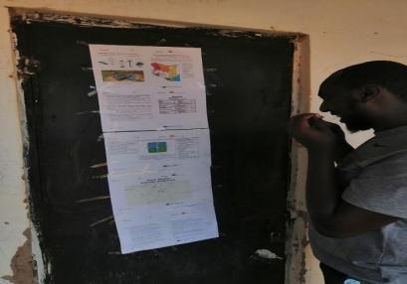 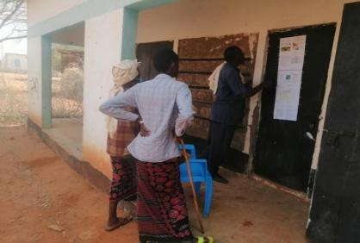

Plate 5: Project information posted at the chiefs Office and being read by members of the public.

The purpose of the meeting was to: Undertake an environmental and social screening of the proposed sites to check suitability in terms of environmental, technical, social and health requirements; Undertake community engagement to sensitize the community on the project; Explain the land requirements for the project and sensitize the community on their rights in regard to land so that they can make an informed decision; Need to set up Grievance Redress Mechanism for the project; Guide the community in electing Grievance Redress Mechanism committee members and sensitize the members of their work during project implementation.

*The community of Sarohindi unanimously agreed to set aside land for Minigrid construction. A Land Identification form was signed by the representative of the community, the county government and the Implementing Agencies summarizing the process of land identification and the agreements reached with the community. (Attach the Land Identification Form)*

* + 1. **Area Chief’s Remarks**

The Chief of the Area invited Sheikh Abdi Bashir Mohamed to open the Baraza with a word of prayer. He then briefly informed the gathering about KOSAP projects, importance, and possible impacts. He then welcomed the members and urged them to fully participate in the discussions.

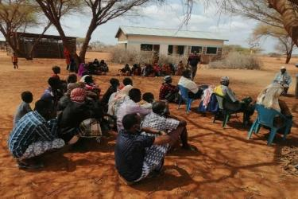 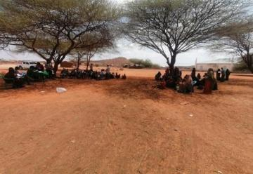

**Plate 6: Members of public being sensitized on the project implications by ESIA Consultants.**

* + 1. **Consultant’s Remarks**

The Consultant, Mr. Ibrahim Adan elaborated on the possible socio-economic impacts of the project to the residents of Sarohindi and requested the participants to give information for documentation. The consultant with assistance from the Area Chief guided the Focused Group Discussions.

* + 1. **Positive Comments about the Project from the Participants**

Some of the positive impacts that were identified by the participants include the following.

* Learning will improve due to availability of lighting
* Business opportunities will improve since farmers will be able to cool their milk, welding business will arise
* Employment opportunities will increase for the youth due to increase in business opportunities
* Security will improve due to availability of lighting
* Medical services will improve due to availability of refrigeration services.
* The electricity will assist in pumping of water from the boreholes.
  + 1. **The identified negative impacts of the project**

Some of the positive impacts that were identified by the participants include the following.

* **Accidents**: some of the members raised concerns of possible accidents from electrocution especially the children as well as possible accidents from falling of the electric poles. The community suggested extra care when, protection of appliances and reinforcement of electric poles to mitigate these accidents.
* **Employment Disputes:** There was a concern over the possibility of disputes arising between the local community with people of different cultures in the construction sites. The community suggested that proponents should consider employing local construction workers.
* **Dust Generation:** The participants expressed concern over the possibility of generation of large amounts of dust within the project site and surrounding areas because of demolition, excavation works and transportation of building materials.
* The proponent will ensure that dust levels at the site are minimized through sprinkling water in areas being excavated and along the tracks used by the transport trucks within the site. Additional mitigation measures presented in this report will be fully implemented to minimize the impacts of dust generation.
* **Environmental Aesthetics** It was seen that the aesthetics of the area would be affected negatively during construction. It was suggested that the proponent should ensure landscaping is conducted after construction.
* **Environmental Aesthetics**: Some neighbors will be affected by too much noise and exhaust fumes from the site.

**Other concerns**

* Some of the members requested for implementation of the project done as soon as possible.
* Questions were also raised on charges of installation and usage.
* Request was also made on the consideration of locals in the job opportunities.
  + 1. **Consultant’s Response**

The consultant, while addressing the community’s issues raised, gave the following response.

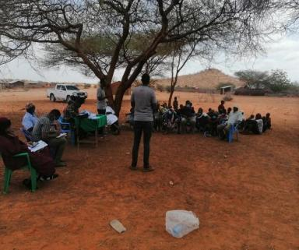

**Plate 7: On-going community deliberation process.**

* Every resident, business or public facility will be connected to the electricity at an affordable cost of initial connection fee of KShs.1000 (USD 8.0);
* That the Contractor/KOSAP will rehabilitate and plant trees after the construction phase of the project.
* Contractor will lease a campsite from the community and ensure all construction waste is properly handled and disposed of.
* All non-skilled labor will be sourced from the Sarohindi Community and not from outside
* He assured the community that the project will commence soon after ESIA.
  + 1. **Consent**

The Community members present unanimously accepted the Project Proposal for development of mini-grid system.

* + 1. **Community Presentation**

#### Adult to youth Representation

During the stakeholder’s consultation adults were more represented than the youth.

#### Gender Representation

Gender representation was 47% male and 52% women. This was attributed to men being away tending to their livestock with the ongoing drought resulting in pasture campsites moving farther away from settlements. Women are more freely available.

#### Heads of Households

Male are the household heads as established during the stakeholder consultation.

* + 1. **Focused Group Discussions Analysis**

The in-depth interviews were used as a tool for stakeholder identification and mobilization as well as collection of baseline data to enable identification of the likely project impacts. In addition, it provided an opportunity to the participants to raise their fears and concerns as well as make recommendations as pertains to the project.

During the discussions, information was gathered on different roles, livelihood, health issues, challenges, perception of quality of life, education options for children, health care and project perception.

The consultative meeting had a wide representation as follows:

Table 15: The consultative meeting had a wide representation

|  |  |  |  |
| --- | --- | --- | --- |
| Category | Male | Female | Total |
| Youth | 31 | 15 | 46 |
| Adult | 10 | 30 | 40 |
| TOTAL | **41** | **45** | **86** |

The target groups of the FGD were Males, Females, Health sector, Education sector as well as and the Youths.

#### Female Stakeholders’ Consultation and Participation

The participants were N=30 between 21-56 years of age. Some of the respondents (2No) are physically challenged. The respondent indicated that the community has female headed households (widows with those present in the meeting at N=7). The Somali community believes widows are particularly vulnerable as households are traditionally expected to be male headed and such households do not enjoy access to opportunities as they are not seen to have a male person to front for their interests.

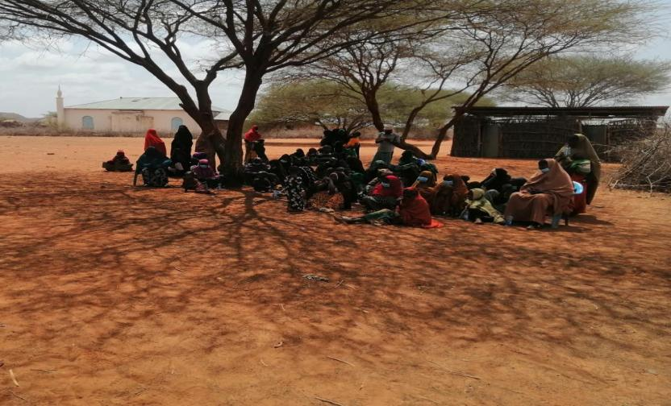

Plate 8. Female FGD participants at Sarohindi.

1. **The project perception**

The participants had knowledge of the solar project since the village was visited in the past during the screening phase and the community appraised the project. According to the respondents the project will provide lighting for school going students, used for pumping water and creating employment during the construction phase and operations as small businesses such as welding works, electronic shops and maintenance, cybercafés, general trading involving food kiosks will spring up and thrive in the community.

Women stakeholders felt electricity availability enhances their security greatly at night allowing them to undertake some economic activities in the late hours thereby enhancing their productivity and greatly improving their income levels.

1. **Role of Female in the community**

* Building houses, fetching firewood and water.
* Cooking and other house chores.
* Women and men have no equal opportunities in the community. However, women control household equipment while male control livestock and other major assets.
* Women feel safe in the community and the level of crime is low. Conflict (inter clan clashes) is experienced occasionally with women the most affected.
* The challenges encountered by women include inadequate water, lack of proper sanitation, high levels of illiteracy.
* Women receive information about local issues and development or news from their husbands and the local chief through community meetings or from relatives.
* Women are currently involved in decision making to an extent, a role that was exclusively for men in the past.

1. **Institutions/community Development**

* Women are involved in decision making at the household level not at the community level.
* Females are involved in doing business generally petty trading to cater for household’s income.
* The main community development in order of priority include;
  + Health
  + Water
  + Economic empowerment through access to credit financing and education and such.
  + Education.

1. **Economy /income generation by women**

* Women earn income from operation of small-scale eateries, boutiques, selling livestock and livestock products. Some are involved in selling firewood.
* At the household level, women contribute less income than men.
* To have greater economic opportunities, women suggested they should be economically empowered through access to credit facilities for their involvement in businesses.
* The women have no access to any bank/credit/saving accounts in Sarohindi. However, they use mobile telephone money services.

1. **Land use by women**

* Land is mainly used for grazing.
* The livestock (goats and sheep, cattle camels, and donkeys) are reared for both subsistence and income generation.
* Community members are nomadic and move with their livestock in search of water and pasture during the dry seasons.
* Women collect natural resources like firewood for both domestic use and commercial purposes.
* Occasionally, conflict is experienced in the community over pasture and water or clan skirmishes.
* Some Women in the FGD indicated that sometimes they experience gender-based violence (GBV) at household level. To eliminate GBV the women suggested creation of awareness on reducing GBV among community members.

1. **Education, literacy, and training of Women in Sarohindi**

* The women noted that they have access to education but majorly affected by challenges like inadequate teaching facilities, cultural biases for girl child education and teachers.
* Girls access basic education at the Sarohindi primary school though their population is at 32 percent of the boy child even though the women population is nearly equal to male gender. This is an indicator to the cultural education preferences for males.
* A few women can read and write in the community, especially the young adults.

1. **Health care for Women in Sarohindi**

* The women access health care from Libehia health center some 10km away, though the main health problems/challenges facing women include inadequate medicine, lack of maternity care, healthcare education and sanitation. Health care services are not sufficient and do not meet the needs of the community.
* Environmental issues affecting health in the community are mainly air pollution because of the main road that passes through the village leading to particulate matter releases into homes with consequent respiratory diseases.
* Diseases affecting women include urinary tract infection, maternity complication and PUD
* The women have no access to family planning.
* There are some people living with disabilities and lack specialized home care due to lack of adequate facilities and cultural norms towards persons living with disabilities makes access to medical support facilities difficult.
* Women majorly prefer using hospitals than traditional healthcare services.

1. **Access to Water by women**

* The community is served by a borehole with slightly salty water and shallow wells.
* The water is mainly used for domestic use, sanitation, and livestock watering.
* The village also accesses water from a water pan. The water is turbid with dust particles and suspension.
* During dry season water is not sufficient therefore the community solely relies on water tracking support from County government and shallow wells.

1. **Sanitation and hygiene for women**

* The main type of toilets in the village are pit latrines. Open defecation was also reported by the FGD for some households attributed to extreme poverty in some cases.

1. **Hygiene and waste management by Women**

* Women in Sarohindi access sanitary facilities and or products e.g., sanitary towels. However, due to low income most of them cannot afford resorting to traditional methods.
* Household waste is burnt in heaps or dumped in compost. pit.

1. **Access to Power**

* Sources of energy and their uses in Sarohindi village include;
* For lighting use of kerosine lanterns and torches using batteries. Some have portable solar piccos system that operate torches, radios and telephone charging ports.
* Cooking -wood fuel/charcoal. This is 100 percent source of the energy for each household.
* Charging mobile-a few uses portable solar.
* The village has limited sources of power as the main challenge.

1. **Transport and communication**

* The main forms of transport are motorcycles, vehicles, donkey carts and camels.
* The village is served by an earth road that is impassable during wet seasons.
* The area is served by *Safaricom* as the dominant means of communication.

1. **Cultural heritage**

* The area has no cultural heritage/historical sites.

#### Male Stakeholders’ Consultation and Participation

The male participants were N=10 of middle age to elderly during the FGD. The small number was attributed to some participants dispersing for the noon prayers. However, the participants present were diverse in age and livelihoods. The male participants are the household heads. The following were the responses provided by the participants.

1. **The project perception**

* As per the study, male participants were aware of the proposed project having been aware and participated in previous project sensitization.
* According to these groups of respondents the project would boost the businesses especially those dealing with cold drinks, milk and other electricity reliant businesses e.g. welding. They also indicated that the electricity was used for lighting homes by school going children to carry out their school preparation work. Other benefits include phone charging, security within the village.
* The male respondents were concerned with the management of any solid/liquid waste generated from the project especially during the construction and operation phase in particular battery waste. *(This has been addressed in this report in the ESMP).*

1. **Role of Men**

* According to the respondents’ male respondents herd livestock, undertake retail businesses, sell firewood, collect natural resources like the gums and resins for sale, excavation of small-scale water pans. Men are also involved in the construction sector undertaking various works within the community.
* Men in Sarohindi have more opportunities compared to females, especially in matters of education.
* In the community the men control livestock and major projects like the water pans, livestock market compared to women who control poultry and homesteads.
* Men in the community face the following challenges: -
* Controlling livestock diseases and pests,
* High levels of illiteracy,
* Inadequate financial support for various developments.
* Male feel safe in the community. However, interclan conflicts and terror groups from neighboring Somalia have had significant impacts on the male gender with their recruitment and involvement leaving orphaned households.
* Men receive information through radio, telephone and by word of mouth from the area chief.

1. **Institutions/community development**

* The top three community development as per the male FGD include:
* Dispensary,
* Piped water from the river,
* Support for youth and their capacity building, especially access to credit.

1. **Economy /income generation**

* The main sources of income in Sarohindi include: -
* Livestock and livestock products,
* Retailing of household food and non-food items,
* Overall, men contribute more income to the household compared to females in part due to cultural requirements.
* To improve the community economy, men suggested that they should be engaged in growing crops during the rainy seasons, be involved in construction work and access credit facilities to be involved in trading.
* Mobile phones are used as banks. However, there are no major credit facilities, the community rely primarily on savings through M-Pesa, KCB and Equity.

1. **Land use**

* Land in Sarohindi is mainly communal and is used mainly for grazing livestock.
* Men keep livestock both as subsistence and income-generating activities. Livestock reared include cattle, camels, sheep, goats, donkeys as well as local chicken.
* Community members are nomadic- moving with livestock in search of water and pasture especially during the dry seasons.
* The men are also involved in collection of natural resources like firewood, fruits, herbs, and gum Arabic from the nearby vegetation covers. Sand, pellets, gravel, and ballast are collected from the nearby quarries and are used for construction at the household level and for sale.
* According to the men's FGD, land-conflicts are experienced within the communities because of demarcation of land by some individuals. Elders in the village are involved in solving the land disputes.

1. **Education, literacy, and training as per the FGD**

* The village has only one primary school. Boys in the community can read and write.
* Sarohindi Primary school is about 1km from the village center and provides access to formal basic education and madrasas for Islamic education and studies.
* 1/8 of The male population generally complete their studies up to grade 8 and Form level.
* The factors preventing men from accessing further education include lack of school fees due to high levels of poverty, responsibilities like livestock rearing and finally security which caused inadequacy of teachers.
* Ability to read and write among the male population is 3/8.

1. **Health care analysis by the male FGD**

* The men access health care from Libehia dispensary. However, complicated cases are referred to Mandera or Nairobi counties.
* The dominant health issues among men include blood and urine infection, gastric issues and arthritis.
* The PLWDs are present among the male population and are mostly managed at home and only taken to a health facility in case of any complications.

1. **Access to Water analysis by the male FGD**

* Water pans 550m provide water for the community to use for drinking, cooking, washing, bathing, and livestock use.
* Women and children are involved in fetching water for the community members.
* The men are responsible for searching for water to be provided to the livestock while women collect water for both livestock use and domestic use.
* The community also has a borehole.

1. **Sanitation and hygiene according to Male FGD**

* The main type of toilets is pit latrines.
* Men indicated that open defecation is commonly practiced as an alternative where access to latrines is impossible.

1. **Hygiene and waste management**

* Handwashing and general cleaning are done by use of basins and jerry cans.

1. **Access to Power**

* Sources of energy for Sarohindi village
* For lighting, they use kerosene lamps.
* For warming they use firewood
* Cooking -firewood
* Charging mobile-private solar
* Cooling – solar fridges
* The village has limited sources of power since the solar power which they mostly rely on is privately owned and access to maintenance is limited and the systems are of low standards.
* The men suggested that the project will be of great importance to the community.

1. **Transport and communication**

* The main form of transport is motorcycles, vehicles, donkey carts and camels.
* The village is served by an earth road (Mandera - Rhamu).
* The area is served with *Safaricom* service providers as the dominant means of communication.

1. **Religious heritage**

* Mosques are the main religious sites within the Sarohindi community as is the larger Somali community.
* The main festivals undertaken by men include religious festivities e.g., Idd, weddings and children passage rites.

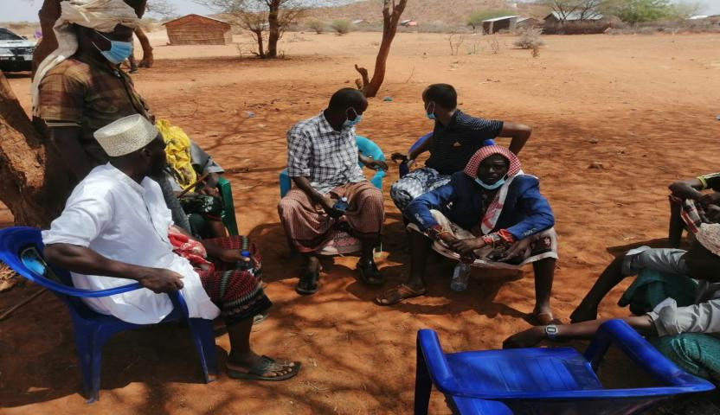

**Plate 9: Male FGD at Sarohindi**

#### Youth Stakeholders’ Consultation and Participation

The youth participants were N=46 in number (31male and 15female). The following opinions were provided by the youth participants during the FDG.

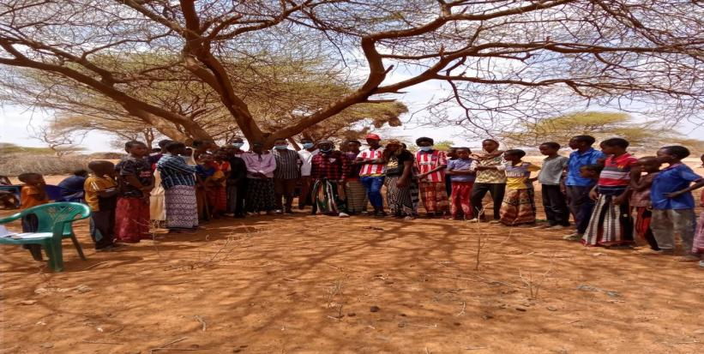

Plate 10: Youth FGD at Sarohindi

1. **The Project perception**

* The youth revealed that they were aware and understood the importance and benefits of the project to the community.
* The respondents suggested that the project will provide the required electricity for charging mobile telephone, used for lighting homes for children to study, used to run refrigerators, televisions, small businesses, and radios.
* They however noted that negative impact as likely injuries through electric shocks and suggested great care while handling electrical appliances with training suggested for community members to minimize impact on the community.

1. **Role of the Youth**

* The youth said that they are well involved in community matters, but their voices are not heard sufficiently.
* Key priorities among the youth include livestock keeping, which is affected by drought and disease.
* Youth are involved in decision making in the community albeit on regular forceful engagement at times.

1. **Institutions/community Development**

* The community has a Youth Group whose function is to address general wellbeing of the community and youth.
* There are no development or aid programmes of youth within the community.

1. **Economy /Income Generation/Employment**

* Eighty (80%) of the respondents are self-employed while about (0%) have full-time salary jobs per the group involved.
* The income-generating activities predominant among youth in Sarohindi include casual work like construction, fetching and selling of firewood, trading in livestock especially goats, transportation business by use of motorbikes and through selling of Miraa.
* Other skills that enable them gain employment include motorcycle riding, tailoring, barber shops and carpentry.

1. **Education, literacy, and training for youth FGD**

* 25% of youth have completed secondary school.
* About (15%) have completed vocational/colleges.
* The major skills among the youth include motorcycle riding, tailoring, barber shops and carpentry.

1. **Unemployment**

* zero percent of youth in the community have full-time salaried jobs. eighty percent of youth are self-employed with the main job being petty trade.

1. **Recreation**

* Most youth are involved in football.

#### Vulnerable and marginalized group (VMG)

1. **The project perception.**

The Vulnerable and Marginalized Group (VMG) revealed that they were aware of the project and confirmed that they understand the project well and will be benefitted by the project.

1. **Baseline on VMG.**

The following are groups of people that are considered Vulnerable and equally marginalized: -

* The orphans.
* The divorcees.
* The widows.
* The elderly, and,
* People living with disabilities.
* In Sarohindi, the old aged are considered the most vulnerable group since they have so many children and upbringing them becomes a problem.
* Approximately twenty households are considered vulnerable within the village.
* The main source of livelihood for the group is charity.
* The public social amenities provided in the locality are; schools, dispensary and water point and they all serve the residents equally VMGs included.
* The community occasionally receives relief food (twice annually) and VMGs are mostly considered during distribution.
* The major challenge faced by VMG is poverty and it is addressed by charity.
* There are no organizations that have a program in the area that support the VMGs.

1. **The project impacts**

* There were many public projects that were implemented in the area like schools, boreholes and water pans. The VMGs were well involved in the implementation of the public projects.
* The project will benefit the VMGs by increasing accessibility to water, improvement in the health sector and education sector.
* The benefits can be maximized by considering free education and financial support for the VMGs.
* The top 3 development priorities among the VMGs are;
* Standard health facility to those with medical conditions.
* Socio-Economic Empowerment.
* Education.

#### Education Stakeholders’ Consultation and Participation (KI)

The village has Sarohindi Primary school with a student population of 244 students: 165 boys and 79 girls.

**The project perception**

* The project would have a positive impact to the school through access to electricity that will provide light especially in the evening study by students. Learning will also be digitized.
* He suggested that any possible negative impact of the solar project can be mitigated through regular maintenance checks and proper installation. The community should be capacity built on repair and maintenance.

**Infrastructure/Resources**

* Sarohindi primary School currently has **5 teachers**
* The school has a solar system for lighting installed by the national government but due to poor maintenance reliability has been wanting.
* The challenges facing the school include inadequate water, **lack of electricity**, inadequate learning infrastructure e.g., desks, classrooms, and toilets (for staff) as well as inadequate teachers.
* The school receives support from the national government as part of the free primary program with exercise books, classroom construction etc.
* The average walking distance of students to school is 2.5km per key informant.
* Students are sometimes provided with meals.
* Teachers receive their salaries from TSC, County government and PTA.

**The School Performance**

* The school’s performance in national examinations is very poor, similar to all schools in the county. This is partly attributed to lack of teachers among other resources such as library,
* The performance of boys is generally better than girls as per national exams results analysis.

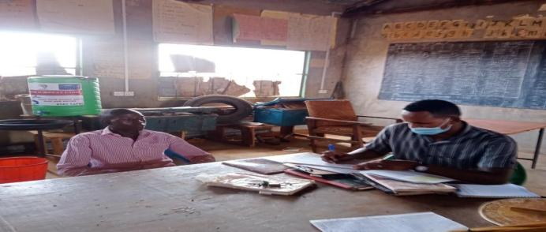

Plate 11: KII Education Sarohindi.

## Stakeholder Engagement and Grievance Management Post ESIA

During implementation of the project or construction phase, stakeholder engagement will be progressed to ensure the community and other stakeholders are kept abreast of the progress of the project. For the target community this will take the form of meetings and focus group discussions between local community and the contractor which will also act as forums for the community to ask questions or provide feedback. Therefore, the contractor will prepare a stakeholder engagement plan to guide on the engagements with various stakeholders guided by the Stakeholder Engagement Plan prepared during ESIA

**Objectives and Principles of Stakeholder Engagement**

Stakeholder engagement is the basis for building strong, constructive, and responsive relationships that are essential for the successful management of a project's environmental and social impacts.

In order to ensure effective engagement and consultation of all stakeholders, the contractor and the proponent KPLC will apply the following principles.

* Ensure the affected persons are provided opportunities to express their views on project risks, impacts and mitigation measures, and response provided.
* Begin consultations early even before construction begins because there is a lapse of time between ESIA consultations and implementation time. Identification of environmental and social risks and impacts should continue an ongoing basis as risks and impacts arise.
* Consultations should continue in a manner that is transparent, objective, meaningful and allow for ease in accessing information in a culturally appropriate local language(s) and format that is understandable to affected and interested persons.
* Consultations with affected persons and interested parties should avoid manipulation, interference, coercion, or intimidation.
* Consultations should also pay attention to the needs of VMGs, vulnerable individuals and households.

The contractor shall identify the stakeholders early and consider appropriate methods for engaging them. The stakeholder engagements will be reported to KPLC on monthly basis alongside the construction progress reports

# GRIEVANCE REDRESS MECHANISM

## Introduction

Grievance mechanisms should receive and facilitate resolution of the affected institutional or communities’ concerns and grievances. Community concerns should be addressed promptly using an understandable and transparent process that is culturally appropriate and readily acceptable to all segments of affected communities, at no cost and without retribution. Mechanisms should be appropriate to the scale of impacts and risks presented by a project. Grievances can be an indication of growing stakeholder concerns (real and perceived) and can escalate if not identified and resolved. The management of grievances is therefore a vital component of stakeholder management and an important aspect of risk management for a project. Projects may have a range of potential adverse impacts to people and the environment in general, identifying grievances and ensuring timely resolution is therefore very necessary. As such the project has developed a grievance management process to serve as a guide during project implementation.

The constitution of Kenya section 159, Land and Environmental Court Act 2011, National Land Commission Act 2012, and Land Act, 2012, advocates for alternative dispute resolution mechanisms before seeking formal legal redress in disputes relating to environment, land, and resettlement. In practice this can be the village head and other local or traditional dispute resolution mechanisms.

The Land Act 2012 and National Land Commission Act 2012 obligate the NLC to support grievances and disputes related to resettlement or land amicably in conjunction with the implementing agencies-KPLC/REREC. One of the key roles of the Grievance Redress Committees, will be to address disputes led by the administrative chiefs. All PAPs will be informed how to register grievances or complaints, including specific concerns about land and environment.

## Grievance Mechanism

One of the key roles of the Grievance Redress Committees, will be to address disputes led by the administrative chiefs. All PAPs will be informed how to register grievances or complaints, including specific concerns about land and environment. The PAPs will be informed about the dispute resolution process, specifically about how the disputes will be resolved in an impartial and timely manner. Environmental and Land Court will provide opportunity for appeal when a solution will not be found using the established local mechanisms. The court will deal with land related disputes. However, the Land Act, 2012, and Environment and Land Court Act, 2011, HU advocates for Alternative Dispute Resolution (ADR) methods in tackling land related disputes. Alternative dispute resolution approaches will be given preference and based on customary rules, arbitration, or third-party mediation. ADR will be promoted or defended as a resolution to disputes related to land.

## National Grievances Redress Committee (NGRC)

NGRC has been established at the National level to ensure participatory and transparent implementation of the project. The NGRC will help the project carry out its mandate efficiently- particularly ensuring effective and amicable settling of disputes among the communities/PAP’s.

Members to **NGRC** include representation from the following agencies and entities

1. Representative from the Ministry, chair of the Committee
2. Representative from NLC to handle matters that involve land take
3. Representative of the Implementing Agencies (IA)-KPLC and REREC
4. Representative from the Ministry’s Legal office to guide on Alternative Dispute Resolution methods
5. Representative from the County Grievance Redress Committee-depending on the matter at hand; Land or Environment
6. Representative from Gender and Social Development Office who will be responsible for ensuring gender issues are well addressed.
7. Representative from NEMA to handle environmental issues
8. County Surveyor/Physical planner from the county Lands office
9. Project Affected Persons-to represent the matter before the committee
   * 1. **Functions of the National Grievances Redress Committee**
10. Ensuring effective flow of information between PAPs, the implementing agency and the County Grievance Redress committee on matters brought before the committee
11. Coordinate County Grievance Redress Committees (LGRC)
12. Coordinate activities between the various organizations involved; facilitate grievance and conflict resolution at the highest level
13. Resolving disputes that may arise within the project. If it is unable to resolve any such problems, the PAP’s can seek legal redress.

## County Grievance Redress Committees (CGRC)

CGRC has been established at the county level to ensure participatory and transparent implementation of the project. The CGRC will help the project carry out its mandate efficiently- particularly ensuring effective communication with the communities.

Members to **CGRC** will include representation from the following agencies and entities

1. Representative of NLC, to grant legitimacy to the acquisition process and ensure that legal procedures as outlined in Land Act 2012
2. Representative of the implementing agency
3. Representative of NEMA to handle environmental issues
4. The County Administration representative, which will provide the much-needed community mobilization, and support to the sub-project.
5. The County Land Survey Officer will survey all affected land and produce maps.
6. The County Gender and Social Development Officer who will be responsible for ensuring gender programs are adhered to.
7. The County Lands Registrar will verify all affected land and validate the same.
8. Two PAP representatives from Location Grievance Resettlement Committee – act as voice for the PAPs
9. NGOs and CBOs locally active in relevant fields

The CGRC will have the following **specific responsibilities:**

1. Ensuring effective flow of information between PAPs and the implementing agency
2. Coordinate Locational Grievance Redress Committees (LGRC)
3. Coordinate activities between the various organizations involved; facilitate grievance and conflict resolution; and provide support and assistance to vulnerable groups.
4. Conducting extensive public awareness and consultations with the affected people so that they can air their concerns, interests, and grievances.
5. Resolving disputes that may arise within the project. If it is unable to resolve any such problems, channel it to the National Grievance Redress committee before utilizing the appropriate formal grievance procedures.

## Locational Grievance Redress Committee (LGRC)

Since counties are large, a further decentralized Grievance Redress Committee was formed at the location of the sub-project. Subsequently, Locational Grievance Redress Committees(LGRC’s), based at each location of a sub-projects, were established. The LGRC consists of implementing agencies and representatives of CGRCs through consultation with the PAPs and it acts as the voice of the PAPs.

The LGRCs work under guidance and coordination of CGRC and the implementing agencies. Their membership comprises of the following:

1. The locational Chief, who is the Government administrative representative at the locational unit and who deals with community disputes will represent the Government in LGRC

2. Assistant Chiefs, who support the local Chief and Government in managing local community disputes in village units will form membership of the team.

3. Female PAP, elected by women PAPs, represent women and children related issues regarding the project

4. Youth representative, elected by youths, represent youth related concerns in the LGRCs

5. Male representatives elected by the members of the PAPs

6. Vulnerable persons represent and represent vulnerable persons issues in the LGRCs.

7. CBO representatives

Membership of LGRCs was elected by each category of PAPs except the local Chief and assistant chiefs who will be automatic members of the team by virtue of their positions. Each of LGRCs elected their own chairperson and a secretary among themselves.

**The roles of LRCCs** will include among others the following:

1. Conducting extensive public awareness and consultations with the affected people.
2. Help ensure that local concerns raised by PAPs as regards to the project are promptly addressed by relevant authorities.
3. Resolve manageable disputes that may arise relating to the project. If it is unable to resolve/help refer such grievances to the CGRCs instituted.
4. Ensure that the concerns of vulnerable persons such as the disabled, widowed women, orphaned children affected by the sub project are addressed.
5. Assist the community in recording grievances, including helping those who cannot write or read.
6. Help the vulnerable groups access project benefits
7. Ensure that all the PAPs in their locality are informed about the project

It should be noted that if complainants are not satisfied with the grievance process, even after arbitration they have the right to present their complaint through the court system.

It is expected that most disputes will be resolved at the lowest level-Locational Grievance Redress Committee and since most disputes arise during the Construction and operation period the contractor’s Environmental and Social Safeguard team specifically the Community Liaison Officer will work closely with the community to be able to resolve disputes

Responsibilities of the Community Liaison Officer include.

* Monitor day to day Implementation of the Project
* Address grievances as they arise on the project
* A member of the Locational and County Grievances Redress Management Committee to respond on issues that may have been brought to the attention of the committee before escalating to the National Grievance Redress Committee
* Escalate grievances internally to get a lasting solution

# IMPACT ASSESSMENT AND MITIGATION MEASURES

## Introduction

This section provides an assessment of potential environmental and social impacts from the proposed Projects as well as the proposed mitigation measures to avoid, reduce, remediate, or compensate for potential negative impacts and to enhance positive impacts. A description of the assessment methodology used to assess the significance of potential impacts, considering impact magnitude and sensitivity of receptors and resources affected, is provided below. To facilitate the reading of the ESIA, the same heading structure in terms of environmental indicators, receptors or resources affected by the project activities were considered as the ones used in the baseline and listed in section 4. All the mitigation measures identified in this chapter have been collated into the Environmental and Social Management Plan (‘ESMP’) matrix. This includes Occupational Health and Safety.

## Impact Assessment Methodology

An impact is essentially any change to a resource or receptor brought about by the presence of the Project component or by the execution of a Project related activity. In general, the assessment of impacts will proceed through an iterative process considering four key elements:

* Prediction of potential impacts and their magnitude (i.e., the consequences of the development of the natural and social environment).
* Evaluation of the importance (or significance) of potential impacts taking the sensitivity of the environmental resources or human receptors into account.
* Development of mitigation measures to avoid, reduce or manage the potential impacts or enhancement measures to increase positive impacts; and
* Assessment of residual significant impacts after the application of mitigation and enhancement measures.

Where significant residual impacts remain, further options for mitigation may be considered and impacts re-assessed until they are as low as reasonably practicable for the Project and would be deemed to be within acceptable levels.

## Defining Impact

Impacts will be defined in several ways, including:

* Nature of impact: positive or negative.
* Type of impact: direct, indirect, or cumulative.
* Duration of impact: temporary, short-term, national, international
* Scale of impact: onsite, local, regional, national, international.

## Assessment of Significance

Criteria for assessing the significance of impacts will stem from the following key elements:

* Status of compliance with relevant Kenyan legislation, policies and plans and any relevant Kenyan or industry policies, standards, or guidelines, as well as international best practice standards and guidelines.
* The magnitude (including nature, scale, and duration) of the change to the natural or socioeconomic environment (e.g., an increase in coastal erosion, or an increase in employment opportunities), expressed, wherever practicable, in quantitative terms. The magnitude of all impacts is viewed from the perspective of those affected by considering the likely perceived importance as understood through stakeholder engagement.
* The nature and sensitivity of the impact receptor (physical, biological, or human). Where the receptor is physical, the assessment considers the quality, sensitivity to change and importance of the receptor. For a human receptor, the sensitivity of the household, community or wider societal group is considered along with their ability to adapt to and manage the effects of the impact; and
* The likelihood (probability) that the identified impact will occur. This is estimated based upon experience or evidence that such an outcome has previously occurred.

It is generally accepted that significance is a function of the magnitude of the impact and the likelihood of the impact occurring.

For this assessment, significance has been defined based on five levels described in table below.

Table 16. categories of significance

| **Category** | **Significance** |
| --- | --- |
| Positive impacts | Positive impacts provide resources or receptors, most often people, with positive benefits. It is noted that concepts of equity need to be considered in assessing the overall positive nature of some impacts such as economic benefits, or opportunities for employment |
| Negligible impacts (or Insignificant impacts) | Negligible impacts (or Insignificant impacts) are where a resource or receptor (including people) will not be affected in any way by a particular activity, or the predicted effect is deemed to be ‘negligible’ or ‘imperceptible’ or is indistinguishable from natural background variations. |
| Minor | An impact of minor significance (‘Minor impact’) is one where an effect will be experienced, but the impact magnitude is sufficiently small (with or without mitigation) and well within accepted standards, and/or the receptor is of low sensitivity/value. |
| Moderate | An impact of moderate significance (‘Moderate impact’) is one within accepted limits and standards. Moderate impacts may cover a broad range, from a threshold below which the impact is minor, up to a level that might be just short of breaching a legal limit. Clearly, to design an activity so that its effects only just avoid breaking a law and/or cause a major impact is not best practice. The emphasis for moderate impacts is therefore on demonstrating that the impact has been reduced to a level that is ALARP (as-low-as-reasonably-possible). This does not necessarily mean that ‘Moderate’ impacts must be reduced to ‘Minor’ impacts, but that moderate impacts are being managed effectively and efficiently. |
| Major | An impact of major significance (‘Major impact’) is one where an accepted limit or standard may be exceeded, or large magnitude impacts occur to highly valued/sensitive resource/receptors. An aim of EIA is to get to a position where the Project does not have any major residual impacts, certainly not ones that would endure into the long-term or extend over a large area. However, for some aspects there may be major residual impacts after all practicable mitigation options have been exhausted (i.e., ALARP has been applied). It is then the function of regulators and stakeholders to weigh such negative factors against the positive ones in coming to a decision on the Project. |

For environmental impacts the significance criteria used in this ESIA is shown in the table below.

Table 17. Overall Significance Criteria for Environmental Impacts

|  |  |  |  |  |
| --- | --- | --- | --- | --- |
|  | | Sensitivity/vulnerability/importance of resource/receptor | | |
| Low | Medium | High |
| Magnitude of impact | Negligible | Negligible | Negligible | Negligible |
| Small | Negligible | Minor | Moderate |
| Medium | Minor | Moderate | Major |
| Large | Moderate | Major | Major |

For the social impact assessment, the perceptions of stakeholders, expressed as opinions around certain issues, can be as important as actual impacts. Consequently, the concept of perception is explicitly brought into the evaluation of significance after an impact is evaluated. When an impact is of significant stakeholder concern, this may be causing to raise the significance rating. This prompts the formulation of more rigorous and appropriate mitigation measures which focus on the source of the impact and address stakeholder perceptions. The risk of not addressing stakeholder perceptions is that reputational damage could arise, resulting in the loss of a ‘social license to operate.

## Magnitude of Impact

The impact assessment describes what will happen by predicting the magnitude of impacts and quantifying these to the extent practical. The term ‘magnitude’ covers all the dimensions of the predicted impact to the natural and social environment including:

* The nature of the change (what resource or receptor is affected and how).
* The spatial extent of the area impacted, or proportion of the population or community affected.
* Its temporal extent (i.e., duration, frequency, reversibility); and
* Where relevant (accidental or unplanned events), the probability of the impact occurring.

For social impacts, the magnitude considers the perspective of those affected by considering the likely perceived importance of the impact, the ability of people to manage and adapt to change and the extent to which a human receptor gains or loses access to, or control over, socio-economic resources resulting in a positive or negative effect on their well-being (a concept combining an individual's health, prosperity, their quality of life, and their satisfaction).

Table below (under Likelihood) provides an account of the key features (definitions) of each of the impact significance classifications (from Not Significant to High); specifically linking them to the need for mitigation measures.

## Sensitivity of Resources and Receptors

Sensitivities are defined as aspects of the natural or social environment which support and sustain people and nature. Once affected, their disruption could lead to a disturbance of the stability or the integrity of that environment. For ecological impacts, sensitivity can be assigned as low, medium, or high based on the conservation importance of habitats and species. For habitats, these are based on naturalness, extent, rarity, fragility, diversity, and importance as a community resource.

For socio-economic impacts, the degree of sensitivity of a receptor is defined as ‘a stakeholder’s (or groups of stakeholders’) resilience or capacity to cope with sudden changes or economic shocks. The sensitivity of a resource is based on its quality and value/importance, for example, by its local, regional, national, or international designation, its importance to the local or wider community, or its economic value.

## Likelihood

Terms used to define likelihood of occurrence of an impact are explained in the table below.

Table 18. Explanation of Terms Used for Likelihood of Occurrence

|  |
| --- |
| An impact with a |
| High probability | Refers to a very likely impact | Refers to very frequent impacts |
| Medium probability | Refers to a likely impact | Refers to occasional impacts |
| Low probability | Refers to rare impacts | Refers to rare impacts |
|  | As far as one-time events (e.g., air emissions) or slowly developing effects are concerned (e.g., impacts on local lifestyle) | As far as possibly recurring impacts are concerned, such as accident or unplanned events (e.g., traffic accident, fire) |

## Definition of mitigation measures

Mitigation measures are developed to avoid, reduce, remedy, or compensate for significant potential negative impacts, and to create or enhance potential positive impacts, such as environmental and social benefits. In this context, the term “mitigation measures” includes operational controls as well as management actions. These measures are often established through industry standards and may include:

* Changes to the design of the project during the design process (e.g., changing the development approach).
* Engineering controls and other physical measures applied (e.g., wastewater treatment facilities).
* Operational plans and procedures (e.g., waste management plans); and
* The provision of like-for-like replacement, restoration, or compensation.

For potential impacts that are assessed to be of major significance, a change in design is sometimes required to avoid or reduce the significance. For potential impacts assessed to be of moderate significance, specific mitigation measures such as engineering controls are often sufficient to reduce these impacts to ALARP (‘as-low-as-reasonably-practicable’) levels. This approach considers the technical and financial feasibility of mitigation measures. Potential impacts assessed to be of minor significance are usually sufficiently managed through good industry practice, operational plans, and procedures.

In developing mitigation measures, the first focus is on measures that will prevent or minimize potential impacts through the design and management of the Project rather than on reinstatement and compensation measures.

## Assessing residual impacts

Impact prediction considers any mitigation, control and operational management measures that are part of the project design and project plan. A residual impact is the impact that is predicted to remain once mitigation measures have been designed into the intended activity. Social, economic, and biophysical impacts are inherently and inextricably interconnected. Change in any of these domains will lead to changes in the other domains.

* + 1. **Positive Impacts During Construction Phase**

This section enumerates and discusses the positive impacts associated with the proposed project during the construction phase of the project.

1. **Creation of Employment Opportunities**

Various employment opportunities will be available during construction. The opportunities will be both skilled and unskilled. Majority of the unskilled and semi-skilled jobs will be taken up by the local community. Employment of the locals will increase skill transfer from the contractors.

The approximate number of workers to be employed by the proposed project is not yet known, however, this will contribute to easing unemployment level in the area. There will be a trickle-down effect to the economy at large resulting from new income revenues as well as services provided through this project.

The impact significance is low as it will employ few people over a short period

**Enhancement Measures**

* Contractor should ensure that they prioritize the local community in allocating job opportunities.
* Contractor should ensure that job opportunities are not discriminatory
* Equal opportunities should be given to both men and women

1. **Improving local economy Provision of Market for Supply of Building Materials**

During this phase, the project will require supply of building materials most of which will be sourced locally at the nearest trading center and its environs to the extent possible. Therefore, the project will provide a ready market for local enterprises with such materials and boost the local economy.

1. **Boosting of Businesses**

The businesses that will benefit during this phase are such as hotels, shops, artisan industries and food vending who will benefit directly from the construction, as people working there will need commodities from them. This will promote the informal sector in securing some temporary revenues and hence improved livelihoods.

One of the responsibilities of the beneficiaries of the proposed Solar Mini-grid is to undertake wiring of their premises before they are connected and payment of a connection fee of Ksh 1000. The MOE through its implementing agency KPLC should consider supporting at least 50 households that are very poor through installation of ready boards to offset the cost of wiring so that they can also access electricity.

The impact significance is low as it will buy few materials over a short period of time

* KPLC should ensure that their contractors/suppliers remit taxes and have a tax compliance certificate
* Prioritize local purchases over imports.
* Remit taxes on behalf of employees
* Contractor should prioritize local purchases over imports;
* Contractor should give preference to local labor which increases the local’s ability to spend
  + 1. **Positive Impacts during Operation Phase**

1. **Quality, Reliable Power Supply**

There is no electricity in *Sarohindi*. This is a maiden project with an aim of supplying power through solar because the area is far away from the national power grid. Once operational, household and public institutions (dispensary, primary school) and shopping centers in the area will greatly benefit from the stable power supply.

The impact significance is high as it will provide power where it wasn’t for a long period

**Enhancement Measures**

* KPLC should ensure that they have a functional customer support team and a field response team;
* KPLC should ensure that they communicate power outages early to consumers

1. **Employment Creation**

Employment opportunities will also be created during the operation phase of the project. Opportunities that will be created include unskilled, semi-skilled to skilled jobs. These will involve security personnel, and staff to operate and maintain the Mini-grid. Employment will increase skill transfers.

The impact significance is low as it will employ people to manage the substation

**Enhancement Measures**

* KPLC should ensure that they prioritize the local community in allocating job opportunities.
* KPLC should ensure that job opportunities are not discriminatory
* Equal opportunities should be given to both men and women

1. **Reduction of Pollution Associated with Thermal Power Generation, Kerosene and Wood Fuel Usage:**

Residents in the area use different sources of energy. Electricity supply will imply that as many as are willing can apply for connection and get connected. This will result in reduced individuals and organizations using diesel generators, less reliance on kerosene, wood fuel and charcoal. This would mean less carbon dioxide is released to the environment and destruction of forests will be reduced hence decreasing greenhouse gasses.

The impact significance is high as it will provide cleaner energy over a long [period of time for manny households

**Enhancement Measures**

* KPLC should ensure that the power provided cost is competitive to discourage the locals from using unclean sources of power.
* KPLC should ensure that they communicate power outages early to consumers

1. **Improvement of Local and National Economy**

The mini-grid project will ensure supply of a stable power that will reduce damage to the electronics and this will result in promotion of businesses both in the formal and informal sectors. Availability of power will enable businessmen to scale up their businesses while making it possible to set up businesses such as salons, barber shops, photocopying machines, cyber cafes, welding, refrigeration of drinks among others. This will result in income improvements at the individual level and for the national economy. More customers will be connected and retail of reliable electricity by the power utility firm will attract increased tax revenues to the government.

The impact significance is low as it will buy few materials over a long period of time

**Enhancement Measures**

* KPLC should ensure that their contractors/suppliers remit taxes and have a tax compliance certificate
* Prioritize local purchases over imports.
* Remit taxes on behalf of employees

1. **Education**

Access to electricity at the household level and schools will create opportunities for children to be able to study even for longer hours. Additionally, children in households can also access education programs being aired through different radio and T.V. channels. Schools will be able to take advantage of information technology and communication that are becoming a way of life in the education sector and learning in general.’

The impact significance is high as it will provide power to schools over a long period for additional study time in the night and morning

**Enhancement Measures**

* KPLC should consider having the transmission lines are closer to schools for them to benefit from the power supply;
* KPLC should consider partnering with the county government in providing street lighting to improve security for children and teachers leaving for school early or leaving late for home

1. **Health Benefits of the Project**

Solar energy for lighting is better than kerosene lamps that are in use currently. This is because kerosene lamps emit particles that cause air pollution. The health risks posed by this indoor air pollution mainly include acute lower respiratory infections. Additionally, insufficient illumination (low light) conditions can cause some degree of eye strain and reading in these conditions over long periods of time may have the potential to increase the development of nearsightedness in children and adults. The project will result in many families replacing kerosene lamps for lighting with electricity there-by reducing chances of the aforementioned disease incidences.

1. **Improved Standard of Living**

Availability of power will result in lifestyle changes through improved night lighting, pumping of water instead of manual pumping and refrigeration to maintain food safety and quality.

1. **Security**

The area will benefit from improved security since houses, businesses and public institutions will be well lit using electricity. This is as a result of more security flood lights bulbs which helps keep off opportunistic crimes including gender-based violence.

1. **Communications**

Access to electricity will lead to improved communication. This will be enabled by the fact that charging of mobile phones will be easier and cheaper. Access to mass media like radio and T.V will provide opportunities for the households to access a wide range of information which is useful for decision making.

* + 1. **Positive Impacts during Decommissioning Phase**

1. **Employment Opportunities**

Once the project has served its purpose it will then be decommissioned. This will involve demolition and removal of the facility. During demolition, unskilled, semi-skilled and skilled employment opportunities will be available to the public.

1. **Site Rehabilitation**

After demolition of the proposed project, rehabilitation of the project site will be carried out to restore it to its original status or to a better state than it was. This will include replacement of topsoil and re-vegetation which will lead to restoration of the visual, vegetative and aesthetic state of the site.

## Negative Impacts during Pre-construction Phase

* + 1. **Land Take**

The identified site for the proposed Mini-grid is part of a 1.214 Ha of land acquired from Sarohindicommunity and compensation in kind offered. The assessment found that;

* No residential houses or businesses premises were on the piece of land
* No socio-economic activity was taking place on the land
* No physical relocation will take place.
  + 1. **Way Leaves**

Supply of electricity will involve passing of low voltage (LV) lines to connect the customers to power. It is estimated that a total of 12.83 km of LV circuit will be constructed mainly along the road reserve and along the boundaries to supply power.

The impact significance for this impact is assessed minor considering the community wilfully allocated the land for project construction.

**Mitigation Measures**

* Land for mini-grids will be acquired by NLC compulsorily and affected communities compensated in-kind.
* The contractor will sign and adhere to the agreement for use of community land for contractor facilities and worker’s camps, and restoration of the site after use.
* The construction activities will be restricted to within the allocated land and the immediate surroundings only.
* After construction work, any land taken for a temporary basis for storage of material will be restored to their original form.
* Consultations with the community during construction of the low voltage lines

## Negative Impacts During Construction Phase

Despite the positive impacts identified, the project will also have negative impacts. However, adverse impacts are not anticipated due to its size and nature and most of the impacts will be experienced during the construction phase of the project. The negative impacts and their mitigation are discussed below.

* + 1. **Vegetation Clearance**

The construction process of the proposed Mini-grid and other associated facilities and structures will involve clearing of the existing vegetation cover (mainly grass) and trees. The project site is located in an open area with minimal settlement around besides the dispensary and residential homes. Both the magnitude and sensitivity of this impact will be low. The impact will be direct, permanent and minor.

**Mitigation Measures**

1. Clear only the necessary areas
2. Ensure proper demarcation and delineation of the project area to be affected by construction works.
3. Specify locations for vehicles and equipment, and areas of the site which should be kept free of traffic, equipment, and storage.
4. Designate access routes and parking areas
5. Re-vegetation including planting of trees around the plant/facility
   * 1. **Soil Erosion Impact**

During clearing of the area to pave way for ground-breaking soil erosion may take place. This will be due to surface run off or blowing away by the wind if not properly managed. This is bound to happen because the soil will be loose. The area is gently sloped on the lower side and surface runoff can also result in soil erosion. The impact significance will be minor due to the nature of the works and the fact that construction activities will be confined in the small project area.

**Mitigation Measures**

* The contractor shall avoid ground-breaking during the seasons of high rainfall to avoid erosion.
* Monitoring of areas of exposed soil during rainy seasons to ensure that any incidents of erosion are quickly controlled.
* The contractor should ensure that construction related impacts like erosion and cut slope destabilizing should be addressed through landscaping and grassing, carting away and proper disposal of construction materials
* Use silt traps where necessary
* Cover soil stockpiles stock piles.
* Landscaping with grass on areas without electrical installation (lower areas)
* The contractor should ensure recovery of exposed soils with grass and other ground cover as soon as possible.
* The contractor should put up proper drainage to avoid unnecessary erosion and do compaction of spoil areas to avoid land instability in the form of soil subsidence, slip and mass movement.
* Areas compacted by vehicles during site preparation and construction should be scarified (ripped) by the contractor in order to allow penetration of plant roots and the re growth of the natural vegetation
  + 1. **Contamination of Soil from Fossil Fuels**

The potential sources of soil contamination during the construction phase are oil /fuel leaks or spills from machinery used in site preparation and trucks used in transporting construction materials. Depending on the size and source of the spill, liquid and gaseous state, petroleum hydrocarbons may remain mobile for long periods of time, threatening to contaminate the soil. The significance of the impact to the soil will be minor due to the nature of the works and the fact that construction activities will be confined in the small project area.

**Mitigation Measures**

* Construction vehicles must be maintained in good state and proper servicing to ensure no oils are likely to leak
* Care must be exercised not to spill any fossil fuels
* Any contaminated soil shall be scooped and disposed-off appropriately.
  + 1. **Dust Emissions**

Initial activities such as site clearing, excavation if done in dry weather conditions will result in dust pollution. Dust emission from construction machinery is regarded as a nuisance when it reduces visibility and is aesthetically displeasing. This is expected during construction works. Dust will be generated from construction earthworks, transportation activities and aggregate mixing.

The receptors were noted to be mainly residential and a health facility. The distances from a source that dust impacts can occur is highly site specific and will depend on the extent and nature of incorporated mitigation measures, prevailing wind conditions, rainfall and the presence of natural screening. Due to the variability of the weather, it is impossible to predict what the weather conditions will be when specific construction activities are being undertaken. Therefore, the assessment of construction dust impacts is typically qualitative.

**Mitigation Measures**

* The construction area should be fenced off to reduce dust to the public
* Sprinkle loose surface earth areas with water to keep dust levels down.
* Construction trucks moving materials to site, delivering sand and cement to the site should be covered to prevent material dust emissions into the surrounding areas;
* Masks should be provided to all personnel in areas prone to dust emissions during construction
* Stockpiles of excavated soil should be enclosed/covered/watered during dry or windy conditions to reduce dust emissions.
* Drivers of construction vehicles must be sensitized so that they limit their speeds so that dust levels are lowered.
* Trees can be planted around the plant provided they do not cast shadows to the solar panels to act as wind breakers and hence decrease dust pollution
  + 1. **Vehicle Exhaust Emissions**

Exhaust emissions are likely to be generated by the construction vehicles and equipment. Motor vehicles that will be used to ferry construction materials would cause air quality impact by emitting pollutants through exhaust emissions. There are few Receptors (settlements) within 500 m of the project site and the impact magnitude will be medium and sensitivity medium hence the impact significance will be moderate.

**Mitigation Measures**

* Drivers of construction vehicles must be sensitized so that they do not leave vehicles idling so that exhaust emissions are lowered.
* Maintain all machinery and equipment in good working order to ensure minimum emissions of carbon monoxide, NOX, SOX and suspended particulate matter;
  + 1. **Pollution from Solid Waste Generation**

It is expected that solid waste will be generated during the construction phase of the project. Solid waste is anticipated to be produced during site preparation, civil works, spoil from excavations and will include; mortar, wood, paper, waste paper wrappings, conductor off cuts, masonry chips and left-over food stuffs. Effects of mismanaged waste include:

* Public nuisance due to littering or smell in case of rotting
* Contamination of soils and water courses
* Creation of breeding grounds for vermin like rodents and cockroaches

The significance of this impact will be minor due to the nature of the works and the fact that construction activities will be confined in the small project area.

**Mitigation Measures**

* Ensure spoil from excavations is arranged according to the various soil layers. This soil can then be returned during landscaping and then rehabilitation, in the correct order which they were removed that is top soil last;
* Segregate waste and dispose of appropriately using a licensed waste handler
* Provide litter collection facilities such as bins and create awareness campaigns to segregate as early as possible, using the appropriate bins
* Contractor to put in place and comply with a site waste management plan
* The contractor should comply with the requirement of OSHA ACT 2007 and Building rules on storage of construction materials
* Use of durable, long-lasting materials that will not need to be replaced as often, thereby reducing the amount of waste generated over time
* Recovery of materials remains and return to stores
* Re-use of materials where possible
* Proper budgeting to avoid waste generation
  + 1. **Impacts on Water Resources and Water Quality**

During construction, excavation activities will involve soil exposure which results in soil erosion due to wind and surface runoff due to rains. Seepage from spilled fuels and oils and leaking machinery can also negatively impact groundwater water which could lead to potential contamination. Generally, due to the localized area of impact, the overall significance of the related impacts on water quality is considered to be minor, provided the necessary mitigation/ management measures are implemented. The people in *Sarohindi* area use an earth dam as the main source of water and care must be exercised to avoid any pollution to the water source.

**Mitigation Measures**

Measures shall be put in place to minimize erosion and sediment mobility, especially during construction. These measures include:

* Clear the necessary areas only.
* Appropriate remedial measures shall be implemented by the contractor in the event of erosion.
* Infrastructure shall be designed to ensure that contaminated run-off does not reach watercourses.
* In the event of an oil spill the procedures contained in the emergency response plan of the contractor will come into effect.
* No vehicle maintenance and service shall be done at project site but in approved garages or service stations to avoid any possible oil and fuel spills that could contaminate soils and possibly ground water quality.
* Ensure that potential sources of petro-chemical pollution are handled in such a way to reduce chances of spills and leaks.
* Construction activities to avoid any unchanneled flow of water at the site
* Storage areas that contain hazardous substances should be bundled with an approved impermeable liner and provision for a pit to be made in case of oil spill.
* The excavation and use of rubbish pits during construction should be strictly prohibited.
* A waste disposal area should be designated within the active construction area and this should be equipped with suitable containers i.e., skips or bins of sufficient capacity and designed to contain and prevent refuse from being blown by wind,
* Areas contaminated by spilled concrete and/or fuels and oils leaking from vehicles and machinery should be cleaned immediately.
* The contractor to source for alternative source of water for construction purposes to avoid potential conflict with the community
  + 1. **Noise and vibration**

During construction activities noise pollution will occur and is bound to be a nuisance and a disturbance to neighboring communities. This noise is from construction equipment, excavation works, concrete mixing and vehicles coming to site but will be temporary. From the prediction of the specialist study on ambient noise quality measurements, the traffic noise that will be emitted by traffic accessing the proposed project site during construction is expected to have an adverse impact on ambient noise. The level of traffic noise will increase depending on the traffic volume. General guideline indicates that an increase of 20% in traffic volume approximates to a noise level increase of around 1 dB, while a doubling of traffic volume results in a noise level increase of about 3 dB. It is, however, worth noting that the level of noise is attenuated with increase in distance from the source and thus the sites/objects in close proximity to the source will receive more noise in comparison to those at remote location. The impact significance has therefore been assessed minor. This is due to the fact that the impact magnitude is low and the receptor sensitivity is medium. The site is in very close proximity to a few residential houses nearby.

**Mitigation Measures for Noise and Vibration**

These proposed mitigation measures aim to ensure that noise generated during construction is kept to minimum and adheres to relevant noise standards. They include:

* Fencing off the construction site with iron sheet during construction
* Install portable barriers to shield compactors thereby reducing noise levels.
* Use of noise-suppression techniques to minimize the impact of construction noise at the project site.
* Use equipment designed with noise control elements.
* Coordinate with relevant agencies regarding all construction activities.
* Limit vehicles to minimum idling time and observe a common-sense approach to vehicle use, and encourage drivers to switch off vehicle engines whenever possible.
* Set and observe speed limits and avoid raving of engines
* The Contractor shall ensure that construction activities are limited to working hours (i.e., between 8am and 5pm daily) from Monday to Saturday, or as required in terms of legislation.
* Compliance with Noise and Vibration Regulations of 2009 is expected
  + 1. **Impacts from Hazardous Materials**

Some hazardous materials will be used during the construction phase of the project. They include insulating oil, paints, solvents and oils. Spilled chemicals can contaminate soil as well as pollute water resources. Additionally, hazardous and flammable substances if improperly stored and handled on site become potential health hazards for construction workers and the public. The amount of hazardous waste generated will be minimal. The significance of the impact will be minor due to a low magnitude and medium sensitivity.

**Mitigation Measures**

* Maintenance of construction vehicles will not be done on site
* All hazardous products and waste should be labelled and handled properly to avoid contact with the ground
* Material handling to be done by trained and qualified staff
* The contractor site should have designated area (concrete bunded) for storing hazardous materials
  + 1. **Accidental Oil Spills or Leaks**

There is a possibility of oil leaks from construction vehicles. The construction machines on the proposed site have moving parts which will require continuous oiling to minimize the usual corrosion or wear and tear. These processes may lead to oil spill to the ground. The impact significance will be minor due to the nature of the works and the fact that construction activities will be confined in the small project area.

**Mitigation Measures**

* In the event of accidental leaks, contaminated topsoil should be scooped and disposed of appropriately.
* It is proposed that the refuelling and maintenance of vehicles will not take place at the construction site.
* Contractor to create awareness for the employees on site on procedures of dealing with spills and leaks from oil for the construction machinery
* Vehicles and equipment must be serviced regularly and kept in good state to avoid leaks.
* In case of spillage the contractor should isolate the source of oil spill and contain the spillage using sandbags, sawdust, absorbent materials and/or other materials approved by materials.
* Proper training for the handling and uses of fuels and hazardous material for construction workers.
* All chemicals should be stored within the bunded areas and clearly labelled detailing the nature and quantity of chemicals within individual containers.
  + 1. **Fire Hazards**

During construction of the project, fire hazards are likely to occur especially when precaution measures are not taken to account. Smoking is one of the causes of fires and this can happen if cigarette butts are left carelessly. Additionally, keeping of fuels on site during construction can be a potential cause of fire. This impact is evaluated to be of moderate significance. All the construction activities will be confined at the project site hence high sensitivity and low magnitude.

**Mitigation Measures**

The following measures should be put in place to prevent fire hazards:

* Create awareness to the construction workers on potential fire hazards
* Provision of firefighting equipment (extinguishers) on site during construction.
* No smoking shall be done on construction site
* ‘No smoking’ signs shall be posted at the construction site
* A fire evacuation plan must be posted in various points of the construction site including procedures to take when a fire is reported.
  + 1. **Impacts of construction material sourcing (e.g., quarrying)**

The construction of the project will utilize materials such as; stone, ballast, sand and hardcore. It is anticipated that they will be obtained from quarry and mining operations. Conscious or unwitting purchase of these materials from unlicensed operations indirectly supports, encourages and promotes environmental degradation at the illegal quarry sites and causes medium to long term negative impacts at source, including landslides. The significance of this impact will be moderate due to high sensitivity and low magnitude.

**Mitigation Measures**

* The contractor should source all building materials such as stone, sand, ballast and hard core from NEMA approved sites.
* Ensure accurate budgeting and estimation of actual construction materials to avoid wastage.
* Reuse of construction materials where possible.
  + 1. **Increased Water Demand**

During the construction of the project there will be increased demand for water by the construction workers and the construction workers. Water will be mostly used in the construction works and for wetting surfaces or cleaning completed structures. It will also be used by the construction workers to wash themselves and even drink. Although the sensitivity of the receptor (surface water) in the project area is high owing to unavailability of feasible alternative source of water for the local community, the overall significance of impacts is assessed to be negligible due to negligible magnitude of the impact.

**Mitigation Measures**

* Prudent use of available water
* Consultations with the project local committee on use of water in the community to avoid conflicts with the community
* Contractor to make own arrangements to provide water for construction works different from the community dam to avoid any conflicts with the community.
  + 1. **Energy Consumption**

The construction works will consume fossil fuels (mainly diesel) to run transport vehicles and construction machinery. Fossil energy is non-renewable and its excessive use may have serious environmental implications on its availability, price and sustainability. This impact will be negligible owing to the size of the project that will require very few trucks during the construction phase.

**Mitigation Measures**

Proper planning of transportation of materials will ensure that fossil fuels (diesel, petrol) are not consumed in excessive amounts. Complementary to these measures, the contractor shall monitor energy use during construction and set targets for reduction of energy use.

* Regular maintenance of vehicles to ensure efficient consumption of fuels.

* + 1. **Occupational Health and Safety Impacts**

There are several activities involved during construction. These activities can pose potential health and safety risks to the workers. The activities include excavation, backfilling, civil works, pole erection, stringing of conductors. Risk of accidents and incidents are likely during construction activities. As already noted during construction, the safety and health of employees may be exposed to risk as a result of the use of tools and other machinery to construct the Mini-grid. Occupational safety and health risks include accidents, falls from heights, pricks by sharp objects etc. The impact on occupational health and safety during the construction phase is evaluated to be of moderate significance. All the construction activities will be confined at the project site hence high sensitivity and low magnitude.

**Mitigation Measures**

* The contractor should use skilled personnel for activities that demand that.
* Awareness creation/Tool box talks on safety to workers while at construction site and documentation kept
* Workers coming to the site should be knowledgeable on safety precautions to take
* Appropriate PPE (helmet, safety harness, gloves, safety shoes, masks, climbing irons among others)
* Proper housekeeping and maintain good hygiene
* Close supervision of workers
* Engagement of trained first aider on site
* Provide safe drinking water for workers
* Availability of equipped first aid box on site
* Risk assessment by contractor of the construction activities and implement mitigation measures appropriately
* Adherence to occupational Safety and Health Act 2007
* Establish Safety committees
* The contractor must acquire insurance for the workers-WIBA cover
  + 1. **Community Safety -Access to Site by General Public**

If access to the Mini-grid site is not controlled then it can lead to people entering the site including animals. This can result to accidents. Impact significance is rated as moderate considering the high impact magnitude and low receptor sensitivity.

**Mitigation Measures**

* Proper barricading
* Awareness creation to community
* Hazard communication.
* Controlled access to the site by designated personnel
* Maintain records of any person who comes to site
  + 1. **Spread of HIV/AIDS and STIs**

HIV and AIDS remain a major challenge in Kenya as well as in Mandera County. The epidemic continues to adversely impact all spheres of the County; economic, social and health sectors. With an estimated HIV prevalence of 5.7% (National HIV Estimates 2014) Mandera County is ranked as a medium-epidemic county. With 21,159 People Living with HIV (PLHIV) in the county, it is of concern that two thirds of this population are women and over 2,600 of them are children. These facts prompt us to audit our efforts towards elimination of mother-to-child HIV transmission (eMTCT) and other related programmes.

The project construction will improve the economic status of some of the people employed thus increasing the disposable income with the probability of indulgence in substance abuse and using the money to solicit for sex. Researchers have indicated that HIV prevalence rates are higher in areas where there is high disposable income as might be the case during construction of the project

**Mitigation measures include:**

* Develop and implement HIV/AIDS Policy to promote awareness of HIV/AIDS and access to treatment.
* Employees, contractors and subcontractors will be required to follow, and will be trained in, the Worker Code of Conduct which includes context specific guidelines on worker-community interactions, worker-worker interactions and alcohol and drug use.
* Employees, contractors, and subcontractors will be trained and educated to improve awareness of transmission routes and methods of prevention of sexually transmitted infections, communicable diseases and vector borne diseases, notably malaria, prior to working on the Project site. Other diseases will be covered as appropriate.
* Provide access to free condoms at all worker sites and accommodation.
* Work with NGOs or the Ministry of Health to develop and implement a community sensitisation programme on HIV/AIDs and communicable diseases.
* Continue to implement a programme of stakeholder engagement including a grievance mechanism in communities in the Project Area.
* Monitor health trends during Project construction (and operations) in order to be aware of and respond appropriately to any negative health trends that may be linked to the Project and its workers.
  + 1. **Increase in competition for scarce resources and strain on public utilities**

The influx of workers in the area is expected to lead to an increase in demand for public amenities such as hospitals, transport, schools, water resources etc. This could lead to a loss of access to these services by locals especially those who could be among the vulnerable categories. Due to an increase in demand, the cost of housing near the sites will disadvantage the locals.

* + 1. **Labor Influx and Related Impacts**

The nature of the project will require technical skills that might not be available in this community. This might require movement of construction workers into the community. With an increase in population of the area the social set up may be affected resulting different negative social impacts such as competition for resources (such as housing), illicit behavior, crime (including prostitution, theft and substance abuse) and spread of communicable diseases such as HIV/AIDS and STDs. HoweverIt is expected that , except for the technically skilled personnel might be sourced from outside the community while the unskilled labor , most of the labor is expected to be sourced locally. It is therefore a possibility that the neighboring communities might go out looking for opportunities in the project area thus creating competition. The significance of this impact is considered to be minor because the receptor sensitivity will be medium medium, and the impact magnitude is low.

**Mitigation Measures**

* Reduction of labor influx by tapping into the local workforce to the extent possible
* Recruitment of local workforce to the extent possible especially unskilled and semi-skilled jobs
* Consultations with and involvement of local community in project planning and other phases of the project
* Awareness-raising among local community and workers on the need to have a good /cordial working relation
* Sensitization/awareness to workers regarding engagement with the local community.
* Contactor shall make provision to provide resources needed by the workers if the need for such resources may result to competition e.g., water
* Establishment and operationalization of an effective Grievance Redress Mechanism accessible to community members
* The contractor and the project/community grievance redress committee work closely to address complaints raised on time.
* Gender considerations in employment opportunities
* Appropriate compensation for work done
* Respect for community values/culture
* Prompt payments as per the contractual agreements/terms
  + 1. **Child Labor**

Implementation of the project will lead to increased opportunities for the host community to sell goods and services to the incoming workers. This can lead to child labor to produce and deliver these goods and services, which in turn can lead to school truancy. The impact significance is rated minor, based on low sensitivity of the receptor and medium magnitude of the impact.

**Mitigation Measures**

* + Awareness creation to the community that child labor is illegal and that children have a right to education.
  + Communication to the contractor that child labor is illegal and adherence to employment act is required.
    1. **Gender Based Violence- SEA and SH**

Gender-based violence (GBV) is an umbrella term for any harmful act that is perpetrated against a person’s will and that is based on socially ascribed (i.e., gender) differences between males and females. It includes acts that inflict physical, sexual or mental harm or suffering, threats of such acts, coercion, and other deprivations of liberty. GBV in project may manifest in terms of sexual exploitation and abuse (SEA) and workplace sexual harassment (SH).

***Sexual Exploitation and Abuse (SEA)*** is any actual or attempted abuse of a position of vulnerability, differential power, or trust, for sexual purposes, including but not limited to, profiting monetarily and socially from the sexual exploitation of another. Sexual abuse is further defined as “the actual or threatened physical intrusion of a sexual nature, whether by force or under unequal or coercive conditions.” Women, girls, boys and men can experience SEA.

***Workplace sexual harassment (SH)*** includes unwanted sexual advances, request for sexual favors and sexual physical contact.

Sexual exploitation and abuse (SEA) of community members by project workers and sexual harassment (SH) among project workers are forms of GBV that are a potential risk and impacts to this proposed project. GBV has serious and far-reaching negative effects including physical injuries resulting in death or disfigurement, psychological trauma, infection with HIV/AIDS, unwanted pregnancies, social stigmatization and exclusion and economic deprivation among others. Consequently, it is incumbent that preventive measures be mooted to prevent occurrence of such cases.

There is no incident of gender-based violence in *Sarohindi* as identified during FGD with Men, women and youths. However, it cannot be ruled out during project implementation. Thus, the significance of this impact is considered to be Minor considering low sensitivity of the receptor and low magnitude of the impact.

**Mitigation Measures**

To manage GBV risks, the contractor will prepare a SEA/SH Prevention and Response Action Plan that will include a GRM that ensures confidentiality. The plan should have an Accountability and Response Framework. The plan will include the necessary measures for prevention and response. The contractor can refer to the World Bank’s Good Practice Note for Addressing Gender-based Violence in Investment Project Financing involving Major Civil Works (Sept 2020) for further guidance.

It should be noted that the decision to report a GBV case lies with the survivor or the guardians if the survivor (in case of a minor) and such a decision must be respected. Therefore, the contractor or project will only refer the survivor or guardian to the established referral pathway, including the nearest police station with a gender desk for handling GBV cases. Also, should a survivor choose legal redress, the project will similarly facilitate him/her by referring him/her to the nearest established legal support facility that offers legal support to GBV survivors.

**Key tasks will include:**

* Community engagement to create awareness on GBV SEA/SH risk/ issues
* Creating awareness to workers on the need to refrain from GBV SEA/SH incidences
* Mandatory awareness creation for workers on required lawful conduct in the community and legal consequences for failure to comply with laws
* Mandatory signing and implementation of code of conduct for the workers
* Creation of partnership or liaison with specialized actors in GBV who can respond appropriately in case of any incidence (provide contacts to community)
* Ensure a survivor centered approach in responding to GBV SEA/SH incidences i.e., decision to report lies with the survivor or the guardian in case of a minor.
* Contractor to provide established referral pathway including police station with a gender desk for handling GBV SEA/SH cases and also free toll numbers/hotlines for reporting GBV
* The contractor will also facilitate any survivor who decides to take legal action by referring them to the nearest established legal support facility that offers legal support to GBV survivors.
* Ensure Confidential reporting and responding to GBV SEA/SH cases if reported;
* Encourage reporting of all GBV SEA/SH incidences to the chief or the grievance redress committee members or community elders; and
* Ensure all complaints on GBV SEA/SH or harassment are reported directly through CREO - county renewable energy officer.
  + 1. **Public Health Impacts**

Construction works/activities will bring people together and new interactions between people are likely to happen. These interactions are likely to pose risks to the social fabric of the community. Such risks include public health related issues such as (COVID-19 infections and spread, HIV/AIDS, communicable and sexually transmitted diseases (STDs). The receptor sensitivity is medium and low magnitude, hence Minor significance.

**Mitigation Measures**

* Sensitize workers and the community on prevention and mitigation of HIV/AIDS and other sexually transmitted diseases, through staff training, awareness campaigns and community *Barazas.*
* Awareness creation and consultations with local communities prior and during construction on the dangers of these diseases
* Informing workers on local cultural values and health matters.
* Provision of condoms to workers
* Allowing migrant workers time to be with their families
* The contractor is impressed upon not to set a construction camp on site.
* The contractor will provide public education/information about HIV/AIDS transmission and prevention measures.
* Ensure equal treatment of workers
* Provide all appropriate COVID-19 preventive measures including campaign to maintain individual measures at the workplace.
  + 1. **Public Health Impacts Sanitary Waste**

Currently at the site there is no sanitary waste system (toilet) except one that is being constructed for the dispensary. There is a need to dispose of sanitary waste in a manner that will not pose health hazards to the workers and the community. The receptor sensitivity is medium and low magnitude, hence Minor significance.

**Mitigation Measures**

* Construct/ install pit latrines for both genders clearly labeled
  + 1. **Forced Labor**

During construction of the mini-grid the risk of forced labor is likely to occur and precaution is needed to safeguard the community from being subjected to forced labor. The impact significance is rated minor, based on low sensitivity of the receptor and medium magnitude of the impact.

**Mitigation Measures**

* Contractor must adhere to the employment Act which outlaws any form of forced labor
* Community to report any form of forced labor at the site
* Contractor to ensure that all workers have a national ID card or documentation to show they are adults (above 18 years).
  + 1. **Risks related to Inadequate Stakeholder Engagement**

Lack of timely and adequate stakeholder engagement during construction is a recipe for dissatisfaction among stakeholders affected and can result in grievances which may turn to conflicts and delays in project construction. With the implementation of the mitigation measures the impact significance is minor.

**Mitigation measures;**

* The contractor will design and implement a stakeholder engagement schedule to ensure various stakeholders are engaged at and informed about the project on a timely basis and respond to issues that the stakeholders may require.
* The contractor will also prepare and implement a grievance redress mechanism to deal with grievances. The grievance redress mechanism committee of this GRM should also include representatives from the community.

## Negative impacts during Operation phase of the project

**NOTE:** According to the MOE the proposed project will be constructed by a third party (contractor) who will also operate and maintain the solar mini-grid for a period of seven years years and then hand over the plant to Kenya Power who is the implementing agency of the plant on behalf of the MOE. Therefore, mitigation measures against negative impacts during the first seven years will be the responsibility of the contractor after which KPLC will take over.

* + 1. **Solid Waste Generation**

The proposed Mini-grid is expected to generate some amounts of solid waste during its operation phase. The type of the solid waste generated during the operation of the project will consist of paper, drums, plastic, cables, meters, panels. Such wastes can be injurious to the environment. Some of these waste materials especially the plastic, cables, metals, polythene among others are not biodegradable hence may cause long-term injurious effects to the environment. The overall impact significance on land due to waste disposal during the O & M phase has been assessed as minor due to medium sensitivity and low magnitude.

**Mitigation measures**

The contractor will be responsible for efficient management of solid waste generated by the project during its operation. In this regard, the contractor;

* Will provide waste handling facilities such as labeled waste bins for temporarily holding solid waste generated at the site.
* He shall put in place an emphasis on prudent waste generation and will give priority to reduction at source. This option will demand a solid waste management awareness among the employees.
* Separation of hazardous waste from non-hazardous waste is required
* Use long-lasting materials that will not need to be replaced as often, thereby reducing the amount of waste generated.
* He will ensure that waste is disposed of regularly and appropriately.
* Waste should then be handled, collected, transported and disposed according to the Environmental Management and coordination (waste management) regulations of 2006.
  + 1. **Liquid Waste/Oils Generation**

The solar Mini-grid will have a small diesel backup generator which will operate in the event that the solar energy is limited for example during rainy and cloudy seasons. From its operations there will be waste oil. There is also potential for oil spills and accidents during oil loading to the generator, storage and operations. These oil spills can pollute the soil and even ground water. The liquid waste to be generated is hazardous hence may cause long-term injurious effects to the environment. The overall impact significance on land due to liquid waste disposal has been assessed as minor due to medium sensitivity and low magnitude.

**Mitigation measures**

* Proper storage of the oil is required to ensure no leakages/ spills to the ground
* Frequent inspection and maintenance of the generator to minimize leakages.
* No vehicles should be serviced or maintained at the Mini-grid area.
* The waste oil or used oil must be disposed-off using NEMA approved waste handlers
* Proper training for the handling and use of fuels for the operators of the Mini-grid.
* In the event of accidental leaks, contaminated topsoil should be scooped and disposed of in accordance to the law
  + 1. **Increased oil Consumption**

The proposed Mini-grid shall consume fuel/oil in the process of backing up the solar energy required. The fuel is produced mainly through non-renewable resources, implying this will have adverse impacts on these non-renewable resources base and their sustainability. The impact will be of minor significance.

**Mitigation Measures**

* To ensure efficient energy consumption during the operation phase of the project, the contractor installed an energy-efficient lighting system at the project site facilities. This will contribute immensely to energy saving during the operational phase of the project. In addition, the plant operators will be sensitized to ensure energy efficiently in their daily operations.
  + 1. **Increased Storm Water Flow**

The panels, building roofs and pavements of the proposed Mini-grid will lead to increased volume and velocity of storm water or run-off flowing across the area covered by the solar panels during the operation phase. This will lead to increased amounts of storm water entering the drainage systems. The impact will be of minor significance.

**Mitigation Measures**

* Construct the drainage system in a way to follow natural drain of the water
* Concrete only the required area and leave the rest of the land with vegetation like grass
* Construct rain harvesting system on the control buildings/office and harness into storage tanks for use
  + 1. **Fire Outbreaks**

Carelessness and negligence both at the solar mini-grid and by the beneficiaries of electricity may cause fires. With the mitigation measures in place the impact is evaluated to be of moderate significance due to high sensitivity and low magnitude.

**Mitigation Measures**

* The power plant must contain firefighting equipment (Portable fire extinguishers) of recommended standards and in key strategic points
* Detection/alarm systems that can detect fire should be considered and installed
* A fire risk assessment and evacuation plan should be prepared and posted at strategic points and should include procedures to take when a fire is reported.
* Workers especially operators of the plant must be trained on fire fighting and management
* ‘No smoking’ signs shall be posted within the Mini-grid area
* A fire Assembly point should be identified and marked
  + 1. **Visual Impacts**

Once complete the Mini-grid will present visual impacts, both by its physical presence and by visual impacts of its associated structures. Visual intrusion caused by the Mini-grid may cause alteration to the natural scenery of the project area. Some people however, do not notice structures or do not find them objectionable from an aesthetic perspective. To some, the Mini-grid and its utilities may be viewed as part of the infrastructure necessary to enhance everyday lives and activities while to others it represents economic development. The project and its surrounding area are new for such a developmental project and will have visual impacts during the initial period of the Project and the same will disappear over a period of time. Based on the above, significance of visual impact on landscape during operation phase of the project has been assessed as minor due to low receptor sensitivity and impact magnitude being medium.

**Mitigation Measures**

* The visual negative impacts can be mitigated through putting up a fence round to keep off/screen the solar panels.
* Planting of short trees along the fence
  + 1. **Water demand**

During this period the demand for water will be lesser than that used in construction. However, some amounts of water will be needed in wiping of the panels and use at the solar plant facility. Therefore, caution needs to be exercised to ensure prudent use of water. The impact is assessed to be negligible due to the very low magnitude of the impact.

**Mitigation Measures**

* There is need to source for a sustainable water source for use
* Install water-conserving automatic taps
* Encourage water harvesting from rooftops and storage for cleaning purposes (washing the panels off dust)
* Any water leaks through damaged pipes and faulty taps should be fixed promptly.
  + 1. **Sanitary waste**

Although there are few people who will be running the Mini-grid during the operation phase, provision for disposal of sanitary waste must be put in place through septic tanks. The impact is assessed to be negligible due to the very low magnitude of the impact.

**Mitigation Measures**

* The area is not served by a sewer system and sanitary waste will be drained through use of septic tanks.
  + 1. **Flooding**

Flooding may occur and cause damage to the plant and other associated infrastructure but the risk of occurrence is low since the area is not known for regular flooding. The impact is assessed to be negligible due to the very low magnitude of the impact.

**Mitigation measures**

* Ensure drainage channels are free of any obstruction at all times i.e., not blocked
* Construct more channels and or expand existing ones
* Raise foundations of the solar panels and ensure a proper and firm concrete base
* Create flooding diversions and or spill ways to divert water from getting into the solar power facility
  + 1. **Workers Occupation Health and Safety**

Working within the Mini-grid can pose potential health hazards and accidents to workers. Therefore, caution must be taken to ensure that the Mini-grid does not pose health and safety risks to workers. Because the maintenance activities will be conducted less frequently, the impact magnitude on occupational Safety and Health will be low. Considering that the accidents may result in injuries and death, the sensitivity is considered to be High. Therefore, the significance is Moderate.

**Mitigation Measures**

* Ensure only qualified staff are employed to work in the facility
* All workers operating the Mini-grid must be equipped with appropriate and adequate personal protective equipment (PPE) such as; safety footwear, helmet among others.
* Operators must be skilled on firefighting management
* Annual environmental audits should be done
* WIBA cover for staff is mandatory
  + 1. **Hazardous waste**

The amount of hazardous waste generated will be very low and possibly originate from maintenance works and would include; used up batteries, damaged panes, waste oil, and their containers, used rags and spent clean-up rags. This impact is assessed as minor due to medium sensitivity and low magnitude.

**Mitigation Measures**

* These waste wastes should not be mixed with other non-hazardous waste
* Operator to have a designated waste storage area for absolute lead-acid batteries awaiting disposal
* These wastes should be disposed by NEMA approved handlers
  + 1. **Noise and Vibration**

Negligible noise and vibration will be produced during the operation phase of the project and would be from the backup generator.

**Mitigation Measures**

* The generator room should be made sound proof to ensure no noise of a nuisance level will be produced. The contractor should also monitor noise levels by taking tests and putting in appropriate measures.
  + 1. **Electric and magnetic fields (EMFs)**

Electric magnetic fields are only anticipated during the operation period, but these are negligible. The exposure to would be little EMFs is highly negligible because the EMFs produced by the electrical installation are low. Consequently, the study does not anticipate impacts of EMFs.

* + 1. **Shocks and electrocutions to the beneficiaries**

Majority of the beneficiaries who will be customers and users of the power have not used electricity before. Failure to take appropriate precaution while interacting with electricity can result in electric shocks, fires and even electrocution/death. Impact significance is rated as moderate considering the high impact magnitude and low receptor sensitivity.

**Mitigation Measures**

The following precaution/preventive measures need to be observed in order to prevent risk of electric shocks, fires and electrocutions.

* Inspect the wiring of the houses before connecting power
* Safety awareness campaigns to the community before connection of power on safety precautions such as
  + Require community to engage a certified technician to do wiring in the premises
  + Use of quality materials while wiring
  + Refraining from individual illegal extensions of power lines to other houses
  + Observing safety measures while using electricity such as not touching sockets and switches with wet hands or wiping with wet cloths
  + Keeping off all electricity infrastructure e.g., not tying livestock on electric poles, no cutting earth wires that run along some electric poles, not interfering with sockets or switches
  + Reporting any electric wire/conductors if found fallen on the ground
  + Report any incident regarding electricity at the local office –staff in charge of operating the Mini-grid
    1. **Community safety -Access to the facility by general public**

Once operational the facility/plant will need controlled access from the public to avoid any safety risks. The contractor will put the following measures to ensure the public will not access the site without permission. Impact significance is rated as moderate considering the high impact magnitude and low receptor sensitivity.

**Mitigation Measures**

* Fencing off the facility to keep of community members, children and livestock from entering into the facility
* Controlled access to the site only with prior approval
* Maintain records of any person who comes to site
  + 1. **Risks related to poor or inadequate stakeholder engagement (Conflict)**

During operation of the project there are grievances that may arise from community and other stakeholders related to poor or inadequate engagement of stakeholders and other need for information or challenges in using power by the community. Therefore, the contractor will design and implement a grievance redress mechanism to deal with grievances. The grievance redress mechanism committee should also include representatives from the community. With the implementation of the mitigation measures the impact significance is minor to negligible.

**Mitigation measures**

* Employ from the community to the extent possible
* Engage the community members and other stakeholders in a timely manner
* Work closely with the GRM committee members in solving the conflicts
* Solve all conflicts/grievances at the earliest time possible
* Ensure all grievances are logged and closed
* Monitoring the pattern of grievances to come up will long term measures
  + 1. **Gender Based Violence- SEA/ SH**

Gender based violence risk is also possible during the operation phase although the labor force will be smaller. The impact is assessed as minor due to the low magnitude and medium receptor sensitivity. Therefore, measures must be put in place to address GBV risks.

**Mitigation Measures**

* To manage GBV risks, the contractor will prepare a SEA/SH Prevention and Response Action Plan that will include a GRM that ensures confidentiality. The plan will include the necessary measures for prevention and response.

**Key tasks will include**

* Community engagement to create awareness on GBV risk/ issues
* Creating awareness to workers on the need to refrain from GBV incidences
* Mandatory awareness creation for workers on required lawful conduct in the community and legal consequences for failure to comply with laws
* Mandatory signing and implementation of code of conduct for the workers
* Creation of partnership or liaison with specialized actors in GBV who can respond appropriately in case of any incidence (provide contacts to community)
* Ensure a survivor cantered approach in responding to GBV incidences i.e., decision to report lies with the survivor or the guardian in case of a minor.
* Contractor to provide established referral pathway including police station with a gender desk for handling GBV cases and also free toll numbers/hotlines for reporting GBV
* The contractor will also facilitate any survivor who decides to take legal action by referring them to the nearest established legal support facility that offers legal support to GBV survivors.
* Ensure Confidential reporting and responding to GBV cases if reported;
* Encourage reporting of all GBV incidences to the chief or the grievance redress committee members or community elders; and
* Ensure all complaints on GBV or harassment are reported directly through CREO - county renewable energy officer.
  + 1. **Public Health Impacts –HIV/AIDs**

There is potential for HIV/AIDs risks during the operation phase. Therefore, the contractor needs to take measures to prevent the same. Based on the fact that the receptor sensitivity will be medium and the impact magnitude low, the impact significance will be Minor.

**Mitigation Measures**

* Sensitize workers and the community on prevention and mitigation of HIV/AIDS and other sexually transmitted diseases, through staff awareness and awareness campaigns for the community
* The contractor will provide public education/information about HIV/AIDS transmission and prevention measures.
* Provision of condoms to workers
* Allowing migrant workers time to be with their families
  + 1. **Public health Impacts -Covid 19 disease**

It is likely that the project will be implemented during the Covid 19 pandemic and so preventive measures must be put in place to prevent the disease from spreading. The receptor sensitivity will be medium and the impact magnitude low, therefore, the impact significance will be Minor.

**Mitigation Measures**

* Social distance must be observed
* Provision of hand wash facilities before access
* Provide thermal guards for temperature check and monitoring for workers and any other person coming to site
* Enforce wearing of masks
* Make provision for testing and treating especially of workers
* Display Ministry of Health guidelines on COVID 19 at strategic points and ensure adherence
* Create awareness on COVID 19 preventive measures
* Provision of contact numbers for the nearest health facility for testing and treatment
* Adhering to any other measures from the ministry of health which may be issued from time to time
  + 1. **Dust emissions**

During the operation phase minimal dust will be generated from the facility but wind and dust storms are potential impacts. This impact will be negligible because there will be no activities on site that will have the potential to generate dust.

**Mitigation Measures**

* Trees can be planted around the plant/facility provided they do not cast shadows to the solar panels to act as wind breakers and hence decrease dust pollution
* Ensure planting of grass around and within the facility compound
  + 1. **Vehicle exhaust emissions**

Exhaust emissions are likely to be generated by the vehicles coming to the facility though on a low risk. Due to the low magnitude of the impact and the low sensitivity, the significance will be minor.

**Mitigation Measures**

* Drivers of the vehicles must be sensitized so that they do not leave vehicles idling so that exhaust emissions are lowered.
* Company vehicles should be well maintained

## Negative impacts during decommissioning phase

**Preparation for decommissioning**

The solar power plant may be decommissioned due to various reasons and there are impacts that will need to be mitigated. Once the KPLC makes the decision for decommissioning the following will be required;

* Prepare a Decommissioning Plan and submit it to NEMA and the County Governments of Mandera to obtain approval for implementation.
* Implement the decommissioning plan including backfilling, revegetation, disposal of waste material, recycling of recyclable material among others

Some of the negative impacts associated with the proposed project during its decommissioning phase include;

* + 1. **Noise and Vibration**

The demolition works will lead to significant deterioration of the acoustic environment within the project site and the surrounding areas. This will be as a result of the noise from demolition works. The impact significance has been assessed minor due to the fact that the impact magnitude is low and the receptor sensitivity is medium.

**Mitigation Measures**

Significant impacts on the acoustic environment will be mitigated by the KPLC who will put in place several measures that will mitigate noise pollution. The following noise-suppression techniques will be employed to minimize the impact of temporary noise at the project site.

* Install portable barriers to shield compressors and other small stationary equipment where necessary.
* Use quiet equipment (i.e., equipment designed with noise control elements).
* Coordinate with relevant agencies in case the noise produced will require a license.
* Limit pickup trucks and other small equipment to a minimum idling time and observe a common-sense approach to vehicle use and encourage workers to shut off vehicle engines whenever possible.
* Demolish mainly during the day when most of the neighbors are out working.
  + 1. **Solid Waste Generation**

Demolition of the Mini-grid and related infrastructure will result in generation of solid waste. The waste will contain the materials used in construction including concrete, metal, wood, glass, paints, adhesives, sealants and fasteners, conductors, poles, solar panels and batteries. Although demolition waste is generally considered as less harmful to the environment since they are composed of inert materials, there is growing evidence that large quantities of such waste may lead to release of certain hazardous chemicals into the environment. The impact will be of major significance due to high magnitude and medium receptor sensitivity. The batteries and panels need to be disposed of in a specific way, in accordance with the manufacturer’s guidelines and relevant regulations (both National and Mandera County Government regulations).

**Mitigation Measures**

* Demolition contractor to adhere to the various manufacturer’s guidelines and requirements regarding demolition and disposal
* Segregation of waste in order to separate hazardous waste from nonhazardous waste and other streams of waste
* Provision of facilities for proper handling and storage of demolition materials to reduce the amount of waste caused by damage or exposure to the elements
* Adequate collection and storage of waste on site
* Safe transportation to the disposal sites / designated area
* Hazardous waste must be disposed by NEMA approved waste handler
  + 1. **Dust Emissions**

Some dust will be generated during demolition works. This will affect demolition staff as well as the neighbors. The impact will be of minor significance.

**Mitigation Measures**

High levels of dust concentration resulting from demolition or dismantling works will be minimized as follows:

* Watering all active demolition areas to kill dust.
* Cover all trucks hauling soil, sand and other loose materials or require all trucks to maintain at least two feet of freeboard.
  + 1. **HIV/AIDs awareness and prevention**

Interactions during the decommissioning phase will be for a very limited time. The project will sensitize workers and the surrounding communities on prevention and mitigation of HIV/AIDS and other sexually transmitted diseases, through staff training and awareness campaigns/ to the community. This impact is assessed to be Minor due to the low magnitude and medium receptor sensitivity.

## Social Protection

There will adequate mechanisms in place to protect local vulnerable population especially women and minors from risks associated with influx of workers (harassment, underage sex). This system will ensure having security on site provided by the contractor as well as sensitization and enforcement by the contractor. There will also be a code of conduct established for contractor employees and contract workers acknowledging a zero-tolerance policy towards child labor and child sexual exploitation. Additionally, the contractor will employ their skilled staff and apply unskilled construction labor from the local population as far as possible to minimize the influx of foreigners into the community.

## Social Inclusion

* + 1. **Gender Mainstreaming**

Projects usually affect women and men differently, and their roles are highly delineated. The project shall ensure that both men and women are equally consulted about the project and benefit from employment and other opportunities the project will present.

In addition, among communities, some groups are faced with barriers that prevent them from fully participating in political, economic, and social life. Disadvantage is often based on social identity, which may be derived from gender, age, economic status, ethnicity, disability, among other factors. These factors make some groups of people more vulnerable to project impacts than others alongside posing barriers to accessing project benefits. Thus, development projects affect people differently but vulnerable groups are more severely affected than those that are better off. In this project, some groups of the society that can be categorized as the vulnerable. These include the very poor, poor female headed households, poor children headed households, the poor elderly and the special needs persons (disabled). To ensure social inclusion and social sustainability, deliberate effort must be made to ensure the vulnerable take advantage of the project benefits as well as shielding them from adverse impacts of the project.

# ENVIRONMENTAL AND SOCIAL MANAGEMENT PLAN (ESMP)

## Introduction

Environmental and Social Management and Monitoring Plan (ESMMP) for development projects provides a logical framework within which identified negative environmental and socio–economic impacts can be mitigated and monitored. The ESMMP has been developed to be used as a tool to manage the environmental and social impacts that the activities of the proposed project will cause. The contractor before construction will refer to this ESMMP and develop specific implementation plans. In addition, the ESMMP assigns responsibilities of actions to various actors and provides a timeframe within which mitigation measures and monitoring can be done.

The key objectives of the ESMMP are:

* To monitor the implementation of mitigation measures against potential adverse impacts of construction and operation phases of the project to ensure that they conform and comply with relevant environmental and social policies, guidelines and legislation
* To assess for emerging non-anticipated adverse environmental and social impacts and implement relevant mitigation measures to maintain them within acceptable levels
* To maintain best practice in environmental, social health and safety during project construction and operation

The ESMMP outlined below addresses the identified potential negative impacts and mitigation measures of the proposed Mini-grid during pre-construction, construction, operational and decommissioning phases, based on the chapter of Environmental Impacts and Mitigation Measures of the potential negative impacts.

## Monitoring

**Monitoring** denotes a systematic process of collecting, analyzing and using information to track the progress of implementation of the ESMMP including coming up with measures to address any emerging issues. Monitoring of the ESMMP will involve recording information to track performance and recommendations to keep implementation of ESMMP on track. Reporting is a key component of the monitoring exercise.

The proposed ESMMP will be subjected to monitoring. Monitoring will have two elements: routine monitoring against standards or performance criteria; and periodic review or evaluation. Monitoring will often focus on the effectiveness and impact of the ESMMP as a whole.

During the construction phase, the Implementing agency (KPLC) shall monitor the contractor’s activities in order to verify that the management measures/procedures/specifications are implemented as contained in the ESMMP. Compliance will mean that the contractor is fulfilling their contractual obligation.

During the operation phase, KPLC will monitor the facility's operations to ensure compliance with management measures in the ESMMP and operation procedures. As part of this monitoring, the KPLC will undertake or statutory initial environmental audit as required by the ESIA/EA Regulations, 2003 and subsequent annual environmental audits.

## Plan Monitoring

All of the management plans make provision for monitoring and evaluation. Special attention should be given to the monitoring arrangements relating to biophysical impacts, occupational health and safety, social risks, facility operational and emergency response.

During the construction phase of the project, the contractor’s Environmental Health and Safety Officer (EHSO) shall report on the implementation of the ESMMP i.e., all environmental, safety and health impacts as well as accidents and incidents to the implementing agency. The social specialist of the contractor will report on implementation of the social measures as spelt out in the ESMMP.

The reported impacts and incidents will be captured on a database to ascertain trends and track progress in the implementation of preventive and corrective actions, and benchmarking against other, similar operations.

During operation, the implementing agency – KPLC will monitor the health and safety of personnel and contractors, in compliance with legislative requirements. Emergency incidents should be reported to the relevant authorities. The reported impacts and incidents will be captured on a database to identify weakness in the emergency response plan and track progress in the implementation of preventative and corrective and benchmarking against other similar operations.

The Environmental and Social Management and Monitoring Plan (*ESMMP*) will provide the basis for monitoring of potential Environmental, social and health Impacts associated with the project. The ESMMP provides effective observation and documentation of monitorable parameters that will help in analyzing the effectiveness of the proposed mitigation measures with the advantages of improving operational efficiency, promoting competitive advantage, improving risk management, reducing liabilities and improving business performance. The ESMMP has been provided in **Tables 19, 20, 21 & 22** below.

## Environmental and Social Monitoring by Contractors

KPLC will require that contractors monitor, keep records and report on the following environmental, health and social issues of the proposed project.

1. *Safety*: hours worked, recordable incidents and corresponding root cause analysis (lost time incidents, medical treatment cases), first aid cases, high potential near misses, and remedial and preventive activities required (for example, revised job safety analysis, new or different equipment, skills training, and so forth).
2. *Environmental incidents and near misses*: environmental incidents and high potential near misses and how they have been addressed, what is outstanding, and lessons learned.
3. *Major works*: those undertaken and completed, progress against project schedule, and key work fronts (work areas).
4. *E&S requirements*: noncompliance incidents with permits and national law (legal noncompliance), project commitments, or other E&S requirements.
5. *E&S inspections and audits*: to include date, inspector or auditor name, and records reviewed, major findings, and actions recommended and implemented.
6. *Workers*: number of workers, indication of origin (expatriate, local, nonlocal nationals), gender, age and skill level (unskilled, skilled, supervisory, professional, management).
7. *Training on E&S issues*: including dates, number of trainees, and topics.
8. *Footprint management*: details of any work outside boundaries or major off-site impacts caused by ongoing construction—to include date, location, impacts, and actions taken.
9. *External stakeholder engagement*: highlights, including number of formal and informal meetings, and information disclosure and dissemination—to include a breakdown of women and men consulted and themes coming from various stakeholder groups, including vulnerable groups (e.g., disabled, elderly, children, etc.).
10. *Details of any security risks*: details of risks the contractor may be exposed to while performing its work—the threats may come from third parties external to the project.
11. *Worker grievances*: details including occurrence date, grievance, and date submitted; actions taken and dates; resolution (if any) and date; and follow-up yet to be taken—grievances listed should include those received since the preceding report and those that were unresolved at the time of that report.
12. *External stakeholder e.g., community grievances*: grievance and date submitted, action(s) taken and date(s), resolution (if any) and date, and follow-up yet to be taken—grievances listed should include those received since the preceding report and those that were unresolved at the time of that report. Grievance data should be age and gender-disaggregated.
13. Major changes to contractor’s environmental and social practices.
14. *Deficiency and performance management*: actions taken in response to previous notices of deficiency or observations regarding E&S performance and/or plans for actions to be taken—these should continue to be reported until KPLC determines the issue is resolved satisfactorily.

A detailed Environmental and social management plan for pre-construction, construction and decommissioning phase is well illustrated in the table below.

Table 19: Environmental and Social Management Plan (ESMP)

Social Impacts

| **Potential Impacts** | **Recommended Mitigation Measures** | **Project phase** | **Responsibility** | **Monitoring Indicator** | **Frequency** | **Estimated Cost (Ksh)** |
| --- | --- | --- | --- | --- | --- | --- |
| **Local employment** | -Prioritize hire of locals for all unskilled labour.  -Implement a local recruitment plan that is fair and transparent (including recruitment processes that ensure inclusivity of both men and women, vulnerable individuals, minority clans, ethnic groups and VMGs.  -Adhere to labour laws, and labour management practices (timely renumeration, equitable compensation for both genders for equal work etc.)  -Create awareness to workers and the community on worker and project grievance redress mechanisms. | Construction  Operations  Decomissioning | Proponent, Construction,  O&M Contractor | -Fair and transparent local recruitment plan in place.  -Recruitment processes (job adverts, interviews, selection etc.).  -Number of locals employed based on gender, vulnerability, ethnic group, clan etc.  -Type of employment (skilled, semi-skilled and unskilled).  -Grievances raised, those aggrieved, status of resolution. | Quarterly | Contractor’s cost |
| **Local Sourcing** | -Source materials from local businesses/communities, and where necessary give opportunities to businesses owned or operated by vulnerable individuals. | Construction  Decomissioning |  | -Number and types of businesses sourced from, businesses owned and operated by vulnerable individuals, types and quantities of materials etc. | Quarterly | No additional cost |
| **Land acquisition and compensation for land and assets on land** | In line with the RPF provisions;  -Prepare and implement an **Abbreviated Resettlement Action Plan (A-RAP)** to guide land acquisition for the mini-grid, and wayleaves for power distribution. Further, the proponent will fast-track A-RAP preparation to ensure that land acquisition and contractor mobilization to the site is undertaken after the A-RAP is finalized, cleared, and disclosed.  -The contractor will implement and adhere to agreements for temporal use of land and restoration of land after use.  -Compensate affected communities in-kind (priority project) for the loss of land.  -The construction activities will be restricted to within the allocated land and the immediate surroundings only.  -After construction work, any land taken for a temporary basis for storage of material will be restored to their original form.  -Consultations with the community on the low voltage lines.  -The design of the distribution line will utilize the existing road reserves. However, any damage to structures, crops, trees, community facilities and other assets will be compensated in line with the RPF provisions. | Pre- Construction | Contractor- *(contractors’ facilities, workers camps)*  Proponent- *(project land for generation assets)* | -Land Acquisition and consultation report (consultation (minutes and lists of participants).  -Type and amount of compensation paid to affected persons.  - Priority community project implemented and handed over to affected communities.  -Signed agreements with communities on the use and restoration of their land. | Quarterly | Value of compensation in kind project will be equivalent to the value of land acquired as per NLC |
| **Labor Influx and related impacts (SEA/SH, HIV/AIDs and other STIs)** | -Tap into the local workforce to the extent possible to reduce labor influx.  -Recruit local workforce to the extent possible especially for unskilled and semi-skilled jobs.  -Consult with and involve local community in project planning and other phases of the project.  -Raise awareness among local community and workers on the need to have a good /cordial working relation  -Sensitize workers regarding engagement with local community.  -Make provision to provide resources needed by the workers if the need for such resources may result to competition e.g., water.  -Establish and operationalize an effective Grievance Redress Mechanism accessible to community members.  -The contractor and the project/community grievance redress committee to work closely address complains raised on time.  -Include gender considerations in employment opportunities.  -Provide appropriate compensation for work done.  -Respect for community values/culture.  -Prompt payment of workers as per the contractual agreements/terms. | Construction  Decomissioning | Proponent, Construction,  O&M Contractor | -Records of employees/updated employee register.  -Number of local community employees and external employees/ updated employee register. | Quarterly | 50,000.00 |
| **Child labor** | -Employ workers who are 18 years and above, and with a valid national ID at the time of hire.  -Implement and monitor the employment register regularly. Compliance with the national labor laws and labour management practices.  -Put visible signage on site “**No Jobs for children**”  -Do not allow children at the project site. | Construction  Decomissioning | Proponent, Construction,  O&M Contractor | -Updated employment register indicating locals employed, their ages, national identification numbers etc.  -Grievances raised, aggrieved persons and status on resolution etc. | Quarterly | 20,000.00 |
| **GBV- SEA and SH** | -Prepare an SEA/SH Prevention and Response Action Plan, to manage the SEA/SH risks.  -The Action Plan to be proportionate to potential SEA/SH risks, and to include measures such as awareness creation for communities and workers; identification of referral services for survivors and a GRM that ensures confidential reporting of GBV cases.  -Implement a code of conduct signed by all those with physical presence on site. | Construction  Operations  Decomissioning | Proponent, Construction,  O&M Contractor | -Minutes of awareness creation sessions for the community and workers on GBV-SEA/SH.  -Code of conduct signed by all those with physical presence on site.  -GRM that ensures confidentiality of GBV cases in place.  Documented referral services for survivors.  -Grievances raised, aggrieved persons and status on resolution etc | Quarterly | 50,000.00 |
| **Forced Labor** | -Adhere to the Employment Act which outlaws any form of forced labor.  -Report any form of forced labor at the site.  -Ensure that all workers have a national ID card or documentation to show they are adults (above 18 years). | Construction  Decomissioning | Proponent, Construction,  O&M Contractor | -Number of reported cases of forced labor. | Quarterly | 20,000.00 |
| **Risks related to Inadequate stakeholder engagement** | -Prepare a stakeholder engagement/consultation plan (SEP) that is proportionate to the subproject and the identified stakeholders.  -Timely and prior disclosure of project all project information, including project instruments, the full rights and entitlements of project affected persons, sub-project positive and negative impacts and opportunities, proposed subproject budget.  -In line with the SEP, undertake adequate consultations prior to construction and throughout the project cycle with all segments of the community and other relevant stakeholders.  -Prepare and implement a grievance redress mechanism to deal with grievances.  -The grievance redress committee to include representatives from the community.  -Sensitize stakeholders on SEP and GRM. | Construction  Operations  Decomissioning | Proponent, Construction,  O&M Contractor | -Availabiliy of and implementation of the Stakeholder Engagement Plan.  -# of stakeholder consultations held  -Record of stakeholder consultations held (minutes of meetings and list of participants).  -Information disclosed, to whom it was disclosed  (men women, PWD, youth, vulnerable individuals and households etc., methods and languages used in the disclosure (culturally appropriate and accessible), grievances raised and status on resolution etc.  -Concerns raised andactons raised. | Quarterly | 30,000.00 |
| **Exclusion of VMGs and vulnerable individuals and households** | In line with the provisions of the ESMF, VMGF and Social Assessment ensure the following.   * Early identification and inclusion of VMGs and disadvantaged groups. * Meaningful consultation to effectively participate in the project. * Timely and prior disclosure of relevant project information to VMGs and disadvantaged groups. * Adequate and ongoing consultations with VMGs and disadvantaged groups in line with the SEP. * All concerns or grievances raised are fully resolved in a timely manner. * Access to culturally appropriate project benefits and opportunities. | Pre-construction  Construction  Operations  Decommissioning | Proponent, Construction,  O&M Contractor | Minutes of consultative meetings with all community segments including VMGs and vulnerable individuals and households, grievances raised and status on resolution etc. | Quarterly | No additional cost |
| **Inaccessibility of project benefits to VMGs and other vulnerable individuals due to affordability challenges** | -Consult VMGs and Vulnerable individuals and households on charges for sub project services, and put in place specific interventions to ensure the vulnerable equally access project benefits. | Operations | Proponent, Construction,  O&M Contractor | -Interventions to enable those vulnerable access project benefits.  -Number of complaints raised by VMGs/vulnerable individuals regarding access to project services.  -GRM that is culturally appropriate and accessible.  Grievances raised and status on resolution etc | Quarterly | No additional cost |
| **Inadequate grievances management** | -Constitute a Local Grievances Committee is in consultation with all community segments, and incorporates the existing local dispute resolution mechanism.  -Implement a workers grievances mechanism.  -Awareness on the culturally appropriate and accessible GRM to all community segments  including VMGs, vulnerable individuals and households and CSOs  -All reported grievances are logged, dated, processed, resolved and closed out in a timely manner.  -Proportionate representation of VMGs and vulnerable individuals in the local grievances committee.  -GRM provides for confidential reporting of particularly sensitive social aspects such as GBV, as well as anonymity. | Construction  Operations  Decomissioning | Proponent, Construction,  O&M Contractor | -Local Grievances Committee in place, composition of committee, awareness of community and workers on project and worker GRMs, updated GRM logs, types of grievances  -Availability of grievance redress process  -Number of grievances reported  -Number of grievances resolved in a timely manner  -Number of grievances escalated to national courts and the World Bank Grievances Redress Service and Inspection Panel. | Quarterly | No additional cost |
| **Environmental Impacts** | | | | | | |
| **Vegetation clearance** | 1. Clear only the necessary areas 2. Ensure proper demarcation and delineation of the project area to be affected by construction works. 3. Specify locations for vehicles and equipment, and areas of the site which should be kept free of traffic, equipment, and storage. 4. Designate access routes and parking areas 5. Re-vegetation including planting of trees around the plant/facility | Construction | Proponent, Construction,  O&M Contractor | -Number of trees cleared  -Planted trees | Once off | 50,000.00 |
| **Soil erosion** | 1. Avoid groundbreaking during the seasons of high rainfall to avoid erosion. 2. Monitoring of areas of exposed soil during rainy seasons to ensure that any incidents of erosion are quickly controlled. 3. Construction related impacts like erosion and cut slope destabilizing should be addressed through landscaping and grassing, carting away and proper disposal of construction materials 4. Use silt traps where necessary 5. Cover soil stock piles 6. Landscaping with grass on areas without electrical installation (lower areas) 7. Monitoring of areas of exposed soil during rainy seasons to ensure that any incidents of erosion are quickly controlled. | Construction | Proponent, Construction,  O&M Contractor | Assess size of rills or Gulleys forming from accelerated run off from compacted areas | Quarterly | Part of contractor’s fee |
| **Contamination of soil from fossil fuels** | 1. Ensure waste water generated is discharged or drained into approved drainage facilities 2. Construction vehicles must be maintained in good state and proper servicing to ensure no oils are likely to leak 3. Care must be exercised not to spill any fossil fuels 4. Any contaminated soil shall be scooped and disposed-off appropriately. 5. No servicing vehicles on site | Construction | Proponent, Construction,  O&M Contractor | Records of any leakages from construction equipment/ vehicles. | Quarterly | 50,000.00 |
| **Dust emissions** | 1. The construction area should be fenced off to reduce dust to the public 2. Suppress dust during dry periods by use of water sprays; 3. Stockpiles of excavated soil should be enclosed/covered/watered during dry or windy conditions to reduce dust emissions. 4. Burning of woody debris & construction waste to be prohibited 5. Use of personnel protective equipment (PPE) -masks should be provided to all personnel in areas prone to dust emissions 6. Restrict speed on loose surface roads during dry or dusty conditions 7. Keep stockpiles and exposed soils compacted and re-vegetate as soon as possible. 8. Construction trucks moving materials to site, delivering sand and cement to the site should be covered to prevent material dust emissions into the surrounding areas 9. Plant short trees to break speed of wind | Construction | Proponent, Construction,  O&M Contractor | -Visual Observation of dust  -Provision of PPEs especially masks | Daily | 100,000.00 |
| **Vehicle exhaust and emissions from Generator** | 1. Drivers of construction vehicles must be sensitized so that they do not leave vehicles idling so that exhaust emissions are lowered. 2. Maintain all machinery and equipment in good working order to ensure minimum emissions of carbon monoxide, NOX, SOX and suspended particulate matter 3. Maintain equipment in good running condition – no vehicles to be used that generate excessive black smoke 4. Use of diesel which is Sulphur- free to run the power producing generators to be encouraged 5. The stack chimney of the generators will be increased from its normal height of 3 meters to 6 meters | Construction | Proponent, Construction,  O&M Contractor | -Engine maintenance records  - inspection of stacks | Quarterly | 100,000.00 |
| **Solid waste generation** | 1. Ensure spoil from excavations is arranged according to the various soil layers. This soil can then be returned during landscaping and then rehabilitation, in the correct order which they were removed that is top soil last; 2. Segregate waste 3. Provide litter collection facilities such as bins 4. Contractor to put in place and comply with a site waste management plan 5. The contractor should comply with the requirement of OSHA ACT 2007 and Building rules on storage of construction materials 6. Use of durable, long-lasting materials that will not need to be replaced as often, thereby reducing the amount of waste generated over time 7. Recovery of materials remains and return to stores 8. Re-use of materials where possible 9. Proper budgeting to avoid waste generation 10. Proper disposal of waste in line with solid waste regulation 11. Construction wastes to be managed in accordance with construction standards in Kenya | Construction | Proponent, Construction,  O&M Contractor | Presence of well-maintained receptacles and centralized collection points | Quarterly | 100,000.00 |
| **Impacts on Water Resources and Water Quality** | 1. Clear the necessary areas only. 2. Appropriate remedial measures shall be implemented by the contractor in the event of erosion. 3. Infrastructure shall be designed to ensure that contaminated run-off does not reach water source i.e., earth dam. 4. Contractor to develop an oil-spill containment plan as part of the emergency response plan. In the event of an oil spill the procedures contained in the emergency response plan of the contractor will come into effect. 5. No vehicle maintenance and service shall be done at project site 6. Ensure that potential sources of petro-chemical pollution are handled in such a way to reduce chances of spills and leaks. | Construction | Proponent, Construction,  O&M Contractor | -Oil spill containment plan.  -Provision of fuel/oil drip and spill trays | Quarterly | 150,000 |
| **Noise & vibration** | 1. Construction activities to avoid any unchanneled flow of water at the site 2. Storage areas that contain hazardous substances should be bunded with an approved impermeable liner and provision for a pit to be made in case of oil spill. 3. The excavation and use of rubbish pits during construction should be strictly prohibited. 4. A waste disposal area should be designated within the active construction area and this should be equipped with suitable containers i.e., skips or bins of sufficient capacity and designed to contain and prevent refuse from being blown by wind, 5. Areas contaminated by spilled concrete and/or fuels and oils leaking from vehicles and machinery should be cleaned immediately | Construction | Proponent, Construction,  O&M Contractor | Noise levels-Records of noise measurements done by contractor within the project area and at distances of 30m from the Solar mini-grid | Quarterly | 150,000.00 |
| **Impacts from Hazardous materials -** | 1. Maintenance of construction vehicles will not be done on site 2. All hazardous products and waste should be labeled and handled properly to avoid contact with the ground 3. Dispose hazardous waste through a NEMA approved waste handler | Construction | Proponent, Construction,  O&M Contractor | Presence of well-maintained receptacles and centralized collection points | Quarterly | 100,000.00 |
| **Accidental Oil Spills or Leaks** | 1. In the event of accidental leaks, contaminated top soil should be scooped and disposed of appropriately. 2. Refueling and maintenance of vehicles will not take place at the construction site. 3. Create awareness for the employees on site on procedures of dealing with spills and leaks 4. Vehicles and equipment must be serviced regularly and kept in good state to avoid leaks. 5. In case of spillage the contractor should isolate the source of oil spill and contain the spillage using sandbags, sawdust, absorbent materials and/or other materials approved by materials. 6. All chemicals should be stored within the bunded areas and clearly labeled detailing the nature and quantity of chemicals within individual containers. | Construction | Proponent, Construction,  O&M Contractor | Records of all accidental spills and number of liters | Quarterly | 150,000.00 |
| **Fire Hazards** | 1. Create awareness to the construction workers on potential fire hazards 2. Provision of firefighting equipment on site during construction. 3. No smoking shall be done on construction site 4. ‘No smoking’ signs shall be posted at the construction site 5. A fire risk assessment and evacuation plan should be prepared and must be posted in various points of the construction site including procedures to take when a fire is reported. 6. Designate an assembly point | Construction | Proponent, Construction,  O&M Contractor | -Records of any Fire incidences  -Fire equipment and evacuation plan | Quarterly | 100,000.00 |
| **Impacts of construction material sourcing (e.g., quarrying)** | 1. Source all building materials such as stone, sand, ballast and hard core from NEMA approved sites. 2. Ensure accurate budgeting and estimation of actual construction materials to avoid wastage. 3. Reuse of construction materials where possible. | Construction | Proponent, Construction,  O&M Contractor | Sources of raw materials (from local community) | Quarterly | Part of contractor’s cost |
| **Increased water demand** | 1. Prudent use of available water 2. Consultations with the project local committee on use of water in the community to avoid conflicts with the community 3. Source and utilize a sustainable and reliable water supply for both construction and operation phase. | Construction | Proponent, Construction,  O&M Contractor | Water usage records | Quarterly | Part of contractor’s cost |
| **Energy Consumption** | 1. Ensure responsible electricity use at the construction site through sensitization of staff to conserve electricity by switching off electrical equipment or appliances when they are not being used. 2. Proper planning of transportation of materials will ensure that fossil fuels (diesel, petrol) are not consumed in excessive amounts. 3. Complementary to these measures, they monitor energy use during construction and set targets for reduction of energy use. | Construction | Proponent, Construction,  O&M Contractor | Energy consumption records | Quarterly | No additional cost |
| **Occupational Health and safety Impacts** | 1. Use skilled personnel for activities which demand skills/technical tasks 2. Awareness creation/Tool box talks on safety to workers while at construction site 3. Workers coming to the site should be knowledgeable on safety precautions to take 4. Appropriate PPE (helmet, safety harness, boots, masks, climbing irons) 5. Proper general house keeping 6. Close supervision of workers 7. Risk assessment by contractor of the construction activities and implement mitigation measures appropriately 8. Adherence to occupational Safety and Health Act 2007 9. Availability of equipped first aid box on site 10. Provide safe drinking water for workers 11. Engagement of trained first aider on site 12. Ensure the WIBA cover is taken for the staff 13. Establish safety committees | Construction | Proponent, Construction,  O&M Contractor | Records of any near misses, incident, and accidents.  Records of corrective actions implemented if there was an accident. | Quarterly | 1,000,000.00 |
| **Community safety –access** | 1. Proper barricading 2. Hazard communication. 3. Controlled access to the site by designated personnel 4. Maintain records of any person who comes to site | Construction | Proponent, Construction,  O&M Contractor, | Presence of a controlled access and records of every person accessing the site | Daily | 20,000.00 |
| **Public Health Impacts** | 1. Sensitize workers and the community on prevention and mitigation of HIV/AIDS and other sexually transmitted diseases, through staff training, awareness campaigns and community *Barazas.* 2. Awareness creation and consultations with local communities prior and during construction on the dangers of these diseases 3. Informing workers on local cultural values and health matters. 4. Provision of condoms to workers 5. Allowing migrant workers time to be with their families 6. The contractor is impressed upon not to set a construction camp on site. 7. The contractor will provide public education/information about HIV/AIDS transmission and prevention measures. 8. Ensure equal treatment of workers 9. Provide all appropriate COVID-19 preventive measures including campaign to maintain individual measures at the workplace. | Construction | Proponent, Construction,  O&M Contractor | Number of awareness creation sessions conducted.  -Availability of and distribution of condoms | Quarterly | 20,000.00 |
| **Sanitary waste** | 1. Construct/ install pit latrines for both genders clearly labelled | Construction | Proponent, Construction,  O&M Contractor | Presence of separate and clean washrooms for both the gents and ladies | Quarterly | 300,000.00 |
| **Solid Waste Generation** | 1. Provide waste handling facilities such as labeled waste bins 2. Emphasis on prudent waste generation and give priority to reduction at source 3. Solid waste management awareness to operators 4. Operator to contract a NEMA licensed waste handler to collect and dispose solid waste | Operation | Proponent, Construction,  O&M Contractor | Presence of well-maintained receptacles and centralized collection points | Quarterly | 50,000.00 |
| **Liquid Waste/Oils Generation** | 1. Proper storage of the oil is required to ensure no leakages 2. Frequent inspection and maintenance of the generator to minimize leakages. 3. No vehicles should be serviced or maintained at the Mini-grid area. 4. The waste oil or used oil must be disposed-off appropriately. 5. Proper training for the handling and use of fuels for the operators of the Mini-grid. 6. In the event of accidental leaks, contaminated top soil should be scooped and disposed of appropriately. | Operation | Proponent, Construction,  O&M Contractor | -Engine maintenance records  -Oil spill containment plan | Quarterly | 200,000.00 |
| **Increased oil Consumption** | 1. Efficient energy consumption 2. Install an energy-efficient lighting system | Operation | Proponent, Construction,  O&M Contractor | Energy consumption records | Quarterly | No additional cost |
| **Increased storm water flow** | 1. Construct the drainage system in a way to follow natural drain of the water 2. Concrete only the required area and leave the rest of the land with vegetation like grass 3. Construct rain water harvesting system on the control buildings/office and harness into storage tanks for use | Operation | Proponent, Construction,  O&M Contractor | Provision of a drainage system and a rain water harvesting system | Quarterly inspections | 200,000.00 |
| **Fire Outbreaks** | 1. The power plant must contain firefighting equipment (Portable fire extinguishers) of recommended standards and in key strategic points 2. Detection/alarm systems that can detect fire should be and installed 3. A fire evacuation plan should be prepared and posted at strategic points and should include procedures to take when a fire is reported. 4. Workers especially operators of the plant must be trained on fire management 5. ‘No smoking’ signs shall be posted within the Mini-grid area 6. A fire Assembly point should be identified and marked | Operation | Proponent, Construction,  O&M Contractor | -Provision of serviced fire equipment, evacuation plan and safety signages  -Records of fire safety training | Quarterly | 50,000.00 |
| **Visual Impacts** | 1. Fence round the solar Mini-grid to keep off/screen the solar panels. | Operation | Proponent, Construction,  O&M Contractor | Presence of a perimeter fence | Quarterly inspections | No additional cost |
| **Water demand** | 1. Ensure prudent use of water. 2. Install water-conserving automatic taps. 3. Any water leaks through damaged pipes and faulty taps should be fixed promptly. | Operation | Proponent, Construction,  O&M Contractor | Water usage records | Quarterly | 20,000.00 |
| **Sanitary waste** | 1. Provide sanitary waste facilities for both genders clearly marked 2. Disposal of waste through septic tanks | Operation | Proponent, Construction,  O&M Contractor | Presence of separate and clean washrooms for both the gents and ladies | Quarterly | No additional cost |
| **Flooding** | 1. Ensure drainage channels are free of any obstruction at all times i.e., not blocked 2. Construct more channels and or expand existing ones 3. Raise foundations of the solar panels and ensure a proper and from concrete base 4. Create flooding diversions and or spill ways to divert water from getting into the solar power facility | Operation | Proponent, Construction,  O&M Contractor | -Provision of drainage system  -Raised foundations for the structures | Quarterly | 100,000.00 |
| **Occupation health and Safety** | 1. Ensure only qualified staff are employed to work in the facility 2. All workers operating the Mini-grid must be equipped with appropriate and adequate person protective equipment (PPE) such as; safety footwear, helmet among others. 3. Operators must be skilled on firefighting management 4. Annual environmental audits should be done 5. WIBA cover for staff is mandatory | Operation | Proponent, Construction,  O&M Contractor | -Provision of PPEs and WIBA cover  -Environmental audit reports | Quarterly | 100,000.00 |
| **Hazardous waste-damaged panels** | 1. Segregation from other waste streams 2. Proper disposal through a NEMA approved/licensed handler | Operation | Proponent, Construction,  O&M Contractor | Presence of well-maintained receptacles and centralized collection | Quarterly | 200,000.00 |
| **Noise and Vibration** | 1. Generator room should be sound proof to ensure no noise of a nuisance level will be produced. 2. Monitor noise levels | Operation | Proponent, Construction,  O&M Contractor | Noise levels-Records of noise measurements done by contractor within the project area and at distances of 30m from the Solar mini-grid | Quarterly | Part of contractor’s cost |
| **Shocks and electrocutions** | 1. Inspect the wiring of the houses before connecting power 2. Safety awareness campaigns to the community before connection of power on safety precautions such as:    * Require community to engage a certified technician to do wiring in the premises    * Use of quality materials while wiring    * Refraining from individual illegal extensions of power lines to other houses    * Observing safety measures while using electricity such as not touching sockets and switches with wet hands or wiping with wet cloths    * Keeping off all electricity infrastructure e.g., not tying livestock on electric poles, no cutting earth wires that run along some electric poles, not interfering with sockets or switches    * Reporting any electric wire/conductors if found fallen on the ground    * Report any incident regarding electricity at the local office –staff in charge of operating the Mini-grid | Operation | Proponent, Construction,  O&M Contractor Consumer | -Records of awareness sessions conducted  -Incidences report | Quarterly | No additional cost |
| **Community Safety- Access to site by general public** | 1. Fencing off the facility to keep of community members, children and livestock from entering into the facility 2. Controlled access to the site only with prior approval 3. Maintain records of any person who comes to site | Operation | Proponent, Construction,  O&M Contractor | Presence of a controlled access and records of every person accessing the site | Daily | Part of contractor’s cost |
| **Risks related to poor or inadequate stakeholder engagement (Conflict)** | 1. Employ from the community to the extent possible 2. Engage the community members and other stakeholders in a timely manner 3. Work closely with the GRM committee members in solving the conflicts 4. Solve all conflicts/grievances at the earliest time possible 5. Ensure all grievances are logged and closed 6. Monitoring the pattern of grievances to come up will long term measures | Operation | Proponent, Construction,  O&M Contractor | Grievance records | Quarterly | 20,000.00 |
| **Gender Based Violence –SEA and SH** | To manage GBV risks, the contractor will prepare a SEA/SH Prevention and Response Action Plan that will include a GRM that ensures confidentiality. The plan will include the necessary measures for prevention and response and must ensure survivor-based approach | Operation | Proponent, Construction,  O&M Contractor | -SEA/SH Prevention and Response Action Plan  -Grievance records | Quarterly | 20,000.00 |
| **Public Health Impacts –HIV/AIDs** | 1. Sensitize workers and the community on prevention and mitigation of HIV/AIDS and other sexually transmitted diseases, through staff awareness and awareness campaigns for the community 2. Provision of condoms to workers 3. Allowing migrant workers time to be with their families | Operation | Proponent, Construction,  O&M Contractor | Number of awareness creation sessions conducted.  -Availability of and distribution of condoms |  | 20,000.00 |
| **Public health Impacts -Covid 19 disease** | 1. Social distance must be observed 2. Provision of hand wash facilities before access 3. Temperature check and monitoring of the temperature of workers and any other person coming to site 4. Enforce wearing of masks 5. Make provision for testing and treating especially of workers 6. Provision of contact numbers for the nearest health facility for testing and treatment 7. Adhering to any other measures from the ministry of health which may be issued from time to time | Operation | Proponent, Construction,  O&M Contractor | Availability of hand washing facilities  Utilization of hand washing facilities  Number of Covid-19 cases reported | Quarterly | 30,000.00 |
| **Dust Emission** | 1. Trees can be planted around the plant/facility provided they do not cast shadows to the solar panels to act as wind breakers and hence decrease dust pollution 2. Ensure planting of grass around and within the facility compound | Operation | Proponent, Construction,  O&M Contractor | Visual inspection | Quarterly | 50,000.00 |
| **Vehicle Exhaust Emissions** | 1. Drivers of the vehicles must be sensitized so that they do not leave vehicles idling so that exhaust emissions are lowered. 2. Company vehicles should be well maintained | Operation | Proponent, Construction,  O&M Contractor | Engine maintenance records | Quarterly | No additional cost |
| **Noise and Vibration** | 1. Install portable barriers to shield compressors and other small stationary equipment where necessary. 2. Use quiet equipment (i.e., equipment designed with noise control elements). 3. Co-ordinate with relevant agencies in case the noise produced will require a license. 4. Limit pickup trucks and other small equipment to a minimum idling time and observe a common-sense approach to vehicle use and encourage workers to shut off vehicle engines whenever possible. 5. Demolish mainly during the day when most of the neighbors are out working. | Decommissioning | Proponent, Construction,  O&M Contractor | Noise levels-Records of noise measurements done by contractor within the project area and at distances of 30m from the Solar mini-grid | Once off | 20,000.00 |
| **Solid Waste Generation** | 1. Demolition contractor to adhere to the various manufacturer’s guidelines and requirements regarding demolition and disposal 2. Segregation of waste in order to separate hazardous waste from nonhazardous waste and other streams of waste 3. Provision of facilities for proper handling and storage of demolition materials to reduce the amount of waste caused by damage or exposure to the elements 4. Adequate collection and storage of waste on site 5. Safe transportation to the disposal sites / designated area 6. Hazardous waste must be disposed by NEMA approved waste handler | Decommissioning | Proponent, Construction,  O&M Contractor | Presence of well-maintained receptacles and centralized collection points | Daily | 700,000.00 |
| **Dust Emissions** | 1. Cover all trucks hauling soil, sand and other loose materials or require all trucks to maintain at least two feet of freeboard | Decommissioning | Proponent, Construction,  O&M Contractor | Visual inspection | Daily | 20,000.00 |
| **Public Health- HIV/AIDS** | The project will sensitize workers and the surrounding communities on prevention and mitigation of HIV/AIDS and other sexually transmitted diseases, through staff training and awareness campaigns/ to the community. | Decommissioning | Proponent, Construction,  O&M Contractor | Records of awareness creation sessions conducted.  -Availability of and distribution of condoms | Once off | 20,000.00 |
|  | Total |  |  |  |  | 4,380,000.00 |

Table 23: Institutional Framework and Compliance/ Implementation of the ESIA/ESMP

|  |  |  |
| --- | --- | --- |
| **No** | **Institution** | **Role/Function** |
| 1 | The National Environment Management Authority (NEMA | NEMA:   * Approve the ESIA Report * Issue EIA License for project implementation * Carry out independent Audit to determine compliance with ESMP |
| 2 | Directorate of Occupational Safety and Health Services (DOSHS) | DOSHS:   * Provides OSH permits for workplaces of the project including campsites and quarries * Conduct inspections to ensure conformance to OSHA |
| 3 | Water Resources Authority (WRA) | WRA   * Provides necessary water abstraction permits for boreholes and surface water sources (rivers, streams etc.) * Monitor water use in the region and provide guidance water use |
| 4 | National Land Commission (NLC) | NLC   * Verify the identified land for the purposes of ascertaining land ownership * Transfer of land ownership details to the proponent |
| 5 | National Gender and Equality Commission | The Commission:   * Ensures that there is gender equality and equity throughout the implementation of the project. * Representatives will monitor and evaluate gender quality and equity with regards to job provision and harassment cases on site to ensure compliance with the law |
| 6 | Department of Community Development | Work with poor, marginalized, vulnerable and disadvantaged communities as its primary target group will ensure that this group is supported and is not left out of the project implementation |
| 7 | County Government of Mandera | County Governments will:  • Provide approval for the project & project site   * Approval of community land consent & verification   • Provide support |
| 8 | Supervision Consultant | **Supervising Consultant**   * Will engage the following dedicated full-time safeguards staff to support risk management   + Supervising Engineer (RE)   + Social Safeguards Specialist   + Environmental Safeguards Specialist * Review and approval of the ESMPs and other plans * Day to day supervision of Contractor implementation of the ESMPs and other plans * Regular reporting on the ESMP implementation * Has full time Environmental, Health and Safety and Social Specialists |
| 9 | Contractor | **Contractor**   * Will engage the following dedicated full-time safeguards staff;   + Environmental Safeguards Specialist   + Social Safeguards Specialist   + Registered Occupational Health and Safety (OHS) Expert * Will Prepare the CESMPs and other plans before commencing construction. * Will Operationalize and implement the CESMPs. * Has full time Environmental, Health and Safety and Social Specialists. * Carries out day to day management of ES, H& S risks. * Reports on incidents and accidents to the Resident Engineer and regulators. |

# IMPACT SUMMARY AND CONCLUSION

## Introduction

The Ministry of Energy (MOE) Kenya is coordinating the implementation of the Kenya Off-Grid Solar Access Project (KOSAP) to provide access to clean and modern energy services through off-grid solar to Sarohindi Village in Mandera county. During the implementation of the project, there shall be some impacts both positive and negative. The negative impact shall be controlled through suggested mitigation measures.

## Impacts Requiring Detailed Assessment

During the assessment of the proposed site the following negative impacts were identified by the experts in consultation with the community and other stakeholders. They included air pollution (dust/particulate, smoke emissions and noise/vibrations) which shall be minimized through sprinkling of water in dusty areas, provision of mouth masks to reduce the inhalation of emissions by the construction worker, repair of vehicles and grout machineries to avoid excess emission of smoke. Degradation of vegetation and associated fauna. Destruction of trees and other vegetation shall be avoided at any cost. Construction waste generation like empty cement bags, cartons, empty containers of paint shall be managed through collection and dumping in receptacles later transported to disposed to designated by the authorities. Accidents (falls, slips, flying object are some of the causes of accidents) during construction shall be managed by provision of PPEs to the construction workers. Hazardous waste generation from defective battery wastes and solar panel materials that would be disposed off to NEMA approved waste handlers. Signage and warnings shall be placed conspicuously. Fire or explosion within the store shall be managed by training the workers and installing fire extinguishers with construction materials. social impacts like labor influx is mitigated by practicing labor management plan.spread of diseases like HIV/AIDS mitigated by enlightening personnel about STDs and use of condoms. child labour minimized by devoloping code of conduct to ensure children are protected and also contractor to strictly higher people who are above 18 years of age.

## Conclusion

Before implementation of the project, environmental and social impact assessment has been undertaken to fulfill the legal requirements, obtain background biophysical information of the site, assess and predict the potential environmental and social impacts and associated mitigation measures during the project cycle, suggestions of possible alterations to the proposed design based on the assessment findings were made, public and stakeholder consultation and participation was undertaken, an environmental and social management plan (ESMP) and monitoring plan were developed. The project has been guided by World Bank safeguards regulations and EMCA 1999 *(amended 2015).* During the ESIA various stakeholders including VMGs were consulted, and their views incorporated in the report.

The proponent/contractor will further consult all relevant service providers and authorities (i.e., County Administrators, NEMA, amongst others) to harmonize the projects infrastructural and socio-economic developments with existing facilities.

It is recommended that during the project cycle the proponent and contractor shall adhere to ESMP to minimize risks and delays that may occur. This shall also reduce the cost of the project in the long run. It is also suggested that the positive impacts that emanate from such activities shall be enhanced as much as possible. Lastly, this CPR to be cleared and approved by WB while the National Environment Management Authority (NEMA) to issue ESIA license subject to annual environmental audits after operating for one year. It is recommended that an Environmental Audit (EA) be undertaken annually.

# APPENDICES

|  |  |
| --- | --- |
| **Summary of Appendices** | |
| **Appendix 1:** | Summary of Community Consultation meeting during ESIA Public Participation |
| **Appendix 2:** | ESIA Meeting List of Attendance |
| **Appendix 3:** | Summary of Community Consultation Meeting Leading to Land Identification and GRC Constitution |
| **Appendix 4:** | Land Identification and GRC Meeting List of Attendance |
| **Appendix 5:** | Land Acquisition Form for the proposed project |
| **Appendix 6:** | Abbreviated Resettlement Action Plan (A-RAP) |
| **Appendix 7:** | Lead Expert’s Practicing Licence |

## Minutes of ESIA Consultation Meeting

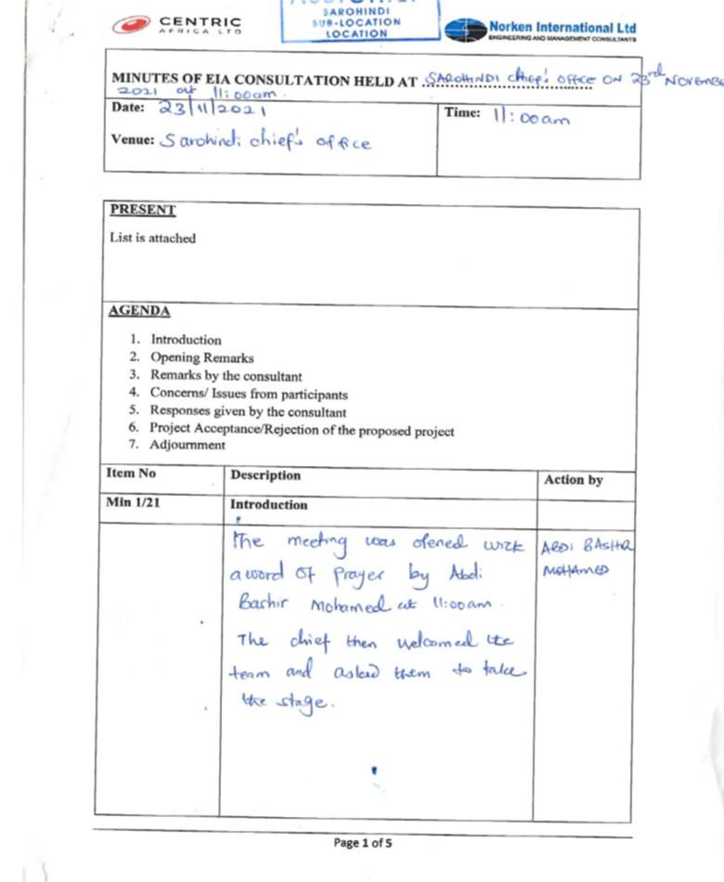

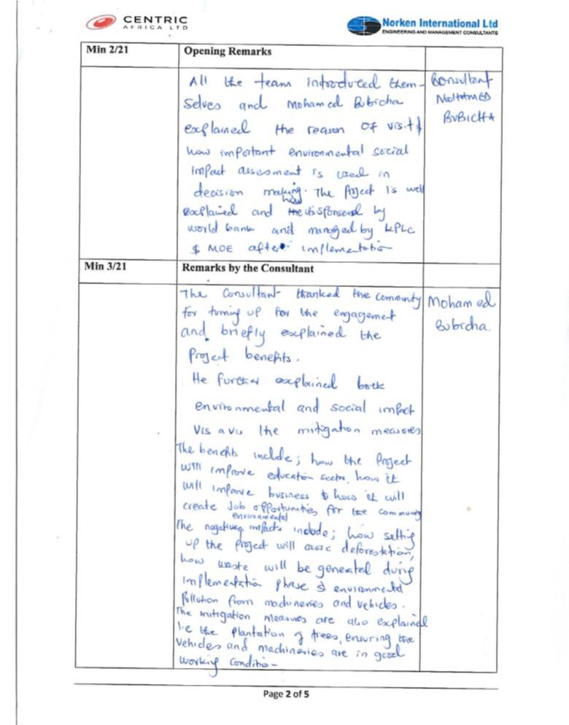

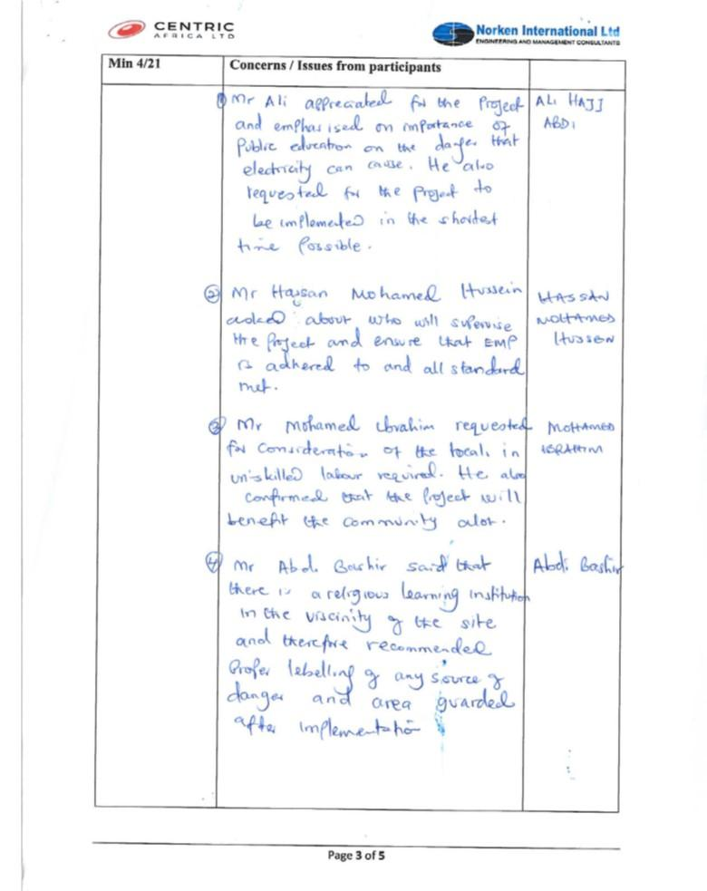

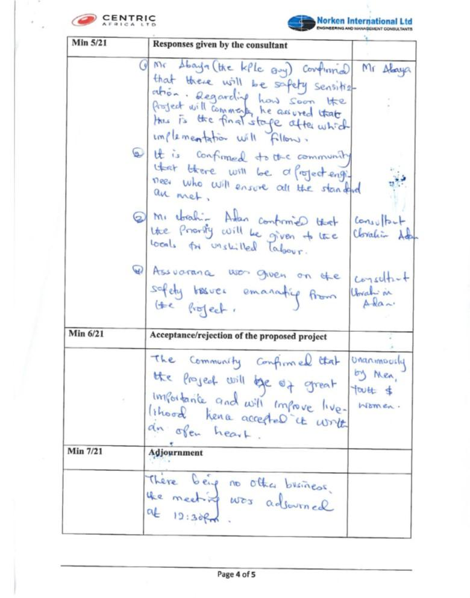

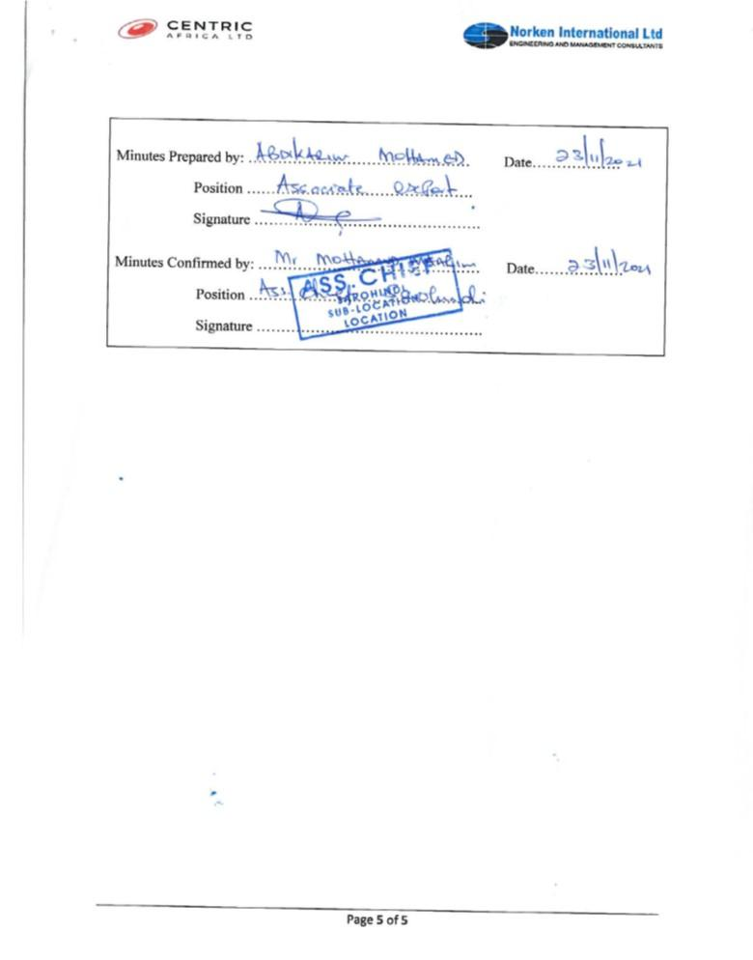

## ESIA List of Attendance

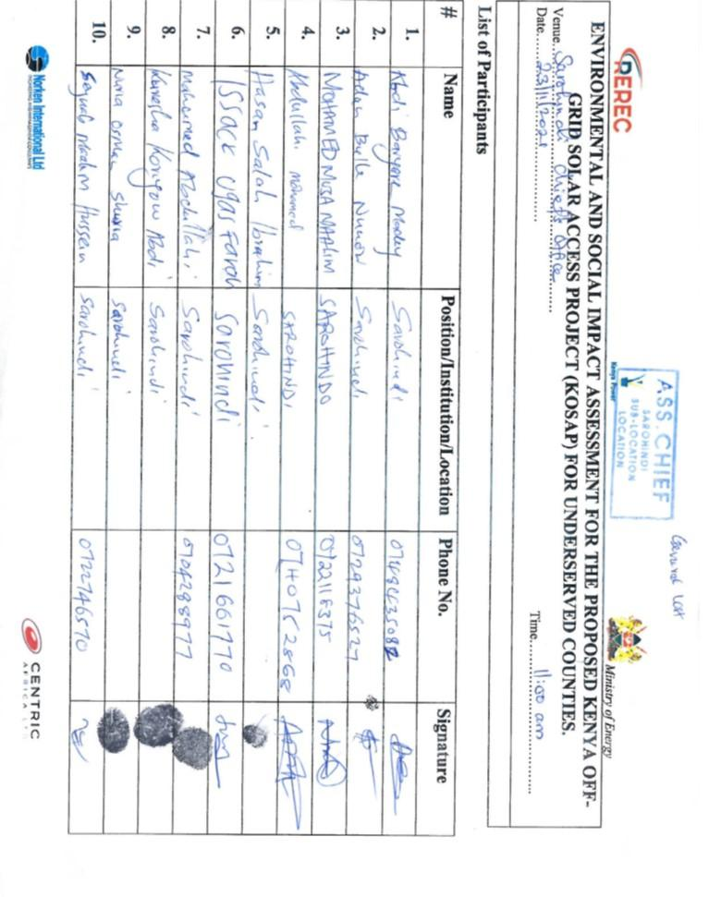

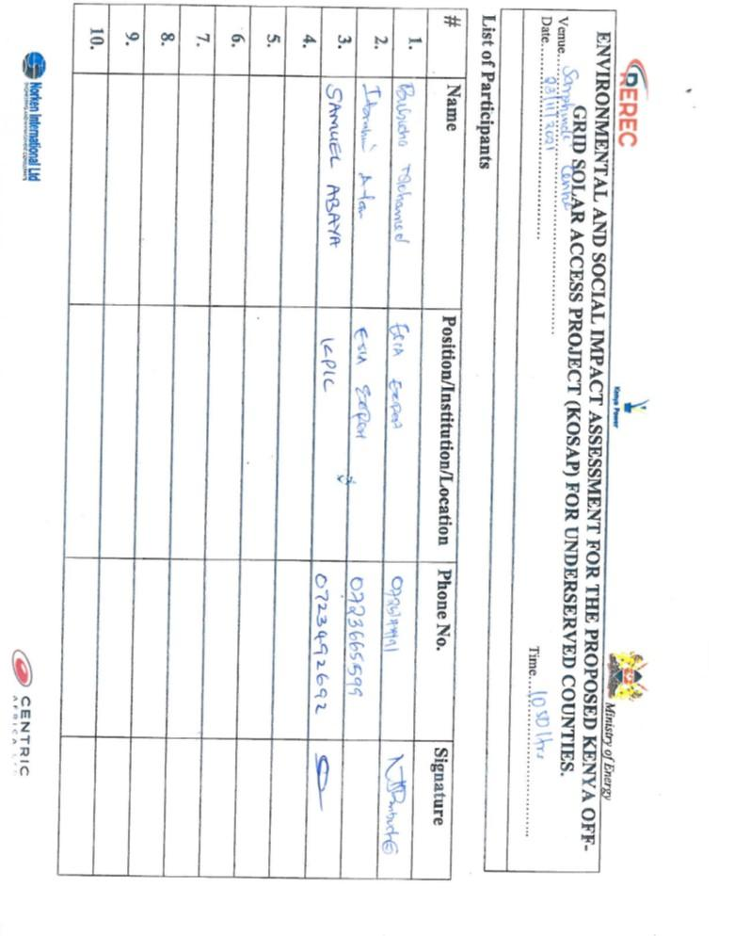

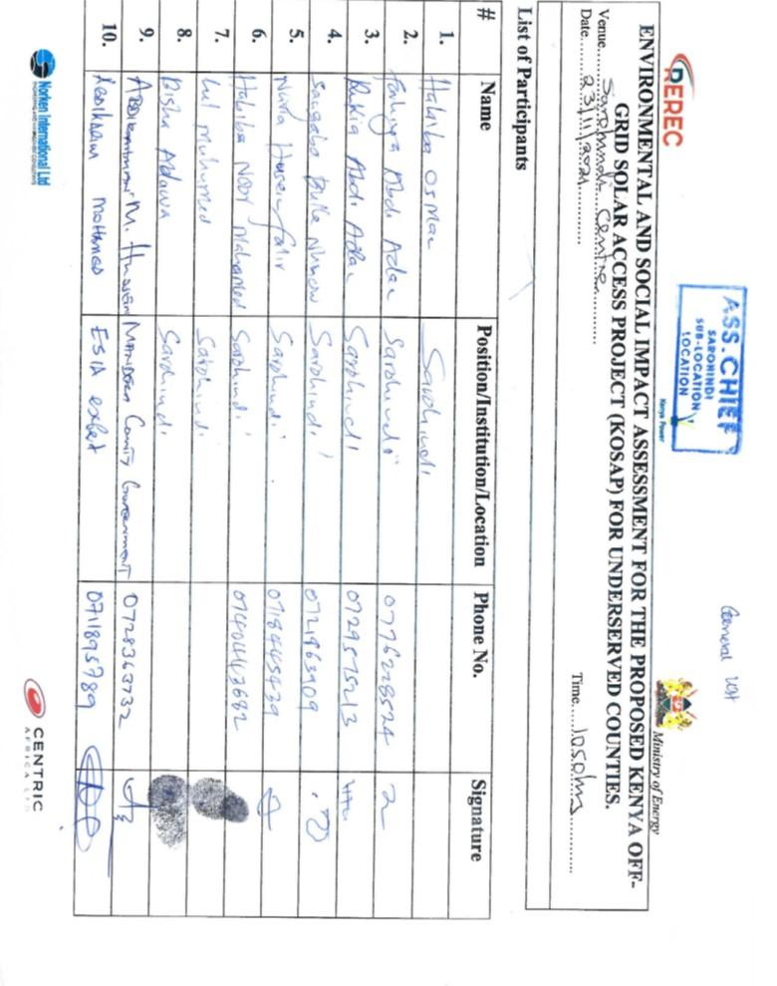

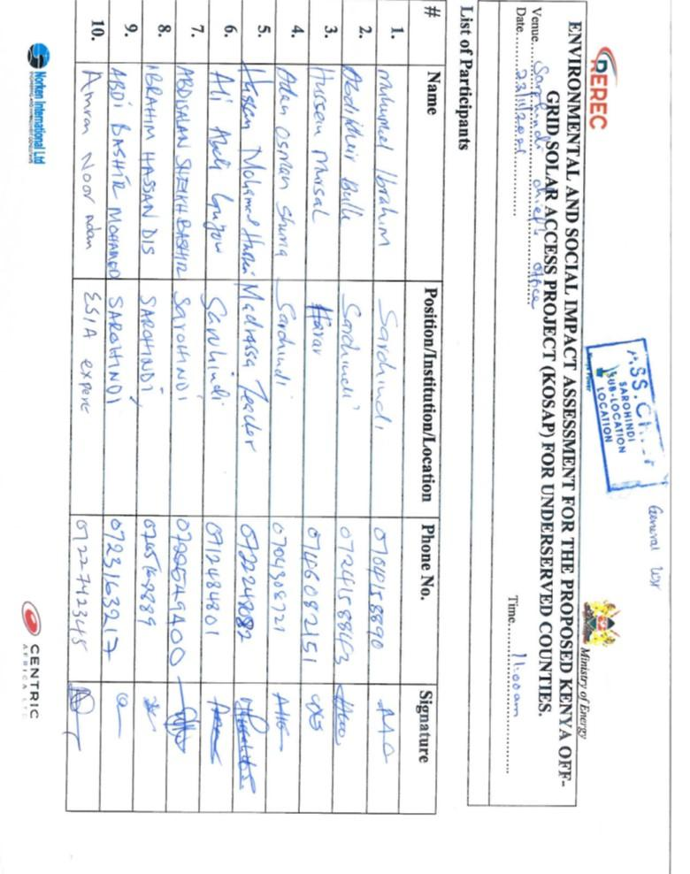

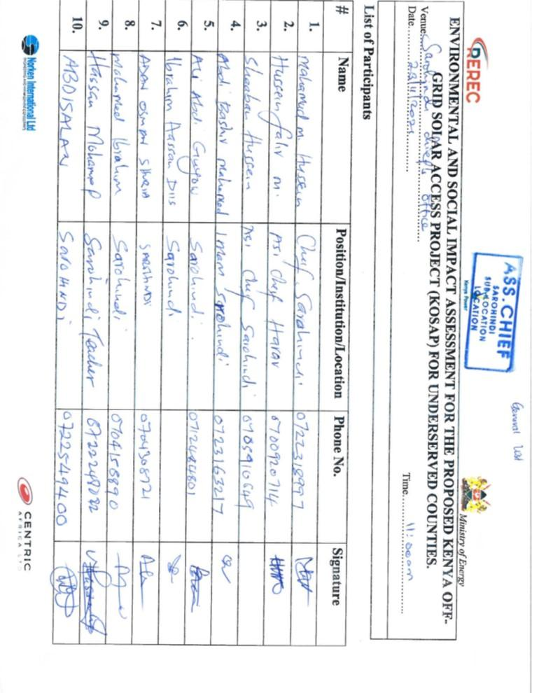

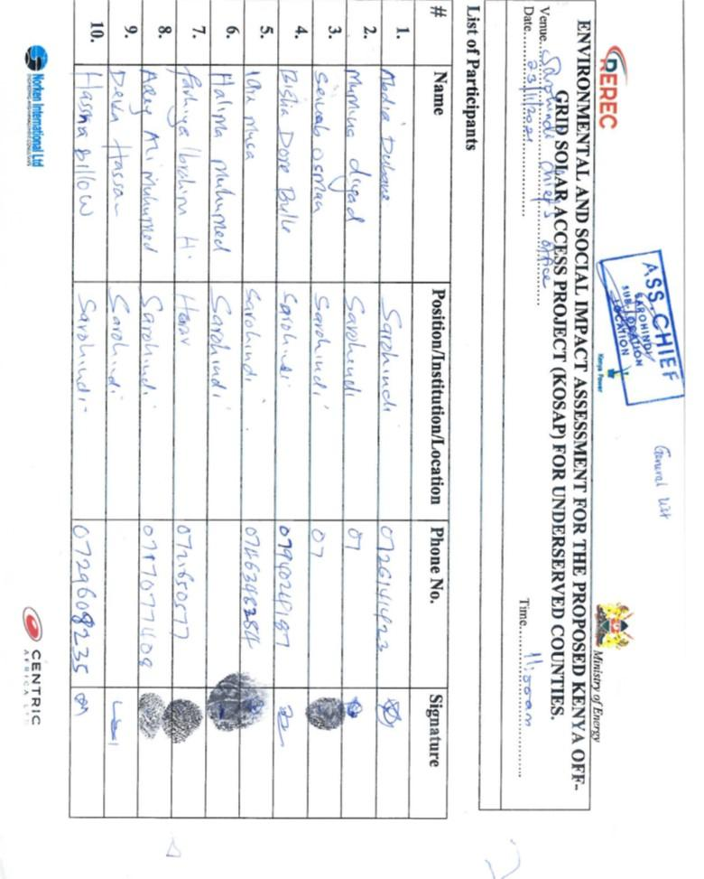

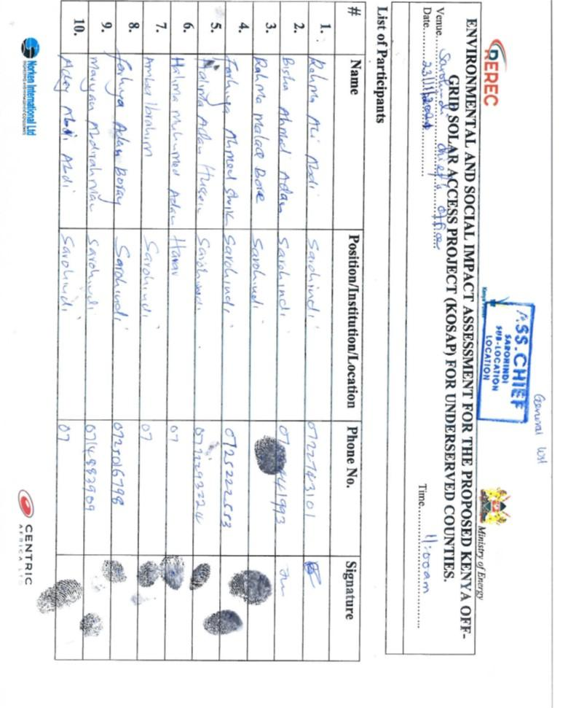

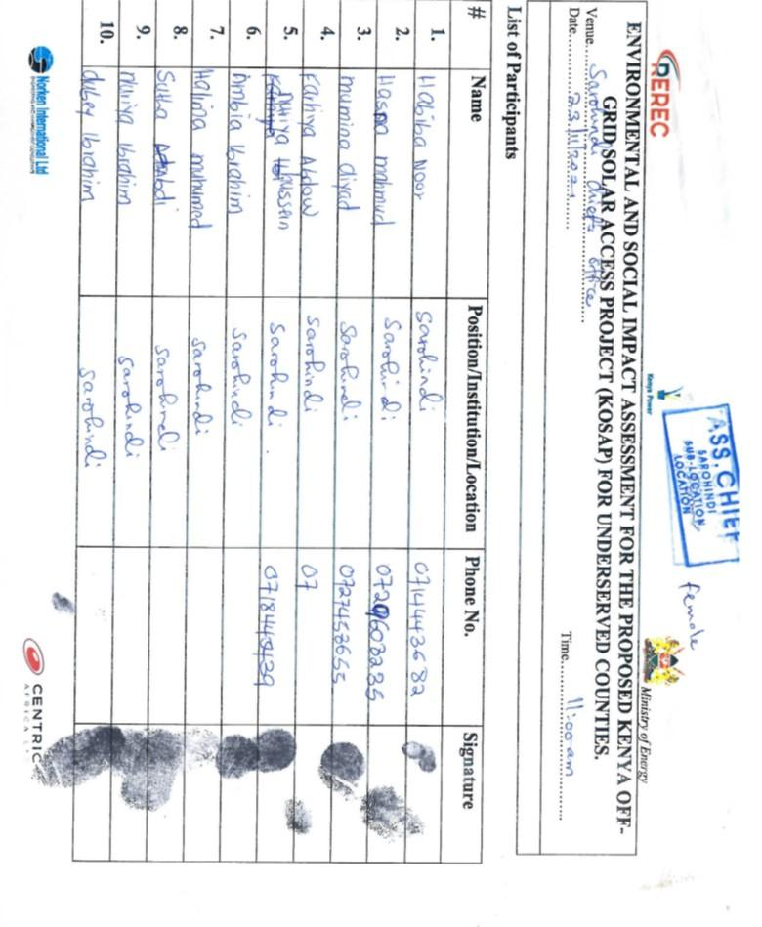

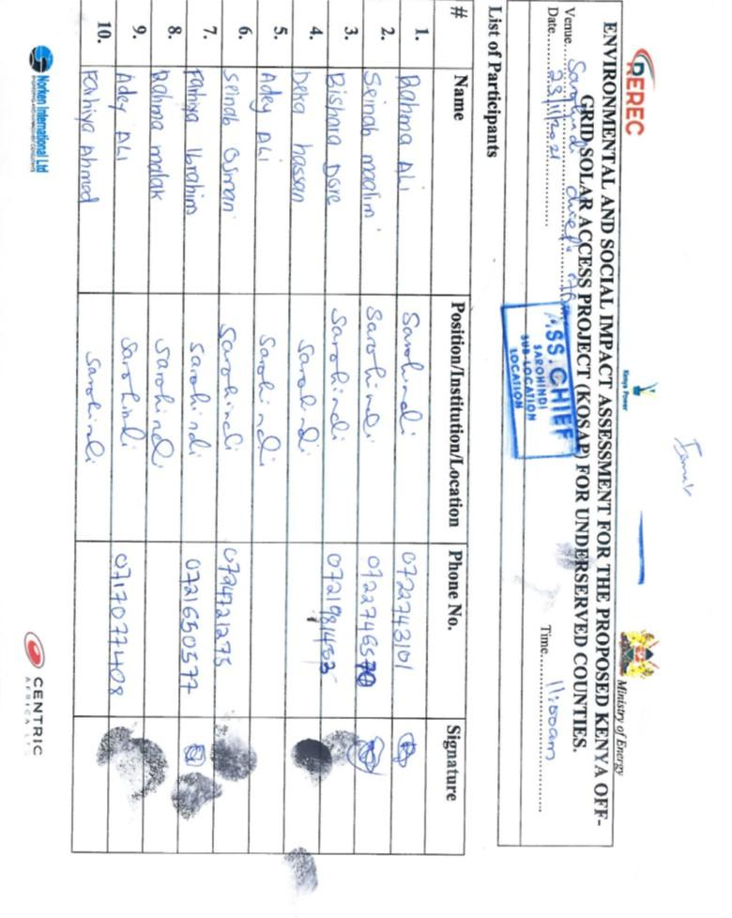

## Minutes of land acquisition meetings

**MINUTES OF PUBLIC CONSULTATION MEETING HELD OF 25TH FEBRUARY 2020 IN SAROHINDI MARKET NEXT TO THE MOSQUE ON THE ENVIRONMENTAL AND SOCIAL SCREENING OF THE PROPOSED SITE AND LAND ACQUISITION PROCESS.**

**Min: 1 Agenda:**

* Preliminaries
* Introductions
* Project design
* Land acquisition process
* Positive and Negative impacts of the proposed project /mitigation measures
* Way forward
* A.O.B

**MIN 2 Meeting Preliminaries**

The meeting was called to order by the area chief at 2:20 pm, a word of prayer was offered by Maalim Abdi Bashir. The area chief welcomed the team from MoE, KPLC, REREC and Mandera county government in a special way, he further welcomed the community members present for attending the developmental meeting in the community. He further emphasized the importance of having electricity in their community since it will improve their standards. The chief further informed the team from MoE, KPLC, REREC and Mandera county government that there is one Primary School, shopping centre, Health centre, Islamic school (Madrasa) and a mosque within the neighborhood and requested these facilities to be given first priority to be considered for electricity connection. He also further noted that there are other community facilities that include; water points, shallow well and a water pan in the area. He finished making introductory remarks by inviting the team from MoE, KPLC, REREC and Mandera county government to address the meeting

**Min 3. Introduction of the Project Implementation Unit Team (PIU)**

Samuel Abaya thanked all community members present and went on introducing team members from MoE, KPLC, REREC and Mandera county government. He in turn invited Eng. Kamau to take members through the project design.

**MIN. 4 Project Design**

Eng Kamau explained to the meeting that the government of Kenya through vision 2030 is planning that every household should be connected with power hence the government has come up with this project called Kenya Off Grid Solar Access Project (KOSAP) that is meant to connect Kenyans in the rural areas which are far from the national grid. This project is being implemented in the 14 counties where Mandera is one of them and the process of starting the project has commenced in Mandera. He further noted the proposed project will have solar panels, small diesel generator, control room, distribution lines to various homesteads. The project is being funded by the World Bank and the government of Kenya.

Eng Kamau informed the meeting that the project would also involve the reticulation of power connection to each homestead in the area. He informed the meeting that each household will be required to pay Kshs 1,000 (Kenya Shillings One Thousand only) as connection fees. After the payment each household will pay for their bills based on their consumption. He further explained to the meeting that we needed land from the community to construct the mini grid. He then welcomed the Land Surveyor to speak to the gathering

**MIN 5 Land acquisition process**

The team Surveyor Joseph Korir told the meeting that the team appreciated the time they took to come for the meeting to discuss the project. He informed the meeting that the projects would be implemented in 14 counties in the country. He said Mandera is the first county in which the project is commencing. Mr. Korir explained to the meeting that the project could only commence once the request for land is granted freely by the community.

Mr. Korir confirmed to the community present that land is both a social and economic factor of life. The land for the community has been inherited through generation. He also said that the land within the community is categorized as community land. Further confirmation of the same will be carried out during the acquisition process He explained to the gathering that he would map out the land donated. The project he said required a minimum of 2 (two) acres. He said that since the town is expanding due to the increasing population a minimum 2 acres will be sufficient, however to plan ahead if the community donated 5(five) acres it would be appreciated. The Surveyor asked the meeting if it was the first time they had heard about the project. The members of the community confirmed that a team had visited the town some time earlier regarding this said project.

Mr. Korir explained to the gathering that the team that had previously come to their area was a team of consultants. The members present confirmed the same and that they had shown them the site of the proposed mini grid. He told them that the team that had come previously were consultants who had come to view the land. He further said that he was the surveyor of the team and would take the coordinates of the land to commence the land acquisition process. He further explained that he would then prepare a sketch map of the land and forward the same to the County Government for approval. Once the county approved the scheme it would be forwarded to the National Land Commission for approval and the process of preparation of a letter of allotment. The meeting was told that the title would finally be in the name of either Kenya Power and Lightening Company (KPLC) or the Rural Electrification and Renewable Energy Corporation (REREC). Mr. Korir then welcomed the Mr. Abaya speak to the community.

**MIN 6. Compensation of proposed site options**

Mr. Abaya explained to the community that even though they had donated the land, it was necessary that we disclosed to the community that they were also entitled to compensation. He further explained to the gathering the options that they are entitled to. The first thing was that the community may have donated the land but are entitled to compensation for the land. This can be in the form of compensation by paying the community cash for the land. In this case the land would have to be valued by a Government Valuer and the cash amount based on the value is given to the Community. The cash would however be held on their behalf in an escrow account by the County until they are able to open an account of their own after registering their land.

The other option of compensation explained to the community was that the community can also be compensated in kind. The community can request for compensation in kind like a well, or classrooms to be built or any other item that will benefit the community.

Another option would be compensation of land for land. The community may request the Government to buy a similar piece of land for the community. To compensate for land donated for construction of the mini grid. He informed the meeting that they are at liberty to deliberate on the options given and they should not feel coerced to donate the land for the project. With the remarks made he once again thanked the community for supporting the project.

At this point the community members through their leadership agreed to donate 3 acres of land freely without being given back any form of compensation options as mentioned above. He further noted that the proposed project will benefit the community more than anything else.

Mr. Abaya thanked the community members once again for their time and the donation of the land towards the proposed project that will benefit the community has a whole.

**MIN 7: Positive and Negative impacts of the proposed project /mitigation measures**

The Team Environmental and Social Expert Samuel Abaya continued with the meeting and thanked the community once again for listening to the input of all the Team members. He told the meeting that a list of attendance would be circulated where all present would write their names and sign the form. They were informed that minutes would be taken as we proceeded with the meeting.

Samuel told the gathering that it was important that there be consensus for the land donated. He said the team was ready and open to discuss any issue or dissenting voices regarding the land donated for the project.

Samuel explained to the meeting that another meeting will be hold for Environmental and Social Impact Assessment for the proposed site which will be submitted to National Environmental and Management Authority (NEMA) for review. NEMA officers would come and confirm if an Environmental and Social Impact Assessment had been done on the project and assess the community engagement with the proposed project. Subsequent to this the Contractor would then commence the construction of the mini grid.

Samuel then told the meeting that he would give them both the positives and the negatives impacts of the project. He began with the benefits. He said, the community would enjoy light from electricity and each household connected will no longer need to use paraffin lamps to light their homes. Electricity will be generally cheaper that the use of paraffin for lighting. Electricity will benefit school going children. They will be able to study with light late in the evenings. There will also be an opportunity for the Teachers to teach the students late into the evening and also use the same light to give them early morning classes.

The community will also enjoy power for security lights at night. This will enhance security within the community at night. He further told the community that there may be members in the community who would love to buy televisions. Televisions will be a good source of entertainment and information of current affairs both locally and internationally. With electricity some community members will start businesses, the youth will open Barber shops. He asked the community where they cut their hair and many responded that they travel to Mandera. He told them this will then not be necessary as the electricity will enable barber shops to be established within the market.

Samuel also told the gathering that the project will come with employment opportunities for the community. This will be in the category of skilled and semi-skilled jobs. The project will give priority to the locals for employment opportunities. The works will be for masons, electricians when the contractor begins the construction. The work will be available for Men, Women and the youth. The rates payable will be agreed with the contractor. The Women will have an opportunity to sell tea, chapatti and food to the workers who will be working on the site of the mini grid.

The Contractor will also buy building materials like sand, gravel, stones and cement from the local community. Materials that will be available within the community for sale will be purchased by the contractor. Some materials like solar panels will be imported for the project.

The local Health Centre will also be supplied with electricity. This will be a benefit in that the dispensary will now be able to refrigerate medicines that require being stored in cool places for patients. Laboratory and Pharmacy services will be more efficient for the community. As Pastoralists with the sale of livestock when the meat or milk is not all sold in a day, it can also be refrigerated.

Samuel told the meeting that every project has both positives and negatives effects. He went further to explain the negative aspects of the project. He said the project will involve non local people coming to work on the site. This means that the non locals may come with habits that are not culturally acceptable to Community. The workers may walk around the sites without shirts and in shorts. This may be unacceptable behavior to the community. If the community have rules they wish to have adhered to, it will be negotiated with the non-locals.

The community will also experience noise pollution during the construction period the noise will be from excavation, drilling and vehicles driving to and from the site. This will be for just a while. The contractor will be limited to working from 8am to 5pm to control the noise. Samuel acknowledged that water is scarce in this area. He said that the contractor will require water from the locals to carry out the construction of the project. This will be an inconvenience for a while.

Dust pollution will also emerge from the site. The contractor will mitigate this by pouring water at different times to reduce the dust. The vehicles may at times be driven at a high speed when transporting materials. The introduction of bumps will be used to control the speed of the vehicles. During construction of the project, the community may have trees on the donated land. In case the land has trees, they will be cut and cleared for the project. However the contractor will plant trees to replace the ones cut and plant additional trees for the community on the site.

Accidents may occur during this period too. For example a worker could get injured by a stone falling on them or hammer injuring a worker. The contractor will ensure that all workers wear a helmet, gloves, overall and safety boots at all times when on site. If a worker is found without any of the safety gear, he will be dismissed from the site on the spot. In case of any injury to the workers the Contractor will bear the responsibility for the staff. The contractor will give all the workers the regulations they must abide to while at work.

Sam also talked about Gender Based Violence as an issue that needed to be mentioned. He said if a man got a job on site and is paid his wages, his wife may demand money knowing that he has been paid. This also applies in vice versa. The woman may work and the husband may demand money from the wages paid. If one spouse does not cooperate, the consequence could lead to violence in the home.

Another negative may occur when the women are employed on the site or cook for the workers they may be sexually harassed. Such cases must be reported. HIV AIDS is also a disadvantage. The risk to this exposure is real and members of the community and workers should be aware since everyone is vulnerable.

Child labor is also a negative activity that will not be condoned. A worker may wish to get additional money by bringing in a child to assist in his work. Such a situation will not be accepted.

Electricity as a source of energy can also be dangerous. Children may play around with nails in the sockets in the house. This can cause electrocution. When trying to save such a child, one may be bare footed and become a path for the electricity and get injured. The children can be curious about the power poles and decide to climb hence risking their lives by falling from the poles. Precautions need to be taken where children and the community warned on the dangers of electricity. With all the disadvantages the meeting was told that there will be a solution for all the issues.

Samuel then told the meeting that to address grievances, the team will require that a Grievance Redress Mechanism to be put in place by the community. This GRM will have a committee that will help solve the grievances arising from the project. The community will need to identify persons who will sit on the committee and they should comprise a man, woman, youth and a person representing the special group e.g a person living with a disability. The Committee will help address grievances to their conclusion. If in any case the committee is unable to solve an issue, they will be guided by the implementing agency on where to forward the matter. If it is still not solved at that level, then the Kenyan Courts will be used to resolve the issue. He said it is our hope that the grievances will be solved at the local level. The meeting was also told that the members of the Committee will be required to volunteer their services. This is because there will be no payment for their services. The committee was elected comprising a representative of men, women, youth and special needs in the society. Their names are;

|  |  |  |  |  |  |
| --- | --- | --- | --- | --- | --- |
| **No** | **Names** | | **Represents** | **Id. No** | **Phone No.** |
| **1** | **Hussein Osman shuriya** | **Youth (gentlemen)** | | **9566473** | **071477005** |
| **2** | **Rahma Ali** | **Youth (ladies)** | |  | **0722743101** |
| **3** | **Ali abdiguyow** | **Men** | | **9220933** | **0712484801** |
| **4** | **Mudey BILOW ADAW** | **Special needs** | | **20178563** | **0722318997** |
| **5** | **MuminaDiat** | **Women** | |  | **0727458655** |

Samuel then concluded by thanking the community for their attention and said we would move to a question and answer session. He also told the meeting that Dorothy a member of the team would meanwhile hold a separate meeting with the girls and women to allow them to also speak their minds and ask questions freely away from the men

**Min. 8. PLENARY SESSION**

|  |  |
| --- | --- |
| **Questions/ comments** | **Response/ Remarks** |
| **Shaaban Hussein (Ass. Chief):** We are grateful for this project and we as a community, we have donated the piece of land required but please, fast track the construction of the power plant. | **Mr. Abaya:** Thanks for the land donation, we will start the construction of the mini grid soon so that you can enjoy electricity in your houses as any other Kenyan in urban areas.  **Eng Kamau:** Noted that after the implementing agencies gets all the required approval then a tender will be issued out for various construction contractors to bid. The successful contractor will be on before the end of this year if all goes well. |
| **Ali Ahmed:** We have donated the land, what is next? Will the community benefit from the project in terms of job creation? | **Eng Kamu:** Tendering process will begin soon, and then the successful bidder will come to Sarohindi for the construction of both solar power generation plant and the overhead distribution line.  **Samuel:** Yes, the community will be given first opportunity when it comes to employment for both skilled and non-skilled. |
| **Hussein Falir:** we have donated the piece of land a year ago, and we still don’t see power, how long will you be away before you come back for the construction? | **Mr. Abaya:** at the moment, we can’t confirm the date but the contractor will soon be on the ground and construction of the mini grid will commence. |

**Level of involvement men and women**

* To do manual work
* Provision of security services
* Provision of local available building materials
* To be consulted regular
* Assist in dispute resolution
* Setting up small business-like tailoring where electricity will be utilized

**Way Forward**

Members present welcomed the project and requested that it be implemented the soonest possible so that their problems of without electrical power to be sorted once and for all. They further agreed that the land they are giving for the proposed project is a donation and no any form of compensation will be demanded by the community.

**MINUTE 9: A.O.B**

Five community members were identified to sign land donation form on behalf of the community.

**MINUTE 10: Closure of meeting**

There being no other business, the Chairperson thanked all the attendants for their turn up and contributions. Members agreed to keep in touch and clarify on any necessary information as regards the intended projects. The meeting ended with a closing prayer at 5:20 p.m.

**END.**

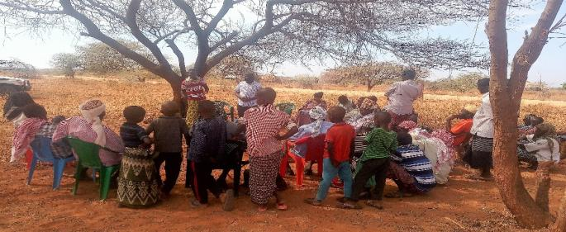

Eng. Kamau addressing the meeting

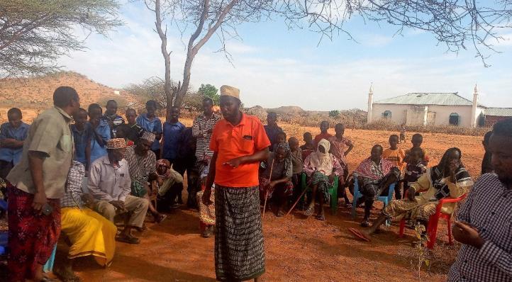

One of the elders asking a question

## List of attendance minutes of land acquisition

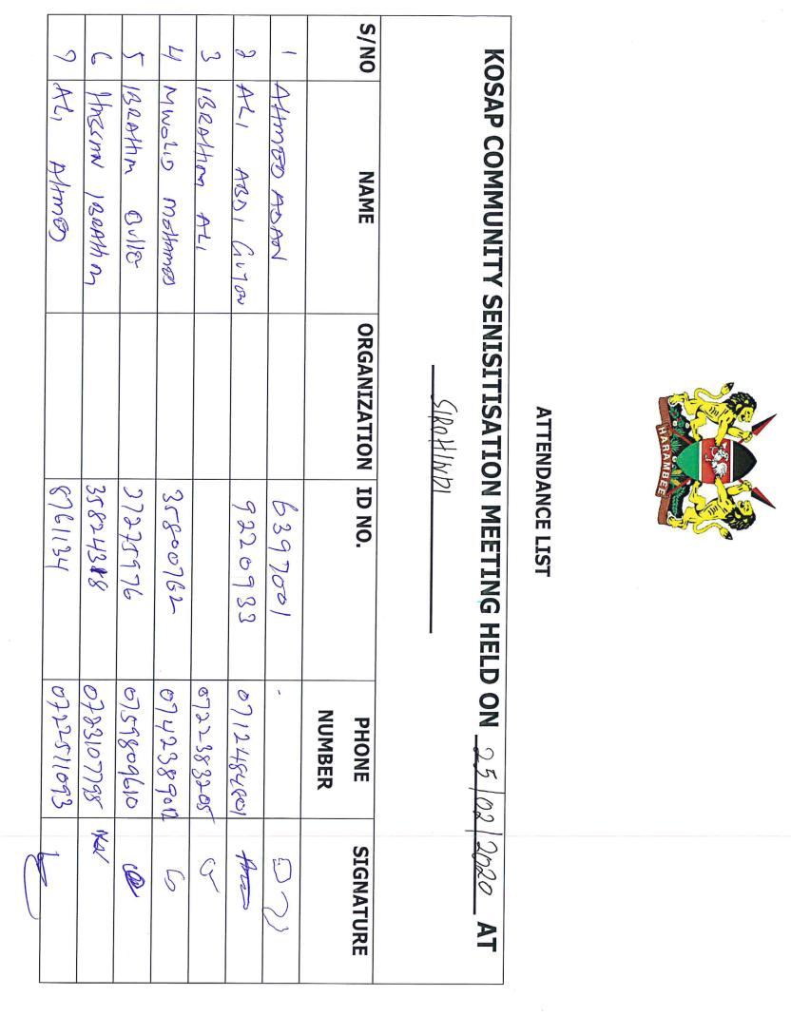

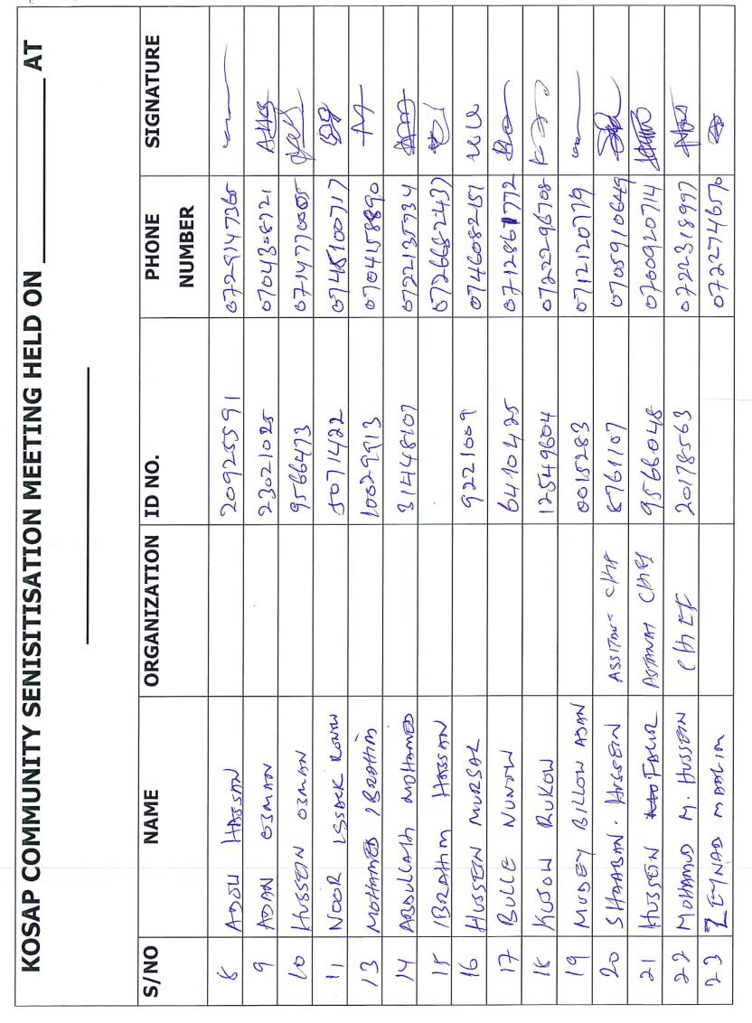

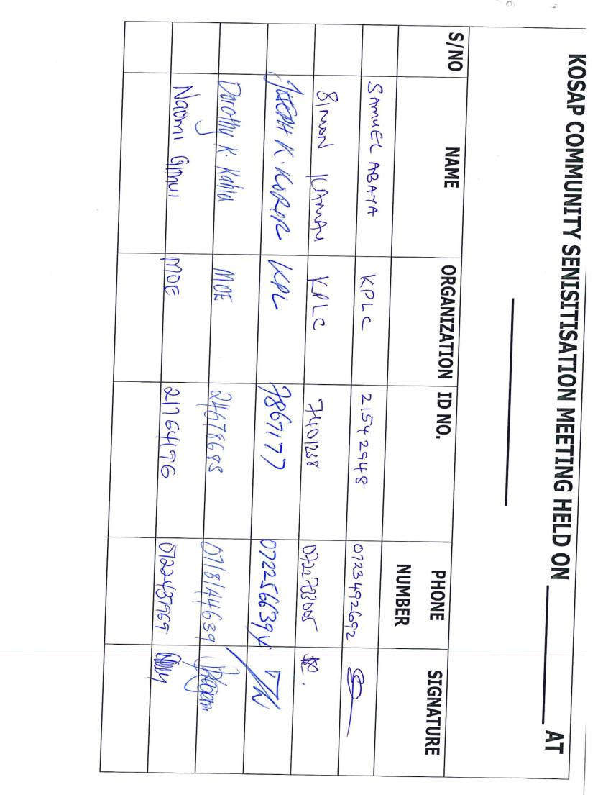

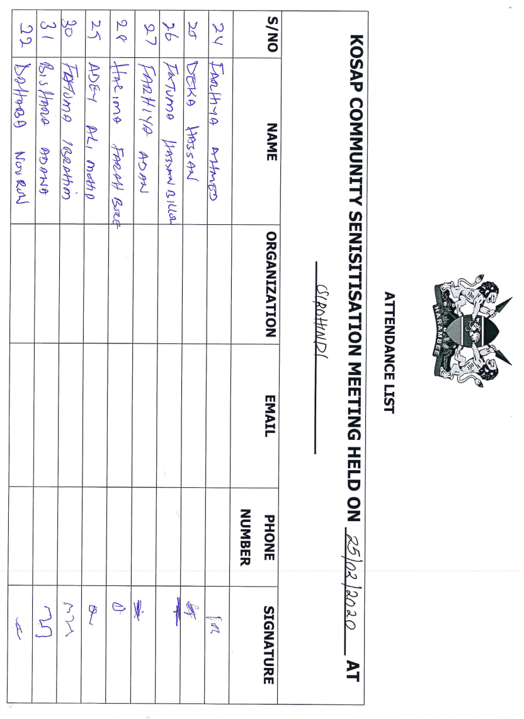

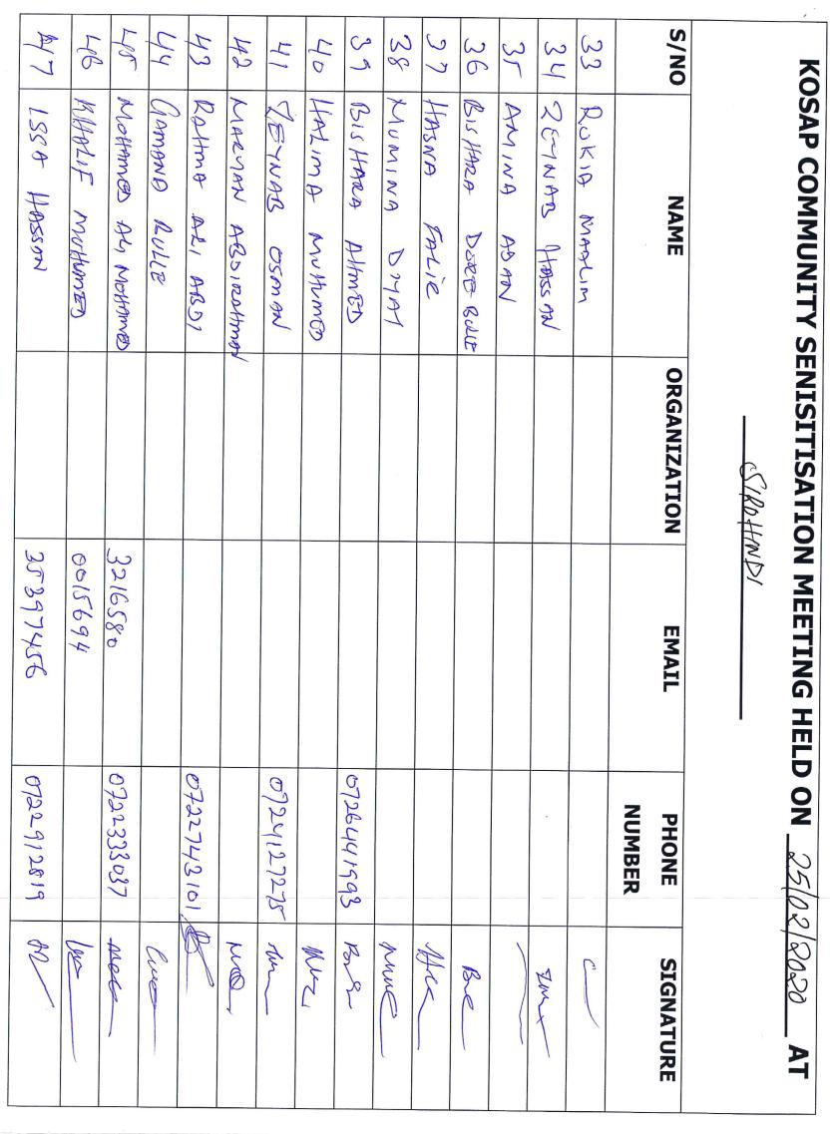

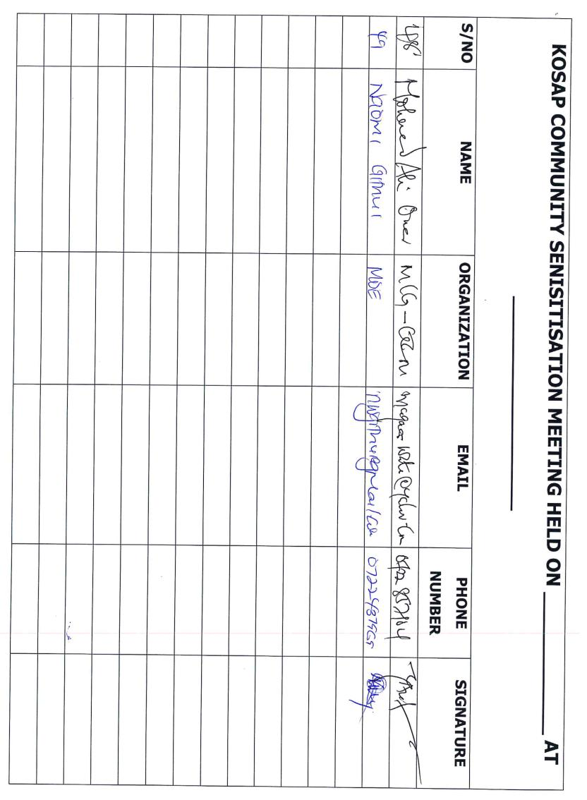

## Land Identification Form

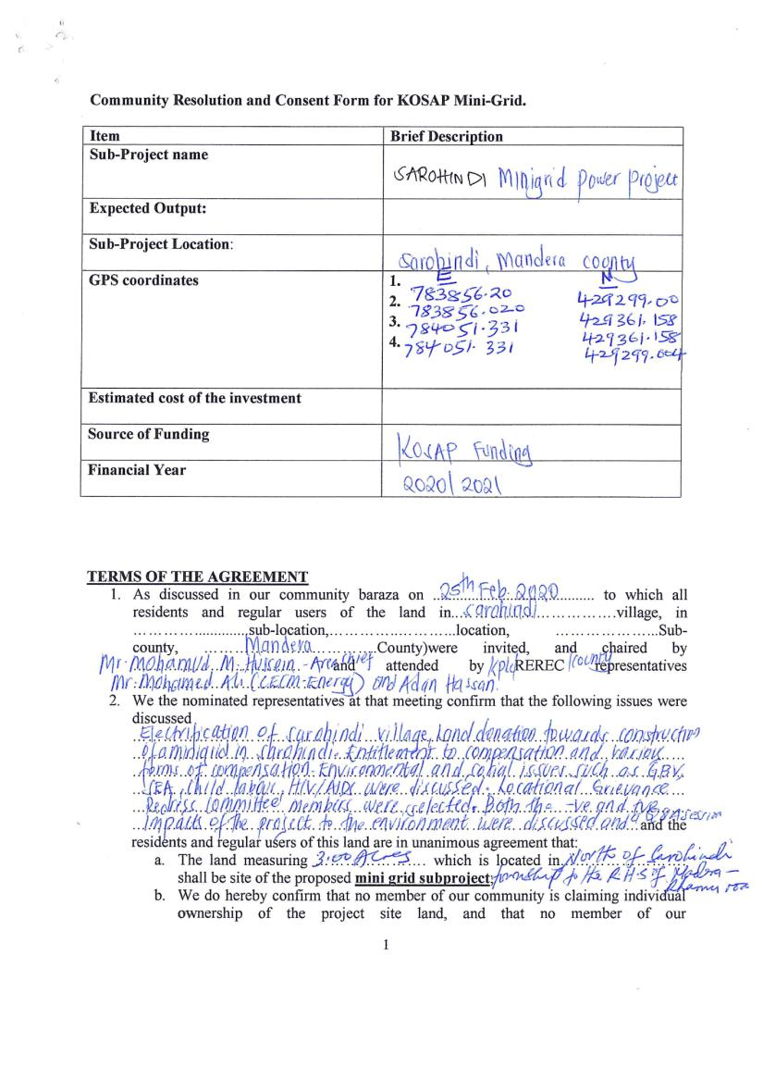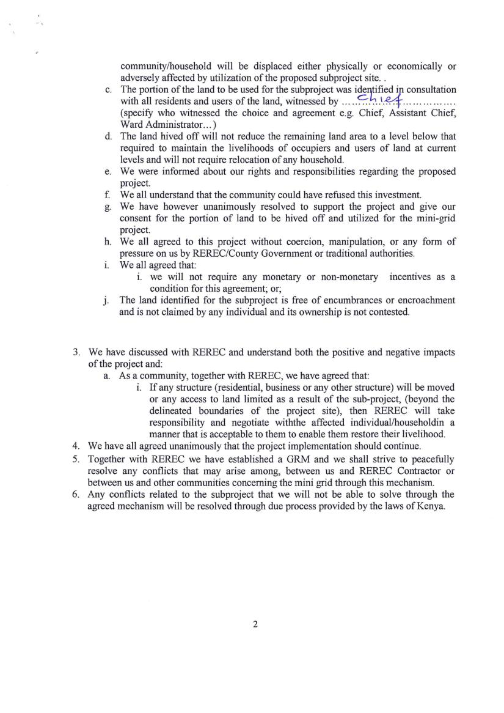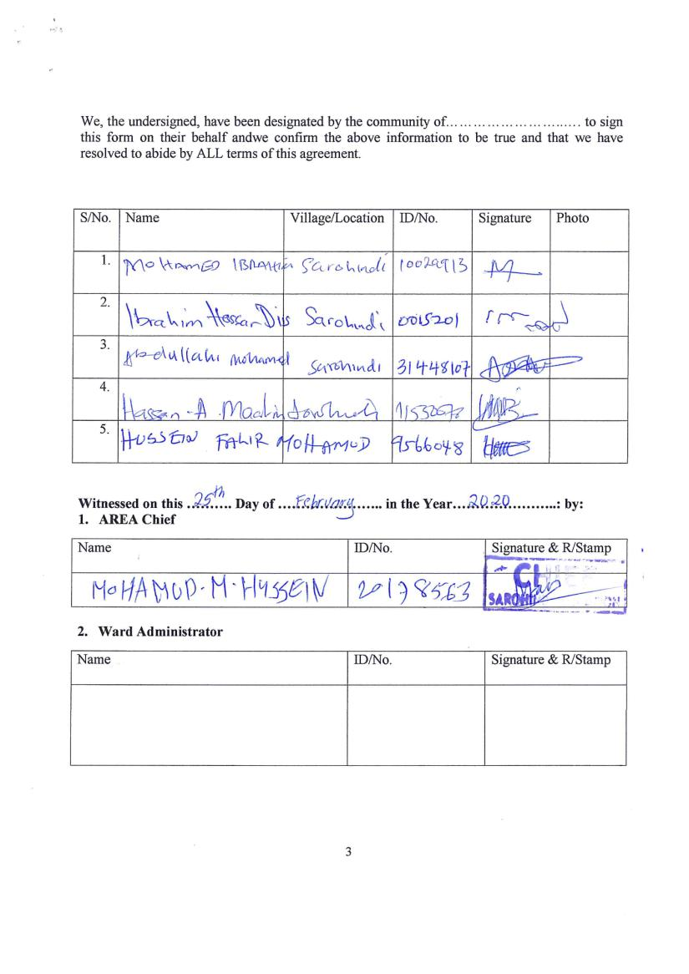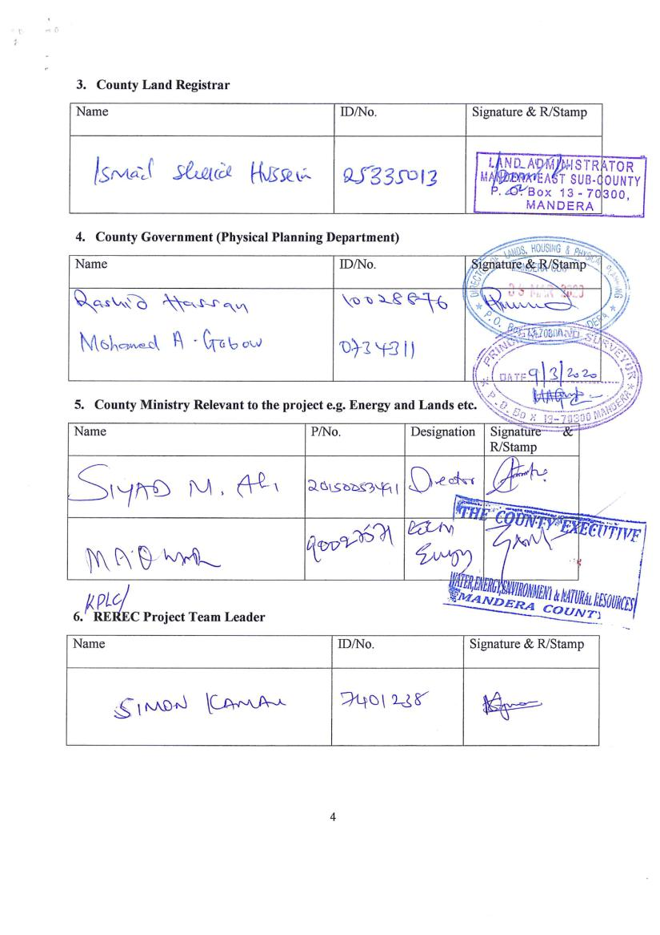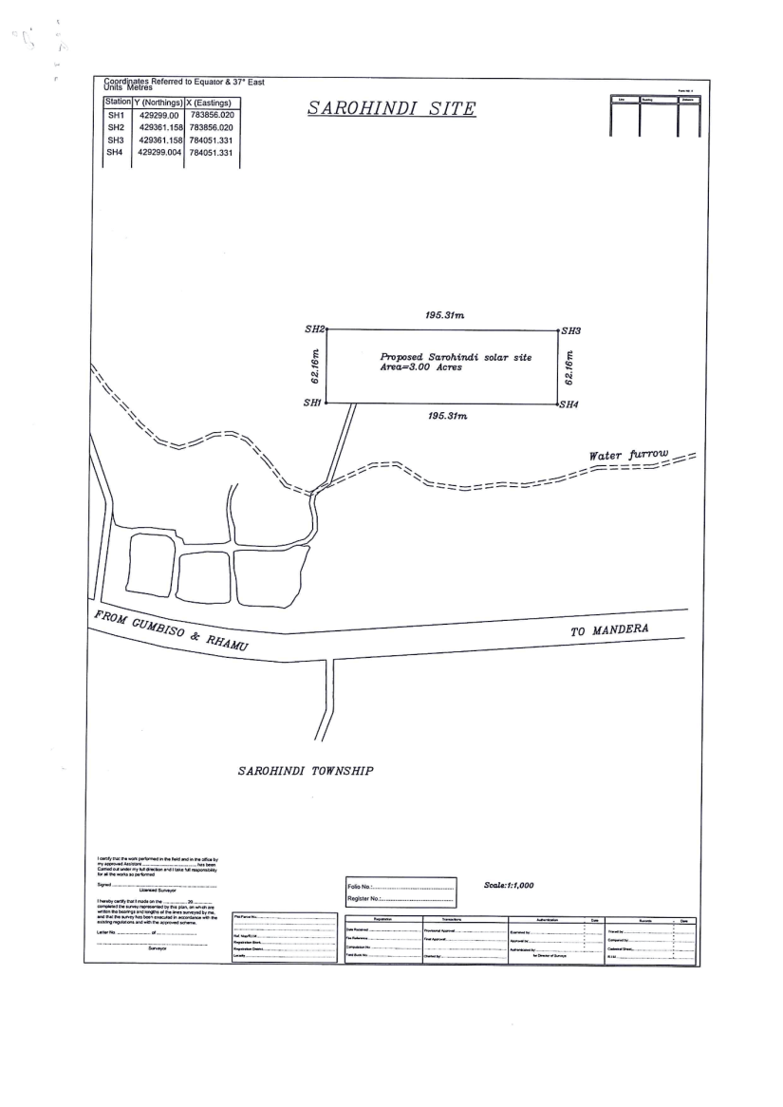

## Abbreviated Resettlement Action Plan (A-RAP)

1. **Sarohindi Sub-project Site**

The Sarohindi sub-project site is on unregistered community land and held in trust by the County Government of Mandera on behalf of the community, in line with the Community Land Act 2016. The proposed site is uninhabited, has no structures, community facilities, or encumbrances, and utilized by the community for livestock grazing. The site has few acacia trees, shrubs and withered grasslands. Consultations leading to the identification and selection of the sub-project site are captured in the Environmental and Social Screening report for Sarohindi. *Refer to Chapter 4 of the ESIA for the comprehensive socio-economic profile.*

1. **Actual Census Survey of PAPs and Valuation of Affected Assets**

The number of project-affected persons (PAPs) is 1800 (approximately 231 households). The land acquisition-related impacts are loss of land and pasture. Mitigation measures include in-kind compensation for loss of land and pasture, and designing power distribution lines to avoid impacting trees, crops, structures, and community facilities. No physical displacement is anticipated; however, there is minimal loss of pasture occasioned by the acquisition of land utilized by the community for grazing. The 1.214 hectares identified for the sub-project will be acquired compulsorily by the National Land Commission (NLC). The proposed site will be valued and compensated in line with the provisions of the Resettlement Policy Framework (RPF) prepared under KOSAP. *Refer to section 2.2 of the ESIA for the sketch map of the site.*

1. **Compensation Measures Agreed with the PAPs and other Resettlement Assistance to be Provided**

The proponent requested the community identify three priority projects, whereby one out of the three would be provided as in-kind compensation for loss of land and pasture. The Sarohindi community requested for construction of two rooms that will be used as a dispensary. The value of the priority community project will be proportional to or higher than the value of land under acquisition. In addition, loss or damage to crops, trees, structures, and community facilities will be compensated in line with the provisions of the RPF, and as summarized in the entitlement matrix below.

**3.1 Entitlement Matrix**

|  |  |  |  |
| --- | --- | --- | --- |
| **Types of Impact** | **Person(s) Affected/Eligible for Compensation** | **Compensation/Entitlement/Benefits** | **Responsible organization** |
| 1. **Loss of Land** |  |  |  |
| Loss of unregistered community land. | Community. | Compensation in-kind as prioritized by the community. | KPLC |
| Loss of land in unregistered group ranches. | Group ranch members. | Compensation in-kind as prioritized by the community. |
| Loss of land in registered group ranches. | Group ranch members. | Compensation in-kind as prioritized by the community. |
| Loss of land owned by the National Police, county governments and the Ministry of Interior | Government agencies. | No compensation for public land allocated to another government body. |
| Loss of land owned by the Kenya Forest Service (KFS) and Kenya Wildlife Service (KWS). | Government agencies. | No compensation for public land allocated to another government body. However, payment of conservation fees to KWS and KFS as stipulated under their respective regulations is foreseen. |
| 1. **Loss of Use on Land** |  |  |  |
| Loss of use on public land (e.g., grazing, farming etc.). | Communities utilizing public land. | Communities do not own public land; however, they utilize public land with consent from the relevant agencies. The project will implement the infrastructure project prioritized by the community as compensation for the loss of public land use. | KPLC |
| Loss of use on unregistered community land, unregistered group ranches and registered group ranches ( e.g., grazing, farming etc.). | Communities utilizing unregistered community land, unregistered group ranches, and registered group ranches. | Compensation in-kind as prioritized by the community. |
| 1. **Loss of /Damage to Assets on Land** |  |  |  |
| Trees | Community members on unregistered community land; community members utilizing public land; members of registered and unregistered group ranches and government entities. | During detailed design for power distribution lines and construction of the mini grid and community project, any crops, structures, trees, and community facilities shall be avoided to the extent possible. However, loss or damage to the above will be compensated/restored at full replacement cost,[2] in line with the provisions of the RPF. | KPLC |
| Crops |
| Structures |
| Community facilities e.g., water sources (earth pans, boreholes etc.). | Community members on unregistered community land, community members utilizing public land, and members of registered and unregistered group ranches. |

**4. Consultations with PAPs About Acceptable Compensation Options and Alternatives that have been Considered**

Detailed consultations with PAPs on land acquisition and compensation, including the modalities of acquiring land and compensation options, were undertaken during the Environmental and Social Screening, Environmental and Social Impact Assessment, and the NLC land valuation process. The following sections provide a summary of the consultations.

**4.1 Engagement of Project -Affected Persons (PAPs)**

Local administration and County Renewable Energy Officers (CREOs) supported the proponent and implementing agency (IA) to mobilize community members and other stakeholders for public consultations and engagement activities. National and county government entities, community segments (men, women, youth, elders, persons with disability, vulnerable and marginalized groups, etc.), NGOs, and local leaders were engaged through key informant interviews, community meetings, and focus-group discussions. The proponent and IA implemented appropriate measures to ensure PAPs effectively participated in the consultations. *Refer to Chapter 6 of the ESIA on public consultation and engagement.*

Once the compensation award and Bill of Quantities (BoQs) are known, the Implementing Agency (IA) will engage the community and agree on the community project to be executed as in-kind compensation. During these consultations, the IA and the community will define the roles and responsibilities of the community in monitoring the implementation of in-kind compensation and maintenance once the IA hands it over to the community. Thus, the IA and the community will effect an agreement to be signed by the local leadership; representatives of the Grievance Redress Committees at the locational, county, and national levels; A-RAP Implementation Committee, and Implementing Agencies.

**4.2 Identification of Community Representatives**

The Sarohindi Locational Grievance Redress Committee (LGRC), constituting a chairperson, secretary, and three members, was formed through community consensus. The committee’s membership comprises men, women, youth, persons with disabilities, and ethnic minorities. The LGRC is responsible for engaging PAPs and resolving complaints. Refer to Chapter 6 of the ESIA on the Grievance Redress Committees. Further, the community will constitute the A-RAP Implementation Committee responsible for coordinating community engagements on the A-RAP and monitoring the implementation and closure of the A-RAP. The representation of the committee will consider gender, vulnerability, and intergenerational sensitivities.

**4.3 Summary of Consultations on Land Acquisition and Compensation Options**

|  |  |  |  |  |  |
| --- | --- | --- | --- | --- | --- |
| **Date** | **Objective** | **Implementing**  **Entities** | **Land Acquisition and Compensation Aspects**  **Discussed** | **Key Issues Raised** | **Responses**  **Given** |
| **Feb 25th**  **2020** | Environmental and Social Screening.  Voluntary land donation (VLD).  Constitution of the Locational Grievance Redress Committee (GRC). | Ministry of Energy (MoE)  Kenya Power (KPLC)  Rural Electrification and Renewable Energy Corporation (REREC) | Site identification and land allocation for the sub-project.  Criteria for VLD.  Community entitlements (forms of compensation and implications for each). | We are grateful for this project and we as a community, we have donated the piece of land required but please, fast track the construction of the power plant. | Thanks for the land donation, we will start the construction of the mini grid soon so that you can enjoy electricity in your houses as any other Kenyan in urban areas.  Noted that after the implementing agencies gets all the required approval then a tender will be issued out for various construction contractors to bid. The successful contractor will be on before the end of this year if all goes well. |
| We have donated the land, what is next? Will the community benefit from the project in terms of job creation? | Tendering process will begin soon, and then the successful bidder will come to Sarohindi for the construction of both solar power generation plant and the overhead distribution line.  Yes, the community will be given first opportunity when it comes to employment for both skilled and non-skilled. |
| We have donated the piece of land a year ago, and we still don’t see power, how long will you be away before you come back for the construction? | At the moment, we can’t confirm the date, but the contractor will soon be on the ground and construction of the mini grid will commence. |
| **Nov 23rd 2021** | Environmental and Social Impact Assessment. | Consultants  MoE  KPLC  REREC | Land acquisition through compulsory acquisition (not voluntary land donation).  Selection of three priority community projects, whereby one is to be implemented as in-kind compensation for land. | construction of 2No. rooms that will be used as a dispensary | The proponent has set aside KES 1 million to implement the priority in-kind compensation project.  The value of the project will be proportional to or greater than the value of land.  NLC will determine the value of land. |
| May 2023 | Compulsory Land Acquisition. | NLC | Site inspection and inquiries.  Land valuation.  Award of compensation. |  |  |

**5. Institutional Responsibility for Implementation of the ARAP**

|  |  |
| --- | --- |
| **Entity** | **Role** |
| Ministry of Energy | * Coordinate A-RAP implementation and provide budget for in-kind compensation. |
| National Land Commission | * Implement the statutory process for compulsorily land acquisition, including site gazettement and inspections, inquiries, valuation, and award of compensation. |
| Kenya Power | * Monitor all land acquisition and compensation aspects (including A-RAP closure), complemented by a third-party monitor. * Provide budgets for stakeholder engagement, grievance management, and monitoring, including the facilitation of the Land Acquisition and Compensation Implementation Committee, and the Grievance Redress Committee. |
| Mini-grid Contractor | * Implement in-kind compensation concurrently with the solar mini-grid project. |
| Supervising Consultant | * Monitor and report on implementation of in-kind compensation, and overall project compliance with social safeguards. |
| Grievance Redress Committees | * Formed at the locational, county, and national levels, and responsible for resolving complaints, including A-RAP related grievances. |
| A-RAP Implementation Committee | * Coordinate A-RAP engagements at the community level, monitoring A-RAP implementation and closure. |
| Affected Community | * Responsible for the operation and maintenance (O&M) of in-kind compensation project. An agreement stipulating the O&M roles and responsibilities of the community will be effected. |

**6. Procedures for Grievance Redress**

The Project procedures for grievance redress were established through a public consultation process and informed by the existing conflict resolution structures in the community. The Grievance Redress Mechanism (GRM) comprises tiers at the project, county, and national levels. *Refer to Chapter 7 of the ESIA for a detailed GRM.*

**7. Implementation Timetable and Budget for the ARAP Implementation**

**7.1 Timelines**

The proponent will commission the community project by May 25th, 2025, before operationalizing the mini-grid. The mini-grid contractor will implement the mini-grid and the community project simultaneously. The Supervision Consultant and IAs will implement a commitment register to ensure the mini-grid contractor can achieve the agreed-upon milestones. The register will be complete with clear and practical timebound indicators, which can be monitored by all parties – the PAPs, IAs, the Ministry, third-party monitor, and the Bank.

**7.2 Budget**

The proponent has set aside KES 1 million for the community project (budget captured in the ESMP). The compensation award from NLC and the Bill of Quantities will inform the final cost of the community project. The costs for in-kind compensation, stakeholder engagement, grievance management (including the facilitation of the GRCs and the A-RAP Implementation Committee), and monitoring are covered under the project.

## Firm and Lead Expert EIA Practicing Licenses

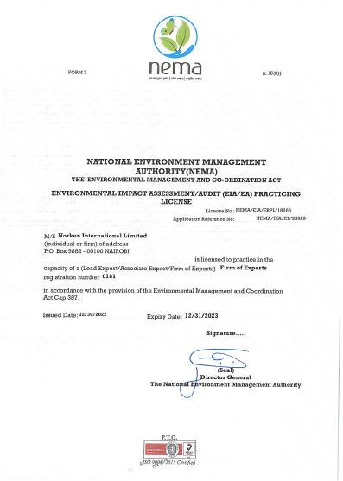

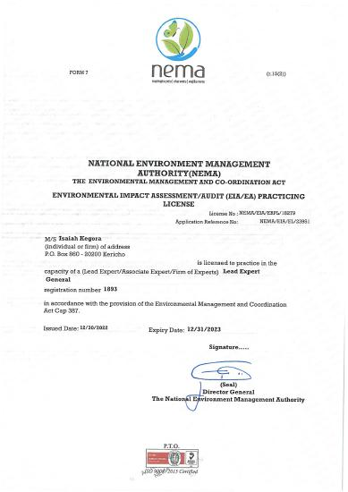

1. () As per the Energy Act of 2019, this role will now be performed by the Energy and Petroleum Regulatory Authority (EPRA).
2. A cost basis that will yield compensation sufficient to replace assets, plus necessary transaction costs associated with asset replacement).