 | MINISTRY OF ENERGY  Nairobi  Republic of Kenya

 | Investment Project Financing Kenya: Off-grid Solar Access Project for Underserved Counties (P160009)



Environmental & Social Impact Assessment

KENYA OFF-GRID SOLAR ACCESS PROJECT (KOSAP) FOR UNDERSERVED COUNTIES

Component 1: Mini grids for Community Facilities, Enterprises, and Households

Comprehensive Project Report (CPR) FOR THE PROPOSED YAQO OFF-GRID SOLAR PROJECT (GPS: 02° 13′ 00.78″ N, 039° 36′ 54.32″ E)

 | 2023
 |  |  |  | 

CERTIFICATION
This Comprehensive Project Report (CPR) has been prepared by ESIA /EA Firm of Experts, Centric Africa Ltd, Reg. No.7112 and Norken International Ltd, Reg. No.0181. The report has been written with diligence in accordance with the World Bank Operational Procedures OP, Environmental Safeguards Standards (ESS), the EMCA 1999 (Amended, 2015) and the Environmental and Social Impact Assessment and Audit Regulations, 2003 to bring out the true nature of the intended development. The report was prepared based on the information provided by various stakeholders and community members at Yaqo, Wajir County as well as from primary and secondary sources. It is therefore, issued without any prejudice.
We the undersigned, certify that the particulars in this CPR are correct and righteous to the best of our knowledge.
PROPONENT:
Mr. Rodney I. Sultani
Project Coordinator, KOSAP
Ministry of Energy and Petroleum,
P.O. Box 30582-00100,
Kawi House, Nairobi, Kenya.

Signature: ________________________ Date: ______________________

ESIA/EA FIRM OF EXPERTS:


Signature: ________________________ Date: ______________________
Isaiah Kegora
NEMA Expert (Reg. No. 1893).
For Norken (I) Ltd & Centric Africa Ltd

ACKNOWLEDGEMENT
The ESIA/Audit Experts are grateful to the project proponent for commissioning this Environment Social Impact Assessment. We would like to acknowledge with great appreciation Yaqo community members who were involved in public participation and consultation process, for their cooperation throughout the exercise. I further acknowledge the support, either direct or indirect, from the various parties who assisted the ESIA/EA experts’ team towards the successful completion of this ESIA report. They include environmental experts from Centric Africa Limited and Norken International Limited. Finally, I wish to recognize and appreciate the efforts and inputs of the reviewers at the Ministry of Energy, Kenya Power and Lighting as well as REREC and team of experts from World Bank Group for reviewing this document to the required standards. We wish to thank the community leaders that supported the organization of community members during public participation and stakeholder consultation.

LIST OF ACRONYMS
CBO | Community Based Organization
CDI | County Development Index
CGRC | County Grievance Redress Committees
CoC | Code of Conduct.
Covid 19, | Coronus Virus Diseases 2019
CPR | Comprehensive Project Report
CPS | Country Partnerships Strategy
CRA | Commission on Revenue Allocation
DOSHS | Directorate of Occupational Safety and Health Services
ECD | Early Childhood Development
EHS | Environmental and Health Standards
EMCA | Environment Management Coordination Act
EPRA | Energy and Petroleum Regulatory Authority
EPT: | Energy and Petroleum Tribunal
ESI | Electricity Supply Industry
ESIA | Environmental and Social Impact Assessment
ESM | Environmental and Social Management
ESMP | Environmental and Social Management Plan
FGD | Focus Group Discussions
GBV | Gender Based Violence
GDC | Geothermal Development Company
HIV/STD | Human Immune Deficiency syndromes/Sexually transmitted diseases
IA | Impact Assessment
KETRACO: | The Kenya Electricity Transmission Company
KII | Key Informant Interview
KOSAP | Kenya Off-Grid Solar Access Project
KPLC | Kenya Power and Lighting Company
LEP | Labor & Employment Plan
LGRC | Locational Grievance Redress Committees
MoE | Ministry of Energy
NEMA | National Environmental management Authority
NGOs | Non-Government organizations
NGRC | National Grievances Redress Committee
NLC | National Lands commission
OP | Operation procedures
OP/BP | Operational Procedures/bank policy
PLWDs | People living with disabilities
REREC | Rural Electrification and Renewable Energy Corporation
SA | Social Assessment
SEA/SH | Sexually Exploitation Activity/Sexual Harassment
TSC | Teachers Service Commission
VMGs | Vulnerable and Marginalized Groups
WB | World Bank’s

TABLE OF CONTENTS
CERTIFICATION ii
ACKNOWLEDGEMENT iii
LIST OF ACRONYMS iv
LIST OF TABLES xi
LIST OF PLATES xii
LIST OF FIGURES xiii
EXECUTIVE SUMMARY 14
1 INTRODUCTION 1-23
1.1 Context 1-23
1.2 Project Overview 1-24
1.3 Purpose and Scope of Work 1-24
1.4 ESIA Methodology 1-25
1.4.1 Screening and Scoping 1-25
1.4.2 ESIA TEAM 1-25
1.4.3 Data Collection 1-25
1.4.4 Environmental Impact Assessment 1-25
1.4.5 Project Description 1-26
1.4.6 Baseline Condition 1-26
1.4.7 Impact Assessment (IA) Prediction 1-26
1.4.8 Environmental and Social Management Plan (ESMP) 1-27
1.5 Limitations 1-28
1.6 Layout of the Report 1-29
2 PROJECT DESCRIPTION 2-30
2.1 Introduction 2-30
2.2 Project Location 2-30
2.2.1 Project site setting 2-32
2.3 Description of Project Facilities, Components and Activities 2-32
2.3.1 Project Components 2-32
2.3.2 Project Phases and Activities 2-33
2.4 Resource Requirement 2-34
2.4.1 Workforce Requirement 2-34
2.4.2 Water Requirement and Source 2-34
2.4.3 Raw Material Requirement 2-35
2.4.4 Power Requirement 2-35
2.4.5 Fire Safety and Security 2-35
2.5 Pollution Streams during Construction Phase 2-36
2.5.1 Solid Waste Generation 2-36
2.5.2 Air Emissions 2-36
2.5.3 Waste Generation 2-37
2.5.4 Noise Emissions 2-37
2.6 Analysis of Alternatives and Project Justification 2-37
2.6.1 Power Scenario in Yaqo 2-37
2.6.2 Present Power Supply Position 2-38
2.6.3 Alternate Location for Project Site 2-38
2.6.4 Alternate Method of Power Generation 2-39
2.6.5 Vision 2030 2-40
2.6.6 Zero or No Project Alternative 2-40
2.6.7 Analysis of Alternative Construction Materials and Technology 2-40
2.6.8 Conclusion 2-41
3 LAND REQUIREMENT AND PROCUREMENT PROCESS 3-42
3.1 Land Requirement and Procurement Process 3-42
3.1.1 Land Requirement 3-42
4 APPLICABLE AND REGULATORY FRAMEWORK 4-43
4.1 Introduction 4-43
4.2 Kenya Policy Provisions 4-43
4.2.1 Kenya Energy Policy, 2014 4-43
4.2.2 Policy paper on Environment and Development (Sessional Paper No. 6 of 1999) 4-45
4.2.3 National Policy on Water Resources Management and Development, 1999 4-45
4.2.4 Sessional Paper No. 10 of 2014 on the National Environmental Policy, 2014 4-45
4.2.5 Kenya Off-grid Solar Access Project (KOSAP) Environmental & Social Management Framework, 2017 4-46
4.2.6 Resettlement Policy Framework (RPF) 4-46
4.2.7 Vulnerable and marginalized Groups Framework (VMGF) for KOSAP 4-46
4.3 National Legal Framework 4-48
4.3.1 Administrative Framework 4-48
4.4 Relevant statutes 4-49
The Employment Act No 11 of 2007 4-54
The Work Injury Benefit Act, 2007 4-55
Air Quality Regulations (2014) 4-55
Land value amendment Act 2019 4-55
Land Registration Act, 2012 4-55
The Physical and Land Use Planning Act, 2019 4-55
The Employment Act No 11 of 2007 4-56
The Work Injury Benefit Act, 2007 4-56
Air Quality Regulations (2014) 4-56
4.5 National Administrative Requirements 4-57
4.6 International Safeguard Requirements 4-57
5 BASELINE SETTINGS- ENVIRONMENT, ECOLOGY AND SOCIAL 5-59
5.1 Study Area 5-59
5.2 Environment Baseline 5-59
5.2.1 Geology and Soil 5-59
5.2.2 Topography 5-59
5.2.3 Hydrogeology and Drainage 5-59
5.2.4 Ground Water Development 5-59
5.3 Ecological Conditions 5-59
5.4 Climatic Conditions 5-59
5.5 Socio-economic Environment 5-60
5.5.1 Community Profile 5-60
5.5.2 Socio-economic status of Study Area 5-60
6 STAKEHOLDER ENGAGEMENT 6-62
6.1 Stakeholder Consultation and Disclosure Requirement for the Project 6-62
6.2 Stakeholder Characterization and Identification 6-62
6.2.1 Stakeholder Mapping 6-62
6.3 Stakeholder Analysis 6-63
6.4 KEY FEEDBACK RECEIVED DURING STAKEHOLDER CONSULTATION PROCESS 6-63
6.4.1 Area Chief’s Remarks 6-64
6.4.2 Consultant’s Remarks 6-64
6.4.3 Positive Comments about the Project from the Participants 6-64
6.4.4 The identified negative impacts of the project 6-64
6.4.5 Consultant’s Response 6-65
6.4.6 Consent 6-65
6.4.7 Community Presentation 6-65
6.4.8 Focused Group Discussions analysis 6-66
7 GRIEVANCE REDRESS MECHANISM 7-74
7.1 Introduction 7-74
7.2 Grievance Mechanism 7-74
7.3 National Grievances Redress Committee (NGRC) 7-74
7.4 County Grievance Redress Committees (CGRC) 7-75
7.5 Locational Grievance Redress Committee (LGRC) 7-75
8 IMPACT ASSESSMENT AND ENHANCEMENT MEASURES 8-1
8.1 Identification of Impacts 8-1
8.2 Impact Assessment Methodology 8-1
8.3 Defining Impact 8-1
8.4 Assessment of Significance 8-1
8.5 Magnitude of Impact 8-3
8.6 Sensitivity of Resources and Receptors 8-4
8.7 Likelihood 8-4
8.8 Definition of Enhancement Measures 8-4
8.9 Positive Impacts During Construction Phase 8-5
8.9.1 Creation of Employment Opportunities 8-5
8.9.2 Improving local economy 8-6
8.10 Positive Impacts during Operation Phase 8-6
8.10.1 Quality, Reliable Power Supply 8-6
8.10.2 Employment Creation 8-7
8.10.3 Reduction of Pollution Associated with Thermal Power Generation, Kerosene and Wood Fuel Usage: 8-7
8.10.4 Improvement of Local and National Economy 8-7
8.10.5 Education 8-8
8.10.6 Health Benefits of the Project 8-8
8.10.7 Improved Standard of Living 8-8
8.10.8 Security 8-9
8.10.9 Communications 8-9
8.11 Positive Impacts during Decommissioning Phase 8-9
8.11.1 Employment Opportunities 8-9
8.11.2 Site Rehabilitation 8-9
8.12 Negative Impacts during Pre-construction Phase 8-9
8.12.1 Land Take 8-9
8.13 Negative Impacts During Construction Phase 8-10
8.13.1 Vegetation Clearance 8-10
8.13.2 Soil Erosion Impact 8-10
8.13.3 Contamination of Soil from Fossil Fuels 8-11
8.13.4 Dust Emissions 8-11
8.13.5 Vehicle Exhaust Emissions 8-12
8.13.6 Pollution from Solid Waste Generation 8-12
8.13.7 Impacts on Water Resources and Water Quality 8-13
8.13.8 Noise and vibration 8-14
8.13.9 Impacts from Hazardous Materials 8-14
8.13.10 Accidental Oil Spills or Leaks 8-15
8.13.11 Fire Hazards 8-15
8.13.12 Impacts of construction material sourcing (e.g., quarrying) 8-16
8.13.13 Increased Water Demand 8-16
8.13.14 Energy Consumption 8-17
8.13.15 Occupational Health and Safety Impacts 8-17
8.13.16 Community Safety -Access to Site by General Public 8-18
8.13.17 Spread of HIV/AIDS and STIs 8-18
8.13.18 Increase in competition for scarce resources and strain on public utilities 8-19
8.13.19 Child Labor 8-19
8.13.20 Gender Based Violence- SEA and SH 8-20
8.13.21 Public Health Impacts 8-21
8.13.22 Forced Labor 8-22
8.13.23 Risks related to Inadequate Stakeholder Engagement 8-22
8.14 Negative impacts during Operation phase of the project 8-23
8.14.1 Solid Waste Generation 8-23
8.14.2 Liquid Waste/Oils Generation 8-23
8.14.3 Increased oil Consumption 8-24
8.14.4 Increased Storm Water Flow 8-24
8.14.5 Fire Outbreaks 8-24
8.14.6 Visual Impacts 8-25
8.14.7 Water demand 8-25
8.14.8 Sanitary waste 8-25
8.14.9 Flooding 8-26
8.14.10 Workers Occupation Health and Safety 8-26
8.14.11 Hazardous waste 8-26
8.14.12 Noise and Vibration 8-27
8.14.13 Electric and magnetic fields (EMFs) 8-27
8.14.14 Shocks and electrocutions to the beneficiaries 8-27
8.14.15 Community safety -Access to the facility by general public 8-27
8.14.16 Risks related to poor or inadequate stakeholder engagement (Conflict) 8-28
8.14.17 Gender Based Violence- SEA/ SH 8-28
8.14.18 Public Health Impacts –HIV/AIDs 8-29
8.14.19 Public health Impacts -Covid 19 disease 8-29
8.14.20 Dust emissions 8-30
8.14.21 Vehicle exhaust emissions 8-30
8.15 Negative impacts during decommissioning phase 8-30
8.15.1 Noise and Vibration 8-30
8.15.2 Solid Waste Generation 8-31
8.15.3 Dust Emissions 8-31
8.15.4 HIV/AIDs awareness and prevention 8-32
8.16 Social Protection 8-32
8.17 Social Inclusion 8-32
8.18 ENVIRONMENTAL AND SOCIAL MANAGEMENT AND MONITORING PLAN (ESMMP) 8-33
8.19 Environmental and Social Management and Monitoring Plan 8-33
9 IMPACT SUMMARY AND CONCLUSION 9-1
9.1 Introduction 9-1
9.2 Impacts Requiring Detailed Assessment 9-1
9.3 Conclusion 9-1
10 APPENDICES 10-2
10.1 Appendix 1: Minutes for the meeting leading to land identification and GRC Constitution 10-2
10.2 Appendix 2: Attendance List Land Identification: Yaqo Baraza 10-17
10.3 Appendix 3: Community Profile - Yaqo 10-36
10.4 Appendix 4: ESIA Public Participation - Minutes for Meeting Held at Yaqo 10-41
10.5 Appendix 5: ESIA Attendance List: Yaqo Baraza 10-46
10.6 Appendix 6: Abbreviated Resettlement Action Plan (ARAP) 10-53
10.7 Appendix 8: Firm and Lead Expert Practicing Licence 10-65

LIST OF TABLES

Table 1. Summary of WB policies 15
Table 2. Summary of Construction Phase Impacts 18
Table 3. Summary of Operations Phase Impacts 18
Table 4. Summary of Decommissioning Impacts 18
Table 5: Structure of the ESIA Report 1-26
Table 6: Component of the proposed Solar Mini-grid 2-27
Table 7. Kenya power stakeholders and their roles 4-40
Table 8. Administrative stakeholders and their roles 4-44
Table 9. National Policy Framework 4-46
Table 10: Relevant Enforcement agencies 4-52
Table 11: World Bank safeguards 4-52
Table 12: Demographic profile of Yaqo 5-54
Table 13: Identified Stakeholders 6-56
Table 14: Stakeholder Significance and Engagement Requirement 6-57
Table 15: The consultative meeting had a wide representation 6-60
Table 16: Impact characteristic terminology 8-1
Table 17: Impact type definitions 8-2
Table 18: Impact qualitative scale 8-2
Table 19: Impact Significance 8-3
Table 20: Interactions identified that are likely to result in significant impacts 8-4
Table 21: Sensitivity assessment criteria for land use 8-5
Table 22: For Impact Magnitude for assessment of impact to land use 8-5
Table 23: Sensitivity assessment criteria for topography 8-6
Table 24: Topography and drainage sensitivity criteria 8-6
Table 25: Sensitivity assessment criteria for soil Quality 8-8
Table 26: magnitude of soil criteria 8-8
Table 27: Sensitivity Assessment Criteria for Water Resources (Surface and groundwater) 8-9
Table 28: Criteria for Impact Magnitude for Assessment of Impact to Surface and Groundwater Resources 8-9
Table 29: Sensitivity criteria for air quality 8-10
Table 30: Criteria for Impact Magnitude for Assessment of Impact to Air 8-10
Table 31: Sensitivity criteria for ambient noise 8-11
Table 32: Criteria for impact magnitude for assessment of impact to ambient noise 8-11
Table 33: Impact Magnitude for Local Communities 8-11
Table 34: Receptor Sensitivity for Local Communities 8-12
Table 35: Impact significance matrix 8-12
Table 36: Identified interactions that are likely to result in significant impacts 8-12
Table 37: Environmental and social management plan ESMP 9-1

LIST OF PLATES
Plate 1. Women feching water 6-58
Plate 2. FDGs for women 6-60
Plate 3. FDGs for men 6-62
Plate 4. FDGs for Youth 6-63
Plate 5. Consultants Addressing the Barazas/Community Members. 6-65

LIST OF FIGURES
Figure 1: Proposed site 14
Figure 2. Map showing the proposed site 1-21
Figure 3: Summary of Environmental and Social Impact Assessment Methodology 1-25
Figure 4: Project location 2-28
Figure 5: Map showing the KOSAP Counties Lot 3 2-29
Figure 8: School Enrolment and School Completion rate 6-67
Figure 9. KOSAP Grievance Redress Mechanism 7-70

EXECUTIVE SUMMARY
E1- Introduction and Project Brief
The Ministry of Energy (MOE) hereinafter refer to as proponent is implementing the Kenya Off-Grid Solar Access Project (KOSAP) in 14 underserved counties in Kenya. The aim of the project is to provide clean and modern energy services through off-grid solar solutions. The Proponent is coordinating the implementation of the project through the implementing agencies; Kenya Power (KP) and the Rural Electrification and Renewable Emergency Corporation (REREC). The project is funded by the World Bank Group with $150 million and a $5 million grant from the Carbon Initiative for Development. The goal of the project is to bring electricity to around 250,000 households, 476 community facilities, and 380 boreholes in the target counties, benefiting low-income groups. It also includes the sale and installation of 150,000 efficient cook stoves. The project focuses on marginalized areas based on the County Development Index (CDI) and aims to address infrastructure deficits, lack of access to roads, electricity, water, and social services in these underserved counties. To ensure sustainability, the project relies on public funding, local community participation, and the institutional capacity of KP, REREC, and the MOE.
The KOSAP consists of four main components. The first component focuses on the implementation of mini-grids to provide electricity to community facilities, enterprises, and households in areas where mini-grids are the most cost-effective option. The second component aims to electrify households through standalone solar systems in areas without load clusters where standalone systems are the best technical and financial solution. The third component supports the electrification of public institutions and community facilities using standalone solar systems. It also includes the installation of solar PV-powered water pumps for consumptive purposes. Lastly, the fourth component, provides funding for implementation support, technical assistance, and capacity building activities to ensure the sustainability and impact assessment of the interventions carried out under the other components of KOSAP.
In Wajir County, one of the target counties, the Proponent is proposing to develop a number of mini grid facilities including Yaqo Mini Grid discussed in this report. In order to adhere to both national and donor requirements, the Proponent engaged the services to the consortium of Norken International Limited and Centric Africa Limited to undertake the ESIA. The ESIA has been conducted following the requirements outlined in the Environmental Management and Coordination Act (EMCA) 1999 and its amendments, as well as international environmental and social policies such as the World Bank's OP 4.01 on environmental assessment.
E- 2 Project Categorisation and Justification
In the World Bank context, there have been several projects supported by the organization that aim to provide electricity to communities located far from the national grid. These projects utilize off-grid approaches, meaning they are independent of a national or regional grid. The experience gained from these projects provides valuable guidance for designing sustainable off-grid electrification initiatives, particularly those targeting dispersed and economically disadvantaged communities. The Yaqo proposed site aligns with this category of projects that the World Bank has been involved in.
In the Kenyan context, the Environmental Management and Coordination Act (EMCA) of 1999, as amended in April 2019 through Legal Notice No. 31, classifies solar power farms and plants as medium risk projects. This categorization provides a framework for assessing and managing the potential environmental and social impacts associated with such projects. By categorizing the Yaqo site as a solar power facility, it falls within the medium risk project category as per the Kenyan legislative framework.

E- 3 Approach and Methodology
The Environmental and Social Impact Assessment (ESIA) for the proposed project followed a structured process, beginning with kick-off meetings and online discussions involving the Proponent, Implementing agencies, and the World Bank Environmental and Social Safeguard Team. These consultations were instrumental in establishing the project's scope, deliverables, timeline, and methodology. Subsequently, screening and scoping exercises were conducted to evaluate potential social and environmental risks. A thorough desk-based review was also undertaken to assess existing project documentation, legal requirements, and relevant plans.
The study employed a comprehensive approach to gather primary and secondary data for the project. Both qualitative and quantitative methods were utilized, with secondary data obtained through literature reviews. Primary data collection involved various techniques, including physical observations, photography, interviews, and stakeholder consultations. This comprehensive approach enabled a comprehensive examination of the project's environmental and social aspects, ensuring a holistic understanding of its potential impacts.
The study further involved the identification and assessment of potential impacts throughout the project's life cycle. Key areas of evaluation included land use, water resources, biodiversity, air quality, noise levels, community health and safety, and socio-economic conditions. To mitigate adverse effects, the study developed environmental and social management and monitoring plan, aiming to address both positive and negative impacts that may arise from the project. These measures aimed to ensure the project's sustainability and enhance its overall environmental and social performance.
E-4 Proposed Project
The proposed project site is in Yaqo village, Yaqo sub-Location, Yaqo Location, Eldas Sub-county, Wajir County at GPS coordinates 02° 13′ 00.78″ N, 039° 36′ 54.32″ E. The proposed solar mini grid will be located on an approximately 1.260 Ha piece of land. The Yaqo Centre is located in the Northeastern Province of Kenya.
The project is expected to serve 700 consumers of which 12 are Shops/Commercial Premises. The Length of main street 2 km and the Width of the town 1.7km and a distance from the grid supply is of 34km. The facilities include Yaqo a primary school, Police post, mosque and a proposed dispensary from County Government the town also has a dam with diesel generators as per the CREO report done on 8th July.

The project will utilize solar photovoltaic panels, a Battery Energy Storage System, and a Diesel Generator to generate electricity. A Low Voltage Power Distribution Network will be established to distribute the power to customers. The estimated cost of the project is around USD. 932,911 although this amount may change as more detailed plans are developed.
The project consists of two main components: Hybrid Mini-Grids and power line reticulation lines. The Hybrid Mini-Grids will combine solar panels and diesel power generation. These energy sources will be integrated through a centralized photovoltaic plant connected to a 3-phase AC busbar line. The configuration is designed to prioritize direct supply from the solar generator during daylight hours, reducing reliance on battery storage. The battery storage will primarily be used when solar generation is low or demand is high. The construction of power line reticulation lines will ensure the efficient distribution of electricity to residential, commercial, and other consumers, ensuring a reliable and efficient power supply.
To develop the Mini Grid, approximately 1.26 hectares of land will be compulsorily acquired by the National Land Commission. This land is part of the community's designated public purposes area. The Proponent engaged with the community during the land acquisition process, and there were no objections to transferring 1.26 hectares of land to Kenya Power and Lighting Company (KPLC) for the management of the solar mini-grid. In accordance with the World Bank's Operation Procedure 4.12 on Involuntary Resettlement, an abbreviated Resettlement Action Plan (A-RAP) was prepared, outlining the principles and procedures for land acquisition and compensation. This plan is annexed to the project report.
The solar mini grid will contain Solar panels, batteries, invertors, perimeter fence and length of transmission line to cover a radius of approximately 3km.

E-5 Analysis of Alternatives
Solar energy is identified as a non-polluting and site-specific option, and the proposed site for YaqoMG is chosen as the most suitable location for the mini-grid based on factors such as sunlight availability and the community's lack of grid connectivity. The use of wind power, thermal power, fossil fuels, and power import from neighbouring countries are considered as alternative methods of power generation but are found to have limitations or environmental concerns. Solar energy is favoured due to its low production costs, versatility, clean nature, and economic savings. The "No Project" alternative is deemed unfavourable as it would maintain the current lack of electricity access and hinder socio-economic development. The project will be constructed using modern materials and technology, with a focus on public health, safety, security, and environmental requirements. The technology will involve a Battery Energy Storage System.
E-6 Baseline Information

The project site in Yaqo village in Yaqo sub-location, Yaqo Location, Eldas Sub- County, Wajir County. The proposed solar mini grid will be located on an approximately 1.26Ha piece of land. The Yaqo Centre is located in the Northeastern Province of Kenya. The project site is approximately 36km away from Eldas town. The site soil is primarily sandy within the area. The project area in Yaqo Village,Wajir County, exhibits a semi-arid climate with irregular rainfall patterns and scarce natural resources. Water scarcity poses a significant challenge, affecting both the local population and livestock. The vegetation predominantly comprises drought-tolerant shrubs, thorny bushes, and arid-adapted grasses. Overgrazing and deforestation have resulted in land degradation and soil erosion, further exacerbating the environmental issues. The region is also prone to natural hazards like flash floods and sandstorms. The area encompasses scarce tree species.

The area experiences annual average relative humidity of 61.8 per cent. The county receives an average of 240 mm precipitation annually. The higher areas of Bute and Gurar receive higher rainfall of between 500mm and 700mm. The average temperature is 29°C. There are two rainy seasons’ i.e., short, and long rains. The short rains are expected between October to December and the long rains from March to May each year. Much of the County’s livestock population are indigenous sheep, goats, cattle and camel.

The area’s ecological conditions are influenced by the soil type, altitude, vegetation, rainfall pattern and human activities. The surrounding rangelands is home to a variety of wildlife including Gazelles, Warthogs and Giraffes. A major threat to the vegetation cover is the destruction caused by human activities including grazing, charcoal burning, extraction of wood fuel and cutting down of trees without replacement resulting in adverse ecological effects.
The topography of the project area is diverse, featuring vast plains, scattered low-lying hills, and occasional rocky outcrops. It is part of a semi-arid landscape with undulating terrain. The flat plains offer space for livestock grazing.
The area is characterized by high levels of poverty, unemployment, and limited access to essential services such as education and healthcare. Livestock herding and small-scale enterprises are the primary economic activities, but opportunities for economic growth are constrained. Gender disparities persist, with women having limited decision-making power and economic empowerment. Infrastructure development, including roads, electricity, and water supply, is insufficient to meet the needs of the community.
County: Wajir County
Location: Yaqo
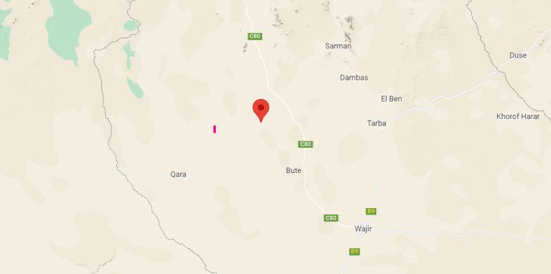
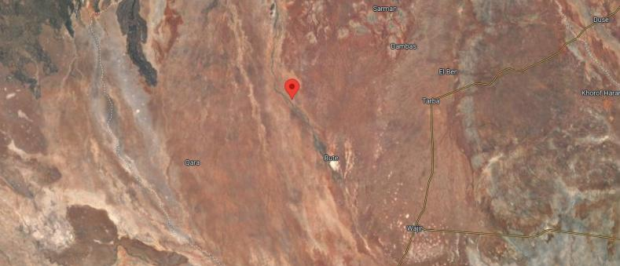
Figure 1: Project Location

E-7 Legislative regulatory Framework
The evaluation, planning, and implementation of the proposed project is guided by the World Bank's Environmental and Social Framework, the national legislative framework, and the project's safeguard instruments. These measures aim to ensure environmental sustainability, protect the rights and needs of indigenous peoples and marginalized groups, and minimize adverse impacts through effective management and Enhancement Measures .
The Government of Kenya established the Environmental Management and Coordination Act (EMCA) in 1999, providing a legal framework for environmental management. EMCA takes precedence over other sectoral laws related to the environment. In 2013, the government formulated a national Environmental Policy with the goal of promoting sustainable management and use of the environment.
Collaboration and consultation among government agencies and stakeholders are essential for coordinating environmental management effectively. Key institutions in Kenya responsible for environmental issues include the National Environment Management Authority (NEMA), County Environment Committees, National Environmental Complaints Committee, National Environment Action Plan Committee, Standards and Enforcement Review Committee, National Environment Tribunal, and National Environment Council (NEC).
The project also adheres to the World Bank Safeguard Policies, which aim to improve decision-making processes, promote sustainable project options, and involve affected people in consultations. The applicable operational policies for this project include Environment Assessment, Natural Habitats, Indigenous Peoples, and Involuntary Resettlement. The Environmental and Social Impact Assessment (ESIA) considers these policies and addresses potential environmental and social concerns.
Additionally, the ESIA references other Safeguard Instruments prepared under the Kenya Off-Grid Solar Access Project (KOSAP), including the Environmental and Social Management Framework (ESMF), Resettlement Policy Framework (RPF), and Vulnerable and Marginalized Groups Framework (VMGF). These instruments provide procedures and guidelines for assessing and managing environmental and social aspects specific to the proposed subprojects under KOSAP.
E-8 Stakeholder Engagement
It is important to highlight that two forms of stakeholder engagement were carried out for the project. The first form as noted earlier, focused on the acquisition of land for the project and involved the Proponent and the implementing agency (KP). The second form of engagement was conducted specifically for the Environmental and Social Impact Assessment (ESIA) study.
For the ESIA study, various methods were employed to engage stakeholders, taking into consideration their different categories. Face-to-face discussions were held with government officials and key stakeholders, while separate focused group discussions were conducted with men, women, and youth. Additionally, a public baraza or meeting was organized to allow community members to participate.
During the ESIA stakeholder engagement public meeting, which took place on October 23, 2021, a total of 129 stakeholders attended. The meeting provided an opportunity to discuss project details, including the preliminary design, positive and negative impacts, and Enhancement Measures . Stakeholders were encouraged to share their views and provide feedback on the project.
Some of the concerns raised by stakeholders included the type of fence to be constructed around the project site, the treatment of the community regarding the land acquired for the mini-grid construction, and the connection of community boreholes to electricity. The study team addressed these concerns by assuring stakeholders that a chain-link fence supported by concrete poles would be constructed. They also stated that additional projects would be undertaken for the community as compensation, based on their priorities. Furthermore, public facilities such as schools, health centers, and boreholes would be connected to the electricity supply.
E-10 – Impacts and Enhancement Measures
The Environmental and Social Impact Assessment (ESIA) for the proposed Solar Mini-grid project has identified both positive and negative impacts across its different phases: pre-construction, construction, operation, and decommissioning. In the construction phase, positive impacts include local employment opportunities, boosting local businesses, and sourcing materials locally. During the operation phase, positive impacts encompass reliable power supply, economic improvement, education, health benefits, improved living standards, and enhanced security and communication. Similarly, the decommissioning phase offers positive impacts such as local employment and sourcing.
On the negative side, the pre-construction phase involves minor impacts like land acquisition, while the construction phase encompasses various minor to moderate impacts such as vegetation clearance, soil erosion, dust emissions, and occupational health and safety concerns. Challenges related to stakeholder engagement, labor influx, child labor, and exclusion of vulnerable individuals are also anticipated. In the operation phase, negative impacts include waste generation, increased oil consumption, fire outbreaks, occupational health and safety concerns, and inadequate stakeholder engagement. Issues of exclusion, inadequate grievance management, and public health concerns may arise as well.
During the decommissioning phase, negative impacts primarily relate to solid waste generation, noise and vibration, and challenges in stakeholder engagement, labor influx, child labor, gender-based violence, and exclusion of vulnerable individuals and households.
Tables 0-2 to 0-5 below present summaries of anticipated impacts and their corresponding levels of significance, both pre- and post-mitigation.
Table 0-2: Summary of Pre-construction Impacts
Impact | Significance Of Impact (Pre-Mitigation) | Residual Impacts (Post-Mitigation)
Land acquisition | Minor | Negligible
Way leaves | Minor | Negligible
Stakeholder identification and consultations | Major | Minor

Table 0-3: Summary of Construction Phase Impacts
Impact | Significance Of Impact (pre-mitigation) | Residual Impacts (Post-Mitigation)
Impacts on Local Economy and Employment | Positive | Positive
Change in land use | Moderate | Negligible
Topography | Minor | Negligible
Soil environment | Minor | Negligible
Air Quality | Moderate | Negligible
Ambient noise | Minor | Negligible
Visual intrusion and change in landscape | Minor | Negligible
Waste generation and soil contamination | Minor | Negligible
Impact on water environment | Minor | Negligible
Impacts from hazardous materials | Minor | Negligible
Fire hazards | Moderate | Minor
Impacts of construction material sourcing | Moderate | Minor
Energy consumption | Negligible | Negligible
Occupational safety and health | Moderate | Minor
Community safety and health | Moderate | Minor
Labor influx | Minor | Negligible
Child labor | Minor | Negligible
Cultural heritage | Minor | Negligible
Gender based violence, SEA and SH | Minor | Negligible
Exclusion of VMGs, Vulnerable individuals and households | Major | Minor
Risk of communicable diseases | Minor | Negligible
Increased water demand | Negligible | Negligible
Forced labor | Minor | Negligible
Table 0-4: Summary of Operation Phase Impacts
Impact | Significance Of Impact (Pre-Mitigation) | Residual Impacts (Post-Mitigation)
Impact On Economy and Employment | Positive | Positive
Quality, reliable power supply | Positive | Positive
Reduction of pollution associated with thermal power generation, kerosine and wood fuel usage | Positive | Positive
Education | Positive | Positive
Health benefits | Positive | Positive
Improved standard of living | Positive | Positive
Security | Positive | Positive
Communication | Positive | Positive
Soil environment | Minor | Negligible
Waste generation and management | Minor | Negligible
Water environment | Negligible | Negligible
Landscape and visual impacts | Minor | Negligible
Increased oil consumption | Minor | Negligible
Increased storm water flow | Minor | Negligible
Fire outbreaks | Moderate | Minor
Water demand | Negligible | Negligible
Sanitary waste | Negligible | Negligible
Flooding | Negligible | Negligible
Noise and Vibration | Negligible | Negligible
Electric and magnetic fields (EMFs) | Negligible | Negligible
Dust Emission | Negligible | Negligible
Vehicle Exhaust emission | Minor | Negligible
Collision and electrical hazards from distribution infrastructure | Minor | Negligible
Occupational safety and health | Moderate | Minor
Community safety and health | Moderate | Minor
Gender based violence, SEA and SH | Minor | Negligible
Exclusion of VMGs, Vulnerable individuals and households | Major | Minor
Risk of communicable diseases | Minor | Negligible
Shocks and electrocution to the beneficiaries | Moderate | Minor
Risks related to poor and inadequate stakeholder engagement (conflict) | Minor | Negligible
Table 0-5: Summary of Decommissioning Impacts
Impact | Significance Of Impact (Pre-Mitigation) | Residual Impacts (Post-Mitigation)
Employment opportunities | Positive | Positive
Site rehabilitation | Positive | Positive
Soil environment | Minor | Negligible
Air quality | Moderate | Negligible
Ambient Noise | Minor | Negligible
Waste generation and soil contamination | Minor | Negligible
Occupational safety and health | Moderate | Minor
Gender based violence, SEA and SH | Minor | Negligible
Exclusion of VMGs, Vulnerable individuals and households | Major | Minor
Risk of communicable diseases | Minor | Negligible

E-11 Environmental and Social Management and Monitoring Plan
A comprehensive set of Enhancement Measures in the form of an Environmental and Social Management and Monitoring Plan (ESMMP) have been prepared for the project. The ESMMP serves as a comprehensive framework for the integrated management of all environmental and social impacts throughout the project's lifecycle. It has been prepared to ensure that the social and environmental impacts and risks identified during the Environmental and Social Impact Assessment (ESIA) process are appropriately managed during the construction, operations, and decommissioning phases of the project. It specifies the mitigation and management measures that the project proponent and contractor are committed to implementing and outlines how organizational capacity and resources will be mobilized to achieve these measures. The ESMMP also ensures compliance with the relevant laws, regulations within Kenya, as well as the environmental and social sustainability requirements of the World Bank's Operational Policies (OPs).
These measures emphasize a proactive approach, prioritizing prevention rather than reaction. They encompass various aspects such as proper waste handling and disposal to prevent pollution, engaging stakeholders to address grievances, providing personal protective equipment (PPE) for workers, ensuring adequate supervision, and emphasizing good workmanship from the contractor. Specific plans are also outlined to address specific issues that may arise. The ESMMP also highlights environmental performance indicators that should be regularly monitored. Monitoring serves as a means to detect and draw attention to any changes or problems in environmental quality. It involves continuous or periodic reviews of the ESMMP implementation progress, allowing for adjustments and improvements as necessary.
While accommodating the recommended Enhancement Measures to the extent practical and economically viable, the project proponent and contractor should ensure that the measures do not compromise the economic viability of the project or have long-lasting adverse impacts on the environment.
For the Enhancement Measures to be successful, it is imperative that the Kenya Power and Lighting Company (KPLC) allocates sufficient resources for the implementation of the ESMMP. Adequate resources will enable the proper execution of the proposed measures and ensure their effectiveness in minimizing the identified negative impacts.
Following the project's commissioning, it is mandatory to conduct statutory Environmental and Safety Audits in accordance with national legal requirements. These audits serve to evaluate the environmental performance of the site operations and assess their compliance with the recommended Enhancement Measures .
E- 12 Conclusion
Based on the assessment findings, the consultant concludes that there are no substantial reasons to hinder the proposed project from progressing to the next stage of planning and development. However, this progression is conditional upon the implementation of the recommended mitigations and the monitoring of potential environmental and socio-economic impacts as outlined in the ESMMP.
Note: The Solar Mini-grid will be installed operated and maintained by the contractor for the first seven (7) years and then handed over to KPLC engineers and operators. So, for the seven years KPLC will be monitoring the operations of the contractor.
It is in the opinion of the Environmental expert that the anticipated negative impacts can readily and effectively be mitigated and on the whole the proposed project does not pose any significant threat to the Environment and may be licensed to proceed

INTRODUCTION
The Ministry of Energy (MOE) Kenya is coordinating the implementation of the Kenya Off-Grid Solar Access Project (KOSAP) to provide access to clean and modern energy services through off-grid solar to 14 underserved counties. Wajir county was identified as one of the underserved Counties and others include Mandera, Narok, Garissa, Tana River, Samburu, Isiolo, Marsabit, West Pokot, Turkana, Taita Taveta, Kwale, Kilifi and Lamu.
Driven by the imperative to provide equal opportunities across the entire Kenyan territory as key to achieving Kenya’s Vision 2030, and the National target of achieving universal access to electricity by 2020, the GoK now seeks to close the access gap by providing electricity services to remote, low density, and traditionally underserved areas of the country. The World Bank’s (WB)Country Partnerships Strategy (CPS) for Kenya (2014-18) also recognizes the access to basic electricity, as a key developmental issue. The Strategy sets at improving core infrastructure as one of the Projects the WB will be engaged in. It also emphasizes the importance of mobilizing concessional funding to expand the sector including electricity generation, transmission, and distribution to meet the Government’s economic growth targets.
K-OSAP directly promotes the achievement of these objectives by supporting the use of solar and clean cooking Solutions to drive electrification of households (including host communities), enterprises, community facilities, and water pumps in Wajir county as one of the counties in Kenya that have been defined as “marginalized areas” based on the County Development Index (CDI) by the Commission on Revenue Allocation (CRA). According to the CRA as the communities in the marginalized areas have been excluded from social and economic life of Kenya for different reasons” (CRA, 2013).
Wajir County and other identified underserved counties, collectively represent 72% of the Country’s total land area and 20% of the Country’s population, including historically nomadic societies that even today continue to rely on pastoralism. Their population is highly dispersed, at a density four times lower than the national average. They present profound infrastructure deficits, including lack of access to roads, electricity, water, and social services. There is also significant insecurity in certain areas, giving rise to substantial numbers of displaced persons and livelihood adaptations that further undermine economic prosperity.

Context
This ESIA report has been prepared based on Site visit baseline survey, desktop survey, documentation review, consultation with stakeholders and in accordance Environmental Management and Coordination (Amendment) Act, 2015 and World Bank’s Environmental and Social Safeguards. The study has also assessed the requirement of the project with respect to the local and national regulations relevant to the project.
Norken International Limited in Joint Venture with Centric Africa Limited were appointed by Ministry of Energy to undertake consultancy services for the Environmental and Social Impact Assessment (ESIA), Social Assessment (SA) and Vulnerable and Marginalized Groups Plan (VMGP) as per the standard TOR and NEMA and WB ESS. As reported, land acquisition has not resulted in any economic or physical displacement and no resettlement is envisaged for the proposed project.
Due to the remoteness and sometimes dispersed nature of the target populations and considering the lifestyles and socio-economic status of those residing in underserved Counties, the Project is designed to address low affordability of the potential users, and sustainability of service provision. Therefore, sustainability of the proposed approach to energy access expansion beyond the Nationally owned power network is predicated on two primary factors - public funding, local community participation: and institutional capacity of Kenya Power and, Rural Electrification and Renewable Energy Corporation (REREC) and the Ministry of Energy (MOE) as the implementing agencies.
The project components are:
- Component 1- US$40M: Mini-grids for Community Facilities, Enterprises, and Households -This component will support electrification of areas where electricity supply through mini-grids represents the least cost option from a country perspective.
- Component 2- US$48M: Stand-alone Solar Systems and Clean Cooking Solutions for Households; This component will support electrification of households using standalone solar systems in areas where load clusters do not exist, and the best technical and financial solution is standalone solar systems.
- Component 3- US$40M: Stand-alone Solar Systems and Solar Water Pumps for Community Facilities; This component will support electrification of public institutions and community facilities using standalone systems. This component will also support the installation of solar PV-powered water pumps for consumptive purposes.
- Component 4- US$22M: Implementation Support and Capacity Building; This component will finance various technical assistance and capacity building activities to ensure the sustainability and measure the impact of the interventions devised and implemented within the other components of K-OSAP.
The MOE provides overall coordination of the project as well as lead in the implementation of components 2 and 4. Components 1 and 3(a&b) will be implemented by the Kenya Power and Lighting Company (KPLC) and the Rural Electrification and Renewable Energy Corporation (REREC), respectively.

Project Overview
The proposed project site is in Yaqo village, Yaqo sub-Location, Yaqo Location, Eldas Sub-county, Wajir County at GPS coordinates 02° 13′ 00.78″ N, 039° 36′ 54.32″ E. The proposed solar mini grid will be located on an approximately 1.260 Ha piece of land.
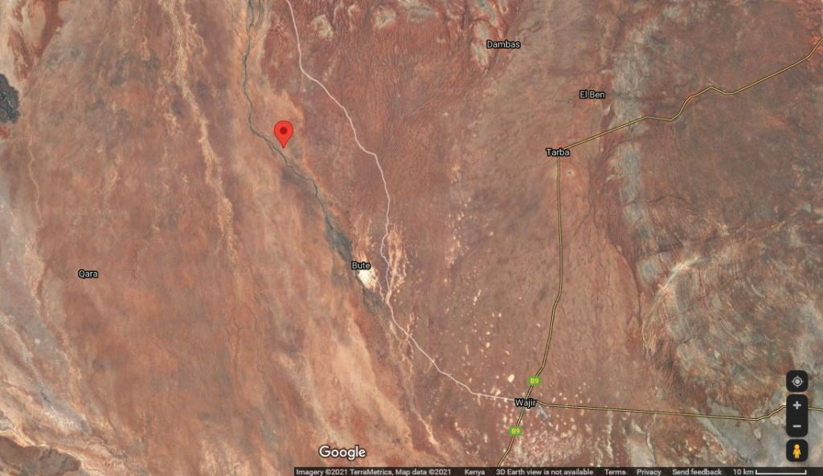
Proposed Site for Yaqo Solar Mini Grid Site
02° 13′ 00.78″ N, 039° 36′ 54.32″ E

Figure 2. Map showing the proposed site
The solar mini grid will contain Solar panels, batteries, invertors, perimeter fence and length of transmission line.

Purpose and Scope of Work
This report discusses the environmental and social baseline within which the proposed solar power project is commissioned and assesses the potential adverse and beneficial impacts that the project could have, along with suitable Enhancement Measures and an Environmental and Social Management Plan (ESMP) for the project. The report also evaluates the environmental and social risks associated with the project and implements Enhancement Measures to avoid adverse impacts for the remainder of the project’s lifecycle. The project must comply with international standards (World Bank Environmental and Social Safeguards) along with applicable national, state, and local regulations.

ESIA Methodology

Screening and Scoping

Screening Methodology
Evaluation of ESIA procedure has been undertaken as a fundamental procedure to implementation of the solar power mini-grid development project which is systematically mainstreamed into the project’s Cycle. World Banks Social safeguards underpin and demonstrate this commitment. The main aim of this is to enhance positive social opportunities and benefits as well as ensure that adverse social and environmental risks and impacts are avoided, minimized, and mitigated.

ESIA TEAM
The ESIA Team comprised of the following Team members;
NAME | ORGANISATION
Micheal Oyier | Ministry of Energy
Daniel Chumo | Centric Africa Limited
Allan Owino | Centric Africa Limited
Umulkheir Abdi | Norken International Limited

Data Collection
The approach and methodology applied during the study enabled collection of both primary and secondary data. Qualitative and quantitative methods of data collection were employed. Secondary data was obtained through literature reviews while primary data was obtained through physical observations, photography, interviews and stakeholders’ consultation. During the ESIA process consultations were also undertaken to obtain the views of immediate community, interested groups and affected groups within the site’s immediate area of influence. The consultation was done with the immediate neighbourhood of the proposed site.

Environmental Impact Assessment
The steps below were followed in the preparation of this ESIA Report.

Kick-off Meeting
Norken and Centric team had a brief kick-off meeting with the Ministry of Energy on 12th July 2021 followed by subsequent online meetings and discussion on various aspects of the project up to 5th August 2021. The meetings addressed varied deliverables and thresholds to be achieved and maintained during this assessment in terms of scope of work, deliverables, timeline, and the methodology. All communication and meetings were done online.

Desk based review and baseline assessment
A comprehensive description of the KOSAP Component 1: project includes a desktop review of all the existing project documentation including the Project Appraisal Document and the four main safeguard framework documents prepared under KOSAP- these are Social Assessment, Vulnerable and Marginalized Group Framework, Resettlement Policy Framework and the Environmental and Social Management Framework.

Project Description
The consultant firm has concisely described the project location including its geographical, ecological and the general layout of associated infrastructure including maps at an appropriate scale where necessary. Location of all projects related development sites, including proximal offsite investments; general layout; flow diagrams/drawings of facilities/operation design basis, size, capacity, flow-through of unit operations, including pollution control technology included if any; pre-construction activities and construction activities; construction schedule; staffing size and support; facilities and services around; commissioning, operation and maintenance activities and plan

Baseline Condition
This entails description and collection of relevant primary data within the project site’s bio-physical, socio-economic, and cultural profile with respect to the biodiversity profile, land use types, cultural heritage and practices, social and economic issues likely to be affected, expected project activities to be involved during the design, construction, and operation of the proposed facility. The information also includes description of the community social structure, employment and labour market, sources and distribution of income, cultural/religious sites and properties, vulnerable groups, and indigenous populations. This also covers description of the sites’ physical environment including their topography, land cover, geology, climate and meteorology, air quality and hydrology. This entails use of secondary data sources and for some specific environmental parameters the deployment of specialized equipment to measure and record the environmental readings as primary data for analysis and inclusion in the ESIA CPR report. The ecological and biophysical environment will focus on describing the flora and fauna resident in the Wajir county at the mini-grid site level. This will be based on ecological surveys, KPIs on local indigenous knowledge on historical and status of rare, endemic, and endangered plant and animal species known to occur in these localities. Vegetation assessment was done to gain an understanding of the mini-grid sites habitat type. This has provided for an in-depth description of existing land use type and their linked socio-economic activities.

Impact Assessment (IA) Prediction
The anticipated impacts generated by the project and subsequent evaluation of their significance is provided by this report. A suite of field data collection methods was deployed including public forums discussions, Focus Group Discussions, Key Informant Interviews incorporating questionnaires for social risks assessment. Based on the outcome of the evaluation, the need for emphasis on critical areas was discussed. To accomplish this task an initial listing of the range of all issues and concerns identified during the study has been undertaken subsequently followed by analysis of the identified potential environmental and social impacts in terms of type (direct, indirect, cumulative, positive, negative), magnitude (local, widespread, random, severity) and duration (temporary, permanent, long term, short term). Consequently, an evaluation system will be used to categorize these impacts and evaluate them. This aided in determining the significance of the identified potential impacts in relation to established criteria or standards, geographic extent of effects, cumulative nature of the impact, community tolerance and preferences, etc. This culminated into generation of a short list of the most critical issues in terms of environmental, ecological, and social impacts both positive and negative associated which the different phases of the project activities that are likely to affect the baseline environmental and social conditions presently occurring at the mini-grid sites.
Socio-cultural risks linked to Component 1 of KOSAP were identified during the assessment. These include, Labour influx, Gender Based Violence, Sexual Exploitation and Abuse, workplace Sexual Harassment, Spread of HIV/AIDS, STDs & other communicable diseases, Gender biases and inequality exclusion of vulnerable and marginalized groups (VMGs) and vulnerable individuals and households from accessing project decision making and governance structures, engagement processes, opportunities, and benefits. The vulnerable individuals and households will include the poor, elderly persons, PWDs, the sick, poor women, poor single mothers, child-headed households. The VMG’s include ethnic minority communities that are present in Yaqo area.
The impacts and risks were identified in relation to free, prior, and informed comprehensive stakeholder consultations on land acquisition for construction of mini-grid, contractor’s facilities e.g., yard and workers camp site, way leave acquisition for the powerline distribution network; restricted access to grazing lands, water resources, soils and tree resources, economic/livelihoods displacement etc.

Environmental and Social Management Plan (ESMP)
The ESMP as the implementation instrument of the ESIA has captured all the parameters that need to be monitored on a routine basis. The parameters as indicated in an Environmental and Social Management and Monitoring Plan (ESMMP) matrix, a detailed description of the implementation and monitoring program.
The ESMMP has a detailed arrangement of responsibilities for managing and monitoring the implementation of Enhancement Measures and the impacts of the project during construction, operation, and decommissioning. This include: a description of monitoring methodology, specific operations, and features to be monitored, monitoring reporting relationships and arrangements to ensure that monitoring is effective. Simple and straightforward monitoring processes established for ease of implementation through the project cycle. This plan follows through a description of the impacts and areas affected, key Enhancement Measures , monitor-able indicators, timeframe, responsibilities, and budget implications.
The ESMP include an implementation schedule and budget cost estimates for the Enhancement Measures both capital and recurrent costs estimates and the financing entity. It also describes institutional arrangements regarding the implementation of the ESMP among the implementing agencies, and the mini-grid contractor(s). This has specific responsibilities, procedures and resources required by each institutional actor engaged in implementing the ESMP.
The “Chance Find Procedures” has also been included in the ESMP as part of prevention and Enhancement Measures that will be implemented in the event physical cultural resources are encountered during subproject implementation.
Additionally, the ESMP has a component on contracting management that will ensure the implementation of the ESMP by all contractors and subcontractors. A contracting mechanism is included in the ESMP to incentivize contractors and their subcontractors to comply with the ESMP or alternatively penalize them for failure to comply with the ESMP. It also includes contractor clauses that will cover worksite health and safety, the environmental and social management of construction sites; labour camps/out of area workers, HIV/AIDS, and other Sexually Transmitted Diseases (STDs), stakeholder engagement plans, grievance redress mechanism, child protection, gender equity and sexual harassment, labor rights and the employment of community members. The ESMP also have a budget to guide the contractor on resources required for the implementation and monitoring of the ESMP.
Figure 2 is a summary of the methodology the firm will adopt in undertaking environmental and social impacts assessment for the proposed KOSAP project
- Preparation and Planning

- Desk Review of available reports and documents

Inception Report

- Stakeholders Consultation and Participation:
  - Key informant interviews
  - Focus Group Discussions (FGDs
Draft SA Reports

Incorporation of Review Comments from PCU & IAs

Deliverable 1

Deliverable 2

Final SA Reports for the proposed Yaqo Minigrid
Deliverable 3
- Baseline data gathering
- Identification of Potential Social Impacts
- Summary of mitigation & Management mmeasures
Figure 3: Summary of Environmental and Social Impact Assessment Methodology

Limitations
The limitation experienced during the study are illustrated below.
- The communication barrier. Majority of the community members could not understand national languages (Kiswahili and English). It was mitigated through having a translator on the team
- Due to drought that was being experienced the community member were engaged in looking for water and pasture thus delaying in attending public participation meetings. This was mitigated by starting the meeting early enough.
- Risk of being infected or transmitting COVID-19. The teams had to adopt preventive measures by wearing face mask and providing the community members with face mask and sanitizers during the public meetings and interactions.

Layout of the Report
Table 5: Structure of the ESIA Report
SECTION | TITLE | DESCRIPTION
Section 1 | Introduction | (This section) Introduction to the Project and ESIA scope and methodology adopted.
Section 2 | Project Description | Technical description of the Project & related infrastructure and activities.
Section 3 | Applicable Legal and Regulatory Framework | Discusses the applicable environmental and social regulatory framework and its relevance for the Project. (The world bank safeguards and EMCA and environmental regulations)
Section 4 | Environmental, Ecology and Social Baseline | Outlines Environmental, Ecology and Social Baseline status in the study area of the Project
Section 5 | Stakeholder Engagement and Grievance Redress | Provides an overview of the stakeholder engagement activities undertaken during the ESIA, stakeholder categorization and profiling Additionally, it details the provision of Grievance Redress Mechanism for the project
Section 6 | Impact Assessment and Enhancement Measures | This section includes details of identified environmental impacts and associated risks due to Project activities, assessment of significance of impacts and presents Enhancement Measures for minimizing and /or offsetting adverse impacts identified.
Section 7 | Environmental and Social Management Plan | Outline of the ESMP considering identified impacts and planned Enhancement Measures and monitoring requirements.
Section 8 | Impact Summary and Conclusion | Summary of impacts identified for the Project and conclusion of the study.

PROJECT DESCRIPTION

Introduction
This section provides a description of the project in terms of location, facilities and associated project infrastructure and activities during the project lifecycle and facilitates and identification of the potential impacts on resources and receptors that could result from project activities during the pre-construction, construction, operation, and decommissioning stages.
The components of the proposed solar mini grid are provided as follows.
Table 6: Component of the proposed Solar Mini-grid
 | S/NO. |  | PARTICULARS |  | DESCRIPTION
 | 1. |  | Project location |  | The project is located 36km away from Eldas town in Yaqo village in Yaqo Sub-location, Yaqo location, Eldas Sub-county, Wajir County.  The proposed solar mini off-grid will be located on a 1.260 Ha piece of land at GPS coordinates 2°13'00.8"N 39°36'54.3"E.  The solar mini grid will contain Solar panels, batteries, invertors, perimeter fence and length of transmission line.
 | 2. |  | Proponent |  | Ministry of Energy
 | 3. |  | Administrative location |  | Yaqo Sub-location, Yaqo location, Eldas Sub-county, Wajir County
 | 4. |  | Location Coordinates |  | 2°13'00.8"N 39°36'54.3"E
 | 5. |  | Mini grid Capacity |  | - PV Array (DC- kW) of 180kw; 583KWh Battery Diesel generator Diesel Prime Rating 90 kVA.
 | 6. |  | Mini  grid Power |  | LV Circuit of 18km
 | 7. |  | Climatic condition |  | Average Temperatures range from 31°C  The area receives an average of 240 mm of rainfall per year. The rainfall is usually erratic and short making it unfavorable for vegetation growth. There are two rainy seasons, short and long rains. The short rains are experienced between October to December and the long rains from March to May each year
 | 8. |  | Average Elevation |  | 240m annually
 | 9. |  | Site Conditions |  | The side is generally in open area with minimal fauna and flora.
 | 10. |  | Road Accessibility |  | Earth road joining Wajir and Moyale through Bute
 | 11. |  | Nearest Airport |  | Wajir International Airport at about 80km
 | 12. |  | River/canal/nallah/ pond present in project footprint |  | No rivers are present in the village
 | 13. |  | Protected areas (National Park/ Sanctuary)/ Forest land within 10 kms |  | None
14. |  | Existing grievance redress mechanisms |  | There are elders in the community who provide leadership and oversight to the community. These elders are responsible for dealing with conflicts or grievances or any issue in the community. Any of the grievances that is difficult to resolve is referred to the office of the Chief. Most of the grievances are solved by the elders and we rarely have any cases going to the chief

Project Location
The project site in Yaqo village in Yaqo sub-location, Yaqo Location, Eldas Sub-county, Wajir County at coordinates 2°13'00.8"N 39°36'54.3"E. The proposed power plant will be constructed on approximately 1.260 Ha.
The site soil is primarily sandy within the area. The project site is approximately 36km away from Eldas town.

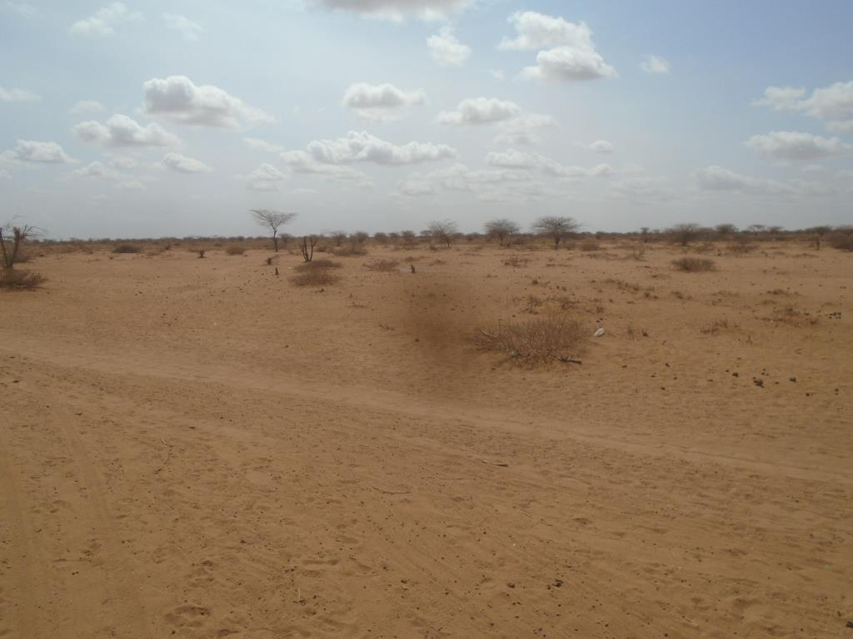
Proposed Yaqo Mini-Grid Site

Coordinates :2°13'00.8"N 39°36'54.3"E
Altitude: 240m

Wajir County, Kenya

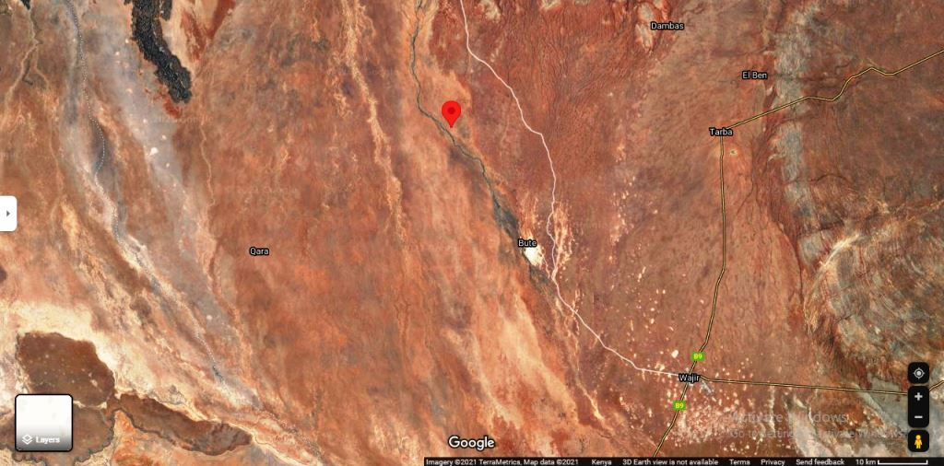
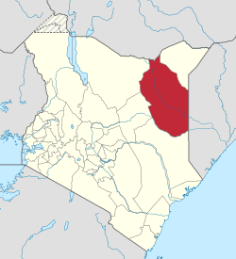
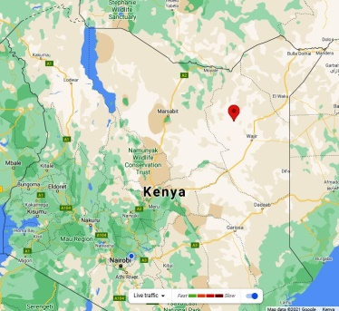
Proposed Site for Yaqo Solar Mini Grid Site
02° 13′ 00.78″ N, 039° 36′ 54.32″ E

Figure 4: Project location

Project site setting
The proposed Yaqo mini grid is in Wajir County. It falls under Lot 4 which has a total of 47 mini-grids out of which 13 are for Wajir County Geographically. Yaqo site falls on coordinates 2°13'00.8"N 39°36'54.3"E.
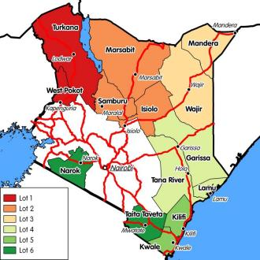

Figure 5: Map showing the KOSAP Counties Lot 3

Description of Project Facilities, Components and Activities

Project Components

Transformers
The Project will use 583KWH batteries which will not use transfers before being feed to the community grid. It will involve direct supply from the mini grid site.

Solar PV modules
The project will use PV Array (DC-kW) 180 polycrystalline silicon module with three strings connected in series. Each string will have five sets of panels connected in series, with output converged at the six-way combiners. The life expectancy of the PV modules is estimated at 25-30 years.

Charge controllers

Solar batteries
The Battery Energy Storage System (BESS) will comprise of Lithium-ion Battery pack that conforms to IEC standards with warranty of 10 years, 3,000 cycles minimum. The Lithium-ion Battery Power Packs will be used to cater for required energy capacity, or equivalent as per approved design, minimum 80% DOD for Lithium-Ion. Batteries will be capable of at least C/4 charge and discharge rate. Batteries will be charged by Battery Inverter / Charger. The project will use -kwh batteries.

Inverters
The Inverters shall be designed for continuous, reliable power supply as per specification and shall have internal protection arrangement against any sustained fault in the feeder line and against lightning strikes in the feeder line. The inverters shall be capable of complete automatic operation including wake-up, synchronization & shut down independently & automatically.

Distribution lines
Supply of concrete poles for the distribution lines will be based on detailed survey and accessories like phase plates, circuit plates, number plates, danger plates, anti-climbing devices as per KPLC requirements/specifications. Erection of the Poles, fixing of insulator strings, stringing of conductor and earth wires along with all necessary line accessories and earthing will be as per KPLC requirements/specification
Yaqo site will have a distribution line circuit of 18 Km in total.

Yaqo solar Mini grid profiles
Name | ID | Residential | Nonresidential | Circuit(km) | Peak demand kW | PV(DC-KW) | Battery Capacity kWh | Generator (KVA) | Cost (USD
Yaqo | Wajir | 710 | 12 | 18 | 72 | 180 | 583 | 90 | 932,911

Construction Contractor
The construction contractor is responsible for building the physical infrastructure required for the mini-grid project. In this case, the infrastructure includes the installation of solar panels, battery storage systems, a diesel generator, inverters, and the low voltage power distribution network.
Their specific responsibilities will include site preparation, installation of solar panels, setting up the battery storage system, configuring the diesel generator, and laying down the distribution network.
The construction contractor will be responsible for ensuring that the components are installed correctly and meet the required standards for safety and performance. They may also manage the workforce, logistics, and project timeline to ensure that construction proceeds smoothly and is completed within the specified timeframe.

Operation and Maintenance (O&M) Contractor

The O&M contractor will be responsible for the ongoing operation and maintenance of the mini-grid system once it is operational. The construction contractor will also double up as the O&M contractor.
The Solar Mini-grid will be operated and maintained by the contractor for the first seven years and then handed over to KPLC engineers and operators. During operation phase of the project, no unauthorized person shall access the Solar Mini-grid site. This is in line with company policy to ensure safety of staff and the public. Routine maintenance is to be done under supervision by authorized staff.

In this project, their responsibilities include monitoring the performance of the solar panels, battery storage system, and the diesel generator to ensure the continuous and reliable supply of electricity to the consumers. The O&M contractor must carry out regular maintenance tasks, such as cleaning and servicing solar panels, inspecting and maintaining the battery energy storage system, and ensuring the diesel generator is in good working condition for backup power needs. They are responsible for addressing any technical issues or faults that may arise, as well as responding to consumer complaints and inquiries related to the electricity supply. The O&M contractor plays a crucial role in maximizing the system's efficiency and longevity by ensuring all components operate optimally.

The contractor will be required to have their own Environment, Health, and Safety (EHS) policy and an EHS officer on site. In the context of the mini-grid project, it will outline the contractor's dedication to upholding safety standards, minimizing environmental impact, and adhering to legal requirements. The presence of an EHS officer on site will be equally essential. Their role will be to oversee and manage all EHS concerns directly at the project location.

Project cost
Yaqo project cost is estimated at USD. 932,911.

Project Phases and Activities
The main project activities include site clearance and leveling, civil works and construction of utilities and structures for the facilities, installation, and connection of the power plant.

Construction Procedures
The project will be constructed based on applicable standards of Kenya, environmental guidelines and health and safety measures in line with OSHA Act 2007.
The project inputs will include the following.
- Construction of raw materials will include solar modules, inverter, wires, metals, among others. All these will be obtained from licensed dealers and especially those that have complied with the environmental management guidelines and policies.
- Construction machines will include machinery such as trucks, and other relevant construction equipment. These will be used for the transportation of materials, clearing of resulting construction debris.
- A construction labour force of both skilled and non-skilled workers will be required.
Construction activities will include the following:
- Contractor mobilization.
- Site Preparation.
- Procurement of construction material from approved dealers and transport to the site.
- Storage of PV modules delivery and their installation.
- Laying of internal electrical connections.
- Installation of inverters, Battery Energy storage system and transformers.

Land Tenure
Land ownership in Wajir County is mainly community land, trust land and private land. The site for the proposed site is on communal land also registered as unregistered community land-land set aside for public us. The community has since offered the land willingly to the project proponent establishment of the proposed project.

Compensation Details
Compensation for the land for the proposed project will be in kind; as a token of appreciation for the donated land by the community, the Proponent will undertake some projects for the community.
- 1st Priority - The community requested provision of clean water
- 2nd Priority –There was also request to construct sanitary facilities in the region since most were using the bush as sanitary facilities.
- 3rd Priority – The community members also requested for the construction and provision of health facilities and services since there was none.

Resource Requirement

Workforce Requirement
A number skilled, semi-skilled and unskilled laborer will be required at the construction stage. During the operation phase, the following personnel will be required; operations and maintenance heads, engineers and technicians.
Unskilled workers will be involved during operation phase of the project for grass cutting where need be and module cleaning. Also trained security guards will be engaged at the operations phase

Water Requirement and Source

Construction Phase
A good amount of water will be required per day for civil works during construction stage. Further, water will be required for workers at project site. However, this quantity of water requirement will vary depending upon the mobilization of construction workers at site. The water for the construction phase will be supplied by a water tanker from the area water vendors.

Operation Phase
The water required during operation phase of the project will be mainly for washing the face of the solar modules, minimal water will be used for this purpose. The quantity of Water requirement during operational phase of the project is not known at this stage of the project. The water for the construction phase will be purchased from the vendors in the area.
As noted previously, approximately, employees (direct and contractual) will be working during operation phase. For this workforce, the exact quantities will be ascertained ones the project is in the implementation stage.

Raw Material Requirement

Construction Phase
The major raw materials required for the construction phase will be solar modules, fencing materials, construction materials like cement, sand, and aggregate. The fencing materials and the construction materials will be sourced from the local hardware facilities. Solar Modules for the project along with associated structures will be obtained from China.

Operation Phase
There will not be major requirement of raw materials during operation phase. Only maintenance spares will be required at this phase.

Power Requirement
Power requirement during the construction phase will be met through Diesel Generators sets. The exact numbers of Diesel Generator sets to be used, as well as the quantity of fuel, will be ascertained once the project is in the implementation stage.

Fire Safety and Security

Construction Phase
Appropriate firefighting system and equipment shall be provided throughout the construction period. The fire extinguishers will be well distributed according to the fire risks and will be available in areas such as the site office, security area, storage yard etc. A comprehensive emergency response plan with all the emergency numbers will be well displayed at the site and on the fence.

Operation Phase
Suitable fire protection and fighting systems that will include portable fire extinguishers, automatic fire detection system and means of fire communication will be made available at the entire PV array area, inverter stations, main control room and switchyard.
The systems and equipment’s will align to the Kenyan Fire Reduction Rules of 2007. The Fire protection and fighting systems will be maintained and serviced after every 6 months.

Pollution Streams during Construction Phase

Solid Waste Generation

Construction Phase
The key solid waste that is expected to be generated during construction phase include; broken solar panels and PV Modules, Hazardous waste like waste oil, lubricants, oil contaminated rags and Domestic soil from the temporary site office.
The hazardous wastes will be stored onsite at separate designated covered area provided with impervious flooring and secondary containment. The storage containers/ bins/ drum will be clearly marked, and color coded for their hazards. The waste will then be collected by a NEMA approved waste handler.
Any broken solar panels or PV Modules will be sent back to the vendor as part of buyback arrangement. All the other domestic solid waste will be disposed at the nearest municipality dumpsite.

Operation Phase
During operation phase, waste generated from the project will include domestic waste at site office, scrap materials like scrap tools, damaged PPEs etc.; hazardous waste like waste oil, lubricants, used transformer oil; damaged batteries; electronic waste like damaged PV modules etc.
The hazardous wastes will be stored onsite at separate designated covered area provided with impervious flooring and secondary containment. The storage containers/ bins/ drum will be clearly marked, and color coded for their hazards. The waste will then be collected by a NEMA approved waste handler.
Any broken solar panels or PV Modules will be sent back to the vendor as part of buyback arrangement. All the other domestic solid waste will be disposed at the nearest municipality dumpsite.

Air Emissions

Construction Phase
Air quality will be impacted due to onsite construction activities. The likely emissions from construction activities would include the following:
- Dust emissions from the dusty roads leading to the site.
- Increased vehicular emissions due to the high traffic of vehicles transporting construction materials, PV Modules, and accessories.
- Dust emissions from site clearing, material handling, piling and use of the construction machinery.
- Exhaust emissions from the diesel generator.
The high dust emissions arising from various activities such as piling, transportation of material (loading and unloading), vehicular movement (on unpaved roads) should be minimized through sprinkling of water and maintaining vehicular speed to 10-15 km/hr.
All the vehicles and the Diesel generator should be well maintained and serviced to reduce the rate of exhaust emissions.

Operation Phase
It is expected that the normal operations of the site will produce minimal gaseous emissions from all the operating areas. The minimal gaseous and fugitive dust emissions will be attributed to the in and out movement of the maintenance vehicles. It will be ensured that well maintained vehicles are used for maintenance purposes.

Waste Generation

Construction Phase
The liquid effluents generated during the construction phase will include domestic sewage from temporary site offices, kitchen and washing areas. As part of the site preparation stage, septic tank will be constructed for the camp and site office. Sewage disposal trucks should be used to periodically remove the sludge/sewage from the septic tank.

Operation Phase
The operational phase will have negligible wastewater generation at site office. Septic tank and soak pits will be provided at the site office for disposal of sewage.

Noise Emissions

Construction Phase
Noise emissions will be generated from piling, movement of vehicle and other construction machinery and operation of the Diesel Generator. The main noise receptors will be the neighboring settlements and the construction workers. Noise from Diesel Generators will be minimized through provision of acoustic enclosures and occasional maintenance of the generator. Every single noise generating activity will be restricted to Day time only.

Operation Phase
Under normal operations, none of the activities of solar power plant will generate noise. The only noise that can be generated at this phase is during the maintenance works and it will be restricted to daytime only.

Analysis of Alternatives and Project Justification
This section analyses the project alternatives in terms of site and technology. Solar projects are non -polluting energy generation projects which are site specific and dependent on the availability of solar irradiance resource. The current site selected is a high solar power potential site with high irradiation and consistent sunny days throughout the year.

Power Scenario in Yaqo
This option involves remaining on the status quo.
The no construct/no project alternative will not achieve the objectives of the project since the listed benefits will not be achieved.
Failure to construct and operate the minigrid will lead to the failure of achieving one of the Kenya’s national long-term development policies that aims to transform Kenya into a newly industrializing, middle-income country, by providing a high quality of life to all its citizens by 2030 in a clean and secure environment. Beneficiaries will be households, public and community institutions, enterprises and community facilities that cannot access electricity through the national grid and whose use of electricity will replace kerosene and other fuels for lighting and other activities like pumping water.

Present Power Supply Position
According to the KIHBS 2005/6, 98.4 per cent of the county households depend on wood fuel (Firewood and Charcoal) for cooking and 31.5 per cent depend on kerosene lantern for lighting. 96.6 per cent of households use traditional stone fire for cooking. This contributes to massive environmental degradation, increased health risks and additional workload for women and girls, and increased emissions of carbon content. Moreover, low enrollment, retention and transition for girls is partly attributed to increased workload related to energy search.
Wajir, Griftu, Abakore, Tarbaj Habaswein and Eldas centers are Wajir County Integrated Development Plan (2018-2022) 30 connected to diesel power plants where over 20,000 households are supplied with power. Bute is connected to the Ethiopian Grid through Moyale. Solar energy accounts for 0.2 per cent (2009 KPHC) of energy source but is also limited to schools and health facilities as it is out of reach for majority of the households.
The county has a huge potential for renewable energy which can tapped through wind and solar energy and hence be channeled to productive sectors within the county as well as export to other counties.

Alternate Location for Project Site
In determining the most appropriate site for the establishment of the minigrid, several options were explored. This site selection process considered the following criteria:
- The availability of primary resources required for the operation of the minigrid, such as Sun
- Availability of land to locate the site and associated infrastructure.
- The availability and accessibility of infrastructure for the provision of services, manpower and social structure for the construction and operation of the power plant.
- General environmental acceptability in terms of social impacts, water utilization, general ecology, etc.
Yaqo was identified as the most suitable area for the establishment of the proposed mini grid based on the following factors:
Location: The area is in a predominantly pastoral setting. The population density is low, and majority of the surrounding land is de-vegetated grazing lands and tree cover is currently low at 15%. There is enough grazing land for the community and use of the site to construct the mini grid will not significantly impact grazing land.
Grid Connection: A grid connection with enough capacity and material was recommended due to the anticipated increasing demand in solar energy. This eliminates the need to overhaul the grid connection when the population increases in Yaqo location.
Land Identification Criteria
Minigrid Sites under KOSAP were selected based on a number of factors.
- Geophysical Factors-Proximity to Hills-Shade effect, Soil erosion, Drainage of the area, Flooding etc.
- Land identified is free from any dispute on ownership or any other encumbrances
- Proximity to public utilities-Schools, Dispensaries, Places of worship and community settlements
- No squatters, encroachers or other claims to the land
- The Size of the Minigrid to be constructed and the optimal coverage of a Minigrid in terms of the number of people to be reached.
- The Land identified should be on spaces set aside for public use within the community centres.
The land was identified by the beneficiary communities and confirmed by technical staff to be suitable for the sub-project and free from any environmental or health risks. The impacts on the Community will be marginal and will not result in displacement of households or cause loss of household’s incomes and livelihood.

The site identified was considered against the criteria highlighted above and was found suitable for Minigrid construction.

Alternate Method of Power Generation
The possible alternatives to electrical energy could be solar power, wind power, thermal power, fossil fuel and firewood. Power import from neighboring countries is another option. Wind power is also a source of clean energy.
The problems in operation of wind power are lack of time series data of wind, trained human resources to intricate design of wind power etc. In addition, providing wind power for Yaqo residents is technically and financially challenging.
Thermal power plants are associated with serious environmental problems like air pollution, waste pollution, noise pollution, temperature pollution etc. Besides coal and petroleum products, the basic input required for the conventional thermal power plants will have to be imported. Therefore, thermal power option based on coal and petroleum products is not a viable option for Yaqo.
The use of firewood and solid waste for electricity generation using thermal technology is another option. But the issue of air pollution and destruction of vegetative cover through firewood harvesting and charcoal burning already are environmental problems of serious concern which will further aggravate the natural environment. For these reasons, the thermal power options evaluated above seem inappropriate for Yaqo on environmental as well as economic grounds.
Solar energy was a desirable option because:
- It has low energy-production costs
- Versatile installation
- It is a clean source of energy hence minimal impact on the environment air quality
- Economic savings.

Vision 2030
Kenya Vision 2030 is the country’s development blueprint covering the period 2008-2030. It aims to transform Kenya into a newly industrialized, ‘middle income’ country providing a high-quality life to all its citizens by the year 2030.’
Vision 2030 is based on three key pillars namely: Economic, Social, and Political. These pillars are anchored on the following foundations:
- Macroeconomic stability.
- Continuity in governance reforms.
- Enhanced equity and wealth creation opportunities for the poor.
- Infrastructure.
- Energy.
- Science, technology, and innovation (STI).
- Land reform.
- Human resources development.
- Security; and
- Public sector reforms.
This policy recognizes that infrastructure, and in particular, a reliable power supply is vital in sparking economic growth. The challenges facing the power sector in Kenya include weak transmission and distribution infrastructure, high cost of power, low per capita power consumption, and low electricity access countrywide.
The Proponent aims to generate power mainly for community use which will contribute towards meeting the growing energy needs and targets as envisioned in Vision 2030.

Zero or No Project Alternative
The No Project option in respect to the proposed project implies that the status quo is maintained. This option is the most suitable alternative from an extreme environmental perspective as it ensures non-interference with the existing conditions. This option will, however, involve several losses both to Yaqo area and Wajir county as a whole. The village and the surrounding area will continue to have no electricity, and this will not help in maximizing and utilizing the area facilities. The No Project Option is the least preferred from the socio-economic and partly environmental perspective due to the following factors:
- The economic status of the local people would remain unchanged.
- Employment opportunities will not be created.
- Increased poverty in the area.
From the analysis above, it becomes apparent that the No Project alternative is no alternative to the local people, Kenyan Government, and Investors.

Analysis of Alternative Construction Materials and Technology
The proposed project will be constructed using modern, locally, and internationally accepted materials to achieve public health, safety, security, and environmental aesthetic requirements. These may not be desirable from a cost and durability perspective. The technology to be adopted will be the most economical and one sensitive to the environment.

Conclusion
The proposed project should be upheld to support the local community based.

LAND REQUIREMENT AND PROCUREMENT PROCESS

Land Requirement and Procurement Process

Land Requirement
The land on which the proposed Yaqo mini-grid will be constructed covers a total 1.260 Ha in size.

Land Tenure
The entire county is categorized as trust land. In Yaqo, the site falls on Communal land (Unregistered community land- land set aside for public use).

Compensation Details
Compensation for the land for the proposed project will be in kind; as a token of appreciation for the donated land by the community, the Proponent will undertake some projects for the community.
- 1st Priority - The community requested provision of clean water. Under the community profile, the chief stated that the community needed water pipes and construction of water kiosks in different sections of the villages.
- 2nd Priority – There was also a request to construct sanitary facilities in the region since most were using the bush as sanitary facilities.
- 3rd Priority – The community members also requested for the construction and provision of health facilities and services since there was none.

APPLICABLE AND REGULATORY FRAMEWORK

Introduction
This Chapter outlines the existing national and international environmental and social legislation, policies, and institutions applicable to energy generation that guide the development of the Project.
As Kenya is a signatory to various international conventions and laws, national projects need to be aligned with their requirements; relevant international conventions and laws are therefore presented in this chapter.
Finally, a summary of the World Bank (WB) Environmental and Social operational policies relevant to this Project are presented.

Kenya Policy Provisions

Kenya Energy Policy, 2014
The Energy Policy sets out the national policies and strategies for the energy sector that align to the Constitution of Kenya and Kenya’s Vision 2030.
The Energy Policy envisages promoting an energy mix that includes solar energy at both the household/institutional levels as well as large-scale solar energy generation. The Government of Kenya has initiated and has been promoting programmes for the provision of electricity to institutions far from the grid through solar PV systems. The Government has also embarked on a programme to provide solar/diesel and solar/wind hybrid generation capacity to off-grid stations.
The Policy strategizes the need to:
- promote the widespread use of solar energy while enforcing existing regulations and standards.
- provide incentives to promote the local production and use of efficient solar systems.
- provide a framework for connecting electricity generated from solar energy to the national and isolated grids, through direct sale or net metering.
- promote the use of hybrid power generation systems involving solar and other energy sources; and
- facilitate the generation of electricity from solar energy by, among other things, funding, provision of land, fast-tracking issuance of permits and licenses, as well as acquisition of data and information to realize at least 100 MW from solar by 2017, 200 MW by 2022 and 500 MW by 2030.
The Kenya Electricity Supply Industry (ESI) is one of the sub-sectors in the energy sector which the Ministry of Energy and Petroleum oversees on behalf of the Government of Kenya (GoK). Under the Energy Act of 2006, the Ministry is responsible for formulation and articulation of policies to provide an enabling environment for operators and other stakeholders in the energy sector. Relevant stakeholders in the ESI are briefly described below.

Table 7. Kenya power stakeholders and their roles
Stakeholders | Role
Kenya Power Company | Responsible for distribution and retail supply of electrical energy to end users. Kenya Power purchases power in bulk from the Kenya Electricity Generating Company Limited (KenGen) and the Independent Power Producers (IPPs) through bilateral contracts or Power Purchase Agreements (PPAs) approved by the Energy Regulatory Commission (ERC) ().
The Energy and Petroleum Regulatory Authority (EPRA) | Established by the Energy Act of 2019. The EPRA’s mandate extends beyond electricity and includes natural gas (including petroleum), renewables and all other forms of energy. The generation, transmission, distribution, supply, import and export of electricity can only be carried out by parties in possession of a license, or a permit issued by the EPRA. If the capacity involved is for own use and less than 1 MW, authorization is not required. Although the generated electricity is expected to be less than 1 MW (0.3 – 1 MW), the fact that the generated electricity is intended for use in a factory and there is a possibility for connection to the national grid and sale of excess power to the government, The project requires a license from the EPRC to generate electricity as stipulated in the Energy Act, 2019.
Ministry of Energy and Petroleum | Aims to facilitate provision of clean, sustainable, affordable, reliable, and secure energy services for national development while protecting the environment.
The Rural Electrification and Renewable Energy Corporation (REREC): | Is established under Section 43 of the Energy Act, 2019 as a corporate body. The Corporation is the successor to the Rural Electrification Authority established under section 66 of the Energy Act No. 12 of 2006 (now repealed) and subject to this Act, all rights, duties, obligations, assets and liabilities of the Rural Electrification Authority existing at the commencement of this Act is to be automatically and fully transferred to the Corporation and any reference to the Rural Electrification Authority in any contract or document shall, for all purposes, be deemed to be a reference to the Corporation.
The Geothermal Development Company (GDC): | Is a 100% state-owned company, formed by the Government of Kenya as a Special Purpose Vehicle to fast track the development of geothermal resources in the country. The creation of GDC was based on the government’s policy on energy - Sessional paper No. 4 of 2004, and the energy Act No. 12 of 2006.
The Kenya Electricity Transmission Company (KETRACO): | Was incorporated on 2nd December 2008 and registered under the Companies Act, Cap 486 pursuant to Sessional paper No. 4 of 2004 on Energy. KETRACO’s mandate is to design, construct, operate and maintain new high voltage electricity transmission infrastructure that will form the backbone of the National Transmission Grid, in line with Kenya Vision 2030.
Energy and Petroleum Tribunal (EPT): | The tribunal is established under section 25 of The Energy Act, 2019. The tribunal is established for the purpose of hearing and determining disputes and appeals in accordance with The Energy Act, 2019 or any other written law. In relation to the proposed Project, any disputes or appeals if they arise will need to be addressed by the EPT.

Policy paper on Environment and Development (Sessional Paper No. 6 of 1999)
The overall goal of this Sessional Paper is to ensure that environmental concerns are integrated into the national planning and management processes and provide guidelines for environmentally sustainable development. The objectives of the Paper are to conserve and manage the natural resources of Kenya including air, land, flora, and fauna and promote environmental conservation about soil fertility and conservation, biodiversity, to foster afforestation activities, and to protect water catchment areas. More importantly, the Policy emphasizes the enhancement of public awareness and appreciation of the essential linkages between development and environment, involving NGOs, private sector, and local communities in the management of natural resources and their living environment and ensures that an environmental impact assessment report is undertaken for all public and private projects and programmes.
The proposed solar plant facility must ensure that it promotes this integrated approach to environmental management and development, without compromising the livelihoods of the local community.

National Policy on Water Resources Management and Development, 1999
While the National Policy on Water Resources Management and Development enhances a systematic development of water facilities in all sectors for promotion of the country’s socio-economic progress, it also recognizes the by-products of this process as wastewater. The Policy therefore calls for development of appropriate sanitation systems to protect people’s health and water resources from institutional pollution. This implies that industrial and business development activities should be accompanied by corresponding waste management systems to handle the wastewater and other waste emanating therefrom.
During construction, water will be required for concrete works and during the operational period water supply may be necessary for cleaning the PV modules. Appropriate water treatment and waste water handling must be incorporated into the Project design to be in alignment with this policy.

Sessional Paper No. 10 of 2014 on the National Environmental Policy, 2014
The overall goal of this Session Paper is to ensure better quality of life for present and future generations through sustainable management and use of the environment and natural resources. This Session Paper calls for the use of environmentally sound technologies based on the best available techniques and policies as a way of minimizing negative impacts to the environment.
Section 5.6 of this Session Paper focusses on infrastructure development and environment and makes explicit policy statements to ensure sustainable management and use of the environment and natural resources during the construction and operation of infrastructure developments. These policy statements require the commitment of the government to:
- Ensure Strategic Environmental Assessment (SEA), Environmental Impact Assessment, Social Impact Assessment and Public participation in the planning and approval of infrastructural projects.
- Develop and implement environmentally friendly national infrastructural development strategy and action plan.
- Ensure that periodic Environmental Audits are carried out for all infrastructural projects
In line with the above policy statements, this ESIA has been conducted for the proposed solar project (including the associated infrastructure) to ensure that environmental and social issues are appropriately addressed.
Once approved by NEMA, the Project Proponent will also need to conduct periodic Environmental Audits to ensure continuous conformity with the overall goal of this Session Paper. In addition, this ESIA has considered analysis of alternatives including alternatives to technology to ensure that the best available and appropriate technology is used.

Kenya Off-grid Solar Access Project (KOSAP) Environmental & Social Management Framework, 2017
The World Bank is concerned about the environmental and social impacts of its activities and requires environmental assessments be done for all projects it finances. Its safeguard policies are aimed at preventing and mitigating undue harm to people and their environment in the development process also provide a platform for the participation of stakeholders in project design and implementation.
The framework was prepared because the geographic coverage for KOSAP was generally known but the exact locations for the sub projects had not been identified. The ESMF provides guidelines for MoE, KPLC & REREC in determining the appropriate level of environmental and social assessment required for the sub-projects and in preparing the necessary environmental and social Enhancement Measures for these sub-projects.
The proposed project will consider all relevant guidelines as provided by the KOSAP- ESMF

Resettlement Policy Framework (RPF)
The RPF states that K-OSAP component 1 (Mini grids for Community Facilities, Enterprises, and Households) which involves installation of mini grids will require land acquisition.
The Framework seeks to avoid, manage, and/or mitigate potential risks arising out of damage to assets, disruption to work, temporary negative impacts on livelihoods and/or in the unlikely case of displacement. To develop a Resettlement Action Plan and propose an implementation framework for RAP to mitigate such effects. Involuntary resettlement and land acquisition will be avoided where feasible, or minimized or compensated where it cannot be eliminated. Where involuntary resettlement and land acquisition are unavoidable, resettlement and compensation activities will be conceived and executed as sustainable development programs, providing resources to give PAPs the opportunity to share project benefits. PAPs will be meaningfully consulted and will participate in planning and implementing of the resettlement activities
There will be no displacement of people/crops/etc. as the land allocated for Minigrid construction in open public Land. The land is part of the wider parcel set aside by the community that they have allocated to the project. Compensation for the land will be in Kind.

Vulnerable and marginalized Groups Framework (VMGF) for KOSAP
As noted above the KOSAP project trigged O.P 4.10 policy on Indigenous People and therefore a Vulnerable and Marginalized Groups Framework (VMGF) was prepared for use by the Ministry of Energy (MOE) and the implementing agencies KPLC and REREC and other stakeholders. The framework was prepared then because was known that IPs are present in all the 14 target project counties. However, at that stage of project preparation, the exact sub-project sites were not yet identified and the exact impacts of the project on VMGs were not yet completely known. The VMGF describes the policy requirements and planning procedures that during the preparation and implementation of components especially those identified as occurring in areas where VMGs are present.
The purpose of the VMGF is to guide management of issues related to vulnerable and marginalised groups during the development and operation of proposed sub projects and to ensure effective mitigation of potentially adverse impacts while enhancing sharing of benefits.
The project area is inhabited by predominantly by the Samburu Community. Their presence in the project’s footprint was clear with the only other communities present in the area that will benefit from the project being the Turkana, Somali and the Rendile
The Samburu, Turkana, Somali and the Rendile falls under communities in Kenya who are categorized by the World Bank’s OP 4.10 and the Constitution of Kenya, 2010, as vulnerable and marginalized groups. Thus the VMGs that have been identified as those who would potentially be impacted by the project are mainly Samburu, Turkana, somali and the rendile who are mainly the minority.

National Legal Framework

Administrative Framework
In 2001, the Government established the administrative structures to implement the Environmental Management and Co-ordination Act of 1999 (EMCA). The main administrative structures are described in the following sections:
Table 8. Administrative stakeholders and their roles
Stakeholders | Role
NEC | The National Environmental Council is responsible for policy formulation and directions for the purposes of EMCA. The Council also sets national goals and objectives and determines policies and priorities for the protection of the environment.  The proponent should ensure that the project abides by the set goals and objectives of the Council.
NEMA | The responsibility of NEMA is to exercise general supervision and co-ordination over all matters relating to the environment and to be the principal instrument of Government in the implementation of all policies relating to the environment.  This ESIA has been prepared for submission to NEMA for review and approval prior to the commencement of the Project activities, in compliance to the EMCA.
PCC | EMCA has also established a Public Complaints Committee, which provides the administrative mechanism for addressing environmental harm. The Committee has the mandate to investigate complaints relating to environmental damage and degradation. The members of the Public Complaints Committee include representatives from the Law Society of Kenya, NGOs, and the business community.  The proponent should address all issues arising from the Project in accordance with the above requirements, including a clear policy of stakeholder engagement and feedback.
WRA | Water Resources Authority is responsible for regulation of water resources issues such as water allocation, source protection and conservation, water quality management and pollution control and international waters. One of its functions among others is to receive water permit applications for water abstraction, water use and recharge and determine issue, vary water permits; and enforce the conditions of those permits as well as formulate and enforce standards, procedures and Regulations for the management and use of water resources and flood mitigation.  The project area experiences serious water scarcity. The proponent will have to purchase water for use during construction.

Relevant statutes
The current legal provisions for natural resource management in Kenya are contained in over seventy sector-specific statutes. For a long time, the country lacked an umbrella legislative guide for harmonious and holistic environmental management. As such, resources were managed sectoral in accordance with the statutes that were in place.
As these statutes were contradictory at times, in 1999, the Government of Kenya enacted the Environmental Management and Co-ordination Act (EMCA) which is an umbrella legal framework under which the environment is being managed. EMCA establishes the institutional framework under which environmental management is to be coordinated. EMCA prevails over all other Sectoral laws relating to the environment in cases of conflict or contradictions. It also grants the public a locus standi in matters of the environment.

Table 9. National Policy Framework

No | Legislation/  Guidelines | Description of the Legislation/Guideline | Relevance of the legislation/regulations in terms of license, permits, and other requirements
 | NATIONAL POLICY FRAMEWORK
 | Vision 2030 | Kenya Vision 2030 is the current national blueprint for development from its inception in 2008 until the milestone year of 2030. This plan is the national long-term development policy that aims to transform Kenya into a newly industrialized, middle-income country by 2030. The Vision is comprised of three key pillars (economic, social, and political), two of which are projected to be positively affected by project implementation. | Under Vision 2030, Energy is identified as one of the key sectors that form the foundation for socio-political and economic growth. Promoting equal opportunities across the entire Kenyan territory and enhancing access to competitively priced, reliable, quality, safe and sustainable energy is essential to the achievement of this vision.
 | The Poverty Reduction Strategy Paper (PRSP) of 2001 | The PRSP has the twin objectives of poverty reduction and enhancing economic growth. The paper articulates Kenya ‘s commitment and approach to fighting poverty; with the basic rationale that the war against poverty cannot be won without the participation of the poor themselves. | - The proposed project aims at provision and access of renewable electricity geared towards improved economic performance and thus will contribute to poverty alleviation in the project area.
 | National Environmental Action Plan (NEAP) of 1994 | The NEAP for Kenya was prepared in mid 1990s. It was a deliberate policy whose main effort is to integrate environmental considerations into the country ‘s economic and social development. The integration process was to be achieved through multi-sectoral approach to develop a comprehensive framework to ensure that environmental management and the conservation of natural resources forms an integral part of societal decision-making. | - The NEMA does not approve a development project unless the impacts of the proposed project are evaluated and Enhancement Measures proposed for incorporation in the project ‘s development plan, which is in line with the requirements of the NEAP.  - The project will be reviewed by NEMA for approval before implementation.
 | Environmental and Development Policy (Session Paper No.6 1999) | As a follow-up to the foregoing, the goal of this policy is to harmonize environmental and developmental goals so as to ensure sustainability. The paper provides comprehensive guidelines and strategies for government action regarding environment and development.  The Government will:  - Ensure Strategic Environment Assessment (SEA), Environmental Impact Assessment, Social Impact Assessment and Public participation in the planning and approval of infrastructural projects.  - Develop and implement environmentally-friendly national infrastructural development strategy and action plan.  - Ensure that periodic Environmental Audits are carried out for all infrastructural projects | The proponent:  - is undertaking an Environmental Impact Assessment, Social Impact Assessment and Public participation as part of the planning and approval of infrastructural projects.  - Will ensure that periodic Environmental Audits are carried out for the project.
 | The National Energy and Petroleum Policy 2015 | The overall objective of the energy and petroleum policy is to ensure affordable, competitive, sustainable and reliable supply of energy to meet national and county development needs at least cost, while protecting and conserving the environment. This policy stipulates the transformation of the Rural Electrification Authority (REA) to Rural Electrification and Renewable Energy Corporation (REREC) to be the lead agency for development of renewable energy resources. | The policy is relevant to the project in the sense that the project will provide sustainable and reliable energy supply and measures will be put in place to protect and conserve the environment during its development. REREC will be in charge of the development of the minigrid and maintenance.
 | The Gender and Development Policy (Sessional paper no.2 2019) | The overall goal of this policy is to achieve gender equality by creating a just society where women, men, boys and girls have equal access to opportunities in the political, economic, cultural and social spheres of life.  The anticipated outcome of this policy as enshrined in the Constitution that aligns to the project include:  a) Equality and economic empowerment will be of both genders,  b) Women and men will have equality of opportunity to participate in decision making and to contribute to the political, social, economic and cultural development agenda;  c) Sexual and Gender based Violence will abate and men, women, boys and girls will live with dignity | - In the absence of appropriate measures, the project can exacerbate gender inequalities and sexual and gender based violence. In adherence to this policy, measures will be put in place to:  - ensure gender inclusivity in decision making, employment opportunity and access to the energy generated from the Mini-Grid  - mitigate social risks including sexual and gender based violence, and any form of discriminations
 | The HIV/ AIDS Policy 2009 | In summary, the policy aims at:  I. Establishing and promoting programmes to ensure non-discrimination and non- stigmatization of the infected;  ii. Contributing to national efforts to minimize the spread and mitigate against the impact of HIV and AIDS;  iii. Ensuring adequate allocation of resources to HIV and AIDS interventions; | - The proposed project is to be implemented in a rural setting at area. The area is not economically empowered hence few HIV/AIDS prevention resources are available. This policy shall provide a framework to both the project proponent and contractor to address issues related to HIV/AIDS during the entire project phase.
LAWS AND LEGISTLATIONS
 | The Constitution of Kenya, 2010 | The Constitution of Kenya promulgated in 2010 is the supreme law of the republic and binds all persons and all State organs at all levels of government. The Constitution provides the broad framework regulating all existence and development aspects of interest to the people of Kenya, and along which all national and sectoral legislative documents are drawn. | The proposed project complies with the Constitution by proposing a structure in its ESIA on how to deal with Social, Health, safety and environmental issues for sustainable development.
 | ENVIRONMENTAL MANAGEMENT AND COORDINATION ACT, 1999 (AND THE AMENDMENTS OF 2015) | The EMCA is a framework environmental law in Kenya. This Act (assented to on January 14, 2000) provides a structured approach to environmental management in Kenya. With the EMCA coming into effect, the environmental provisions within the sectoral laws were not superseded; instead, the environmental provisions within those laws were reinforced to better manage Kenya’s ailing environment. | - The proposed project will be undertaken in accordance with relevant sections of the EMCA, specifically Clauses 58 – 63. These sections of the Act are operationalized by subsidiary legislation promulgated under the Act and specifically Legal Notice (L.N.) 101: Environment (Impact Assessment and Audit) Regulations, 2003.
 | L.N. 101: EIA/EA REGULATIONS, 2003 AND 2016 AMENDMENTS | These regulations provide the framework for undertaking EIAs and EAs in Kenya by NEMA licensed Lead Experts and Firms of Experts. An EIA or EA Study in Kenya is to be undertaken by a firm duly licensed by the National Environmental Management Authority (NEMA). The EIA/EA Regulations also provide information to project proponents on the requirements of either an EIA or EA as required by the EMCA. | - The proposed project is subject to relevant provisions of these regulations and subsequently, the ESIA has been undertaken in accordance with the requirements.
 | L.N. 120: WATER QUALITY REGULATIONS, 2006 | These regulation provides for the sustainable management of water used for various purposes in Kenya. For effluent discharges into the environment and aquatic environment, a Proponent needs to apply directly to the NEMA. For discharges into public sewers, a Proponent needs to apply for the license to the relevant county. The regulation contains discharge limits for various environmental parameters into public sewers and the environment. | - These regulations will apply to the proposed project during the construction and operational phases. The contractor will be required to properly manage the effluent from construction activities in accordance with the above regulations prior to discharge into the environment.
 | L.N. 121: WASTE MANAGEMENT REGULATIONS, 2006 | These regulations are comprehensive and cover the management of various kinds of waste in Kenya. Generally, it is a requirement under the regulations that a waste generator segregates waste (hazardous and non-hazardous) by type and then disposes the them in an environmentally acceptable manner. Under the regulation, it is a requirement that waste is transported using a vehicle that has an approved “Waste Transportation License” issued by NEMA. Wastes generated in Kenya must be disposed of in a licensed disposal facility. Such a facility will require annual environmental audits to be undertaken by NEMA registered Lead Experts.  The regulation requires that prior to generating any hazardous waste, a proponent shall undertake an EIA Study and seek approval from the NEMA. Labelling of hazardous wastes is mandatory under the regulation and the specific labelling requirements are provided in Rule 18. The treatment options for hazardous waste disposal provided in Rule 19 include incineration or any other option approved by the NEMA. | - During the construction and operation phases, the proposed project will generate various streams of wastes. For the most part, it is expected that the wastes will be non-hazardous in nature and can be disposed of in accordance with these regulations.
 | L.N. 61: NOISE AND EXCESSIVE VIBRATION CONTROL REGULATIONS, 2009 | The general prohibition of these regulations states that no person shall make or cause to be made any loud, unreasonable, unnecessary, or unusual noise which annoys, disturbs, injures, or endangers the comfort, repose, health, or safety of others and the environment.  The regulations further provide factors that will be considered in determining whether or not noise and vibration is loud, unreasonable, unnecessary, or unusual. | - Rules 13 and 14 of the regulations define the permissible noise levels for construction sites. These noise limits will be applicable to the proposed project.
 | LICENSES AND PERMITS REQUIRED UNDER THE EMCA | The subsidiary legislations under the EMCA are partially monitored through the use of permits and licenses. Subsequently all licenses and permits required during the construction phase shall be the responsibility of the individual contractors and their agents. During the operational phase, all permits and licenses required to operate the project will be the responsibility of the proponent. | The subsidiary legislations under the EMCA requires some or all the following types of permits to be available for inspection during the construction and operational phases of the project:  - Effluent Discharge License under Legal Notice 120: The Environment Management and Coordination (Water Quality) Regulations 2006;  - Waste Transport License under Legal Notice 121: The Environment Management and Coordination (Waste Management) Regulations 2006 for disposal of all types of wastes; and  - Noise Permit under Legal Notice 61: The Environment Management and Coordination (Noise and Excessive Vibration Control) Regulations, 2009.
 | OCCUPATIONAL HEALTH AND SAFETY ACT, 2007 | The Occupational Safety and Health Act (OSHA) was enacted to provide for the health, safety and welfare of persons employed in workplaces, and for matters incidental thereto and connected therewith.  Part II of the Act provides the General Duties to which the occupier must comply with respect to health and safety in the workplace. Such duties include undertaking safety and health (S&H) risk assessments, S&H audits, notification of accidents, injuries and dangerous occurrences. A number of sections under this part shall be applicable to the proposed project.  Part IV deals with the enforcement provisions that Directorate of Occupational Safety and Health Services (DOSHS) has under the Act. It discusses the instances when Improvement and Prohibition Notices can be issued as well as the powers of Occupational S&H officers. This part of the Act will be mandatory for the occupier to comply with for the proposed project.  Part V of the Act requires all workplaces to be registered with the DOSHS. This part will be applicable for the proposed project as the Occupier will have to apply for registration of their project with the DOSHS on completion of the construction phase and before the operational phase of the project.  Part VI of the Act lists the requirements for occupational health provisions which include cleanliness, ventilation, overcrowding, etc. This section of the Act will apply to the Occupier during the operational phase of the project.  Part VIII of the Act contains provisions for general safety of a workplace, especially fire safety. This part of the Act will apply to the proposed project during the design, construction, and operational phases.  Part X of the Act deals with the General Welfare conditions that must be present during the construction and operational phase of the project. Such conditions include first aid facilities, supply of drinking water, accommodation for clothing, ergonomics, etc. This part of the Act will apply to the proposed project during the construction and operational phases.  Part XI of the Act contains Special Provisions on the management of health, safety, and welfare. These include work permit systems, PPE requirements and medical surveillance. Some sections of this part of the Act will be applicable to the proposed project during the construction and operational phase.  Part XIII of the Act stipulates various fines and penalties associated with non-compliance with the Act. It includes those fines and penalties that are not included in other sections of the Act and will be important for the Occupier to read and understand the penalties for non-compliance with S&H provisions.  Part XIV of the Act is the last section of the Act and contains miscellaneous provisions which are not covered elsewhere in the Act. Some sections under this part of the Act will apply to the proposed project and it is in the interest of the occupier to read, understand, and ensure compliance. | The proposed project will be undertaken in compliance with the OSHA-2007 during the construction, design, and operational phases.  During the construction phase, the contractors will be required to fully comply with the requirements of Legal Notice 40 titled: Building Operations and Works of Engineering Construction Rules, 1984 (BOWEC). Each contractor will develop and implement a formal construction health and safety plan for the entire construction phase duration in alignment with the OSHA and international health and safety best practices.
 | L.N. 31: The Safety and Health Committee Rules, 2004 | These rules came into effect on April 28, 2004, and require that an Occupier formalize a S&H Committee if there is a minimum of 20 persons employed in the workplace. The size of the S&H Committee will depend on the number of workers employed at the place of work.  For the Proponent and Contractor, the OSHA and the S&H Committee Rules 2004 are important as they require compliance with the following measures:  - Posting of an Abstract of the Factories and Other Places of Work Act in key sections of each area of the factory or other workplace;  - Provision of first aid boxes in accordance with Legal Notice No. 160 of 1977;  - Ensuring that there are an appropriate number of certified first aiders trained by an approved institution and that the certification of these first aiders is current;  - Provision of a General Register for recording, amongst other things, all incidents, accidents, and occupational injuries;  - Appointment of a S&H Committee made up of an equal number of members from management and workers based on the total number of employees in the workplace;  - Training of the S&H Committee in accordance with these rules; and  - Appointment of a S&H management representative for the Proponent. | The contractor will be required to constitute Health and Safety Committee to oversee safety and health at the construction site. The number of the committee members will be deducted by the number of staff hired by the contractor. The S&H Committee must meet at least quarterly, take minutes, circulate key action items on bulletin boards, and may be required to send a copy of the minutes to the DOSHS provincial office.  Appropriate record keeping including maintenance of all current certificates related to inspection of critical equipment such as cranes, air compressors, lifts, pulleys, etc. Such inspections need to be undertaken by an approved person registered by the Director of the DOSHS.
 | L.N. 24: Medical Examination Rules, 2005 | These rules provide for Occupiers to mandatorily undertake pre-employment, periodic, and termination medical evaluations of workers whose occupations are stipulated in the Eighth Schedule to the OSHA and the First Schedule to this Rules. Workers that fall under the above two schedules are required to undergo medical evaluations by a registered medical health practitioner duly registered by the DOSHS. | Some construction activities such as metal cutting and grinding, repair or maintenance of construction equipment could expose the construction workers during construction phase and operations and maintenance workers during operation phase to physical and chemical hazards The contractor should that the workers exposed to such hazards undergo requisite medical examinations as required by these rules
 | L.N. 25: Noise Prevention and Control Rules, 2005 | The rules set the permissible level for occupational noise in any workplace (which includes construction sites) as follows:  • 90 dB(A) over an 8-hour time weighted average (TWA) period over 24-hours; and  • 140 dB(A) peak sound level at any given time.  Additionally, the rules set permissible limits for community noise levels emanating from a workplace as follows:  • 50 dB(A) during the day; and  • 45 dB(A) at night.  The Proponent is to ensure that  - any equipment brought to the site for use shall be designed or have built-in noise reduction devices that do not exceed 90 dB(A).  - those employees that may be exposed to continuous noise levels of 85 dB(A) are medically examined as indicated in Regulation 16. If found unfit, the occupational hearing loss to the worker will be compensated as an occupational disease. | It is expected that during the construction phase of the project, there may be plant equipment that exceeds the threshold levels of noise stipulated under the Rules. It will therefore be incumbent on the contractor and his or her sub-contractors to ensure that their equipment is serviced properly and/or use equipment that complies with the threshold noise values given above. Alternatively, each contractor will be required to develop and implement a written hearing conservation programme during the construction phase.
 | L.N. 59: Fire Risk Reduction Rules, 2007 | A number of sections of the rules apply to the proposed project as enumerated below.  - Regulation 5 requires Proponents to ensure that fire resistant materials are used for construction of new buildings. A number of minimum specifications of materials are provided in this rule.  - Regulation 6 requires that all flammable materials be stored in appropriately designed receptacles. Some of the flammable materials anticipated at the project site including; fossil fuel using running construction equipment and vehicles (during construction phase) and stand by generator (operation phase)  - Regulation 7 requires that all flammable storage tanks or flammable liquid containers be labelled with the words “Highly Flammable” in English or Swahili. It is therefore practical for the Proponent to use a system similar to the Hazardous Material Identification System of labelling their product containers. The regulation requires a Proponent to consult the product’s MSDS for appropriate labelling requirements.  - Regulation 8(3) requires a Proponent to have a Spill Prevention, Control, and Countermeasures (SPCC) plan. This may be important if there will be chemicals stored in the refuelling area at the construction site.  - Regulation 16 requires Proponents to ensure that electrical equipment is installed in accordance with the respective hazardous area classification system. It is also a requirement that all electrical equipment is inspected every six months by a competent person and the Proponent is required to keep records of such inspections.  - Regulation 22 provides a description of the functions of a fire-fighting team.  - Regulation 23 requires Proponents to mandatorily undertake fire drills at least once a year.  - Regulation 33 requires Proponents to have adequate fire water storage capacity. As a minimum this regulation requires Proponents to have at least 10 cubic meters of dedicated fire water storage capacity.  - Regulation 34 requires Proponents to develop and implement a comprehensive written Fire Safety Policy. This policy should contain a Fire Safety Policy Statement signed by the CEO, a Fire Safety Policy Manual and a brief summary of the Fire Safety Policy of the company.  - Regulation 35 requires a Proponent to notify the nearest Occupational S&H area office of a fire incident within 24 hours of its occurrence and a written report sent to the Director of DOSHS within 7 days. | The proponent is expected to comply with the requirements of L.N. 59: Fire Risk Reduction Rules, 2007 by  - Carrying out, and record, a fire risk assessment identifying any possible dangers and risks.  - Reducing, or where possible remove, the risk of fire and take precautions to deal with the remaining risks.  - Putting in place protection measures if there are flammable or explosive materials used or stored on the premises.  - Developing an emergency plan should a fire occur which includes evacuation procedures etc.
 | THE ENERGY ACT, 2019 | The Energy Act deals with all matters relating to all forms of energy including the generation, transmission, distribution, supply, and use of electrical energy, as well as the legal basis for establishing the systems associated with these purposes. The Energy Act also established Energy and Petroleum Regulatory Authority (EPRA) in place of the Energy Regulatory Commission (ERC), whose mandate is to regulate all functions and players in the energy sector. One of the duties of the EPRA is to ensure compliance with environmental, health, and safety standards in the energy sector, as empowered by Section 99 of the Energy Act, 2019. In this respect, the following environmental issues will be considered before approval is granted:  - The need to protect and manage the environment and conserve natural resources; and  - The ability to operate in a manner designated to protect the health and safety of the project employees, the locals, and other potentially affected communities.  An ESIA approved by NEMA must support licensing and authorisation to generate and transmit electrical power.  - Part VI Section 121 (1a) stipulates that the EPRA shall, before issuing a license, take into account the impact of the undertaking on the social, cultural or recreational life of the community.  - Part VI Section 121(1b) stipulates that the EPRA shall, before issuing a license, take into account the need to protect the environment and to conserve natural resources in accordance with the Environmental Management and Coordination Act.  - Part VI Section 136 (1a) stipulates that it shall be the duty of a transmission licensee to operate, maintain (including repair and replace if necessary) and protect its transmission grid to ensure the adequate, economic, reliable and safe transmission of electricity; and | The proponent is in line with the Energy act regulations in the following ways;  - The proponent has identified an available site  - alignment of the Mini-Grid Project to County development plans;  - the Mini-Grid proponent has the technical and financial capability to conduct the project  - The proponent has conducted the necessary engagement with the community.
 | THE ENERGY (SOLAR PHOTOVOLTAIC SYSTEMS) REGULATIONS, 2012 | These regulations shall apply to a solar PV system manufacturer, importer, vendor, technician, contractor, system owner, a solar PV system installation and consumer devices.  The Regulations prohibits any person from designing or installing any solar PV system unless he/she is licensed by EPRA. | The Regulations regulates, the design and installation of PV systems. The Proponent will ensure that persons engaged in the designing and installation of the Mini-Grid are licensed by EPRA
 | THE PUBLIC HEALTH ACT (CAP. 242) | The Act prohibits the project proponents from engaging in activities that cause environmental nuisance or those that cause danger, discomfort or annoyance to inhabitants or is hazardous to human and environmental health and safety. | The proponent will be in line with the regulations of this act and will ensure suppression of infectious diseases and maintain proper sanitation during all the phases of the project.
 | COMMUNITY LAND ACT, 2016 | This Act is critical for the proposed project is within community land. Section 6(1) of the Act provides that ‘county governments shall hold in trust all unregistered community land on behalf of the communities for which it is held’. Furthermore, Section 6(2) maintains that ‘the respective county government shall hold in trust for a community any monies payable as compensation for compulsory acquisition of any unregistered community land’. Therefore, the proposed road project can access land or water resources in community land that may be unregistered and pay compensation to the County Government which the law authorizes to hold such monies in trust for the communities.  Section 30(1) states that ‘Every member of the community has a right to equal benefit from community land’. Section 26(1) provides that ‘a community may set aside part of the registered community land for public purposes’ and Sub-section (2) holds that ‘where land is set aside for public purposes under Sub-section (1), the (Land) Commission shall gazette such parcel of land as public land’. This provisions offer a window for the proposed project to acquire land for project works legally for communities as necessary and to convert the same into public land. This is useful for the project as once done powerful groups will not have opportunity to exclude them on account of their socio - economic statuses. In any event, Section 35 holds that, ‘subject to any other law, natural resources found in community land shall be used and managed-  (a) Sustainably and productively;  (b) For the benefit of the whole community including future generations;  (c) With transparency and accountability; and  (d) On the basis of equitable sharing of accruing benefits’.  The concept of community land has been defined broadly enough to include VMGs. Women, children, old people and future generations have been thought of as beneficiaries and thus their rights secured in this Act | The proposed project site falls on unregistered community land set aside by the community for development projects. The community has since offered to the land in kind for project use. The establishment of the minigrid will convert communal land to industrial use for long term. Further, based on community need assessment the proponent will undertake in kind development project to support the community and they have requested for improved water supply and improvement of the existing medical facility.  The proponent should adhere to the provision of this legislation
 | HIV AIDS PREVENTION AND CONTROL (CAP 246A) | This Act is to promote public awareness about the causes, modes of transmission, consequences, means of prevention and control of HIV and AIDS. It also seeks to positively address and seek to address conditions that aggravate the spread of HIV infection. | Like other projects, the proposed project is expected to attract new people to the project area seeking employment. This can lead to increased transmission of HIV/AIDS and other sexually transmitted diseases (STDs) as they engage in sexual relationships amongst themselves and/or local community members. In line with the requirements of this Act, the Contractors will create awareness and sensitize the workers and other persons on the risks of infections to foster prevention and control.
 | THE PHYSICAL AND LAND USE PLANNING ACT, 2019 | This Act of Parliament makes provision for the planning, use, regulation and development of land and for connected purposes.  The objects of this Act related to the project include;  (a) the principles, procedures and standards for the preparation and implementation of physical and land use development plans at the national, county, urban, rural and cities level;  (b) the procedures and standards for development control and the regulation of physical planning and land use; (d) a framework for the co-ordination of physical and land use planning by county governments;  (c) a framework for equitable and sustainable use, planning and management of land; | The proposed site is not in contravention of any Zoning regulations. The project site is within unregistered community land; necessary county approvals will be sought by the proponent e.g. project design approval and change of use. The approvals shall be issued by the Physical planner in the department of Lands, Housing and Urban Development – NarokCounty.
 | The Sexual Offenses Act 2006 | This is a comprehensive law that criminalizes a wide range of behaviours including rape, sexual assault, defilement, compelled or induced indecent acts with child imbeciles or adults, gang rape, child pornography, child trafficking, child sex tourism, child prostitution, exploitation of prostitution, incest by male and female persons, sexual harassment, deliberate transmission of HIV or other life threatening sexually transmitted disease, stupefying with sexual intent, forced sexual acts for cultural or religious reasons among others. The Act also has orders for medical treatment for victims including free HIV prophylaxis, emergency pregnancy pill and counselling. The Act provides stiff penalties in which most of the crimes attract minimum of ten years’ imprisonment which can be enhanced to life imprisonment. | Implementation of a project creates changes in a community in which it is implemented and is has potential to can cause shifts in power dynamics between community members and within households. For instance, male jealousy is a key driver of Gender Based Violence (GBV) which can be triggered by labor influx on a project when workers are believed to be interacting with community women. Hence, abusive behavior can occur not only between project-related staff and those living in and around the project site, but also within the homes of those affected by the project.
 | The Children Act, 2012 | Part 2 of the Act denotes the rights of the children and their welfare shall be protected from child labor and armed conflict i.e. Every child shall be protected from economic exploitation and any work that is likely to be hazardous or to interfere with the child’s education, or to be harmful to the child’s health or physical, mental, spiritual, moral or social development.  The Act also notes that a shall be protected from sexual exploitation and use in prostitution, inducement or coercion to engage in any sexual activity, and exposure to obscene materials. | Sensitization to the community on the need to ensure the protection of children has been done and will continue throughout the project cycle. In addition, the contractor will sensitize workers against abuse and exploitation of children.
 | Persons with Disability Act, Chapter 133 | This Act provides for the protection of the rights of people with disabilities ensuring they are not marginalized and that they enjoy all the necessities of life without discrimination. The Act guarantees that (1) No person shall deny a person with a disability access to opportunities for suitable employment. (2) A qualified employee with a disability shall be subject to the same terms and conditions of employment and the same compensation, privileges, benefits, fringe benefits, incentives or allowances as qualified able-bodied employees. (3) An employee with a disability shall be entitled to exemption from tax on all income accruing from his employment. | The Act will be adhered to in order to ensure that persons with disability are included in all decision making that affects their lives. This will be monitored to make sure they are not excluded from project benefits and exposed to negative impact from the project that could adversely affect them.
 | Land value amendment Act 2019 | It aims at standardizing the value of land in Kenya for the primary purpose of enhancing efficiency and expediting the compulsory land acquisition process for public projects.  It introduces Section 107A into the Land Act, which provides the criteria for the valuation of freehold and community land that is the subject of compulsory acquisition. Community Land, like freehold land, shall be valued based on the criteria outlined in Section 107A and the Land Value Index which will be jointly developed by the national government and county government. Section 5 introduces a list of the forms in which compensation can be made. | Land in Yaqo is community land. The project site land has been allocated by the community for the proposed mini-grid will be acquired for the project. The MOE will pay compensation in kind through implementation of projects in water, education and health sectors. The community will choose the project for purposes of compensation
 | Land Registration Act, 2012 | Section 27 (2) provides that a transfer without valuable consideration shall have the same effect as a transfer for valuable consideration when registered. | Once the KOSAP PIU finalizes stakeholder engagements in all the identified counties, the transfer process shall be commenced to ensure that the land  rights are secured. This gives the project the required land security to allow project implementation, which is in compliance with this legal requirement.

National Administrative Requirements
A brief description of the relevant enforcement agencies with respect to the institutional framework is described in table 6.
Table 10: Relevant Enforcement agencies
Main Actors | Key Functions
Ministry of Energy | Under the leadership of a Cabinet Secretary, the ministry is responsible for formulation and articulation of energy policies through which it provides an enabling environment for all stakeholders. Its tasks include national energy planning, training of manpower and mobilization of financial resources.
Energy and Petroleum Regulatory Authority (EPRA) | The Energy Act establishes the EPRA to, among other functions: regulate production, conversion, distribution, supply, marketing and use of renewable energy; collect and maintain energy data; ensure, in collaboration with the Kenya Bureau of Standards, that only energy-efficient and cost-effective appliances and equipment are imported into the country; and co-ordinate the development and implementation of a national energy efficiency and conservation action plan.  The powers of the Authority include, but are not limited to, the power to: issue and renew licenses and permits for all undertakings and activities in the energy sector; manage electric power tariffs and tariff structures; investigate tariff charges; formulate, set, enforce and review environmental, health, safety and quality standards for the energy sector; approve electric power purchase and network service contracts for all persons engaging in electric power undertakings; investigate and determine complaints or disputes between parties over any matter relating to licenses and license conditions under the Energy Act; and impose such sanctions and fines as may be appropriate for violation.
Energy and Petroleum Tribunal | The Energy Act establishes the Tribunal to hear and determine civil disputes and appeals from the EPRA and any other licensing authority relating to the energy and petroleum sector. The Tribunal has powers to grant equitable reliefs including, but not limited to injunctions, penalties, damages, specific performance, and the power to, on its own motion or upon application by an aggrieved party, review its judgments and orders.
Rural Electrification and Renewable Energy Corporation (RERC) | The main purposes of the RERC are to spearhead development of renewable energy resources in Kenya and to accelerate the pace of rural electrification in the country. The RERC is mandated under the Energy Act to undertake feasibility studies and maintain data with a view to availing the same to developers of renewable energy resources and provide an enabling framework for the efficient and sustainable production, conversion, distribution, marketing, and utilization of renewable sources in Kenya.
Renewable Energy Resource Advisory Committee | The Committee is intended to play an advisory role to the Cabinet Secretary for the Ministry of Energy and Petroleum on the criteria for allocation of renewable energy resource, licensing of renewable energy resource areas, management of water towers and catchment areas, development of multi-purpose projects such as dams and reservoirs for power generation and management and development of renewable energy resources.

International Safeguard Requirements
The table below shows the applicability of World Bank Operational Safeguards as it applies to the proposed project in Yaqo site.

Table 11: World Bank safeguards
The objective of the World Bank’s environmental and social safeguard policies is to prevent and mitigate undue harm to people and their environment in the development process. These policies provide guidelines for the bank and borrower staffs in the identification, preparation, and implementation of programs and projects. Safeguard policies have often provided a platform for the participation of stakeholders in project design and have been an important instrument for building ownership among local population.

The Safeguard Policies aims at improving decision making, to ensure that project options under consideration are sound and sustainable, and that potentially affected people have been properly consulted.

S.No. | Safeguard Policy | Objective | Applicability
 | Environment Assessment (Operational Policy, OP/BP 4.01) | The objective of this policy is to ensure that Bank-financed projects are environmentally sound and sustainable, and that decision-making is improved through appropriate analysis of actions and of their likely environmental impacts. This policy is considered to be the umbrella policy for the Bank’s environmental ‘safeguard policies. | The policy is applicable to this project because there are environmental and social concerns associated with the construction and operation of the proposed project. In response, the KPLC has commissioned and Environmental impact assessment in order to identify and address the potential impacts to a level that is acceptable.
 | Natural Habitats (Operational Policy, OP/BP 4.04) | This policy recognizes that the conservation of natural habitats is essential to safeguard their unique biodiversity and to maintain environmental services and products for human society and for long-term sustainable development. The Bank therefore supports the protection, management, and restoration of natural habitats in its project financing, as well as policy dialogue and economic and sector work. The Bank supports, and expects borrowers to apply, a precautionary approach to natural resource management to ensure opportunities for environmentally sustainable development. Natural habitats are land and water areas where most of the original native plant and animal species are still present. Natural habitats comprise many types of terrestrial, freshwater, coastal, and marine ecosystems. They include areas lightly modified by human activities but retaining their ecological functions and most native species. | The proposed project will not significantly affect natural habitats due to its area of coverage. Additionally, caution will be taken to ensure minimum disruptions to habitats as guided by the ESMP.
 | Indigenous Peoples (Operational Policy 4.10) | The objective of this policy is to (i) ensure that the development process fosters full respect for the dignity, human rights, and cultural uniqueness of indigenous peoples; (ii) ensure that adverse effects during the development process are avoided, or if not feasible, ensure that these are minimized, mitigated or compensated; and (iii) ensure that indigenous peoples receive culturally appropriate, gender and inter-generationally inclusive social and economic benefits. | OP 4.10 will be applicable due to the known presence of indigenous peoples (IPs)/vulnerable and marginalized groups (VMGs) at the project area. Yaqo area is overwhelmingly IP/VMG area and is inhabited mainly by the Maasai nomadic pastoralist community. The Somali are the predominant inhabitant of Yaqo area. Further the proponent will continue to engage the PAPs in a culturally appropriate way and allow for decision making in a free, prior and informed consent manner throughout the phases of the project.
 | Involuntary Resettlement (Operational Policy, OP/BP 4.12) | The objective of this policy is to (i) avoid or minimize involuntary resettlement where feasible, exploring all viable alternative project designs; (ii) assist displaced persons in improving their former living standards, income earning capacity, and production levels, or at least in restoring them; (iii) encourage community participation in planning and implementing resettlement; and (iv) provide assistance to affected people regardless of the legality of land tenure. | The policy is applicable for the entire project because there is land acquisition for the Mini-grid, Wayleaves, contractor facilities and worker’s camps.

BASELINE SETTINGS- ENVIRONMENT, ECOLOGY AND SOCIAL

Study Area
Based on the secondary information of the region, the following baseline information on environment, ecology and social has been discussed under the sections below.

Environment Baseline

Geology and Soil
The county is generally covered with young sedimentary rocks with loamy soils in the north bordering the Ethiopian highlands. The county has considerable deposits of Limestone and sand. The soils in the project location were predominantly sandy soil with patches of depressed land of loam soil.

Topography
Wajir County is a featureless plain and lies between 150 meters and 460 meters above sea level and along latitude 1°45'N and longitude 40°4'E. The county is prone to seasonal flooding during the rainy seasons which makes roads impassable.

Hydrogeology and Drainage
In Wajir, there is the highly seasonal Ewaso Nyiro River and Lake Yahud. The county is prone to seasonal flooding during the rainy seasons which makes roads impassable. The county has seasonal swamps which together with drainage lines serve as grazing zones during dry season and for cultivation during the rainy seasons. The seasonal swamps are in Lagboghol area and in the western and southern part of Habaswein area.

Ground Water Development
The ground water resources were majorly identified during the site assessment by means of observation and selected data hydrological model of the area. The site has no borehole indicating absence of underground water. However, the community members buy water from water vendors who distribute water.

Ecological Conditions
The project area encompasses low trees, grass, and shrubs. Wajir County is a semi-arid area falling in the ecological zone V-VI. Zone V receives rainfall between 300-600mm annually, has low trees, grass, and shrubs. On the other hand, zone VI receives an annual rainfall of 200-400mm. Crop activity is carried out in the Lorain swamp and along the drainage lines in Bute. The main crops grown in the area are sorghum, beans, fruits, and vegetables.

Climatic Conditions
The county experiences annual average relative humidity of 61.8 per cent. The county receives an average of 240 mm precipitation annually. The higher areas of Bute and Gurar receive higher rainfall of between 500mm and 700mm. The average temperature is 29°C. There are two rainy seasons’ i.e., short, and long rains. The short rains are expected between October to December and the long rains from March to May each year

Socio-economic Environment

Community Profile
Yaqo village in Yaqo sub-location, Yaqo location, Yaqo ward, Eldas Sub-county in Wajir County. The project site is approximately 36km away from Eldas town. The top community development priorities are 1st water, 2nd health and sanitation and 3rd education in that order. The village has been in existence for 10 years. Houses in the community are thatched with a few are roofed by iron sheet. The community support mechanism includes emergency relief food/feed (for livestock and human) from the government. The main ethnic group is Somali. Islam is the dominant religion. Below is a summary of demographic profile of Yaqo.
Table 12: Demographic profile of Yaqo
Attribute | Magnitude/Number
Approx. population | 800
Households | 100
Gender. | Male – 40%  Female – 60%
Ave. No. per household | 8 per household
Indigenous | Indigenous- 100%  Settlers – 0%
Vulnerable classes | Elderly, PLWDs
Dominant ethnic group | Somali
Primary religion | Islam
Other groups | Degodia, Gabra
Employment (formal/Informal) | Formal – About 2%  Informal – 98%

Socio-economic status of Study Area

Demographic Profile
Yaqo has a population of approximately 800, and with about 100 households with an average of 8 people. The gender ration is currently estimated to be about 40% male and 60% female.

Educational Infrastructure
The village has only one primary school - Yaqo Primary School located 1Km away from the village center It has a total of 110 pupils (70 Boys and 40 Girls) with 6 teachers; (3 employed by Teachers Service Commission (TSC), 3 are employed by the County Government. The school completion rate among the boys is approximately (4%) while that of the girls is at (3%). A few number pupils miss school or drops out at class 8 mainly due to lack of school fees, child labor (Taking care of livestock) while migrating in search of pasture during drought seasons. This represent a very high dropout rate in the school.

Occupation and Livelihood Profile
Yaqo community are mainly pastoralists moving with livestock in search of pasture and water. Major livestock kept are camel, cattle, sheep, goats, and minimal local chicken. The community relies on livestock products for food at the household level and for income generation. Formal employment is about 2% while informal employment is about 98%. Other sources of income in the society include sale of wood fuel/charcoal and firewood, building materials, retail shops and eateries. Due to the aridity of the county, food production (crop growing) is limited and contributes little to food security. Few farmers grow maize and sorghum during the rainy season. Bulk of these harvests is for subsistence/household consumption while smaller percentage is sold within the villages.

Land Use
Land in the community is mainly communal. The land is used for homesteads, crop growing and mainly for livestock grazing, underground water is not harnessed from the land because is very low and highly saline. Food production (crop growing) done on small scale. Most of the time, this is not possible due to extended drought periods.

Health facilities
Yaqo has no public health dispensary neither do they have a medical practitioner. Community member do travel to other neighbouring towns in search of health care.

Social and Physical Infrastructure
Water: The only sources of water in the village are water pans; the water from water pan require treatment since its dusty. Villagers walk long distance to access water from the water pans. Most of the established water pans dry up during drought seasons. The community members buy water from water vendors when water pan dry up and there is water shortage.
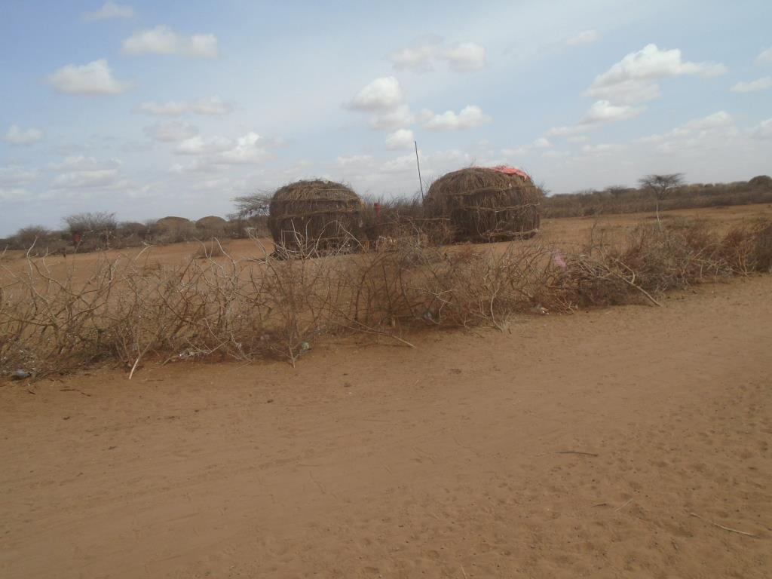
Plate 2. Infrastructure in the area: Manyattas

Sanitation: Open defecation (OP) is widely practiced in the village. There are however few private toilets in the school, dispensary, and Mosque. Waste management is poor.
Road Network: Roads connectivity within the area is also poor and not regularly maintained. The main forms of transport within the area are Motor bikes, taxis and Matatus; that is pro-boxes, while donkeys and camels also provide alternative modes of transport especially while carrying load. The community is along an earth road from Wajir to Moyale.
Mobile Network Coverage: Safaricom is the only Network coverage within the village and majority of people have access to the internet services.
Power/electricity: - the community is not connected to the mains. The population use mainly portable solar at the household for charging mobiles and lighting especially within the centre. Kerosine is also used for lighting homes.

STAKEHOLDER ENGAGEMENT
This section profiles the key stakeholders for the Yaqo site solar project and assesses their potential concerns and levels of influence. The process of stakeholder engagement involved.
- Stakeholder identification and analysis
- Planning how the engagement with stakeholders will take place.
- Disclosure of information.
- Consultation with stakeholders
- Addressing and responding to grievances; and
- Reporting to stakeholders

Stakeholder Consultation and Disclosure Requirement for the Project
The World Bank Environmental Social Safeguards 10 emphasizes on engagement in meaningful consultations with all stakeholders. The stakeholders with timely, relevant, understandable, and accessible information consult with them in a culturally appropriate manner, which is free of manipulation, interference, coercion, discrimination, and intimidation.
A documented record of stakeholder engagement, including a description of the stakeholders consulted, a summary of the feedback received, and a brief explanation of how the feedback was considered is in place.

Stakeholder Characterization and Identification
A stakeholder is “a person, group, or organization that has a direct or indirect stake in a project/organization because it can affect or be affected by the Project/organization's actions, objectives, and policies” Stakeholders thus vary in terms of degree of interest, influence and control they have over the project.
Stakeholders are classified in the following two categories.
- Project affected Persons - Stakeholders who have a direct impact on or are directly impacted by the project.
- Interested Parties - Stakeholders who have an indirect impact or are indirectly impacted by the project.
In line with the nature of the project and its setting in Yaqo the stakeholders have been identified and listed in the table given below.
Table 13: Identified Stakeholders
Stakeholder Groups | Project affected Persons | Interested Parties
Community | Local Laboure’s  Land sellers | VMG’s  Pastoralists  Local Community
Institutions | Faith Based Organizations  Education institutions  Community Based organizations
Government Bodies | NEMA  County Government  District and local administration

Stakeholder Mapping
Stakeholder mapping” is a process of examining the relative influence that different individuals and groups have over a project as well as the influence of the project over them. The purpose of a stakeholder mapping is to:
- Identify each stakeholder group.
- Study their profile and the nature of the stakes.
- Understand each group’s specific issues, concerns as well as expectations from the project
- Gauge their influence on the Project.
The significance of a stakeholder group is categorized considering the magnitude of impact (type, extent, duration, scale, and frequency) or degree of influence (power and proximity) of a stakeholder group and urgency/likelihood of the impact/influence associated with the stakeholder group in the project context. The magnitude of stakeholder impact/influence is assessed taking the power/responsibility and proximity of the stakeholder group and the group is consequently categorized as negligible, small, medium, or large. The urgency or likelihood of the impact on/influence by the stakeholder is assessed in a scale of low, medium, and high. The overall significance of the stakeholder group is assessed as per the matrix provided in Table below.
Table 14: Stakeholder Significance and Engagement Requirement
 |  | Likelihood of Influence on/ by Stakeholder
 |  | Low | Medium | High
Magnitude of impact | Negligible | Negligible | Negligible | Negligible
Magnitude of impact | Small | Negligible | Minor | Moderate
Magnitude of impact | Medium | Minor | Moderate | Major
Magnitude of impact | Large | Moderate | Major | Major

Stakeholder Analysis
The table below has been used to classify the identified stakeholders (directly or indirectly impacting
the project) in accordance with their levels of influence on the project. The influence and priority have
both been primarily rated as:
- High Influence: This implies a high degree of influence of the stakeholder on the project in terms of participation and decision making or high priority to engage with the stakeholder.
- Medium Influence: Which implies a moderate level of influence and participation of the stakeholder in the project as well as a priority level to engage the stakeholder which is neither highly critical nor are insignificant in terms of influence; and
- Low Influence: This implies a low degree of influence of the stakeholder on the project in terms of participation and decision making or low priority to engage that stakeholder.

The intermediary categories s of low to medium or medium to high primarily imply that their influence
and importance could vary in that range subject to context specific conditions or also based on the responses of the project towards the community.

The coverage of stakeholders as stated above includes any person, group, institution, or organization that is likely to be impacted (directly or indirectly) or may have interest/influence over project. Keeping this wide scope of inclusion in stakeholder category and the long life of project, it is difficult to identify all potential stakeholders and gauge their level of influence over project at the outset of the project. Therefore, the project proponent is advised to consider this stakeholder mapping as a live document which should be revised in a timely manner to make it comprehensive for any given period.

KEY FEEDBACK RECEIVED DURING STAKEHOLDER CONSULTATION PROCESS

A Consultative Public Participation (CPPs) session is conducted to provide project information and facts to the local community and other stakeholders especially local government administrator thus giving them a platform to enable them to express their appreciation, concerns and fears as well as contribute ideas and opinions towards the project sustainability.
A detailed CPP and community engagement for Yaqo Solar Mini Grid was held at Yaqo village on 19th October 2021 chaired by the area chief, Chief Abdi Ali Maalim.

During the consultative forum, there were remarks from various key personnel including the following.

Area Chief’s Remarks
Chief of the Area, Mr. Abdi Ali Maalim, after having mobilized the community members, gathered everyone under a tree and opened the Baraza with a word of prayer. He together with Mr. Hassan then briefly informed the gathering about KOSAP projects, importance, and possible impacts. He then welcomed the members and urged then to fully participate in the discussions.

Consultant’s Remarks
The Consultant elaborated on the possible socio-economic impacts of the project to the residents of Yaqo and requested the participants to give information for documentation. The consultant with assistance from the Area Chief guided the Focused Group Discussions.

Positive Comments about the Project from the Participants
Some of the positive impacts that were identified by the participants include the following.
- Learning will improve due to availability of lighting
- Security will improve due to availability of lighting
- Medical services will improve due to availability of refrigeration services
- The electricity will assist in pumping of water from any storage facilities
- Business opportunities will improve since farmers will be able to cool their milk, welding business, phone charging business will arise
- Employment opportunities will increase for the youth due to increase in business opportunities

The identified negative impacts of the project
Some of the positive impacts that were identified by the participants include the following.
- Accidents: some of the members raised concerns of possible accidents from electrocution especially the children and animals as well as possible accidents from falling of the electric poles. The community suggested extra care when, protection of appliances and reinforcement of electric poles to mitigate these accidents.
- Dust Generation: The participants expressed concern over possibility of generation of large amounts of dust within the project site and surrounding areas because of demolition, excavation works and transportation of building materials. The proponent will ensure that dust levels at the site are minimized through sprinkling water in areas being excavated and along the tracks used by the transport trucks within the site. Additional Enhancement Measures presented in this report will be fully implemented to minimize the impacts of dust generation.
- Employment Disputes: There was a concern over the possibility of disputes arising between the local communities with people of different cultures and probably from other areas in the construction sites. The community suggested that proponent should consider employing local construction workers.
- Environmental Aesthetics It was seen that the aesthetics of the area would be affected negatively during construction. It was suggested that the proponent should ensure landscaping is conducted after construction.

- Environmental Aesthetics: Some neighbors will be affected by too much noise and exhaust fumes from the site.
Other concerns
- Questions were also raised on whether the labor and raw materials will be sourced from the community.
- A question was raised on the presence of an electrical engineer in case of a fault

Consultant’s Response
The consultant while addressing the community’s issues raised, gave the following response.
- All non-skilled labor will be sourced from the Yaqo Community and not from outside
- All maintenance works will be supervised by engineers assigned for that purpose.
- He assured the community that the project will commence soon after ESIA and all bidding is done.
- That noise form the Machinery will be minimized
- Every resident, business or public facility will be connected to the electricity at an affordable cost
- That the Contractor/KOSAP will rehabilitate and plant trees after the construction phase of the project

Consent
The Community members present agreed unanimously accepted the Project Proposal.

Community Presentation

Adult to youth Representation
During the stakeholder’s consultation adults were more represented than the youth as shown in the diagram below.
Figure 6: Adult/Youth representation

Gender Representation

With Gender representation, the women were slightly higher than men as shown below
Figure 7: Gender representation

Heads of Households
Male were the household heads during the stakeholder consultation

Focused Group Discussions analysis
The in-depth interviews were used as a tool for stakeholder identification and mobilization as well as collection of baseline data to enable identification of the likely project impacts. In addition, it provided an opportunity to the participants to raise their fears and concerns as well as make recommendation as pertains to the project.
During the discussions, information was gathered different roles, livelihood, health issues, challenges, perception of quality of life, education options for children, health care and project perception.
The consultative meeting had a wide representation as follows:
Table 15: The consultative meeting had a wide representation
Category | Male | Female | Total
Youth | 10 | 0 | 11
Adult | 10 | 16 | 26
TOTAL | 20 | 16 | 36
The target groups of the FGD were Males, Females, Health sector, Education sector as well as and the Youths.

Female Stakeholders’ Consultation and Participation
The females’ participants in the FGD were N=10 and between 30-7O years of age. There were no female headed households in the meeting. However, community members stated that there is a number of families headed by women. The following were their responses.
The project perception
The women indicated that the project would have a positive impact in their lives through provision of lighting especially to be used by children for homework, and power for lighting at night.
Women in Yaqo community and their roles as reported by the FGD
- Fetching of firewood and water.
- Cooking and other house chores
- Women and men do not have equal opportunities in the community however, Women control household equipment while male control livestock and other major assets.
- Women feel safe in the community and level of crime is low. No conflict is experience
- The challenges encountered by women include inadequate water, lack of proper sanitation, high levels of illiteracy.
- Women receive information about local issues and development or news through radios and from the local chief. A few receive information through phone calls
- Women are currently involved in herding of livestock. They are also involved in decision making of various issues in the community
Institutions/community Development
- The women reported that there are no NGOs working with Yaqo community. The main community development priorities/needs include.
  - Improvement of availability and accessibility of water
  - Create and Enhancement of health care services and facilities
Economy /income generation by women
- At the household level, women contribute less income than men
- Women earn income from sale of milk and firewood
- The women have no access to any bank/credit/saving accounts in Yaqo. They only use Mpesa services
Land use by women
- Community members are nomadic and move with their livestock in search of water and pasture during the dry seasons.
- Women collect natural resources like firewood for both domestic use and commercial purposes
- So far, no conflict has been experienced in the community.
- There are no land activities undertaken
- No agriculture (crop growing) is practiced in the village by women
- The livestock (goats and sheep, cattle camels, and donkeys) are reared for both subsistence and income generation.
- Women in the FGD did not indicate cases of gender-based violence (GBV) at household level.
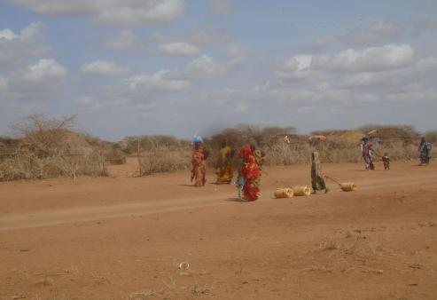

Plate 1: Women Fetching Water

Education, literacy, and training of Women in Yaqo
- The women denoted that they education among women is relatively good.
- A few women can read and write in the community especially the young adults and girls.
Health care for Women in Yaqo
- The women do not have access to health care
- The main health problems/challenges facing women include inadequate ulcers, typhoid and infections.
- The women have no access to family planning
- Environmental issues affecting health in the community is mainly poor sanitation because of inadequate water and use of bush toilets leading to diseases.
- There are some people leaving with disabilities and lack specialized homecare. Family membe do organize for medical practitioner to visit them
- Most of the Community members use traditional medicine.
Access to Water by women
- The community is served by water pans.
- During dry season water is not sufficient
- The water is not of good quality and is turbid with dust particles and suspension.
- During the dry season when the water levels are low the women trek with donkey carts for long distances in search of quality water for domestic use and livestock watering.
Sanitation and hygiene for women
- The main types of toilets in the village are pit latrines. However, this is only seen in institutions. Open defecation was heavily reported by the FGD.
Hygiene and waste management by Women
- Women in Yaqo access do not have access to sanitary facilities such as sanitary towels. Due to low income most of them cannot afford.
- Household waste is dumped in compost pits.
Access to Power as per the FGD
- Sources of energy and their uses in Yaqo village include
- For lighting use of kerosine lantern and torches using batteries
- For warming they use charcoal
- Cooking -wood fuel
- Charging mobile-a few uses portable solar, however, very few have access.

- The village has limited sources of power as the main challenge.
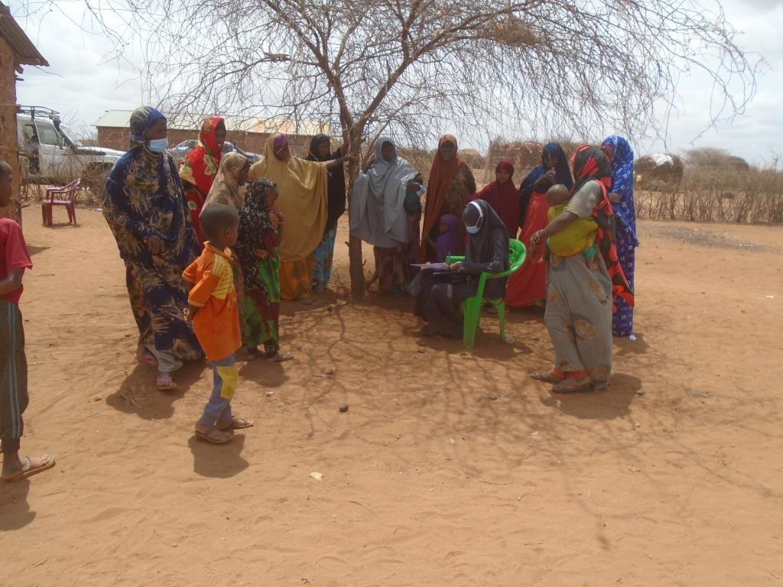
Plate 2. FDGs for women

Transport and communication
- The main forms of transport are vehicles(Probox vehicles), motor bikes, donkey carts and camel
- The village is served by an earth road that is impassable during dry and wet seasons
- The area is severed with Safaricom service provider as the dominant means of communication
Cultural heritage
- The area has no cultural heritage

Male Stakeholders’ Consultation and Participation
- The male participants were N=10 in number between 35-80 years of age. The male participants are household heads. The following were the response during the male FDG.
The project perception
- The men indicated that they had heard about the project
- According to the male the project would have positive impact such as provision of power for cooling their milk and other drinks thereby boosting micro-business; provision of lighting at homes, schools, and health facilities and that these will greatly help the children to study at night.
- No negative effect was highlighted by the men.
Role of Men as per the FGD
- The findings showed that the roles of men are mainly leading in community projects, herding, and watering of livestock, providing leadership and security at the household level and the youth, giving advice to the younger generation.
- They indicated that women and men have equal opportunities in the community
- Men have more control over livestock than women
- Men generally feel safe in the community
- The main challenges encountered by men in Yaqo community mainly include drought which greatly affect the animals thus forcing them to trek for long distances in search of water and pasture.
- Men generally receive information about local issues and development or news through radios, word of mouth and phone calls
- Men do not have any cultural groups.
- Their top three community development priorities include water, health and construction of sanitation facilities.
Economy /income generation
- Men generally earn their income through sale of livestock and livestock products, retailing of goods and sale of agricultural products like watermelon and maize.
- Men have greater economic opportunities than women due to their more control over livestock which they sell to get income. They are also the designated family providers.
- They however have no major credit facilities within the area and reply primarily on their savings through M-Pesa.
Land use
- Community members are nomadic- moving with livestock in search of water and pasture especially during the dry seasons.
- Men in Yaqo grow crops during heavy rains season. These products are consumed within the households and a few are sold to Eldas and Wajir. However, for the last five years, there has been a huge change due to prolonged drought thus discouraging farming.
- Men keep livestock both as subsistence and income-generating activities. Livestock reared include cattle, camels, sheep, goats, donkeys as well as local chicken but in small numbers.
- The men are also involved in collection of natural resources like fruits, herbs and other medicines from the nearby vegetation covers. Collection of firewood is mainly done by women.
- According to the men FGD, land-conflicts are not experienced within the communities.
Education, literacy, and training as per the FGD
- Ability to read and write among the male population is generally high.
- Yaqo Primary school within the village center provides access to formal basic education and madrasas for Islamic education and studies.
- The male population generally completes their studies up to grade 8.
- The factors preventing men from accessing further education include lack of school fees due to high levels of poverty, responsibilities like livestock rearing and lack of enough schools.
Health care analysis by the male FGD
- The men access health care from Eldas dispensary. There are no health facilities at Yaqo. The services provided are satisfactory to men needs but the distance is huge.
- The dominant health issues among men include pneumonia, ulcers and livestock rated diseases.
- The PLWDs are present among the male population and are mostly managed at home and only taken to a health facility at Eldas during complications. Reading Quran was also another method stated by the men.
Access to Water analysis by the male FGD
- The men are responsible for searching water to be provided to the livestock while women collect water for both livestock use a domestic use. At Yaqo, men also help in fetching water.
- The men access water from the community water pans and have no boreholes. During dry seasons, the community buys water from water vendors.
Sanitation and hygiene according to Male FGD
- The main types of toilets are pit latrines.
- Men indicated that open defecation is commonly practiced as an alternative where access to latrines is impossible.
Hygiene and waste management
- Hand washing and general cleaning are done by use of basins from fetched water
Access to Power
- Sources of energy for Yaqo village
- For lighting use of solar gadget
- For warming they use firewood
- Cooking -firewood
- Charging mobile phones-solar
- The village has limited sources of power since the solar power which they mostly rely own since access to maintenance is limited and the systems are of low standards.
- The men suggested that the solar energy system need improvement.
Transport and communication
- The main form of transport is vehicles, motorbikes, donkey carts and camel
- The village is served by an earth road that is impassable during dry and wet seasons
- The area is severed with Safaricom service provider as the dominant means of communication. Strictly men use for calls but youths use for internet connection.
Religious heritage
- Mosques are the main religious sites within Yaqo community.
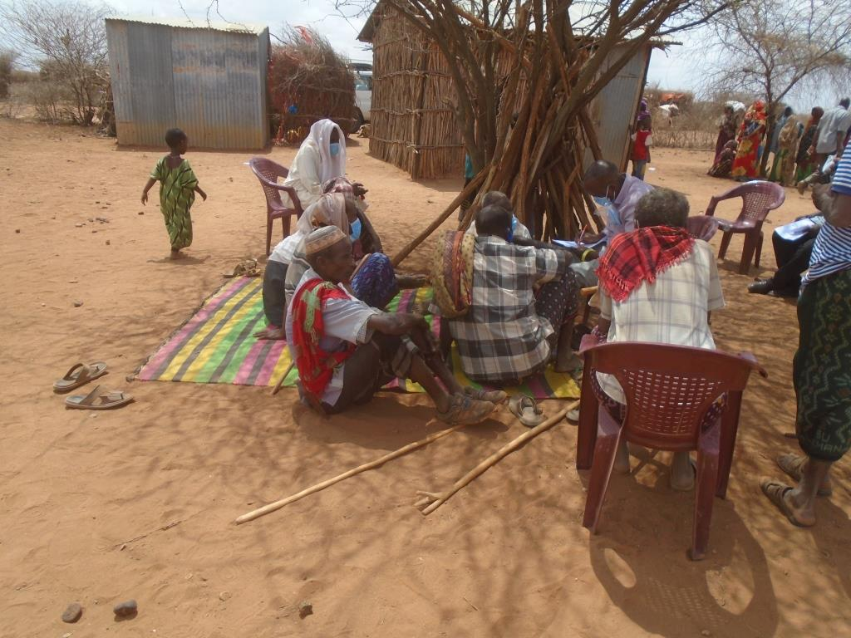
- The main festivals undertaken by men include religious festivities e.g., Idd, weddings and prayers for the rain.
Plate 3. FDGs for men

Youth Stakeholders’ Consultation and Participation
- The youth participants were 10 in number, and all were males. The following opinions were provided by the youth participants during the FDG.
The project perception
- The youth disclosed that they were aware and understood the importance of the project to the community. They also said that they have had such projects in other towns.
- They suggested that the project had positive impact since power will be available for lighting, refrigeration services for water cooling and improved security of the area. They also indicated that they will be able to also charge their phones.
- They denoted on the disposal of electrical components to the environment causing pollution.
Role of Youth
- The youth said that they generally involved in decision making.
Institutions/community Development
- The community do not have any Youth Group and no development or aid programmes of youth within the community.
Economy /Income Generation/Employment
- Forty per cent (30%) of the respondents are self-employed while about (0%) have full-time salary jobs
- The income-generating activities pre-dominant among youth in Yaqo include trading in livestock especially goats, firewood collection, construction work.
Education, literacy, and training for youth FGD
- About 15% the youth respondents have completed secondary education while about 5% have completed Vocational/College level education.
Health care as per FGD
- The youth access health care from Eldas town.
Key Priorities among the Youth
- The Youth top three priorities include provision of clean drinking water, provision of adequate sanitary/toilet facilities, and employment opportunities.
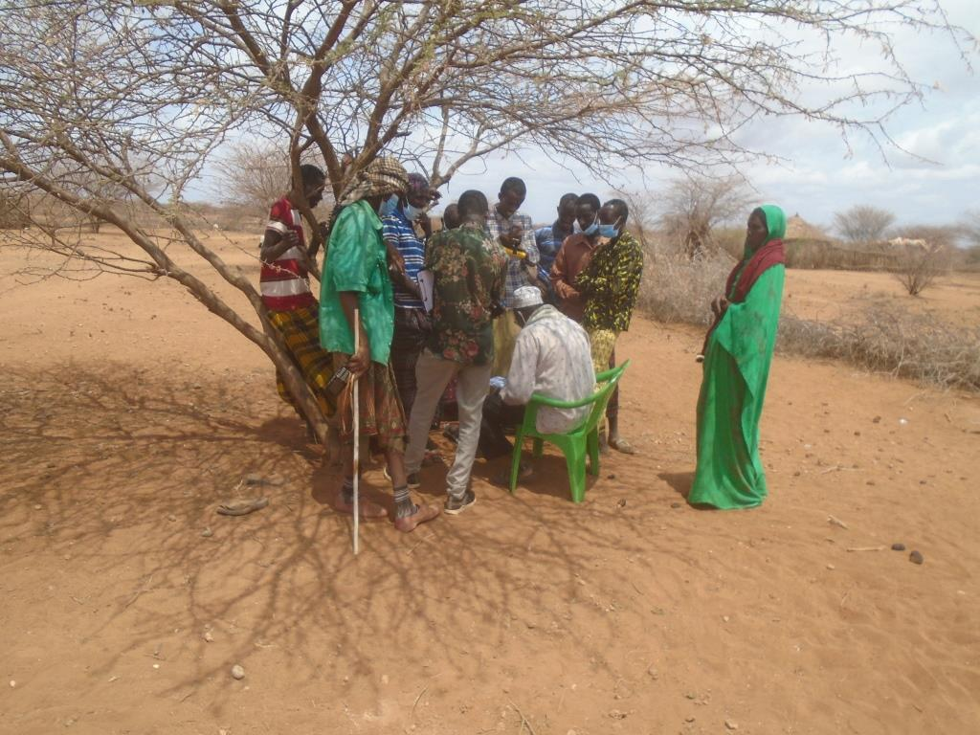
Plate 4: FDGs for Youth

Education Stakeholders’ Consultation and Participation
- The Education Stakeholder in Yaqo was the teacher at Yaqo Primary School which is a government sponsored institution. The teacher has worked at the school for 8 years. The following are his responses during the KII:
The project perception
- He heard about the project before and states that its similar to the one at Basir Area.
- He indicated that the project would have a positive impact to the school through access of electricity that will provide light especially in the evening study/preps by pupils.
- There was a question on whether the project will create job opportunities for the youth.
Infrastructure/Resources
- Yaqo Primary School currently has 6 teachers; 3 are employed by the TSC, 2 are employed through county government.
- The challenges facing the school include inadequate water (water is collected from water pans or bought from water vendors), lack of electricity and lack of teachers.
- The school receives no support from the national government.
- The average walking distance of student to school is 1Km. The furthest student walks a distance of about 30minutes from home
- The Head teacher indicated that the school has a feeding programme done by the government.
- Teachers receive their salaries from banks 140km away in Wajir town.
The School Curriculum
- The teacher pointed out that school attendance is sometimes low as pupils migrate with families in search of pasture and water.
- The performance of boys is generally better than girls according to the Head teacher.
The School Attendance
- 100 pupils: 70 boys and 40 girls.
- School attendance rate for male is 30% and that of female is 30% as well as described by the school teacher.
- The completion rate for male students attending school is 4% compared to 3% of female.

Figure 8: School Enrolment and School Completion rate

Health Stakeholders’ Consultation and Participation
- The health Stakeholder consultation and participation was not done since there was no medical practitioner or a facility for the same.

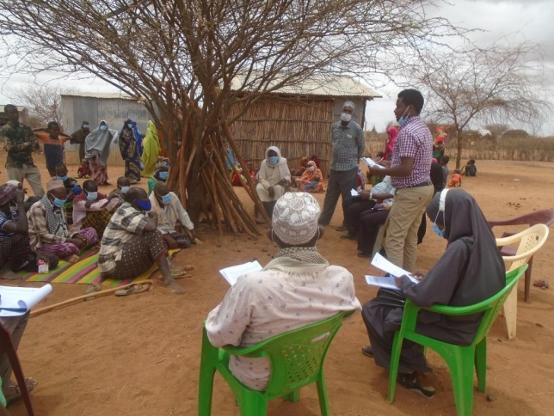
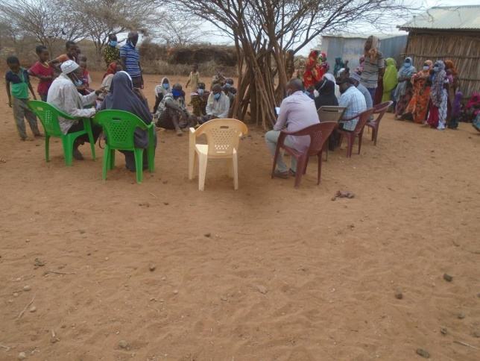
Plate 5. Consultants Addressing the Barazas/Community Members.

GRIEVANCE REDRESS MECHANISM

Introduction
Grievance mechanisms should receive and facilitate resolution of the affected institutional or communities’ concerns and grievances. Community concerns should be addressed promptly using an understandable and transparent process that is culturally appropriate and readily acceptable to all segments of affected communities, at no cost and without retribution. Mechanisms should be appropriate to the scale of impacts and risks presented by a project. Grievances can be an indication of growing stakeholder concerns (real and perceived) and can escalate if not identified and resolved. The management of grievances is therefore a vital component of stakeholder management and an important aspect of risk management for a project. Projects may have a range of potential adverse impacts to people and the environment in general, identifying grievances and ensuring timely resolution is therefore very necessary. As such the project has developed a grievance management process to serve as a guide during project implementation.
The constitution of Kenya section 159, Land and Environmental Court Act 2011, National Land Commission Act 2012, and Land Act 2012 advocates for alternative dispute resolution mechanisms before seeking formal legal redress in disputes relating to environment, land, and resettlement. In practice this can be the village head and other local or traditional dispute resolution mechanisms.
The Land Act 2012 and National Land Commission Act 2012 obligate the NLC to support grievances and disputes related to resettlement or land amicably in conjunction with the implementing agencies-KPLC/REREC. KPLC/REREC will be expected to put in place mechanisms and structures that arbitrate or negotiate with PAPs whenever there are any grievances concerning land or environment.

Grievance Mechanism
One of the key roles of the Grievance Redress Committees, will be to address disputes led by the administrative chiefs. All PAPs will be informed how to register grievances or complaints, including specific concerns about land and environment. The PAPs will be informed about the dispute resolution process, specifically about how the disputes will be resolved in an impartial and timely manner. Environmental and Land Court will provide opportunity for appeal when a solution will not be found using the established local mechanisms. The court will deal with land related disputes. However, the Land Act 2012 and Environment and Land Court Act 2011 advocates for Alternative Dispute Resolution (ADR) methods in tackling land related disputes. Alternative dispute resolution approaches will be given preference and based on customary rules, arbitration, or third-party mediation. ADR will be promoted or defended as a resolution to disputes related to land

National Grievances Redress Committee (NGRC)
NGRC has been established at the National level to ensure participatory and transparent implementation of the project. The NGRC will help the project carry out its mandate efficiently- particularly ensuring effective and amicable settling of disputes among the communities/PAP’s.
Members to NGRC include representation from the following agencies and entities
- Representative from the Ministry, chair of the Committee
- Representative from NLC to handle matters that involve land take
- Representative of the Implementing Agencies (IA)-KPLC and REREC
- Representative from the Ministry’s Legal office to guide on Alternative Dispute Resolution methods
- Representative from the County Grievance Redress Committee-depending on the matter at hand; Land or Environment
- Representative from Gender and Social Development Office who will be responsible for ensuring gender issues are well addressed.
- Representative from NEMA to handle environmental issues
- County Surveyor/Physical planner from the county Lands office
- Project Affected Person’s-to represent the matter before the committee

Functions of the National Grievances Redress Committee
- Ensuring effective flow of information between PAPs, the implementing agency and the County Grievance Redress committee on matters brought before the committee
- Co-ordinate County Grievance Redress Committees (LGRC)
- Co-ordinate activities between the various organizations involved; facilitate grievance and conflict resolution at the highest level
- Resolving disputes that may arise within the project. If it is unable to resolve any such problems, the PAP’s can seek legal redress.

County Grievance Redress Committees (CGRC)
CGRC has been established at the county level to ensure participatory and transparent implementation of the project. The CGRC will help the project carry out its mandate efficiently- particularly ensuring effective communication with the communities.
Members to CGRC will include representation from the following agencies and entities
- Representative of NLC, to grant legitimacy to the acquisition process and ensure that legal procedures as outlined in Land Act 2012
- Representative of the implementing agency
- Representative of NEMA to handle environmental issues
- The County Administration representative, which will provide the much-needed community mobilization, and support to the sub-project.
- County Land Survey Officer will survey all affected land and produce maps.
- The County Gender and Social Development Officer who will be responsible for ensuring gender programs are adhered to.
- The County Lands Registrar will verify all affected land and validate the same.
- Two PAP representatives from Location Grievance Resettlement Committee – act as voice for the PAPs
- NGOs and CBOs locally active in relevant fields

The CGRC will have the following specific responsibilities:
- Ensuring effective flow of information between PAPs and the implementing agency
- Coordinate Locational Grievance Redress Committees (LGRC)
- Coordinate activities between the various organizations involved; facilitate grievance and conflict resolution; and provide support and assistance to vulnerable groups.
- Conducting extensive public awareness and consultations with the affected people so that they can air their concerns, interests, and grievances.
- Resolving disputes that may arise within the project. If it is unable to resolve any such problems, channel it to the National Grievance Redress committee before utilizing the appropriate formal grievance procedures.

Locational Grievance Redress Committee (LGRC)
Since counties are large, further decentralized Grievance Redress Committee will be formed at the location of the sub-project. Subsequently, Locational Grievance Redress Committees (LGRC’s), based at each location of a sub-projects, will be established. The LGRC’s will be constituted by implementing agencies and representatives of CGRCs through consultation with the PAPs and will act as the voice of the PAPs.
The LGRCs will work under guidance and coordination of CGRC and the implementing agencies. Their membership will comprise of the following:
- The locational Chief, who is the Government administrative representative at the locational unit and who deals with community disputes will represent the Government in LGRC
- Assistant Chiefs, who supports the locational Chief and Government in managing local community disputes in village units will form membership of the team.
- Female PAP, elected by women PAPs, will represent women and children related issues regarding the project
- Youth representative, elected by youths, will represent youth related concerns in the LGRCs
- Male representatives elected by the members of the PAPs
- Vulnerable persons representative will deal and represent vulnerable persons issues in the LGRCs.
- CBO representatives
Membership of LGRCs will be elected by each category of PAPs except the locational Chief and assistant chiefs who will be automatic members of the team by virtue of their positions. Each of LGRCs will elect their own chairperson and a secretary among themselves.
The roles of LRCCs will include among others the following:
- Conducting extensive public awareness and consultations with the affected people.
- Help ensure that local concerns raised by PAPs as regards to the project are promptly addressed by relevant authorities.
- Resolve manageable disputes that may arise relating to the project. If it is unable to resolve/help refer such grievances to the CGRCs instituted.
- Ensure that the concerns of vulnerable persons such as the disabled, widowed women, orphaned children affected by the sub project are addressed.
- Assist the community in recording grievances, including helping those who cannot write or read.
- Help the vulnerable groups access project benefits
- Ensure that all the PAPs in their locality are informed about the project
Figure 9. KOSAP Grievance Redress Mechanism
Arbitration

National Grievance Redress Committee
County Grievance Redress Committee (CWG’s)
Locational Grievance Redress Committee
Community Liaison Officer (Contractor) & County Renewable Energy Officer (CREO)

It should be noted that if complainants are not satisfied with the grievance process, even after arbitration they have the right to present their complaint through the court system.
It is expected that most disputes will be resolved at the lowest level-Locational Grievance Redress Committee and since most disputes arise during the Construction and operation period the contractor’s Environmental and Social Safeguard team specifically the Community Liaison Officer will work closely with the community to be able to resolve disputes
Responsibilities of the Community Liaison Officer include.
- Monitor day to day Implementation of the Project
- Address grievances as they arise on the project
- A member of the Locational and County Grievances Redress Management Committee to respond on issues that may have been brought to the attention of the committee before escalating to the National Grievance Redress Committee
- Escalate grievances internally to get a lasting solution

IMPACT ASSESSMENT AND ENHANCEMENT MEASURES

Identification of Impacts
This Section identifies and discusses both negative and positive impacts associated with the proposed construction of solar Mini-grid. The impacts are identified across all the phases namely: Pre-construction Phase, Construction Phase, Operational Phase and Decommissioning Phase.

Identification of project’s positive and negative environmental impacts was done through observations, literature review, consultations and use of experts’ analysis. The positive impacts are presented first then the negative impacts and their Enhancement Measures.

Impact Assessment Methodology
An impact is essentially any change to a resource or receptor brought about by the presence of the Project component or by the execution of a Project related activity. In general, the assessment of impacts will proceed through an iterative process considering four key elements:
- Prediction of potential impacts and their magnitude (i.e., the consequences of the development on the natural and social environment);
- Evaluation of the importance (or significance) of potential impacts taking the sensitivity of the environmental resources or human receptors into account;
- Development of Enhancement Measures to avoid, reduce or manage the potential impacts or enhancement measures to increase positive impacts; and
- Assessment of residual significant impacts after the application of mitigation and enhancement measures.
Where significant residual impacts remain, further options for mitigation may be considered and impacts re-assessed until they are as low as reasonably practicable for the Project and would be deemed to be within acceptable levels:

Defining Impact
Impacts will be defined in a number of ways, including:
- Nature of impact: positive or negative;
- Type of impact: direct, indirect, or cumulative;
- Duration of impact: temporary, short-term, national, international
- Scale of impact: onsite, local, regional, national, international.

Assessment of Significance
Criteria for assessing the significance of impacts will stem from the following key elements:
- Status of compliance with relevant Kenyan legislation, policies and plans and any relevant Kenyan or industry policies, standards or guidelines, as well as international best practice standards and guidelines;
- The magnitude (including nature, scale and duration) of the change to the natural or socioeconomic environment (e.g. an increase in coastal erosion, or an increase in employment opportunities), expressed, wherever practicable, in quantitative terms. The magnitude of all impacts is viewed from the perspective of those affected by considering the likely perceived importance as understood through stakeholder engagement;
- The nature and sensitivity of the impact receptor (physical, biological, or human). Where the receptor is physical, the assessment considers the quality, sensitivity to change and importance of the receptor. For a human receptor, the sensitivity of the household, community or wider societal group is considered along with their ability to adapt to and manage the effects of the impact; and
- The likelihood (probability) that the identified impact will occur. This is estimated based upon experience or evidence that such an outcome has previously occurred.
It is generally accepted that significance is a function of the magnitude of the impact and the likelihood of the impact occurring.
For this assessment, significance has been defined in Table 8-1 based on five levels described in table below;
Table 7-1: Categories of Significance
Category | Significance
Positive impacts | Positive impacts provide resources or receptors, most often people, with positive benefits. It is noted that concepts of equity need to be considered in assessing the overall positive nature of some impacts such as economic benefits, or opportunities for employment
Negligible impacts (or Insignificant impacts) | Negligible impacts (or Insignificant impacts) are where a resource or receptor (including people) will not be affected in any way by a particular activity or the predicted effect is deemed to be ‘negligible’ or ‘imperceptible’ or is indistinguishable from natural background variations.
Minor | An impact of minor significance (‘Minor impact’) is one where an effect will be experienced, but the impact magnitude is sufficiently small (with or without mitigation) and well within accepted standards, and/or the receptor is of low sensitivity/value.
Moderate | An impact of moderate significance (‘Moderate impact’) is one within accepted limits and standards. Moderate impacts may cover a broad range, from a threshold below which the impact is minor, up to a level that might be just short of breaching a legal limit. Clearly to design an activity so that its effects only just avoid breaking a law and/or cause a major impact is not best practice. The emphasis for moderate impacts is therefore on demonstrating that the impact has been reduced to a level that is ALARP (as-low-as-reasonably-possible). This does not necessarily mean that ‘Moderate’ impacts have to be reduced to ‘Minor’ impacts, but that moderate impacts are being managed effectively and efficiently.
Major | An impact of major significance (‘Major impact’) is one where an accepted limit or standard may be exceeded, or large magnitude impacts occur to highly valued/sensitive resource/receptors. An aim of EIA is to get to a position where the Project does not have any major residual impacts, certainly not ones that would endure into the long-term or extend over a large area. However, for some aspects there may be major residual impacts after all practicable mitigation options have been exhausted (i.e., ALARP has been applied). It is then the function of regulators and stakeholders to weigh such negative factors against the positive ones in coming to a decision on the Project.

For environmental impacts the significance criteria used in this ESIA is shown in Table 8-2:
Table 7-2: Overall Significance Criteria for Environmental Impacts
Receptor sensitivity | Impact Magnitude
Receptor sensitivity | Low | Medium | High
Low | Minor | Minor | Moderate
Medium | Minor | Moderate | Major
High | Moderate | Major | Major

For the social impact assessment, the perceptions of stakeholders, expressed as opinions around certain issues, can be as important as actual impacts. Consequently, the concept of perception is explicitly brought into the evaluation of significance after an impact is evaluated. When an impact is of significant stakeholder concern, this may be causing to raise the significance rating. This prompts the formulation of more rigorous and appropriate Enhancement Measures which focus on the source of the impact and also address stakeholder perceptions. The risk of not addressing stakeholder perceptions is that reputational damage could arise, resulting in the loss of a ‘social license to operate.

Magnitude of Impact
The impact assessment describes what will happen by predicting the magnitude of impacts and quantifying these to the extent practical. The term ‘magnitude’ covers all the dimensions of the predicted impact to the natural and social environment including:
- the nature of the change (what resource or receptor is affected and how);
- the spatial extent of the area impacted, or proportion of the population or community affected;
- its temporal extent (i.e., duration, frequency, reversibility); and
- where relevant (accidental or unplanned events), the probability of the impact occurring.
For social impacts, the magnitude considers the perspective of those affected by taking into account the likely perceived importance of the impact, the ability of people to manage and adapt to change and the extent to which a human receptor gains or loses access to, or control over, socio-economic resources resulting in a positive or negative effect on their well-being (a concept combining an individual's health, prosperity, their quality of life, and their satisfaction).

Sensitivity of Resources and Receptors
Sensitivities are defined as aspects of the natural or social environment which support and sustain people and the physical environment. Once affected, their disruption could lead to a disturbance of the stability or the integrity of that environment. For ecological impacts, sensitivity can be assigned as low, medium or high based on the conservation importance of habitats and species. For habitats, these are based on naturalness, extent, rarity, fragility, diversity and importance as a community resource.
For socio-economic impacts, the degree of sensitivity of a receptor is defined as ‘a stakeholder’s (or groups of stakeholders’) resilience or capacity to cope with sudden changes or economic shocks. The sensitivity of a resource is based on its quality and value/importance, for example, by its local, regional, national or international designation, its importance to the local or wider community, or its economic value.

Likelihood
Terms used to define likelihood of occurrence of an impact are explained in Table 8-3 below.
Table 7-3: Explanation of Terms Used for Likelihood of Occurrence
An impact with a
High probability | Refers to a very likely impact | Refers to very frequent impacts
Medium probability | Refers to a likely impact | Refers to occasional impacts
Low probability | Refers to rare impacts | Refers to rare impacts
 | As far as one-time events (e.g., air emissions) or slowly developing effects  are concerned (e.g., impacts on local life  style) | As far as possibly recurring impacts are  concerned, such as accident or unplanned events (e.g., traffic accident,  fire)

Definition of Enhancement Measures
Enhancement Measures are developed to avoid, reduce, remedy or compensate for significant potential negative impacts, and to create or enhance potential positive impacts, such as environmental and social benefits. In this context, the term “Enhancement Measures” includes operational controls as well as management actions. These measures are often established through industry standards and may include:
- Changes to the design of the project during the design process (e.g., changing the development approach);
- Engineering controls and other physical measures applied (e.g., wastewater treatment facilities);
- Operational plans and procedures (e.g., waste management plans); and
- The provision of like-for-like replacement, restoration or compensation.
For potential impacts that are assessed to be of major significance, a change in design is sometimes required to avoid or reduce the significance. For potential impacts assessed to be of moderate significance, specific Enhancement Measures such as engineering controls are often sufficient to reduce these impacts to ALARP (‘as-low-as-reasonably-possible’) levels. This approach takes into account the technical and financial feasibility of Enhancement Measures. Potential impacts assessed to be of minor significance are usually sufficiently managed through good industry practice, operational plans and procedures.
In developing Enhancement Measures, the first focus is on measures that will prevent or minimize potential impacts through the design and management of the Project rather than on reinstatement and compensation measures.

Positive Impacts During Construction Phase
This section enumerates and discusses the positive impacts associated with the proposed project during construction phase of the project.

Creation of Employment Opportunities
Various employment opportunities will be available during construction. The opportunities will be both skilled and unskilled. Majority of the unskilled and semi-skilled jobs will be taken up by the local community. Employment of the locals will increase skill transfer from the contractors.
The approximate number of workers to be employed by the proposed project is not yet known, however, this will contribute to easing unemployment level in the area. There will be a trickledown effect to the economy at large resulting from new income revenues as well as services provided through this project.

The impact significance is low as it will employ few people over a short period

Mitigation
- Contractor should ensure that they prioritise the local community in allocating job opportunities.
- Contractor should ensure that job opportunities are not discriminatory
- Equal opportunities should be given to both men and women

Improving local economy
During this phase, the project will require supply of building materials most of which will be sourced locally at the nearest trading centre and its environs to the extent possible. Therefore, the project will provide ready market for local enterprises with such materials and boosts the local economy.

The businesses that will benefit during this phase are such as hotel, shops, artisan industries and food vending who will be benefit directly from the construction, as people working there will need commodities from them. This will promote the informal sector in securing some temporary revenues and hence improved livelihoods.
One of the responsibilities of the beneficiaries of the proposed Solar Mini-grid is to undertake wiring of their premises before there are connected and payment of a connection fee of Ksh 1000. The MOE through its implementing agency KPLC should consider supporting at least 50 households that are very poor through installation of ready boards to offset the cost of wiring so that they can also access electricity.
The impact significance is low as it will buy few materials over a short period of time

- KPLC should ensure that their contractors/suppliers remit taxes and have a tax compliance certificate
- Prioritise local purchases over imports.
- Remit taxes on behalf of employees
- Contractor should prioritise local purchases over imports;
- Contractor should give preference to local labour which increases the local’s ability to spend

Positive Impacts during Operation Phase

Quality, Reliable Power Supply
There is no electricity in Yaqo. This is a maiden project with an aim of supplying power through solar because the area is far away from the national power grid. Once operational, household and public institutions (dispensary, primary school) and shopping centre in the area will greatly benefit from the stable power supply.

The impact significance is high as it will provide power where it wasn’t for a long period

Mitigation
- KPLC should ensure that they have a functional customer support team and a field response team;
- KPLC should ensure that they communicate power outages early to consumers

Employment Creation
Employment opportunities will also be created during the operation phase of the project. Opportunities that will be created include unskilled, semi-skilled to skilled jobs. These will involve security personnel, and staff to operate and maintain the Mini-grid. Employment will increase skill transfers.

The impact significance is low as it will employee people to manage the substation

Mitigation
- KPLC should ensure that they prioritise the local community in allocating job opportunities.
- KPLC should ensure that job opportunities are not discriminatory
- Equal opportunities should be given to both men and women

Reduction of Pollution Associated with Thermal Power Generation, Kerosene and Wood Fuel Usage:
Residents in the area use different sources of energy. Electricity supply will imply that as many as are willing can apply for connection and get connected. This will result in reduced individuals and organizations using diesel generators, less reliance on kerosene, wood fuel and charcoal. This would mean less carbon dioxide is released to the environment and destruction of forests will be reduced hence decreasing greenhouse gases.

The impact significance is high as it will provide cleaner energy over a long period of time for many households

Mitigation
- KPLC should ensure that the power provided cost is competitive to discourage the locals from using unclean source of power.
- KPLC should ensure that they communicate power outages early to consumers

Improvement of Local and National Economy
The mini-grid project will ensure supply of a stable power that will reduce damage to the electronics and this will result in promotion of businesses both in the formal and informal sectors. Availability of power will enable businessmen to scale up their businesses while making it is possible to set up businesses such as salons, barber shops, photocopying machines, cyber cafes, welding, refrigeration of drinks among others. This will result in income improvements at the individual level and for the national economy. More customers will be connected and retail of reliable electricity by the power utility firm will attract increased tax revenues to the government.

The impact significance is low as it will buy few materials over a long period of time

Mitigation
- KPLC should ensure that their contractors/suppliers remit taxes and have a tax compliance certificate
- Prioritise local purchases over imports.
- Remit taxes on behalf of employees

Education
Access to electricity at the household level and schools will create opportunities for children be able to study even for longer hours. Additionally, children in households can also access education programs being aired through different radio and T.V. channels. Schools will be able to take advantage of information technology and communication that are becoming a way of life in education sector and learning in general.’
The impact significance is high as it will provide power to schools over a long period for additional study time in the night and morning

Mitigation
- KPLC should consider having the transmission lines are closer to schools for them to benefit from the power supply;
- KPLC should consider partnering with the county government in providing street lighting to improve security for children and teachers leaving for school early or leaving late for home

Health Benefits of the Project
Solar energy for lighting is better than kerosene lamps that are in use currently. This is because kerosene lamps emit particles that cause air pollution. The health risks posed by this indoor air pollution mainly include acute lower respiratory infections. Additionally, insufficient illumination (low light) conditions can cause some degree of eye strain and reading in these conditions over long periods of time may have the potential to increase the development of nearsightedness in children and adults. The project will result in many families replacing kerosene lamps for lighting with electricity there-by reducing chances of the afore mentioned disease incidences.

Improved Standard of Living
Availability of power will result in lifestyle changes through improved night lighting, pumping of water instead of manual pumping and refrigeration to maintain food safety and quality.

Security
The area will benefit from improved security since houses, businesses and public institutions will be well lit using electricity. This is as a result of more security flood lights bulbs which helps keep off opportunistic crimes including gender-based violence.

Communications
Access to electricity will lead to improved communication. This will be enabled by the fact that charging of mobile phones will be easier and cheaper. Access to mass media like radio and T.V will provide opportunity for the households to access a wide range of information which is useful for decision making.

Positive Impacts during Decommissioning Phase

Employment Opportunities
Once the project has served its purpose it will then be decommissioned. This will involve demolition and removal of the facility. During demolition, unskilled, semi-skilled and skilled employment opportunities will be available to the public.

Site Rehabilitation
After demolition of the proposed project, rehabilitation of the project site will be carried out to restore it to its original status or to a better state than it was. This will include replacement of topsoil and re-vegetation which will lead to restoration of the visual, vegetative and aesthetic state of the site.

Negative Impacts during Pre-construction Phase

Land Take
The identified site for the proposed Mini-grid is part of the land owned by the Yaqo community that they set aside. The assessment found that;
- No residential houses or businesses premises were on the piece of land
- No socio-economic activity was taking place on the land
- No physical relocation will take place.

Way Leaves
Supply of electricity will involve passing of low voltage (LV) lines to connect the customers to power.

The impact significance for this impact is assessed minor considering the community willfully allocated the land for project construction.

Enhancement Measures
- Land for mini-grids will be acquired by NLC compulsorily and affected communities compensated in-kind.
- The contractor will sign and adhere to the agreement for use of community land for contractor facilities and worker’s camps, and restoration of the site after use.
- The construction activities will be restricted to within the allocated land and the immediate surroundings only.
- After construction work, any land taken for a temporary basis for storage of material will be restored to their original form.
- Consultations with the community during construction of the low voltage lines

Negative Impacts During Construction Phase
Despite the positive impacts identified, the project will also have negative impacts. However, adverse impacts are not anticipated due to its size and nature and most of the impacts will be experienced during construction phase of the project. The negative impacts and their mitigation are discussed below.

Vegetation Clearance
The construction process of the proposed Mini-grid and other associated facilities and structures will involve clearing of the existing vegetation cover (mainly grass) and trees. The project site is located in open area with minimal settlement around besides the dispensary and residential homes. Both the magnitude and sensitivity of this impact will be low. The impact will be direct, permanent and minor.
Enhancement Measures
- Clear only the necessary areas
- Ensure proper demarcation and delineation of the project area to be affected by construction works.
- Specify locations for vehicles and equipment, and areas of the site which should be kept free of traffic, equipment, and storage.
- Designate access routes and parking areas
- Re-vegetation including planting of trees around the plant/facility

Soil Erosion Impact
During clearing of the area to pave way for groundbreaking soil erosion may take place. This will be due to surface run off or blowing away by the wind if not properly managed. This is bound to happen because the soil will be loose. The area is gently slopy on the lower side and surface run off can also result to soil erosion. The impact significance will be minor due to the nature of the works and the fact that construction activities will be confined in the small project area.
Enhancement Measures
- The contractor shall avoid groundbreaking during the seasons of high rainfall to avoid erosion.
- Monitoring of areas of exposed soil during rainy seasons to ensure that any incidents of erosion are quickly controlled.
- The contractor should ensure that construction related impacts like erosion and cut slope destabilizing should be addressed through landscaping and grassing, carting away and proper disposal of construction materials
- Use silt traps where necessary
- Cover soil stockpiles.
- Landscaping with grass on areas without electrical installation (lower areas)
- The contractor should ensure recovery of exposed soils with grass and other ground cover as soon as possible.
- The contractor should put up proper drainage to avoid unnecessary erosion and do compaction of spoil areas to avoid land instability in form of soil subsidence, slip and mass movement.
- Areas compacted by vehicles during site preparation and construction should be scarified (ripped) by the contractor in order to allow penetration of plant roots and the re growth of the natural vegetation

Contamination of Soil from Fossil Fuels
The potential sources of soil contamination during construction phase are oil /fuel leaks or spills from machinery used in site preparation and trucks used in transporting construction materials. Depending on the size and source of the spill, liquid and gaseous state, petroleum hydrocarbons may remain mobile for long periods of time, threatening to contaminate the soil. The significance of the impact to the soil will be minor due to the nature of the works and the fact that construction activities will be confined in the small project area.
Enhancement Measures
- Construction vehicles must be maintained in good state and proper servicing to ensure no oils are likely to leak
- Care must be exercised not to spill any fossil fuels
- Any contaminated soil shall be scooped and disposed-off appropriately.

Dust Emissions
Initial activities such as site clearing, excavation if done in dry weather conditions will result in dust pollution. Dust emission from construction machinery is regarded as a nuisance when it reduces visibility and is aesthetically displeasing. This is expected during construction works. Dust will be generated from construction earthworks, transportation activities and aggregate mixing.
The receptors were noted to be mainly residential and a health facility. The distances from a source that dust impacts can occur is highly site specific and will depend on the extent and nature of incorporated Enhancement Measures, prevailing wind conditions, rainfall and the presence of natural screening. Due to the variability of the weather, it is impossible to predict what the weather conditions will be when specific construction activities are being undertaken. Therefore, the assessment of construction dust impacts is typically qualitative.
Enhancement Measures
- The construction area should be fenced off to reduce dust to the public
- Sprinkle loose surface earth areas with water to keep dust levels down.
- Construction trucks moving materials to site, delivering sand and cement to the site should be covered to prevent material dust emissions into the surrounding areas;
- Masks should be provided to all personnel in areas prone to dust emissions during construction
- Stockpiles of excavated soil should be enclosed/covered/watered during dry or windy conditions to reduce dust emissions.
- Drivers of construction vehicles must be sensitized so that they limit their speeds so that dust levels are lowered.
- Trees can be planted around the plant provided they do not cast shadows to the solar panels to act as wind breakers and hence decrease dust pollution

Vehicle Exhaust Emissions
Exhaust emissions are likely to be generated by the construction vehicles and equipment. Motor vehicles that will be used to ferry construction materials would cause air quality impact by emitting pollutants through exhaust emissions. There are few Receptors (settlements) within 500 m of the project site and the impact magnitude will be medium and sensitivity medium hence the impact significance will be moderate.
Enhancement Measures
- Drivers of construction vehicles must be sensitized so that they do not leave vehicles idling so that exhaust emissions are lowered.
- Maintain all machinery and equipment in good working order to ensure minimum emissions of carbon monoxide, NO_{X}, SO_{X} and suspended particulate matter;

Pollution from Solid Waste Generation
It is expected that solid waste will be generated during construction phase of the project. Solid waste is anticipated to be produced during site preparation, civil works, spoil from excavations and will include; mortar, wood, paper, waste paper wrappings, conductor off cuts, masonry chips and left-over food stuffs. Effects of mismanaged waste include:
- Public nuisance due to littering or smell in case of rotting
- Contamination of soils and water courses
- Creation of breeding grounds for vermin like rodents and cockroaches
The significance of this impact will be minor due to the nature of the works and the fact that construction activities will be confined in the small project area.
Enhancement Measures
- Ensure spoil from excavations is arranged according to the various soil layers. This soil can then be returned during landscaping and then rehabilitation, in the correct order which they were removed that is top soil last;
- Segregate waste and dispose of appropriately using a licensed waste handler
- Provide litter collection facilities such as bins and create awareness campaigns to segregate as early as possible, using the appropriate bins
- Contractor to put in place and comply with a site waste management plan
- The contractor should comply with the requirement of OSHA ACT 2007 and Building rules on storage of construction materials
- Use of durable, long-lasting materials that will not need to be replaced as often, thereby reducing the amount of waste generated over time
- Recovery of materials remains and return to stores
- Re-use of materials where possible
- Proper budgeting to avoid waste generation

Impacts on Water Resources and Water Quality
During construction, excavation activities will involve soil exposure which results in soil erosion due to wind and surface runoff due to rains. Seepage from spilled fuels and oils and leaking machinery can also negatively impact groundwater water which could lead to potential contamination. Generally, due to the localized area of impact, the overall significance of the related impacts on water quality is considered to be minor, provided the necessary mitigation/ management measures are implemented. The people in Yaqo area use an earth dam as the main source of water and care must be exercised to avoid any pollution to the water source.

Enhancement Measures
Measures shall be put in place to minimize erosion and sediment mobility, especially during construction. These measures include:
- Clear the necessary areas only.
- Appropriate remedial measures shall be implemented by the contractor in the event of erosion.
- Infrastructure shall be designed to ensure that contaminated run-off does not reach watercourses.
- In the event of an oil spill the procedures contained in the emergency response plan of the contractor will come into effect.
- No vehicle maintenance and service shall be done at project site but in approved garages or service stations to avoid any possible oil and fuel spills that could contaminate soils and possibly ground water quality.
- Ensure that potential sources of petro-chemical pollution are handled in such a way to reduce chances of spills and leaks.
- Construction activities to avoid any unchanneled flow of water at the site
- Storage areas that contain hazardous substances should be bundled with an approved impermeable liner and provision for a pit to be made in case of oil spill.
- The excavation and use of rubbish pits during construction should be strictly prohibited.
- A waste disposal area should be designated within the active construction area and this should be equipped with suitable containers i.e., skips or bins of sufficient capacity and designed to contain and prevent refuse from being blown by wind,
- Areas contaminated by spilled concrete and/or fuels and oils leaking from vehicles and machinery should be cleaned immediately.
- The contractor to source for alternative source of water for construction purposes to avoid potential conflict with the community

Noise and vibration
During construction activities noise pollution will occur and is bound to be a nuisance and a disturbance to neighboring communities. This noise is from construction equipment, excavation works, concrete mixing and vehicles coming to site but will be temporary. From the prediction of the specialist study on ambient noise quality measurements, the traffic noise that will be emitted by traffic accessing the proposed project site during construction is expected to have an adverse impact on ambient noise. The level of traffic noise will increase depending on the traffic volume. General guideline indicates that an increase of 20% in traffic volume approximates to a noise level increase of around 1 dB, while a doubling of traffic volume results in a noise level increase of about 3 dB. It is however, worth noting that the level of noise is attenuated with increase in distance from the source and thus the sites/objects in close proximity to the source will receive more noise in comparison to those at remote location. The impact significance has therefore been assessed minor. This due to the fact that the impact magnitude is low and the receptor sensitivity is medium. The site is on very close proximity to Yaqo dispensary and few residential houses nearby.

Enhancement Measures for Noise and Vibration
These proposed Enhancement Measures aim to ensure that noise generated during construction is kept to minimum and adheres to relevant noise standards. They include:
- Fencing off the construction site with iron sheet during construction
- Install portable barriers to shield compactors thereby reducing noise levels.
- Use of noise-suppression techniques to minimize the impact of construction noise at the project site.
- Use equipment designed with noise control elements.
- Co-ordinate with relevant agencies regarding all construction activities.
- Limit vehicles to minimum idling time and observe a common-sense approach to vehicle use, and encourage drivers to switch off vehicle engines whenever possible.
- Set and observe speed limits and avoid raving of engines
- The Contractor shall ensure that construction activities are limited to working hours (i.e., between 8am and 5pm daily) from Monday to Saturday, or as required in terms of legislation.
- Compliance with Noise and Vibration Regulations of 2009 is expected

Impacts from Hazardous Materials
Some hazardous materials will be used during construction phase of the project. They include insulating oil, paints, solvents and oils. Spilled chemicals can contaminate soil as well as pollute water resources. Additionally, hazardous and flammable substances if improperly stored and handled on site become potential health hazard for construction workers and the public. The amount of hazardous waste generated will be minimal. The significance of the impact will be minor due to a low magnitude and medium sensitivity.

Enhancement Measures
- Maintenance of construction vehicles will not be done on site
- All hazardous products and waste should be labelled and handled properly to avoid contact with the ground
- Material handling to be done by trained and qualified staff
- The contractor site should have designated area (concrete bunded) for storing hazards materials

Accidental Oil Spills or Leaks
There is possibility of oil leaks from construction vehicles. The construction machines on the proposed site have moving parts which will require continuous oiling to minimize the usual corrosion or wear and tear. These processes may lead to oil spill to the ground. The impact significance will be minor due to the nature of the works and the fact that construction activities will be confined in the small project area.

Enhancement Measures
- In the event of accidental leaks, contaminated top soil should be scooped and disposed of appropriately.
- It is proposed that the refuelling and maintenance of vehicles will not take place at the construction site.
- Contractor to create awareness for the employees on site on procedures of dealing with spills and leaks from oil for the construction machinery
- Vehicles and equipment must be serviced regularly and kept in good state to avoid leaks.
- In case of spillage the contractor should isolate the source of oil spill and contain the spillage using sandbags, sawdust, absorbent materials and/or other materials approved by materials.
- Proper training for the handling and use of fuels and hazardous material for construction workers.
- All chemicals should be stored within the bunded areas and clearly labelled detailing the nature and quantity of chemicals within individual containers.

Fire Hazards
During construction of the project, fire hazards are likely to occur especially when precaution measures are not taken to account. Smoking is one of causes of fires and this can happen if cigarette butts are left carelessly. Additionally, keeping of fuels onsite during construction can be a potential cause of fire. This impact is evaluated to be of moderate significance. All the construction activities will be confined at the project site hence high sensitivity and low magnitude.
Enhancement Measures
The following measures should be put in place to prevent fire hazards:
- Create awareness to the construction workers on potential fire hazards
- Provision of firefighting equipment (extinguishers) on site during construction.
- No smoking shall be done on construction site
- ‘No smoking’ signs shall be posted at the construction site
- A fire evacuation plan must be posted in various points of the construction site including procedures to take when a fire is reported.

Impacts of construction material sourcing (e.g., quarrying)
The construction of the project will utilize materials such as; stone, ballast, sand and hardcore. It is anticipated that they will be obtained from quarry and mining operations. Conscious or unwitting purchase of these materials from unlicensed operations indirectly supports, encourages and promotes environmental degradation at the illegal quarry sites and causes medium to long term negative impacts at source, including landslides. The significance of this impact will be moderate due to high sensitivity and low magnitude.

Enhancement Measures
- The contractor should source all building materials such as stone, sand, ballast and hard core from NEMA approved sites.
- Ensure accurate budgeting and estimation of actual construction materials to avoid wastage.
- Reuse of construction materials where possible.

Increased Water Demand
During the construction of the project there will be increased demand for water by the construction workers and the construction works. Water will be mostly used in the construction works and for wetting surfaces or cleaning completed structures. It will also be used by the construction workers to wash themselves and even drink. Although the sensitivity of the receptor (surface water) in the project area is high owing to unavailability of feasible alternative source of water for the local community, the overall significance of impacts is assessed to be negligible due to negligible magnitude of the impact.
Enhancement Measures
- Prudent use of available water
- Consultations with the project local committee on use of water in the community to avoid conflicts with the community
- Contractor to make own arrangements to provide water for construction works different from the community dam to avoid any conflicts with community.

Energy Consumption
The construction works will consume fossil fuels (mainly diesel) to run transport vehicles and construction machinery. Fossil energy is non-renewable and its excessive use may have serious environmental implications on its availability, price and sustainability. This impact will be negligible owing to the size of the project that will require very few trucks during the construction phase.

Enhancement Measures
Proper planning of transportation of materials will ensure that fossil fuels (diesel, petrol) are not consumed in excessive amounts. Complementary to these measures, the contractor shall monitor energy use during construction and set targets for reduction of energy use.
- Regular maintenance of vehicles to ensure efficient consumption of fuels.

Occupational Health and Safety Impacts
There are several activities involved during construction. These activities can pose potential health and safety risks to the workers. The activities include excavation, backfilling, civil works, pole erection, stringing of conductors. Risk of accidents and incidents are likely during construction activities. As already noted during construction, the safety and health of employees may be exposed to risk as a result of the use of tools and other machinery to construct the Mini-grid. Occupation safety and health risks includes accidents, fall from heights, pricks by sharp objects etc. The impact on occupational health and safety during the construction phase is evaluated to be of moderate significance. All the construction activities will be confined at the project site hence high sensitivity and low magnitude.
Enhancement Measures
- The contractor should use skilled personnel for activities that demand that.
- Awareness creation/Tool box talks on safety to workers while at construction site and documentation kept
- Workers coming to the site should be knowledgeable on safety precautions to take
- Appropriate PPE (helmet, safety harness, gloves, safety shoes, masks, climbing irons among others)
- Proper housekeeping and maintain good hygiene
- Close supervision of workers
- Engagement of trained first aider on site
- Provide safe drinking water for workers
- Availability of equipped first aid box on site
- Risk assessment by contractor of the construction activities and implement Enhancement Measures appropriately
- Adherence to occupational Safety and Health Act 2007
- Establish Safety committees
- The contractor must acquire insurance for the workers-WIBA cover

Community Safety -Access to Site by General Public
If access to the Mini-grid site is not controlled then it can lead to people entering the site including animals. This can result to accidents. Impact significate is rated as moderate considering the high impact magnitude and low receptor sensitivity.
Enhancement Measures
- Proper barricading
- Awareness creation to community
- Hazard communication.
- Controlled access to the site by designated personnel
- Maintain records of any person who comes to site

Spread of HIV/AIDS and STIs
HIV and AIDS remain a major challenge in Kenya as well as in Wajir County. The epidemic continues to adversely impact on all spheres of the County; economic, social and health sectors. Wajir County is ranked as a medium-epidemic county. With good number of People Living with HIV (PLHIV) in the county, it is of concern that two thirds of this population are women and children. These facts prompt us to audit our efforts towards elimination of mother-to-child HIV transmission (eMTCT) and other related programmes.
The project construction will improve the economic status of some of the people employed thus increasing the disposable income with the probability of indulgence in substance abuse and using the money to solicit for sex. Researchers have indicated that HIV prevalence rates are higher in areas where there is high disposable income as might be the case during construction of the project
Enhancement Measures include:

- Develop and implement at HIV/AIDS Policy to promote awareness of HIV/AIDS and access to treatment.
- Employees contractors and subcontractors will be required to follow, and will be trained in, the Worker Code of Conduct which includes context specific guidelines on worker-community interactions, worker-worker interactions and alcohol and drug use.
- Employees, contractors, and subcontractors will be trained and educated to improve awareness of transmission routes and methods of prevention of sexually transmitted infections, communicable diseases and vector borne diseases, notably malaria, prior to working on the Project site. Other diseases will be covered as appropriate.
- Provide access to free condoms at all worker sites and accommodation.
- Work with NGOs or the Ministry of Health to develop and implement a community sensitisation programme on HIV/AIDs and communicable diseases.
- Continue to implement a programme of stakeholder engagement including a grievance mechanism in communities in the Project Area.
- Monitor health trends during Project construction (and operations) in order to be aware of and respond appropriately to any negative health trends that may be linked to the Project and its workers.

Increase in competition for scarce resources and strain on public utilities

The influx of workers in the area is expected to lead to increase in demand for public amenities such as hospitals, transport, schools water resources etc. This could lead to a loss of access to these services by locals especially those who could be among the vulnerable categories. Due an increase in demand, cost of housing near the sites will disadvantage the locals.
The nature of the project will require technical skills that might not be available in the community. This might require movement of construction workers into the community.. It is expected that technically skilled personnel might be sourced from outside the community while the unskilled labour is expected to be sourced locally. It is therefore a possibility that the neigbouring communities might go out looking for opportunities in project area thus creating competition. The significance of this impact is considered to be minor because the receptor sensitivity will be medium, and the impact magnitude is low.
Enhancement Measures
- Reduction of labour influx by tapping into the local workforce to the extent possible
- Recruitment of local workforce to the extent possible especially unskilled and semi-skilled jobs
- Consultations with and involvement of local community in project planning and other phases of the project
- Awareness-raising among local community and workers on the need to have a good /cordial working relation
- Sensitization/awareness to workers regarding engagement with local community.
- Contactor shall make provision to provide resources needed by the workers if the need for such resources may result to competition e.g., water
- Establishment and operationalization of an effective Grievance Redress Mechanism accessible to community members
- The contractor and the project/community grievance redress committee to work closely address complains raised on time.
- Gender considerations in employment opportunities
- Appropriate compensation for work done
- Respect for community values/culture
- Prompt payments as per the contractual agreements/terms

Child Labor
Implementation of the project will lead to increased opportunities for the host community to sell goods and services to the incoming workers. This can lead to child labour to produce and deliver these goods and services, which in turn can lead to school truancy. The impact significance is rated minor, based on low sensitivity of the receptor and medium magnitude of the impact.
Enhancement Measures
  - Awareness creation to the community that child labour is illegal and that children have a right to education.
  - Communication to the contractor that child labour is illegal and adherence to employment act is required.

Gender Based Violence- SEA and SH
Gender-based violence (GBV) is an umbrella term for any harmful act that is perpetrated against a person’s will and that is based on socially ascribed (i.e., gender) differences between males and females. It includes acts that inflict physical, sexual or mental harm or suffering, threats of such acts, coercion, and other deprivations of liberty. GBV in project may manifest in terms of sexual exploitation and abuse (SEA) and workplace sexual harassment (SH).

Sexual Exploitation and Abuse (SEA) is any actual or attempted abuse of a position of vulnerability, differential power, or trust, for sexual purposes, including but not limited to, profiting monetarily and socially from the sexual exploitation of another. Sexual abuse is further defined as “the actual or threatened physical intrusion of a sexual nature, whether by force or under unequal or coercive conditions.” Women, girls, boys and men can experience SEA.

Workplace sexual harassment (SH) includes unwanted sexual advances, request for sexual favors and sexual physical contact.

Sexual exploitation and abuse (SEA) of community members by project workers and sexual harassment (SH) among project workers are forms of GBV that are a potential risk and impacts to this proposed project. GBV has serious and far-reaching negative effects including physical injuries resulting in death or disfigurement, psychological trauma, infection with HIV/AIDS, unwanted pregnancies, social stigmatization and exclusion and economic deprivation among others. Consequently, it is incumbent that preventive measures be mooted to prevent occurrence of such cases.

There is no incident of gender-based violence in Yaqo as identified during FGD with Men, women and youths. However, it cannot be ruled out during project implementation. Thus, the significance of this impact is considered to be Minor considering low sensitivity of the receptor and low magnitude of the impact.
Enhancement Measures
To manage GBV risks, the contractor will prepare a SEA/SH Prevention and Response Action Plan that will include a GRM that ensures confidentiality. The plan should have an Accountability and Response Framework. The plan will include the necessary measures for prevention and response. The contractor can make reference to World Bank’s Good Practice Note for Addressing Gender-based Violence in Investment Project Financing involving Major Civil Works (Sept 2020) for further guidance.
It should be noted that the decision to report a GBV case lies with the survivor or the guardians if the survivor (in case of a minor) and such a decision must be respected. Therefore, the contractor or project will only refer the survivor of guardian to the established referral pathway, including the nearest police station with a gender desk for handling GBV cases. Also, should a survivor choose legal redress, the project will similarly facilitate him/her by referring him/her to the nearest established legal support facility that offers legal support to GBV survivors.

Key tasks will include:
- Community engagement to create awareness on SEA/SH risk/ issues
- Creating awareness to workers on the need to refrain from SEA/SH incidences
- Mandatory awareness creation for workers on required lawful conduct in the community and legal consequences for failure to comply with laws
- Mandatory signing and implementation of code of conduct for the workers
- Creation of partnership or liaison with specialized actors in GBV who can respond appropriately in case of any incidence (provide contacts to community)
- Ensure a survivor centered approach in responding to SEA/SH incidences i.e., decision to report lies with the survivor or the guardian in case of a minor.
- Contractor to provide established referral pathway including police station with a gender desk for handling SEA/SH cases and also free toll numbers/hot lines for reporting GBV
- The contractor will also facilitate any survivor who decides to take legal action by referring them to the nearest established legal support facility that offers legal support to GBV survivors.
- Ensure Confidential reporting and responding to SEA/SH cases if reported;
- Encourage reporting of all SEA/SH incidences to the chief or the grievance redress committee members or community elders; and
- Ensure all complaints on SEA/SH or harassment are reported directly through CREO - county renewable energy officer.

Public Health Impacts
Construction works/activities will bring people together and new interactions between people are likely to happen. These interactions are likely to pose risks to the social fabric of the community. Such risks include public health related issues such as (COVID-19 infections and spread, HIV/AIDS, communicable and sexually transmitted diseases (STDs). The receptor sensitivity is medium and low magnitude, hence Minor significance.
Proposed Enhancement Measures
- Sensitize workers and the community on prevention and mitigation of HIV/AIDS and other sexually transmitted diseases, through staff training, awareness campaigns and community Barazas.
- Awareness creation and consultations with local communities prior and during construction on the dangers of these diseases
- Informing workers on local cultural values and health matters.
- Provision of condoms to workers
- Allowing migrant workers time to be with their families
- The contractor is impressed upon not to set a construction camp on site.
- The contractor will provide public education/information about HIV/AIDS transmission and prevention measures.
- Ensure equal treatment of workers
- Provide all appropriate COVID-19 preventive measures including campaign to maintain individual measures at the work place.

w) Public Health Impacts Sanitary Waste
Currently at the site there is not sanitary waste system (toilet) except one that is being constructed for the dispensary. There is need to dispose sanitary waste in manner that will not pose health hazards to the workers and the community. The receptor sensitivity is medium and low magnitude, hence Minor significance.

Enhancement Measures
- Construct/ install pit latrines for both genders clearly labelled

Forced Labor
During construction of the mini-grid the risk of forced labour is likely to occur and precaution is need to safe guard the community from being subjected to forced labour. The impact significance is rated minor, based on low sensitivity of the receptor and medium magnitude of the impact.

Enhancement Measures
- Contractor must adhere to the employment Act which outlaws any form of forced labour
- Community to report any form of forced labour at the site
- Contractor to ensure that all workers have a national ID card or documentation to show they are adults (above 18 years).

Risks related to Inadequate Stakeholder Engagement
Lack of timely and adequate stakeholder engagement during construction is a recipe for dissatisfaction among stakeholders affected and can result to grievances which may turn to conflicts and delays in project construction. With the implementation of the Enhancement Measures the impact significance is minor.

Enhancement Measures;
- The contractor will design and implement a stakeholder engagement schedule to ensure various stakeholders are engaged at and informed about the project on a timely basis and respond to issues that the stakeholders may require.
- The contractor will also prepare and implement a grievance redress mechanism to deal with grievances. The grievance redress mechanism committee of this GRM should also include representatives from the community.

Negative impacts during Operation phase of the project
NOTE: According to the MOE the proposed project will be constructed by a third party (contractor) who will also operate and maintain the solar mini-grid for a period of seven years and then hand over the plant to Kenya Power who is the implementing agency of the plant on behalf of the MOE.

Solid Waste Generation
The proposed Mini-grid is expected to generate some amounts of solid waste during its operation phase. The type of the solid waste generated during the operation of the project will consist of paper, drums, plastic, cables, meters, panels. Such wastes can be injurious to the environment. Some of these waste materials especially the plastic, cables, metals, polythene among others are not biodegradable hence may cause long-term injurious effects to the environment. The overall impact significance on land due to waste disposal during O&M phase has been assessed as minor due to medium sensitivity and low magnitude.
Mitigation Measures
The contractor will be responsible for efficient management of solid waste generated by the project during its operation. In this regard, the contractor;
- Will provide waste handling facilities such as labelled waste bins for temporarily holding solid waste generated at the site.
- He shall put in place an emphasis on prudent waste generation and will give priority to reduction at source. This option will demand a solid waste management awareness among the employees.
- Separation of hazardous waste from non-hazardous waste is required
- Use long-lasting materials that will not need to be replaced as often, thereby reducing the amount of waste generated.
- He will ensure that waste is disposed of regularly and appropriately.
- Waste should then be handled, collected, transported and disposed according to the Environmental Management and coordination (waste management) regulations of 2006.

Liquid Waste/Oils Generation
The solar Mini-grid will have a small diesel backup generator which will operate in the event that the solar energy is limited for example during rainy and cloudy seasons. From its operations there will be waste oil. There is also potential for oil spills and accidents during oil loading to the generator, storage and operations. These oil spills can pollute the soil and even ground water. The liquid waste to be generated is hazardous hence may cause long-term injurious effects to the environment. The overall impact significance on land due to liquid waste disposal has been assessed as minor due to medium sensitivity and low magnitude.
Proposed mitigation Measures
- Proper storage of the oil is required to ensure no leakages/ spills to the ground
- Frequent inspection and maintenance of the generator to minimize leakages.
- No vehicles should be serviced or maintained at the Mini-grid area.
- The waste oil or used oil must be disposed-off using NEMA approved waste handlers
- Proper training for the handling and use of fuels for the operators of the Mini-grid.
- In the event of accidental leaks, contaminated top soil should be scooped and disposed of in accordance to the law

Increased oil Consumption
The proposed Mini-grid shall consume fuel/oil in the process of backing up the solar energy required. The fuel is produced mainly through non-renewable resources, implying this will have adverse impacts on these non-renewable resources base and their sustainability. The impact will be of minor significance.
Mitigation Measures
To ensure efficient energy consumption during the operation phase of the project, the contractor to install an energy-efficient lighting system at the project site facilities. This will contribute immensely to energy saving during the operational phase of the project. In addition, the plant operators will be sensitized to ensure energy efficiently in their daily operations.

Increased Storm Water Flow
The panels, building roofs and pavements of the proposed Mini-grid will lead to increased volume and velocity of storm water or run-off flowing across the area covered by the solar panels during operation phase. This will lead to increased amounts of storm water entering the drainage systems. The impact will be of minor significance.
- Mitigation Measures
- Construct the drainage system in a way to follow natural drain of the water
- Concrete only the required area and leave the rest of the land with vegetation like grass
- Construct rain harvesting system on the control buildings/office and harness into storage tanks for use

Fire Outbreaks
Carelessness and negligence both at the solar mini-grid and by the beneficiaries of electricity may cause fires. With the Enhancement Measures in place the impact is evaluated to be of moderate significance due to high sensitivity and low magnitude.
- Mitigation Measures
- The power plant must contain firefighting equipment (Portable fire extinguishers) of recommended standards and in key strategic points
- Detection/alarm systems that can detect fire should be considered and installed
- A fire risk assessment and evacuation plan should be prepared and posted at strategic points and should include procedures to take when a fire is reported.
- Workers especially operators of the plant must be trained on fire fighting and management
- ‘No smoking’ signs shall be posted within the Mini-grid area
- A fire Assembly point should be identified and marked

Visual Impacts
Once complete the Mini-grid will present visual impacts, both by its physical presence and by visual impacts of its associated structures. Visual intrusion caused by the Mini-grid may cause alteration to the natural scenery of the project area. Some people however, do not notice structures or do not find them objectionable from an aesthetic perspective. To some, the Mini-grid and its utilities may be viewed as part of the infrastructure necessary to enhance everyday lives and activities while to other it represents economic development. The project and its surrounding area are new for such developmental project and will have visual impacts during initial period of Project and the same will disappear over a period of time. Based on the above, significance of visual impact on landscape during operation phase of the project has been assessed as minor due to low receptor sensitivity and impact magnitude being medium.
- Mitigation Measures
- The visual negative impacts can be mitigated through putting up a fence round to keep off/screen the solar panels.
- Planting of short trees along the fence

Water demand
During this period the demand for water will be lesser than that used in construction. However, some amounts of water will be needed in wiping of the panels and use at the solar plant facility. Therefore, caution need to be exercised to ensure prudent use of water. The impact is assessed to be negligible due to very low magnitude of the impact.
- Mitigation Measures
- There is need to source for a sustainable water source for use
- Install water-conserving automatic taps
- Encourage water harvesting from rooftops and storage for cleaning purposes (washing the panels off dust)
- Any water leaks through damaged pipes and faulty taps should be fixed promptly.

Sanitary waste
Although there are few people who will be running the Mini-grid during operation phase provision for disposal of sanitary waste must be put in place through septic tanks. The impact is assessed to be negligible due to very low magnitude of the impact.
Mitigation Measures
The area is not served by a sewer system and sanitary waste will be drained through use of septic tanks.

Flooding
Flooding may occur and cause damage to the plant and other associated infrastructure but the risk of occurrence is low since the area is not known for regular flooding. The impact is assessed to be negligible due to very low magnitude of the impact.

- Mitigation Measures
- Ensure drainage channels are free of any obstruction at all times i.e., not blocked
- Construct more channels and or expand existing ones
- Raise foundations of the solar panels and ensure a proper and firm concrete base
- Create flooding diversions and or spill ways to divert water from getting into the solar power facility

Workers Occupation Health and Safety
Working within the Mini-grid can poses potential health hazards and accidents to workers. Therefore, caution must be taken to ensure that the Mini-grid does not pose a health and safety risks to workers. Because the maintenance activities will be conducted less frequently, the impact magnitude on occupational Safety and Health will be low. Considering that the accidents may result in injuries and death, the sensitivity is considered to be High. Therefore, the significance is Moderate.
- Mitigation Measures
- Ensure only qualified staff are employed to work in the facility
- All workers operating the Mini-grid must be equipped with appropriate and adequate person protective equipment (PPE) such as; safety footwear, helmet among others.
- Operators must be skilled on firefighting management
- Annual environmental audits should be done
- WIBA cover for staff is mandatory

Hazardous waste
The amount of hazardous waste generated will be very low and possibly originate from maintenance works and would include; used up batteries, damaged panes, waste oil, and their containers, used rags and spent clean-up rags. This impact is assessed as minor due to medium sensitivity and low magnitude.
Mitigation Measures
- These waste wastes should not be mixed with other non-hazardous waste
- Operator to have a designated waste storage area for absolute lead-acid batteries awaiting disposal
- These wastes should be disposed by NEMA approved handlers

Noise and Vibration
Negligible noise and vibration will be produced during operation phase of the project and would be from the backup generator.
Mitigation Measures
The generator room should be made sound proof to ensure no noise of a nuisance level will be produced. The contractor should also monitor noise levels by taking tests and putting in appropriate measures.

Electric and magnetic fields (EMFs)
Electric magnetic fields are only anticipated during operation period, but these are negligible. The exposure to would be little EMFs is highly negligible because the EMFs produced by the electrical installation are low. Consequently, the study does not anticipate impacts of EMFs.

Shocks and electrocutions to the beneficiaries
Majority of the beneficiaries who will be customers and users of the power have not used electricity before. Failure to take appropriate precaution while interacting with electricity can result in electric shocks, fires and even electrocution/death. Impact significate is rated as moderate considering the high impact magnitude and low receptor sensitivity.
Mitigation Measures

The following precaution/preventive measures need to be observed in order to prevent risk of electric shocks, fires and electrocutions.
- Inspect the wiring of the houses before connecting power
- Safety awareness campaigns to the community before connection of power on safety precautions such as
  - Require community to engage a certified technician to do wiring in the premises
  - Use of quality materials while wiring
  - Refraining from individual illegal extensions of power lines to other houses
  - Observing safety measures while using electricity such as not touching sockets and switches with wet hands or wiping with wet cloths
  - Keeping off all electricity infrastructure e.g., not tying livestock on electric poles, no cutting earth wires that run along some electric poles, not interfering with sockets or switches
  - Reporting any electric wire/conductors if found fallen on the ground
  - Report any incident regarding electricity at the local office –staff in charge of operating the Mini-grid

Community safety -Access to the facility by general public
Once operational the facility/plant will need controlled access from the public to avoid any safety risks. The contractor will put the following measures to ensure the public will not access the site without permission. Impact significance is rated as moderate considering the high impact magnitude and low receptor sensitivity.

- Mitigation Measures
- Fencing off the facility to keep of community members, children and livestock from entering into the facility
- Controlled access to the site only with prior approval
- Maintain records of any person who comes to site

Risks related to poor or inadequate stakeholder engagement (Conflict)
During operation of the project there are grievances that may arise from community and other stakeholders related to poor or inadequate engagement of stakeholders and other need for information or challenges in using power by the community. Therefore, the contractor will design and implement a grievance redress mechanism to deal with grievances. The grievance redress mechanism committee should also include representatives from the community. With the implementation of the Enhancement Measures the impact significance is minor to negligible.

- Mitigation Measures
- Employ from the community to the extent possible
- Engage the community members and other stakeholders in a timely manner
- Work closely with the GRM committee members in solving the conflicts
- Solve all conflicts/grievances at the earliest time possible
- Ensure all grievances are logged and closed
- Monitoring the pattern of grievances to come up will long term measures

Gender Based Violence- SEA/ SH
Gender based violence risk is also possible during operation phase although the labor force will be smaller. the impact is assessed as minor due to the low magnitude and medium receptor sensitivity. Therefore, measures must be put in place to address GBV risks.

Mitigation Measures
To manage GBV risks, the contractor will prepare a SEA/SH Prevention and Response Action Plan that will include a GRM that ensures confidentiality. The plan will include the necessary measures for prevention and response.

Key tasks will include
- Community engagement to create awareness on GBV risk/ issues
- Creating awareness to workers on the need to refrain from GBV incidences
- Mandatory awareness creation for workers on required lawful conduct in the community and legal consequences for failure to comply with laws
- Mandatory signing and implementation of code of conduct for the workers
- Creation of partnership or liaison with specialized actors in GBV who can respond appropriately in case of any incidence (provide contacts to community)
- Ensure a survivor centered approach in responding to GBV incidences i.e., decision to report lies with the survivor or the guardian in case of a minor.
- Contractor to provide established referral pathway including police station with a gender desk for handling GBV cases and also free toll numbers/hot lines for reporting GBV
- The contractor will also facilitate any survivor who decides to take legal action by referring them to the nearest established legal support facility that offers legal support to GBV survivors.
- Ensure Confidential reporting and responding to GBV cases if reported;
- Encourage reporting of all GBV incidences to the chief or the grievance redress committee members or community elders; and
- Ensure all complaints on GBV or harassment are reported directly through CREO - county renewable energy officer.

Public Health Impacts –HIV/AIDs
There is potential for HIV/AIDs risks during operation phase. Therefore, the contractor need to put measures to prevent the same. Based on the fact that the receptor sensitivity will be medium and the impact magnitude low, the impact significance will be Minor.
- Mitigation Measures
- Sensitize workers and the community on prevention and mitigation of HIV/AIDS and other sexually transmitted diseases, through staff awareness and awareness campaigns for the community
- The contractor will provide public education/information about HIV/AIDS transmission and prevention measures.
- Provision of condoms to workers
- Allowing migrant workers time to be with their families

Public health Impacts -Covid 19 disease
It is likely that the project will be implemented during the Covid 19 pandemic and so preventive measures must be put in place to prevent the disease from spreading. The receptor sensitivity will be medium and the impact magnitude low, therefore, the impact significance will be Minor.

- Mitigation Measures
- Social distance must be observed
- Provision of hand wash facilities before access
- Provide thermal guards for temperature check and monitoring for workers and any other person coming to site
- Enforce wearing of masks
- Make provision for testing and treating especially of workers
- Display Ministry of Health guidelines on COVID 19 at strategic points and ensure adherence
- Create awareness on COVID 19 preventive measures
- Provision of contact numbers for the nearest health facility for testing and treatment
- Adhering to any other measures from the ministry of health which may be issued from time to time

Dust emissions
During operation phase not much dust will be generated from the facility but wind and dust storms are potential impacts. This impact will be negligible because there will be no activities on site that will have the potential to generate dust.

- Mitigation Measures
- Trees can be planted around the plant/facility provided they do not cast shadows to the solar panels to act as wind breakers and hence decrease dust pollution
- Ensure planting of grass around and within the facility compound

Vehicle exhaust emissions
Exhaust emissions are likely to be generated by the vehicles coming to the facility though on a low risk. Due to the low magnitude of the impact and the low sensitivity, the significance will be minor.
- Mitigation Measures
- Drivers of the vehicles must be sensitized so that they do not leave vehicles idling so that exhaust emissions are lowered.
- Company vehicles should be well maintained

Negative impacts during decommissioning phase
Preparation for decommissioning
The solar power plant may be decommissioned due to various reasons and there are impacts that will need to be mitigated. Once the KPLC makes the decision for decommissioning the following will be required;
- Prepare a Decommissioning Plan and submit to NEMA and the County Governments of Wajir to obtain approval for implementation.
- Implement the decommissioning plan including backfilling, revegetation, disposal of waste material, recycling of recyclable material among others
Some of the negative impacts associated with the proposed project during its decommissioning phase include;

Noise and Vibration
The demolition works will lead to significant deterioration of the acoustic environment within the project site and the surrounding areas. This will be as a result of the noise from demolition works. The impact significance has been assessed minor due to the fact that the impact magnitude is low and the receptor sensitivity is medium.
Mitigation Measures
Significant impacts on the acoustic environment will be mitigated by the KPLC who will put in place several measures that will mitigate noise pollution. The following noise-suppression techniques will be employed to minimize the impact of temporary noise at the project site.
- Install portable barriers to shield compressors and other small stationary equipment where necessary.
- Use quiet equipment (i.e., equipment designed with noise control elements).
- Co-ordinate with relevant agencies in case the noise produced will require a license.
- Limit pickup trucks and other small equipment to a minimum idling time and observe a common-sense approach to vehicle use and encourage workers to shut off vehicle engines whenever possible.
- Demolish mainly during the day when most of the neighbors are out working.

Solid Waste Generation
Demolition of the Mini-grid and related infrastructure will result in generation of solid waste. The waste will contain the materials used in construction including concrete, metal, wood, glass, paints, adhesives, sealants and fasteners, conductors, poles solar panels and batteries. Although demolition waste is generally considered as less harmful to the environment since they are composed of inert materials, there is growing evidence that large quantities of such waste may lead to release of certain hazardous chemicals into the environment. The impact will be of major significance due to high magnitude and medium receptor sensitivity. The batteries and panels need to be disposed in a specific way, in accordance to the manufacturer’s guidelines and relevant regulations (both National and WajirCounty Government regulations).
- Mitigation Measures
- Demolition contractor to adhere to the various manufacturer’s guidelines and requirements regarding demolition and disposal
- Segregation of waste in order to separate hazardous waste from nonhazardous waste and other streams of waste
- Provision of facilities for proper handling and storage of demolition materials to reduce the amount of waste caused by damage or exposure to the elements
- Adequate collection and storage of waste on site
- Safe transportation to the disposal sites / designated area
- Hazardous waste must be disposed by NEMA approved waste handler

Dust Emissions
Some dust will be generated during demolition works. This will affect demolition staff as well as the neighbors. The impact will be of minor significance.
Mitigation Measures
High levels of dust concentration resulting from demolition or dismantling works will be minimized as follows:
- Watering all active demolition areas to kill dust.
- Cover all trucks hauling soil, sand and other loose materials or require all trucks to maintain at least two feet of freeboard.

HIV/AIDs awareness and prevention
Interactions during the decommissioning phase will be for a very limited time. The project will sensitize workers and the surrounding communities on prevention and mitigation of HIV/AIDS and other sexually transmitted diseases, through staff training and awareness campaigns/ to the community. This impact is assessed to be Minor due to the low magnitude and medium receptor sensitivity.

Social Protection
There will adequate mechanisms in place to protect local vulnerable population especially women and minors from risks associated with influx of workers (harassment, underage sex). This system will ensure having security on site provided by the contractor as well as sensitization and enforcement by the contractor. There will also be a code of conduct established for contractor employees and contract workers acknowledging a zero-tolerance policy towards child labor and child sexual exploitation. Additionally, the contractor will employ their skilled staff and apply unskilled construction labor from the local population as far as possible to minimize on influx of foreigners into the community.

Social Inclusion
Gender Mainstreaming
Projects usually affect women and men differently, and their roles are highly delineated. The project shall ensure that both men and women are equally consulted about the project and benefit from employment and other opportunities the project will present.
In addition, among communities, some groups are faced with barriers that prevent them from fully participating in political, economic, and social life. Disadvantage is often based on social identity, which may be derived from gender, age, economic status, ethnicity, disability, among other factors. These factors make some groups of people more vulnerable to project impacts than others alongside posing barriers to accessing project benefits. Thus, development projects affect people differently but vulnerable groups are more severely affected than those that are better off. In this project, some groups of the society that can be categorized as the vulnerable. These include the very poor, poor female headed households, poor children headed households, the poor elderly and the special needs persons (disabled). To ensure social inclusion and social sustainability, deliberate effort must be made to ensure the vulnerable take advantage of the project benefits as well as shielding them adverse impacts of the project.

ENVIRONMENTAL AND SOCIAL MANAGEMENT AND MONITORING PLAN (ESMMP)

Environmental and Social Management and Monitoring Plan
A detailed Environmental and social management plan for preconstruction, construction and decommissioning phase is well illustrated in the table below.
Table 37: Environmental and social management plan ESMP

Potential Impacts | Recommended Enhancement Measures | Project phase | Responsibility | Monitoring Indicator | Frequency | Estimated Cost (Ksh)
Local employment | -Prioritize hire of locals for all unskilled labour.  -Implement a local recruitment plan that is fair and transparent (including recruitment processes that ensure inclusivity of both men and women, vulnerable individuals, minority clans, ethnic groups and VMGs.  -Adhere to labour laws, and labour management practices (timely renumeration, equitable compensation for both genders for equal work etc.)  -Create awareness to workers and the community on worker and project grievance redress mechanisms. | Construction  Operations  Decomissioning | Proponent, construction,  O&M Contractor | -Fair and transparent local recruitment plan in place.  -Recruitment processes (job adverts, interviews, selection etc.).  -Number of locals employed based on gender, vulnerability, ethnic group, clan etc.  -Type of employment (skilled, semi-skilled and unskilled).  -Grievances raised, those aggrieved, status of resolution. | Quarterly | Contractor’s cost
Local Sourcing | -Source materials from local businesses/communities, and where necessary give opportunities to businesses owned or operated by vulnerable individuals. | Construction  Decomissioning | Proponent, construction,  O&M Contractor | -Number and types of businesses sourced from, businesses owned and operated by vulnerable individuals, types and quantities of materials etc. | Quarterly | No additional cost
Land acquisition and compensation for land and assets on land | In line with the RPF provisions;  -Prepare and implement an Abbreviated Resettlement Action Plan (A-RAP) to guide land acquisition for the mini-grid, and wayleaves for power distribution. Further, the proponent will fast-track A-RAP preparation to ensure that land acquisition and contractor mobilization to the site is undertaken after the A-RAP is finalized, cleared, and disclosed.  -The contractor will implement and adhere to agreements for temporal use of land and restoration of land after use.  -Compensate affected communities in-kind (priority project) for the loss of land.  -The construction activities will be restricted to within the allocated land and the immediate surroundings only.  -After construction work, any land taken for a temporary basis for storage of material will be restored to their original form.  -Consultations with the community on the low voltage lines.  -The design of the distribution line will utilize the existing road reserves. However, any damage to structures, crops, trees, community facilities and other assets will be compensated in line with the RPF provisions. | Pre- Construction | Contractor- (contractors’ facilities, workers camps)  Proponent- (project land for generation assets) | -Land Acquisition and consultation report (consultation (minutes and lists of participants).  -Type and amount of compensation paid to affected persons.  - Priority community project implemented and handed over to affected communities.  -Signed agreements with communities on the use and restoration of their land. | Quarterly | Value of compensation in kind project will be equivalent to the value of land acquired as per NLC
Labor Influx and related impacts (SEA/SH, HIV/AIDs and other STIs) | -Tap into the local workforce to the extent possible to reduce labor influx.  -Recruit local workforce to the extent possible especially for unskilled and semi-skilled jobs.  -Consult with and involve local community in project planning and other phases of the project.  -Raise awareness among local community and workers on the need to have a good /cordial working relation  -Sensitize workers regarding engagement with local community.  -Make provision to provide resources needed by the workers if the need for such resources may result to competition e.g., water.  -Establish and operationalize an effective Grievance Redress Mechanism accessible to community members.  -The contractor and the project/community grievance redress committee to work closely address complains raised on time.  -Include gender considerations in employment opportunities.  -Provide appropriate compensation for work done.  -Respect for community values/culture.  -Prompt payment of workers as per the contractual agreements/terms. | Construction  Decomissioning | Proponent, construction,  O&M Contractor | -Records of employees/updated employee register.  -Number of local community employees and external employees/ updated employee register. | Quarterly | 50,000.00
Child labor | -Employ workers who are 18 years and above, and with a valid national ID at the time of hire.  -Implement and monitor the employment register regularly. Compliance with the national labor laws and labour management practices.  -Put visible signage on site “No Jobs for children”  -Do not allow children at the project site. | Construction  Decomissioning | Proponent, construction,  O&M Contractor | -Updated employment register indicating locals employed, their ages, national identification numbers etc.  -Grievances raised, aggrieved persons and status on resolution etc. | Quarterly | 20,000.00
GBV- SEA and SH | -Prepare an SEA/SH Prevention and Response Action Plan, to manage the SEA/SH risks.  -The Action Plan to be proportionate to potential SEA/SH risks, and to include measures such as awareness creation for communities and workers; identification of referral services for survivors and a GRM that ensures confidential reporting of GBV cases.  -Implement a code of conduct signed by all those with physical presence on site. | Construction  Operations  Decomissioning | Proponent, construction,  O&M Contractor | -Minutes of awareness creation sessions for the community and workers on GBV-SEA/SH.  -Code of conduct signed by all those with physical presence on site.  -GRM that ensures confidentiality of GBV cases in place.  Documented referral services for survivors.  -Grievances raised, aggrieved persons and status on resolution etc | Quarterly | 50,000.00
Forced Labor | -Adhere to the Employment Act which outlaws any form of forced labor.  -Report any form of forced labor at the site.  -Ensure that all workers have a national ID card or documentation to show they are adults (above 18 years). | Construction  Decomissioning | Proponent, construction,  O&M Contractor | -Number of reported cases of forced labor. | Quarterly | 20,000.00
Risks related to Inadequate stakeholder engagement | -Prepare a stakeholder engagement/consultation plan (SEP) that is proportionate to the subproject and the identified stakeholders.  -Timely and prior disclosure of project all project information, including project instruments, the full rights and entitlements of project affected persons, sub-project positive and negative impacts and opportunities, proposed subproject budget.  -In line with the SEP, undertake adequate consultations prior to construction and throughout the project cycle with all segments of the community and other relevant stakeholders.  -Prepare and implement a grievance redress mechanism to deal with grievances.  -The grievance redress committee to include representatives from the community.  -Sensitize stakeholders on SEP and GRM. | Construction  Operations  Decomissioning | Proponent, construction,  O&M Contractor | -Availabiliy of and implementation of the Stakeholder Engagement Plan.  -# of stakeholder consultations held  -Record of stakeholder consultations held (minutes of meetings and list of participants).  -Information disclosed, to whom it was disclosed  (men women, PWD, youth, vulnerable individuals and households etc., methods and languages used in the disclosure (culturally appropriate and accessible), grievances raised and status on resolution etc.  -Concerns raised andactons raised. | Quarterly | 30,000.00
Exclusion of VMGs and vulnerable individuals and households | In line with the provisions of the ESMF, VMGF and Social Assessment ensure the following.  - Early identification and inclusion of VMGs and disadvantaged groups.  - Meaningful consultation to effectively participate in the project.  - Timely and prior disclosure of relevant project information to VMGs and disadvantaged groups.  - Adequate and ongoing consultations with VMGs and disadvantaged groups in line with the SEP.  - All concerns or grievances raised are fully resolved in a timely manner.  - Access to culturally appropriate project benefits and opportunities. | Pre-construction  Construction  Operations  Decommissioning | Proponent, construction,  O&M Contractor | Minutes of consultative meetings with all community segments including VMGs and vulnerable individuals and households, grievances raised and status on resolution etc. | Quarterly | No additional cost
Inaccessibility of project benefits to VMGs and other vulnerable individuals due to affordability challenges | -Consult VMGs and Vulnerable individuals and households on charges for sub project services, and put in place specific interventions to ensure the vulnerable equally access project benefits. | Operations | Proponent, construction,  O&M Contractor | -Interventions to enable those vulnerable access project benefits.  -Number of complaints raised by VMGs/vulnerable individuals regarding access to project services.  -GRM that is culturally appropriate and accessible.  Grievances raised and status on resolution etc | Quarterly | No additional cost
Inadequate grievances management | -Constitute a Local Grievances Committee is in consultation with all community segments, and incorporates the existing local dispute resolution mechanism.  -Implement a workers grievances mechanism.  -Awareness on the culturally appropriate and accessible GRM to all community segments  including VMGs, vulnerable individuals and households and CSOs  -All reported grievances are logged, dated, processed, resolved and closed out in a timely manner.  -Proportionate representation of VMGs and vulnerable individuals in the local grievances committee.  -GRM provides for confidential reporting of particularly sensitive social aspects such as GBV, as well as anonymity. | Construction  Operations  Decomissioning | Proponent, construction,  O&M Contractor | -Local Grievances Committee in place, composition of committee, awareness of community and workers on project and worker GRMs, updated GRM logs, types of grievances  -Availability of grievance redress process  -Number of grievances reported  -Number of grievances resolved in a timely manner  -Number of grievances escalated to national courts and the World Bank Grievances Redress Service and Inspection Panel. | Quarterly | No additional cost
Environmental Impacts
Vegetation clearance | - Clear only the necessary areas  - Ensure proper demarcation and delineation of the project area to be affected by construction works.  - Specify locations for vehicles and equipment, and areas of the site which should be kept free of traffic, equipment, and storage.  - Designate access routes and parking areas  - Re-vegetation including planting of trees around the plant/facility | Construction | Proponent, construction,  O&M Contractor | -Number of trees cleared  -Planted trees | Once off | 50,000.00
Soil erosion | - Avoid groundbreaking during the seasons of high rainfall to avoid erosion.  - Monitoring of areas of exposed soil during rainy seasons to ensure that any incidents of erosion are quickly controlled.  - Construction related impacts like erosion and cut slope destabilizing should be addressed through landscaping and grassing, carting away and proper disposal of construction materials  - Use silt traps where necessary  - Cover soil stock piles  - Landscaping with grass on areas without electrical installation (lower areas)  - Monitoring of areas of exposed soil during rainy seasons to ensure that any incidents of erosion are quickly controlled. | Construction | Proponent, construction,  O&M Contractor | Assess size of rills or Gulleys forming from accelerated run off from compacted areas | Quarterly | Part of contractor’s fee
Contamination of soil from fossil fuels | - Ensure waste water generated is discharged or drained into approved drainage facilities  - Construction vehicles must be maintained in good state and proper servicing to ensure no oils are likely to leak  - Care must be exercised not to spill any fossil fuels  - Any contaminated soil shall be scooped and disposed-off appropriately.  - No servicing vehicles on site | Construction | Proponent, construction,  O&M Contractor | Records of any leakages from construction equipment/ vehicles. | Quarterly | 50,000.00
Dust emissions | - The construction area should be fenced off to reduce dust to the public  - Suppress dust during dry periods by use of water sprays;  - Stockpiles of excavated soil should be enclosed/covered/watered during dry or windy conditions to reduce dust emissions.  - Burning of woody debris & construction waste to be prohibited  - Use of personnel protective equipment (PPE) -masks should be provided to all personnel in areas prone to dust emissions  - Restrict speed on loose surface roads during dry or dusty conditions  - Keep stockpiles and exposed soils compacted and re-vegetate as soon as possible.  - Construction trucks moving materials to site, delivering sand and cement to the site should be covered to prevent material dust emissions into the surrounding areas  - Plant short trees to break speed of wind | Construction | Proponent, construction,  O&M Contractor | -Visual Observation of dust  -Provision of PPEs especially masks | Daily | 100,000.00
Vehicle exhaust and emissions from Generator | - Drivers of construction vehicles must be sensitized so that they do not leave vehicles idling so that exhaust emissions are lowered.  - Maintain all machinery and equipment in good working order to ensure minimum emissions of carbon monoxide, NO_{X}, SO_{X} and suspended particulate matter  - Maintain equipment in good running condition – no vehicles to be used that generate excessive black smoke  - Use of diesel which is Sulphur- free to run the power producing generators to be encouraged  - The stack chimney of the generators will be increased from its normal height of 3 meters to 6 meters | Construction | Proponent, construction,  O&M Contractor | -Engine maintenance records  - inspection of stacks | Quarterly | 100,000.00
Solid waste generation | - Ensure spoil from excavations is arranged according to the various soil layers. This soil can then be returned during landscaping and then rehabilitation, in the correct order which they were removed that is top soil last;  - Segregate waste  - Provide litter collection facilities such as bins  - Contractor to put in place and comply with a site waste management plan  - The contractor should comply with the requirement of OSHA ACT 2007 and Building rules on storage of construction materials  - Use of durable, long-lasting materials that will not need to be replaced as often, thereby reducing the amount of waste generated over time  - Recovery of materials remains and return to stores  - Re-use of materials where possible  - Proper budgeting to avoid waste generation  - Proper disposal of waste in line with solid waste regulation  - Construction wastes to be managed in accordance with construction standards in Kenya | Construction | Proponent, construction,  O&M Contractor | Presence of well-maintained receptacles and centralized collection points | Quarterly | 100,000.00
Impacts on Water Resources and Water Quality | - Clear the necessary areas only.  - Appropriate remedial measures shall be implemented by the contractor in the event of erosion.  - Infrastructure shall be designed to ensure that contaminated run-off does not reach water source i.e., earth dam.  - Contractor to develop an oil-spill containment plan as part of the emergency response plan. In the event of an oil spill the procedures contained in the emergency response plan of the contractor will come into effect.  - No vehicle maintenance and service shall be done at project site  - Ensure that potential sources of petro-chemical pollution are handled in such a way to reduce chances of spills and leaks. | Construction | Proponent, construction,  O&M Contractor | -Oil spill containment plan.  -Provision of fuel/oil drip and spill trays | Quarterly | 150,000
Noise & vibration | - Construction activities to avoid any unchanneled flow of water at the site  - Storage areas that contain hazardous substances should be bunded with an approved impermeable liner and provision for a pit to be made in case of oil spill.  - The excavation and use of rubbish pits during construction should be strictly prohibited.  - A waste disposal area should be designated within the active construction area and this should be equipped with suitable containers i.e., skips or bins of sufficient capacity and designed to contain and prevent refuse from being blown by wind,  - Areas contaminated by spilled concrete and/or fuels and oils leaking from vehicles and machinery should be cleaned immediately | Construction | Proponent, construction,  O&M Contractor | Noise levels-Records of noise measurements done by contractor within the project area and at distances of 30m from the Solar mini-grid | Quarterly | 150,000.00
Impacts from Hazardous materials - | - Maintenance of construction vehicles will not be done on site  - All hazardous products and waste should be labeled and handled properly to avoid contact with the ground  - Dispose hazardous waste through a NEMA approved waste handler | Construction | Proponent, construction,  O&M Contractor | Presence of well-maintained receptacles and centralized collection points | Quarterly | 100,000.00
Accidental Oil Spills or Leaks | - In the event of accidental leaks, contaminated top soil should be scooped and disposed of appropriately.  - Refueling and maintenance of vehicles will not take place at the construction site.  - Create awareness for the employees on site on procedures of dealing with spills and leaks  - Vehicles and equipment must be serviced regularly and kept in good state to avoid leaks.  - In case of spillage the contractor should isolate the source of oil spill and contain the spillage using sandbags, sawdust, absorbent materials and/or other materials approved by materials.  - All chemicals should be stored within the bunded areas and clearly labeled detailing the nature and quantity of chemicals within individual containers. | Construction | Proponent, construction,  O&M Contractor | Records of all accidental spills and number of liters | Quarterly | 150,000.00
Fire Hazards | - Create awareness to the construction workers on potential fire hazards  - Provision of firefighting equipment on site during construction.  - No smoking shall be done on construction site  - ‘No smoking’ signs shall be posted at the construction site  - A fire risk assessment and evacuation plan should be prepared and must be posted in various points of the construction site including procedures to take when a fire is reported.  - Designate an assembly point | Construction | Proponent, construction,  O&M Contractor | -Records of any Fire incidences  -Fire equipment and evacuation plan | Quarterly | 100,000.00
Impacts of construction material sourcing (e.g., quarrying) | - Source all building materials such as stone, sand, ballast and hard core from NEMA approved sites.  - Ensure accurate budgeting and estimation of actual construction materials to avoid wastage.  - Reuse of construction materials where possible. | Construction | Proponent, construction,  O&M Contractor | Sources of raw materials (from local community) | Quarterly | Part of contractor’s cost
Increased water demand | - Prudent use of available water  - Consultations with the project local committee on use of water in the community to avoid conflicts with the community  - Source and utilize a sustainable and reliable water supply for both construction and operation phase. | Construction | Proponent, construction,  O&M Contractor | Water usage records | Quarterly | Part of contractor’s cost
Energy Consumption | - Ensure responsible electricity use at the construction site through sensitization of staff to conserve electricity by switching off electrical equipment or appliances when they are not being used.  - Proper planning of transportation of materials will ensure that fossil fuels (diesel, petrol) are not consumed in excessive amounts.  - Complementary to these measures, they monitor energy use during construction and set targets for reduction of energy use. | Construction | Proponent, construction,  O&M Contractor | Energy consumption records | Quarterly | No additional cost
Occupational Health and safety Impacts | - Use skilled personnel for activities which demand skills/technical tasks  - Awareness creation/Tool box talks on safety to workers while at construction site  - Workers coming to the site should be knowledgeable on safety precautions to take  - Appropriate PPE (helmet, safety harness, boots, masks, climbing irons)  - Proper general house keeping  - Close supervision of workers  - Risk assessment by contractor of the construction activities and implement Enhancement Measures appropriately  - Adherence to occupational Safety and Health Act 2007  - Availability of equipped first aid box on site  - Provide safe drinking water for workers  - Engagement of trained first aider on site  - Ensure the WIBA cover is taken for the staff  - Establish safety committees | Construction | Proponent, construction,  O&M Contractor | Records of any near misses, incident, and accidents.  Records of corrective actions implemented if there was an accident. | Quarterly | 1,000,000.00
Community safety –access | - Proper barricading  - Hazard communication.  - Controlled access to the site by designated personnel  - Maintain records of any person who comes to site | Construction | Proponent, construction,  O&M Contractor | Presence of a controlled access and records of every person accessing the site | Daily | 20,000.00
Public Health Impacts | - Sensitize workers and the community on prevention and mitigation of HIV/AIDS and other sexually transmitted diseases, through staff training, awareness campaigns and community Barazas.  - Awareness creation and consultations with local communities prior and during construction on the dangers of these diseases  - Informing workers on local cultural values and health matters.  - Provision of condoms to workers  - Allowing migrant workers time to be with their families  - The contractor is impressed upon not to set a construction camp on site.  - The contractor will provide public education/information about HIV/AIDS transmission and prevention measures.  - Ensure equal treatment of workers  - Provide all appropriate COVID-19 preventive measures including campaign to maintain individual measures at the workplace. | Construction | Proponent, construction,  O&M Contractor | Number of awareness creation sessions conducted.  -Availability of and distribution of condoms | Quarterly | 20,000.00
Sanitary waste | - Construct/ install pit latrines for both genders clearly labelled | Construction | Proponent, construction,  O&M Contractor | Presence of separate and clean washrooms for both the gents and ladies | Quarterly | 300,000.00
Solid Waste Generation | - Provide waste handling facilities such as labeled waste bins  - Emphasis on prudent waste generation and give priority to reduction at source  - Solid waste management awareness to operators  - Operator to contract a NEMA licensed waste handler to collect and dispose solid waste | Operation | Proponent, construction,  O&M Contractor | Presence of well-maintained receptacles and centralized collection points | Quarterly | 50,000.00
Liquid Waste/Oils Generation | - Proper storage of the oil is required to ensure no leakages  - Frequent inspection and maintenance of the generator to minimize leakages.  - No vehicles should be serviced or maintained at the Mini-grid area.  - The waste oil or used oil must be disposed-off appropriately.  - Proper training for the handling and use of fuels for the operators of the Mini-grid.  - In the event of accidental leaks, contaminated top soil should be scooped and disposed of appropriately. | Operation | Proponent, construction,  O&M Contractor | -Engine maintenance records  -Oil spill containment plan | Quarterly | 200,000.00
Increased oil Consumption | - Efficient energy consumption  - Install an energy-efficient lighting system | Operation | Proponent, construction,  O&M Contractor | Energy consumption records | Quarterly | No additional cost
Increased storm water flow | - Construct the drainage system in a way to follow natural drain of the water  - Concrete only the required area and leave the rest of the land with vegetation like grass  - Construct rain water harvesting system on the control buildings/office and harness into storage tanks for use | Operation | Proponent, construction,  O&M Contractor | Provision of a drainage system and a rain water harvesting system | Quarterly inspections | 200,000.00
Fire Outbreaks | - The power plant must contain firefighting equipment (Portable fire extinguishers) of recommended standards and in key strategic points  - Detection/alarm systems that can detect fire should be and installed  - A fire evacuation plan should be prepared and posted at strategic points and should include procedures to take when a fire is reported.  - Workers especially operators of the plant must be trained on fire management  - ‘No smoking’ signs shall be posted within the Mini-grid area  - A fire Assembly point should be identified and marked | Operation | Proponent, construction,  O&M Contractor | -Provision of serviced fire equipment, evacuation plan and safety signages  -Records of fire safety training | Quarterly | 50,000.00
Visual Impacts | - Fence round the solar Mini-grid to keep off/screen the solar panels. | Operation | Proponent, construction,  O&M Contractor | Presence of a perimeter fence | Quarterly inspections | No additional cost
Water demand | - Ensure prudent use of water.  - Install water-conserving automatic taps.  - Any water leaks through damaged pipes and faulty taps should be fixed promptly. | Operation | Proponent, construction,  O&M Contractor | Water usage records | Quarterly | 20,000.00
Sanitary waste | - Provide sanitary waste facilities for both genders clearly marked  - Disposal of waste through septic tanks | Operation | Proponent, construction,  O&M Contractor | Presence of separate and clean washrooms for both the gents and ladies | Quarterly | No additional cost
Flooding | - Ensure drainage channels are free of any obstruction at all times i.e., not blocked  - Construct more channels and or expand existing ones  - Raise foundations of the solar panels and ensure a proper and from concrete base  - Create flooding diversions and or spill ways to divert water from getting into the solar power facility | Operation | Proponent, construction,  O&M Contractor | -Provision of drainage system  -Raised foundations for the structures | Quarterly | 100,000.00
Occupation health and Safety | - Ensure only qualified staff are employed to work in the facility  - All workers operating the Mini-grid must be equipped with appropriate and adequate person protective equipment (PPE) such as; safety footwear, helmet among others.  - Operators must be skilled on firefighting management  - Annual environmental audits should be done  - WIBA cover for staff is mandatory | Operation | Proponent, construction,  O&M Contractor | -Provision of PPEs and WIBA cover  -Environmental audit reports | Quarterly | 100,000.00
Hazardous waste-damaged panels | - Segregation from other waste streams  - Proper disposal through a NEMA approved/licensed handler | Operation | Proponent, construction,  O&M Contractor | Presence of well-maintained receptacles and centralized collection | Quarterly | 200,000.00
Noise and Vibration | - Generator room should be sound proof to ensure no noise of a nuisance level will be produced.  - Monitor noise levels | Operation | Proponent, construction,  O&M Contractor | Noise levels-Records of noise measurements done by contractor within the project area and at distances of 30m from the Solar mini-grid | Quarterly | Part of contractor’s cost
Shocks and electrocutions | - Inspect the wiring of the houses before connecting power  - Safety awareness campaigns to the community before connection of power on safety precautions such as:  - Require community to engage a certified technician to do wiring in the premises  - Use of quality materials while wiring  - Refraining from individual illegal extensions of power lines to other houses  - Observing safety measures while using electricity such as not touching sockets and switches with wet hands or wiping with wet cloths  - Keeping off all electricity infrastructure e.g., not tying livestock on electric poles, no cutting earth wires that run along some electric poles, not interfering with sockets or switches  - Reporting any electric wire/conductors if found fallen on the ground  - Report any incident regarding electricity at the local office –staff in charge of operating the Mini-grid | Operation | Proponent, construction,  O&M Contractor Consumer | -Records of awareness sessions conducted  -Incidences report | Quarterly | No additional cost
Community Safety- Access to site by general public | - Fencing off the facility to keep of community members, children and livestock from entering into the facility  - Controlled access to the site only with prior approval  - Maintain records of any person who comes to site | Operation | Proponent, construction,  O&M Contractor | Presence of a controlled access and records of every person accessing the site | Daily | Part of contractor’s cost
Risks related to poor or inadequate stakeholder engagement (Conflict) | - Employ from the community to the extent possible  - Engage the community members and other stakeholders in a timely manner  - Work closely with the GRM committee members in solving the conflicts  - Solve all conflicts/grievances at the earliest time possible  - Ensure all grievances are logged and closed  - Monitoring the pattern of grievances to come up will long term measures | Operation | Proponent, construction,  O&M Contractor | Grievance records | Quarterly | 20,000.00
Gender Based Violence –SEA and SH | To manage GBV risks, the contractor will prepare a SEA/SH Prevention and Response Action Plan that will include a GRM that ensures confidentiality. The plan will include the necessary measures for prevention and response and must ensure survivor-based approach | Operation | Proponent, construction,  O&M Contractor | -SEA/SH Prevention and Response Action Plan  -Grievance records | Quarterly | 20,000.00
Public Health Impacts –HIV/AIDs | - Sensitize workers and the community on prevention and mitigation of HIV/AIDS and other sexually transmitted diseases, through staff awareness and awareness campaigns for the community  - Provision of condoms to workers  - Allowing migrant workers time to be with their families | Operation | Proponent, construction,  O&M Contractor | Number of awareness creation sessions conducted.  -Availability of and distribution of condoms |  | 20,000.00
Public health Impacts -Covid 19 disease | - Social distance must be observed  - Provision of hand wash facilities before access  - Temperature check and monitoring of the temperature of workers and any other person coming to site  - Enforce wearing of masks  - Make provision for testing and treating especially of workers  - Provision of contact numbers for the nearest health facility for testing and treatment  - Adhering to any other measures from the ministry of health which may be issued from time to time | Operation | Proponent, construction,  O&M Contractor | Availability of hand washing facilities  Utilization of hand washing facilities  Number of Covid-19 cases reported | Quarterly | 30,000.00
Dust Emission | - Trees can be planted around the plant/facility provided they do not cast shadows to the solar panels to act as wind breakers and hence decrease dust pollution  - Ensure planting of grass around and within the facility compound | Operation | Proponent, construction,  O&M Contractor | Visual inspection | Quarterly | 50,000.00
Vehicle Exhaust Emissions | - Drivers of the vehicles must be sensitized so that they do not leave vehicles idling so that exhaust emissions are lowered.  - Company vehicles should be well maintained | Operation | Proponent, construction,  O&M Contractor | Engine maintenance records | Quarterly | No additional cost
Noise and Vibration | - Install portable barriers to shield compressors and other small stationary equipment where necessary.  - Use quiet equipment (i.e., equipment designed with noise control elements).  - Co-ordinate with relevant agencies in case the noise produced will require a license.  - Limit pickup trucks and other small equipment to a minimum idling time and observe a common-sense approach to vehicle use and encourage workers to shut off vehicle engines whenever possible.  - Demolish mainly during the day when most of the neighbors are out working. | Decommissioning | Proponent, construction,  O&M Contractor | Noise levels-Records of noise measurements done by contractor within the project area and at distances of 30m from the Solar mini-grid | Once off | 20,000.00
Solid Waste Generation | - Demolition contractor to adhere to the various manufacturer’s guidelines and requirements regarding demolition and disposal  - Segregation of waste in order to separate hazardous waste from nonhazardous waste and other streams of waste  - Provision of facilities for proper handling and storage of demolition materials to reduce the amount of waste caused by damage or exposure to the elements  - Adequate collection and storage of waste on site  - Safe transportation to the disposal sites / designated area  - Hazardous waste must be disposed by NEMA approved waste handler | Decommissioning | Proponent, construction,  O&M Contractor | Presence of well-maintained receptacles and centralized collection points | Daily | 700,000.00
Dust Emissions | - Cover all trucks hauling soil, sand and other loose materials or require all trucks to maintain at least two feet of freeboard | Decommissioning | Proponent, construction,  O&M Contractor | Visual inspection | Daily | 20,000.00
Public Health- HIV/AIDS | The project will sensitize workers and the surrounding communities on prevention and mitigation of HIV/AIDS and other sexually transmitted diseases, through staff training and awareness campaigns/ to the community. | Decommissioning | Proponent, construction,  O&M Contractor | Records of awareness creation sessions conducted.  -Availability of and distribution of condoms | Once off | 20,000.00
 | Total |  |  |  |  | 4,380,000.00

IMPACT SUMMARY AND CONCLUSION

Introduction
The Ministry of Energy (MOE) Kenya is coordinating the implementation of the Kenya Off-Grid Solar Access Project (KOSAP) to provide access to clean and modern energy services through off-grid solar to Yaqo Village in Wajir county. during the implementation of the project, there shall be some impacts both positive and negative. The negative impact shall be controlled through suggested Enhancement Measures.

Impacts Requiring Detailed Assessment
During the assessment of the proposed site the following negative impacts were identified by the experts in consultation with the community and other stakeholders. They included air pollution (dust/particulate, smoke emissions and noise/vibrations) which shall be minimized through sprinkling of water in dusty areas, provision of mouth masks to reduce the inhalation of emissions by the construction worker, repair of vehicles and grout machineries to avoid excess emission of smoke. Degradation of land, that is; vegetation and associated fauna. Destruction of trees and other vegetation shall be avoided at any cost. Construction waste generation like empty cement bags, cartons, empty containers of paint shall be managed through collection and dumping in receptacles later transported to disposed to designated by the authorities. Accidents (falls, slips, flying object are some of the causes of accidents) during construction shall be managed by provision of PPEs to the construction workers. Signage and warnings shall be placed conspicuously. Fire or explosion within the store shall be managed by training the workers and installing fire extinguishers with construction materials

Conclusion
Before implementation of the project, environmental and social impact assessment has been undertaken to fulfil the legal requirements, obtain background biophysical information of the site, assess and predict the potential environmental and social impacts and associated Enhancement Measures during the project cycle, suggestions of possible alterations to the proposed design based on the assessment findings were made, public and stakeholder consultation and participation was undertaken, an environmental and social management plan (ESMP) and monitoring plan were developed. The project has been guided by World Bank safeguards regulations and EMCA 1999 (amended 2015). During the ESIA various stakeholders including VMGs were consulted, and their views incorporated in the report.
The proponent/contractor to consult all relevant service providers and authorities (i.e., County Administrators, NEMA, amongst others) to harmonize the projects infrastructural and socio-economic developments with existing facilities.
It is recommended that during the project cycle the proponent and contractor shall adhere to ESMP to minimize risks and delays that may occur. This shall also reduce the cost of the project in the long run. It is also suggested that the positive impacts that emanate from such activities shall be enhanced as much as possible.
Note: The Solar Mini-grid will be installed operated and maintained by the contractor for the first seven (7) years and then handed over to KPLC engineers and operators. So, for the seven years KPLC will be monitoring the operations of the contractor.
Lastly, this CPR to be cleared and approved by WB while the National Environment Management Authority (NEMA) to issue ESIA license subject to annual environmental audits after operating for one year. It is recommended that an Environmental Audit (EA) be undertaken annually.

APPENDICES
NO. | APENDIX | ITEM
1 | APPENDIX 1 | THE MEETING LEADING TO LAND IDENTIFICATION AND GRC CONSTITUTION
2 | APPENDIX 2 | LAND IDENTIFICATION ATTENDANCE LIST: YAQO BARAZA
3 | APPENDIX 3 | COMMUNITY PROFILE: YAQO
4 | APPENDIX 4 | MINUTES FOR ESIA MEETING
5 | APPENDIX 5 | ESIA ATTENDANCE LIST: YAQO BARAZA
6 | APPENDIX 6 | A-RAP DOCUMENT
7. | APPENDIX 7 | FIRM AND LEAD EXPERT PRACTICING LICENCE

Appendix 1: Minutes for the meeting leading to land identification and GRC Constitution
Community consultations leading to land acquisition
The project team undertook community engagement forums with the target beneficiaries and the communities where the solar Mini-grids will be set. The main objective was to explain to them the project details including need for land acquisition and solicit broad community support and acceptability of the project. Community engagement proceedings and resolutions are presented in this section in form of minutes taken/written during the meeting.

Mobilization for the Community Engagement Meeting
Prior to the community engagement meetings, notice was done/issued to inform the community members of the meeting. This was done by the county renewable energy officer (CREO) who was able to coordinate with the area chief on venue of the meeting.
The meeting was successfully attended by a good number of community members which was a good sign of how much they were in need of the project.
Methods of consultations
The methods used during the consultation meeting were as follows;
Public forum/meeting
An open meeting with all the community members was held at Yaqo centre whereby a good number of attendees was well witnessed. The (KOSAP team) explained to the community members about the solar project and other related information as discussed in the minutes. The meeting was then opened up for a plenary session – (discussed further in the section).
Focus Group Discussions
Separate focus discussion was held with the men, women and the youth.
Disclosure of project frameworks
Information in the RPF, ESMF and VMGF was shared with the community representatives at the county level. The county government officials especially in the ministry of energy are aware of the information in the documents as it was shared by the implementing agencies to representatives of all the counties that are beneficiaries of KOSAP. The county working groups including CREO are also aware of the project details.
The main objective of the meeting was to provide more information and details of the project to the community members who are also the direct beneficiaries of the project, engage on the aspect of land acquisition, sensitize on GRM and support the constitution of GRC.
The following section details the discussions leading to land acquisition and constitution of a GRC.

Courtesy call meeting with the CEC held on 24/5/2021
The ESIA team were invited by the CEC –Energy, Environment and Natural Resources in order to have discussions about the project together with the logistics of movement within the county. The meeting started at 11:30 am, with a word of prayer from Ahmed Noor and was held at Wajir Guest house.
The CEC welcomed the entire team to Wajir county and was very pleased because at long last the county will be well established with power.
In attendance were the county staffs together with the KOSAP team members.
Dorothy gave brief summary of the KOSAP project whereby she noted this is the Kenya National Electrification Strategy of having all households connected to electricity by 2023and the National Government partnered with World Bank and conceptualized a project by the name KOSAP (Kenya Off-grid Solar Access Project).
KOSAP Objective:
The objective of KOSAP is to increase access to modern energy services in underserved counties of Kenya, and is be achieved through the implementation of the components below;
- Component 1: Mini grids for Community Facilities, Enterprises, and Households
- Component 2: Standalone Solar Systems and Cooking Solutions for Households
- Component 3: Standalone Solar Systems and Solar Water Pumps for Community Facilities
- Component 4: Implementation Support and Capacity Building

The project targets 14 out of the 47 counties in Kenya that have been defined as marginalized or underserved by the Commission on Revenue Allocation (CRA). The 14 underserved counties collectively represent 72% of the country’s total land mass and 20% of the total population. The proposed project is being implemented jointly by the Ministry of Energy, the Kenya Power and Lighting Company (KPLC) and the Rural Electrification and Renewable Energy Corporation (REREC) in partnership with the World Bank as a development partner, County Government as a partner and the communities in Off-grid areas being the beneficiaries. Off-grid areas are those places where the National Electricity Grid has not reached, and whose electricity access has been very low.
NRECA (a consultant) had visited the area earlier to check demand for the project and noted that Wajir county had 30 sites to benefit from and the project was in the preliminary implementation stages. The land size to be acquired is 3 acres and should be centrally positioned so that the project can be able to serve enough people.
The agenda of the visit was;
- Undertake an environmental and social screening of the proposed sites to check suitability in terms of environmental, technical, social and health requirements.
- Undertake community engagement to sensitize the community about the KOSAP project.
- Need to set up Grievance Redress Mechanism for the project.
- Guide the community in having Grievance Redress Mechanism committee members and sensitize the members of their work during project implementation
The CEC noted some areas may not have titles because they are not yet adjudicated and the issues of title deeds may take a little longer time to process. Irene (KPLC) noted the team was going to seek for advance possession from the community as they await other land processes.
The CEC noted they are in full support of the project and wished the KOSAP team well as they embarked on the land acquisition activity.
- The meeting ended at 12:30pm with a word of prayer.
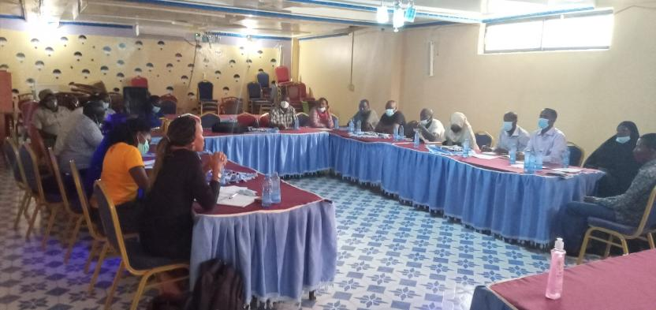

Minutes of community consultative meeting leading to land acquisition
Project: Proposed Solar Mini-grid at Yaqo
Venue of meeting-Yaqo center
Village -Yaqo
Sub- county-Eldas
Location-Abdi Waqo
Sub-location-Yaqo
Date:25/5/2021

AGENDAS
- Preliminaries
- Project description
- Positive Impacts of the project
- Negative Impacts of the project and mitigations measures
- Public safety in regards to electricity
- Technical aspects of the proposed project
- Land acquisition process
- Grievance Redress Mechanism for the project
- Plenary Session
- Focus Group Discussions/Election of respective GRM committee
- Environmental and social screening of the proposed site.
- Conclusions of the consultative meeting

Minute 1/KOSAP/2021: Preliminaries
The area chief, Mr. Abdi Ali Maalim, called the meeting at 11:00 am and requested a member to pray. Due to language barrier, the chief requested the head teacher Yaqo primary school to be the translator. The chief welcomed everyone to the meeting and thanked the KOSAP team for coming and informed them to pay attention to what will be discussed and ask questions where they do not understand.
The chief was able to introduce the Member of Parliament representative –Mohammed Maalim Abdi to address the community.
Mohammed Maalim informed the members the following aspects;
- They should take advantage of the project since it is beneficial to them especially on the basis on employment
- Everyone should be able to exercise their knowledge about the project
- They should respect the people coming to do the works in the area.
He was then able to welcome Wilfred Koech of Kenya Power and Lightning Company (KPLC).
Wilfred Koech as the team leader was able to introduce the KOSAP team together with the staffs from the county government of Wajir. Below is a list of the team members.
S/No | Names | Position
1 | Wilfred Koech | Environmental and Social specialist-KPLC
2. | John Kuria | Surveyor-KPLC
3 | Kennedy Gachau | Engineer-KPLC
4 | Rachael Kisiangani | Planner-KPLC
5 | Roseline Njeru | Socio Economist-KPLC
6 | Joselyne Masiga | Social expert-REREC
7 | Fahma Yussuf | CREO
8 | Bashir Kheir | Assistant county surveyor
9 | Adan Salat | Director Natural Resources

Minute 2/KOSAP/2021: Project Description
Koech gave brief description of the proposed project which is solar minigrid under Kenya Off-grid Solar Access Project (KOSAP) and is a project that is to be placed in off-grid areas i.e. places where the National electricity grid has not reached and whose electricity access has been very low and the fact that the areas are well endowed with natural sunlight and with high temperatures that can produce solar energy.
The use of solar energy was because it would take a long period of time for the National grid to reach to those places and the communities to be connected with electricity which will be an expensive venture to be implemented. He told the community members that the project was in the preliminary implementation stages.
KOSAP is financed by the World Bank and jointly implemented by the Ministry of Energy, the Kenya Power and Lighting Company (KPLC) and the Rural Electrification and Renewable Energy Corporation (REREC) in partnership with the World Bank as the development partner, County Government as a partner and the communities in Off-grid areas being the beneficiaries. He explained that the government’s target is to achieve universal access to electricity by 2023 using various sources and explained to them that the National Government is implementing KOSAP in partnership with County Governments in 14 underserved counties i.e ( Garissa, Isiolo, Kilifi, Kwale, Lamu, Mandera, Marsabit, Narok, Samburu, Taita Taveta, Tana River, Turkana, Wajir, and West Pokot).
He then noted that Wajir county as a beneficiary under the KOSAP project has 30 sites which are; Konton, Bojigaras, Kajaja 2, Dasheeg, Dambas, Mansa, Ogarale, Jigjiga, Yaqo, Lakole south, Dagahley, Dadhantalai, Ajawa, Qudama, Danaba, Wajirbor, Jowhar, Ibrahim Urey, Burder, Diif, Ddajabula, Daful, Sabuli, Meri, Laghbokhol, Qara, Qarse Qof, Adhibokol, Arbajahan and Barmishi that are to be sited and constructed in an area which is about 3 acres each.
The implementing agencies (KPLC and REREC) through the leadership of the Ministry of Energy have established the County Working Groups (CWGs) with representation from the 14 counties headed by the Governors towards successful implementation of KOSAP.
He further noted that the agenda of the visit was to:
- undertake an environmental and social screening of the proposed sites to check suitability in terms of environmental, technical, social and health requirements.
- Undertake community engagement to sensitize the community on the project.
- Need to set up grievance redress mechanism committee during the project implementation.
- Need for the focus group discussions
The positive, negative impacts of electricity and the safety precautions of electricity were discussed as follows;
Minute 3/KOSAP/2021: Positive Impacts/Benefits of the Project
- Better source of lighting- replacement of Kerosene lamp and small de-lite lamps with electricity lighting which is clean and has better lighting
- Benefits to education- provide source of lighting which enables pupils and students to take advantage of longer hours of preps/study in homes. Electricity will be useful in availing power needed to enable use of radio and television sets. Once parents are able to buy these gadgets pupils can access electronic educational materials
- Business Opportunities-Power provides energy needed to power some gadgets that are difficult and expensive to power with generators. Access to electricity will therefore allow the community to take advantage of new business opportunities and enhance the existing ones e.g. (Barber shops, salons, posho/maize mills, welding, and expanding existing businesses, photo copying, printing, fuel stations, milk coolers and fridges to preserve meat among others
- Employment and wealth creation- community members will get opportunities to provide non-skilled and skilled labor during construction and operation phases
- Local Material Supplies and other requirements- the propose project provides opportunities to supply some materials available locally
- Up Scaling Electricity Access to the off-grid areas- this area is far away from the grid and so the proposed project it helps to reach such areas faster and in a cost effective manner as opposed to grid connections.
- Impact on HIV/AIDS-due to availability of power communities will be able to purchase communication equipment like radios and televisions which in turn provides access to information on various issues such as health topics on HIV/AIDs, the current Covid-19 pandemic among other information
- Health benefits of the project- health benefits of the project includes elimination of use of kerosene lamps, reduced or no use of fuel generators in the trading centres which emits smoke causing respiratory diseases, the health Centre under construction will also benefit from power that can be used to preserve drugs and vaccines alongside powering other medical equipment
- Improved standard of living- Living standards of the community is bound to improve as they take advantage of small house hold appliances like e.g. TV, Fridges, radios, blenders, iron boxes etc.
- Security- Enhanced security due to improvement in lighting up of the area. Improved security also means more hours of business
- Communications- improve communication due to availability of electricity to charge phones, opportunities to set up information communication and technology related business like cyber cafes, access to e-government services among others
- Presence of electricity will also attract other business investors

Minute 4/KOSAP/2021: Negative impacts of the project
The negative impacts were presented alongside the Enhancement Measures so that the members can be able to understand and take note if any impact is not dealt with well, they are able to voice out.
 | Negative impact | Enhancement Measures by contractor
1 | Vegetation clearance at the proposed site | - Clear only the areas that are needed to put up the mini-grid  - After construction, do landscaping with grass to areas that have no electrical installation as opposed to living areas bare  - Planting of trees
2 | Air pollution dust from construction activities | - Fence off construction site to reduce dust going to the public  - Use of masks for workers
3 | Air pollution dust from construction vehicles | - Limit vehicle speed to minimum possible when passing residential areas
4 | Air pollution from vehicle emissions | - Maintain vehicles/service vehicles  - No idling of vehicles
5 | Solid waste | - Clear all solid waste and dispose appropriately
6 | Occupation safety and health hazards e.g. accidents, fall from heights, pricks by sharp objects | - Use of proper personal protective equipment like gloves, overalls, helmet, safety shoes  - Allocating work according to skills  - Toolbox talks to workers to identify hazards and risky activities and Enhancement Measures  - Allocating works according to one’s skills  - Close supervision of work
7 | Labor influx. The nature of the project will require technical skills that are not all available in the area. This will require movement of construction workers (labour influx) into this community. There are some risks that are involved with labor influx and we need to mitigate them as follows to avoid negative impacts on our community. | - Establishment and operationalize an effective Grievance Redress Mechanism accessible to community members where our grievances can be sorted  - Reduction of labor influx by tapping into the local workforce
8 | Risk of social conflict due to competition for resources and opportunities | - Awareness-raising among local community and workers on the need to have a good /cordial working relation  - Consultations with and involvement of local communities in project planning  - Provision of cultural sensitization awareness for workers regarding engagement with local community.  - Recruitment of local workforce to the extent possible especially unskilled and semi-skilled jobs  - Contactor shall make provision to provide resources needed by the workers if the need for such resources may result to competition e.g. water  - Working closely between contractor and the project grievance redress committee to address complains on time.
9 | Increased or illicit behavior and  crime (including prostitution, theft and substance abuse) | - Sensitization campaigns both for workers and local communities against such social evils  - Enforcement of sanctions (e.g., dismissal) for workers involved in criminal activities
10 | Communicable diseases (including STDs and HIV/AIDS) | - Education/awareness about transmission of diseases  - Awareness creation on STDs among the workers and local community on ethics, morals, general good behavior and the need for the project to co-exist with the neighbors during the community and worker engagement forums.  - Provide condoms to employees
11 | Gender-based violence including sexual harassment and sexual exploitation and Abuse | - Information and awareness raising campaigns to you community members and specifically women and girls.  - Mandatory awareness creation for workers on required lawful conduct in the community and legal consequences for failure to comply with laws  - Report all complaints on gender-based violence or harassment through the GRM and also directly through CREO  - Working closely and Instruction of local law enforcement to act on community complaints on time  - Inclusion of GBV specific Enhancement Measures in the environmental and social management plan of contractor  - Requirement of contractor to have code of conduct for the workers and to implement them
12 | Child labour | - Ensuring that children and minors are not employed directly or indirectly on the project.  - Enforcement of Employment Act that requires contractor to adhere to minimum age  - Allowing your children to be employed is illegal and punishable by law because it interferes with the children’s right to education  - Report any case to the chief’s office
13 | Demand for Material/resources e.g. water, sand, ballast | Contractor to consult with elders before using scarce resources in the community like the water to avoid conflicts.
14 | Oil Spill Hazards | - Contractor not to repair vehicles or equipment on site  - Maintain vehicles and equipment in good state
15 | Storm water and erosion | - Contractor to put measures to harvest rainwater and control erosion during construction
16 | Wastewater/ effluent | Contractor will provide sanitation facilities for workers
17 | Noise resulting from excavation machinery, vehicles and workers | - Contractor to work only during the day  - In case of blasting contractor to give notice to community through the village elders, grievance committee and chiefs office
18 | Visual and Aesthetic Landscape Impacts | - The visual negative impacts can be mitigated through putting up a wall round the facility to keep off/screen the project stacks, poles, cables, panels by the contractor.  - Proper siting decisions can help to avoid aesthetic impacts to the landscape.
19 | Hazardous materials from damaged Panels- Photovoltaic panels may contain hazardous materials, and although they are sealed under normal operating conditions, there is the potential for environmental contamination if they were damaged or improperly disposed upon decommissioning. | - Proper planning and good maintenance practices can be used to minimize impacts from hazardous materials.  - Proper disposal of used or Damage solar batteries and panels using NEMA registered disposers for such wastes
20 | Fuel storage on site | - Contractor will undertake proper installation of the fuel storage tanks for the backup generator.  - Have a budded wall 1.5 times the fuel stored to allow controlled collection in case of a spill.  - During operation implementing agency will ensure proper maintenance of the solar panels
21 | Public safety –potential risk of shocks and electrocution | As explained below in details

Minute 5/KOSAP/2021: Public safety in regards to electricity

The community were educated on the safety precautions of handling electricity so as to avoid electric shocks, fires and even electrocution/death. They included;
- Always engaging a certified technician to do wiring in their premises
- The use of quality materials during wiring
- Do not engage in individual illegal extensions of power lines to other houses
- Don’t touch sockets and switches with wet hands or wipe with wet cloths
- Do not tie livestock on the poles
- Do not cut earth wires that run along some electric poles
- Do not touch or go near any electric wire if you find it fallen on the ground
- Report any incident regarding electricity at the local office –staff in charge of operating the Mini-grid
- Vet all new people coming to the village by checking whether they registered their presence with the office of the chief especially those purporting to be technicians
- In case of a black out/no power do not open sockets or switches

Koech then invited Kennedy Gachau (KPLC)-Engineer

Minute 6/KOSAP/2021: Technical aspects of the project
The technical aspects of the Mini grids will entail the installation of the solar PV panels, usable battery and thermal diesel backup unit that will be running for support.
The mini-grid will be operated by the implementing agency KPLC and the beneficiaries/those interested will be expected to pay for connection fee (one thousand shillings) and do wiring in their houses. (use a qualified and certified technician)
The beneficiaries will be expected to pay for electricity consumed and that the tariff employed will be the same as what other Kenya Power customers are paying. The use of tokens will be employed.
Once the designs are done, the community will be notified of the exact routes during future consultations and that they will be required to give way leave consent (allowing the service lines to pass through their land in the extreme cases). He noted that the project will not compensate for way leaves due to budget constraints.
He then invited Rachael Kisiangani-planner (KPLC).
Minute 7/KOSAP/2021: Land acquisition process
Rachael was able to talk about the land acquisition process for the proposed Mini-grid. The following aspects concerning land were discussed;
- The land needs to have been set aside for public facilities
- The land should be free from disputes i.e. nobody should claim the land
- The land located should be in a central position so that the project serves most people
- The land will be registered under KPLC who are the implementing agencies
She requested the community to allow advance possession of the land before the process of registration is complete.
Consent form agreement whereby it will include the following: men, women, youth, people living with disability, government representative (i.e. chief) will have to be formed to show they are in agreement with the project and the land acquisition process.
The surveyor will need to pick exact GPS points of the agreed area so that the portion acquired for the solar Mini-grid be later physically demarcated, and the exact measurements be known to the community members following the laid down procedures by law.

Minute 8/KOSAP/2021: Grievance Redress Mechanism for the project

Wilfred Koech noted of how important it was to have a Grievance Redress Mechanism (GRM) which are sets of arrangements that enable local communities to raise grievances with the investor and seek redress when they recognize a negative impact arising from the investor’s activities.
It involves members of the community who will work hand in hand with the area chief concerning issues arising from the proposed project and form a GRC.
He spoke about the grievance mechanism that involves;

- Locational grievance redress committee. This is the lowest level (forum) where the community will get project information and also ask questions. At this level the community will choose project committee members who will also double as grievance redress committee. The membership will comprise of elders/men representatives, representatives from women, youth, special needs (persons with disability), and the office of the chief. This will be the first stop for receiving information and raising grievances. The members to be chosen should possess leadership skills and it is hoped that most of the grievances will be resolved at this level.
- The second level of grievance redress will be the county Grievance Redress committee comprising members of the county working group. This committee is at the county level and will resolve complains or issues that are unable to be resolved at the locational/project level. The chairman of the project grievance redress committee at the community will forward issues/ complains to the county grievance redress committee through CREO who will also be responsible for giving feed back to the local committee.
- The third level will be the National GRC comprising of KOSAP Project Implementation Unit at the Ministry of Energy and the implementing agencies. Matters that could not be resolved at the county level will be escalated to this National GRC by the CEC.
- The last level of the GRM for the community or project affected persons will be arbitration or legal redress in a court of law once all the three levels have been exhausted. Koech explained further that members of the project/ grievance redress committee will be chosen by the community members themselves. The committee chosen will be in charge of giving project information to the community and be a focal point for reporting project related issues of concern or grievances.

The composition of the committee should have representatives from all groups i.e. men, women, youths and Persons living with disability of which the community will be given time to select the members of the committee in their focus group discussions.

Minute 9/KOSAP/2021: Plenary Session
There being no questions raised in the meeting, the members were directed to respective groups for discussions.
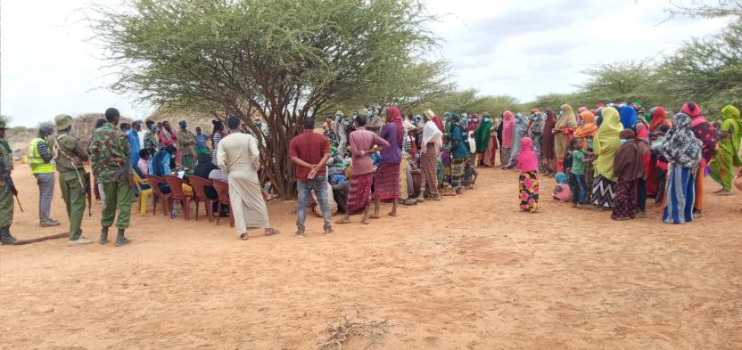photo of the consultative meeting held at Yaqo center
Minute 10/KOSAP/2021: Focus group discussions /Election of respective GRM committee
Focus Group Discussions for Men
Wilfred informed the men of how important it was to hold the separate discussions so that everybody gets enough opportunities to be informed of the project and be free to ask questions. The public participation in projects is crucial as it helps build consensus and enables people to make informed choices regarding projects.
The agenda of the visit by the officers was to; undertake an environmental and social screening of the proposed site to check suitability in terms of environmental, technical, social and health requirements. The second objective was to undertake community engagement to sensitize the community on the project. The third objective was on land acquisition and the need for a project grievance redress mechanism.
A summary of the project in terms of its positive and negative impacts and their Enhancement Measures was repeated and the men were encouraged to take up jobs during project implementation process.
He also explained the need for the men to select representatives to the project committee who would represent their views/issues to the committee for redress.
The elders said they welcome and support the project since it brings positiveness to the society. The discussion was then opened up for questions.
Name of Person making the contribution (e.g. comment or question) | Question, Comment, Suggestion | Feedback/Responses by project team | Response by agency on how feedback will be used or acted upon

Focus Group Discussions for women
The group was led by Roselyne who was able to explain why a separate discussion was put up in order for them to have the opportunity to freely express themselves.
She explained the agenda of the visit by the officers from National government and county government was to undertake an environmental and social screening of the proposed site to check suitability in terms of environmental, technical, social and health requirements.
The second objective was to undertake community engagement to sensitize the community on the project and the third objective was about land acquisition for the project and the need for a project grievance redress mechanism.
She gave a summary of the project in terms of its positive and negative impacts and their Enhancement Measures , the safety precautions and the land acquisition process. She also explained the need for the women to select a representative to the project committee who would represent their views/issues to the committee for redress.
She ensured all the women had understood their rights, roles and benefits concerning the project. Further the women were educated on how they can take up economic opportunities that will raise during project implementation. They were also given opportunity to air their issues/ questions and or /give suggestions to make the project implementation process better.
The discussions went further to bring out issues on how the women can take advantage of the project benefits rather than taking a back seat. She explained to them that they would benefit more from the electricity because they will be able to use clean energy to cook and also benefit from access to information through use of radios and TV that are powered by electricity enabling them to make informed choices on different issues such as nutrition, health, farming among others. They were also set to benefit if they could set up small businesses like salons, cold drink kiosks, cooling milk because it spoils easily, children will have time to study and enhanced security due to the fact that the area will be well lit among other benefits. Gender based violence issues were also discussed including; forms of GBV, rationale for addressing GBV, ways in which a project can worsen existing GBV risks or create new risks, the need to report and document any complaints against workers, report incidences of GBV while ensuring survivor centered approach (respect for the choices, wishes, rights and dignity of the survivor). The women were told to be more vigilant to ensure young girls do not fall prey to GBV incidences. The women were requested to keep talking to the girls on GBV risks and the need to raise alarm in case of risks factors early enough.
All the women were in agreement for the project to be brought to Yaqo.
Question, Suggestions, feedback and response for Focus group discussion with women
Name of Person making the contribution (e.g. comment or question) | Question, Comment, Suggestion | Feedback/Responses by project team | Response by agency on how feedback will be used or acted upon

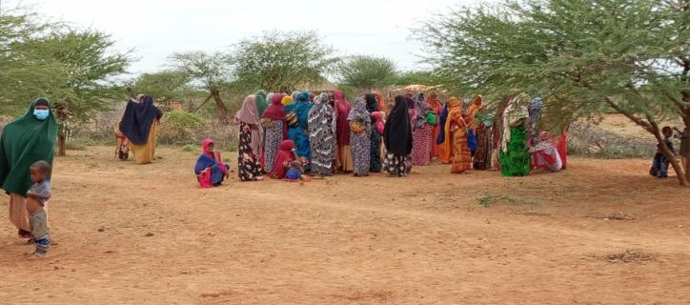
Photo of the women focus group discussions

Focus group discussions for the youths
The group was led by Joselyne who spoke the agenda of the visit by the officers from National government and county government was to undertake an environmental and social screening of the proposed site to check suitability in terms of environmental, technical, social and health requirements. The need to undertake community engagement to sensitize the community on the project and the third objective was on land acquisition for the proposed project and the need for a project grievance redress mechanism.
A summary was given in terms of its positive and negative impacts and their Enhancement Measures plus the safety precautions while dealing with electricity and added youths will benefit a lot because they will be able to open up businesses such as salons, barber shops, welding places among others.
Explanation about the need for the youths to select a representative to the project committee who would present their views/issues to the committee for redress. The youths were allowed time to ask questions, give suggestions and seek clarifications.
Question, Suggestions, feedback and response for Focus group discussion with youths
Name of Person making the contribution (e.g. comment or question) | Question, Comment, Suggestion | Feedback/Responses by project team | Response by agency on how feedback will be used or acted upon
Omar Ibrahim | Will the government do wiring for the people? | -One is to do wiring for him or herself | NA
Abdulahi Gulle | Incase of damages who will compensate? | Always use a qualified person to do wiring to avoid accidents. | N/A
Issa Keynan | Will my tokens expire? | Not really. It goes by amount of consumption you use | N/A

The youth representive chosen for the committee was-Guliye Mohammed Abdi
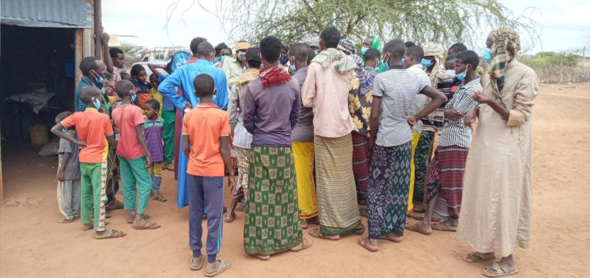Photo of the youths focus group discussions
Minute 10/KOSAP/2020: Environmental and social screening of the proposed site
On completion of the focus group discussions, the KOSAP team headed to the site to conduct the screening accompanied by the committee members and other village members, whereby the site was assessed and was found to be environmentally good for the proposed project.
The meeting was concluded by vote of thanks from the area chief. The meeting ended at 12:40 p.m.
Minute 11/KOSAP/2020: Conclusions of the Community Consultative Meeting
- The community welcomed the project and are in full support.
- The community willingly pointed out and agreed on where the project should be set up
- The need for a grievance redress mechanism (GRM) was explained to the community including the need and roles of a grievance redress committee (GRC). A GRC was chosen with representatives from the men, women, youth and special needs group.
- It was clearly disclosed to the community that the ownership of the land will be transferred to KPLC and that the project will be managed by the implementing agencies and not the community. The community agreed to the need to the transfer of the land.
- The need for advance possession of the land as the process of survey and registration progresses was explained the community and the community agreed to the same.
- The community understood that it will be their responsibility to do wiring of their premises, pay connection fee and pay for power consumed.
The community in Yaqo unanimously agreed to set aside land for Mini grid construction. A Land Identification form was signed by the representative of the community, the county government and the Implementing Agencies summarizing the process of land identification and the agreements reached with the community. (Attach the Land Identification Form)

Appendix 2: Attendance List Land Identification: Yaqo Baraza
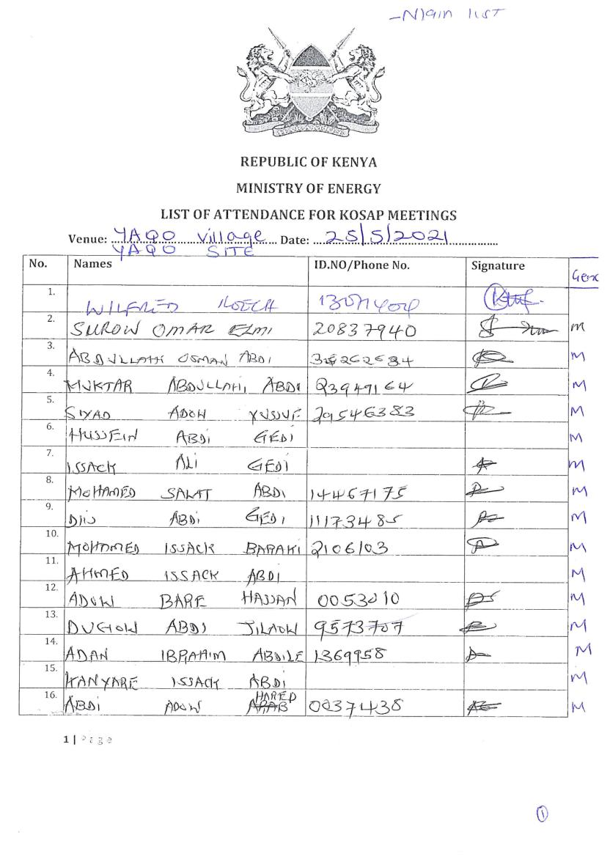
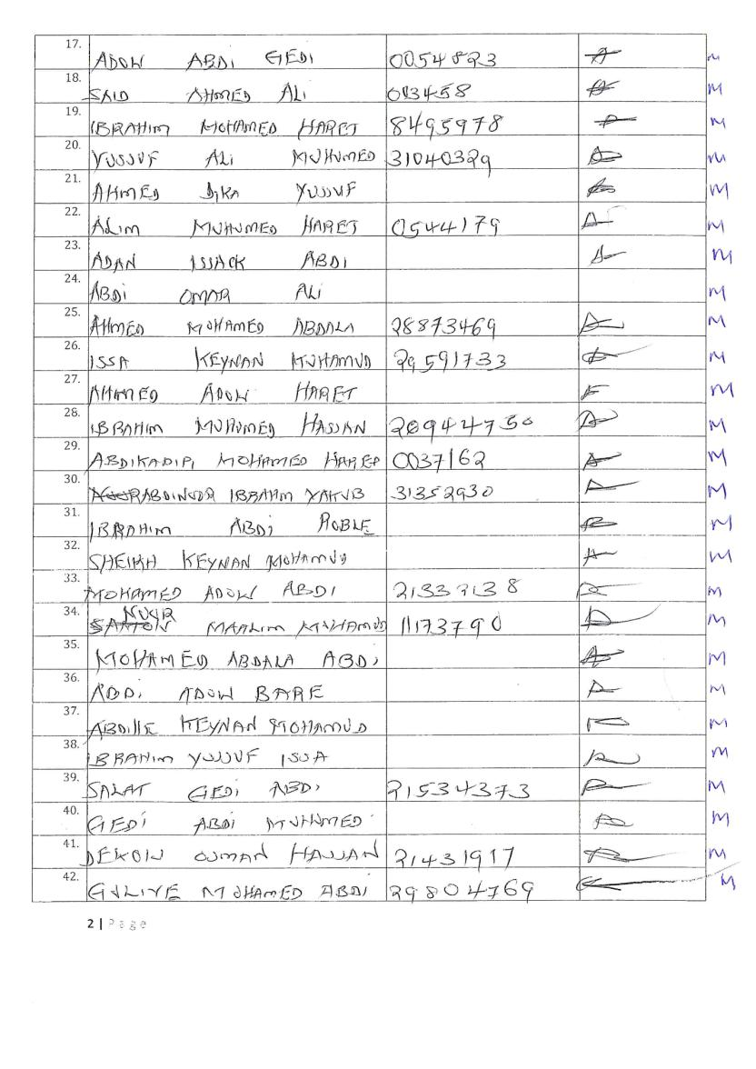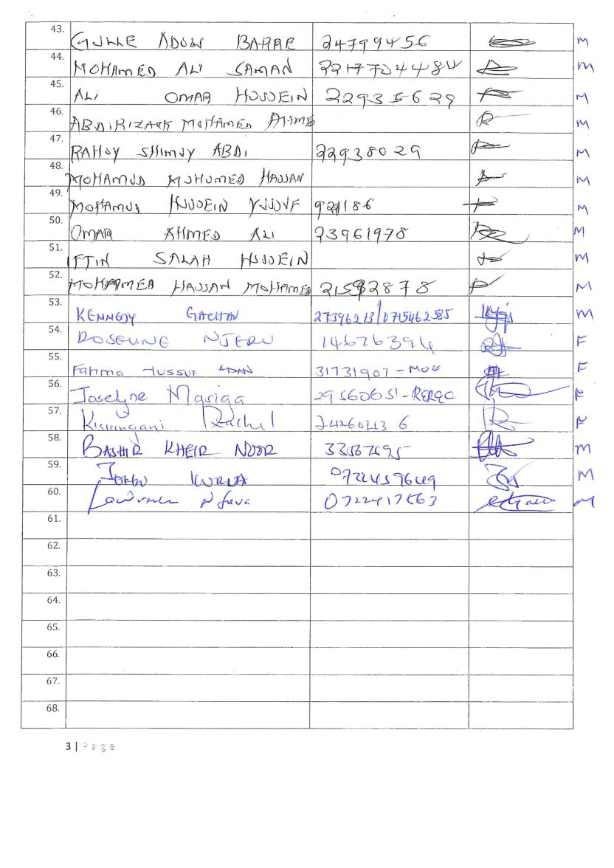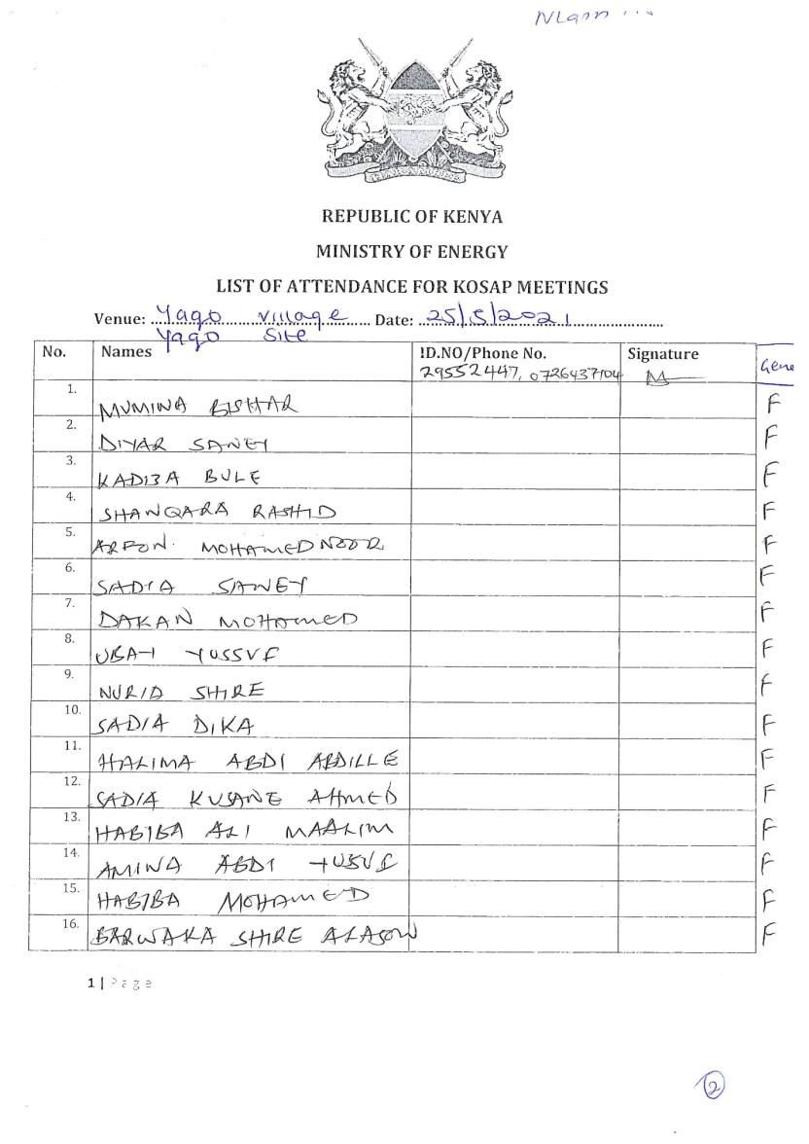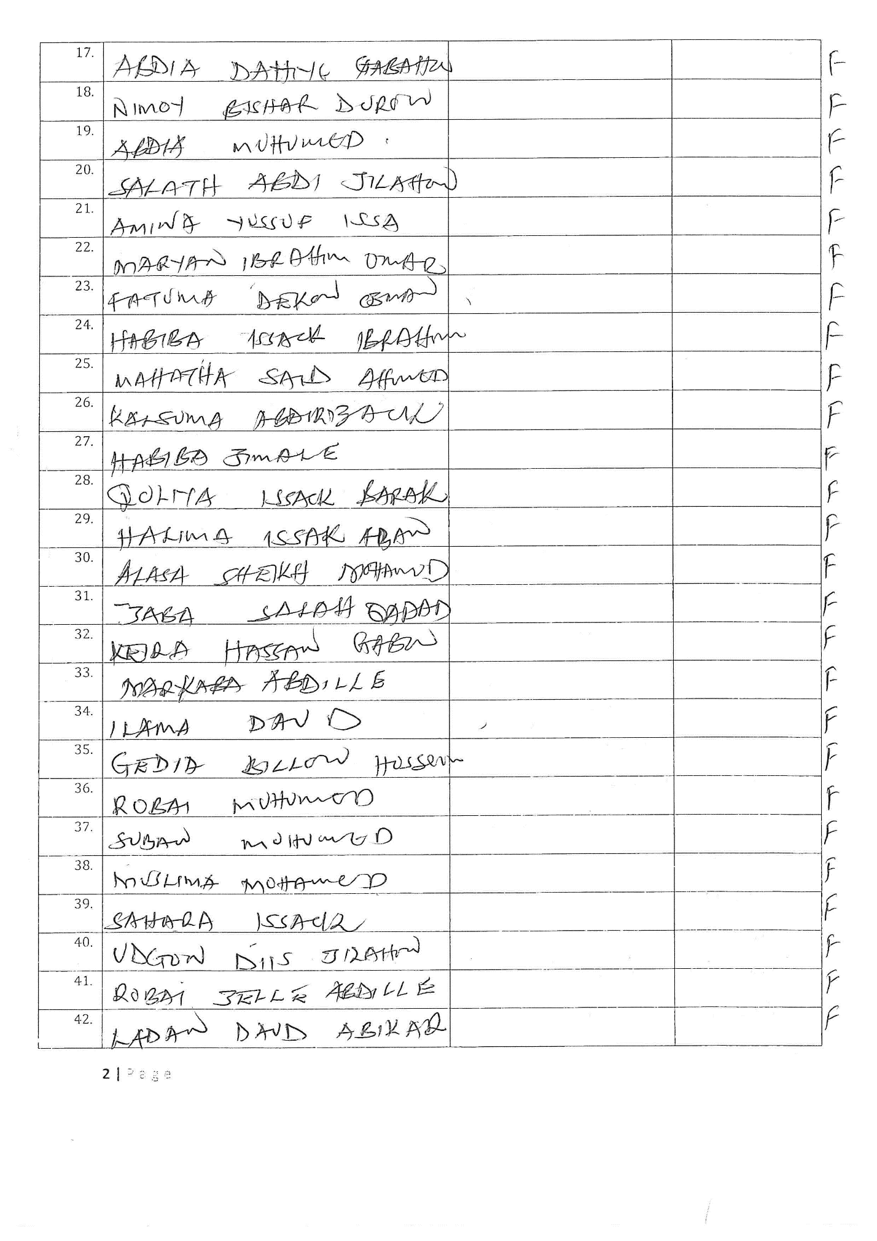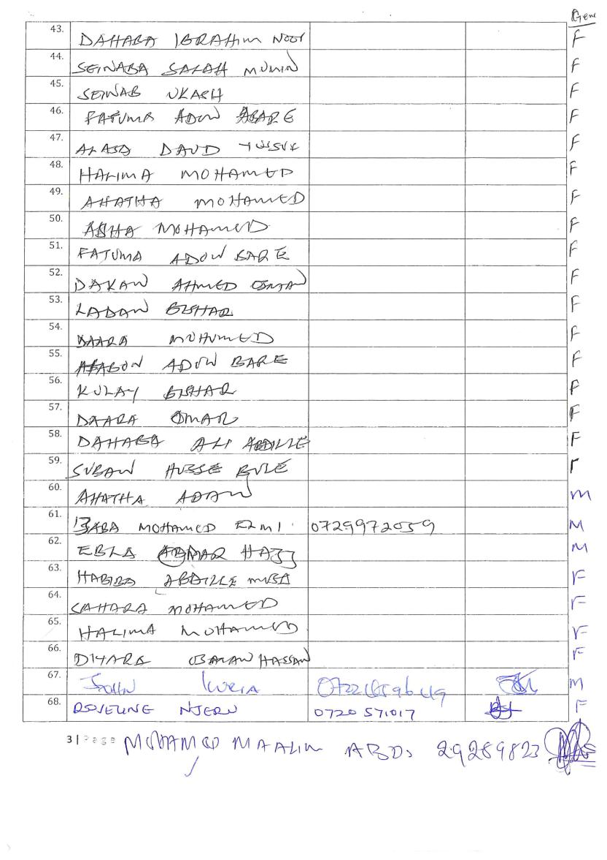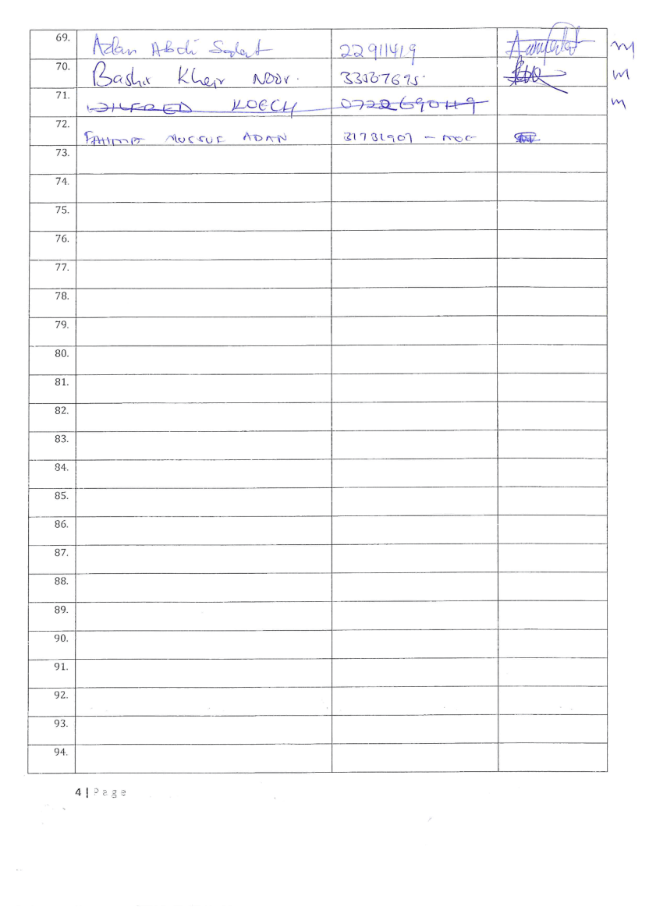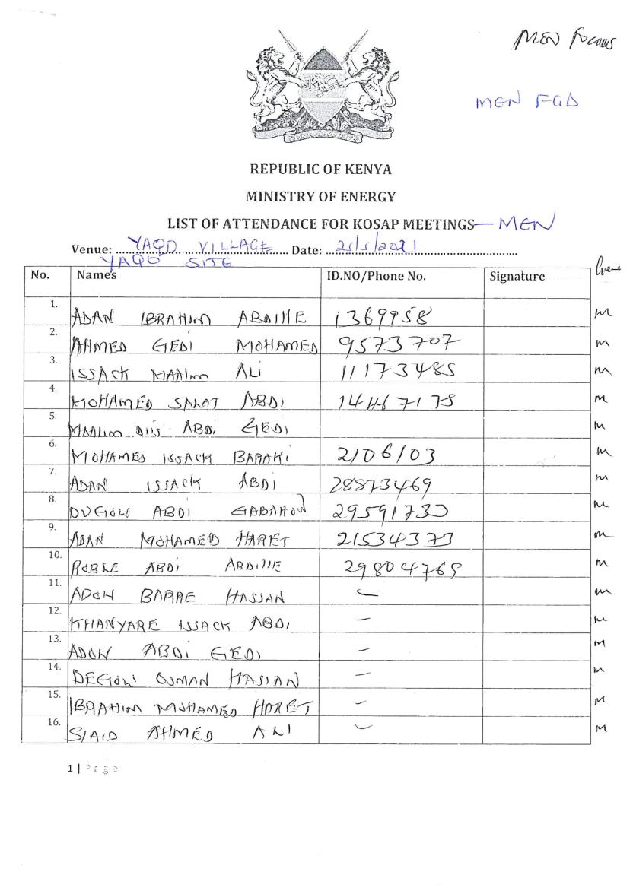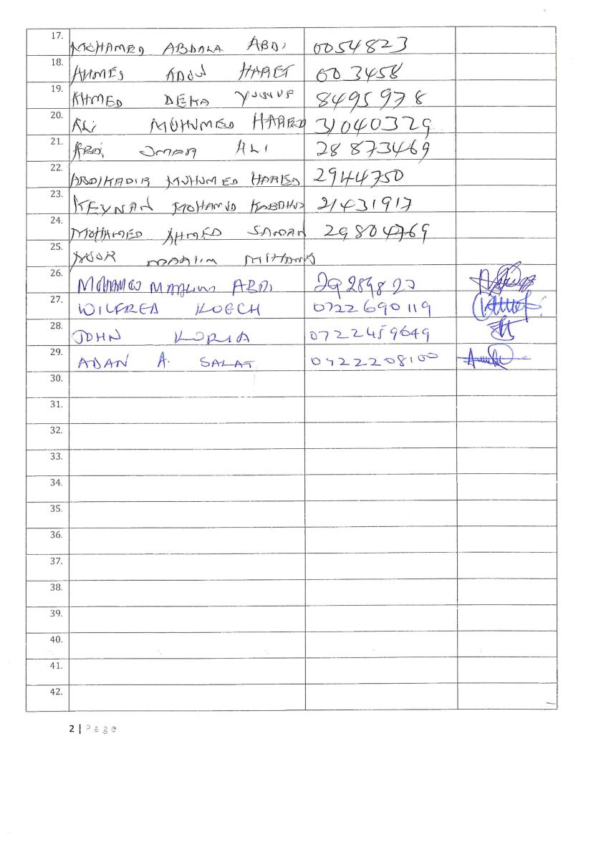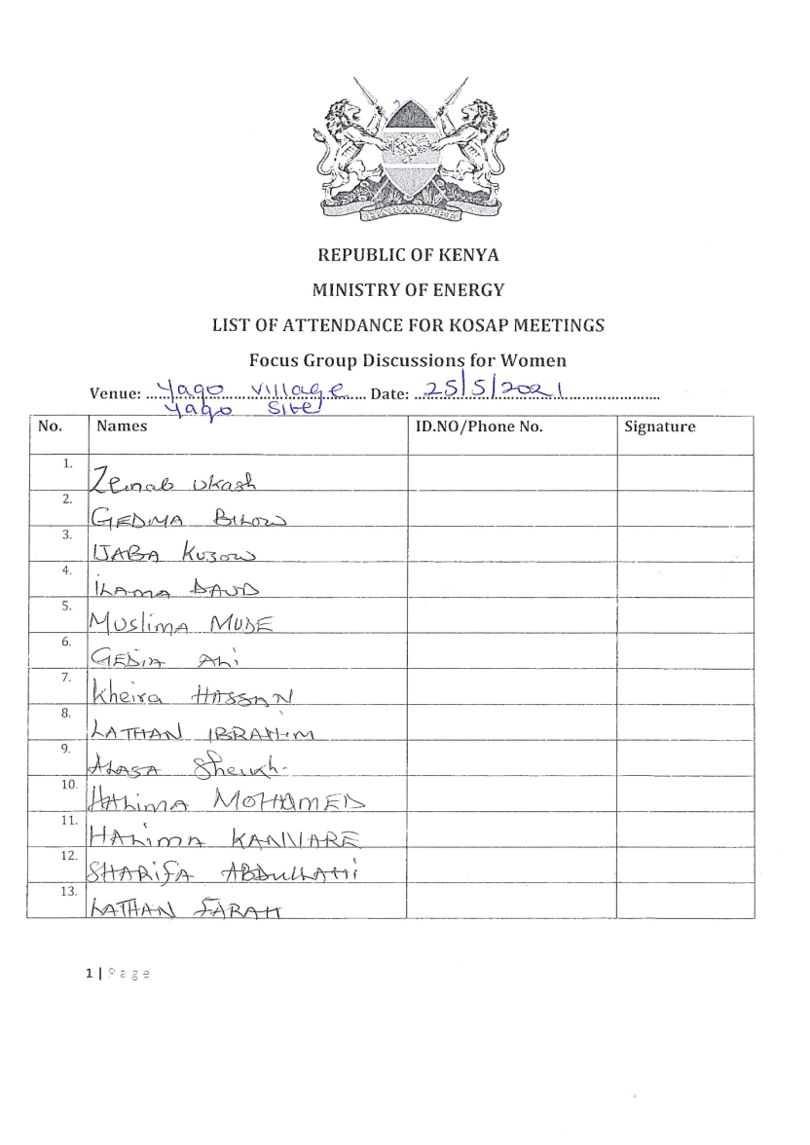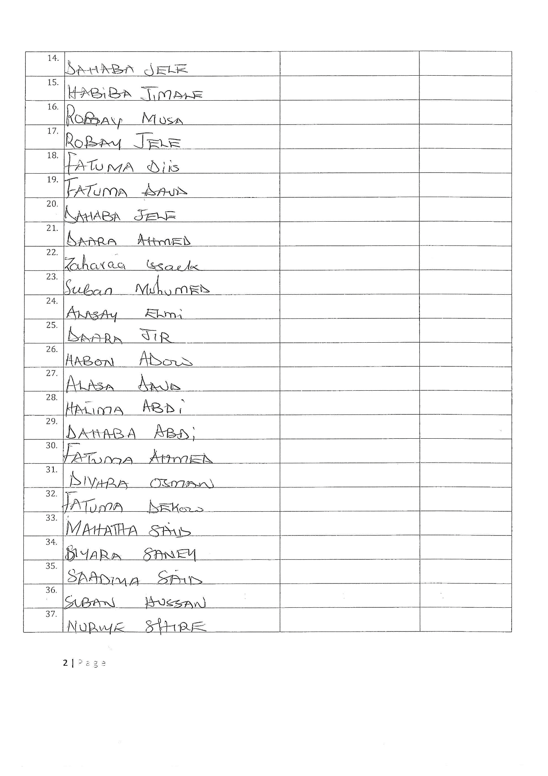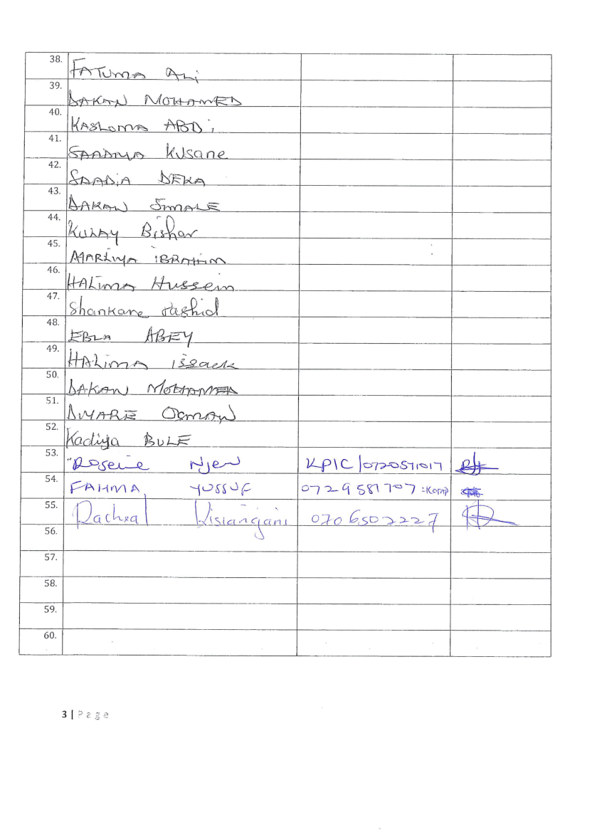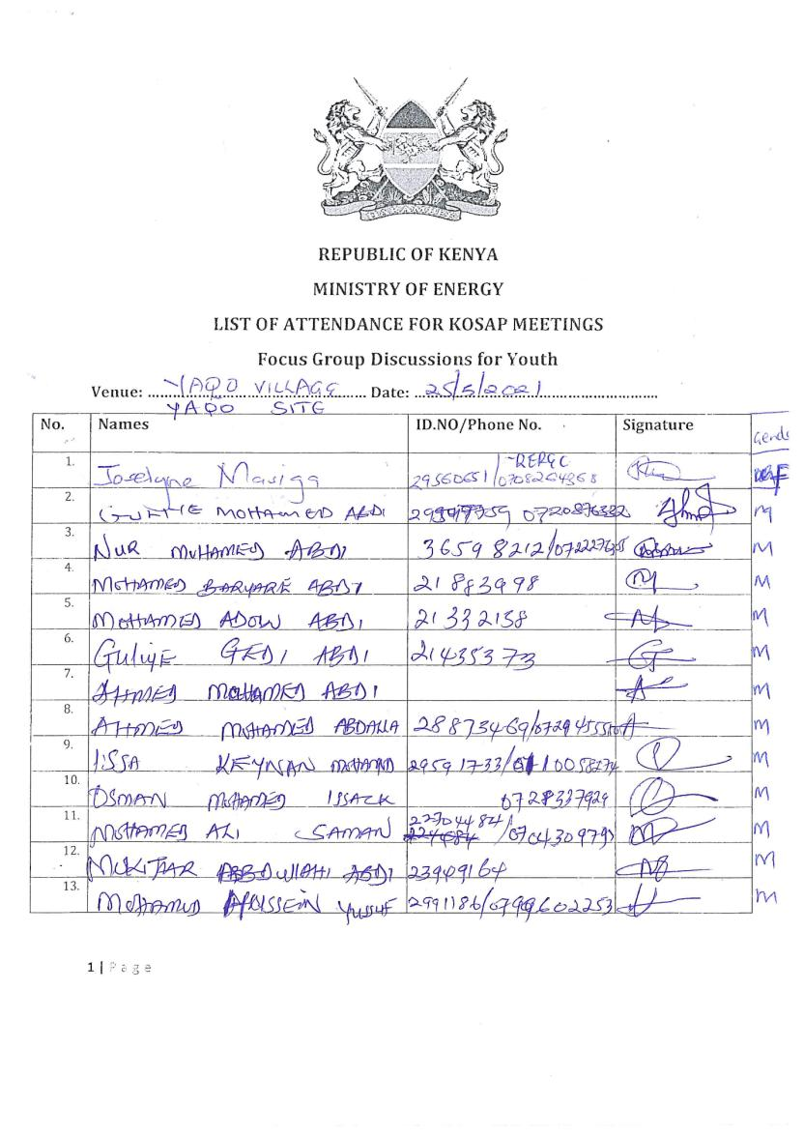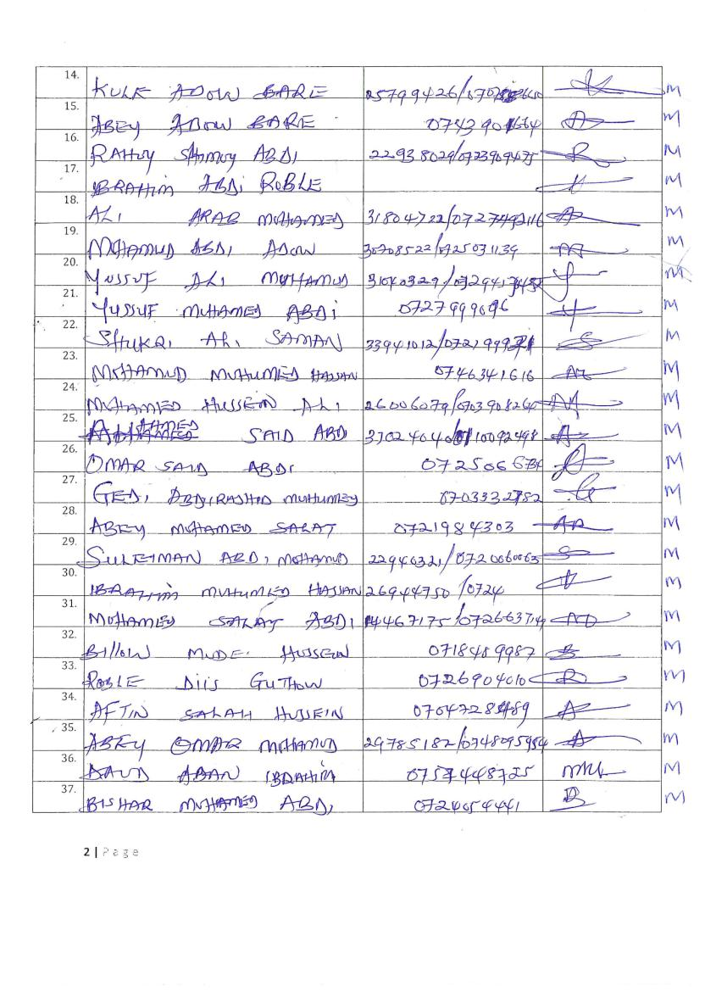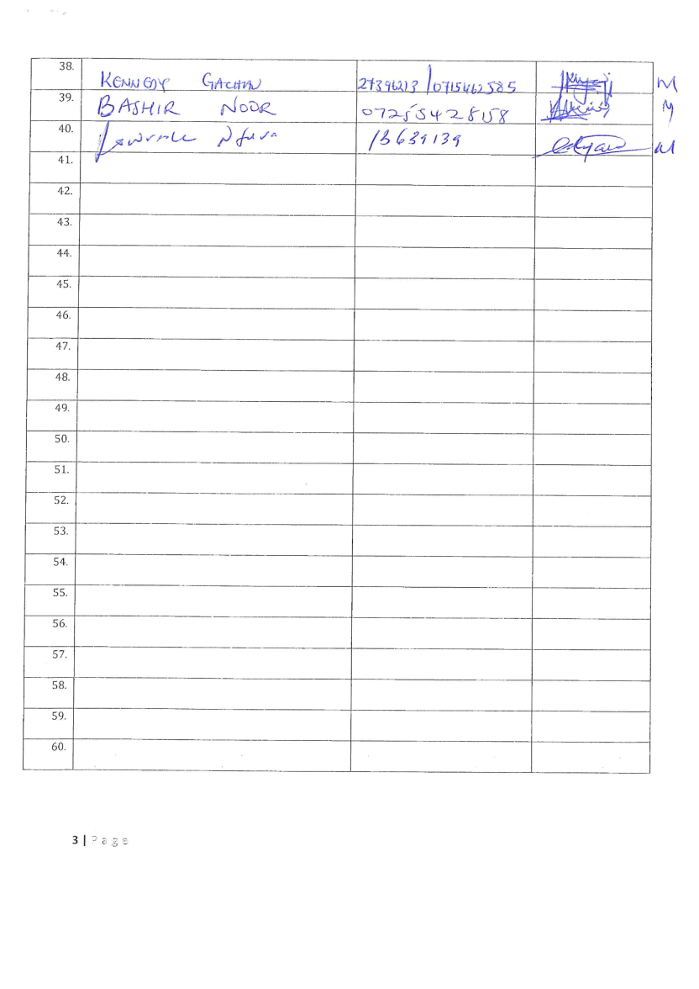

Appendix 3: Community Profile - Yaqo
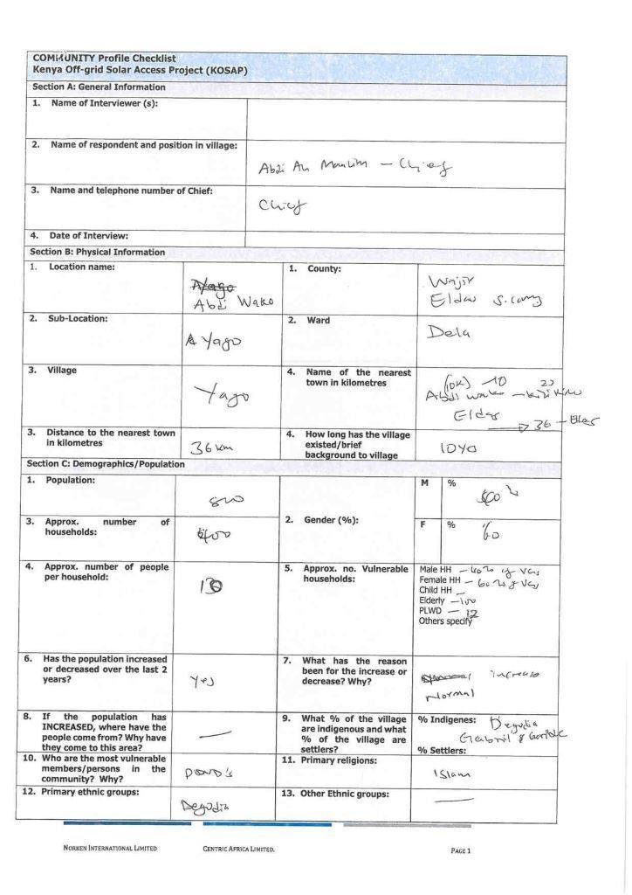
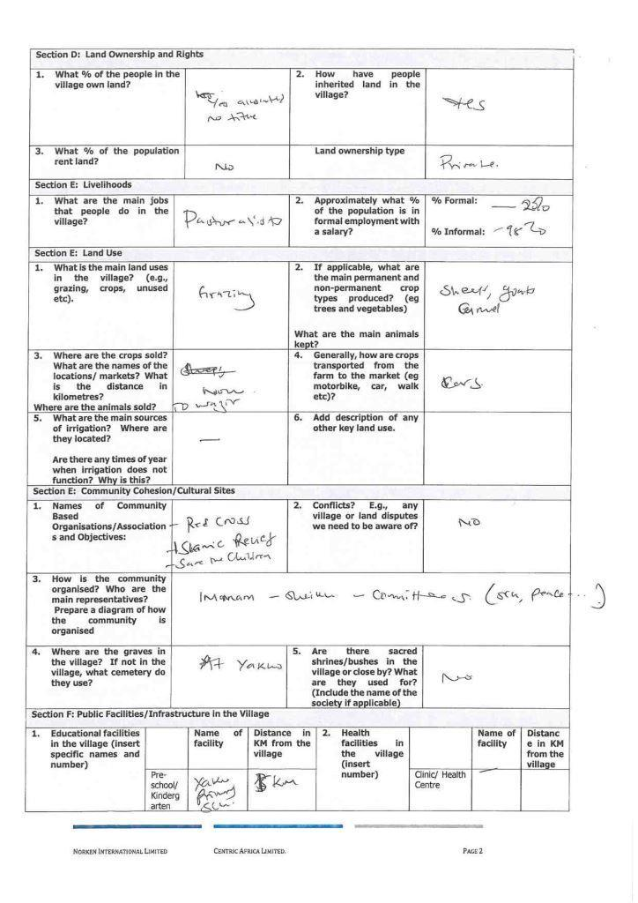
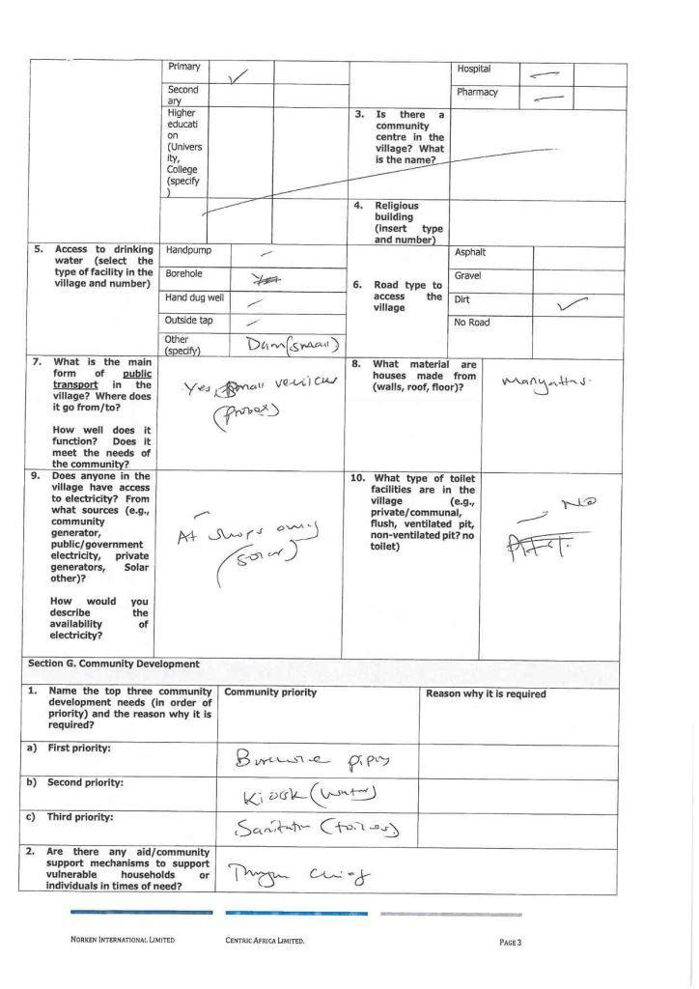
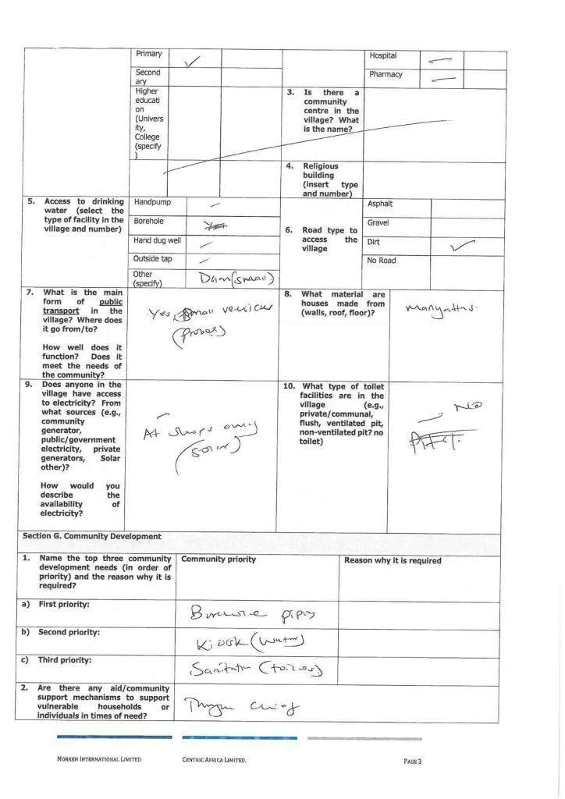
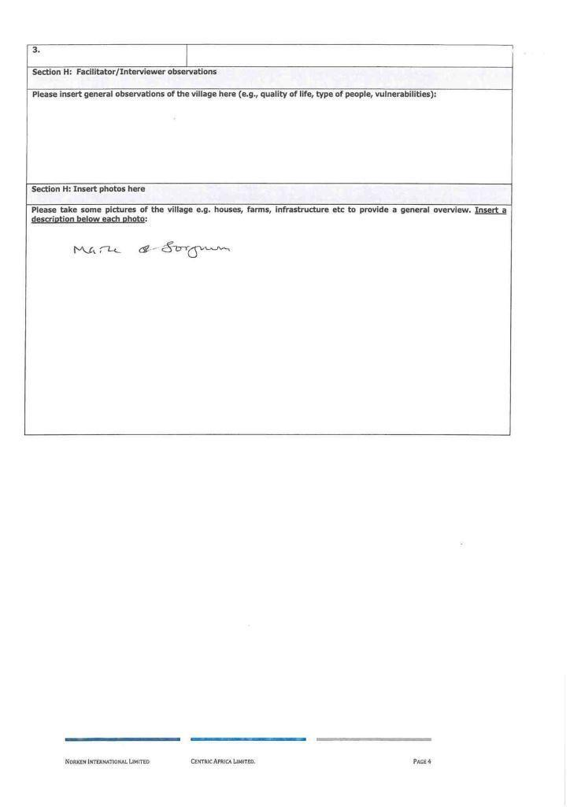

Appendix 4: Minutes - ESIA Public Participation Meeting Held at Yaqo
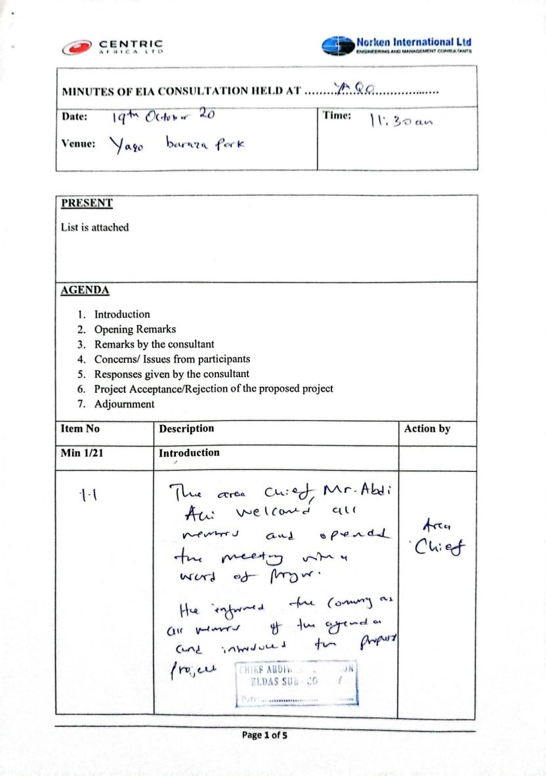
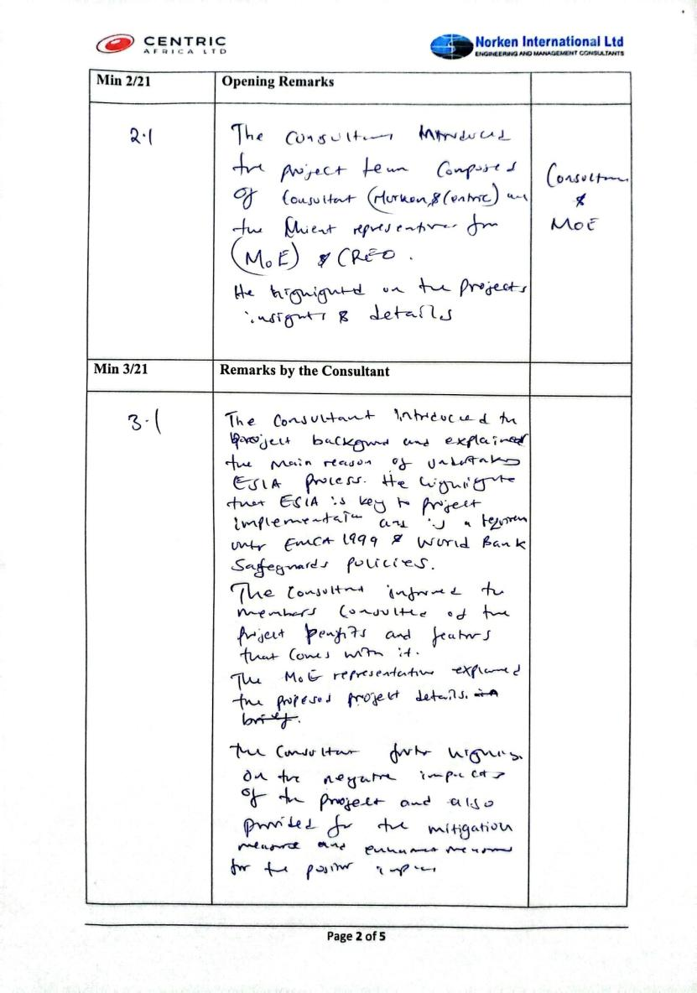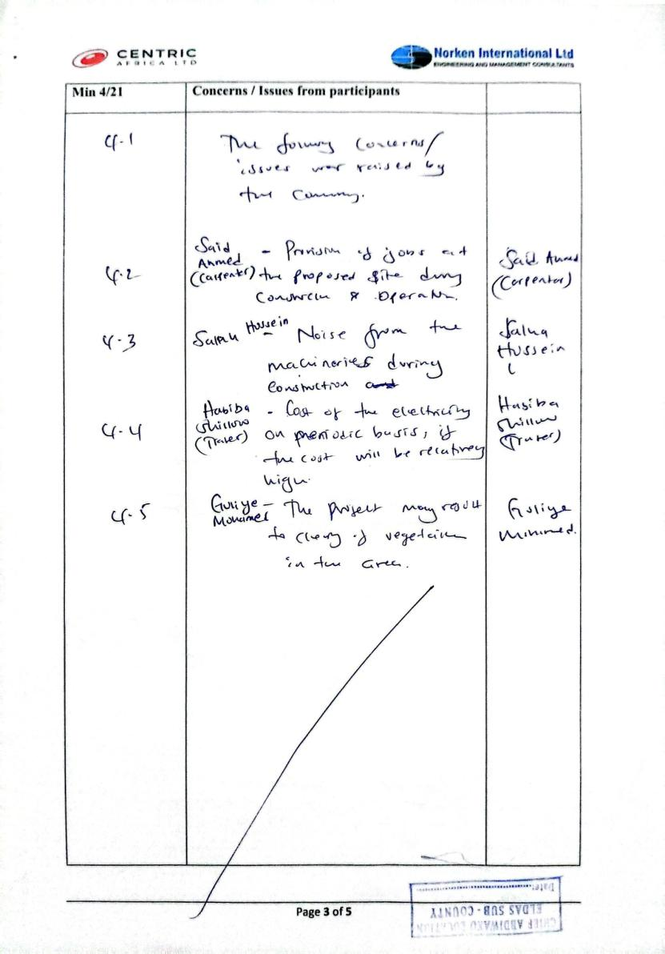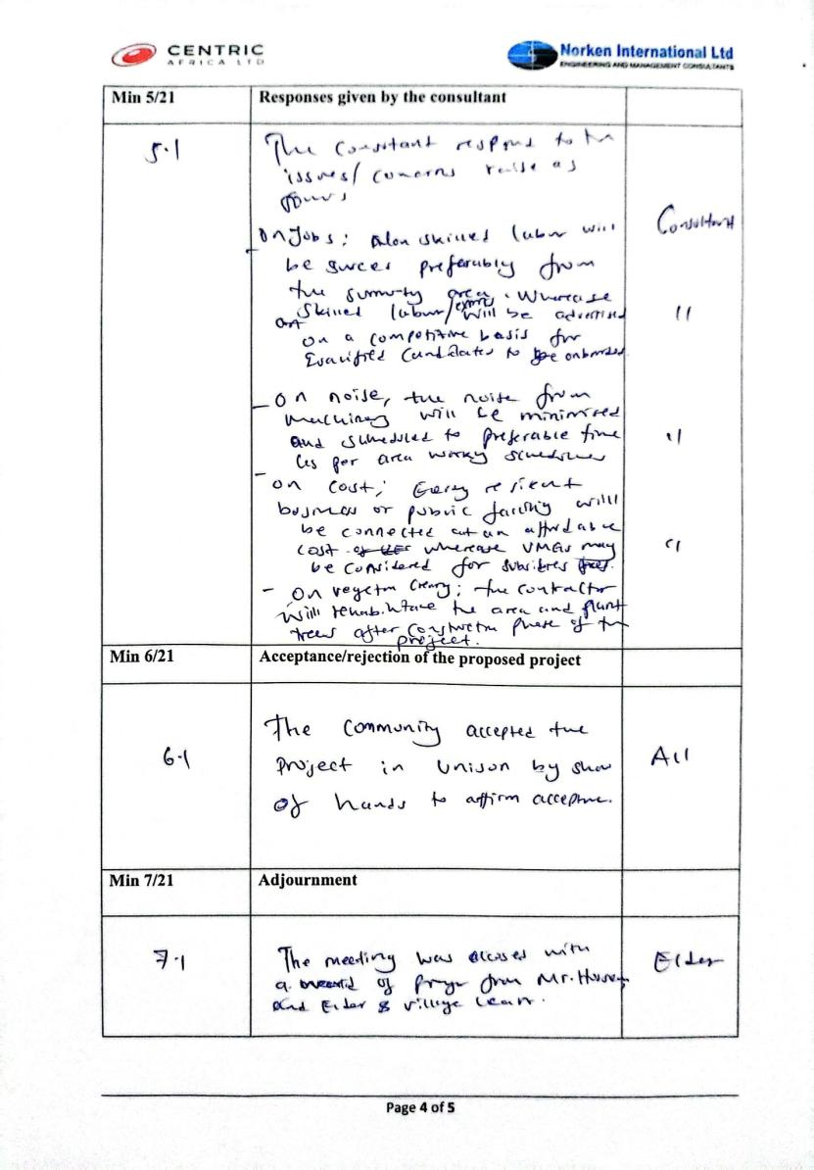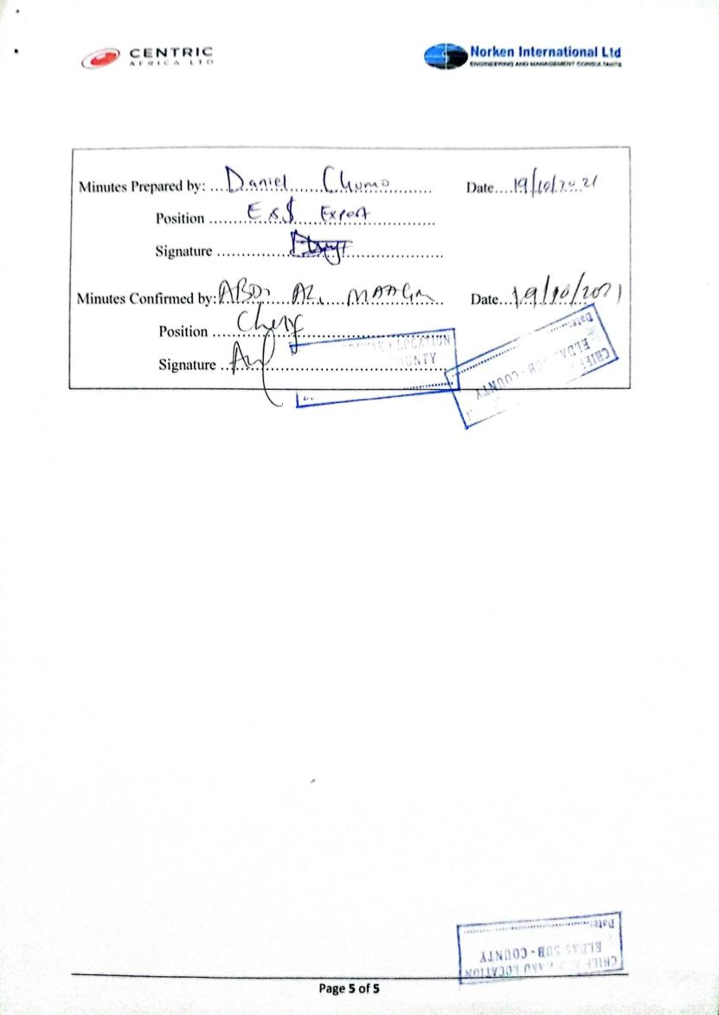

Appendix 5: ESIA Attendance List: Yaqo Baraza
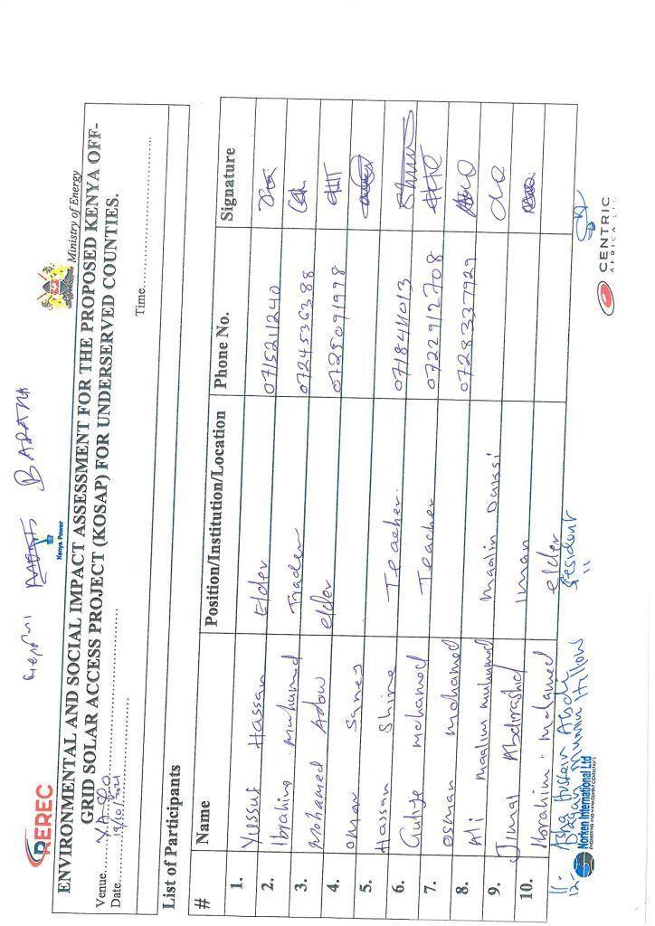
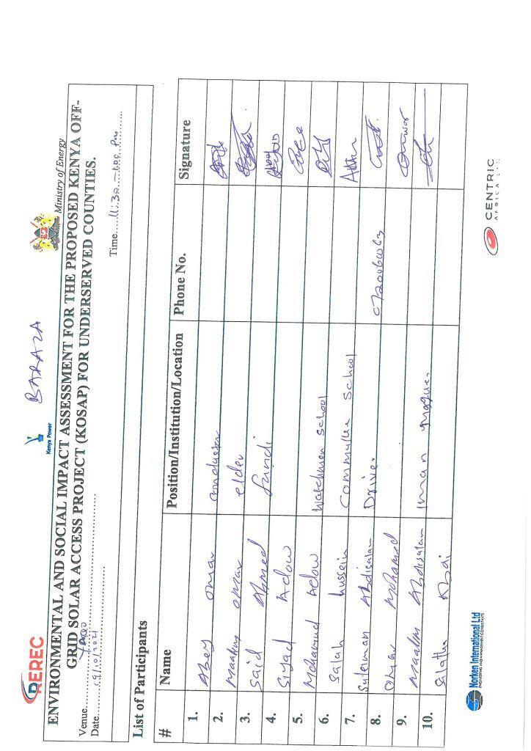

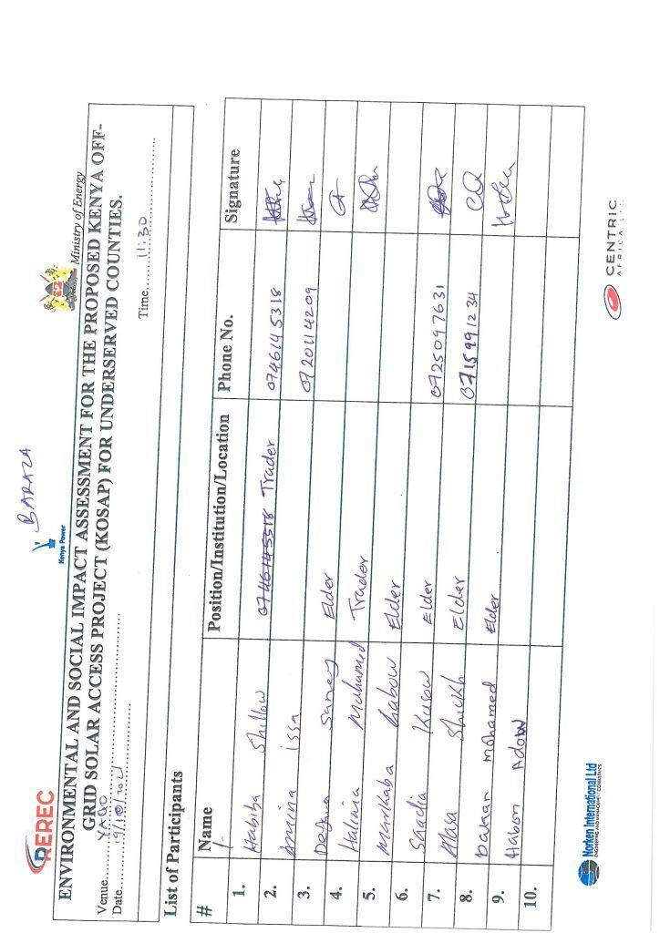
- FDGs list for the Elders/Men
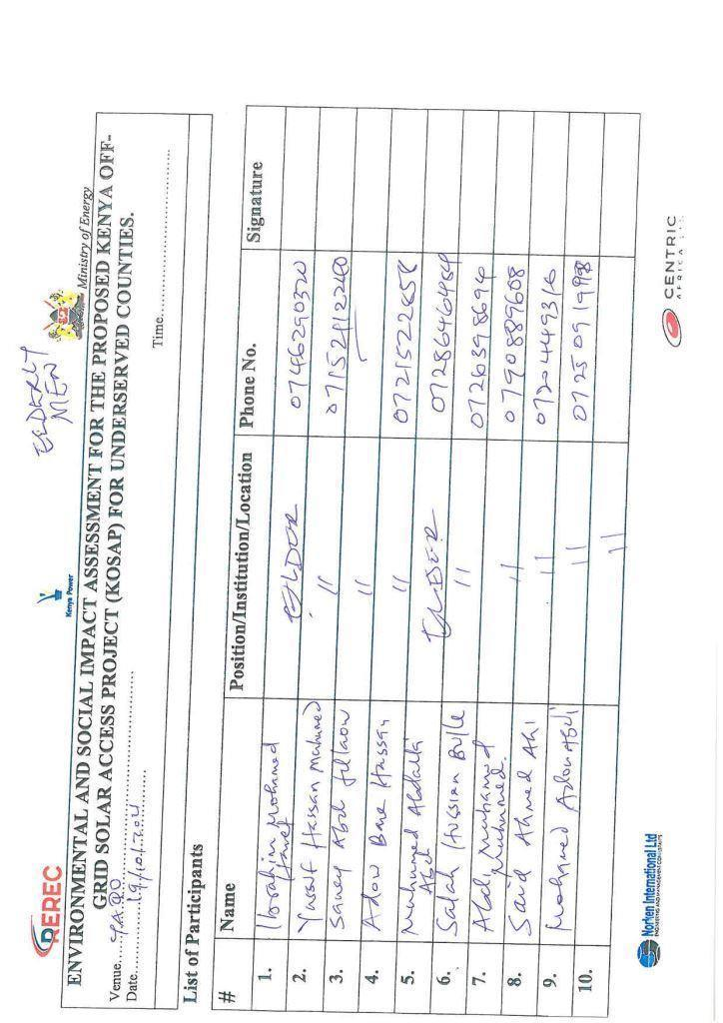
- FDGs list for the Women/Female
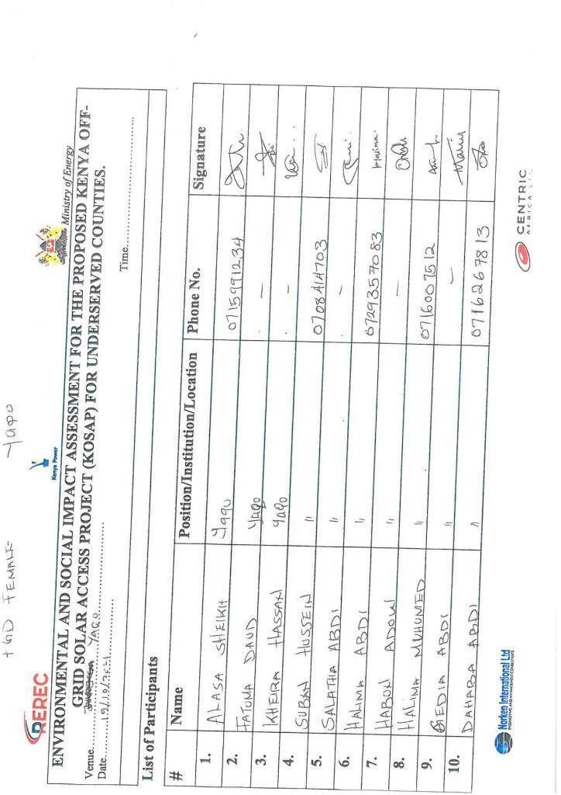
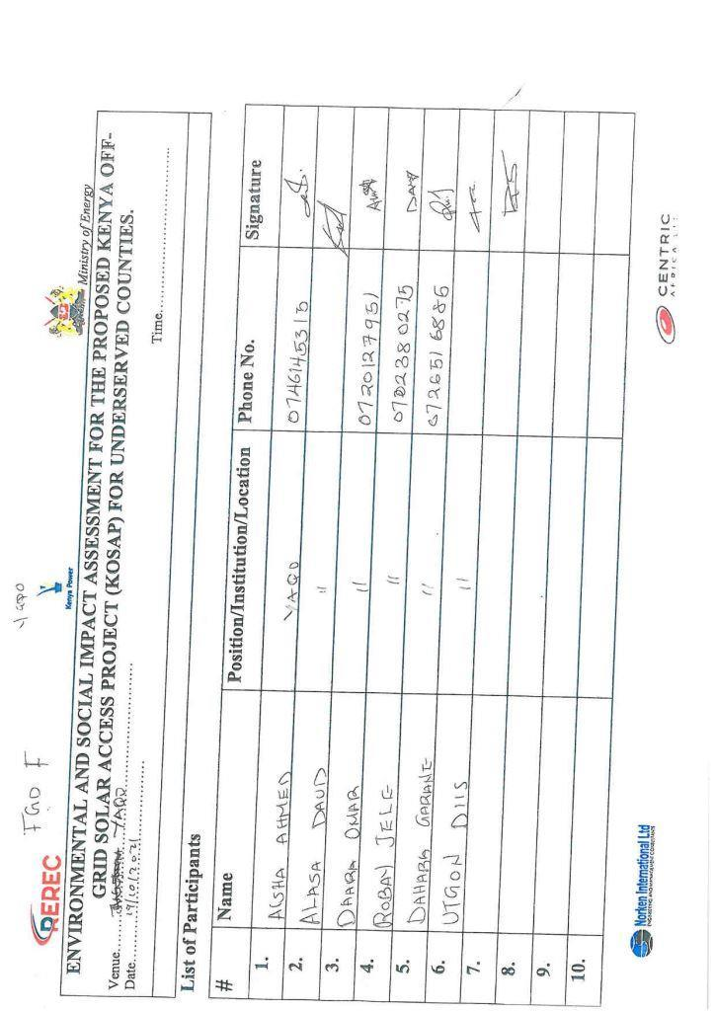
- ESIA - FDGs list for the Youth

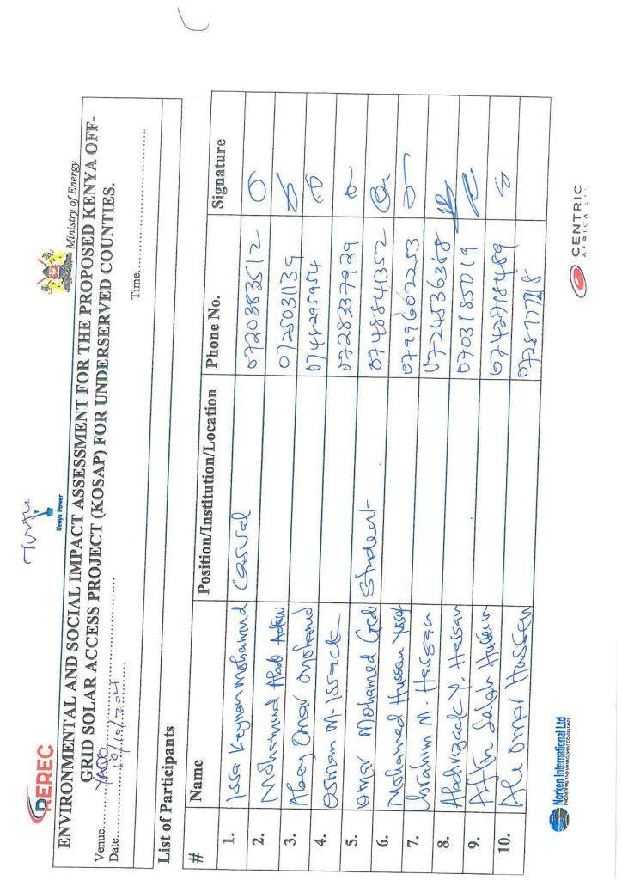

Appendix 6: Abbreviated Resettlement Action Plan (ARAP)

- Yaqo Sub-project Site
The Yaqo sub-project site is on unregistered community land and held in trust by the County Government of Wajir on behalf of the community, in line with the Community Land Act 2016. The proposed site is uninhabited, has no structures, community facilities, or encumbrances. The land is vacant characterized by sandy soils. Consultations leading to the identification and selection of the sub-project site are captured in the Environmental and Social Screening report for Yaqo. Refer to Chapter 4 of the ESIA for the comprehensive socio-economic profile.

- Actual Census Survey of PAPs and Valuation of Affected Assets
The number of project-affected persons (PAPs) is of approximately 800, and with about 100 households with an average of 8 people. The land acquisition-related impacts are loss of land and pasture. Enhancement Measures include in-kind compensation for loss of land and pasture, and designing power distribution lines to avoid impacting trees, crops, structures, and community facilities. No physical displacement is anticipated; however, there is minimal loss of pasture occasioned by the acquisition of land utilized by the community for grazing. The 1.260 Hectares identified for the sub-project will be acquired compulsorily by the National Land Commission (NLC). The proposed site will be valued and compensated in line with the provisions of the Resettlement Policy Framework (RPF) prepared under KOSAP. Refer to section 2.2 of the ESIA for the sketch map of the site.

- Compensation Measures Agreed with the PAPs and other Resettlement Assistance to be Provided
The proponent requested the community identify three priority projects, whereby one out of the three would be provided as in-kind compensation for loss of land and pasture. The Yaqo community proposed as a 1st priority provision of clean water. Under the community profile, the chief stated that the community needed water pipes and construction of water kiosks in different sections of the villages. The 2nd Priority to be considered was to construct sanitary facilities in the region since most were using the bush as sanitary facilities and the 3rd Priority was the construction and provision of health facilities and services since there was none. The value of the priority community project will be proportional to or higher than the value of land under acquisition. In addition, loss or damage to crops, trees, structures, and community facilities will be compensated in line with the provisions of the RPF, and as summarized in the entitlement matrix below.

3.1 Entitlement Matrix

Types of Impact | Person(s) Affected/Eligible for Compensation | Compensation/Entitlement/Benefits | Responsible organization
- Loss of Land
Loss of unregistered community land. | Community. | Compensation in-kind as prioritized by the community. | KPLC
Loss of land in unregistered group ranches. | Group ranch members. | Compensation in-kind as prioritized by the community. | KPLC
Loss of land in registered group ranches. | Group ranch members. | Compensation in-kind as prioritized by the community. | KPLC
Loss of land owned by the National Police, county governments and the Ministry of Interior | Government agencies. | No compensation for public land allocated to another government body. | KPLC
Loss of land owned by the Kenya Forest Service (KFS) and Kenya Wildlife Service (KWS). | Government agencies. | No compensation for public land allocated to another government body. However, payment of conservation fees to KWS and KFS as stipulated under their respective regulations is foreseen. | KPLC
- Loss of Use on Land
Loss of use on public land (e.g., grazing, farming etc.). | Communities utilizing public land. | Communities do not own public land; however, they utilize public land with consent from the relevant agencies. The project will implement the infrastructure project prioritized by the community as compensation for the loss of public land use. | KPLC
Loss of use on unregistered community land, unregistered group ranches and registered group ranches ( e.g., grazing, farming etc.). | Communities utilizing unregistered community land, unregistered group ranches, and registered group ranches. | Compensation in-kind as prioritized by the community. | KPLC
- Loss of /Damage to Assets on Land
Trees | Community members on unregistered community land; community members utilizing public land; members of registered and unregistered group ranches and government entities. | During detailed design for power distribution lines and construction of the mini grid and community project, any crops, structures, trees, and community facilities shall be avoided to the extent possible. However, loss or damage to the above will be compensated/restored at full replacement cost, in line with the provisions of the RPF. | KPLC
Crops |  |  | KPLC
Structures |  |  | KPLC
Community facilities e.g., water sources (earth pans, boreholes etc.). | Community members on unregistered community land, community members utilizing public land, and members of registered and unregistered group ranches. |  | KPLC

4. Consultations with PAPs About Acceptable Compensation Options and Alternatives that have been Considered
Detailed consultations with PAPs on land acquisition and compensation, including the modalities of acquiring land and compensation options, were undertaken during the Environmental and Social Screening, Environmental and Social Impact Assessment, and the NLC land valuation process. The following sections provide a summary of the consultations.

4.1 Engagement of Project -Affected Persons (PAPs)
Local administration and County Renewable Energy Officers (CREOs) supported the proponent and implementing agency (IA) to mobilize community members and other stakeholders for public consultations and engagement activities. National and county government entities, community segments (men, women, youth, elders, persons with disability, vulnerable and marginalized groups, etc.), NGOs, and local leaders were engaged through key informant interviews, community meetings, and focus-group discussions. The proponent and IA implemented appropriate measures to ensure PAPs effectively participated in the consultations. Refer to Chapter 5 of the ESIA on public consultation and engagement.
Once the compensation award and Bill of Quantities (BoQs) are known, the Implementing Agency (IA) will engage the community and agree on the community project to be executed as in-kind compensation. During these consultations, the IA and the community will define the roles and responsibilities of the community in monitoring the implementation of in-kind compensation and maintenance once the IA hands it over to the community. Thus, the IA and the community will effect an agreement to be signed by the local leadership; representatives of the Grievance Redress Committees at the locational, county, and national levels; A-RAP Implementation Committee, and Implementing Agencies.

4.2 Identification of Community Representatives
The Yaqo Locational Grievance Redress Committee (LGRC), constituting a chairperson, secretary, and three members, was formed through community consensus. The committee’s membership comprises men, women, youth, persons with disabilities, and ethnic minorities. The LGRC is responsible for engaging PAPs and resolving complaints. Refer to Chapter 6 of the ESIA on the Grievance Redress Committees. Further, the community will constitute the A-RAP Implementation Committee responsible for coordinating community engagements on the A-RAP and monitoring the implementation and closure of the A-RAP. The representation of the committee will consider gender, vulnerability, and intergenerational sensitivities.

4.3 Summary of Consultations on Land Acquisition and Compensation Options
Date | Objective | Implementing  Entities | Land Acquisition and Compensation Aspects  Discussed | Key Issues Raised | Responses  Given
25th May 2021 | Environmental and Social Screening.  Voluntary land donation (VLD).  Constitution of the Locational Grievance Redress Committee (GRC). | Ministry of Energy (MoE)  Kenya Power (KPLC)  Rural Electrification and Renewable Energy Corporation (REREC) | Site identification and land allocation for the sub-project.  Criteria for VLD.  Community entitlements (forms of compensation and implications for each). | None | None
19th October 2021 | Environmental and Social Impact Assessment. | Consultants  MoE  KPLC  REREC | Land acquisition through compulsory acquisition (not voluntary land donation).  Selection of three priority community projects, whereby one is to be implemented as in-kind compensation for land. | 1st Priority - Provision of clean water  2nd Priority – to construct sanitary facilities in the region since most were using the bush as sanitary facilities.  3rd Priority – construction and provision of health facilities and services since there was none. | The proponent has set aside KES 1 million to implement the priority in-kind compensation project.  The value of the project will be proportional to or greater than the value of land.  NLC will determine the value of land.
May 2023 | Compulsory Land Acquisition. | NLC | Site inspection and inquiries.  Land valuation.  Award of compensation.

5. Institutional Responsibility for Implementation of the ARAP
Entity | Role
Ministry of Energy | - Coordinate A-RAP implementation and provide budget for in-kind compensation.
National Land Commission | - Implement the statutory process for compulsorily land acquisition, including site gazettement and inspections, inquiries, valuation, and award of compensation.
Kenya Power | - Monitor all land acquisition and compensation aspects (including A-RAP closure), complemented by a third-party monitor.  - Provide budgets for stakeholder engagement, grievance management, and monitoring, including the facilitation of the Land Acquisition and Compensation Implementation Committee, and the Grievance Redress Committee.
Mini-grid Contractor | - Implement in-kind compensation concurrently with the solar mini-grid project.
Supervising Consultant | - Monitor and report on implementation of in-kind compensation, and overall project compliance with social safeguards.
Grievance Redress Committees | - Formed at the locational, county, and national levels, and responsible for resolving complaints, including A-RAP related grievances.
A-RAP Implementation Committee | - Coordinate A-RAP engagements at the community level, monitoring A-RAP implementation and closure.
Affected Community | - Responsible for the operation and maintenance (O&M) of in-kind compensation project. An agreement stipulating the O&M roles and responsibilities of the community will be effected.

6. Procedures for Grievance Redress
The Project procedures for grievance redress were established through a public consultation process and informed by the existing conflict resolution structures in the community. The Grievance Redress Mechanism (GRM) comprises tiers at the project, county, and national levels. Refer to Chapter 6 of the ESIA for a detailed GRM.

7. Implementation Timetable and Budget for the ARAP Implementation

7.1 Timelines
The proponent will commission the community project by May 25th, 2025, before operationalizing the mini-grid. The mini-grid contractor will implement the mini-grid and the community project simultaneously. The Supervision Consultant and IAs will implement a commitment register to ensure the mini-grid contractor can achieve the agreed-upon milestones. The register will be complete with clear and practical timebound indicators, which can be monitored by all parties – the PAPs, IAs, the Ministry, third-party monitor, and the Bank.

7.2 Budget
The proponent has set aside KES 1 million for the community project (budget captured in the ESMP). The compensation award from NLC and the Bill of Quantities will inform the final cost of the community project. The costs for in-kind compensation, stakeholder engagement, grievance management (including the facilitation of the GRCs and the A-RAP Implementation Committee), and monitoring are covered under the project.

Appendix 7: Firm and Lead Expert Practicing Licence
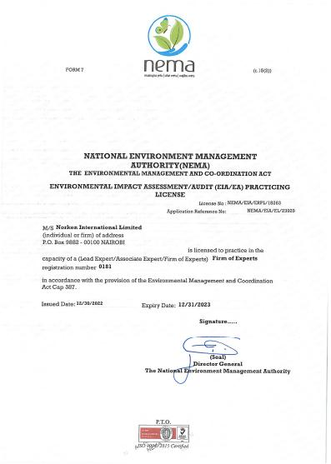
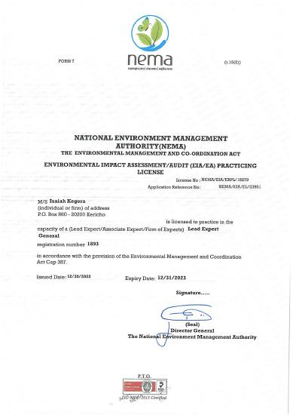

() As per the Energy Act of 2019, this role will now be performed by the Energy and Petroleum Regulatory Authority (EPRA).
A cost basis that will yield compensation sufficient to replace assets, plus necessary transaction costs associated with asset replacement).

