 | MINISTRY OF ENERGY AND PETROLEUM  Nairobi  Republic of Kenya
 | Investment Project Financing Kenya: Off-grid Solar Access Project for Underserved Counties (P160009)
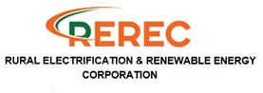
Environmental & Social Impact Assessment, Social Assessment and Vulnerable & Marginalised Groups

KENYA OFF-GRID SOLAR ACCESS PROJECT (KOSAP) FOR UNDERSERVED COUNTIES
 | Component 1: Mini-grids for Community Facilities, Enterprises, and Households
 | ESIA REPORT FOR THE PROPOSED DASHEEG OFF-GRID SOLAR PROJECT IN TARBAJ SUB COUNTY, WAJIR COUNTY
Rev | Description | Date
1 | Issued as Draft | March 2022
2 | Final Draft | June 2023
3 | Final | 2023

 |  |  |  | 

CERTIFICATION
This ESIA project report for the proposed Dasheeg Off-Grid Solar Project was prepared diligently in accordance with the Environmental Management and Coordination Act (EMCA), 1999 and the Environmental (Impact Assessment and Audit) regulations, 2003 and their subsequent amendments EMCA (amendments), 2015 and EIA/EA regulations 9ammendments), 2019 and The World Bank operational procedures OP and Environmental Safeguards Standards (ESS) for submission to the National Environment Management Authority (NEMA). We hereby certify that to the best of our knowledge and belief, the information and particulars provided in this report are correct and true. Further, it reflects the views provided by various stakeholders and village elders at Dasheeg Sub Location wajir county.
ESIA/EA FIRM OF EXPERTS:
  P. O. Box 9882 - 00100  Nairobi, Kenya  Tel. 254 020 2248762  Registration No. of Firm of Experts: 0181 | P.O. Box 102081-00101  Nairobi, Kenya  Tel. +254718068517  Registration No. of Firm of Experts: 7112

Signature: ________________________ Date: ______________________
Isaiah Kegora
NEMA Expert (Reg. No. 1893).
For Norken (I) Ltd & Centric Africa Ltd
PROPONENT:
Mr. Rodney I. Sultani
Project Coordinator, KOSAP
Ministry of Energy and Petroleum,
P.O. Box 30582-00100,
Kawi House, Nairobi, Kenya.

Signature: ________________________ Date: ______________________

------------------------------------------------------------------------------------------------------------------------------
Disclaimer:
This ESIA report is strictly confidential to MoE and Petroleum (the Proponent) and any use of the materials thereof should strictly be in accordance with the agreement between the Proponent and the consultants Norken International Limited and Centric Africa Limited (the Environmental Impact Assessor). It is, however, subject to conditions in the Environmental (Impact Assessment and Audit) Regulations, 2003 under the Kenya Gazette Supplement No. 56 of 13th June 2003

ACKNOWLEDGEMENT
The consultant wishes to acknowledge and appreciate the efforts and inputs by MOEP, the Implementing Agencies (KPLC), and the World Bank Group teams in reviewing this report.

TABLE OF CONTENTS
ACKNOWLEDGEMENT iii
TABLE OF CONTENTS 1-i
LIST OF TABLES 1-vii
LIST OF PLATES 1-viii
LIST OF FIGURES 1-ix
EXECUTIVE SUMMARY 1-i
1 INTRODUCTION 1-1
1.1 Context 1-2
1.2 Project Overview 1-3
1.3 Purpose and Scope of Work 1-3
1.4 ESIA Methodology 1-3
1.4.1 Screening and Scoping 1-3
1.4.2 Environmental Impact Assessment 1-3
1.4.3 Environmental and Social Management Plan (ESMP) 1-5
1.5 Layout of the Report 1-7
1.6 ESIA Study Team 1-7
2 PROJECT DESCRIPTION 2-8
2.1 Introduction 2-8
2.2 Project Location 2-9
2.3 Description of Project Facilities, Components and Activities 2-1
2.3.1 Project Components 2-1
2.3.2 Architecture and Basic Design Specifications 2-2
2.4 Resource Requirement 2-4
2.4.1 Workforce Requirement 2-4
2.4.2 Water Requirement and Source 2-4
2.4.3 Raw Material Requirement 2-4
2.4.4 Power Requirement 2-4
2.4.5 Fire Safety and Security 2-5
2.5 Pollution Streams during Construction Phase 2-5
2.5.1 Solid Waste Generation 2-5
2.5.2 Air Emissions 2-6
2.5.3 Liquid Waste Generation 2-6
2.5.4 Noise Emissions 2-6
2.6 Analysis of Alternatives and Project Justification 2-7
2.6.1 Present Power Supply Position 2-7
2.6.2 Site Selection 2-7
2.6.3 Alternate Location for Project Site 2-8
2.6.4 Analysis of Alternative Construction Materials and Technology 2-8
2.6.5 Conclusion 2-8
3 APPLICABLE AND REGULATORY FRAMEWORK 3-9
3.1 Introduction 3-9
3.2 Kenya Electricity Supply Industry (ESI) 3-9
3.3 National Legal Framework rEVIEW 3-10
3.4 World Bank OP applicability 3-18
4 BASELINE SETTINGS - ENVIRONMENT, ECOLOGY AND SOCIAL 4-20
4.1 Area of Influence 4-20
4.1.1 Project Footprint Area 4-20
4.1.2 Study Area 4-21
4.2 Environment Baseline 4-21
4.2.1 Land Use 4-21
4.2.2 Physical and Topographic Features 4-21
4.2.3 Hydrogeology and Drainage 4-22
4.2.4 Ecology 4-22
4.2.5 Water Resources 4-23
4.2.6 Ambient Air Quality 4-23
4.2.7 Ambient Noise Quality 4-23
4.2.8 Soil Type 4-23
4.2.9 Climate and Meteorology 4-23
4.3 Socio-economic Environment 4-24
4.3.1 Socio-economic status of Study Area 4-24
5 STAKEHOLDER ENGAGEMENT 5-27
5.1 Stakeholder Consultation and Disclosure Requirement for the Project 5-27
5.2 Stakeholder Characterisation and Identification 5-27
5.2.1 Stakeholder Mapping 5-28
5.3 Stakeholder Analysis 5-28
5.4 summary of community consultation meeting leading to land identification and Grievance Redress Committee constitution 5-29
5.4.1 Land requirements for the project 5-29
5.4.2 Plenary session 5-30
5.4.3 Grievance Redress Mechanism 5-31
5.5 KEY FEEDBACK RECEIVED DURING STAKEHOLDER CONSULTATION PROCESS 5-31
5.5.1 Remarks from the Baraza meeting 5-32
5.5.2 Consultant’s Remarks 5-32
5.5.3 Benefits of the Project 5-32
5.5.4 Negative impacts Identified on the project and Consultant’s Response 5-32
5.5.5 Consent 5-33
5.6 FEEDBACK RECEIVED DURING focused group discussion 5-35
5.6.1 Education Feedback from the FGD 5-35
5.6.2 Health Stakeholders’ Consultation and Participation 5-36
5.6.3 Feedback from the Men FGD in Dasheeg: 5-37
5.6.4 Feedback from the Women Stakeholders’ in Dasheeg: 5-38
5.6.5 Summary of feedback from the youth in Dasheeg: 5-39
6 IMPACT ASSESSMENT AND MITIGATION MEASURES 6-41
6.1 Introduction 6-41
6.2 Impact Assessment Methodology 6-41
6.3 Defining Impact 6-41
6.4 Assessment of Significance 6-41
6.5 Magnitude of Impact 6-43
6.6 Sensitivity of Resources and Receptors 6-43
6.7 Likelihood 6-44
6.8 Definition of mitigation measures 6-44
6.9 Assessing residual impacts 6-45
6.10 Positive Impacts During Construction Phase 6-45
6.10.1 Creation of Employment Opportunities 6-45
6.10.2 Improving local economy 6-45
6.11 Positive Impacts during Operation Phase 6-46
6.11.1 Quality, Reliable Power Supply 6-46
6.11.2 Employment Creation 6-46
6.11.3 Reduction of Pollution Associated with Thermal Power Generation, Kerosene and Wood Fuel Usage: 6-47
6.11.4 Improvement of Local and National Economy 6-47
6.11.5 Education 6-48
6.11.6 Health Benefits of the Project 6-48
6.11.7 Improved Standard of Living 6-48
6.11.8 Security 6-48
6.11.9 Communications 6-48
6.12 Positive Impacts during Decommissioning Phase 6-49
6.12.1 Employment Opportunities 6-49
6.12.2 Site Rehabilitation 6-49
6.13 Negative Impacts during Pre-construction Phase 6-49
6.13.1 Land Take 6-49
6.14 Negative Impacts During Construction Phase 6-51
6.14.1 Vegetation Clearance 6-51
6.14.2 Soil Erosion Impact 6-51
6.14.3 Contamination of Soil from Fossil Fuels 6-52
6.14.4 Dust Emissions 6-52
6.14.5 Vehicle Exhaust Emissions 6-53
6.14.6 Pollution from Solid Waste Generation 6-53
6.14.7 Impacts on Water Resources and Water Quality 6-54
6.14.8 Noise and vibration 6-54
6.14.9 Impacts from Hazardous Materials 6-55
6.14.10 Accidental Oil Spills or Leaks 6-56
6.14.11 Fire Hazards 6-56
6.14.12 Impacts of construction material sourcing (e.g., quarrying) 6-57
6.14.13 Increased Water Demand 6-57
6.14.14 Energy Consumption 6-57
6.14.15 Occupational Health and Safety Impacts 6-58
6.14.16 Community Safety -Access to Site by General Public 6-58
6.14.17 Spread od HIV/AIDS and STIs 6-59
6.14.18 Increase in competion for scarce resources and strain on public utilities 6-59
6.14.19 Child Labor 6-60
6.14.20 Gender Based Violence- SEA and SH 6-60
6.14.21 Public Health Impacts 6-62
6.14.22 Forced Labor 6-63
6.14.23 Risks related to Inadequate Stakeholder Engagement 6-63
6.15 Negative impacts during Operation phase of the project 6-63
6.15.1 Solid Waste Generation 6-63
6.15.2 Liquid Waste/Oils Generation 6-64
6.15.3 Increased oil Consumption 6-64
6.15.4 Increased Storm Water Flow 6-64
6.15.5 Fire Outbreaks 6-65
6.15.6 Visual Impacts 6-65
6.15.7 Water demand 6-65
6.15.8 Sanitary waste 6-66
6.15.9 Flooding 6-66
6.15.10 Workers Occupation Health and Safety 6-66
6.15.11 Hazardous waste 6-66
6.15.12 Noise and Vibration 6-67
6.15.13 Electric and magnetic fields (EMFs) 6-67
6.15.14 Shocks and electrocutions to the beneficiaries 6-67
6.15.15 Community safety -Access to the facility by general public 6-67
6.15.16 Risks related to poor or inadequate stakeholder engagement (Conflict) 6-68
6.15.17 Gender Based Violence- SEA/ SH 6-68
6.15.18 Public Health Impacts –HIV/AIDs 6-69
6.15.19 Public health Impacts -Covid 19 disease 6-69
6.15.20 Dust emissions 6-69
6.15.21 Vehicle exhaust emissions 6-70
6.16 Negative impacts during decommissioning phase 6-70
6.16.1 Noise and Vibration 6-70
6.16.2 Solid Waste Generation 6-71
6.16.3 Dust Emissions 6-71
6.16.4 HIV/AIDs awareness and prevention 6-71
6.17 Social Protection 6-71
6.18 Social Inclusion 6-72
6.19 Cumulative Impacts 6-1
6.19.1 Cumulative Impact Assessment 6-1
7 ENVIRONMENTAL AND SOCIAL MANAGEMENT PLAN (ESMP) 7-1
7.1 environmetal and social management plan 7-1
8 IMPACT SUMMARY AND CONCLUSION 8-1
8.1 Introduction 8-1
8.2 Summary of impacts identified and assessed 8-1
8.2.1 Construction Phase Impacts 8-1
8.2.2 Operational Phase Impacts 8-1
8.3 sa and VMGP Conclusion 8-1
8.4 Conclusion AND RECOMMENDATIONS 8-2
9 APPENDICES 9-3
Appendix 1: Minutes for Community Consultation meeting during ESIA Public Participation 9-4
Appendix 2: List of Participants - ESIA 9-9
Appendix 3: Minutes for Community Consultation Meeting Leading to Land Identification and GRC Constitution-(screening level) 9-22
Appendix 4: List of Participants - Land Acquisition 9-37
Appendix 5: Abbreviated Resettlement Action Plan (A-RAP) 9-47
Appendix 6: Project Design 9-52
Appendix 7: Lead Expert’s Practicing Licence 9-53

LIST OF TABLES
Table 0-2: Summary of Pre-construction Impacts 1-v
Table 0-3: Summary of Construction and Decommissioning Phases Impacts 1-v
Table 0-4: Summary of Operation Phase Impacts 1-vi
Table 5: Structure of the ESIA Report 1-7
Table 6: Summary Information oof the proposed Dasheeg East Solar Mini-grid 2-8
Table 7: National Legal framework 3-1
Table 8: Summary of demographic profile Dasheeg Sub Location 4-24
Table 9: Identified Stakeholders 5-27
Table 10: Stakeholder Significance and Engagement Requirement 5-28
Table 11:Summary of Stakeholder Influence 5-29
Table 12: FGD dates and attendance 5-35
Table 13: Categories of Significance 6-42
Table 14: Overall Significance Criteria for Environmental Impacts 6-43
Table 15: Explanation of Terms Used for Likelihood of Occurrence 6-44
Table 15: Environmental and Social Management Plan 7-1
Table 21: Institutional Framework and Compliance/Implementation of the ESIA/ESMP 7-1

LIST OF PLATES
Plate 1: Project site area, Dasheeg area 2-9
Plate 2: Project area flora presentation 4-22

LIST OF FIGURES
Figure 2: Summary of Environmental and Social Impact Assessment Methodology 1-6
Figure 3: Project Location Site and immediate surrounding 2-9

Abbreviations
ACRONYM DEFINITION
ADR Alternative Dispute Resolution
AoI Area of Influence
CBOs Community Based Organizations
CoK Constitution of Kenya
CDI County Development Index
CEMP Construction Environmental Management Plan
CGRCs County Grievance Redress Committees
CRA Commission on Revenue Allocation
CSR Customer Social Responsibility
CIDP County Integrated Development Plan
CPS Country Partnerships Strategy
DOSHS Directorate of Occupational Safety and Health Services
EHS Environment Health and Safety
EIA Environmental Impact Assessment
EPRA Energy Petroleum Regulatory Authority
EPT Energy and Petroleum Tribunal
EPRA Energy and Petroleum Regulatory Authority
ESI Electrical Supply Industry
ESIA Environmental and Social Impact Assessment
ESMF Environmental and Social Management Framework
ESMP Environmental and Social Management Plan
ESMMP Environmental and Social Management and Monitoring Plan
EMCA Environmental Management and Coordination Act
EMF Electromagnetic Field
FGD Focus Group Discussions
GDC Geothermal Development Company
GBV Gender Based Violence
GoK Government of Kenya
HDPE High Density Poly Ethylene
IAs Implementing Agencies
IPPs Independent Power Procedures
IPs Indigenous Peoples
JV Joint Venture
KETRACO Kenya Electricity Transmission Company
KII Key Informant Interviews
KOSAP Kenya Off-Grid Solar Access Project
KPLC Kenya Power and Lighting Company
LEP Labour and Employment Plan
LGRCs Local Grievance Redress committee
MGs Mini Grids
MOEP Ministry of Energy and Petroleum
MSDS Material Safety Datasheet
NEMA National Environmental Management Authority
NGOs Non-Governmental Organizations
NLC National Land Commission
NTSA National Transport and Safety Authority
OHS Occupational Health and Safety
OM Operation and Maintenance
OP Operational Policies
PAD Project Appraisal Document
PAPs Project Affected Persons
PCU Project Co-ordination Unit
PPAs Power Purchase Agreements
PPEs Personal Protective Equipment
PV Photo-voltaic
REREC Rural Electrification and Renewable Energy Corporation
RPF Resettlement Policy Framework
SA Social Assessment
SEA Strategic Environmental Assessment
SHS Solar Home Systems
SIA Social Impact Assessment
SOP Safe Operation Procedure
STDs Sexually Transmitted Diseases
STI Science, technology and innovation
SMMP Social Management and Monitoring Plan
ToR Terms of Reference
VMGF Vulnerable and Marginalised Groups Framework
VMGs Vulnerable and marginalized groups
VMGP Vulnerable and Marginalised Group Plan
WB World Bank
WMP Waste Management Plan
WRA Water Resources Authority

EXECUTIVE SUMMARY
E-1- Introduction and Project Brief
The Ministry of Energy (MOE) hereinafter refer to as proponent is implementing the Kenya Off-Grid Solar Access Project (KOSAP) in 14 underserved counties in Kenya. The aim of the project is to provide clean and modern energy services through off-grid solar solutions. The Proponent is coordinating the implementation of the project through the implementing agencies; Kenya Power (KP) and the Rural Electrification and Renewable Emergency Corporation (REREC). The project is funded by the World Bank Group with $150 million and a $5 million grant from the Carbon Initiative for Development. The goal of the project is to bring electricity to around 250,000 households, 476 community facilities, and 380 boreholes in the target counties, benefiting low-income groups. It also includes the sale and installation of 150,000 efficient cook stoves. The project focuses on marginalized areas based on the County Development Index (CDI) and aims to address infrastructure deficits, lack of access to roads, electricity, water, and social services in these underserved counties. To ensure sustainability, the project relies on public funding, local community participation, and the institutional capacity of KP, REREC, and the MOE.
The KOSAP consists of four main components. The first component, focuses on the implementation of mini-grids to provide electricity to community facilities, enterprises, and households in areas where mini-grids are the most cost-effective option. The second component, aims to electrify households through standalone solar systems in areas without load clusters where standalone systems are the best technical and financial solution. The third component, supports the electrification of public institutions and community facilities using standalone solar systems. It also includes the installation of solar PV-powered water pumps for consumptive purposes. Lastly, the fourth component, provides funding for implementation support, technical assistance, and capacity building activities to ensure the sustainability and impact assessment of the interventions carried out under the other components of KOSAP.
In Wajir County, one of the target counties, the Proponent is proposing to develop 27 No. mini grid facilities including Dasheeg Mini Grid discussed in this report. In order to adhere to both national and donor requirements, the Proponent engaged the services to the consortium of Norken International Limited and Centric Africa Limited to undertake the ESIA. The ESIA has been conducted following the requirements outlined in the Environmental Management and Coordination Act (EMCA) 1999 and its amendments, as well as international environmental and social policies such as the World Bank's OP 4.01 on environmental assessment.
E-2- Project Categorization and Justification
In the World Bank context, there have been several projects supported by the organization that aim to provide electricity to communities located far from the national grid. These projects utilize off-grid approaches, meaning they are independent of a national or regional grid. The experience gained from these projects provides valuable guidance for designing sustainable off-grid electrification initiatives, particularly those targeting dispersed and economically disadvantaged communities. The Dasheeg proposed site aligns with this category of projects that the World Bank has been involved in.
In the Kenyan context, the Environmental Management and Coordination Act (EMCA) of 1999, as amended in April 2019 through Legal Notice No. 31, classifies solar power farms and plants as medium risk projects. This categorization provides a framework for assessing and managing the potential environmental and social impacts associated with such projects. By categorizing the Dasheeg site as a solar power facility, it falls within the medium risk project category as per the Kenyan legislative framework.
E-3 Approach and Methodology
The Environmental and Social Impact Assessment (ESIA) for the proposed project followed a structured process, beginning with kick-off meetings and online discussions involving the Proponent, Implementing agencies, and the World Bank Environmental and Social Safeguard Team. These consultations were instrumental in establishing the project's scope, deliverables, timeline, and methodology. Subsequently, screening and scoping exercises were conducted to evaluate potential social and environmental risks. A thorough desk-based review was also undertaken to assess existing project documentation, legal requirements, and relevant plans.
The study employed a comprehensive approach to gather primary and secondary data for the project. Both qualitative and quantitative methods were utilized, with secondary data obtained through literature reviews. Primary data collection involved various techniques, including physical observations, photography, interviews, and stakeholder consultations. This comprehensive approach enabled a comprehensive examination of the project's environmental and social aspects, ensuring a holistic understanding of its potential impacts.
The study further involved the identification and assessment of potential impacts throughout the project's life cycle. Key areas of evaluation included land use, water resources, biodiversity, air quality, noise levels, community health and safety, and socio-economic conditions. To mitigate adverse effects, the study developed environmental and social management and monitoring plan, aiming to address both positive and negative impacts that may arise from the project. These measures aimed to ensure the project's sustainability and enhance its overall environmental and social performance.
E-4 Legislative Regulatory Framework
The evaluation, planning, and implementation of the proposed project is guided by the World Bank's Environmental and Social Framework, the national legislative framework, and the project's safeguard instruments. These measures aim to ensure environmental sustainability, protect the rights and needs of indigenous peoples and marginalized groups, and minimize adverse impacts through effective management and mitigation measures.
The Government of Kenya established the Environmental Management and Coordination Act (EMCA) in 1999, providing a legal framework for environmental management. EMCA takes precedence over other sectoral laws related to the environment. In 2013, the government formulated a national Environmental Policy with the goal of promoting sustainable management and use of the environment.
Collaboration and consultation among government agencies and stakeholders are essential for coordinating environmental management effectively. Key institutions in Kenya responsible for environmental issues include the National Environment Management Authority (NEMA), County Environment Committees, National Environmental Complaints Committee, National Environment Action Plan Committee, Standards and Enforcement Review Committee, National Environment Tribunal, and National Environment Council (NEC).
The project also adheres to the World Bank Safeguard Policies, which aim to improve decision-making processes, promote sustainable project options, and involve affected people in consultations. The applicable operational policies for this project include Environment Assessment, Natural Habitats, Indigenous Peoples, and Involuntary Resettlement. The Environmental and Social Impact Assessment (ESIA) considers these policies and addresses potential environmental and social concerns.
Additionally, the ESIA references other Safeguard Instruments prepared under the Kenya Off-Grid Solar Access Project (KOSAP), including the Environmental and Social Management Framework (ESMF), Resettlement Policy Framework (RPF), and Vulnerable and Marginalized Groups Framework (VMGF). These instruments provide procedures and guidelines for assessing and managing environmental and social aspects specific to the proposed subprojects under KOSAP.
E-5 Environmental Setting
The project area in Dasheeg village in Wajir County, at the Dasheeg sub-location, Dasheeg Location, Tarbaj Ward, Tarbaj Sub County. The project area is characterized by a lack of trees and plants, resulting in a semi-arid environment that falls within ecological zones V-VI. Zone V, and receives 300-600mm of rain per year. The county receives an average of 240 mm of unpredictable and short rainfall per year, making it unsuitable for vegetation growth and rain-fed agriculture.
Droughts are common in the area, and their intensity and amplitude are increasing, putting pressure on pastures and water resources. As a result, land degradation, inter- and intra-community conflicts, and the risk of livelihood loss are all on the rise. The initiative's purpose is to increase pastoral communities' resilience by linking them to a solar mini grid system, which will increase their income sources.
E-6 Project Description
The Dasheeg Mini Grid project aims to provide electricity to approximately 426 residential and 7 nonresidential consumers in Dasheeg village at Dasheeg sub-location, Dasheeg Location, Tarbaj Ward, Tarbaj Sub County in Wajir County. The project will utilize solar photovoltaic panels, a Battery Energy Storage System, and a Diesel Generator to generate electricity. A Low Voltage Power Distribution Network will be established to distribute the power to customers. The estimated cost of the project is around USD 621,812 although this amount may change as more detailed plans are developed.
The project utilizes solar panels with a total capacity of 108 kWp to harness solar energy. Solar power is a clean and renewable energy source that will provide a significant portion of the electricity needed for the project. A 350 kWh Battery Energy Storage System is incorporated to store excess solar energy during the day, ensuring a consistent power supply even during cloudy or nighttime conditions. A 50 kVA diesel generator is included to serve as a backup power source for periods of low solar generation or in case of battery depletion. It provides reliability and backup in the event of extended periods of cloudy weather or high demand. A 2,000-liter fuel tank is provided to store diesel fuel for the generator, ensuring continuous operation during extended periods of low solar or high demand. Additionally, PV Inverter: A 90 kW solar PV inverter is used to convert the direct current (DC) electricity generated by the solar panels into alternating current (AC) electricity suitable for consumer use. The proposed minigrid site has a circuit distribution length of 12km.
The project consists of two main components: Hybrid Mini-Grids and power line reticulation lines. The Hybrid Mini-Grids will combine solar panels and diesel power generation. These energy sources will be integrated through a centralized photovoltaic plant connected to a 3-phase AC busbar line. The configuration is designed to prioritize direct supply from the solar generator during daylight hours, reducing reliance on battery storage. The battery storage will primarily be used when solar generation is low or demand is high. The construction of power line reticulation lines will ensure the efficient distribution of electricity to residential, commercial, and other consumers, ensuring a reliable and efficient power supply.
To develop the Mini Grid, approximately 1.11 hectares of land will be compulsorily acquired by NLC. This land is part of the community's designated public purposes area. The Proponent engaged with the community during the land acquisition process, and there were no objections to transferring 1.11 hectares of land to Kenya Power and Lighting Company (KPLC) for the management of the solar mini-grid. In accordance with the World Bank's Operation Procedure 4.12 on Involuntary Resettlement, an abbreviated Resettlement Action Plan (A-RAP) was prepared, outlining the principles and procedures for land acquisition and compensation. This plan is annexed to the project report.

E-7 Project Alternatives
Solar energy is identified as a non-polluting and site-specific option, and the proposed site for Dasheeg MG is chosen as the most suitable location for the mini-grid based on factors such as sunlight availability and the community's lack of grid connectivity. The use of wind power, thermal power, fossil fuels, and power import from neighboring countries are considered as alternative methods of power generation but are found to have limitations or environmental concerns. Solar energy is favored due to its low production costs, versatility, clean nature, and economic savings. The "No Project" alternative is deemed unfavorable as it would maintain the current lack of electricity access and hinder socio-economic development. The project will be constructed using modern materials and technology, with a focus on public health, safety, security, and environmental requirements. The technology will involve a Battery Energy Storage System.
E-8 Stakeholder Engagement
It is important to highlight that two forms of stakeholder engagement were carried out for the project. The first form as noted earlier, focused on the acquisition of land for the project and involved the Proponent and the implementing agency (KP). The second form of engagement was conducted specifically for the Environmental and Social Impact Assessment (ESIA) study.
For the ESIA study, various methods were employed to engage stakeholders, taking into consideration their different categories. Face-to-face discussions were held with government officials and key stakeholders, while separate focused group discussions were conducted with men, women, and youth. Additionally, a public baraza or meeting was organized to allow community members to participate.
During the ESIA stakeholder engagement public meeting, which took place on October 27, 2021, a total of 136 stakeholders attended. The meeting provided an opportunity to discuss project details, including the preliminary design, positive and negative impacts, and mitigation measures. Stakeholders were encouraged to share their views and provide feedback on the project.
The Dasheeg area community requested the following: Fencing of Dasheeg waterpan/small dam and additionally install water distribution lines from the water pan to settlement areas; and the headteacher of Dasheeg primary school requested for fencing of the school which is currently located in an open area.
E-9 – Impacts and Mitigation Measures
The Environmental and Social Impact Assessment (ESIA) for the proposed Solar Mini-grid project has identified both positive and negative impacts across its different phases: pre-construction, construction, operation, and decommissioning. In the construction phase, positive impacts include local employment opportunities, boosting local businesses, and sourcing materials locally. During the operation phase, positive impacts encompass reliable power supply, economic improvement, education, health benefits, improved living standards, and enhanced security and communication. Similarly, the decommissioning phase offers positive impacts such as local employment and sourcing.
On the negative side, the pre-construction phase involves minor impacts like land acquisition, while the construction phase encompasses various minor to moderate impacts such as vegetation clearance, soil erosion, dust emissions, and occupational health and safety concerns. Challenges related to stakeholder engagement, labor influx, child labor, and exclusion of vulnerable individuals are also anticipated. In the operation phase, negative impacts include waste generation, increased oil consumption, fire outbreaks, occupational health and safety concerns, and inadequate stakeholder engagement. Issues of exclusion, inadequate grievance management, and public health concerns may arise as well.
During the decommissioning phase, negative impacts primarily relate to solid waste generation, noise and vibration, and challenges in stakeholder engagement, labor influx, child labor, gender-based violence, and exclusion of vulnerable individuals and households.
Tables 0-2 to 0-5 below present summaries of anticipated impacts and their corresponding levels of significance, both pre- and post-mitigation.
Table 0-2: Summary of Pre-construction Impacts
Impact | Significance Of Impact (Pre-Mitigation) | Residual Impacts (Post-Mitigation)
Land acquisition | Minor | Negligible
Way leaves | Minor | Negligible
Stakeholder identification and consultations | Major | Minor

Table 0-3: Summary of Construction and Decommissioning Phases Impacts
Impact | Pre-construction | Construction phase | Decommissioning phase
Impacts on Local Economy and Employment | Not Applicable | Positive | Positive
Change in land use | Not Applicable | Moderate | Positive
Site rehabilitation | Not Applicable | Not Applicable | Positive
Topography | Not Applicable | Minor | Not Applicable
Soil environment | Not Applicable | Minor | Minor
Air Quality | Not Applicable | Moderate | Moderate
Ambient noise | Not Applicable | Minor | Minor
Visual intrusion and change in landscape | Not Applicable | Minor | Positive
Waste generation and soil contamination | Not Applicable | Minor | Minor
Impact on water environment | Not Applicable | Minor | Not Applicable
Impacts from hazardous materials | Not Applicable | Minor | Not Applicable
Fire hazards | Not Applicable | Moderate | Minor
Impacts of construction material sourcing | Not Applicable | Moderate | Not Applicable
Energy consumption | Not Applicable | Negligible | Not Applicable
Occupational safety and health | Not Applicable | Moderate | Moderate
Community safety and health | Not Applicable | Moderate | Moderate
Labor influx | Not Applicable | Minor | Minor
Child labor | Not Applicable | Minor | Negligible
Cultural heritage | Not Applicable | Minor | Not Applicable
Gender based violence, SEA and SH | Not Applicable | Minor | Minor
Exclusion of VMGs, Vulnerable individuals and households | Not Applicable | Major | Major
Risk of communicable diseases | Not Applicable | Minor | Minor
Increased water demand |  | Negligible | Negligible
Forced labor |  | Minor | Negligible
Table 0-4: Summary of Operation Phase Impacts
Impact | Significance Of Impact (Pre-Mitigation) | Residual Impacts (Post-Mitigation)
Impact On Economy and Employment | Positive | Positive
Quality, reliable power supply | Positive | Positive
Reduction of pollution associated with thermal power generation, kerosine and wood fuel usage | Positive | Positive
Education | Positive | Positive
Health benefits | Positive | Positive
Improved standard of living | Positive | Positive
Security | Positive | Positive
Communication | Positive | Positive
Soil environment | Minor | Negligible
Waste generation and management | Minor | Negligible
Water environment | Negligible | Negligible
Landscape and visual impacts | Minor | Negligible
Increased oil consumption | Minor | Negligible
Increased storm water flow | Minor | Negligible
Fire outbreaks | Moderate | Minor
Water demand | Negligible | Negligible
Sanitary waste | Negligible | Negligible
Flooding | Negligible | Negligible
Noise and Vibration | Negligible | Negligible
Electric and magnetic fields (EMFs) | Negligible | Negligible
Dust Emission | Negligible | Negligible
Vehicle Exhaust emission | Minor | Negligible
Collision and electrical hazards from distribution infrastructure | Minor | Negligible
Occupational safety and health | Moderate | Minor
Community safety and health | Moderate | Minor
Gender based violence, SEA and SH | Minor | Negligible
Exclusion of VMGs, Vulnerable individuals and households | Major | Minor
Risk of communicable diseases | Minor | Negligible
Shocks and electrocution to the beneficiaries | Moderate | Minor
Risks related to poor and inadequate stakeholder engagement (conflict) | Minor | Negligible

E-10 Environmental and Social Management and Monitoring Plan
A comprehensive set of mitigation measures in the form of an Environmental and Social Management and Monitoring Plan (ESMMP) have been prepared for the project. The ESMMP serves as a comprehensive framework for the integrated management of all environmental and social impacts throughout the project's lifecycle. It has been prepared to ensure that the social and environmental impacts and risks identified during the Environmental and Social Impact Assessment (ESIA) process are appropriately managed during the construction, operations, and decommissioning phases of the project. It specifies the mitigation and management measures that the project proponent and contractor are committed to implementing and outlines how organizational capacity and resources will be mobilized to achieve these measures. The ESMMP also ensures compliance with the relevant laws, regulations within Kenya, as well as the environmental and social sustainability requirements of the World Bank's Operational Policies (OPs).
These measures emphasize a proactive approach, prioritizing prevention rather than reaction. They encompass various aspects such as proper waste handling and disposal to prevent pollution, engaging stakeholders to address grievances, providing personal protective equipment (PPE) for workers, ensuring adequate supervision, and emphasizing good workmanship from the contractor. Specific plans are also outlined to address specific issues that may arise. The ESMMP also highlights environmental performance indicators that should be regularly monitored. Monitoring serves as a means to detect and draw attention to any changes or problems in environmental quality. It involves continuous or periodic reviews of the ESMMP implementation progress, allowing for adjustments and improvements as necessary.
While accommodating the recommended mitigation measures to the extent practical and economically viable, the project proponent and contractor should ensure that the measures do not compromise the economic viability of the project or have long-lasting adverse impacts on the environment.
For the mitigation measures to be successful, it is imperative that the Kenya Power and Lighting Company (KPLC) allocates sufficient resources for the implementation of the ESMMP. Adequate resources will enable the proper execution of the proposed measures and ensure their effectiveness in minimizing the identified negative impacts.
Following the project's commissioning, it is mandatory to conduct statutory Environmental and Safety Audits in accordance with national legal requirements. These audits serve to evaluate the environmental performance of the site operations and assess their compliance with the recommended mitigation measures.
E- 11 Conclusion
Based on the assessment findings, the consultant concludes that there are no substantial reasons to hinder the proposed project from progressing to the next stage of planning and development. However, this progression is conditional upon the implementation of the recommended mitigations and the monitoring of potential environmental and socio-economic impacts as outlined in the ESMMP.
It is in the opinion of the Environmental expert that the anticipated negative impacts can readily and effectively be mitigated and on the whole the proposed project does not pose any significant threat to the Environment and may be licensed to proceed.

INTRODUCTION
Kenya's government has pledged to increase economic growth and job creation in order to improve the economic well-being of Kenyans. Extension of the electrical distribution infrastructure to make it more accessible is one of the several interventions to achieve this, allowing more Kenyans to join the grid at a reasonable cost and thereby begin microeconomic activity. Mini grids and standalone systems are recommended as a solution where grid penetration is limited.
In Kenya Vision 2030 and the Second Medium Plan 2013-2017, energy is recognized as one of the infrastructural enablers for transformation into "a newly industrialising, middle-income country giving a good quality of life to all its citizens in a clean and safe environment." The Vision cannot be realized without low-cost, reliable, high-quality, safe, and sustainable energy. The Ministry of Energy and Petroleum (MoEP) is in charge of Kenya's energy industry, and it produces policies aimed at establishing an enabling environment for the sector's efficient operation and expansion. It creates the sector's strategic direction and offers all stakeholders with a long-term vision.
Kenya's north and north-eastern regions are trailing behind, with substantially lower off-grid solar penetration than the Kenyan average. These areas also do poorly on a number of development indicators, such as poverty levels, which are at 70%, and power availability, which is at 7%. In response to this discrepancy, the World Bank established the North and North Eastern Development Initiative (NEDI) to boost investments in the region and complement ongoing government initiatives to strengthen equity and eliminate severe poverty. The Kenya Off-Grid Solar Access Project for Underserved Counties (KOSAP) is the World Bank’s energy sector’s contribution to NEDI, and is being implemented by the Ministry of Energy and Petroleum (MoEP), Kenya Power and Lighting Company (KPLC), and the Rural Electrification Authority (REA), with support from Lighting Africa, between 2018 – 2023, in fourteen counties. The counties incude: Mandera, Wajir, Garissa, Tana River, Samburu, Isiolo, Marsabit, West Pokot, Turkana, Taita Taveta, Kwale, Kilifi, and Lamu. The proposed Dasheeg project site is located in Dasheeg village, Dasheeg Sub location, Dasheeg Location, Tarbaj Ward, Tarbaj Sub County in Wajir County.

Wajir County, along with similar underserved counties, makes up 72 percent of the country's total land area and 20 percent of its population, including traditionally nomadic communities that still rely on pastoralism today. Their population is dispersed, with a density four times higher than the national average. They have major infrastructure issues, including road, energy, water, and social service shortages. There is also a lot of instability in some places, which leads to a lot of displaced individuals and livelihood changes, further eroding economic development.

The World Bank has funded Kenya Off-Grid Solar Access Project (K-OSAP) for Underserved Counties, which is being implemented by the Ministry of Energy, Kenya Power Company (KP), and Rural Electrification and Renewable Energy Corporation (REREC). The project aims to provide a comprehensive suite of investments to provide electricity to households, enterprises, community facilities, and boreholes. K-OSAP directly supports the achievement of these goals by promoting the use of solar and clean cooking solutions to drive electrification of households (including host communities), enterprises, community facilities, and water pumps in Wajir County, which has been designated as a "marginalized area" by the Commission on Revenue Allocation (CRA) based on the County Development Index (CDI).

Context
This ESIA report has been prepared based on Site visit baseline survey, desktop survey, documentation review, consultation with stakeholders and in accordance Environmental Management and Co-ordination Act (EMCA), 1999 and its amendments; the Environmental Management and Coordination (Amendment) Act, 2015 and World Bank’s Environmental and Social Operational policies. The study has also assessed the requirement of the project with respect to the local and national regulations relevant to the project.

Norken International Limited in Joint Venture with Centric Africa Limited were appointed by Ministry of Energy to undertake consultancy services for the Environmental and Social Impact Assessment (ESIA), Social Assessment (SA) and Vulnerable and Marginalized Groups Plan (VMGP) as per the standard TOR and NEMA and WB Operational policies. The two firms are licensed by National Environment Management Authority (NEMA) to undertake environmental impact assessment studies. As reported, land acquisition has not resulted in any economic or physical displacement and no resettlement is envisaged for the proposed project.

Due to the remoteness and sometimes dispersed nature of the target populations and considering the lifestyles and socio-economic status of those residing in underserved Counties, the Project is designed to address low affordability of the potential users, and sustainability of service provision. Therefore, sustainability of the proposed approach to energy access expansion beyond the Nationally owned power network is predicated on two primary factors - public funding, local community participation; and institutional capacity of Kenya Power and Lighting Company and, Rural Electrification and Renewable Energy Corporation (REREC) and the Ministry of Energy (MOE) as the implementing agencies.

The following are the project’s components: Component 1: Mini-grids for Community Facilities, Enterprises, and Households (US$40M)-This component will support electrification of areas where mini-grids are the most cost-effective solution from a country standpoint; Component 2: Stand-alone Solar Systems and Clean Cooking Solutions for Households (US$48M:)- - In locations where load clusters do not exist and freestanding solar systems are the best technical and financial answer, this component will promote electrification of houses utilizing standalone solar systems; Component 3; Stand-alone Solar Systems and Solar Water Pumps for Community Facilities (US$40M)- This component will encourage the use of freestanding solar systems to electrify public institutions and community facilities. This component will also help to fund the installation of solar-powered water pumps for domestic use; Component 4: Implementation Support and Capacity Building (US$22M); This component will fund a variety of technical assistance and capacity-building activities in order to ensure the long-term viability of the interventions planned and executed by the other K-OSAP components and to assess their impact.

The MoEP provides overall coordination of the project as well as lead in the implementation of components 2 and 4. Components 1 and 3 (a&b) will be implemented by the Kenya Power and Lighting Company (KPLC) and the Rural Electrification and Renewable Energy Corporation (REREC), respectively. KP will be responsible for implementation of a total of 99 mini-grid sites including the Dasheeg East mini-grid which is the subject of this report while REREC will be responsible for a total of 57 mini-grids.

Project Overview
At latitude latitude 1°52'51.1"N and longitude 40°15'35.4"E the planned Project site is located within Dasheeg village in Dasheeg sub-location, Dasheeg Location, Tarbaj Ward, Tarbaj Constituency in Wajir County. The proposed solar mini grid will be built on an unregistered community land set aside for public use within the Dasheeg trading center. Solar panels, batteries, invertors, a perimeter fence, and an 11.9-kilometer distribution line will make up the solar mini grid, which will cover a radius of around 1.5 kilometers. The project is projected to serve 433 people, with 326 of them being residential and 7 non-residential.

Purpose and Scope of Work
This report examines the environmental and social context in which the planned solar power project is commissioned, as well as the project's possible negative and positive impacts, as well as appropriate mitigation measures and an Environmental and Social Management Plan (ESMP). The report also assesses the project's possible environmental and social hazards and suggests mitigation actions to minimize negative consequences for the rest of the project's lifecycle. The project must adhere to worldwide environmental and social operational policies set forth by the World Bank, as well as any national and local requirements.

ESIA Methodology

Screening and Scoping
Evaluation of ESIA procedure has been undertaken as a fundamental procedure to implementation of the solar power minigrid development project which is systematically mainstreamed into the project’s Cycle. World Banks Social OPs underpin and demonstrate this commitment. The main aim of this is to enhance positive social opportunities and benefits as well as ensure that adverse social and environmental risks and impacts are avoided, minimized, and mitigated.

Environmental Impact Assessment
The steps below were followed in the preparation of this ESIA Report .

Kick-off Meeting
Norken and Centric team had a brief kick-off meeting with the Proponent on 12th July 2021 followed by subsequent online meetings and discussion on various aspects of the project up to 5th August, 2021 and 15th September, 2021. The meetings addressed varied deliverables and thresholds to be achieved and maintained during this assessment in terms of scope of work, deliverables, timeline and the methodology. All communication and meetings were done online.

Desk based review and baseline assessment
A comprehensive description of the KOSAP Component 1: project included a desktop review of all the existing project documentation provided by the Proponent including: the Project Appraisal Document and the four main safeguard framework documents prepared under KOSAP- these are Social Assessment, Vulnerable and Marginalized Group Framework, Resettlement Policy Framework and the Environmental and Social Management Framework.

Project Description
The consultant has concisely described the project location including its geographical, ecological and the general layout of associated infrastructure including maps at an appropriate scale where necessary. Location of all project related development sites, including proximal offsite investments; general layout; flow diagrams/drawings of facilities/operation design basis, size, capacity, flow-through of unit operations, including pollution control technology included if any; pre-construction activities and construction activities; construction schedule; staffing size and support; facilities and services around; commissioning, operation and maintenance activities and plan.

Baseline Condition
This entails description and collection of relevant primary data within the project site’s bio-physical, socio-economic and cultural profile with respect to the biodiversity profile, land use types, cultural heritage and practices, social and economic issues likely to be affected, expected project activities to be involved during the design, construction and operation of the proposed facility. The information also includes description of the community social structure, employment and labour market, sources and distribution of income, cultural/religious sites and properties, vulnerable groups and indigenous populations. This also covers description of the sites’ physical environment including their topography, land cover, geology, climate and meteorology, air quality and hydrology. This entailed use of secondary data sources and for some specific environmental parameters the deployment of specialized equipment to measure and record the environmental readings as primary data for analysis and inclusion in the ESIA report. The ecological and biophysical environment will focued on describing the flora and fauna resident in the Wajir County and at the mini-grid site level. This was be based on sobservation of flora and fauna, KPIs on local indigenous knowledge on historical and current status of rare, endemic and endangered plant and animal species known to occur in the project area. Vegetation assessment was done to gain an understanding of the mini-grid sites habitat type. This has provided for an in depth description of existing land use type and their linked socio-economic activities.

Impact Assessment (IA) Prediction
The anticipated impacts generated by the project and subsequent evaluation of their significance is provided by this report. A suite of field data collection methods was deployed including public forums discussions, Focus Group Discussions, Key Informant Interviews incorporating questionnaires for social risks assessment. Based on the outcome of the evaluation, the need for emphasis on critical areas was discussed. In order to accomplish this task an initial listing of the range of all issues and concerns identified during the study has been undertaken subsequently followed by analysis of the identified potential environmental and social impacts in terms of type (direct, indirect, cumulative, positive, negative), magnitude (local, widespread, random, severity) and duration (temporary, permanent, long term, short term). Consequently, an evaluation system was used to categorize these impacts and evaluate them. This aided in determining the significance of the identified potential impacts in relation to established criteria or standards, geographic extent of effects, cumulative nature of the impact, community tolerance and preferences, etc. This culminated into generation of a short list of the most critical issues in terms of environmental, ecological and social impacts both positive and negative associated which the different phases of the project activities that are likely to affect the baseline environmental and social conditions presently occurring at the mini-grid sites.
Socio-cultural risks linked to Component 1 of KOSAP were identified during the assessment. These include, Labour influx, Gender Based Violence, Sexual Exploitation and Abuse, workplace Sexual Harassment, Spread of HIV/AIDS, STDs & other communicable diseases, Gender biases and inequality exclusion of vulnerable and marginalized groups (VMGs) and vulnerable individuals and households from accessing project decision making and governance structures, engagement processes, opportunities and benefits. The vulnerable individuals and households identified included: chronic diseases, children suffering from families facing domestic violence, Orphans, elderly, Persons Living with Disability (PLWD). The VMG’s include ethnic minority communities that are present in Dasheeg area.
The impacts and risks were identified in relation to free, prior and informed comprehensive stakeholder consultations on land acquisition for construction of mini-grid, contractor’s facilities e.g., yard and workers camp site, way leave acquisition for the power line distribution network; restricted access to grazing lands, water resources, soils and tree resources, economic/livelihoods displacement etc.

Environmental and Social Management Plan (ESMP)
The ESMP as the implementation instrument of the ESIA has captured all the parameters that need to be monitored on a routine basis. The parameters are indicated in an Environmental and Social Management and Monitoring Plan (ESMMP) matrix, a detailed description of the implementation and monitoring program.
The ESMMP has a detailed arrangement of responsibilities for managing and monitoring the implementation of mitigation measures and the impacts of the project during construction, operation and decommissioning. This include: a description of monitoring methodology, specific operations, and features to be monitored, monitoring reporting relationships and arrangements to ensure that monitoring is effective. Simple and straightforward monitoring processes established for ease of implementation through out the project cycle. This Plan follows through a description of the impacts and areas affected, key mitigation measures, monitor-able indicators, timeframe, responsibilities, and budget implications.
The ESMP include an implementation schedule and budget cost estimates for the mitigation measures. It also describes institutional arrangements with regard to the implementation of the ESMP among the implementing agencies, and the mini-grid contractor(s). This has specific responsibilities, procedures and resources required by each institutional actor engaged in implementing the ESMP.
The “Chance Find Procedures” has also been included in the ESMP as part of prevention and mitigation measures that will be implemented in the event physical cultural resources are encountered during subproject implementation.
Additionally, the ESMP has a component on contracting management that will ensure the implementation of the ESMP by all contractors and subcontractors. A contracting mechanism is included in the ESMP to incentivize contractors and their subcontractors to comply with the ESMP or alternatively penalize them for failure to comply with the ESMP. It also includes contractor clauses that will cover worksite health and safety, the environmental and social management of construction sites; labour camps/out of area workers, HIV/AIDS and other Sexually Transmitted Diseases (STDs), stakeholder engagement plans, grievance redress mechanism, child protection, gender equity and sexual harassment, labour rights and the employment of community members. The ESMP also have a budget to guide the contractor on resources required for the implementation and monitoring of the ESMP.
Figure 2 is a summary of the methodology the consultant adopted in undertaking environmental and social impacts assessment for the proposed Dasheeg East ESIA project.

- Preparation and Planning

- Desk Review of available reports and documents

Inception Report

- Stakeholders Consultation and Participation:
  - Key informant interviews
  - Focus Group Discussions (FGDs)
Draft ESIA Reports

Incorporation of Review Comments from Proponent/WB

Deliverable 1

Deliverable 2

Final ESIA Reports for the proposed Dasheeg East Minigrid
Deliverable 3
- Baseline Environmental and social data gathering
- Identification of Potential Impacts
Summary of mitigation & Management measures
Figure 2: Summary of Environmental and Social Impact Assessment Methodology

Layout of the Report
Table 5: Structure of the ESIA Report
SECTION | TITLE | DESCRIPTION
Section 1 | Introduction | Introduction to the Project and ESIA scope and methodology adopted.
Section 2 | Project Description | Technical description of the Project & related infrastructure and activities.
Section 3 | Applicable Legal and Regulatory Framework | Discusses the applicable environmental and social regulatory framework and its relevance for the Project.
Section 4 | Environmental, Ecology and Social Baseline | Outlines Environmental, Ecology and Social Baseline status in the study area of the Project
Section 5 | Stakeholder Engagement and Grievance Redress | Provides an overview of the stakeholder engagement activities undertaken during the ESIA, stakeholder categorization and profiling Additionally, it details the provision of Grievance Redress Mechanism for the project
Section 6 | Impact Assessment and Mitigation Measures | This section includes details of identified environmental impacts and associated risks due to Project activities, assessment of significance of impacts and presents mitigation measures for minimizing and /or offsetting adverse impacts identified.
Section 7 | Environmental and Social Management Plan | Outline of the ESMP taking into account identified impacts and planned mitigation measures and monitoring requirements.
Section 8 | Impact Summary and Conclusion | Summary of impacts identified for the Project and conclusion of the study.

ESIA Study Team
Below is the list of the planning and field team for the study:
NAME | INSTITUTION | POSITION
Daniel Chumo | Centric Africa Limited | Environmentalist
Elijah Lwevo | Centric Africa Limited | Environmentalist
Bubicha Mohamed | Centric Africa Limited | Environmentalist
Lydia Komen | Norken International Limited | Environmentalist
CLIENT REPRESENTATIVES
Wilfried Koech | KPLC Nairobi | Environmentalist
Fahma Yussuf | Wajir County Government | CREO

PROJECT DESCRIPTION

Introduction
This section provides a description of the Project in terms of location, facilities and associated Project infrastructure and activities during the Project lifecycle. It also presents the potential impacts on resources and receptors that could result from Project activities during the pre-construction, construction, operation and decommissioning stages.
Table 6 below provides a summary of the pertinent information of the proposed Dasheeg East solar mini grid;
Table 6: Summary Information oof the proposed Dasheeg East Solar Mini-grid
S. NO. | PARTICULARS | DESCRIPTION
1. | Project location | The proposed project is located in Dasheeg village at Dasheeg sub-location, Dasheeg Location, Tarbaj Ward, Tarbaj Sub County in Wajir County. Geographically, the site is located on latitude 1°52'51.1"N and longitude 40°15'35.4"E.
2 | Land Size/Tenarure | The proposed solar mini grid will be located within Dasheeg area, adjacent to Dasheeg primary school on a portion of land communally owned. The land is a 1.110Ha unregistered community land.
3. | Minigrid Capacity | PV Capacity of 108kWp; 350kWh Battery; 50Kva generator
4. | Minigrid Power | LV Circuit of 12km
5. | Target Consumers | 433 (426 Residential and 7 Non-Residential)
6. | Climatic condition | The County experiences annual average relative humidity of 61.8 per cent which ranges from 56% in February to 68% in June. Average annual precipitation is 240mm or 20mm each month. June is the driest with an average 1mm of rain while April is the wettest month with an average of 68mm.  The higher areas of Bute and Gurar receive higher rainfall of between 500mm and 700mm. The average temperature is 27.9 °C and the range of average monthly temperatures is 3.5 °C. The warmest months are February & March with an average of 36°C while the coolest months are June, July, August & September with an average low of 21 °C.
7. | Site Conditions | The side is generally in open area with minimal fauna and flora.
8. | Road Accessibility | Via Wajir- Moyale Murram road.
9. | Nearest Airport | Wajir Airport at about 29km
10. | River/canal/nallah/ pond present in project footprint | Shallow wells and Water pans approximately within 2 kilometers and 1 kilometer respectively from Dasheeg area.
11. | Protected areas (National Park/ Sanctuary)/ Forest land within 10 kms | None

Project Location
The proposed project is in Dasheeg village in Wajir County, at the Dasheeg sub-location, Dasheeg Location, Tarbaj Ward, Tarbaj Sub County. The site is located at latitude 1°52'51.1"N and longitude 40°15'35.4"E. The project is approximately 28 kilometers north west of Wajir town and 100 meters from Dasheeg primary school. Dasheeg health centre, Dasheeg Primary, as well as mosque and Koran instruction, are all located within the project area. Within the area, the site soil is mostly loamy clay.
Figure 3 and Plate 1 below present the location of the proposed project site.

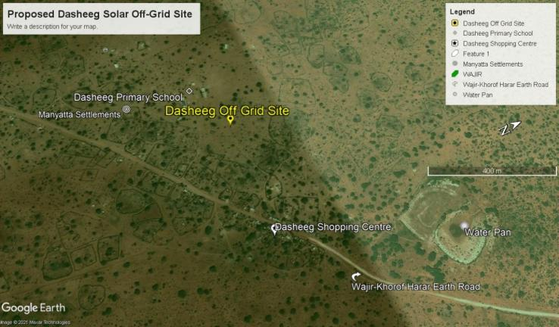
Dasheeg Project site
Figure 3: Project Location Site and immediate surrounding

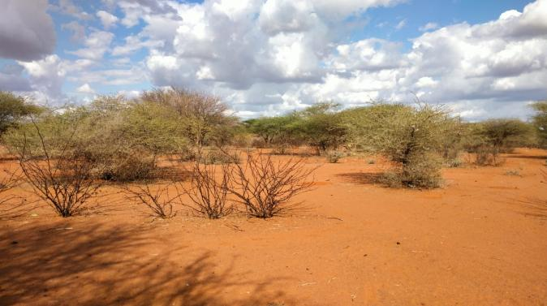
Plate 1: Project site area, Dasheeg area

Description of Project Facilities, Components and Activities

Project Components

Residential Users (No.) | 426
Non-Residential Users (No.) | 7
PV Capacity (kWp) | 108
Battery Capacity (kWh) | 350
PV Inverter (kW) | 90
Generator Capacity (kVA) | 50
Fuel Tank for diesel generator (Litres) | 2,000
LV Network (km) | 12

Key Components of the Project:

Power Generation Sources:
Solar Photovoltaic Panels: The project utilizes solar panels with a total capacity of 90 kW to harness solar energy. Solar power is a clean and renewable energy source that will provide a significant portion of the electricity needed for the project.
Battery Energy Storage System: A 350 kWh Battery Energy Storage System is incorporated to store excess solar energy during the day, ensuring a consistent power supply even during cloudy or night time conditions.
Diesel Generator: A 50 kVA diesel generator is included to serve as a backup power source for periods of low solar generation or in case of battery depletion. It provides reliability and backup in the event of extended periods of cloudy weather or high demand.
Fuel Tank for Diesel Generator: A 2,000-liter fuel tank is provided to store diesel fuel for the generator, ensuring continuous operation during extended periods of low solar or high demand.
Inverters and Chargers:
PV Inverter: A 90 kW solar PV inverter is used to convert the direct current (DC) electricity generated by the solar panels into alternating current (AC) electricity suitable for consumer use.
Battery Inverter Charger: A 69 kW battery inverter charger is employed to manage the energy flow to and from the battery storage system. It ensures efficient charging and discharging of the battery, maximizing the system's overall performance.
Low Voltage Power Distribution Network:
A 12-kilometer Low Voltage (LV) power distribution network is established to distribute the generated electricity to the residential and non-residential consumers. The LV network is designed to efficiently transmit power while minimizing losses, ensuring a stable supply to the customers.
Project Metrics:
Monthly Energy Demand: The project is expected to meet a total monthly energy demand of 10,492 kWh.
Daily Energy Demand: The average daily energy demand is approximately 350 kWh, ensuring a consistent supply for the consumers.
Peak Demand: The peak demand of the system is 40 kW, which is the maximum power requirement during any given moment.
PV Capacity: The solar photovoltaic panels have a total capacity of 90 kWp.

Solar PV modules
PV Array (DC-kW) 140 polycrystalline silicon module with three strings connected in series will be used for the project. Five sets of panels will be connected in series in each string, with output converged at the six-way combiners. PV modules are expected to last between 25 and 30 years.

Charge controllers
Remote monitoring system (SCADA) for synchronizing and controlling SPGP assets under a load-following will follow algorithm. Features are stated on the technical data sheet and the mini-grid controller shall be accessible and configurable both remotely and on-site.

Battery Energy Storage System
The Battery Energy Storage System (BESS) will comprise of Lithium-ion Battery pack that conforms to IEC standards with warranty of 10 years, 3,000 cycles minimum. The Lithium-ion Battery Power Packs will be used to cater for required energy capacity, or equivalent as per approved design, minimum 80% DOD for Lithium-Ion. Batteries will be capable of at least C/4 charge and discharge rate. Batteries will be charged by Battery Inverter/ Charger.

Inverters
The Inverters shall be designed for continuous, reliable power supply as per specification and shall have internal protection arrangement against any sustained fault in the feeder line and against lightning strikes in the feeder line. The inverters shall be capable of complete automatic operation including wake-up, synchronization & shut down independently & automatically.

Distribution lines
Dasheeg site will have a distribution line circuit of 12km in total. Supply of concrete poles for the distribution lines will be based on detailed survey and accessories like phase plates, circuit plates, number plates, danger plates, anti-climbing devices as per KPLC requirements/specifications. Erection of the Poles, fixing of insulator strings, stringing of conductor and earth wires along with all necessary line accessories and earthing will be as per KPLC requirements/specifications.

Architecture and Basic Design Specifications
This hybrid power generation site is projected to generate 108 (kWp) and is meant to serve approximately 433 households (customers). The proposed mini-grid installations will be built to comply the International Electro technical Commission (IEC) standards. It will have an installation of solar panels of with a capacity of 108 (kWp) and battery house with 350 kWh. The solar panels will have a connection to the batteries through underground cables. The standby generator will also be connected to the system as a backup.

This generator will be a capacity of 50 kVA capacity with a fuel tank. To optimize this hybrid system the HOMER software will be used. The goal of the hybridization of diesel systems is to reduce fuel consumption by switching off diesel generator set(s) for several hours a day, in order to reach a PV energy, share in the final mix of at least 60% or more. The power will be distributed to the customers by overhead lines. The project site is expected to serve clients within a radius of 6km from the site (generation source).

The PV plant and the battery capacity have been sized accordingly to the daily demand and the solar resources. In addition to this Design architecture, the project site shall have a site office that shall also have a Control Room adjacent as well as a guard house. The guard house shall be constructed using concrete and masonry works whereas the control room and office can also be a containerized facility.
The Solar PV hybrid system is based on a centralized photovoltaic plant connected to a 3-phase 415V AC busbar line, where the multi-mode battery inverter and the diesel generator are also connected.
The plant is configured such that a significant portion of daytime loads is fed directly from the solar generator (grid-tie inverter) without intermediate battery storage usage. The solar PV power plant is also equipped with a Diesel Generator, which is normally used as reserve power. The diesel generator switches on automatically whenever the battery state of charge reaches a certain defined DOD (Depth of Discharge). The diesel generator comprises of 50 kVA unit in three-phase operation and it’s equipped with automatic startup function controlled by the battery inverter charger.

Project Activities
The main project activities include site clearance and leveling, civil works and construction of utilities and structures for the facilities, installation and connection of the power plant.

Construction Procedures
The project will be constructed based on applicable standards of Kenya, environmental guidelines and health and safety measures in line with OSHA Act 2007.
The project inputs will include the following;
- Construction of raw materials will include solar modules, inverter, wires, metals, among others. All these will be obtained from licensed dealers and especially those that have complied with the environmental management guidelines and policies.
- Construction machines will include machinery such as trucks, and other relevant construction equipment. These will be used for the transportation of materials, clearing of resulting construction debris.
- A construction labour force of both skilled and non-skilled workers will be required.
Construction activities will include the following:
- Contractor mobilization;
- Site Preparation;
- Procurement of construction material from approved dealers and transport to the site.
- Storage of PV modules delivery and their installation;
- Laying of internal electrical connections;
- Installation of inverters, Battery Energy storage system and transformers;

Project Cost
Mini Grid project cost is estimated at USD. 621,812

Land Tenure
Community land, trust property, and private land are the three types of land ownership in Wajir County. The Dasheeg East proposed site is on unregistered Community Land that has been set aside for public use. Since then, the community has offered the site to the project proponent for the building of a minigrid.

Compensation Details
Compensation for the land for the proposed project will be in kind; as a token of appreciation for the donated land, the Proponent will undertake some projects for the community. In Dasheeg area, the community requested for fencing of Dasheeg waterpan/small dam and additionally install water distribution lines from the water pan to settlement areas.

Resource Requirement

Workforce Requirement
During the construction phase, a number of skilled, semi-skilled, and unskilled laborers will be required. The following employees will be required during the operation phase: operations and maintenance chiefs, engineers, and technicians. During the project's operation phase, unskilled people will be involved in grass mowing and module cleaning as needed. During the operations phase, trained security guards will also be employed..

Water Requirement and Source

Construction Phase
A reasonable amount of water per day will be required for civil activities throughout the construction stage. Personnel working on the project will also require access to water. The amount of water needed, on the other hand, will vary depending on the number of construction workers on the job. Water will be provided by local water companies during the construction period.

Operation Phase
During the project's operation phase, the majority of the water will be utilized to clean the solar modules' faces; however, only a little amount of water will be used for this purpose. At this point in the project, the amount of water required during the operational phase is unknown. The water will be acquired from the local vendors.
As previously stated, employees (direct and contractual) will be employed to work during the operation phase. Once the project is operational, the exact quantities will be determined for this workforce.

Raw Material Requirement

Construction Phase
The major raw materials required for the construction phase will be solar modules, fencing materials, construction materials like cement, sand and aggregate. The fencing materials and the construction materials will be sourced from the local hardware facilities. Solar Modules for the project along with associated structures will be obtained from suppliers in in the Country or if not availableimported from suppliers outside the country.

Operation Phase
There will be no major requirement of raw materials during operation phase. Only maintenance spares will be required at this phase.

Power Requirement
Power requirement during the construction phase will be met through a 80Kva Diesel Generators sets. The exact number of Diesel Generator sets to be used, as well as the quantity of fuel, will be ascertained once the the project design is finalized.

Fire Safety and Security

Construction Phase
Throughout the construction stage, an adequate firefighting system and equipment must be provided. The fire extinguishers will be adequately dispersed in areas such as the site office, security area, and storage yard, and will be available according to the fire hazards. At the project site, a detailed emergency response plan including all emergency numbers will be prominently displayed.

Operation Phase
At the PV array area, inverter stations, main control room, and switchyard, appropriate fire protection and fighting devices, such as portable fire extinguishers, automatic fire detection systems, and means of fire communication, will be made accessible.

The systems and equipment’s will align to the Kenyan Fire Reduction Rules of 2007. The Fire protection and fighting systems will be maintained and serviced after every 6 months. The team managing the site will be trained on Fire safety as per the requirement on Fire Risk reduction rules. Further the proponent will be required to undertake Annual OSH Audits, Fire audits and Risk assessment as per the requirement of OSHA 2007 and the relevant subsidiary legislation.

Pollution Streams during Construction Phase

Solid Waste Generation
- Construction Phase
The key solid waste that is expected to be generated during construction phase include;
- Broken solar panels and PV Modules
- Hazardous waste like waste oil, lubricants, oil contaminated rags from maintenance of fossil fuel operated construction equipment such as the excavators, trucks,
- Domestic waste from the temporary site office.
The hazardous wastes will be stored onsite at separate designated covered area provided with impervious flooring and secondary containment. The storage containers/ bins/ drum will be clearly marked and colour coded for their hazards. The waste will then be collected by a NEMA approved waste handler for disposal in an approved disposal facility.

Any broken solar panels or PV Modules, will be sent back to the vendor as part of buyback arrangement. All the other domestic solid waste will be disposed at the nearest NEMA approved disposal site .
All waste tracking documents must be maintained onsite by the contractor as per the waste management rules in Kenya.

- Operation Phase
During operation phase, waste generated from the project will include domestic waste at site office, scrap materials like scrap tools, damaged PPEs etc.; hazardous waste like waste oil, lubricants, used transformer oil; damaged batteries; and electronic waste like damaged PV modules etc. The hazardous wastes will be stored onsite at separate designated covered area provided with impervious flooring and secondary containment. The storage containers/ bins/ drum will be clearly marked and colour coded for their hazards. The waste will then be collected by a NEMA approved waste handler for disposal in an approved disposal facility. Any broken solar panels or PV Modules, will be sent back to the vendor as part of buyback arrangement. All the other domestic solid waste will be disposed at the nearest NEMA approved disposal facility.
All the waste tracking documents must be maintained by the proponent.

Air Emissions

Construction Phase
It is anticipated that air emissions from construction activities are likely to impact on local air quality. The sources will include:
- Dust emissions from the earth roads leading to the site;
- Increased vehicular emissions due to the high traffic of vehicles transporting construction materials, PV Modules and accessories;
- Dust emissions from site clearing, material handling, piling and use of the construction machinery.
- Exhaust emissions from the diesel generator.
The high dust emissions arising from various activities such as piling, transportation of material (loading and unloading), vehicular movement (on unpaved roads) should be minimized through sprinkling of water and maintaining vehicular speed to 10-15 km/hr. All the vehicles and the diesel generator should be well maintained and serviced to reduce the rate of exhaust emissions.

Operation Phase
It is expected that the normal operations of the site will produce minimal gaseous emissions from all the operating areas. The minimal gaseous and fugitive dust emissions will be attributed to the in and out movement of the maintenance vehicles. It will be ensured that well maintained vehicles are used for maintenance purposes.

Liquid Waste Generation

Construction Phase
The liquid effluents generated during the construction phase will include domestic sewage from temporary site offices, kitchen and washing areas. As part of the site preparation stage, the constructor should provide sanitary waste facility such as septic tank, or biodigester for the camp and site office as the area is not sewered. If the septic tank option is adopted, there will be need for periodic removal of the sludge/sewage and disposed in a sewerage treatment plant.

Operation Phase
The operational phase will have negligible wastewater generation at site office. A soak away system or biodigester system will be provided at the site office for disposal of sewage.

Noise Emissions

Construction Phase
Noise emissions will be generated from piling, movement of vehicle and other construction machinery and operation of the diesel generator. The main noise receptors will be the neighbouring settlements and the construction workers. Noise from diesel generators will be minimized through provision of acoustic enclosures and occasional maintenance of the generator. Every single noise generating activity will be restricted to Day time only.

Operation Phase
Under normal operations, none of the activities of solar power plant will generate noise. The only noise that can be generated at this phase is during the maintenance works and it will be restricted to daytime only.

Analysis of Alternatives and Project Justification
This section analyses the project alternatives in terms of site and technology. Solar projects are non -polluting energy generation projects which are site specific and dependent on the availability of solar irradiance resource. The current site selected is a high solar power potential site with high irradiation and consistent sunny days throughout the year.

Present Power Supply Position
According to the KIHBS 2005/6, 98.4% of the county households depend on wood fuel (Firewood and Charcoal) for cooking and 31.5% depend on kerosene lantern for lighting. 96.6% of households use traditional stone fire for cooking. This contributes to massive environmental degradation, increased health risks and additional workload for women and girls, and increased emissions of carbon content. Moreover, low enrollment, retention and transition for girls is partly attributed to increased workload related to energy search.
Wajir, Griftu, Abakore, Tarbaj Habaswein and Eldas towns are connected to diesel power plants where over 20,000 households are supplied with power. Bute is connected to the Ethiopian Grid through Moyale. Solar energy accounts for 0.2% (2009 KPHC) of energy source but is also limited toschools and health facilities as it is out of reach for majority of the households.
The county has a huge potential for renewable energy which can tapped through wind and solar energy and hence be channeled to productive sectors within the county as well as export to other counties.
Majority of the families in Dasheeg employ solar lighting and phone charging solutions (D-light) and firewood. Women's access to power was mentioned during Focus Group Discussions with women.
If the project does not go on, it will involve several losses both to Dasheeg village, Tarbaj Ward and Tarbaj Sub County as a whole. The village and the surrounding area will continue to have no electricity and this will not help in maximizing and utilizing the area facilities thus leading to:
- The economic status of the local people remaining unchanged.
- Employment opportunities not created.
- Increased poverty in the area.
- Continued insecurity in the region
From the foregoing analysis, it is clear that the No Project option is not an option for the locals, government, or investors.

Site Selection
Minigrid Sites under KOSAP were selected based on a number of factors.
- Geophysical Factors-Proximity to Hills-Shade effect, Soil erosion, Drainage of the area, Flooding etc.
- Land identified is free from any dispute on ownership or any other encumbrances
- Proximity to public utilities-Schools, Dispensaries, Places of worship and community settlements
- No squatters, encroachers or other claims to the land
- The Size of the Minigrid to be constructed and the optimal coverage of a Minigrid in terms of the number of people to be reached.
- The Land identified should be on spaces set aside for public use within the community centres.
The land was identified by the beneficiary communities and confirmed by technical staff to be suitable for the sub-project and free from any environmental or health risks. The impacts on the Community will be marginal and will not result in displacement of households or cause loss of household’s incomes and livelihood.
The site identified was considered against the criteria highlighted above and was found suitable for Minigrid construction.

Alternate Location for Project Site
In determining the most appropriate site for the establishment of the minigrid, several options were explored. This site selection process considered the following criteria:
- The availability of primary resources required for the operation of the minigrid, such as Sun
- Availability of land to locate the site and associated infrastructure;
- The availability and accessibility of infrastructure for the provision of services, manpower and social structure for the construction and operation of the power plant;
- General environmental acceptability in terms of social impacts, water utilization, general ecology, etc.
Based on the following criteria, Dasheeg area was selected as the best location for the planned minigrid:
Location: The majority of the region is in a pastoral setting. The population density is minimal, and grazing area makes up the majority of the surrounding territory. The neighborhood has ample grazing area, and using the property to build the mini grid will not have a substantial impact on grazing land. In comparison to other parts of the country, the community is further marginalized by the lack of energy grid connectivity.
Grid Connection: Due to the expected increase in solar energy demand, a grid connection with sufficient capacity and material was proposed. This avoids the need to upgrade the grid connection as the population in Dasheeg Sub-Location and Tarbaj Sub County grows.

Analysis of Alternative Construction Materials and Technology
The proposed project will be constructed using modern, locally and internationally accepted materials to achieve public health, safety, security and environmental aesthetic requirements. The materials will include all consumables, tools, testing instruments or any other equipment required for successful commissioning of the project.These may not be desirable from a cost and durability perspective. The technology to be adopted will be the most economical and one sensitive to the environment. The technology will involve a Battery Energy Storage System (including battery Inverter and charger).

Conclusion
Based on the community need assessment and options discussed above, the proposed project should be approved to help the local community. The Focus Group Discussion exercise demonstrates a high level of willingness to engage in the project.

APPLICABLE AND REGULATORY FRAMEWORK

Introduction
This Chapter outlines the existing national and international environmental and social legislation, policies and institutions applicable to energy generation that guide the development of the Project.
As Kenya is a signatory to various international conventions and laws, national projects need to be aligned with their requirements; relevant international conventions and laws are therefore presented in this chapter.
Finally, a summary of the World Bank (WB) Environmental and Social operational policies. relevant to this Project are presented.

Kenya Electricity Supply Industry (ESI)
The Kenya Electricity Supply Industry (ESI) is one of the sub-sectors in the energy sector which the Ministry of Energy and Petroleum oversees on behalf of the Government of Kenya (GoK). Relevant stakeholders in the ESI are briefly described below.
- Kenya Power and Lighting Company: responsible for distribution and retail supply of electrical energy to end users. Kenya Power and Lighting Company purchases power in bulk from the Kenya Electricity Generating Company Limited (KenGen) and the Independent Power Producers (IPPs) through bilateral contracts or Power Purchase Agreements (PPAs) approved by the Energy and Petroleum Regulatory Authority(EPRA).
KPLC will be responsible for implementing the project, construction of the generation systems and distribution network for the Dasheeg site. Supply of power will be through KPLC and same tariffs will be charged for each category.
- The Energy and Petroleum Regulatory Authority (EPRA): established by the Energy Act of 2019. The EPRA’s mandate extends beyond electricity and includes natural gas (including petroleum), renewables and all other forms of energy. The generation, transmission, distribution, supply, import and export of electricity can only be carried out by parties in possession of a license or a permit issued by the EPRA. In the event that the capacity involved is for own use and less than 1 MW, authorization is not required. Although the generated electricity is expected to be less than 1 MW (0.3 – 1 MW), the fact that the generated electricity is intended for use in a factory and there is a possibility for connection to the national grid and sale of excess power to the government, the project requires a license from the EPRC to generate electricity as stipulated in the Energy Act, 2019.
The Energy and Petroleum Regulatory Authority (Authority) together with industry stakeholders have developed the Draft Energy (Mini-Grid) Regulations, 2021 (the ‘Regulations’). The Regulations have been developed within provisions 10, 11 and 208 of the Energy Act, 2019 (the ‘Act’) and shall constitute Regulations to the Act. The Regulations will amongst others, provide guidance to mini-grid developers and other stakeholders on the tariff approval and licensing requirements. This will be directly applicable to the Dasheeg site.
- Ministry of Energy and Petroleum: aims to facilitate provision of clean, sustainable, affordable, reliable, and secure energy services for national development while protecting the environment.
The ministry will be responsible for not only implementing the community projects like water and cooking slotions from the proposed but also the overall coordination of project implementation and oversight.
- The Rural Electrification and Renewable Energy Corporation (REREC): is established under Section 43 of the Energy Act, 2019 as a corporate body. The Corporation is the successor to the Rural Electrification Authority established under section 66 of the Energy Act No. 12 of 2006 (now repealed) and subject to this Act, all rights, duties, obligations, assets and liabilities of the Rural Electrification Authority existing at the commencement of this Act is to be automatically and fully transferred to the Corporation and any reference to the Rural Electrification Authority in any contract or document shall, for all purposes, be deemed to be a reference to the Corporation.

National Legal Framework rEVIEW
The applicabe legal framework is illustrated in table 7 below.

Table 7: National Legal framework
No | Legislation/  Guidelines | Description of the Legislation/Guideline | Relevance of the legislation/regulations in terms of license, permits, and other requirements
 | NATIONAL POLICY FRAMEWORK
 | Vision 2030 | - Kenya Vision 2030 is the current national blueprint for development from its inception in 2008 until the milestone year of 2030. This plan is the national long-term development policy that aims to transform Kenya into a newly industrialised, middle-income country by 2030. The Vision is comprised of three key pillars (economic, social, and political), two of which are projected to be positively affected by project implementation. | - Under Vision 2030, Energy is identified as one of the key sectors that form the foundation for sociopolitical and economic growth. Promoting equal opportunities across the entire Kenyan territory and enhancing access to competitively priced, reliable, quality, safe and sustainable energy is essential to the achievement of this vision.
 | The Poverty Reduction Strategy Paper (PRSP) of 2001 | - The PRSP has the twin objectives of poverty reduction and enhancing economic growth. The paper articulates Kenya ‘s commitment and approach to fighting poverty; with the basic rationale that the war against poverty cannot be won without the participation of the poor themselves. | - The proposed project aims at provision and access of renewable electricity geared towards improved economic performance and thus will contribute to poverty alleviation in the project area.
 | National Environmental Action Plan (NEAP) of 1994 | - The NEAP for Kenya was prepared in mid 1990s. It was a deliberate policy whose main effort is to integrate environmental considerations into the country ‘s economic and social development. The integration process was to be achieved through multi-sectoral approach to develop a comprehensive framework to ensure that environmental management and the conservation of natural resources forms an integral part of societal decision-making. | - The NEMA does not approve a development project unless the impacts of the proposed project are evaluated and mitigation measures proposed for incorporation in the project ‘s development plan, which is in line with the requirements of the NEAP.  - The project will be reviewed by NEMA for approval before implementation.
 | Environmental and Development Policy (Session Paper No.6 1999) | As a follow-up to the foregoing, the goal of this policy is to harmonize environmental and developmental goals so as to ensure sustainability. The paper provides comprehensive guidelines and strategies for government action regarding environment and development.  The Government will:  1. Ensure Strategic Environment Assessment (SEA), Environmental Impact Assessment, Social Impact Assessment and Public participation in the planning and approval of infrastructural projects.  2. Develop and implement environmentally-friendly national infrastructural development strategy and action plan.  3. Ensure that periodic Environmental Audits are carried out for all infrastructural projects | The proponent:  - is undertaking an Environmental Impact Assessment, Social Impact Assessment and Public participation as part of the planning and approval of infrastructural projects.  - Will ensure that periodic Environmental Audits are carried out for the project
 | The National Energy and Petroleum Policy 2015 | The overall objective of the energy and petroleum policy is to ensure affordable, competitive, sustainable and reliable supply of energy to meet national and county development needs at least cost, while protecting and conserving the environment. This policy stipulates the transformation of the Rural Electrification Authority (REA) to Rural Electrification and Renewable Energy Corporation (REREC) to be the lead agency for development of renewable energy resources. | The policy is relevant to the project in the sense that the project will provide sustainable and reliable energy supply and measures will be put in place to protect and conserve the environment during its development. REREC will be in charge of the development of the minigrid and maintenance.
 | The Gender and Development Policy (Sessional paper no.2 2019) | - The overall goal of this policy is to achieve gender equality by creating a just society where women, men, boys and girls have equal access to opportunities in the political, economic, cultural and social spheres of life.  - The anticipated outcome of this policy as enshrined in the Constitution that aligns to the project include:  a) Equality and economic empowerment will be of both genders,  b) Women and men will have equality of opportunity to participate in decision making and to contribute to the political, social, economic and cultural development agenda;  c) Sexual and Gender based Violence will abate and men, women, boys and girls will live with dignity | - In the absence of appropriate measures, the project can exacerbate gender inequalities and sexual and gender based violence. In adherence to this policy, measures will be put in place to :  - ensure gender inclusivity in decision making, employment opportunity and access to the energy generated from the Mini-Grid  - mitigate social risks including sexual and gender based violence, and any form of discriminations
 | The HIV/ AIDS Policy 2009 | In summary, the policy aims at:  i. Establishing and promoting programmes to ensure non-discrimination and non- stigmatization of the infected;  ii. Contributing to national efforts to minimize the spread and mitigate against the impact of HIV and AIDS;  iii. Ensuring adequate allocation of resources to HIV and AIDS interventions; | - The proposed project is to be implemented in the a rural setting at Dasheeg area. The area is not economically empowered hence few HIV/AIDS prevention resources are available. This policy shall provide a framework to both the project proponent and contractor to address issues related to HIV/AIDS during the entire project phase.
 | NATIONAL LAWS
 | The Constitution of Kenya, 2010 | The Constitution of Kenya promulgated in 2010 is the supreme law of the republic and binds all persons and all State organs at all levels of government. The Constitution provides the broad framework regulating all existence and development aspects of interest to the people of Kenya, and along which all national and sectoral legislative documents are drawn. | - The proposed project complies with the Constitution by proposing a structure in its ESIA on how to deal with Social, Health, safety and environmental issues for sustainable development.
 | ENVIRONMENTAL MANAGEMENT AND COORDINATION ACT, 1999 (AND THE AMENDMENTS OF 2015) | - The EMCA is a framework environmental law in Kenya. This Act (assented to on January 14, 2000) provides a structured approach to environmental management in Kenya. With the EMCA coming into effect, the environmental provisions within the sectoral laws were not superseded; instead, the environmental provisions within those laws were reinforced to better manage Kenya’s ailing environment. | - The proposed project will be undertaken in accordance with relevant sections of the EMCA, specifically Clauses 58 – 63. These sections of the Act are operationalised by subsidiary legislation promulgated under the Act and specifically Legal Notice (L.N.) 101: Environment (Impact Assessment and Audit) Regulations, 2003.
 | L.N. 101: EIA/EA REGULATIONS, 2003 AND 2016 AMENDMENTS | - These regulations provide the framework for undertaking EIAs and EAs in Kenya by NEMA licensed Lead Experts and Firms of Experts. An EIA or EA Study in Kenya is to be undertaken by a firm duly licensed by the National Environmental Management Authority (NEMA). The EIA/EA Regulations also provide information to project proponents on the requirements of either an EIA or EA as required by the EMCA. | - The proposed project is subject to relevant provisions of these regulations and subsequently, the ESIA has been undertaken in accordance with the requirements.
 | L.N. 120: WATER QUALITY REGULATIONS, 2006 | - These regulation provides for the sustainable management of water used for various purposes in Kenya. For effluent discharges into the environment and aquatic environment, a Proponent needs to apply directly to the NEMA. For discharges into public sewers, a Proponent needs to apply for the license to the relevant county. The regulation contains discharge limits for various environmental parameters into public sewers and the environment. | - These regulations will apply to the proposed project during the construction and operational phases. The contractor will be required to properly manage the effluent from construction activities in accordance with the above regulations prior to discharge into the environment.
 | L.N. 121: WASTE MANAGEMENT REGULATIONS, 2006 | - These regulations are comprehensive and cover the management of various kinds of waste in Kenya. Generally, it is a requirement under the regulations that a waste generator segregates waste (hazardous and non-hazardous) by type and then disposes the them in an environmentally acceptable manner. Under the regulation, it is a requirement that waste is transported using a vehicle that has an approved “Waste Transportation License” issued by NEMA. Wastes generated in Kenya must be disposed of in a licensed disposal facility. Such a facility will require annual environmental audits to be undertaken by NEMA registered Lead Experts.  - The regulation requires that prior to generating any hazardous waste, a proponent shall undertake an EIA Study and seek approval from the NEMA. Labelling of hazardous wastes is mandatory under the regulation and the specific labelling requirements are provided in Rule  - The treatment options for hazardous waste disposal provided in Rule 19 include incineration or any other option approved by the NEMA. | - During the construction and operation phases, the proposed project will generate various streams of wastes. For the most part, it is expected that the wastes will be non-hazardous in nature and can be disposed of in accordance with these regulations.
 | L.N. 61: NOISE AND EXCESSIVE VIBRATION CONTROL REGULATIONS, 2009 | - The general prohibition of these regulations states that no person shall make or cause to be made any loud, unreasonable, unnecessary, or unusual noise which annoys, disturbs, injures, or endangers the comfort, repose, health, or safety of others and the environment.  - The regulations further provide factors that will be considered in determining whether or not noise and vibration is loud, unreasonable, unnecessary, or unusual. | - Rules 13 and 14 of the regulations define the permissible noise levels for construction sites. These noise limits will be applicable to the proposed project.
 | LICENSES AND PERMITS REQUIRED UNDER THE EMCA | - The subsidiary legislations under the EMCA are partially monitored through the use of permits and licenses. Subsequently all licenses and permits required during the construction phase shall be the responsibility of the individual contractors and their agents. During the operational phase, all permits and licenses required to operate the project will be the responsibility of the proponent. | - The subsidiary legislations under the EMCA requires some or all the following types of permits to be available for inspection during the construction and operational phases of the project:  - Effluent Discharge License under Legal Notice 120: The Environment Management and Coordination (Water Quality) Regulations 2006;  - Waste Transport License under Legal Notice 121: The Environment Management and Coordination (Waste Management) Regulations 2006 for disposal of all types of wastes; and  - Noise Permit under Legal Notice 61: The Environment Management and Coordination (Noise and Excessive Vibration Control) Regulations, 2009.
 | OCCUPATIONAL HEALTH AND SAFETY ACT, 2007 | - The Occupational Safety and Health Act (OSHA) was enacted to provide for the health, safety and welfare of persons employed in workplaces, and for matters incidental thereto and connected therewith.  - Part II of the Act provides the General Duties to which the occupier must comply with respect to health and safety in the workplace. Such duties include undertaking safety and health (S&H) risk assessments, S&H audits, notification of accidents, injuries and dangerous occurrences. A number of sections under this part shall be applicable to the proposed project.  - Part IV deals with the enforcement provisions that Directorate of Occupational Safety and Health Services (DOSHS) has under the Act. It discusses the instances when Improvement and Prohibition Notices can be issued as well as the powers of Occupational S&H officers. This part of the Act will be mandatory for the occupier to comply with for the proposed project.  - Part V of the Act requires all workplaces to be registered with the DOSHS. This part will be applicable for the proposed project as the Occupier will have to apply for registration of their project with the DOSHS on completion of the construction phase and before the operational phase of the project.  - Part VI of the Act lists the requirements for occupational health provisions which include cleanliness, ventilation, overcrowding, etc. This section of the Act will apply to the Occupier during the operational phase of the project.  - Part VIII of the Act contains provisions for general safety of a workplace, especially fire safety. This part of the Act will apply to the proposed project during the design, construction, and operational phases.  - Part X of the Act deals with the General Welfare conditions that must be present during the construction and operational phase of the project. Such conditions include first aid facilities, supply of drinking water, accommodation for clothing, ergonomics, etc. This part of the Act will apply to the proposed project during the construction and operational phases.  - Part XI of the Act contains Special Provisions on the management of health, safety, and welfare. These include work permit systems, PPE requirements and medical surveillance. Some sections of this part of the Act will be applicable to the proposed project during the construction and operational phase.  - Part XIII of the Act stipulates various fines and penalties associated with non-compliance with the Act. It includes those fines and penalties that are not included in other sections of the Act and will be important for the Occupier to read and understand the penalties for non-compliance with S&H provisions.  - Part XIV of the Act is the last section of the Act and contains miscellaneous provisions which are not covered elsewhere in the Act. Some sections under this part of the Act will apply to the proposed project and it is in the interest of the occupier to read, understand, and ensure compliance. | - The proposed project will be undertaken in compliance with the OSHA-2007 during the construction, design, and operational phases.  - During the construction phase, the contractors will be required to fully comply with the requirements of Legal Notice 40 titled: Building Operations and Works of Engineering Construction Rules, 1984 (BOWEC). Each contractor will develop and implement a formal construction health and safety plan for the entire construction phase duration in alignment with the OSHA and international health and safety best practices.
 | L.N. 31: The Safety and Health Committee Rules, 2004 | These rules came into effect on April 28, 2004, and require that an Occupier formalise a S&H Committee if there is a minimum of 20 persons employed in the workplace. The size of the S&H Committee will depend on the number of workers employed at the place of work.  For the Proponent and Contractor, the OSHA and the S&H Committee Rules 2004 are important as they require compliance with the following measures:  - Posting of an Abstract of the Factories and Other Places of Work Act in key sections of each area of the factory or other workplace;  - Provision of first aid boxes in accordance with Legal Notice No. 160 of 1977;  - Ensuring that there are an appropriate number of certified first aiders trained by an approved institution and that the certification of these first aiders is current;  - Provision of a General Register for recording, amongst other things, all incidents, accidents, and occupational injuries;  - Appointment of a S&H Committee made up of an equal number of members from management and workers based on the total number of employees in the workplace;  - Training of the S&H Committee in accordance with these rules; and  - Appointment of a S&H management representative for the Proponent. | - The contractor will be required to constitute Health and Safety Committee to oversee safety and health at the construction site. The number of the committee members will be didacted by the number of staff hired by the contructor. The S&H Committee must meet at least quarterly, take minutes, circulate key action items on bulletin boards, and may be required to send a copy of the minutes to the DOSHS provincial office.  - Appropriate recordkeeping including maintenance of all current certificates related to inspection of critical equipment such as cranes, air compressors, lifts, pulleys, etc. Such inspections need to be undertaken by an approved person registered by the Director of the DOSHS.
 | L.N. 24: Medical Examination Rules, 2005 | - These rules provide for Occupiers to mandatorily undertake pre-employment, periodic, and termination medical evaluations of workers whose occupations are stipulated in the Eighth Schedule to the OSHA and the First Schedule to this Rules. Workers that fall under the above two schedules are required to undergo medical evaluations by a registered medical health practitioner duly registered by the DOSHS. | - Some construction activities such as metal cutting and grinding, repair or maintainance of construction equipment could expose the construction workers during construction phase and operations and maintenance workers during operation phase to physical and chemical hazards The contractor should that the workers exposed to such hazards undergo requisite medical examinations as required by these rules
 | L.N. 25: Noise Prevention and Control Rules, 2005 | The rules set the permissible level for occupational noise in any workplace (which includes construction sites) as follows:  - 90 dB(A) over an 8-hour time weighted average (TWA) period over 24-hours; and  - 140 dB(A) peak sound level at any given time.  Additionally, the rules set permissible limits for community noise levels emanating from a workplace as follows:  - 50 dB(A) during the day; and  - 45 dB(A) at night.  The Proponent is to ensure that  - any equipment brought to the site for use shall be designed or have built-in noise reduction devices that do not exceed 90 dB(A).  - those employees that may be exposed to continuous noise levels of 85 dB(A) are medically examined as indicated in Regulation 16. If found unfit, the occupational hearing loss to the worker will be compensated as an occupational disease. | - It is expected that during the construction phase of the project, there may be plant equipment that exceeds the threshold levels of noise stipulated under the Rules. It will therefore be incumbent on the contractor and his or her sub-contractors to ensure that their equipment is serviced properly and/or use equipment that complies with the threshold noise values given above. Alternatively, each contractor will be required to develop and implement a written hearing conservation programme during the construction phase.
 | L.N. 59: Fire Risk Reduction Rules, 2007 | A number of sections of the rules apply to the proposed project as enumerated below.  • Regulation 5 requires Proponents to ensure that fire resistant materials are used for construction of new buildings. A number of minimum specifications of materials are provided in this rule.  • Regulation 6 requires that all flammable materials be stored in appropriately designed receptacles. Some of the flammable materials anticipated at the project site including; fossil fuel using running construction equipment and vehicles (during construction phase) and stand by generator (operation phase)  • Regulation 7 requires that all flammable storage tanks or flammable liquid containers be labelled with the words “Highly Flammable” in English or Swahili. It is therefore practical for the Proponent to use a system similar to the Hazardous Material Identification System of labelling their product containers. The regulation requires a Proponent to consult the product’s MSDS for appropriate labelling requirements.  • Regulation 8(3) requires a Proponent to have a Spill Prevention, Control, and Countermeasures (SPCC) plan. This may be important if there will be chemicals stored in the refuelling area at the construction site.  • Regulation 16 requires Proponents to ensure that electrical equipment is installed in accordance with the respective hazardous area classification system. It is also a requirement that all electrical equipment is inspected every six months by a competent person and the Proponent is required to keep records of such inspections.  • Regulation 22 provides a description of the functions of a fire-fighting team.  • Regulation 23 requires Proponents to mandatorily undertake fire drills at least once a year.  • Regulation 33 requires Proponents to have adequate fire water storage capacity. As a minimum this regulation requires Proponents to have at least 10 cubic meters of dedicated fire water storage capacity.  • Regulation 34 requires Proponents to develop and implement a comprehensive written Fire Safety Policy. This policy should contain a Fire Safety Policy Statement signed by the CEO, a Fire Safety Policy Manual and a brief summary of the Fire Safety Policy of the company.  • Regulation 35 requires a Proponent to notify the nearest Occupational S&H area office of a fire incident within 24 hours of its occurrence and a written report sent to the Director of DOSHS within 7 days. | - The proponent is expected to comply with the requirements of L.N. 59: Fire Risk Reduction Rules, 2007 by  - Carrying out, and record, a fire risk assessment identifying any possible dangers and risks.  - Reducing, or where possible remove, the risk of fire and take precautions to deal with the remaining risks.  - PuTting in place protection measures if there are flammable or explosive materials used or stored on the premises.  - Developing an emergency plan should a fire occur which includes evacuation procedures etc
 | THE ENERGY ACT, 2019 | - The Energy Act deals with all matters relating to all forms of energy including the generation, transmission, distribution, supply, and use of electrical energy, as well as the legal basis for establishing the systems associated with these purposes. The Energy Act also established Energy and Petroleum Regulatory Authority (EPRA) in place of the Energy Regulatory Commission (ERC), whose mandate is to regulate all functions and players in the energy sector. One of the duties of the EPRA is to ensure compliance with environmental, health, and safety standards in the energy sector, as empowered by Section 99 of the Energy Act, 2019. In this respect, the following environmental issues will be considered before approval is granted:  - The need to protect and manage the environment and conserve natural resources; and  - The ability to operate in a manner designated to protect the health and safety of the project employees, the locals, and other potentially affected communities.  An ESIA approved by NEMA must support licensing and authorisation to generate and transmit electrical power.  - Part VI Section 121 (1a) stipulates that the EPRA shall, before issuing a license, take into account the impact of the undertaking on the social, cultural or recreational life of the community.  - Part VI Section 121(1b) stipulates that the EPRA shall, before issuing a license, take into account the need to protect the environment and to conserve natural resources in accordance with the Environmental Management and Coordination Act.  - Part VI Section 136 (1a) stipulates that it shall be the duty of a transmission licensee to operate, maintain (including repair and replace if necessary) and protect its transmission grid to ensure the adequate, economic, reliable and safe transmission of electricity; and | - The proponent is in line with the Energy act regultions in the following ways;  - The proponent has identified an available site  - alignment of the Mini-Grid Project to County development plans;  - the Mini-Grid proponent has the technical and financial capability to conduct the project  - The proponent has conducted the necessary engagement with the community.
 | THE ENERGY (SOLAR PHOTOVOLTAIC SYSTEMS) REGULATIONS, 2012 | - These regulations shall apply to a solar PV system manufacturer, importer, vendor, technician, contractor, system owner, a solar PV system installation and consumer devices.  - The Regulations prohibits any person from designing or installing any solar PV system unless he/she is licensed by EPRA. | - The Regulations regulates, the design and installation of PV systems. The Proponent will ensure that persons engaged in the the designing and installation of the Mini-Grid are licensed by EPRA
 | THE PUBLIC HEALTH ACT (CAP. 242) | - The Act prohibits the project proponents from engaging in activities that cause environmental nuisance or those that cause danger, discomfort or annoyance to inhabitants or is hazardous to human and environmental health and safety. | - The proponent will be in line with the regulations of this act and will ensure suppression of infectious diseases and maintain proper sanitation during all the phases of the project.
 | COMMUNITY LAND ACT, 2016 | - This Act is critical for the proposed project is within community land. Section 6(1) of the Act provides that ‘county governments shall hold in trust all unregistered community land on behalf of the communities for which it is held’. Furthermore, Section 6(2) maintains that ‘the respective county government shall hold in trust for a community any monies payable as compensation for compulsory acquisition of any unregistered community land’. Therefore, the proposed road project can access land or water resources in community land that may be unregistered and pay compensation to the County Government which the law authorizes to hold such monies in trust for the communities.  - Section 30(1) states that ‘Every member of the community has a right to equal benefit from community land’. Section 26(1) provides that ‘a community may set aside part of the registered community land for public purposes’ and Sub-section (2) holds that ‘where land is set aside for public purposes under Sub-section (1), the (Land) Commission shall gazette such parcel of land as public land’. This provisions offer a window for the proposed project to acquire land for project works legally for communities as necessary and to convert the same into public land. This is useful for the project as once done powerful groups will not have opportunity to exclude them on account of their socio - economic statuses. In any event, Section 35 holds that, ‘subject to any other law, natural resources found in community land shall be used and managed-  (a) Sustainably and productively;  (b) For the benefit of the whole community including future generations;  (c) With transparency and accountability; and  (d) On the basis of equitable sharing of accruing benefits’.  - The concept of community land has been defined broadly enough to include VMGs. Women, children, old people and future generations have been thought of as beneficiaries and thus their rights secured in this Act | - The proposed project site falls on community land and the land belongs to the Ajuran community pastoralist in Dasheeg Location. The community has since offered to the land in kind for project use. The establishment of the minigrid will convert communal land to industrial use for long term. Further, based on community need assessment the proponent will undertake in kind development project to support the community water needs.  - The proponent should adhere to the provision of this legistalation
 | HIV AIDS PREVENTION AND CONTROL (CAP 246A) | - This Act is to promote public awareness about the causes, modes of transmission, consequences, means of prevention and control of HIV and AIDS. It also seeks to positively address and seek to address conditions that aggravate the spread of HIV infection. | - Like other projects, the proposed project is expected to attract new people to the project area seeking employment. This can lead to increased transmission of HIV/AIDS and other sexually transmitted diseases (STDs) as they engage in sexual relationships amongst themselves and/or local community members. In line with the requirements of this Act, the Contractors will create awareness and sensitize the workers and other persons on the risks of infections to foster prevention and control.
 | THE PHYSICAL AND LAND USE PLANNING ACT, 2019 | - This Act of Parliament makes provision for the planning, use, regulation and development of land and for connected purposes.  The objects of this Act related to the project include;  (a) the principles, procedures and standards for the preparation and implementation of physical and land use development plans at the national, county, urban, rural and cities level;  (b) the procedures and standards for development control and the regulation of physical planning and land use; (d) a framework for the co-ordination of physical and land use planning by county governments;  (c) a framework for equitable and sustainable use, planning and management of land; | - The proposed site is not in contravention of any Zoning regulations. The project site is within unregistered community land; necessary county approvals will be sought by the proponent eg. project design approval and change of use. The approvals shall be issued by the Physical planner in the department of Lands, Housing and Urban Development – Wajir County.

World Bank OP applicability
The table below shows the applicability of World Bank Operational OPs to the proposed project in Dasheeg site;

S.No. | Safeguard Policies | Description
1. | OP 4.01 (Environmental and Social Impact Assessment) | The objective of this policy is to ensure that Bank-financed projects are environmentally sound and sustainable, and that decision-making is improved through appropriate analysis of actions and of their likely environmental impacts. This policy has been triggered due to implementation of activities outlined under Components 1:(civil works that would be limited to construction of the mini-grids in remote areas; Component 2: installation of stand-alone systems for households and Component 3: installation of solar PV for water pumping, and construction of distribution lines to connect new customers; and (b) environmental, health, and safety concerns likely to be associated with recycling and disposal of spent batteries at the end of their useful lives.  The project is assigned as a Category B Partial Assessment, assigned to projects that are likely to have limited and reversible environmental impacts, that can readily be mitigated. There are no significant and /or irreversible adverse environmental issues anticipated from the project subcomponents to be financed under the project.
2. | OP 4.10 (Indigenous People) | The objective of this policy is to (i) ensure that the development process fosters full respect for the dignity, human rights, and cultural uniqueness of indigenous peoples; (ii) ensure that adverse effects during the development process are avoided, or if not feasible, ensure that these are minimized, mitigated or compensated; and (iii) ensure that indigenous peoples receive culturally appropriate and gender and intergenerational inclusive social and economic benefits.  The 14 counties targeted by this project are considered as marginalized areas in Kenya. Therefore, the Borrower has prepared an SA report to identify and avert any potentially adverse effects from project interventions on VMGs and to ensure that project benefits that are culturally appropriate reach these groups in an equitable manner. The final versions of SA and VGMF was disclosed in March 2017.  The consultants have identified that the overwhelming majority of project beneficiaries in Dasheeg area are considered vulnerable and marginalized, the most vulnerable among them being orphans and the elderly.
3. | OP 4.12 (Land Acquisition and Involuntary Settlement) | The objective of this policy is to (i) avoid or minimize involuntary resettlement where feasible, exploring all viable alternative project designs; (ii) assist displaced persons in improving their former living standards, income earning capacity, and production levels, or at least in restoring them; (iii) encourage community participation in planning and implementing resettlement; and (iv) provide assistance to affected people regardless of the legality of land tenure.  The consultant has described land tenure and implications for the project such as what the preferred nature of compensation.
4. | Natural Habitats OP/BP 4.04 | This policy recognizes that the conservation of natural habitats is essential to safeguard their unique biodiversity and to maintain environmental services and products for human society and for long-term sustainable development. The Bank therefore supports the protection, management, and restoration of natural habitats in its project financing, as well as policy dialogue and economic and sector work.  Predicated on the assumption that project activities are likely to affect the natural habitats through erection of poles, construction of the and mini-grids.

BASELINE SETTINGS - ENVIRONMENT, ECOLOGY AND SOCIAL

Area of Influence
The Area of Influence (AoI) of the project comprises of the project site and the surrounding area, where the influence of the project activities is anticipated. The areas likely to be affected by the project and its associated activities include:
- The areas where project activities and facilities operated and managed by the Ministry of Energy, Kenya Power and Lighting Company (KPLC), will be established,
- Project site where project components such as solar modules, control room and transmission line to power grid sub-stations; and any other selected CSR project, such as the construction water abstraction and distribution points will be established
- Areas where impacts from unplanned but predictable developments caused by the project that shall occur later or at a related location such as increase in traffic on the approach road;
- Areas where there is biodiversity or on ecosystem services upon which affected communities’ livelihood are dependent; and
- Areas where associated facilities will be established e.g. approach road construction and widening of existing road.
Further to this, the AoI with respect to the environmental and social resources was considered based on the following reach of impacts:
Air Quality
- Impact on ambient air quality from vehicle exhaust;
- Impact of air pollutants emission from construction activities and
- Dust fall- typically up to 200 m from construction activities
Noise
- Noise impact area (defined as the area over which an increase in environmental noise levels due to the project can be detected) - typically 500m from operations and 200m from the access road
Water
- Water pans and shallow wells mainly used for livestock within the project area
- Groundwater abstraction in 1 to 2 km radius of project footprint
Flora and Fauna
- The direct footprint of the project comprising the project site
- The areas immediately adjacent to the project footprint within which a zone of ecological disturbance is created through increased dust, human presence and project related activities (e.g., trampling, water intake/outfall, transportation). This kind of disturbance has been estimated to occur within the project footprint and surrounding areas of about 500 m to 1 km from the activity areas. Based on the above the AoI for environmental studies was limited to 5 km from the project site.
Socio-economic/Social
The AoI for social receptors was fixed to include 1.5 km radial zone which has been developed based on the reconnaissance site visits and stakeholder consultations with the local community. The AoI for development of the social baseline is within Dasheeg Village which according to the administrative structure falls within Dasheeg Location. The socio-economic information presented in this report has drawn from primary socio-economic survey and the Population and housing census 2019, Kenya Bureau of Statistics (KBS).

Project Footprint Area
The proposed project is located in Dasheeg Sub Location, Dasheeg Location, Tarbaj Ward, Tarbaj sub county in Wajir County.
The area is primarily made up of plants and grassland. The terrain is mostly flat. Within the Dasheeg center, the local communities keep cattle and run small enterprises. They engage in small-scale farming during the rainy seasons of October and April. Vegetation growth is unfavorable due to unpredictable and brief rainfall. The site is near the Dasheeg primary school in Dasheeg village. Within the Dasheeg area, land is mostly owned by the community.

Study Area
The site is located at latitude 1°52'51.1"N and longitude 40°15'35.4"E. The project is approximately 28 kilometers north west of Wajir town and 100 meters from Dasheeg primary school. Dasheeg health centre, Dasheeg Primary, as well as mosque and Koran instruction, are all located within the project area. Within the area, the site soil is mostly loamy clay.
In order to acquire representative baseline data, the survey locations were chosen based on secondary information about the region. The location of air and noise sample sites was determined by their proximity to the project site, vehicular traffic on main and access roads, and nearby towns, as well as the wind direction. Surface water quality sample areas were chosen based on the drainage pattern of the area. Soil sampling locations were determined based on the land use and land cover of the study region. The locations of ecological and social surveys were also determined based on receptor locations; additionally, areas within 1.5 kilometers of the project site and distribution lines were given additional scrutiny.

Environment Baseline

Land Use
Except for a minor portion of the total territory inhabited by townships, the entire county is classified as community land. Nomadic pastoralism is the most common usage of the land. Individuals or groups do, however, operate small-scale agriculture in a few limited places. The majority of the inhabitants practice nomadic pastoralism, with grazing zones covering a considerable amount of the area. There are, nevertheless, a tiny number of farmers who practice rain-fed and irrigated farming on a small scale.
There are two types of land; Private and Communal land. Private land is mainly found is town and used for residential, business and crop/fodder production. The communal land is for grazing. The average land size for private land is a quarter of an acre.

Visual interpretation, survey maps of the area, and ground checking during field surveys were used to interpret the land-use and land-cover of the research area (5kms). Within a 5-kilometer radius of the project site, grassland and open shrub area are used for residential, commercial, and grazing purposes. The region is mostly semi-arid, and the population is scarce. However, when compared to neighboring settlements, the population of Dasheeg is larger.

Physical and Topographic Features
Wajir County is a flat plain with elevations ranging from 150 to 460 meters above sea level. At the foothills of Ethiopia's highlands, the plains rise gently from the south and east to the north, reaching 200 meters at Buna and 460 meters at Bute and Gurar.
During the rainy season, seasonal floods inundate the project region and the county as a whole, making roads inaccessible and preventing access to essential services. It has seasonal wetlands that serve as grazing zones during the dry season and agriculture zones during the rainy season, thanks to drainage lines. The Lagboghol area, as well as the western and southern parts of Habaswein, have seasonal marshes. The county is largely covered in young sedimentary rocks with loamy soils in the north, near the Ethiopian highlands. The county is rich in limestone and sand resources, both of which are utilised in the local building industry.
The project site is characterized by loamy clay soils, that support shrubs and grasslands Ideal for livestock keeping.

Hydrogeology and Drainage
Wajir sub county has seasonal marshes that serve as grazing zones during the dry season and for farming during the rainy season, thanks to drainage lines. Wajir County's soil structure is fairly uniform, with two types of sedimentary sandstone dominating: sedimentary sandstone, which has similar formations but may have better potential for (deep) groundwater and groundwater storage; and variable sedimentary, which has the potential for water pans and underground tanks. This area is the most affected by land degradation. Groundwater recharge) formations, including the project site, can be provided through soil and water conservation and rangeland management. Central, Western, and Northern Wajir have the most diverse sedimentary strata. They are made up of various lithological and geological formations, as well as various soil types. The project site is located in the county's east end, in the Dasheeg sublocation, Tarbaj Ward, Tarbaj Sub County, and features similar geological formations.

Ecology
Wajir County is a semi-arid area falling in the ecological zone V-VI. Zone V receives rainfall between 300-600mm annually, has low trees, grass and shrubs. On the other hand zone VI receives an annual rainfall of 200-400mm. Overall, the county receives an average of 240 mm of rainfall per year which is erratic and short making it unfavourable for vegetation growth and rain fed agriculture. There are two rainy seasons’ i.e. short and long rains. The short rains are expected between October to December and the long rains from March to May each year. Crop activity is carried out in the Lorain swamp and along the drainage lines in Bute. The main crops grown in the area are sorghum, beans, fruits and vegetables. The locals mainly farm in October and April when there rains.
The Fauna in the area comprise Somali ostriches, antelopes, dik-dik, as well as various avian species such as kites, herons, sacred birds, and marabou storks.

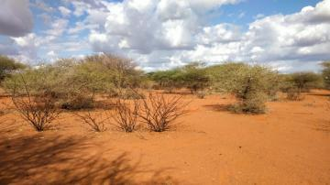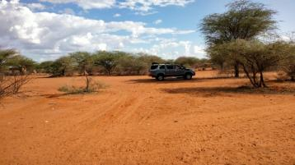
Plate 2: Project area flora presentation

Water Resources
Wajir county has a diverse range of water resources, including underground, surface, and sub-surface sources; the county has 272 boreholes, 15 mega pans, and 260 water pans. Rainwater collection has a lot of potential in the Dasheeg sublocation, especially after extended rains when flash floods occur. To identify areas with significant groundwater potential, comprehensive geological surveys are required.

The community borehole, shallow wells, and water pans are the main sources of water in the Dasheeg region, which is about 2 kilometers from the settlement areas. The residents raised concerns about the water quality.

Ambient Air Quality
The planned project location is within Dasheeg centre, near Dasheeg primary school, and is usually rural, with natural vegetation and grazing lands as interfaces. There are no large industrial developments and most of the areas are characterized by shrubs. As a result, the air quality at the proposed project areas is typically judged to be good. Air quality will be monitored in accordance with the ESMP.

Ambient Noise Quality
In general, the project area is a trading centre setting where the main source of noise is from motorists and from machines such as the generators used to supply power. Baseline noise data will be collected in the project area and the data analysed as per the ESMP.

Soil Type
With the north, near the Ethiopian highlands, the county is mostly covered in young sedimentary rocks with loamy soils. High temperatures cause crop withering, resulting in lower/no yields. Strong winds cause crop breakage, logging, or physical harm; they erode top soil, diminishing soil fertility; and they cause crop stress and yield decline by accelerating evapotranspiration. Strong winds, landslides, and dust storms all contribute to the loss of soil fertility by eroding the fertile top soils and transporting them elsewhere.

Climate and Meteorology
The yearly average relative humidity in the county is 61.8 percent, ranging from 56 percent in February to 68 percent in June. The average annual precipitation is 240 millimeters, or 20 millimeters each month. The driest month is June, with an average of 1mm of rain, while the wettest month is April, with an average of 68mm of rain.
Rainfall is heavier in the upper parts of Bute and Gurar, ranging from 500mm to 700mm. The average monthly temperature is 27.9 degrees Celsius, with a range of 3.5 degrees Celsius. February and March are the warmest months, with average temperatures of 36°C, while June, July, August, and September are the coolest, with average temperatures of 21°C.
Droughts are common in the county, especially from June to September, wreaking havoc on livestock, crop production, education, nutrition, and access to water and pasture. On the other hand, the county is prone to flash floods, which cause infrastructure damage and shoat deaths (goats, camel and sheep). The frequency and intensity of the extreme climatic events has been increasing in the recent past disrupting the livelihood of the communities.

Socio-economic Environment

Socio-economic status of Study Area

Demographic Profile
The demographic profile of the selected villages surveyed in the study region in terms of total population, number of households, household size, and gender ratio has been described in detail in the section below.
According to the most recent Kenya National Population and Housing Census (2019), the county has a total population of 781,263, with Tarbaj Sub County having a total population of 56,637, with 26,856 males and 29,776 females. The inter-censual growth rate in the county is 3.22 percent, which is greater than the national rate of 3.0 percent.

Tarbaj Sub County, Tarbaj Ward, Dasheeg Location is the project site and has a population of around 4000 people, with a density of roughly 7 people per square kilometer. The population of the project area is anticipated to be 60 percent female and 40 percent male on average. The demographic profile of Dasheeg Sub Location is summarized in Table 8 below.

Table 8: Summary of demographic profile Dasheeg Sub Location
Attribute | Magnitude/Number
Approx. population | 4000
Households | 550
Gender. | Male – 40%  Female – 60%
Ave. No. per household | 7 per house
Indigenous | Indigenous- 99%  Settlers – 1%
Vulnerable classes | - Persons Living with Disability (PLWD)  - Orphans  - The elderly
Dominant ethnic group | Somali
Primary religion | Muslim
Other groups | None
Employment (formal/Informal) | Formal – 10%  Informal – 90%

Educational Infrastructure
As per the observation and information sought from Dasheeg Location, the area has a school; Dasheeg primary school located to the immediate southe of the project site location.

Occupation and Livelihood Profile
Pastoralism and small scale businesses are the two main sources of income for the residents of Dasheeg. Pastoralism is primarily practiced in Tarbaj Ward rural areas, as well as the extensive grassland and shrubland of Tarbaj subcounty. During the rainy season, small-scale farming is practiced in rural regions. Tarbaj Ward and settlements in the Tarbaj subcounty benefit from the operations of the Dasheeg trading centre.
The main formal jobs at the area are NGO staff, teaching and other civil services which accounts to approximately 5% of the population. The other 95% of the population is involved in informal employment.

Land Use
The entire county is categorized as community land, with the exception of a small percentage of the overall region occupied by townships. The most popular use of the land is nomadic pastoralism. Small-scale agriculture is practiced by individuals or groups in a few select locations. Nomadic pastoralism is practiced by the majority of the population, with grazing zones occupying a large portion of the land. Nonetheless, a small number of farmers undertake rain-fed and irrigated agriculture on a small scale.
There are two types of land; Private and Communal land. Private land is mainly found is town and used for residential, business and crop/fodder production. The communal land is for grazing. The average land size for private land is a quarter of an acre.
During the rainy season the resident practice farming. Some of the crops they grow include maize and millet.

Social and Physical Infrastructure
Public and private institutions found in the project area include: a school, health facilities, worship facilities and businesses. The institutions observed in the area during the field visit include Dasheeg primary school, mosque, Dasheeg health centre and pharmacy. The health facility avaliable is a public health centre that is operational.
Underground water from boreholes and shallow wells, pans and dams, and the seasonal Ewaso Nyiro river are the county's main sources of water. Water is acquired from both surface and groundwater sources in the project area. When it rains, the Dasheeg well, pans, and dams are the main sources of surface water. However, the water from these two sources (surface and ground) is turbid and partially salty. The community also gets its water from a borehole about 2.5 kilometers away from the project site.
The project site is accessed via Isiolo-Mandera/B9 earth road and located approximately 45 kilometers East of Wajir town.

Vulnerable groups
A vulnerable group, according to the World Bank paper Vulnerability: A View from Different Disciplines by Jeffry Alwang and Paul B. Siegel, is a population that has some distinctive features that make it more likely than others to slip into poverty.
The most needy households have limited access to basic necessities and rely heavily on neighborhood well-wishers. Such households should be considered for power connection in the project. The majority of them cannot pay the connection costs of one thousand shillings.

Gender based vulnerability
The patriarchal family structure characterizes the society in the project area. Early marriages and child marriages, minimal participation in home or economic decision-making, limited economic freedom, and limited opportunities to mingle with other females in the village continue to be embedded in traditional social norms. Men had more influence over home resources such as land, assets, and equipment, according to the Female Focus Group Discussion. In a typical household, the eldest male member is the head of the household, and the man has decision-making authority. Furthermore, men are accountable for securing the family's financial security. Women, on the other hand, are in charge of home tasks including fetching water, cooking, cleaning, and caring for children. Female literacy was reported to be low among women over the age of 18 and higher among the younger girls, however it has improved compared to earier days as girls now attend school.

Gender Based Violence
Children from households where domestic violence exists have significant learning obstacles, according to a focus group discussion with an education representative (Dasheeg Primary School).

Culture and heritage
No cultural site of significance was reported/observed within the project area. Dasheeg area is predominantly made up of the Somali community that value keeping livestock including cattle, camel, sheep and goats. The Somali community in the project area are a patriarchal society; men typically speak for women and make decisions in the family. The community practices polygamy and encourages early marriages for young girls.

Religion in the project area
The community members confirmed that their culture is strong. Hence the community members are predominantly muslims with a mosque within the locality.

HIV/AIDs prevalence
Wajir County’s overall HIV prevalence of the adult population was 0.2%. The number of People Living with HIV (PLHIV) was estimated at 810; 667 adults and 133 children. Over the years, very low rate of HIV infections have been reported in the County with the annual adult HIV incidence rate of 18 people in 2013. Due to their higher vulnerability, women living in the county have been greatly affected by the epidemic, with a higher HIV prevalence of 0.3% compared to 0.1%. for men. Approximately, 79 adults (men and women) and 10 children in Wajir County died of AIDS-related conditions in 2013.
HIV/AIDS infections in Dasheeg was confirmed to be low by the Clinical Officer at Dasheeg Health Centre.

STAKEHOLDER ENGAGEMENT
This section profiles the key stakeholders of the Dasheeg site solar project and assesses their potential concerns and levels of influence. The process of stakeholder engagement involved;
- stakeholder identification and analysis
- planning for the stakeholder engagement;
- disclosure of information;
- consultation with stakeholders
- addressing and responding to grievances; and
- reporting to stakeholders

Stakeholder Consultation and Disclosure Requirement for the Project
The World Bank Environmental Social OPs 10 on Stakeholder Engagement and Information Disclosure emphasises on engagement in meaningful consultations with all stakeholders. The stakeholders should be provided with timely, relevant, understandable, and accessible information, and consult with them in a culturally appropriate manner, which is free of manipulation, interference, coercion, discrimination, and intimidation.
A documented record of stakeholder engagement, including a description of the stakeholders consulted, a summary of the feedback received, and a brief explanation of how the feedback was; has been explained in this chapter.

Stakeholder Characterisation and Identification
A stakeholder is defined as "a person, group, or organization with a direct or indirect interest in a project/organization because it can influence or be influenced by the project/activities, organization's aims, and policies." Stakeholders differ in terms of their level of involvement, impact, and control over the project. Stakeholders are classified in the following two categories;
- Primary Stakeholders- Stakeholders who have a direct impact on or are directly impacted by the project.
- Secondary Stakeholders- Stakeholders who have an indirect impact or are indirectly impacted by the project.
In line with the nature of the project and its setting in Dasheeg, the stakeholders have been identified and listed in the table given below;
Table 9: Identified Stakeholders
Stakeholder Groups | Primary Stakeholders | Secondary Stakeholders
Community | Local Labourers  Land sellers | VMG’s  Pastoralists  Local Community
Institutions | Community Based Organisations  Education institutions  Health Institutions  Youth Groups/Associations
Government Bodies | County Government  Local administration

Stakeholder Mapping
Stakeholder mapping is a process of examining the relative influence that different individuals and groups have over a project as well as the influence of the project over them. The purpose of a stakeholder mapping is to:
- Identify each stakeholder group;
- Study their profile and the nature of the stakes;
- Understand each group’s specific issues, concerns as well as expectations from the project
- Gauge their influence on the Project;

The significance of a stakeholder group is categorized considering the magnitude of impact (type, extent, duration, scale and frequency) or degree of influence (power and proximity) of a stakeholder group and urgency/likelihood of the impact/influence associated with the particular stakeholder group in the project context. The magnitude of stakeholder impact/influence is assessed taking the power/responsibility and proximity of the stakeholder group and the group is consequently categorized as negligible, small, medium or large. The urgency or likelihood of the impact on/influence by the stakeholder is assessed in a scale of low, medium and high. The overall significance of the stakeholder group is assessed as per the matrix provided in Table below.
Table 10: Stakeholder Significance and Engagement Requirement
 |  | Likelihood of Influence on/ by Stakeholder
 |  | Low | Medium | High
Magnitude of impact | Negligible | Negligible | Negligible | Negligible
Magnitude of impact | Small | Negligible | Minor | Moderate
Magnitude of impact | Medium | Minor | Moderate | Major
Magnitude of impact | Large | Moderate | Major | Major

Stakeholder Analysis
The Stakeholder influence and priority have both been primarily rated as:
- High Influence: This implies a high degree of influence of the stakeholder on the project in terms of participation and decision making or high priority to engage with the stakeholder;
- Medium Influence: Which implies a moderate level of influence and participation of the stakeholder in the project as well as a priority level to engage the stakeholder which is neither highly critical nor are insignificant in terms of influence; and
- Low Influence: This implies a low degree of influence of the stakeholder on the project in terms of participation and decision making or low priority to engage that stakeholder.
The intermediary categories of low to medium or medium to high primarily imply that their influence and importance could vary in that particular range subject to context specific conditions or also based on the responses of the project towards the community.

The coverage of stakeholders as stated above includes any person, group, institution or organization that is likely to be impacted (directly or indirectly) or may have interest/influence over project. Keeping this wide scope of inclusion in stakeholder category and the long life of project, it is difficult to identify all potential stakeholders and gauge their level of influence over project at the outset of the project. Therefore, the project proponent is advised to consider this stakeholder mapping as a live document which should be revised in a timely manner so as to make it comprehensive for any given period of time.

Table 11:Summary of Stakeholder Influence
Stakeholder Category | Relevant Stakeholders | Magnitude of Influence/ Impact | Urgency/Likelihood of Influence | Overall stakeholder rating
Primary Stakeholders | Community land owners | Medium | Low | Minor
Primary Stakeholders | Local Labourers and subcontractors | Small | Medium | Minor
Primary Stakeholders | County Government of Wajir, District and local administration | Medium | Low | Minor
Primary Stakeholders | FBOs, CBOs and Educational Institutions | Medium | Low | Minor
Secondary Stakeholders | VMGs | Small | Medium | Minor
Secondary Stakeholders | Pastoralists | Small | Medium | Minor
Secondary Stakeholders | Local Community | Medium | Low | Minor

summary of community consultation meeting leading to land identification and Grievance Redress Committee constitution
The community members present and emphasized the importance of their participation in the stakeholder engagement exercise, as it contributes to the planning process.

Land requirements for the project
The project team informed the community that one of the objectives of the project team's visit was to assess the land or site that the community had identified or would identify for the project. Together with the community, the project team would conduct an environmental and social screening to determine the suitability of the land for the proposed solar project. KPLC representative addressed the community regarding the factors to consider when selecting the land for the project.
The project team explained to the community during the public forum that the proposed project would require approximately 2-3 acres of land. She inquired about the nature of land ownership in the area, to which the community responded that the land is collectively owned by the community without individual title deeds. They also mentioned that the land had not undergone formal subdivision, implying that it had not been surveyed or adjudicated.
The team clarified that based on the community's description of land ownership, their land fell under the category of community land, and its use and management were governed by the Community Land Act of 2016. They informed them that land under this Act is owned by the community but held in trust by the County Government of Wajir since the community is not registered. They further explained that the Kenyan government had secured a loan from its development partners, such as the World Bank, to implement the KOSAP project. The government sought a partnership with the community for the KOSAP project, where the community would identify land for the mini-grid setup while the government would provide the funding.

During the consultation, they provided the community with important information, including:
- The various methods of acquiring interest in land, such as allocation by the owner, land adjudication process, compulsory acquisition, settlement programs, transfers, donations, and long-term leases.
- The Community Land Act clarified that the County Government of Wajir holds the land in trust for the community, and community members are the rightful owners of the land.
- The significance of public participation by key stakeholders, including community members, throughout the planning and operation phases of the project.
- The community's right to express their views, opinions, or concerns regarding the proposed project.
- The community's right to accept or refuse the project.
- The transfer of land ownership to KPLC and the management of the project by KPLC.
- The community/beneficiaries of the project being responsible for a Ksh 1000 power connection fee and the payment for power consumption to KPLC.
The community in Dasheeg unanimously agreed to set aside land for Minigrid construction. A Land Identification form was signed by the representative of the community, the county government and the Implementing Agencies summarizing the process of land identification and the agreements reached with the community. The land identification form is attached as annex at the end of this report.

Survey of the land and request for advance possession.
The project team members, acknowledged the lengthy procedures involved in land allocation, surveying, and acquisitions/transfers. The team requested the community's cooperation in granting advance possession of the land. This would allow construction work to commence while the land allocation process continued. The community agreed to this arrangement and consented to advance possession.
To facilitate the land allocation process, the KPLC surveyor informed the community that exact GPS points of the agreed area would be collected. This information would be crucial for progressing the land allocation procedure.

Plenary session
Following that, the team extended an invitation to the community members to participate in a plenary session, providing an opportunity for them to ask questions or seek clarifications regarding the information that had been shared. The project officers were prepared to document the questions raised and provide corresponding answers. The questions raised during the session are presented in the table below.
# | Name | Questions/ suggestions | Response | Response by agency on how feedback will be used or acted upon
1. | Hirab | Clarify on the area of supply | The supply from the solar mini-grid will be about 1.1km radius for quality power | -
2. | Mohammed Ali | Is Ksh 1000 able to cover everything to get power? | Ksh 1000 for connection fees i.e for meter, for wiring in their houses. | -
3 | Mohammed Ali | When will the project begin? | Construction will begin once all the approvals are acquired | -

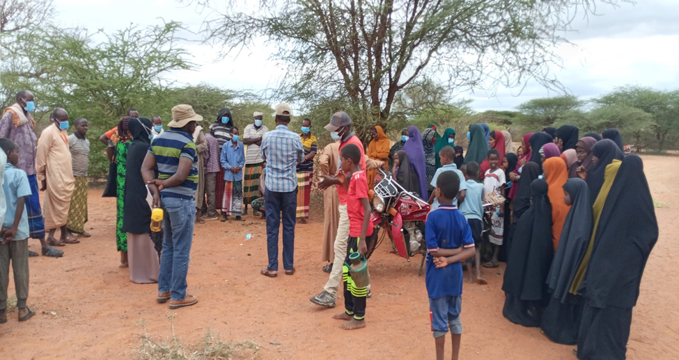
Photo 1: Public Community Meeting at Dasheeg

The community in Dasheeg agreed to set aside land for Minigrid construction. A Land Identification form was signed by the representative of the community, the county government and the Implementing Agencies summarizing the process of land identification and the agreements reached with the community.
The minutes for land acquisition has been annexed at the end of this report.

Grievance Redress Mechanism
The project team highlighted the possibility of grievances arising within a project and stressed the importance of establishing a grievance redress mechanism (GRM) that would be accessible to all community members without any associated costs. Prior to explaining the process of setting up the GRM, they encouraged the community to share their current approach in addressing grievances or issues.

Existing grievance redress mechanism in the village.
One of the elders reported that the elders in the community provide leadership and oversight to the community. These elders are resolve the conflicts or grievances or any issue in the village/centre. Any of the grievances that is difficult to resolve is referred to the office of the Chief.

KEY FEEDBACK RECEIVED DURING STAKEHOLDER CONSULTATION PROCESS
The main objective of the general stakeholder consultation session is to provide information and facts to the local community and other interested stakeholders, such as the local administration, so that they can express their opinions about the project and contribute ideas and opinions to its long-term viability. The general stakeholder consultation was done in a public meeting (Baraza) organized at the Dasheeg baraza point where 11 youth, 23 females, 12 security team members, 22 males and 87 stakeholders were in attendance. The meeting was chaired by the area chief assisted by the assistant chief and the “Nyumba Kumi” leaders.
The feeback received during the stakeholder consultation process have been summarized below:

Remarks from the Baraza meeting
The baraza meeting was carried out on 27th November 2021 at Dasheeg ward administrator. He welcomed all the stakeholders and invited the consultant team to introduce the project to the community members.

Consultant’s Remarks
The consultation gave a comprehensive overview of the project. Its relevance and the project's broader view are discussed. He explained why the public consultation was held as part of the ESIA process, as well as the Kenyan rules that regulate EIA/EA. He also talked over the project's many components and the overall consequences (Positive and negative).

Benefits of the Project
The community was enthusiastic about the project. Citing the project will beneficial to the community as it will:
  - Boost community business, thereby improving their living
  - Improve security in the village, which is a major worry influencing regional activities
  - Create jobs for residents, including youth and women. The region has a high rate of unemployment.
  - Boost learning at the primary school by allowing students to make up for lost time during night preps

Negative impacts Identified on the project and Consultant’s Response
- The community raised they following concerns:
  - Restriction of unauthorized people and animal to the sproject site: they pointed out the source of electricity area should be fenced to limit access by unauthorized persons and animals. The consultant informed him the project site will well secured
  - Fear of electrocution and fire outbreaks: The project's safety to community members were questioned. With concern about electrocution from power lines and fire outbreaks being noted. They requested the implementing agencies to creating awareness on safety among the community members. The consultant informed him the that project will be regularly maintained and closely monitored. Employees installing the facility will be well trained and be qualified to handle all machinery and power.
  - Cost of connection per person: The area's poor residents have limited access to basic necessities and rely primarily on well-wishers in the area. Households like this should be evaluated for power connections as part of the project. The bulk of them are unable to pay the one thousand shilling connection fee. They requested that the fees be reasonable and substantial. A KPLC representative assured them that the cost of connecting was merely one thousand Kenya shillings.
  - Awareness creation to all stakeholders: All stakeholders must be aware of the project's positive and negative implications on the community, as well as the mitigation measures that must be implemented. The consult explained by citing the ESMP will be used as reference point throughout the project implementation
  - The youth will be considered for employment opportunities. The consultant replied by saying that the initiative encourages young people to participate and be empowered. He went on to suggest that both skilled and non-skilled jobs will be available, and that they would be evenly distributed.

Community Requests
The community requested the following from the project:
  - Fencing of Dasheeg waterpan/small dam and additionally install water distribution lines from the water pan to settlement areas
  - The headteacher of Dasheeg primary school requested for fencing of the school which is currently located in an open area.

Consent
The Community members present agreed unanimously accepted the Project Proposal

Public participation “Baraza” Session
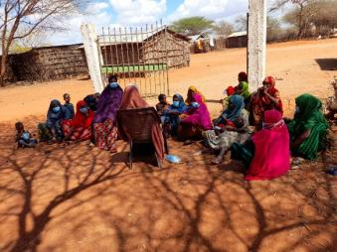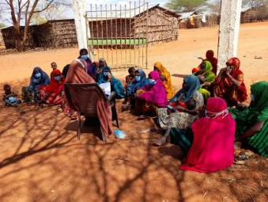
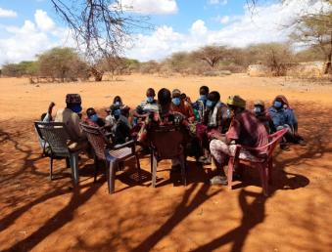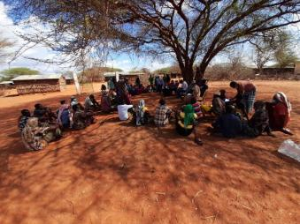
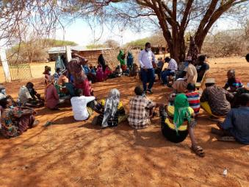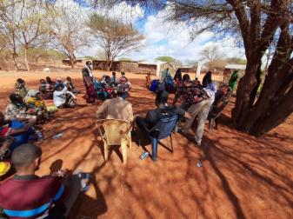
Plate: Stakeholders engagement process

FEEDBACK RECEIVED DURING focused group discussion
The in-depth interviews were used to identify and mobilize stakeholders, as well as collect baseline data that would allow for the identification of the project's potential implications. It also gave participants a chance to express their views regarding the project, as well as make suggestions on the initiative.
The Focus Group Discussions targetted community representative, education sector, Male and female representatives and the youth/Associations. During the discussions, information was gathered different roles, livelihood, health issues, challenges, perception of quality of life, education options for children, health care and project perception. The consultative meeting had a wide representation as follows:

Table 12: FGD dates and attendance
Group | Date | Attendance | Venue
Men | 27th October 2021 | 22 | Dasheeg Baraza Point
Women | 27th October 2021 | 23 | Dasheeg Baraza Point
Youth | 27th October 2021 | 11 | Dasheeg Baraza Point
Security Team | 27th October 2021 | 12 | Dasheeg Baraza Point
Other stakeholders | 27th October 2021 | 68 | Dasheeg Baraza Point

The key concerns and expectations that were raised during the FGDs have been summarized below:

Education Feedback from the FGD
Project Perception
- They are aware and well informed of the project objectives. The welcomed the project citing it will be of great advantage to them and the community at large.
- The project will lead to creation of job opportunities.
- The project was noted to boost businesses by enabling the use of fridge and other powering other business facilities.
- The solar power will aid further learning by children by provision of reliable lighting for studying at night.
- The project will provide for enogh power to charge mobile phones and other accessories
- The project will provide for proper lighting within the area which in effect will improve security.
- The headteacher was concerned that the learing electronics might distract pupils from focusing on studies.
- The project area should be properly fenced off from the school as the school is not fenced.
Infrastructure and Resources
- The headteacher reported to have worked in the school from the year 2015 to date
- The school has four (4) teachers of which 2 are paid by TSc and 2 are BOM.
- The school has enough land resource, free primary education from national government.
- Children face hunger due to prolonged drought in the area
- The headteacher reported issues of insecurity in the area due to terror attacks
- The school has benefited from government programmes of digital learning devices, tablets and 100% transition
- The average distance students wal to school is approximately 1 kilometre with the furthest distance being 3 to 4 kilometers.
- Meals are provided to pupils under boarding arrangement with the school while the day scholers are not provided with food in school.
- The project will improve the school perform as pupils can takeup evening preps.
- Teachers get paid through bank, TSC, and in cash, BOM.
- The consulted headteacher informed that the project will lead to improved performance, security and businesses due to availability of reliable power and lighting.
The School Curriculum
- The headteacher informed that poverty is one of the main contributing factors to accessing education within the area due to the pastroralist nature of the community.
- He reported that the school has VMGs that include; opharns, kids from poor families, kids with special needs, visually impared kids and deafs.
- It was identified the school don’t have enough teachers
- Boys were note to be high performers compared to men. This because they are culturally advantaged due less community responsibilities and chores
- The school has adopted the 100% transition policy effected by the national government.
School Attendance
- There a a total of 220 pupils in the school (120 boys and 100 girls)
- The school attendance rate for boys is higher than girls with 90% among the boys and 80% among the girls
- Both boys and girls have higher completion rates.
- The headteacher also reported that girls normally miss school due to challenges of monthly periods as they are not supplied with sanitary towels.

Health Stakeholders’ Consultation and Participation
The following were responses from the registered clinical officer at the health centre during the KII.
The project perception
- He was aware of the implementation of the project and got information the acquisition team and the local community members in July 2021.
- Project will improve lighting within the area and in effect lead to improved security.
- The health reprepresentative informed that the project will provide for proper lighting and clean water supply within the area.
Facility Profile
- Jowhar Dispensary currently operates from 7:30am to 5:00pm.
- It serves the local community of about which are mainly within 3km of the surroundings.
- The facility provides for outpatient services, vaccination, immunisation, maternity and laboratory services.
Infrastructure/Resources
- The health center has the following staff; 1 RCO and 1 nurse.
- The facility has no wards, however, there are two (2) observation rooms in good condition.
- The facility has basic equipment, however the suction equipment for maternity wing is not adequiate. Wheel and BP machines also not available
- There is no emergency vehicle to transport patients from far villages to the health centre.
- Outreach programmes provided by the facility includres nutrition services, immunization, ANC services and outpatient services.
- The facility has two observation rooms but lack wards.
- Further the health centre has challenges of delay in supply and payments from county government
Prevalence Rates/Health Issues
- The main health issues pre-dominant among the children in Jowhar are upper Respiratory Tract Infections (RTIs) and Diahrrea.
- The main health issues pre-dominant among the women in Jowhar are upper respiratory tract infection and urinary tract infection.
- The main health issues pre-dominant among the men in Jowhar are upper Respiratory Tract Infections (RTIs) and Urinary Tract Infections (URTIs).
- The most vulnerable groups within the community are the children, the poor and malnutritioned persons.
- The community cannot afford to buy food for balanced diet.
- The sexually transmitted diseases are not common in this area.
- Life expectancy for men and women is about 60 years.

Feedback from the Men FGD in Dasheeg:
Project Perception
- The men were aware and well informed of the project objectives. The welcomed the project citing it will be of great advantage to them and the community at large
- The raised issues on maintenance as solar panels as it might get malfunctioned.
- Men also enquired on the number of people to be employed by the project.
Male roles within the community
- Men roles in the community are keeping livestock and fetching/harvesting Arabic gums for sale
- Men feel that they have fair opportunities with the female counterparts, however it was noticed at the time of consultation that women are generally sidelined in decision making.
- Men are decision makers controlling land and assests.
- Men feel that they are safe within the area.
- Men reported that they don’t have power supply for businesses and households within the area.
- Information about local issues and development news are obtained through office of the chief and community barazas/meetings.
Institution/ Community Development
- The men informed that they have traditions/cultural activities such as Quran reasing festivals and Ramadhan festivals.
- Their top three community development priorities include; Water provision since the current sources of water don’t produce good water quality for drinking; fencing of school compound and provision of dining hall for the school.
- Men main income generating activities in the area are pastrolism, shops, sell of gums, sell of sand and selling forest firewood
- Men contribute more to the community and household affair than women.
Land Uses
- Dasheeg experiences rainfall from April to June and October through December. Crops such as maize and beans are planted during the rainy season. The months of October and April.
- Animals mainly kept are cattle, camels and goats.
- Firewood, Arabic gums, pasture and tree are some of the specific natural tesources collected from the area
Education, Literacy and Training
- Pupils walk for upto 3 kilometres to access the school
- The general school completion rates among the boys and girls is the same
- Health caresrvices are obtained from the local dispensary (Dasheeg Health Centre). The dispensary however lhas shortage of drugs.
- Common colds/ flu, pneumonia and typhoid are among the common health issues faced by the prople of Dasheeg
- The sick are normally taken to hospital by use of matatus and ambulance.
Access to water
- Water is mainly sourced from shallow well within Dasheeg area. Located at approximately 2km to settlement area.
- Women are responsible of collecting water
- Water at the shallow well is available even during dry seasons.
Sanitation, Hygine and waste Management
- There are toilet facilities (pit latrines) owned by individual households
- Even with water shortage residents wash their hands regularly
Access to Power
- Energy sources for lighting are torches, firewood is used for keeping warm, cooking and water heating while solar appliances used to charge phones
Transport
- Main models of transport in the area are by foot and by vehicles.
Telecommunications
- The area has good network and utilises Safaricom network provider.

Feedback from the Women Stakeholders’ in Dasheeg:
The females’ participants in the FGD were 23. There was no female headed households in the meeting. The following were their responses
The project perception
The women reported they had heard about the project before and welcomed it to the area.
They highlighted the project will improve businesses and boost education in Dasheeg sub location.
They indicated that they needed to have more information about the project so as to minimize negative effects and mitigate negative impacts.
Women and their roles as reported by the FGD
- Building houses, fetching of firewood and water.
- Cooking and other house chores
- Women and men have equal opportunities in the community however, Women control household equipment while male control livestock and other major assets.
- Women feel safe in the community and level of crime is low. No conflict is experience
- The challenges encountered by women include inadequate water, lack of proper sanitation, high levels of illiteracy.
- Women receive news about local issues and community developments. The news is usually relayed to the men who in turn hardly share with the women. Most of the women rely on their phones to receives information e.g. (through messages and phone call from other women).
- Women in the community engage in collecting herding, and businesses such as vegetable sales. Most of them permanently reside in Dasheeg unlike men and youths who move with the livestock in search for pasture.
Institutions/community Development
- According to the women, the community priority needs in the order of priority are:
- Provision of water
- Improved health
- Education
Economy /income generation by women
- Apart from a lack of resources to care for the family, female-headed households experience no specific problems. The fundamental issue is poverty.
- Women earn the majority of their income through livestock and some through businesses.
- The women indicated that they contribute to the household income in accordance with their incomes.
Education, literacy, and training of Women in Dasheeg
- The women reported that enrolnment.
- The girls and women in the community the are enlightened and generally know how to read write.
Health care for Women in Dasheeg
- The women reported that they access health services from Dasheeg Health Centre.
- Typhoid, ulcers and malaria are the most serious health issue that girls and women face in the Dasheeg.
Access to Water by women
- Drinking, cooking, bathing and livestock are sourced from waterpans in the area located approximately 1km from the project site area. They noted these water points dry out due prolonged drought. The community utilizes community boreholes at such times.
Access to Power as per the FGD
- They cook with firewood and use daylight and solar for lighting and charging.
- The inability to pay for power access is one of the challenges they face in regards to power access.
Sanitation, hygiene and waste management by Women
- The main type of toilets in the village are pit latrines. Open defecation was also reported by the FGD.
- Women in Dasheeg do not have access to sanitary facilities and items such as sanitary towels.
- Household waste is burnt.
Transport and communication
- The main transport and communication means is motorbikes and motorcycles operated by the youth and men
Cultural heritage
- The area has no cultural heritage
Land use by women
- There are land activities undertaken including agriculture (crop growing) is practiced in the village by women
- The livestock (goats and sheep, cattle and donkeys) are reared for both subsistence and income generation.
- The community natural resources include forest resource where they obtain firewood used for cooking. The resources are available in areas of about 10 to 15km.
- Women in the community are involved in business
- The women provide labour to other areas as opposed to hiring.

Summary of feedback from the youth in Dasheeg:
The youth participants were 11 in number, and all were males. The following opinions were provided by the youth participants during the FDG:
The project perception
- The youth had heard of the project and understood it well through community gatherings in June, 2021.
- They identified positive project impacts as creation of employment, boosted businesses, improving security in the region and provision of phone charging power.
- Some of the negative impacts mentioned are fear of electrocution and fire outbreaks by the powerlines.
- The youth at Dasheeg are facing unemployment, the project will create employment for them throughout the project implementation.
- The youth enquired on the measures undertaken to prevent negative effects of the project such as electrocution.
- The youth were also aware that the project will lead to change in social.
- They inqured on the charges and repair schedule that will be undertaken during the project operation phase.
Role of the Youth
- The youth have varied key priorities that includes; water provision for farming, job creation; Eradication of unemployment issues
- The youth feel that they are not usually involved in the community decision making
- The youth have programmes that they currently benefit from which include uwezo fund.
Education, literacy, and training for youth FGD
- 30% of the youth respondents have completed secondary education while a further 5% have completed Vocational/College level education
- The major skills in possession by the youth include driving, farming & mixing gums resins
Employment & Unemployment
- The approximately 3% of the youth are unemployed
- Approximately 8% of the youth in Dasheeg area rea self employed
- Youth mainly sell gums and resins, keep livestock and do bodaboda business as one of their main jobs
- The youth obtain halth services from the community dispensary
Recreation
- The youth undertake Quran reading competitions and carry out adult education classes during their free time

IMPACT ASSESSMENT AND MITIGATION MEASURES

Introduction
This section provides an assessment of potential environmental and social impacts from the proposed Projects as well as the proposed mitigation measures to avoid, reduce, remediate or compensate for potential negative impacts and to enhance positive impacts. A description of the assessment methodology used to assess the significance of potential impacts, taking into account impact magnitude and sensitivity of receptors and resources affected, is provided below. To facilitate the reading of the ESIA, the same heading structure in terms of environmental indicators, receptors or resources affected by the project activities were considered as the ones used in the baseline and listed in section 6. All the mitigation measures identified in this chapter have been collated into the Environmental and Social Management Plan (ESMP) matrix. This is including Occupational Health and Safety.

Impact Assessment Methodology
An impact is essentially any change to a resource or receptor brought about by the presence of the Project component or by the execution of a Project related activity. In general, the assessment of impacts will proceed through an iterative process considering four key elements:
- Prediction of potential impacts and their magnitude (i.e., the consequences of the development on the natural and social environment);
- Evaluation of the importance (or significance) of potential impacts taking the sensitivity of the environmental resources or human receptors into account;
- Development of mitigation measures to avoid, reduce or manage the potential impacts or enhancement measures to increase positive impacts; and
- Assessment of residual significant impacts after the application of mitigation and enhancement measures.
Where significant residual impacts remain, further options for mitigation may be considered and impacts re-assessed until they are as low as reasonably practicable for the Project and would be deemed to be within acceptable levels:

Defining Impact
Impacts will be defined in a number of ways, including:
- Nature of impact: positive or negative;
- Type of impact: direct, indirect, or cumulative;
- Duration of impact: temporary, short-term, national, international
- Scale of impact: onsite, local, regional, national, international.

Assessment of Significance
Criteria for assessing the significance of impacts will stem from the following key elements:
- Status of compliance with relevant Kenyan legislation, policies and plans and any relevant Kenyan or industry policies, standards or guidelines, as well as international best practice standards and guidelines;
- The magnitude (including nature, scale and duration) of the change to the natural or socioeconomic environment (e.g. an increase in coastal erosion, or an increase in employment opportunities), expressed, wherever practicable, in quantitative terms. The magnitude of all impacts is viewed from the perspective of those affected by considering the likely perceived importance as understood through stakeholder engagement;
- The nature and sensitivity of the impact receptor (physical, biological, or human). Where the receptor is physical, the assessment considers the quality, sensitivity to change and importance of the receptor. For a human receptor, the sensitivity of the household, community or wider societal group is considered along with their ability to adapt to and manage the effects of the impact; and
- The likelihood (probability) that the identified impact will occur. This is estimated based upon experience or evidence that such an outcome has previously occurred.

It is generally accepted that significance is a function of the magnitude of the impact and the likelihood of the impact occurring.
For this assessment, significance has been defined based on five levels described in table below;
Table 13: Categories of Significance
category | significance
Positive impacts | Positive impacts provide resources or receptors, most often people, with positive benefits. It is noted that concepts of equity need to be considered in assessing the overall positive nature of some impacts such as economic benefits, or opportunities for employment
Negligible impacts (or Insignificant impacts) | Negligible impacts (or Insignificant impacts) are where a resource or receptor (including people) will not be affected in any way by a particular activity or the predicted effect is deemed to be ‘negligible’ or ‘imperceptible’ or is indistinguishable from natural background variations.
Minor | An impact of minor significance (‘Minor impact’) is one where an effect will be experienced, but the impact magnitude is sufficiently small (with or without mitigation) and well within accepted standards, and/or the receptor is of low sensitivity/value.
Moderate | An impact of moderate significance (‘Moderate impact’) is one within accepted limits and standards. Moderate impacts may cover a broad range, from a threshold below which the impact is minor, up to a level that might be just short of breaching a legal limit. Clearly to design an activity so that its effects only just avoid breaking a law and/or cause a major impact is not best practice. The emphasis for moderate impacts is therefore on demonstrating that the impact has been reduced to a level that is ALARP (as-low-as-reasonably-possible). This does not necessarily mean that ‘Moderate’ impacts have to be reduced to ‘Minor’ impacts, but that moderate impacts are being managed effectively and efficiently.
major | An impact of major significance (‘Major impact’) is one where an accepted limit or standard may be exceeded, or large magnitude impacts occur to highly valued/sensitive resource/receptors. An aim of EIA is to get to a position where the Project does not have any major residual impacts, certainly not ones that would endure into the long-term or extend over a large area. However, for some aspects there may be major residual impacts after all practicable mitigation options have been exhausted (i.e. ALARP has been applied). It is then the function of regulators and stakeholders to weigh such negative factors against the positive ones in coming to a decision on the Project.

For environmental impacts the significance criteria used in this ESIA is shown in Table 14: .

Table 14: Overall Significance Criteria for Environmental Impacts
Receptor sensitivity (or resource value)  Low | Impact Magnitude
Receptor sensitivity (or resource value)  Low | Low | Medium | High
Receptor sensitivity (or resource value)  Low | Minor | Minor | Medium
Medium | Minor | Medium | Major
High | Medium | Major | Major

For the social impact assessment, the perceptions of stakeholders, expressed as opinions around certain issues, can be as important as actual impacts. Consequently, the concept of perception is explicitly brought into the evaluation of significance after an impact is evaluated. When an impact is of significant stakeholder concern, this may be causing to raise the significance rating. This prompts the formulation of more rigorous and appropriate mitigation measures which focus on the source of the impact and also address stakeholder perceptions. The risk of not addressing stakeholder perceptions is that reputational damage could arise, resulting in the loss of a ‘social licence to operate.

Magnitude of Impact
The impact assessment describes what will happen by predicting the magnitude of impacts and quantifying these to the extent practical. The term ‘magnitude’ covers all the dimensions of the predicted impact to the natural and social environment including:
- the nature of the change (what resource or receptor is affected and how);
- the spatial extent of the area impacted, or proportion of the population or community affected;
- its temporal extent (i.e., duration, frequency, reversibility); and
- where relevant (accidental or unplanned events), the probability of the impact occurring.
For biophysical impacts, the definitions for the spatial and temporal dimension of the magnitude of impacts used in this assessment are provided in Table 14
For social impacts, the magnitude considers the perspective of those affected by taking into account the likely perceived importance of the impact, the ability of people to manage and adapt to change and the extent to which a human receptor gains or loses access to, or control over, socio-economic resources resulting in a positive or negative effect on their well-being (a concept combining an individual's health, prosperity, their quality of life, and their satisfaction).

Table 15 below (under Likelihood) provides an account of the key features (definitions) of each of the impact significance classifications (from Not Significant to High); specifically linking them to the need for mitigation measures.

Sensitivity of Resources and Receptors
Sensitivities are defined as aspects of the natural or social environment which support and sustain people and nature. Once affected, their disruption could lead to a disturbance of the stability or the integrity of that environment. For ecological impacts, sensitivity can be assigned as low, medium or high based on the conservation importance of habitats and species. For habitats, these are based on naturalness, extent, rarity, fragility, diversity and importance as a community resource.

For socio-economic impacts, the degree of sensitivity of a receptor is defined as ‘a stakeholder’s (or groups of stakeholders’) resilience or capacity to cope with sudden changes or economic shocks. The sensitivity of a resource is based on its quality and value/importance, for example, by its local, regional, national or international designation, its importance to the local or wider community, or its economic value.

Likelihood
Terms used to define likelihood of occurrence of an impact are explained in Table 15

Table 15: Explanation of Terms Used for Likelihood of Occurrence
An impact with a
High probability | Refers to a very likely impact | Refers to very frequent impacts
Medium probability | Refers to a likely impact | Refers to occasional impacts
Low probability | Refers to rare impacts | Refers to rare impacts
 | As far as one-time events (e.g. air emissions) or slowly developing effects  are concerned (e.g. impacts on local life  style) | As far as possibly recurring impacts are  concerned, such as accident or unplanned events (e.g. traffic accident,  fire)

Definition of mitigation measures
Mitigation measures are developed to avoid, reduce, remedy or compensate for significant potential negative impacts, and to create or enhance potential positive impacts, such as environmental and social benefits. In this context, the term “mitigation measures” includes operational controls as well as management actions. These measures are often established through industry standards and may include:
- Changes to the design of the project during the design process (e.g., changing the development approach);
- Engineering controls and other physical measures applied (e.g., waste water treatment facilities);
- Operational plans and procedures (e.g., waste management plans); and
- The provision of like-for-like replacement, restoration or compensation.
For potential impacts that are assessed to be of major significance, a change in design is sometimes required to avoid or reduce the significance. For potential impacts assessed to be of moderate significance, specific mitigation measures such as engineering controls are often sufficient to reduce these impacts to ALARP (‘as-low-as-reasonably-possible’) levels. This approach takes into account the technical and financial feasibility of mitigation measures. Potential impacts assessed to be of minor significance are usually sufficiently managed through good industry practice, operational plans and procedures.

In developing mitigation measures, the first focus is on measures that will prevent or minimise potential impacts through the design and management of the Project rather than on reinstatement and compensation measures.

Assessing residual impacts
Impact prediction takes into account any mitigation, control and operational management measures that are part of the project design and project plan. A residual impact is the impact that is predicted to remain once mitigation measures have been designed into the intended activity. The residual impacts are described in terms of their significance in accordance with the categories identified in Table 14 above

Social, economic and biophysical impacts are inherently and inextricably interconnected. Change in any of these domains will lead to changes in the other domains.

Positive Impacts During Construction Phase
This section enumerates and discusses the positive impacts associated with the proposed project during construction phase of the project.

Creation of Employment Opportunities
Various employment opportunities will be available during construction. The opportunities will be both skilled and unskilled. Majority of the unskilled and semi-skilled jobs will be taken up by the local community. Employment of the locals will increase skill transfer from the contractors.
The approximate number of workers to be employed by the proposed project is not yet known, however, this will contribute to easing unemployment level in the area. There will be a trickledown effect to the economy at large resulting from new income revenues as well as services provided through this project.

The impact significance is low as it will employ few people over a short period

Enhancement Measures
- Contractor should ensure that they prioritise the local community in allocating job opportunities.
- Contractor should ensure that job opportunities are not discriminatory
- Equal opportunities should be given to both men and women

Improving local economy
During this phase, the project will require supply of building materials most of which will be sourced locally at the nearest trading centre and its environs to the extent possible. Therefore, the project will provide ready market for local enterprises with such materials and boosts the local economy.

The businesses that will benefit during this phase are such as hotel, shops, artisan industries and food vending who will be benefit directly from the construction, as people working there will need commodities from them. This will promote the informal sector in securing some temporary revenues and hence improved livelihoods.
One of the responsibilities of the beneficiaries of the proposed Solar Mini-grid is to undertake wiring of their premises before there are connected and payment of a connection fee of Ksh 1000. The MOE through its implementing agency KPLC should consider supporting at least 50 households that are very poor through installation of ready boards to offset the cost of wiring so that they can also access electricity.
The impact significance is low as it will buy few materials over a short period of time

Enhancement Measures
- KPLC should ensure that their contractors/suppliers remit taxes and have a tax compliance certificate
- Prioritise local purchases over imports.
- Remit taxes on behalf of employees
- Contractor should prioritise local purchases over imports;
- Contractor should give prefence to local labour which increases the local’s ability to spend

Positive Impacts during Operation Phase

Quality, Reliable Power Supply
There is no electricity in Dasheeg. This is a maiden project with an aim of supplying power through solar because the area is far away from the national power grid. Once operational, household and public institutions (dispensary, primary school) and shopping centre in the area will greatly benefit from the stable power supply.

The impact significance is high as it will provide power where it wasn’t for a long period

Enhancement Measures
- KPLC should ensure that they have a functional customer support team and a field response team;
- KPLC should ensure that they commuinate power outages early to consumers

Employment Creation
Employment opportunities will also be created during the operation phase of the project. Opportunities that will be created include unskilled, semi-skilled to skilled jobs. These will involve security personnel, and staff to operate and maintain the Mini-grid. Employment will increase skill transfers.

The impact significance is low as it will employe people to manage the minigrid facility.

Enhancement Measures
- KPLC should ensure that they prioritise the local community in allocating job opportunities.
- KPLC should ensure that job opportunities are not discriminatory
- Equal opportunities should be given to both men and women

Reduction of Pollution Associated with Thermal Power Generation, Kerosene and Wood Fuel Usage:
Residents in the area use different sources of energy. Electricity supply will imply that as many as are willing can apply for connection and get connected. This will result in reduced individuals and organizations using diesel generators, less reliance on kerosene, wood fuel and charcoal. This would mean less carbon dioxide is released to the environment and destruction of forests will be reduced hence decreasing greenhouse gases.

The impact significance is high as it will provide cleaner energy over a long [eriof of time for many households

Enhancement Measures
- KPLC should ensure that the power provided cost is competitive to discourage the locals from using unclean source of power.
- KPLC should ensure that they commuinate power outages early to consumers

Improvement of Local and National Economy
The mini-grid project will ensure supply of a stable power that will reduce damage to the electronics and this will result in promotion of businesses both in the formal and informal sectors. Availability of power will enable businessmen to scale up their businesses while making it is possible to set up businesses such as salons, barber shops, photocopying machines, cyber cafes, welding, refrigeration of drinks among others. This will result in income improvements at the individual level and for the national economy. More customers will be connected and retail of reliable electricity by the power utility firm will attract increased tax revenues to the government.

The impact significance is low as it will buy few materials over a long period of time

Enhancement Measures
- KPLC should ensure that their contractors/suppliers remit taxes and have a tax compliance certificate
- Prioritise local purchases over imports.
- Remit taxes on behalf of employees

Education
Access to electricity at the household level and schools will create opportunities for children be able to study even for longer hours. Additionally, children in households can also access education programs being aired through different radio and T.V. channels. Schools will be able to take advantage of information technology and communication that are becoming a way of life in education sector and learning in general.’
The impact significance is high as it will provide power to schools over a long period for additional study time in the night and morning

Enhancement Measures
- KPLC should consider having the transmission lines are closer to schools for them to benefit from the power supply;
- KPLC should consider partnering with the county government in providing street lighting to improve security for children and teachers leaving for school early or leaving late for home

Health Benefits of the Project
Solar energy for lighting is better than kerosene lamps that are in use currently. This is because kerosene lamps emit particles that cause air pollution. The health risks posed by this indoor air pollution mainly include acute lower respiratory infections. Additionally, insufficient illumination (low light) conditions can cause some degree of eye strain and reading in these conditions over long periods of time may have the potential to increase the development of nearsightedness in children and adults. The project will result in many families replacing kerosene lamps for lighting with electricity there-by reducing chances of the afore mentioned disease incidences.

Improved Standard of Living
Availability of power will result in lifestyle changes through improved night lighting, pumping of water instead of manual pumping and refrigeration to maintain food safety and quality.

Security
The area will benefit from improved security since houses, businesses and public institutions will be well lit using electricity. This is as a result of more security flood lights bulbs which helps keep off opportunistic crimes including gender-based violence.

Communications
Access to electricity will lead to improved communication. This will be enabled by the fact that charging of mobile phones will be easier and cheaper. Access to mass media like radio and T.V will provide opportunity for the households to access a wide range of information which is useful for decision making.

Positive Impacts during Decommissioning Phase

Employment Opportunities
Once the project has served its purpose it will then be decommissioned. This will involve demolition and removal of the facility. During demolition, unskilled, semi-skilled and skilled employment opportunities will be available to the public.

Site Rehabilitation
After demolition of the proposed project, rehabilitation of the project site will be carried out to restore it to its original status or to a better state than it was. This will include replacement of topsoil and re-vegetation which will lead to restoration of the visual, vegetative and aesthetic state of the site.

Negative Impacts during Pre-construction Phase

Land Take
The identified site for the proposed Mini-grid is on a 1.22 Ha unregistered Communal land set aside for public use. The assessment found that;
- No residential houses or businesses premises were on the piece of land
- No socio-economic activity was taking place on the land
- No physical relocation will take place.
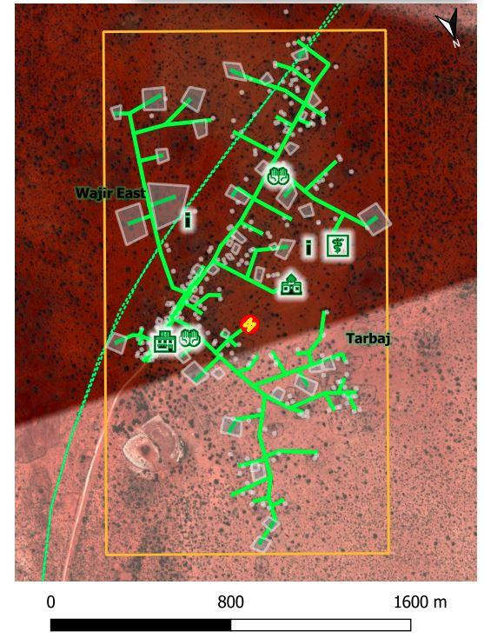
Photo 2: Overview of project area

Way Leaves
Supply of electricity will involve passing of low voltage (LV) lines to connect the customers to power. It is estimated that a total of 13.1 km of LV circuit will be constructed mainly along the road reserve and along the boundaries to supply power.

The impact significance for this impact is assessed minor considering the community wilfully allocated the land for project construction.

Mitigation Measures
- Land for mini-grids will be acquired by NLC compulsorily and affected communities compensated in-kind.
- The contractor will sign and adhere to the agreement for use of community land for contractor facilities and worker’s camps, and restoration of the site after use.
- The construction activities will be restricted to within the allocated land and the immediate surroundings only.
- After construction work, any land taken for a temporary basis for storage of material will be restored to their original form.
- Consultations with the community during construction of the low voltage lines

Negative Impacts During Construction Phase
Despite the positive impacts identified, the project will also have negative impacts. However, adverse impacts are not anticipated due to its size and nature and most of the impacts will be experienced during construction phase of the project. The negative impacts and their mitigation are discussed below.

Vegetation Clearance
The construction process of the proposed Mini-grid and other associated facilities and structures will involve clearing of the existing vegetation cover (mainly grass) and trees. The project site is located in open area with minimal settlement around besides the dispensary and residential homes. Both the magnitude and sensitivity of this impact will be low. The impact will be direct, permanent and minor.
Mitigation Measures
- Clear only the necessary areas
- Ensure proper demarcation and delineation of the project area to be affected by construction works.
- Specify locations for vehicles and equipment, and areas of the site which should be kept free of traffic, equipment, and storage.
- Designate access routes and parking areas
- Re-vegetation including planting of trees around the plant/facility

Soil Erosion Impact
During clearing of the area to pave way for groundbreaking soil erosion may take place. This will be due to surface run off or blowing away by the wind if not properly managed. This is bound to happen because the soil will be loose. The area is gently slopy on the lower side and surface run off can also result to soil erosion. The impact significance will be minor due to the nature of the works and the fact that construction activities will be confined in the small project area.
Mitigation Measures
- The contractor shall avoid groundbreaking during the seasons of high rainfall to avoid erosion.
- Monitoring of areas of exposed soil during rainy seasons to ensure that any incidents of erosion are quickly controlled.
- The contractor should ensure that construction related impacts like erosion and cut slope destabilizing should be addressed through landscaping and grassing, carting away and proper disposal of construction materials
- Use silt traps where necessary
- Cover soil stockpiles.
- Landscaping with grass on areas without electrical installation (lower areas)
- The contractor should ensure recovery of exposed soils with grass and other ground cover as soon as possible.
- The contractor should put up proper drainage to avoid unnecessary erosion and do compaction of spoil areas to avoid land instability in form of soil subsidence, slip and mass movement.
- Areas compacted by vehicles during site preparation and construction should be scarified (ripped) by the contractor in order to allow penetration of plant roots and the re growth of the natural vegetation

Contamination of Soil from Fossil Fuels
The potential sources of soil contamination during construction phase are oil /fuel leaks or spills from machinery used in site preparation and trucks used in transporting construction materials. Depending on the size and source of the spill, liquid and gaseous state, petroleum hydrocarbons may remain mobile for long periods of time, threatening to contaminate the soil. The significance of the impact to the soil will be minor due to the nature of the works and the fact that construction activities will be confined in the small project area.
Mitigation Measures
- Construction vehicles must be maintained in good state and proper servicing to ensure no oils are likely to leak
- Care must be exercised not to spill any fossil fuels
- Any contaminated soil shall be scooped and disposed-off appropriately.

Dust Emissions
Initial activities such as site clearing, excavation if done in dry weather conditions will result in dust pollution. Dust emission from construction machinery is regarded as a nuisance when it reduces visibility and is aesthetically displeasing. This is expected during construction works. Dust will be generated from construction earthworks, transportation activities and aggregate mixing.
The receptors were noted to be mainly residential and a health facility. The distances from a source that dust impacts can occur is highly site specific and will depend on the extent and nature of incorporated mitigation measures, prevailing wind conditions, rainfall and the presence of natural screening. Due to the variability of the weather, it is impossible to predict what the weather conditions will be when specific construction activities are being undertaken. Therefore, the assessment of construction dust impacts is typically qualitative.
Mitigation Measures
- The construction area should be fenced off to reduce dust to the public
- Sprinkle loose surface earth areas with water to keep dust levels down.
- Construction trucks moving materials to site, delivering sand and cement to the site should be covered to prevent material dust emissions into the surrounding areas;
- Masks should be provided to all personnel in areas prone to dust emissions during construction
- Stockpiles of excavated soil should be enclosed/covered/watered during dry or windy conditions to reduce dust emissions.
- Drivers of construction vehicles must be sensitized so that they limit their speeds so that dust levels are lowered.
- Trees can be planted around the plant provided they do not cast shadows to the solar panels to act as wind breakers and hence decrease dust pollution

Vehicle Exhaust Emissions
Exhaust emissions are likely to be generated by the construction vehicles and equipment. Motor vehicles that will be used to ferry construction materials would cause air quality impact by emitting pollutants through exhaust emissions. There are few Receptors (settlements) within 500 m of the project site and the impact magnitude will be medium and sensitivity medium hence the impact significance will be moderate.
Mitigation Measures
- Drivers of construction vehicles must be sensitized so that they do not leave vehicles idling so that exhaust emissions are lowered.
- Maintain all machinery and equipment in good working order to ensure minimum emissions of carbon monoxide, NO_{X}, SO_{X} and suspended particulate matter;

Pollution from Solid Waste Generation
It is expected that solid waste will be generated during construction phase of the project. Solid waste is anticipated to be produced during site preparation, civil works, spoil from excavations and will include; mortar, wood, paper, waste paper wrappings, conductor off cuts, masonry chips and left-over food stuffs. Effects of mismanaged waste include:
- Public nuisance due to littering or smell in case of rotting
- Contamination of soils and water courses
- Creation of breeding grounds for vermin like rodents and cockroaches
The significance of this impact will be minor due to the nature of the works and the fact that construction activities will be confined in the small project area.
Mitigation Measures
- Ensure spoil from excavations is arranged according to the various soil layers. This soil can then be returned during landscaping and then rehabilitation, in the correct order which they were removed that is top soil last;
- Segregate waste and dispose of appropriately using a licensed waste handler
- Provide litter collection facilities such as bins and create awareness campaigns to segregate as early as possible, using the appropriate bins
- Contractor to put in place and comply with a site waste management plan
- The contractor should comply with the requirement of OSHA ACT 2007 and Building rules on storage of construction materials
- Use of durable, long-lasting materials that will not need to be replaced as often, thereby reducing the amount of waste generated over time
- Recovery of materials remains and return to stores
- Re-use of materials where possible
- Proper budgeting to avoid waste generation

Impacts on Water Resources and Water Quality
During construction, excavation activities will involve soil exposure which results in soil erosion due to wind and surface runoff due to rains. Seepage from spilled fuels and oils and leaking machinery can also negatively impact groundwater water which could lead to potential contamination. Generally, due to the localized area of impact, the overall significance of the related impacts on water quality is considered to be minor, provided the necessary mitigation/ management measures are implemented. The people in Dasheeg area use an earth dam as the main source of water and care must be exercised to avoid any pollution to the water source.

Mitigation Measures
Measures shall be put in place to minimize erosion and sediment mobility, especially during construction. These measures include:
- Clear the necessary areas only.
- Appropriate remedial measures shall be implemented by the contractor in the event of erosion.
- Infrastructure shall be designed to ensure that contaminated run-off does not reach watercourses.
- In the event of an oil spill the procedures contained in the emergency response plan of the contractor will come into effect.
- No vehicle maintenance and service shall be done at project site but in approved garages or service stations to avoid any possible oil and fuel spills that could contaminate soils and possibly ground water quality.
- Ensure that potential sources of petro-chemical pollution are handled in such a way to reduce chances of spills and leaks.
- Construction activities to avoid any unchanneled flow of water at the site
- Storage areas that contain hazardous substances should be bundled with an approved impermeable liner and provision for a pit to be made in case of oil spill.
- The excavation and use of rubbish pits during construction should be strictly prohibited.
- A waste disposal area should be designated within the active construction area and this should be equipped with suitable containers i.e., skips or bins of sufficient capacity and designed to contain and prevent refuse from being blown by wind,
- Areas contaminated by spilled concrete and/or fuels and oils leaking from vehicles and machinery should be cleaned immediately.
- The contractor to source for alternative source of water for construction purposes to avoid potential conflict with the community

Noise and vibration
During construction activities noise pollution will occur and is bound to be a nuisance and a disturbance to neighboring communities. This noise is from construction equipment, excavation works, concrete mixing and vehicles coming to site but will be temporary. From the prediction of the specialist study on ambient noise quality measurements, the traffic noise that will be emitted by traffic accessing the proposed project site during construction is expected to have an adverse impact on ambient noise. The level of traffic noise will increase depending on the traffic volume. General guideline indicates that an increase of 20% in traffic volume approximates to a noise level increase of around 1 dB, while a doubling of traffic volume results in a noise level increase of about 3 dB. It is however, worth noting that the level of noise is attenuated with increase in distance from the source and thus the sites/objects in close proximity to the source will receive more noise in comparison to those at remote location. The impact significance has therefore been assessed minor. This due to the fact that the impact magnitude is low and the receptor sensitivity is medium. The site is on very close proximity to Dasheeg dispensary and few residential houses nearby.

Mitigation Measures for Noise and Vibration
These proposed mitigation measures aim to ensure that noise generated during construction is kept to minimum and adheres to relevant noise standards. They include:
- Fencing off the construction site with iron sheet during construction
- Install portable barriers to shield compactors thereby reducing noise levels.
- Use of noise-suppression techniques to minimize the impact of construction noise at the project site.
- Use equipment designed with noise control elements.
- Co-ordinate with relevant agencies regarding all construction activities.
- Limit vehicles to minimum idling time and observe a common-sense approach to vehicle use, and encourage drivers to switch off vehicle engines whenever possible.
- Set and observe speed limits and avoid raving of engines
- The Contractor shall ensure that construction activities are limited to working hours (i.e., between 8am and 5pm daily) from Monday to Saturday, or as required in terms of legislation.
- Compliance with Noise and Vibration Regulations of 2009 is expected

Impacts from Hazardous Materials
Some hazardous materials will be used during construction phase of the project. They include insulating oil, paints, solvents and oils. Spilled chemicals can contaminate soil as well as pollute water resources. Additionally, hazardous and flammable substances if improperly stored and handled on site become potential health hazard for construction workers and the public. The amount of hazardous waste generated will be minimal. The significance of the impact will be minor due to a low magnitude and medium sensitivity.

Mitigation Measures
- Maintenance of construction vehicles will not be done on site
- All hazardous products and waste should be labeled and handled properly to avoid contact with the ground
- Material handling to be done by trained and qualified staff
- The contractor site should have designated area (concrete bunded) for storing hazards materials

Accidental Oil Spills or Leaks
There is possibility of oil leaks from construction vehicles. The construction machines on the proposed site have moving parts which will require continuous oiling to minimize the usual corrosion or wear and tear. These processes may lead to oil spill to the ground. The impact significance will be minor due to the nature of the works and the fact that construction activities will be confined in the small project area.

Mitigation Measures
- In the event of accidental leaks, contaminated top soil should be scooped and disposed of appropriately.
- It is proposed that the refueling and maintenance of vehicles will not take place at the construction site.
- Contractor to create awareness for the employees on site on procedures of dealing with spills and leaks from oil for the construction machinery
- Vehicles and equipment must be serviced regularly and kept in good state to avoid leaks.
- In case of spillage the contractor should isolate the source of oil spill and contain the spillage using sandbags, sawdust, absorbent materials and/or other materials approved by materials.
- Proper training for the handling and use of fuels and hazardous material for construction workers.
- All chemicals should be stored within the bunded areas and clearly labeled detailing the nature and quantity of chemicals within individual containers.

Fire Hazards
During construction of the project, fire hazards are likely to occur especially when precaution measures are not taken to account. Smoking is one of causes of fires and this can happen if cigarette butts are left carelessly. Additionally, keeping of fuels onsite during construction can be a potential cause of fire. This impact is evaluated to be of moderate significance. All the construction activities will be confined at the project site hence high sensitivity and low magnitude.
Mitigation Measures
The following measures should be put in place to prevent fire hazards:
- Create awareness to the construction workers on potential fire hazards
- Provision of firefighting equipment (extinguishers) on site during construction.
- No smoking shall be done on construction site
- ‘No smoking’ signs shall be posted at the construction site
- A fire evacuation plan must be posted in various points of the construction site including procedures to take when a fire is reported.

Impacts of construction material sourcing (e.g., quarrying)
The construction of the project will utilize materials such as; stone, ballast, sand and hardcore. It is anticipated that they will be obtained from quarry and mining operations. Conscious or unwitting purchase of these materials from unlicensed operations indirectly supports, encourages and promotes environmental degradation at the illegal quarry sites and causes medium to long term negative impacts at source, including landslides. The significance of this impact will be moderate due to high sensitivity and low magnitude.

Mitigation Measures
- The contractor should source all building materials such as stone, sand, ballast and hard core from NEMA approved sites.
- Ensure accurate budgeting and estimation of actual construction materials to avoid wastage.
- Reuse of construction materials where possible.

Increased Water Demand
During the construction of the project there will be increased demand for water by the construction workers and the construction works. Water will be mostly used in the construction works and for wetting surfaces or cleaning completed structures. It will also be used by the construction workers to wash themselves and even drink. Although the sensitivity of the receptor (surface water) in the project area is high owing to unavailability of feasible alternative source of water for the local community, the overall significance of impacts is assessed to be negligible due to negligible magnitude of the impact.
Mitigation Measures
- Prudent use of available water
- Consultations with the project local committee on use of water in the community to avoid conflicts with the community
- Contractor to make own arrangements to provide water for construction works different from the community dam to avoid any conflicts with community.

Energy Consumption
The construction works will consume fossil fuels (mainly diesel) to run transport vehicles and construction machinery. Fossil energy is non-renewable and its excessive use may have serious environmental implications on its availability, price and sustainability. This impact will be negligible owing to the size of the project that will require very few trucks during the construction phase.

Mitigation Measures
Proper planning of transportation of materials will ensure that fossil fuels (diesel, petrol) are not consumed in excessive amounts. Complementary to these measures, the contractor shall monitor energy use during construction and set targets for reduction of energy use.
- Regular maintenance of vehicles to ensure efficient consumption of fuels.

Occupational Health and Safety Impacts
There are several activities involved during construction. These activities can pose potential health and safety risks to the workers. The activities include excavation, backfilling, civil works, pole erection, stringing of conductors. Risk of accidents and incidents are likely during construction activities. As already noted during construction, the safety and health of employees may be exposed to risk as a result of the use of tools and other machinery to construct the Mini-grid. Occupation safety and health risks includes accidents, fall from heights, pricks by sharp objects etc. The impact on occupational health and safety during the construction phase is evaluated to be of moderate significance. All the construction activities will be confined at the project site hence high sensitivity and low magnitude.
Mitigation Measures
- The contractor should use skilled personnel for activities that demand that.
- Awareness creation/Tool box talks on safety to workers while at construction site and documentation kept
- Workers coming to the site should be knowledgeable on safety precautions to take
- Appropriate PPE (helmet, safety harness, gloves, safety shoes, masks, climbing irons among others)
- Proper housekeeping and maintain good hygiene
- Close supervision of workers
- Engagement of trained first aider on site
- Provide safe drinking water for workers
- Availability of equipped first aid box on site
- Risk assessment by contractor of the construction activities and implement mitigation measures appropriately
- Adherence to occupational Safety and Health Act 2007
- Establish Safety committees
- The contractor must acquire insurance for the workers-WIBA cover

Community Safety -Access to Site by General Public
If access to the Mini-grid site is not controlled then it can lead to people entering the site including animals. This can result to accidents. Impact significate is rated as moderate considering the high impact magnitude and low receptor sensitivity.
Mitigation Measures
- Proper barricading
- Awareness creation to community
- Hazard communication.
- Controlled access to the site by designated personnel
- Maintain records of any person who comes to site

Spread od HIV/AIDS and STIs
HIV and AIDS remain a major challenge in Kenya as well as in Wajir County. The epidemic continues to adversely impact on all spheres of the County; economic, social and health sectors.
The project construction will improve the economic status of some of the people employed thus increasing the disposable income with the probability of indulgence in substance abuse and using the money to solicit for sex. Researchers have indicated that HIV prevalence rates are higher in areas where there is high disposable income as might be the case during construction of the project
Mitigation measures include:

- Develop and implement at HIV/AIDS Policy to promote awareness of HIV/AIDS and access to treatment.
- Employees contractors and subcontractors will be required to follow, and will be trained in, the Worker Code of Conduct which includes context specific guidelines on worker-community interactions, worker-worker interactions and alcohol and drug use.
- Employees, contractors, and subcontractors will be trained and educated to improve awareness of transmission routes and methods of prevention of sexually transmitted infections, communicable diseases and vector borne diseases, notably malaria, prior to working on the Project site. Other diseases will be covered as appropriate.
- Provide access to free condoms at all worker sites and accommodation.
- Work with NGOs or the Ministry of Health to develop and implement a community sensitisation programme on HIV/AIDs and communicable diseases.
- Continue to implement a programme of stakeholder engagement including a grievance mechanism in communities in the Project Area.
- Monitor health trends during Project construction (and operations) in order to be aware of and respond appropriately to any negative health trends that may be linked to the Project and its workers.

Increase in completion for scarce resources and strain on public utilities

The influx of workers in the area is expected to lead to increase in demand for public amenities such as hospitals, transport, schools water resources etc. This could lead to a loss of access to these services by locals especially those who could be among the vulnerable categories. Due an increase in demand, cost of housing near the sites will disadvantage the locals.
The nature of the project will require technical skills that might not be available in the community. This might require movement of construction workers into the community. It is expected that technically skilled personnel might be sourced from outside the community while the unskilled labour is expected to be sourced locally. It is therefore a possibility that the neigbouring communities might go out looking for opportunities in project area thus creating competition. The significance of this impact is considered to be minor because the receptor sensitivity will be medium, and the impact magnitude is low.
Mitigation Measures
- Reduction of labor influx by tapping into the local workforce to the extent possible
- Recruitment of local workforce to the extent possible especially unskilled and semi-skilled jobs
- Consultations with and involvement of local community in project planning and other phases of the project
- Awareness-raising among local community and workers on the need to have a good /cordial working relation
- Sensitization/awareness to workers regarding engagement with local community.
- Contactor shall make provision to provide resources needed by the workers if the need for such resources may result to competition e.g., water
- Establishment and operationalization of an effective Grievance Redress Mechanism accessible to community members
- The contractor and the project/community grievance redress committee to work closely address complains raised on time.
- Gender considerations in employment opportunities
- Appropriate compensation for work done
- Respect for community values/culture
- Prompt payments as per the contractual agreements/terms

Child Labor
Implementation of the project will lead to increased opportunities for the host community to sell goods and services to the incoming workers. This can lead to child labor to produce and deliver these goods and services, which in turn can lead to school truancy. The impact significance is rated minor, based on low sensitivity of the receptor and medium magnitude of the impact.
Mitigation Measures
  - Awareness creation to the community that child labor is illegal and that children have a right to education.
  - Communication to the contractor that child labor is illegal and adherence to employment act is required.

Gender Based Violence- SEA and SH
Gender-based violence (GBV) is an umbrella term for any harmful act that is perpetrated against a person’s will and that is based on socially ascribed (i.e., gender) differences between males and females. It includes acts that inflict physical, sexual or mental harm or suffering, threats of such acts, coercion, and other deprivations of liberty. GBV in project may manifest in terms of sexual exploitation and abuse (SEA) and workplace sexual harassment (SH).

Sexual Exploitation and Abuse (SEA) is any actual or attempted abuse of a position of vulnerability, differential power, or trust, for sexual purposes, including but not limited to, profiting monetarily and socially from the sexual exploitation of another. Sexual abuse is further defined as “the actual or threatened physical intrusion of a sexual nature, whether by force or under unequal or coercive conditions.” Women, girls, boys and men can experience SEA.

Workplace sexual harassment (SH) includes unwanted sexual advances, request for sexual favors and sexual physical contact.

Sexual exploitation and abuse (SEA) of community members by project workers and sexual harassment (SH) among project workers are forms of GBV that are a potential risk and impacts to this proposed project. GBV has serious and far-reaching negative effects including physical injuries resulting in death or disfigurement, psychological trauma, infection with HIV/AIDS, unwanted pregnancies, social stigmatization and exclusion and economic deprivation among others. Consequently, it is incumbent that preventive measures be mooted to prevent occurrence of such cases.

There is no incident of gender-based violence in Dasheeg as identified during FGD with Men, women and youths. However, it cannot be ruled out during project implementation. Thus, the significance of this impact is considered to be Minor considering low sensitivity of the receptor and low magnitude of the impact.
Mitigation Measures
To manage GBV risks, the contractor will prepare a SEA/SH Prevention and Response Action Plan that will include a GRM that ensures confidentiality. The plan should have an Accountability and Response Framework. The plan will include the necessary measures for prevention and response. The contractor can make reference to World Bank’s Good Practice Note for Addressing Gender-based Violence in Investment Project Financing involving Major Civil Works (Sept 2020) for further guidance.
It should be noted that the decision to report a GBV case lies with the survivor or the guardians if the survivor (in case of a minor) and such a decision must be respected. Therefore, the contractor or project will only refer the survivor of guardian to the established referral pathway, including the nearest police station with a gender desk for handling GBV cases. Also, should a survivor choose legal redress, the project will similarly facilitate him/her by referring him/her to the nearest established legal support facility that offers legal support to GBV survivors.

Key tasks will include:
- Community engagement to create awareness on SEA/SH risk/ issues
- Creating awareness to workers on the need to refrain from SEA/SH incidences
- Mandatory awareness creation for workers on required lawful conduct in the community and legal consequences for failure to comply with laws
- Mandatory signing and implementation of code of conduct for the workers
- Creation of partnership or liaison with specialized actors in GBV who can respond appropriately in case of any incidence (provide contacts to community)
- Ensure a survivor centered approach in responding to SEA/SH incidences i.e., decision to report lies with the survivor or the guardian in case of a minor.
- Contractor to provide established referral pathway including police station with a gender desk for handling SEA/SH cases and also free toll numbers/hot lines for reporting GBV
- The contractor will also facilitate any survivor who decides to take legal action by referring them to the nearest established legal support facility that offers legal support to GBV survivors.
- Ensure Confidential reporting and responding to SEA/SH cases if reported;
- Encourage reporting of all SEA/SH incidences to the chief or the grievance redress committee members or community elders; and
- Ensure all complaints on SEA/SH or harassment are reported directly through CREO - county renewable energy officer.

Public Health Impacts
Construction works/activities will bring people together and new interactions between people are likely to happen. These interactions are likely to pose risks to the social fabric of the community. Such risks include public health related issues such as (COVID-19 infections and spread, HIV/AIDS, communicable and sexually transmitted diseases (STDs). The receptor sensitivity is medium and low magnitude, hence Minor significance.
Proposed Mitigation Measures
- Sensitize workers and the community on prevention and mitigation of HIV/AIDS and other sexually transmitted diseases, through staff training, awareness campaigns and community Barazas.
- Awareness creation and consultations with local communities prior and during construction on the dangers of these diseases
- Informing workers on local cultural values and health matters.
- Provision of condoms to workers
- Allowing migrant workers time to be with their families
- The contractor is impressed upon not to set a construction camp on site.
- The contractor will provide public education/information about HIV/AIDS transmission and prevention measures.
- Ensure equal treatment of workers
- Provide all appropriate COVID-19 preventive measures including campaign to maintain individual measures at the work place.

w) Public Health Impacts Sanitary Waste
Currently at the site there is not sanitary waste system (toilet) except one that is being constructed for the dispensary. There is need to dispose sanitary waste in manner that will not pose health hazards to the workers and the community. The receptor sensitivity is medium and low magnitude, hence Minor significance.

Mitigation Measures
- Construct/ install pit latrines for both genders clearly labelled

Forced Labor
During construction of the mini-grid the risk of forced labor is likely to occur and precaution is need to safe guard the community from being subjected to forced labor. The impact significance is rated minor, based on low sensitivity of the receptor and medium magnitude of the impact.

Mitigation Measures
- Contractor must adhere to the employment Act which outlaws any form of forced labor
- Community to report any form of forced labor at the site
- Contractor to ensure that all workers have a national ID card or documentation to show they are adults (above 18 years).

Risks related to Inadequate Stakeholder Engagement
Lack of timely and adequate stakeholder engagement during construction is a recipe for dissatisfaction among stakeholders affected and can result to grievances which may turn to conflicts and delays in project construction. With the implementation of the mitigation measures the impact significance is minor.

Mitigation measures;
- The contractor will design and implement a stakeholder engagement schedule to ensure various stakeholders are engaged at and informed about the project on a timely basis and respond to issues that the stakeholders may require.
- The contractor will also prepare and implement a grievance redress mechanism to deal with grievances. The grievance redress mechanism committee of this GRM should also include representatives from the community.

Negative impacts during Operation phase of the project
NOTE: According to the MOE the proposed project will be constructed by a third party (contractor) who will also operate and maintain the solar mini-grid for a period of seven years and then hand over the plant to Kenya Power who is the implementing agency of the plant on behalf of the MOE. Therefore, mitigation measures against negative impacts during the first seven years will be the responsibility of the contractor after which KPLC will take over.

Solid Waste Generation
The proposed Mini-grid is expected to generate some amounts of solid waste during its operation phase. The type of the solid waste generated during the operation of the project will consist of paper, drums, plastic, cables, meters, panels. Such wastes can be injurious to the environment. Some of these waste materials especially the plastic, cables, metals, polythene among others are not biodegradable hence may cause long-term injurious effects to the environment. The overall impact significance on land due to waste disposal during O&M phase has been assessed as minor due to medium sensitivity and low magnitude.
Mitigation measures
The contractor will be responsible for efficient management of solid waste generated by the project during its operation. In this regard, the contractor;
- Will provide waste handling facilities such as labeled waste bins for temporarily holding solid waste generated at the site.
- He shall put in place an emphasis on prudent waste generation and will give priority to reduction at source. This option will demand a solid waste management awareness among the employees.
- Separation of hazardous waste from non-hazardous waste is required
- Use long-lasting materials that will not need to be replaced as often, thereby reducing the amount of waste generated.
- He will ensure that waste is disposed of regularly and appropriately.
- Waste should then be handled, collected, transported and disposed according to the Environmental Management and coordination (waste management) regulations of 2006.

Liquid Waste/Oils Generation
The solar Mini-grid will have a small diesel backup generator which will operate in the event that the solar energy is limited for example during rainy and cloudy seasons. From its operations there will be waste oil. There is also potential for oil spills and accidents during oil loading to the generator, storage and operations. These oil spills can pollute the soil and even ground water. The liquid waste to be generated is hazardous hence may cause long-term injurious effects to the environment. The overall impact significance on land due to liquid waste disposal has been assessed as minor due to medium sensitivity and low magnitude.
Proposed mitigation measures
- Proper storage of the oil is required to ensure no leakages/ spills to the ground
- Frequent inspection and maintenance of the generator to minimize leakages.
- No vehicles should be serviced or maintained at the Mini-grid area.
- The waste oil or used oil must be disposed-off using NEMA approved waste handlers
- Proper training for the handling and use of fuels for the operators of the Mini-grid.
- In the event of accidental leaks, contaminated top soil should be scooped and disposed of in accordance to the law

Increased oil Consumption
The proposed Mini-grid shall consume fuel/oil in the process of backing up the solar energy required. The fuel is produced mainly through non-renewable resources, implying this will have adverse impacts on these non-renewable resources base and their sustainability. The impact will be of minor significance.
Mitigation Measures
To ensure efficient energy consumption during the operation phase of the project, the contractor to install an energy-efficient lighting system at the project site facilities. This will contribute immensely to energy saving during the operational phase of the project. In addition, the plant operators will be sensitized to ensure energy efficiently in their daily operations.

Increased Storm Water Flow
The panels, building roofs and pavements of the proposed Mini-grid will lead to increased volume and velocity of storm water or run-off flowing across the area covered by the solar panels during operation phase. This will lead to increased amounts of storm water entering the drainage systems. The impact will be of minor significance.
Mitigation Measures
- Construct the drainage system in a way to follow natural drain of the water
- Concrete only the required area and leave the rest of the land with vegetation like grass
- Construct rain harvesting system on the control buildings/office and harness into storage tanks for use

Fire Outbreaks
Carelessness and negligence both at the solar mini-grid and by the beneficiaries of electricity may cause fires. With the mitigation measures in place the impact is evaluated to be of moderate significance due to high sensitivity and low magnitude.
Mitigation Measures
- The power plant must contain firefighting equipment (Portable fire extinguishers) of recommended standards and in key strategic points
- Detection/alarm systems that can detect fire should be considered and installed
- A fire risk assessment and evacuation plan should be prepared and posted at strategic points and should include procedures to take when a fire is reported.
- Workers especially operators of the plant must be trained on fire fighting and management
- ‘No smoking’ signs shall be posted within the Mini-grid area
- A fire Assembly point should be identified and marked

Visual Impacts
Once complete the Mini-grid will present visual impacts, both by its physical presence and by visual impacts of its associated structures. Visual intrusion caused by the Mini-grid may cause alteration to the natural scenery of the project area. Some people however, do not notice structures or do not find them objectionable from an aesthetic perspective. To some, the Mini-grid and its utilities may be viewed as part of the infrastructure necessary to enhance everyday lives and activities while to other it represents economic development. The project and its surrounding area are new for such developmental project and will have visual impacts during initial period of Project and the same will disappear over a period of time. Based on the above, significance of visual impact on landscape during operation phase of the project has been assessed as minor due to low receptor sensitivity and impact magnitude being medium.
Mitigation Measures
- The visual negative impacts can be mitigated through putting up a fence round to keep off/screen the solar panels.
- Planting of short trees along the fence

Water demand
During this period the demand for water will be lesser than that used in construction. However, some amounts of water will be needed in wiping of the panels and use at the solar plant facility. Therefore, caution need to be exercised to ensure prudent use of water. The impact is assessed to be negligible due to very low magnitude of the impact.
Mitigation Measures
- There is need to source for a sustainable water source for use
- Install water-conserving automatic taps
- Encourage water harvesting from rooftops and storage for cleaning purposes (washing the panels off dust)
- Any water leaks through damaged pipes and faulty taps should be fixed promptly.

Sanitary waste
Although there are few people who will be running the Mini-grid during operation phase provision for disposal of sanitary waste must be put in place through septic tanks. The impact is assessed to be negligible due to very low magnitude of the impact.
Mitigation Measures
The area is not served by a sewer system and sanitary waste will be drained through use of septic tanks.

Flooding
Flooding may occur and cause damage to the plant and other associated infrastructure but the risk of occurrence is low since the area is not known for regular flooding. The impact is assessed to be negligible due to very low magnitude of the impact.

Mitigation measures
- Ensure drainage channels are free of any obstruction at all times i.e., not blocked
- Construct more channels and or expand existing ones
- Raise foundations of the solar panels and ensure a proper and firm concrete base
- Create flooding diversions and or spill ways to divert water from getting into the solar power facility

Workers Occupation Health and Safety
Working within the Mini-grid can poses potential health hazards and accidents to workers. Therefore, caution must be taken to ensure that the Mini-grid does not pose a health and safety risks to workers. Because the maintenance activities will be conducted less frequently, the impact magnitude on occupational Safety and Health will be low. Considering that the accidents may result in injuries and death, the sensitivity is considered to be High. Therefore, the significance is Moderate.
Mitigation Measures
- Ensure only qualified staff are employed to work in the facility
- All workers operating the Mini-grid must be equipped with appropriate and adequate person protective equipment (PPE) such as; safety footwear, helmet among others.
- Operators must be skilled on firefighting management
- Annual environmental audits should be done
- WIBA cover for staff is mandatory

Hazardous waste
The amount of hazardous waste generated will be very low and possibly originate from maintenance works and would include; used up batteries, damaged panes, waste oil, and their containers, used rags and spent clean-up rags. This impact is assessed as minor due to medium sensitivity and low magnitude.
Mitigation Measures
- These waste wastes should not be mixed with other non-hazardous waste
- Operator to have a designated waste storage area for absolute lead-acid batteries awaiting disposal
- These wastes should be disposed by NEMA approved handlers

Noise and Vibration
Negligible noise and vibration will be produced during operation phase of the project and would be from the backup generator.
Mitigation Measures
The generator room should be made sound proof to ensure no noise of a nuisance level will be produced. The contractor should also monitor noise levels by taking tests and putting in appropriate measures.

Electric and magnetic fields (EMFs)
Electric magnetic fields are only anticipated during operation period, but these are negligible. The exposure to would be little EMFs is highly negligible because the EMFs produced by the electrical installation are low. Consequently, the study does not anticipate impacts of EMFs.

Shocks and electrocutions to the beneficiaries
Majority of the beneficiaries who will be customers and users of the power have not used electricity before. Failure to take appropriate precaution while interacting with electricity can result in electric shocks, fires and even electrocution/death. Impact significate is rated as moderate considering the high impact magnitude and low receptor sensitivity.
Mitigation Measures
The following precaution/preventive measures need to be observed in order to prevent risk of electric shocks, fires and electrocutions.
- Inspect the wiring of the houses before connecting power
- Safety awareness campaigns to the community before connection of power on safety precautions such as
  - Require community to engage a certified technician to do wiring in the premises
  - Use of quality materials while wiring
  - Refraining from individual illegal extensions of power lines to other houses
  - Observing safety measures while using electricity such as not touching sockets and switches with wet hands or wiping with wet cloths
  - Keeping off all electricity infrastructure e.g., not tying livestock on electric poles, no cutting earth wires that run along some electric poles, not interfering with sockets or switches
  - Reporting any electric wire/conductors if found fallen on the ground
  - Report any incident regarding electricity at the local office –staff in charge of operating the Mini-grid

Community safety -Access to the facility by general public
Once operational the facility/plant will need controlled access from the public to avoid any safety risks. The contractor will put the following measures to ensure the public will not access the site without permission. Impact significance is rated as moderate considering the high impact magnitude and low receptor sensitivity.

Mitigation Measures
- Fencing off the facility to keep of community members, children and livestock from entering into the facility
- Controlled access to the site only with prior approval
- Maintain records of any person who comes to site

Risks related to poor or inadequate stakeholder engagement (Conflict)
During operation of the project there are grievances that may arise from community and other stakeholders related to poor or inadequate engagement of stakeholders and other need for information or challenges in using power by the community. Therefore, the contractor will design and implement a grievance redress mechanism to deal with grievances. The grievance redress mechanism committee should also include representatives from the community. With the implementation of the mitigation measures the impact significance is minor to negligible.

Mitigation measures
- Employ from the community to the extent possible
- Engage the community members and other stakeholders in a timely manner
- Work closely with the GRM committee members in solving the conflicts
- Solve all conflicts/grievances at the earliest time possible
- Ensure all grievances are logged and closed
- Monitoring the pattern of grievances to come up will long term measures

Gender Based Violence- SEA/ SH
Gender based violence risk is also possible during operation phase although the labor force will be smaller. the impact is assessed as minor due to the low magnitude and medium receptor sensitivity. Therefore, measures must be put in place to address GBV risks.

Mitigation Measures
To manage GBV risks, the contractor will prepare a SEA/SH Prevention and Response Action Plan that will include a GRM that ensures confidentiality. The plan will include the necessary measures for prevention and response.

Key tasks will include
- Community engagement to create awareness on GBV risk/ issues
- Creating awareness to workers on the need to refrain from GBV incidences
- Mandatory awareness creation for workers on required lawful conduct in the community and legal consequences for failure to comply with laws
- Mandatory signing and implementation of code of conduct for the workers
- Creation of partnership or liaison with specialized actors in GBV who can respond appropriately in case of any incidence (provide contacts to community)
- Ensure a survivor centered approach in responding to GBV incidences i.e., decision to report lies with the survivor or the guardian in case of a minor.
- Contractor to provide established referral pathway including police station with a gender desk for handling GBV cases and also free toll numbers/hot lines for reporting GBV
- The contractor will also facilitate any survivor who decides to take legal action by referring them to the nearest established legal support facility that offers legal support to GBV survivors.
- Ensure Confidential reporting and responding to GBV cases if reported;
- Encourage reporting of all GBV incidences to the chief or the grievance redress committee members or community elders; and
- Ensure all complaints on GBV or harassment are reported directly through CREO - county renewable energy officer.

Public Health Impacts –HIV/AIDs
There is potential for HIV/AIDs risks during operation phase. Therefore, the contractor need to put measures to prevent the same. Based on the fact that the receptor sensitivity will be medium and the impact magnitude low, the impact significance will be Minor.
Mitigation Measures
- Sensitize workers and the community on prevention and mitigation of HIV/AIDS and other sexually transmitted diseases, through staff awareness and awareness campaigns for the community
- The contractor will provide public education/information about HIV/AIDS transmission and prevention measures.
- Provision of condoms to workers
- Allowing migrant workers time to be with their families

Public health Impacts -Covid 19 disease
It is likely that the project will be implemented during the Covid 19 pandemic and so preventive measures must be put in place to prevent the disease from spreading. The receptor sensitivity will be medium and the impact magnitude low, therefore, the impact significance will be Minor.

Mitigation Measures
- Social distance must be observed
- Provision of hand wash facilities before access
- Provide thermal guards for temperature check and monitoring for workers and any other person coming to site
- Enforce wearing of masks
- Make provision for testing and treating especially of workers
- Display Ministry of Health guidelines on COVID 19 at strategic points and ensure adherence
- Create awareness on COVID 19 preventive measures
- Provision of contact numbers for the nearest health facility for testing and treatment
- Adhering to any other measures from the ministry of health which may be issued from time to time

Dust emissions
During operation phase not much dust will be generated from the facility but wind and dust storms are potential impacts. This impact will be negligible because there will be no activities on site that will have the potential to generate dust.

Mitigation Measures
- Trees can be planted around the plant/facility provided they do not cast shadows to the solar panels to act as wind breakers and hence decrease dust pollution
- Ensure planting of grass around and within the facility compound

Vehicle exhaust emissions
Exhaust emissions are likely to be generated by the vehicles coming to the facility though on a low risk. Due to the low magnitude of the impact and the low sensitivity, the significance will be minor.
Mitigation Measures
- Drivers of the vehicles must be sensitized so that they do not leave vehicles idling so that exhaust emissions are lowered.
- Company vehicles should be well maintained

Negative impacts during decommissioning phase
Preparation for decommissioning
The solar power plant may be decommissioned due to various reasons and there are impacts that will need to be mitigated. Once the KPLC makes the decision for decommissioning the following will be required;
- Prepare a Decommissioning Plan and submit to NEMA and the County Governments of Wajir to obtain approval for implementation.
- Implement the decommissioning plan including backfilling, revegetation, disposal of waste material, recycling of recyclable material among others
Some of the negative impacts associated with the proposed project during its decommissioning phase include;

Noise and Vibration
The demolition works will lead to significant deterioration of the acoustic environment within the project site and the surrounding areas. This will be as a result of the noise from demolition works. The impact significance has been assessed minor due to the fact that the impact magnitude is low and the receptor sensitivity is medium.
Mitigation Measures
Significant impacts on the acoustic environment will be mitigated by the KPLC who will put in place several measures that will mitigate noise pollution. The following noise-suppression techniques will be employed to minimize the impact of temporary noise at the project site.
- Install portable barriers to shield compressors and other small stationary equipment where necessary.
- Use quiet equipment (i.e., equipment designed with noise control elements).
- Co-ordinate with relevant agencies in case the noise produced will require a license.
- Limit pickup trucks and other small equipment to a minimum idling time and observe a common-sense approach to vehicle use and encourage workers to shut off vehicle engines whenever possible.
- Demolish mainly during the day when most of the neighbours are out working.

Solid Waste Generation
Demolition of the Mini-grid and related infrastructure will result in generation of solid waste. The waste will contain the materials used in construction including concrete, metal, wood, glass, paints, adhesives, sealants and fasteners, conductors, poles solar panels and batteries. Although demolition waste is generally considered as less harmful to the environment since they are composed of inert materials, there is growing evidence that large quantities of such waste may lead to release of certain hazardous chemicals into the environment. The impact will be of major significance due to high magnitude and medium receptor sensitivity. The batteries and panels need to be disposed in a specific way, in accordance to the manufacturer’s guidelines and relevant regulations (both National and Wajir County Government regulations).
Mitigation Measures
- Demolition contractor to adhere to the various manufacturer’s guidelines and requirements regarding demolition and disposal
- Segregation of waste in order to separate hazardous waste from non-hazardous waste and other streams of waste
- Provision of facilities for proper handling and storage of demolition materials to reduce the amount of waste caused by damage or exposure to the elements
- Adequate collection and storage of waste on site
- Safe transportation to the disposal sites / designated area
- Hazardous waste must be disposed by NEMA approved waste handler

Dust Emissions
Some dust will be generated during demolition works. This will affect demolition staff as well as the neighbors. The impact will be of minor significance.
Mitigation Measures
High levels of dust concentration resulting from demolition or dismantling works will be minimized as follows:
- Watering all active demolition areas to kill dust.
- Cover all trucks hauling soil, sand and other loose materials or require all trucks to maintain at least two feet of freeboard.

HIV/AIDs awareness and prevention
Interactions during the decommissioning phase will be for a very limited time. The project will sensitize workers and the surrounding communities on prevention and mitigation of HIV/AIDS and other sexually transmitted diseases, through staff training and awareness campaigns/ to the community. This impact is assessed to be Minor due to the low magnitude and medium receptor sensitivity.

Social Protection
There will adequate mechanisms in place to protect local vulnerable population especially women and minors from risks associated with influx of workers (harassment, underage sex). This system will ensure having security on site provided by the contractor as well as sensitization and enforcement by the contractor. There will also be a code of conduct established for contractor employees and contract workers acknowledging a zero-tolerance policy towards child labor and child sexual exploitation. Additionally, the contractor will employ their skilled staff and apply unskilled construction labor from the local population as far as possible to minimize on influx of foreigners into the community.

Social Inclusion
Gender Mainstreaming
Projects usually affect women and men differently, and their roles are highly delineated. The project shall ensure that both men and women are equally consulted about the project and benefit from employment and other opportunities the project will present.
In addition, among communities, some groups are faced with barriers that prevent them from fully participating in political, economic, and social life. Disadvantage is often based on social identity, which may be derived from gender, age, economic status, ethnicity, disability, among other factors. These factors make some groups of people more vulnerable to project impacts than others alongside posing barriers to accessing project benefits. Thus, development projects affect people differently but vulnerable groups are more severely affected than those that are better off. In this project, some groups of the society that can be categorized as the vulnerable. These include the very poor, poor female headed households, poor children headed households, the poor elderly and the special needs persons (disabled). To ensure social inclusion and social sustainability, deliberate effort must be made to ensure the vulnerable take advantage of the project benefits as well as shielding them adverse impacts of the project.

Cumulative Impacts

Cumulative Impact Assessment
It was observed during the site survey that there are no other similar solar projects within the projects site. Thereore, it is assumed that there will be no cumulative impacts from the above mentioned projects on the local soil, water, land, air and ambient noise environment.

ENVIRONMENTAL AND SOCIAL MANAGEMENT PLAN (ESMP)

environmetal and social management plan
A detailed Environmental and social management plan for preconstruction, construction and decommissioning phase is well illustrated in the table below
Table 15: Environmental and Social Management Plan
Social Impacts

Potential Impacts | Recommended Mitigation Measures | Project phase | Responsibility | Monitoring Indicator | Frequency | Estimated Cost (Ksh)
Local employment | -Prioritize hire of locals for all unskilled labour.  -Implement a local recruitment plan that is fair and transparent (including recruitment processes that ensure inclusivity of both men and women, vulnerable individuals, minority clans, ethnic groups and VMGs.  -Adhere to labour laws, and labour management practices (timely renumeration, equitable compensation for both genders for equal work etc.)  -Create awareness to workers and the community on worker and project grievance redress mechanisms. | Construction  Operations  Decommissioning | Construction contractor  Operations & maintenance contractor  KPLC | -Fair and transparent local recruitment plan in place.  -Recruitment processes (job adverts, interviews, selection etc.).  -Number of locals employed based on gender, vulnerability, ethnic group, clan etc.  -Type of employment (skilled, semi-skilled and unskilled).  -Grievances raised, those aggrieved, status of resolution. | Quarterly | Contractor’s cost
Local Sourcing | -Source materials from local businesses/communities, and where necessary give opportunities to businesses owned or operated by vulnerable individuals. | Construction  Decomissioning | Contractor | -Number and types of businesses sourced from, businesses owned and operated by vulnerable individuals, types and quantities of materials etc. | Quarterly | No additional cost
Land acquisition and compensation for land and assets on land | In line with the RPF provisions;  -Prepare and implement an Abbreviated Resettlement Action Plan (A-RAP) to guide land acquisition for the mini-grid, and wayleaves for power distribution. Further, the proponent will fast-track A-RAP preparation to ensure that land acquisition and contractor mobilization to the site is undertaken after the A-RAP is finalized, cleared, and disclosed.  -The contractor will implement and adhere to agreements for temporal use of land and restoration of land after use.  -Compensate affected communities in-kind (priority project) for the loss of land.  -The construction activities will be restricted to within the allocated land and the immediate surroundings only.  -After construction work, any land taken for a temporary basis for storage of material will be restored to their original form.  -Consultations with the community on the low voltage lines.  -The design of the distribution line will utilize the existing road reserves. However, any damage to structures, crops, trees, community facilities and other assets will be compensated in line with the RPF provisions. | Pre- Construction | Contractor- (contractors’ facilities, workers camps)  Proponent- (project land for generation assets) | -Land Acquisition and consultation report (consultation (minutes and lists of participants).  -Type and amount of compensation paid to affected persons.  - Priority community project implemented and handed over to affected communities.  -Signed agreements with communities on the use and restoration of their land. | Quarterly | Value of compensation in kind project will be equivalent to the value of land acquired as per NLC
Labor Influx and related impacts (SEA/SH, HIV/AIDs and other STIs) | -Tap into the local workforce to the extent possible to reduce labor influx.  -Recruit local workforce to the extent possible especially for unskilled and semi-skilled jobs.  -Consult with and involve local community in project planning and other phases of the project.  -Raise awareness among local community and workers on the need to have a good /cordial working relation  -Sensitize workers regarding engagement with local community.  -Make provision to provide resources needed by the workers if the need for such resources may result to competition e.g., water.  -Establish and operationalize an effective Grievance Redress Mechanism accessible to community members.  -The contractor and the project/community grievance redress committee to work closely address complains raised on time.  -Include gender considerations in employment opportunities.  -Provide appropriate compensation for work done.  -Respect for community values/culture.  -Prompt payment of workers as per the contractual agreements/terms. | Construction  Decommissioning | Proponent, Contractor | -Records of employees/updated employee register.  -Number of local community employees and external employees/ updated employee register. | Quarterly | 50,000.00
Child labor | -Employ workers who are 18 years and above, and with a valid national ID at the time of hire.  -Implement and monitor the employment register regularly. Compliance with the national labor laws and labour management practices.  -Put visible signage on site “No Jobs for children”  -Do not allow children at the project site. | Construction  Decomissioning | Contractor, Proponent | -Updated employment register indicating locals employed, their ages, national identification numbers etc.  -Grievances raised, aggrieved persons and status on resolution etc. | Quarterly | 20,000.00
GBV- SEA and SH | -Prepare an SEA/SH Prevention and Response Action Plan, to manage the SEA/SH risks.  -The Action Plan to be proportionate to potential SEA/SH risks, and to include measures such as awareness creation for communities and workers; identification of referral services for survivors and a GRM that ensures confidential reporting of GBV cases.  -Implement a code of conduct signed by all those with physical presence on site. | Construction  Operations  Decommissioning | Construction contractor  Operations & maintenance contractor  KPLC | -Minutes of awareness creation sessions for the community and workers on GBV-SEA/SH.  -Code of conduct signed by all those with physical presence on site.  -GRM that ensures confidentiality of GBV cases in place.  Documented referral services for survivors.  -Grievances raised, aggrieved persons and status on resolution etc | Quarterly | 50,000.00
Forced Labor | -Adhere to the Employment Act which outlaws any form of forced labor.  -Report any form of forced labor at the site.  -Ensure that all workers have a national ID card or documentation to show they are adults (above 18 years). | Construction  Decomissioning | Contractor  Proponent | -Number of reported cases of forced labor. | Quarterly | 20,000.00
Risks related to Inadequate stakeholder engagement | -Prepare a stakeholder engagement/consultation plan (SEP) that is proportionate to the subproject and the identified stakeholders.  -Timely and prior disclosure of project all project information, including project instruments, the full rights and entitlements of project affected persons, sub-project positive and negative impacts and opportunities, proposed subproject budget.  -In line with the SEP, undertake adequate consultations prior to construction and throughout the project cycle with all segments of the community and other relevant stakeholders.  -Prepare and implement a grievance redress mechanism to deal with grievances.  -The grievance redress committee to include representatives from the community.  -Sensitize stakeholders on SEP and GRM. | Construction  Operations  Decommissioning | Construction contractor  Operations & maintenance contractor  KPLC | -Availabiliy of and implementation of the Stakeholder Engagement Plan.  -# of stakeholder consultations held  -Record of stakeholder consultations held (minutes of meetings and list of participants).  -Information disclosed, to whom it was disclosed  (men women, PWD, youth, vulnerable individuals and households etc., methods and languages used in the disclosure (culturally appropriate and accessible), grievances raised and status on resolution etc.  -Concerns raised and responses given. | Quarterly | 30,000.00
Exclusion of VMGs and vulnerable individuals and households | In line with the provisions of the ESMF, VMGF and Social Assessment ensure the following.  - Early identification and inclusion of VMGs and disadvantaged groups.  - Meaningful consultation to effectively participate in the project.  - Timely and prior disclosure of relevant project information to VMGs and disadvantaged groups.  - Adequate and ongoing consultations with VMGs and disadvantaged groups in line with the SEP.  - All concerns or grievances raised are fully resolved in a timely manner.  - Access to culturally appropriate project benefits and opportunities. | Preconstruction  Construction  Operations  Decommissioning | Construction contractor  Operations & maintenance contractor  KPLC | Minutes of consultative meetings with all community segments including VMGs and vulnerable individuals and households, grievances raised and status on resolution etc. | Quarterly | No additional cost
Inaccessibility of project benefits to VMGs and other vulnerable individuals due to affordability challenges | -Consult VMGs and Vulnerable individuals and households on charges for sub project services, and put in place specific interventions to ensure the vulnerable equally access project benefits. | Operations | Operations & maintenance contractor  KPLC | -Interventions to enable those vulnerable access project benefits.  -Number of complaints raised by VMGs/vulnerable individuals regarding access to project services.  -GRM that is culturally appropriate and accessible.  Grievances raised and status on resolution etc | Quarterly | No additional cost
Impacts from Hazardous materials - | - Maintenance of construction vehicles will not be done on site  - All hazardous products and waste should be labeled and handled properly to avoid contact with the ground  - Dispose hazardous waste through a NEMA approved waste handler | Construction | Contractor | Presence of well-maintained receptacles and centralized collection points | Quarterly | 100,000.00
Sanitary waste | - Construct/ install pit latrines for both genders clearly labelled | Construction | Contractor | Presence of separate and clean washrooms for both the gents and ladies | Quarterly | 300,000.00
Increased oil Consumption | - Efficient energy consumption  - Install an energy-efficient lighting system | Operations | Operations & maintenance contractor  KPLC | Energy consumption records | Quarterly | No additional cost
Risks related to poor or inadequate stakeholder engagement (Conflict) | - Employ from the community to the extent possible  - Engage the community members and other stakeholders in a timely manner  - Work closely with the GRM committee members in solving the conflicts  - Solve all conflicts/grievances at the earliest time possible  - Ensure all grievances are logged and closed  - Monitoring the pattern of grievances to come up will long term measures | Operations | Operations & maintenance contractor  KPLC | Grievance records | Quarterly | 20,000.00
Gender Based Violence –SEA and SH | To manage GBV risks, the contractor will prepare a SEA/SH Prevention and Response Action Plan that will include a GRM that ensures confidentiality. The plan will include the necessary measures for prevention and response and must ensure survivor-based approach | Operations | Operations & maintenance contractor  KPLC | -SEA/SH Prevention and Response Action Plan  -Grievance records | Quarterly | 20,000.00
Gender Based Violence –SEA and SH | To manage GBV risks, the contractor will prepare a SEA/SH Prevention and Response Action Plan that will include a GRM that ensures confidentiality. The plan will include the necessary measures for prevention and response and must ensure survivor-based approach | Operations | Operations & Maintenance contractor  KPLC | -SEA/SH Prevention and Response Action Plan  -Grievance records | Quarterly | 20,000.00
Public Health Impacts –HIV/AIDs | - Sensitize workers and the community on prevention and mitigation of HIV/AIDS and other sexually transmitted diseases, through staff awareness and awareness campaigns for the community  - Provision of condoms to workers  Allowing migrant workers time to be with their families | Operations | Operations & Maintenance contractor  KPLC | Number of awareness creation sessions conducted.  -Availability of and distribution of condoms |  | 20,000.00
Public health Impacts -Covid 19 disease | - Social distance must be observed  - Provision of hand wash facilities before access  - Temperature check and monitoring of the temperature of workers and any other person coming to site  - Enforce wearing of masks  - Make provision for testing and treating especially of workers  - Provision of contact numbers for the nearest health facility for testing and treatment  Adhering to any other measures from the ministry of health which may be issued from time to time | Operations | Operations & Maintenance contractor  KPLC | Availability of hand washing facilities  Utilization of hand washing facilities  Number of Covid-19 cases reported | Quarterly | 30,000.00
Dust Emission | - Trees can be planted around the plant/facility provided they do not cast shadows to the solar panels to act as wind breakers and hence decrease dust pollution  Ensure planting of grass around and within the facility compound | Operations | Operations & Maintenance contractor  KPLC | Visual inspection | Quarterly | 50,000.00
Public Health Impacts –HIV/AIDs | - Sensitize workers and the community on prevention and mitigation of HIV/AIDS and other sexually transmitted diseases, through staff awareness and awareness campaigns for the community  - Provision of condoms to workers  Allowing migrant workers time to be with their families | Operations | Operations & Maintenance contractor  KPLC | Number of awareness creation sessions conducted.  -Availability of and distribution of condoms |  | 20,000.00
 | Total |  |  |  |  | 4,520,000.00

Table 21: Institutional Framework and Compliance/Implementation of the ESIA/ESMP
No | Institution | Role/Function
1 | The National Environment Management Authority (NEMA | NEMA:  - Approve the ESIA Report  - Issue EIA License for project implementation  - Carry out independent Audit to determine compliance with ESMP
2 | Directorate of Occupational Safety and Health Services (DOSHS) | DOSHS:  - Provides OSH permits for workplaces of the project including campsites and quarries  - Conduct inspections to ensure conformance to OSHA
3 | Water Resources Authority (WRA) | WRA  - Provides necessary water abstraction permits for boreholes and surface water sources (rivers, streams etc.)  - Monitor water use in the region and provide guidance water use
4 | National Land Commission (NLC) | NLC  - Verify the identified land for the purposes of ascertaining land ownership  - Transfer of land ownership details to the proponent
5 | National Gender and Equality Commission | The Commission:  - Ensures that there is gender equality and equity throughout the implementation of the project.  - Representatives will monitor and evaluate gender quality and equity with regards to job provision and harassment cases on site to ensure compliance with the law
7 | County Government of Wajir | County Governments will:  • Provide approval for the project & project site  - Approval of community land consent & verification  • Provide support
8 | Supervision Consultant | Supervising Consultant  - Will engage the following dedicated full-time safeguards staff to support risk management  - Supervising Engineer (RE)  - Social Safeguards Specialist  - Environmental Safeguards Specialist  - Review and approval of the ESMPs and other plans  - Day to day supervision of Contractor implementation of the ESMPs and other plans  - Regular reporting on the ESMP implementation  - Has full time Environmental, Health and Safety and Social Specialists
9 | Contractor | Contractor  - Will engage the following dedicated full-time safeguards staff;  - Environmental Safeguards Specialist  - Social Safeguards Specialist  - Registered Occupational Health and Safety (OHS) Expert  - Will Prepare the CESMPs and other plans before commencing construction.  - Will Operationalize and implement the CESMPs.  - Has full time Environmental, Health and Safety and Social Specialists.  - Carries out day to day management of ES, H& S risks.  - Reports on incidents and accidents to the Resident Engineer and regulators.

IMPACT SUMMARY AND CONCLUSION

Introduction
This chapter gives a summary of impacts conclusion and recommendations

Summary of impacts identified and assessed

Construction Phase Impacts
As a result of the projected Dasheeg East project's construction, a number of impacts have been observed. Positive effects on employment, procurement, and the economy have been identified.
The significance of the identified negative impacts associated with the construction phase is moderate prior to the application of appropriate mitigation measures. The significance of two of the identified negative impacts associated with the construction phase, specifically: impacts related to labour and working conditions and visual impacts are minor prior to the application of appropriate mitigation measures. With the application of appropriate mitigation measures, the significance of all the identified negative impacts associated with the construction phase will be reduced to minor or negligible.

Operational Phase Impacts
A number of consequences have also been highlighted as being linked with the proposed Dasheeg East solar project's operational phase. Four of these impacts (referred to as Impacts on Employment, Procurement, and the Economy together) will be beneficial. During the operational phase, none of the indicated negative impacts will be significant unless adequate mitigating measures are implemented. The presence of electrical infrastructure will pose this health threat to avifauna prior to the application of appropriate mitigation measures. Four of the negative impacts are of minor significance before the application of appropriate mitigation measures. These include: impacts on water quality; health, safety and security and visual impacts.
With the application of appropriate mitigation measures, the significance of all the identified negative impacts associated with the operational phase will be reduced to MINOR or NEGLIGIBLE

sa and VMGP Conclusion
The Dasheeg East mini grid project has triggered the World Bank Operational Policy (OP 4.10) for Indigenous Peoples due to the known presence of indigenous peoples (IPs)/vulnerable and marginalized groups (VMGs) at the project area. Dasheeg area is overwhelmingly IP/VMG area and is inhabited predominantly by the Ajuran community. This is addition to The Kenya Constitution requirement to protect and promote the interests and rights of minorities and marginalized communities and the relevant laws and regulations of the Government of Kenya concerning VMG (Vulnerable and Marginalized Groups). The OP 4.10 Indigenous Peoples contributes to the Bank’s mission of poverty reduction and sustainable development by guaranteeing that the development process fully takes due regard to the dignity, human rights and cultures of indigenous people. The Bank requires that the Borrower engage the IPs/VMGs in a process of Free, Prior and Informed Consultations. This was the basis of the public participation in Dasheeg area with the Ajuran community which resulted in broad community support for the project by the affected IPs/VMGs. During the ESIA study the Ajuran community members further identified members of the community they consider vulnerable by the community member. The vulnerable were identified to include; Community members living with chronic diseases; Children from households facing domestic violence; Persons living with diasability (PLWD); orphans.
Displaced persons from neighbouring counties by prolonged drought, over population and clashes from the neighbouring Ethiopia.

Conclusion AND RECOMMENDATIONS
With all of the listed consequences, mitigation will lower their importance to minor or negligible levels. The ESMP has been defined as a vehicle for the continuous integrated management of all such impacts because of the mitigation methods offered and the management of residual impacts detailed in it.
An Environmental and Social Management Plan (ESMP) has been prepared to ensure that social and environmental impacts and risks identified during the ESIA process are effectively managed during the construction and operations of the Project. The ESMP specifies the mitigation and management measures to which the Project Proponent and the Contractor will be committed and shows how the Project will mobilize organizational capacity and resources to implement these measures. The ESMP also shows how mitigation and management measures will be scheduled and will ensure that the Project complies with the applicable laws and regulations within Kenya, as well as the requirements of WB OPs on environmental and social sustainability. The consultant is confident that every effort will be made by the Project Proponent and Contractor to accommodate the mitigation measures recommended during the ESIA process to the extent that is practically possible, without compromising the economic viability of the Project or having a lasting impact on the environment.
In summary, based on the findings of this assessment, the consultant finds no reason why the proposed Project, should not be moved to the next stage of Project planning and development, contingent on the mitigations and monitoring for potential environmental and socio-economic impacts as outlined in the ESMP

APPENDICES

Summary of Appendices
Appendix 1: | Summary of Community Consultation meeting during ESIA Public Participation
Appendix 2: | List of Participants – ESIA
Appendix 3: | Summary of Community Consultation Meeting Leading to Land Identification and GRC Constitution
Appendix 4: | List of Participants – Land Identification
Appendix 5: | Land Acquisition Form for the proposed Solar Mini off-grid project
Appendix 6: | Abbreviated Resettlement Action Plan (A-RAP)
Appendix 7: | Project Design
Appendix 8: | Environmental and social screening form for the proposed project
Appendix 9: | Lead Expert’s Practicing Licence

Appendix 1: Minutes for Community Consultation meeting during ESIA Public Participation
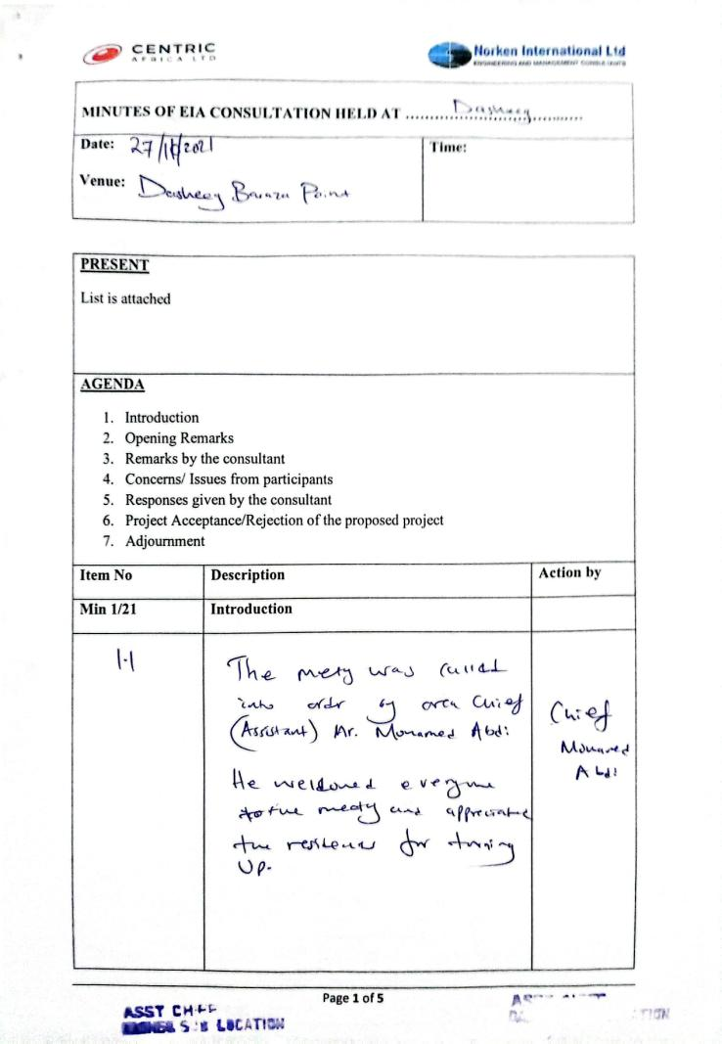
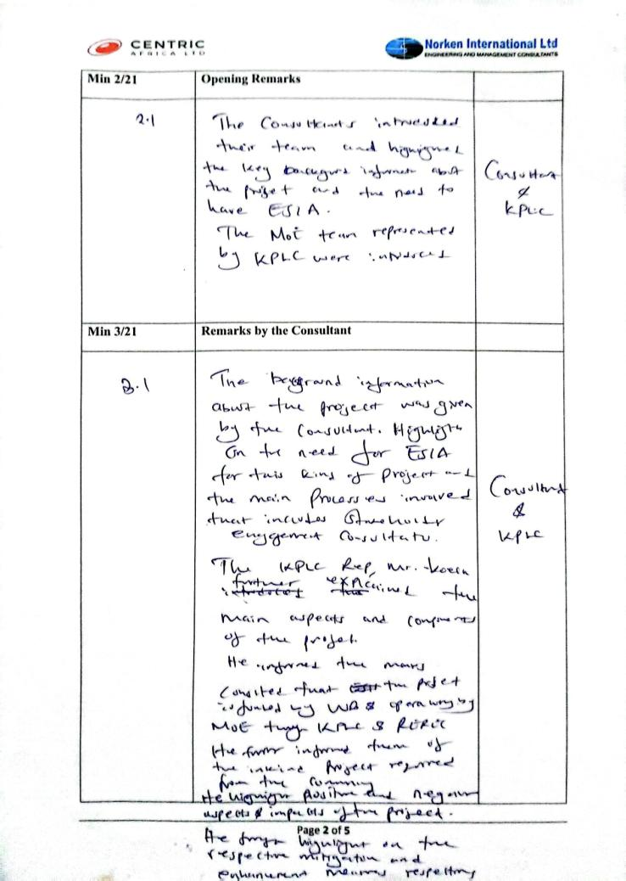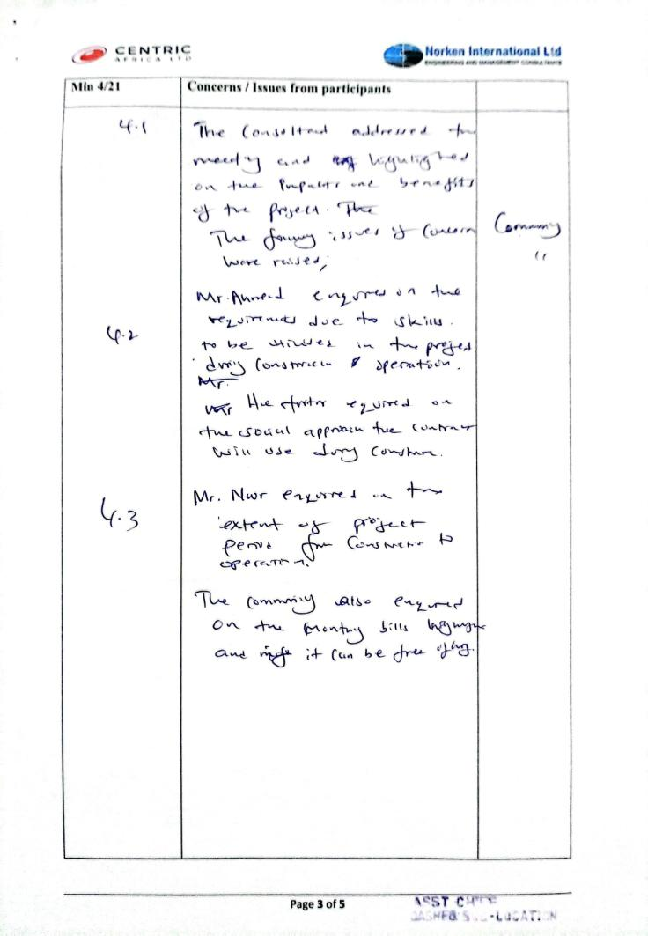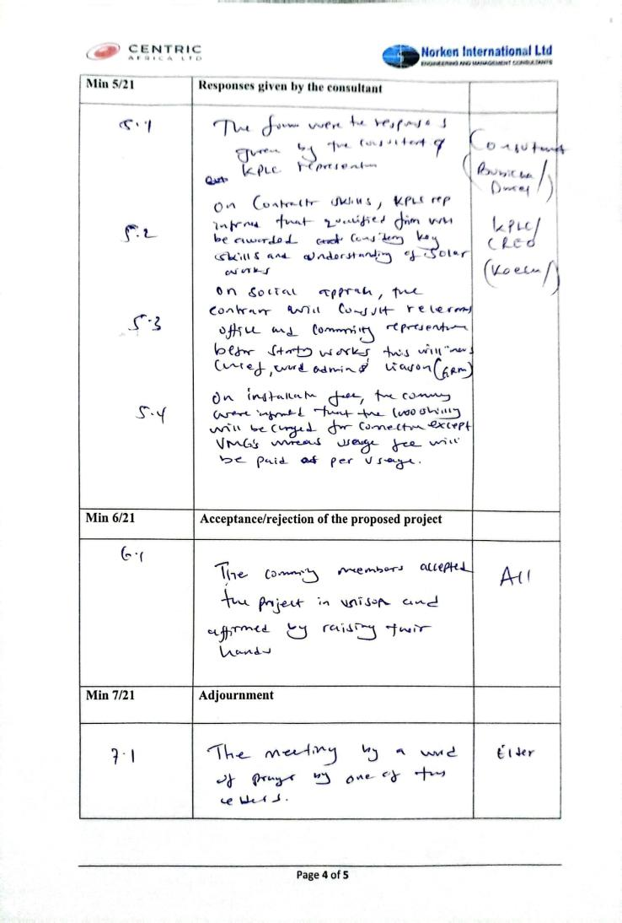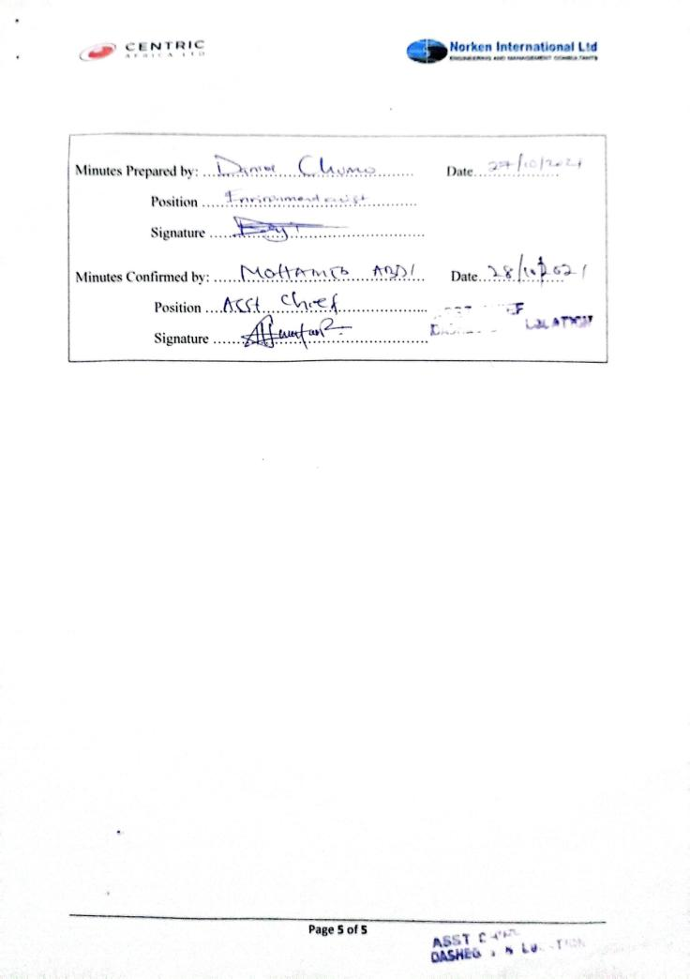

Appendix 2: List of Participants - ESIA
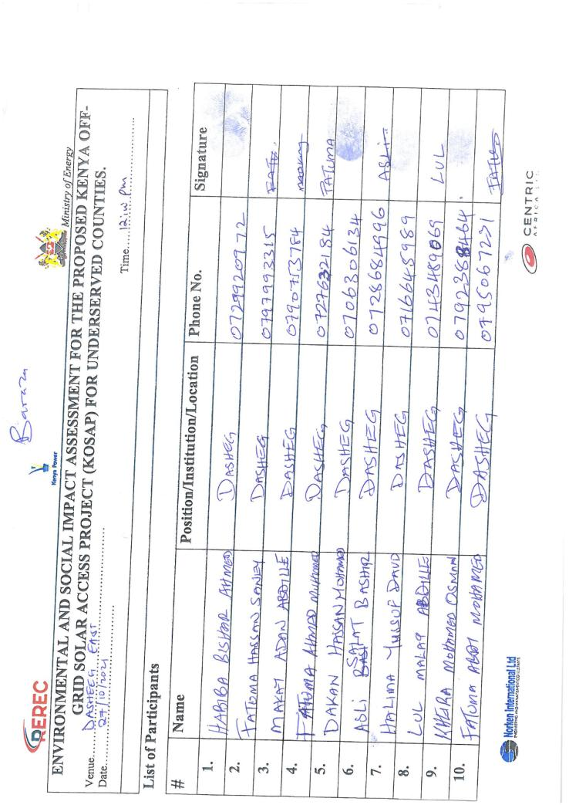
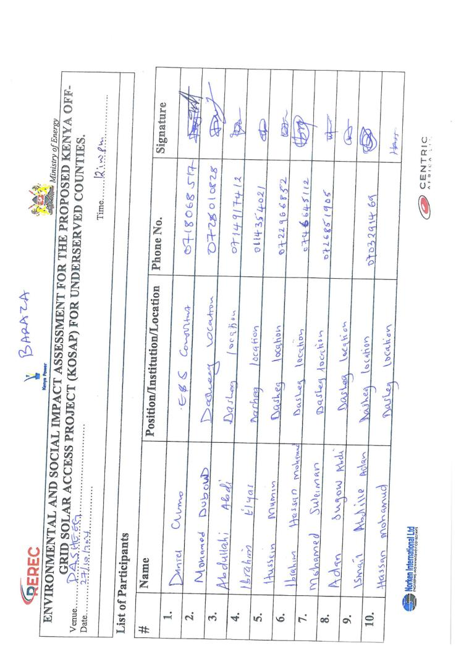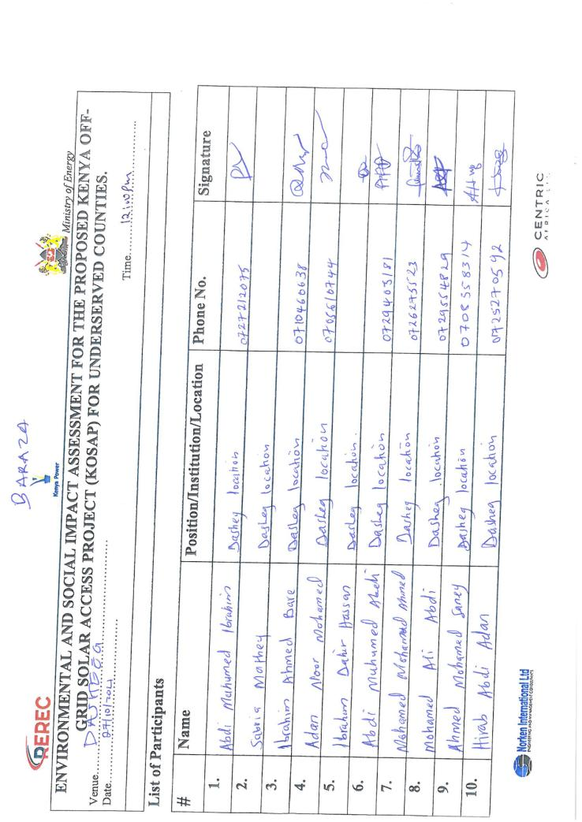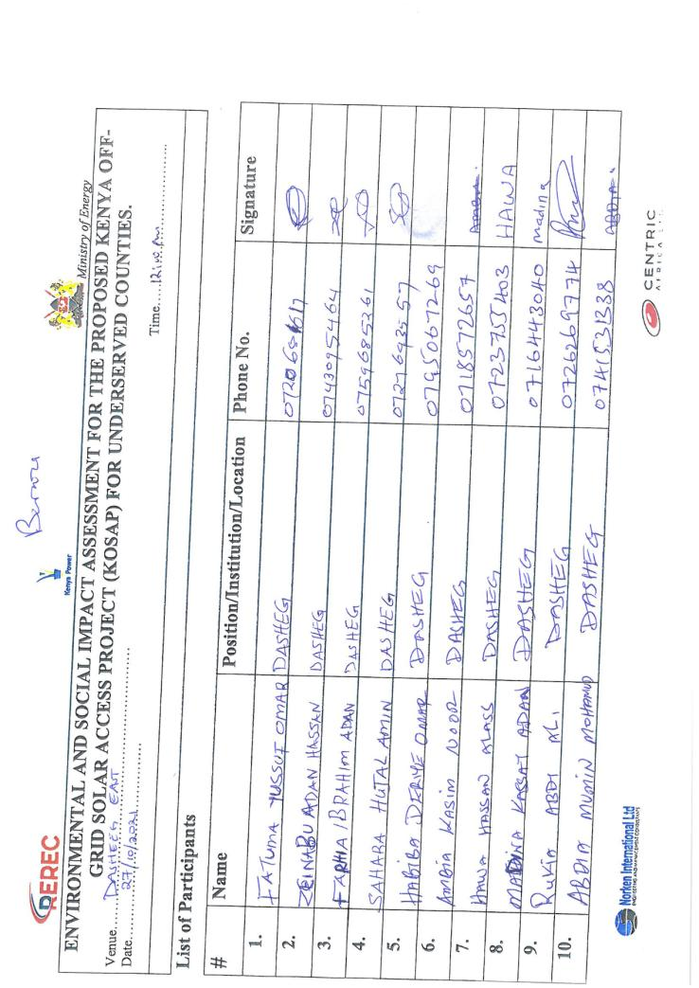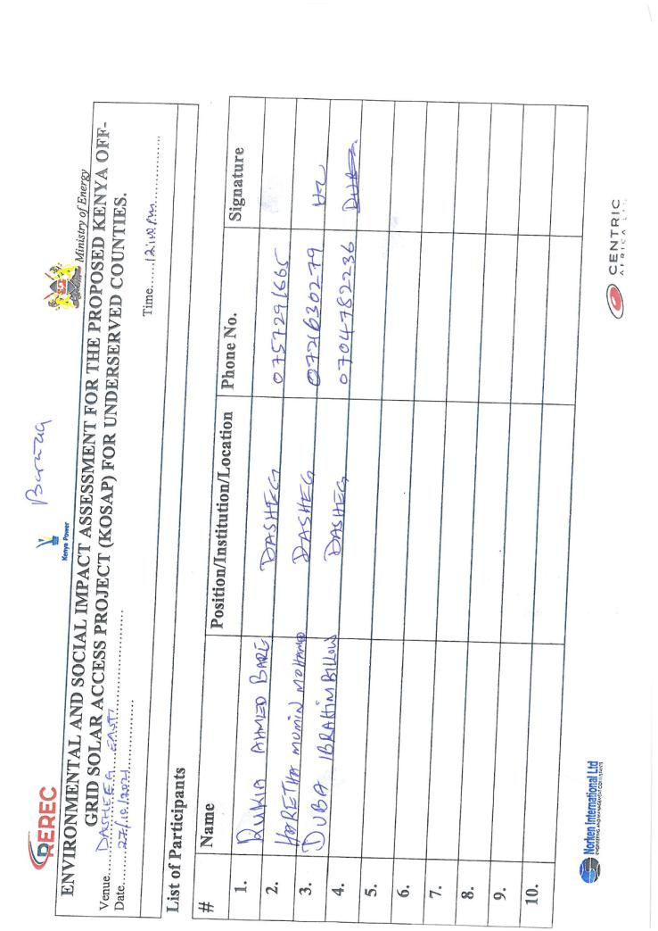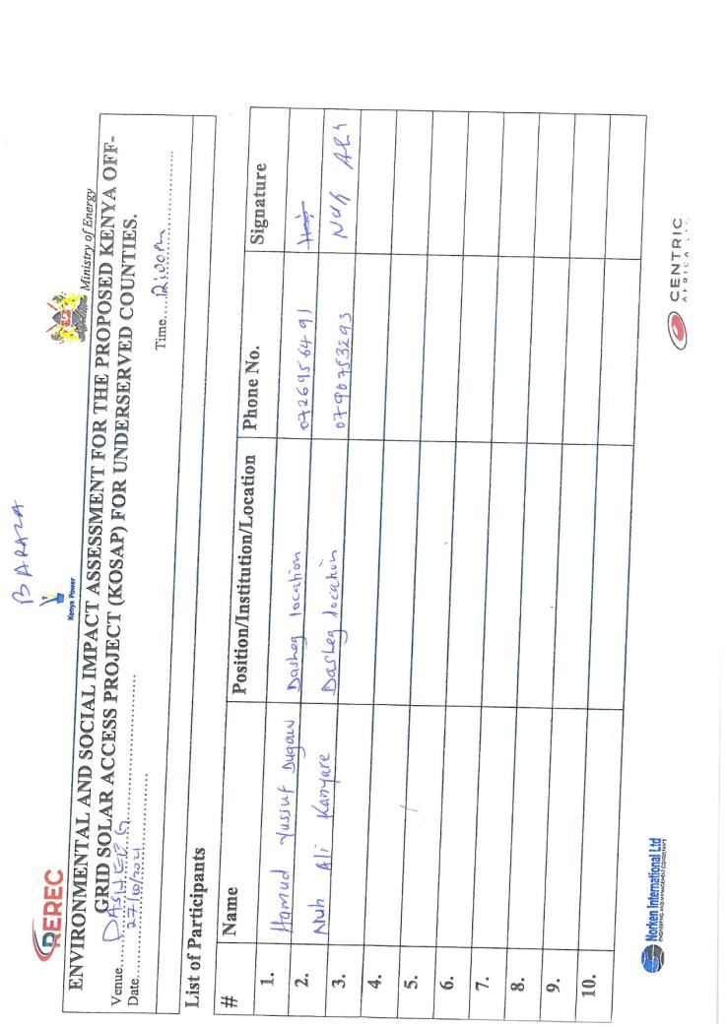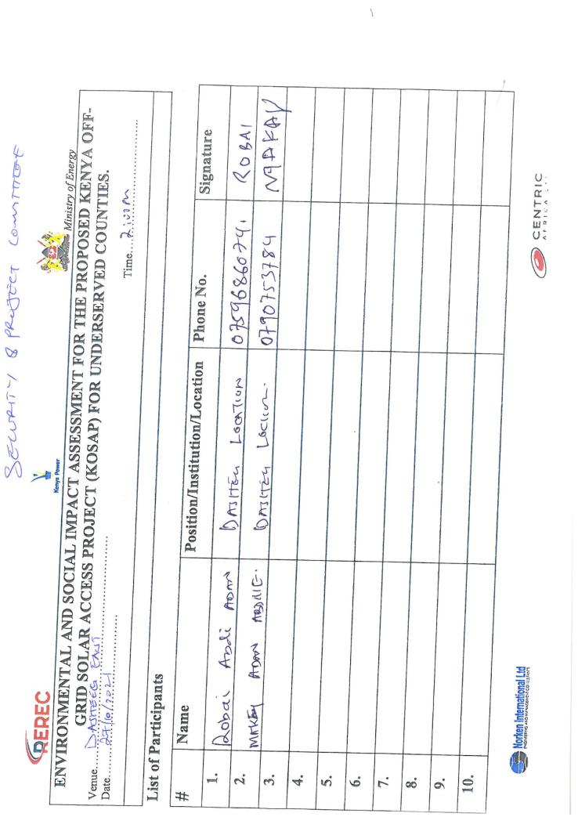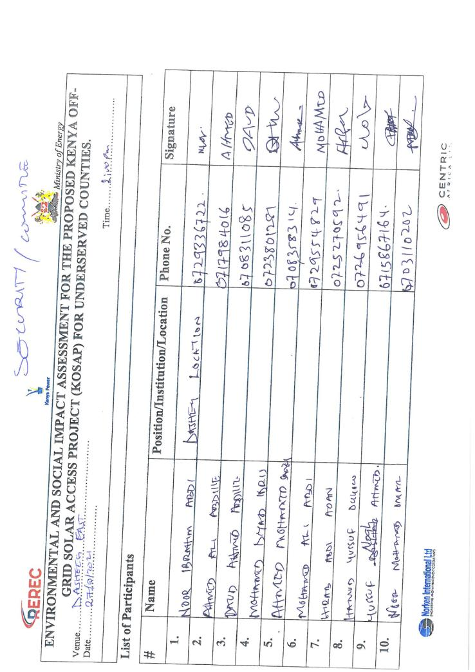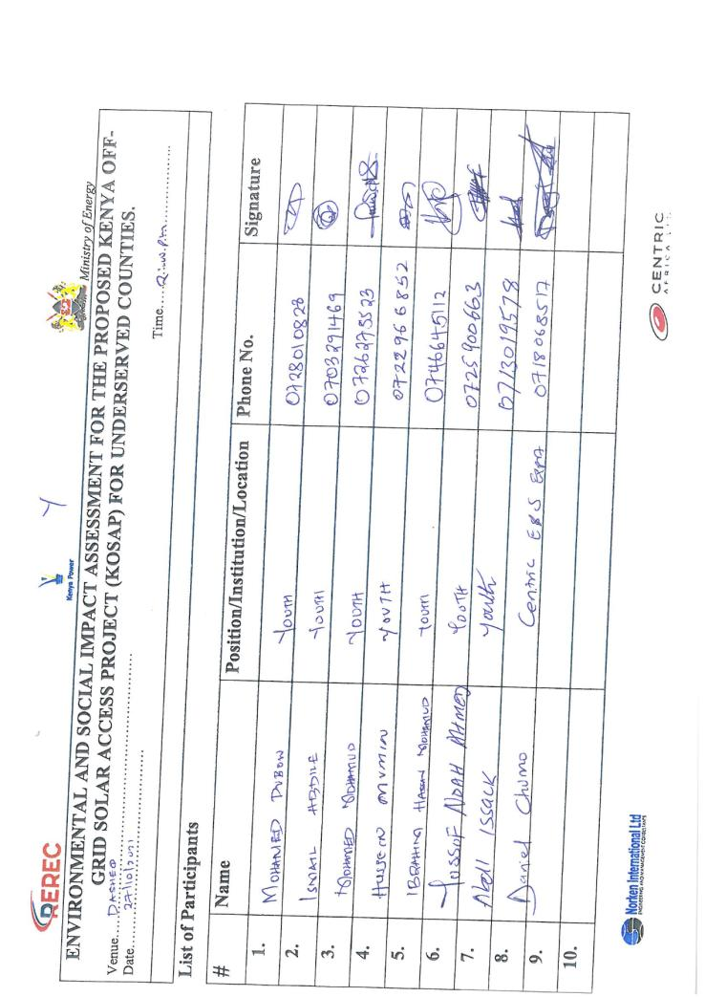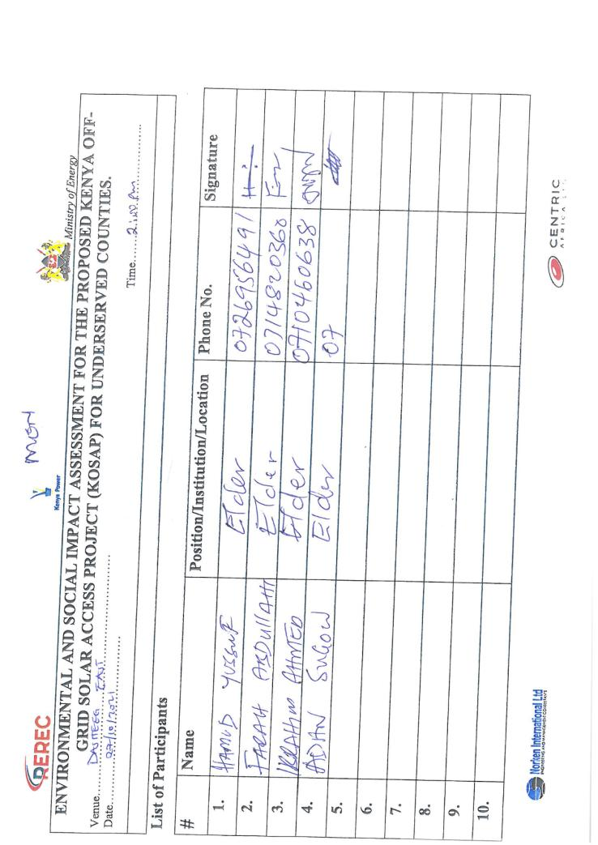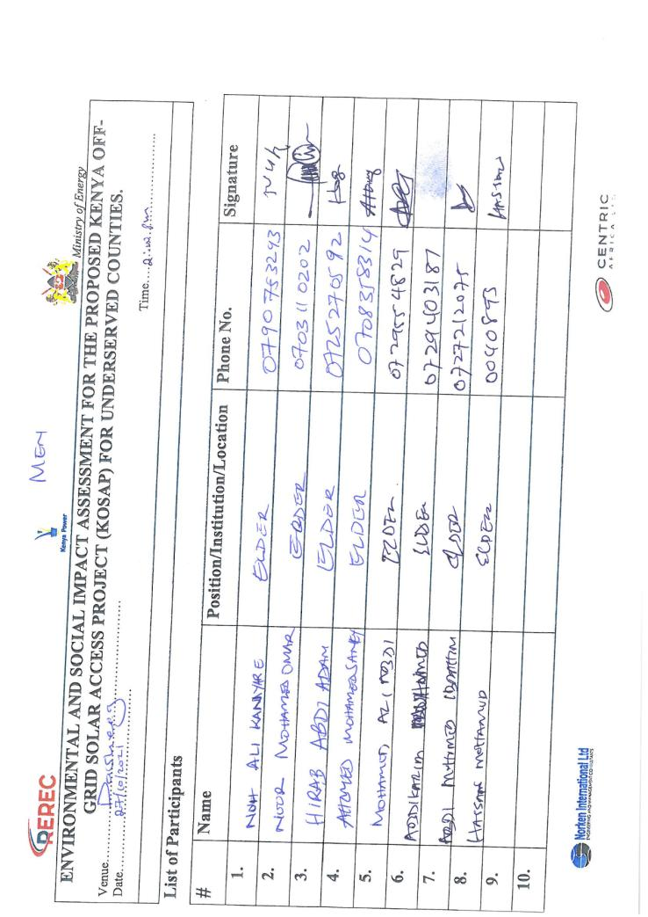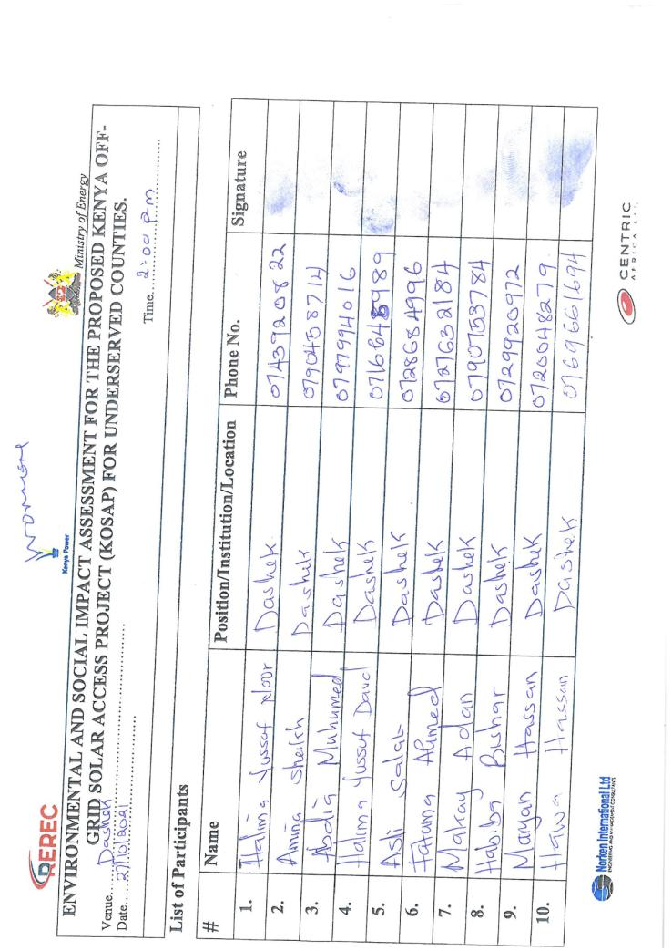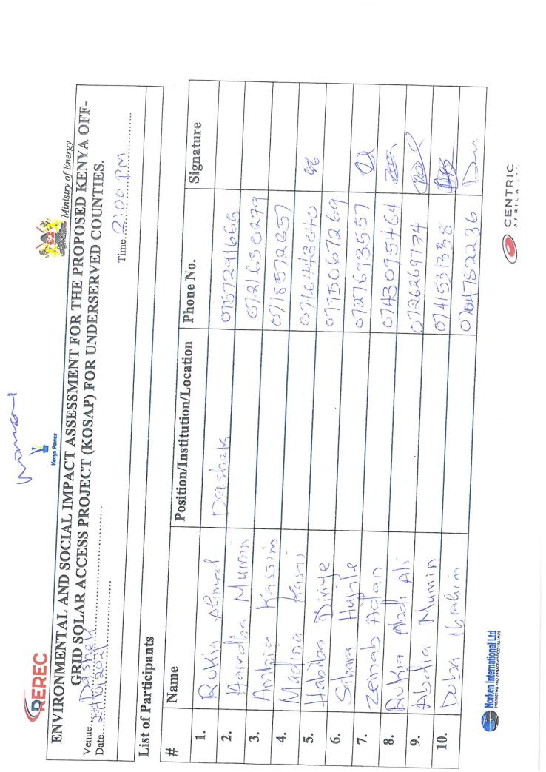

Appendix 3: Minutes for Community Consultation Meeting Leading to Land Identification and GRC Constitution-(screening level)
Minutes of community consultation meeting leading to land identification and Grievance Redress Committee constitution
Project: Proposed Dasheeg Solar Mini-grid
Venue of meeting; Dasheeg village (identified site) in Dasheeg sub location in Dasheeg location, Wajir Easr Sub County of Wajir County
Date: 31/5/2021
AGENDAS
- Preliminaries
- Project description
- Technical aspects of the project
- Positive Impacts of the project –Solar Mini-grid
- Negative Impacts of the project and mitigations measures
- Need for land for the project
- Environmental and social screening of the site
- Grievance Redress Mechanism for the project
- Plenary session
- Focus Group discussions

Minute 1/KOSAP/2021: Preliminaries
The Chief of Dasheeg called meeting to order at 10.37a.m. The meeting began with a word of prayer. The chief spoke in Kiswahili and one elder translated by speaking in the local dialect to ensure all people understood the information. The chief welcomed all in attendance to the meeting. He asked the community members to participate in the stakeholder engagement exercise by as it helps in information the planning process.
The Chief welcomed the Director Environment from Wajir County to welcome the project team. The Director spoke in the local language as the Chief translated to Kiswahili for the sake of the project officers. He welcomed and thanked all for attending the meeting. He said that the County Government of Wajir is in support of the KOSAP project.

He invited Koech (KPLC) to introduce the other officers’ in the project team and proceed with the community engagements. Koech introduced the project team as shown in the table below.

KOSAP Project Team
S/No | Names | Position
1 | Director Environment | County Government of Wajir
2 | Wilfred Koech | Environmental and Social specialist-KPLC
3 | Fahma Yusuf | County Renewable Energy Officer-Wajir County
4 | Joselyne Masiga | REREC –Social expert
5 | Rachel Kisiangani | KPLC –Land/Physical Planner
6 | John Kuria | KPLC –Surveyor
7 | Bashir | Wajir County -Surveyor
8 | Kennedy Gachau | Engineer-KPLC
9 | Roseline Njeru | Socio Economist-KPLC

Minute 2/KOSAP/2021: Project Description
Koech explained that the national government is implementing KOSAP in partnership with County Government in 14 Counties in areas that are far away from the national grid. He said the proposed project is called KOSAP-(Kenya Off-grid Solar Access Project) is being implemented jointly by the Ministry of Energy, the Kenya Power and Lighting Company (KPLC) and the Rural Electrification and Renewable Energy Corporation (REREC) in partnership with the World Bank as a development partner, County Government as a partner and the communities in Off-grid areas being the beneficiaries. Off-grid areas are those places where the national electricity grid has not reached, and whose electricity access has been very low. The reason for choosing solar energy was because the area is far away from the national grid and the fact that the area is well endowed with natural sunlight with high temperatures.
He further expounded that the proposed Solar Mini-grid being implemented under KOSAP is part of the government’s effort towards universal access to power. He said the proposed Dasheeg solar Mini-grid is one of the thirty Solar Mini-grids to be funded through KOSAP in Wajir County. He told the community that the project was in the preliminary implementation stages which requires public participation of various stakeholders.

He further noted that the agenda of the visit was to undertake
- Undertake an environmental and social screening of the proposed sites to check suitability in terms of environmental, technical, social and health requirements.
- Undertake community engagement to sensitize the community on the project.
- Explain the land requirements for the project and sensitize the community on their rights in regard to land so that they can make an informed decision.
- Explain the need to set up Grievance Redress Mechanism for the project.
- Guide the community in electing Grievance Redress Mechanism committee members and sensitize the members of their work during project implementation
He invited (Engineer- Kennedy) to explain to the community the technical aspects of the solar Mini-grid project.

Minute 3/KOSAP/2021: Technical aspects of the project
Kennedy (KPLC) explained the technical aspects of the Mini grids which will entail; the installation of solar PV panels, usable battery, and thermal diesel backup unit (generator) to support solar and street lights. He explained to them that once constructed the Solar mini-grid will be operated by the implementing agency KPLC and the beneficiaries/those interested will be expected to pay for connection of electricity (one thousand shillings) and do wiring in their houses. He told them that connection of power will involve passing of electrical lines along the roads in order to reach their houses, business premises and public facilities and the route for passing the lines is called way leave. He noted that once the designs are done, the community will be notified of the exact routes during future consultations and that they will be required to give way leave consent (allowing the service lines to pass through their land in the extreme cases). He noted that the project will not compensate for way leaves due to budget constraints so that they can make an informed decision. He added that distribution or supply lines will be cover a radius of 1km from the mini-grid.

He told them that once connected, the beneficiaries will be expected to pay for electricity consumed and that the tariff employed will be the same as what other Kenya Power customers paying.

Minute 4/KOSAP/2021: Positive Impacts/Benefits of the Project
Koech explained that, every project has both positive impacts and negative impacts. Our assignment is to explain to you the impacts of the project so that you understand how the project will benefit you and the community at large and also explain to you the negative impacts of the project and the mitigation measures. The project benefit both direct and indirect are as follows:
- Better source of lighting- replacement of Kerosene lamp and small de-lite lamps with electricity lighting which is clean and has better lighting
- Benefits to education- provide source of lighting which enables pupils and students to take advantage of longer hours of preps/study in school and at homes. Electricity will be useful in availing power needed to enable use of radio and television sets. Once parents are able to buy these gadgets pupils can access electronic educational information
- Business opportunities-Power provides energy needed to power some gadgets that are difficult and expensive to power with generators. Access to electricity will therefore allow the community to take advantage of new business opportunities and enhance the existing ones e.g. Barber shops, salons, posho/maize mills, welding, photo copying, printing, fuel stations, milk coolers and fridges to preserve meat, milk among others. He asked the community to take advantage and set up some of these businesses
- Employment and wealth creation- community members will get opportunities to provide non-skilled and skilled labor during construction and operation phases of the project
- Local Material Supplies and other requirements- the proposed project provides opportunities to supply some materials available locally
- Up Scaling Electricity Access to the off-grid areas- this area is far away from the grid and so the proposed project helps to reach this area faster and in a cost effective manner as opposed to grid connections.
- Impact on HIV/AIDS-due to availability of power, communities can purchase communication equipment like radios and televisions which in turn provides access to information on various issues such as health topics on HIV/AIDs, nutrition and the current Covid-19 pandemic among other information
- Health benefits of the project- health benefits of the project are linked to replacement/elimination of use of kerosene lamps and candles, no need to use fuel generators which emits smoke causing respiratory diseases, the dispensary will also benefit from power that can be used to preserve drugs and vaccines alongside powering other medical equipment.
- Improved standard of living- Living standards of the community is bound to improve as they take advantage of small house hold appliances like e.g. TV, Fridges, radios, blenders, iron boxes e.t.c.
- Security- Enhanced security due to improvement in lighting up of the area through the street lights. Improved security also means more hours of business. The place will also be safe as lighting puts off opportunistic criminals who take advantage of darkness.
- Communications- improved communication due to availability of electricity to charge phones, opportunities to set up information communication and technology related business-like cyber cafes, access to E-government services among others.
- Presence of electricity will also attract other business investors to invest in the area

Minute 5/KOSAP/2021: Negative impacts of the project
Having discussed the benefits of the project, Koech explained that projects also have negative impacts. He noted that the most important thing is to be able to mitigate the negative impacts so that they do not affect the community adversely. He said ‘’the proposed solar Mini-grid will have the following negative impacts and he would present them alongside their mitigation measures.

 | Negative impact | Mitigation measures by contractor
1 | Vegetation clearance | - Clear only the areas that are needed to put up the mini-grid according to designs  - After construction, do landscaping with grass to areas that have no electrical installation as opposed to living areas bare  - Planting of trees
2 | Air pollution dust from construction activities | - Fence off construction site to suppress dust  - Use of masks for workers
3 | Air pollution dust from construction vehicles | - Limit vehicle speed to minimum possible when passing residential areas and the centre
4 | Air pollution from vehicle emissions | - Maintain and service vehicles  - No idling of vehicle’s engines
5 | Solid waste | - Clear all solid waste and dispose appropriately
6 | Land.  As you had been briefed before, the site identified should; -must not result in displacement of community members  - We must avoid land that is currently settled or which has squatters. | - The community has a right to allocate or not to allocate land for the project because there is no compensation for the land (the duty of acquiring land for the project rest with the implementing agency and the proponent (Ministry of Energy). The MOE is asking for partnership with the community –requesting community to identify land for setting up the mini-grid.
7 | Occupation safety and health hazards e.g. accidents, fall from heights, pricks by sharp objects | - Use of proper personal protective equipment like gloves, overalls, helmet, safety shoes  - Allocating work according to skills  - Toolbox talks to workers to identify hazards and risky activities and putting mitigation measures  - Close supervision of work
8 | Labor influx. The nature of the project will require technical skills that are not all available in this community. This will require movement of construction workers (labour influx) into this community. There are some risks that are involved with labor influx and we need to mitigate them as follows to avoid negative impacts on our community. | - We shall establishment and operationalize an effective Grievance Redress Mechanism accessible to community members where your grievances can be sorted  - Reduction of labor influx by tapping into the local workforce by the contractor
9 | Risk of social conflict due to competition for resources and opportunities | - Awareness-raising among local community and workers on the need to have a good /cordial working relation  - Consultations with and involvement of local communities in project planning  - Provision of cultural sensitization awareness for workers regarding engagement with local community.  - Recruitment of local workforce to the extent possible especially unskilled and semi-skilled jobs  - Contactor shall make provision to provide resources needed by the workers if the need for such resources may result to competition for resources e.g. water  - Working closely between contractor and the project grievance redress committee to address complains on time.
10 | Increased or illicit behavior and  crime (including prostitution, theft and substance abuse) | - Sensitization campaigns both for workers and local communities against such social evils  - Enforcement of sanctions (e.g., dismissal) for workers involved in criminal activities
11 | Communicable diseases (including STDs and HIV/AIDS) | - Education/awareness about transmission of diseases  - Awareness creation on STDs among the workers and local community on ethics, morals, general good behavior and the need for the project to co-exist with the neighbours during the community and worker engagement forums.  - Provide condoms to employees
12 | Gender-based violence including sexual exploitation and abuse of the community members by workers and sexual harassment among workers | - Information and awareness raising campaigns to you community members and specifically women and girls.  - Mandatory awareness creation for workers by contractor on required lawful conduct in the community and legal consequences for failure to comply with laws  - Report complaints on gender-based violence or harassment through the GRM or elders ensuring a survivor centered approach  - Working closely with chiefs and local law enforcement to act on community complaints on time  - Inclusion of GBV specific mitigation measures in the environmental and social management plan of contractor  - Requirement of contractor to have code of conduct for the workers and to implement them
13 | Child labour | - Ensuring that children and minors are not employed directly or indirectly on the project.  - Enforcement of Employment Act that requires contractor to adhere to minimum age  - Allowing your children to be employed is illegal and punishable by law because it interferes with the children’s right to education  - Report any case to the chief’s office
14 | Demand for Material/resources e.g water, sand, ballast | Contractor to consult with elders before using scarce resources in the community like the water to avoid conflicts.
15 | Oil Spill Hazards | - Contractor not to repair vehicles or equipment on site  - Maintain vehicles and equipment in good state
16 | Storm water and erosion | - Contractor to put measures to harvest rainwater and control erosion during construction
17 | Wastewater/ effluent | Contractor will provide sanitation facilities for workers
18 | Noise resulting from excavation machinery, vehicles and workers | - Contractor to work only during the day  - In case of blasting contractor to give notice to community through the village elders, grievance committee and chiefs office
19 | Visual and Aesthetic Landscape Impacts | - The visual negative impacts can be mitigated through putting up a wall round the facility to keep off/screen the project stacks, poles, panels by the contractor.  - Proper siting decisions can help to avoid aesthetic impacts to the landscape.
20 | Hazardous materials from damaged Panels- Photovoltaic panels may contain hazardous materials, and although they are sealed under normal operating conditions, there is the potential for environmental contamination if they were damaged or improperly disposed upon decommissioning. | - Proper planning and good maintenance practices can be used to minimize impacts from hazardous materials.  - Proper disposal of used or damaged solar batteries and panels using NEMA registered disposers for such wastes
21 | Fuel storage on site | - Contractor will undertake proper installation of the fuel storage tanks for the back-up generator.  - Have a budded wall 1.5 times the fuel stored to allow controlled collection in case of a spill.  - During operation implementing agency will ensure proper maintenance of the solar panels
22 | Public safety –potential risk of shocks and electrocution | As explained below in details

Public safety in regards to electricity
Koech educated the community by highlighting the importance of using electricity safely. He said electricity is good but failure to take safety precautions while interacting with power infrastructure can result in electric shocks, fires and even electrocution/death. He emphasized the following precaution/preventive measures to observe in order to prevent risk of electric shocks, fires and electrocutions.
- Engage a certified technician to do wiring in your premises
- Use quality materials while wiring
- Do not engage in individual illegal extensions of power lines to other houses
- Don’t touch sockets and switches with wet hands or wipe with wet cloths
- Do not tie your livestock on electric poles
- Do not cut earth wires that run along some electric poles
- Do not touch or go near any electric wire if you find it fallen on the ground
- Report any incident regarding electricity at the local office –staff in charge of operating the Mini-grid
- Vet all new people coming to the village by checking whether they registered their presence with the office of the chief especially those purporting to be technicians
- In case of a black out/no power supply do not open sockets or switches

Minute 6/KOSAP/2021: Land requirements for the project
Koech told the community that one of the agendas of the project team’s visit was to check the land/site that the community had or would identify for the project. The project team together with the community would undertake an environmental and social screening to determine whether it is appropriate for the proposed solar project. He then invited Rachel (KPLC) to talk to the community on the issues to consider while identifying the land for the project. Rachel explained to the public forum that the proposed project will require about 2-3 acres of land.

She asked them the nature of ownership of the land in the area and they answered that the ownership is communal where by the community owns the land but no individual title deeds. They also noted that the land is not formally sub divided (implying not surveyed or adjudicated). She explained to them that based on the ownership of land they had explained, their land falls under the category of community land and its use and management is governed by the Community Land Act 2016. The community was told that land under this Act is owned by the community but is held in trust for them by the County Government of Wajir because the community is not registered. She noted that the government of Kenya had secured a loan from its development partners i.e. World Bank to implement the KOSAP project. She explained that the government was seeking partnership with the community in the KOSAP project where by the community would identify land for setting up the mini-grid while the government would provide the money for setting up the mini-grid. She added that the government was not in a position to pay compensation for the land due to budgetary constraints.

She asked them about the ownership of the portion they had identified for the project. The community noted that the land they have identified is part of land which the community set aside for community project services sometimes ago.

Rachel educated the community on the following issues;
- The various forms of acquiring interest in land such as; allocation by the owner, land adjudication process, compulsory acquisition, settlement programs, transfers, donation and long-term leases.
- That in the Community Land Act, the County government of Wajir only holds the land in trust for them and that they are the owners of the land
- Importance of public participation by key stakeholders including community members during the planning and operation phase of the project.
- That they have a right to give their views, opinions or fears on the proposed project
- You have a right to accept or refuse the project
- The ownership of the land will be transferred to KPLC and that the project will be managed by KPLC
- The community/beneficiaries of the project will pay Ksh 1000 for power connection and also pay for consumption of power to KPLC
Survey of the land and request for advance possession.
Rachel noted that the process of land allocation, land surveying and land acquisitions/transfers are long and requested the community for advance possession of the land. This meant that the community would allow construction works to take place as the process of land allocation is progressed. The community agreed to the advance possession. The surveyor (Kuria-KPLC) explained to the community members that the surveyor will need to pick exact GPS points of the agreed area so that the process of land allocation may be progressed.

Rachel explained to the community that the rationale and importance of sharing all that information was to facilitate the community in making informed decisions about the project. Further, she made it clear to the community that they had the power of choice on the project

Minute 7/KOSAP/2021: Plenary session
Koech then invited the community members to a plenary session for the community members to ask questions or seek clarifications on the information shared. The project officers were to write done the question and answer accordingly. The questions raised are presented in the table below.
 | Name | Questions/suggestions | Response | Response by agency on how feedback will be used or acted upon
1. | Hirab | Clarify on the area of supply | The supply from the solar mini-grid will be about 1.1km radius for quality power | -
2. | Mohammed Ali  ,, | Is the Ksh 1000 you have mentioned able to cover everything for us to get power? | Ksh 1000 is for connection fees i.e for meter, the beneficiaries will need to do wiring in their houses. | -
3 | Mohammed Ali  ,, | When will the project begin? | Construction will begin once all the approvals are acquired | -

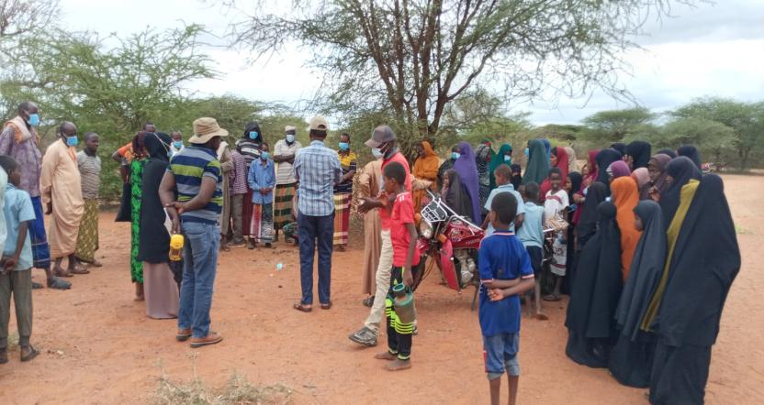
Photo of the community Meeting at Dasheeg

Minute 8/KOSAP/2021: Grievance Redress Mechanism
Koech explained that in a project, grievances may arise and it important to have a grievance redress mechanism that is known to all the community members and accessible with no costs to the community members. Before explaining how to set the GRM, he asked the community to explain how they deal with grievances/issues

Existing grievance redress mechanism in the village.
One of the elders reported that the elders in the community provide leadership and oversight to the community. These elders are resolve the conflicts or grievances or any issue in the village/centre. Any of the grievances that is difficult to resolve is referred to the office of the Chief

KOSAP Project GRM:
Koech explained to the community that it is important to put in place a project grievance redress mechanism (GRM). He noted that the GRM to be set should borrow heavily from the existing conflict resolution structures in the community. He added that the need for a GRM is to provide the community and other stakeholder’s opportunity to share project information and raise questions and grievances about the project. He told the community that they are free to raise any complain or request information about the project. He further explained that the project will have a three-tier grievance redress mechanism as follows.
- Locational grievance redress committee. This is the lowest level (forum) where the community will get project information and also ask questions. At this level you the community will choose project committee members who will also double as grievance redress committee. The membership will comprises; elders/men representatives, representatives from women, youth, special needs (persons with disability), and the office of the chief as Ex-officials. This will be the first stop for receiving information and raising grievances. The members to be chosen should possess leadership skills and it is hoped that most of the grievances will be resolved at this level.
- The second level of grievance redress will be the County Grievance Redress Committee comprising members of the County working group. This committee is at the county level and will resolve complains or issues that are unable to be resolved at the locational/project level. The chairman of the project grievance redress committee at the community will forward issues/ complains to the county grievance redress committee through CREO who will also be responsible for giving feed back to the local committee.
- The third level will be the National GRC comprising of KOSAP Project Implementation Unit at the Ministry of Energy and the implementing agencies. Matters that not resolved at the County level will be escalated to this National GRC by the CEC-Energy
- The last level of the GRM for the community or project affected persons will be arbitration or legal redress in a court of law once all the three levels have been exhausted.

He explained further that members of the project/ grievance redress committee will be chosen by the community members themselves. The committee chosen will be in charge of giving project information to the community and be a focal point for reporting project related issues of concern or grievances. He added that the composition of the committee should have representatives from all groups in the community including men, women, youth and persons with disability. The table below indicates the members of the GRC chosen by the community members
S/No | Name | Representative of | Contacts | ID No
1 | Mohammed Kutab Abdi | Men |  | 9572691
2 | Mohammed Ali Abdi | Men |  | 21093698
3 | Ahmed Mohammed Sanoy | Men |  | 10117125
4 | Hamud Yussuf Duyow | Men |  | 8495140
5 | Hirab Abdi Adan | Men |  | 20143226
6 | Mohammed Abdi Hussein | Ass. Chief |  | 11573370
7 | Robai Abdi | Women | 0759686074
8 | Makary Adan Abdulla | Women |  | 21198790
9 | Noor Mohammed | Special groups |  | 24908797
10 | Yussuf Noah | Youth |  | 26004333

Minute 9/KOSAP/2021: Focus Group Discussions
The community members were told of the need to have focus group discussions to discuss the project further and allow the people more opportunities to ask questions or give suggestions regarding the project. Therefore three separate meetings for men, women and youth were held. In these meetings the message on the project was echoed again especially on benefits and impacts (both positive and Negative) of the project to the community, rights of the community in regard to land and the need to have a grievance redress committee with representation from all groups in the community. Each group was told to elect their representatives to the GRC.

a) Focus Group Discussion with the women
Roseline (KPLC) explained to the women that it was important to hold a separate discussion with them so that they have opportunity to freely express themselves. One focus group discussion was held with the women. She explained the agenda of the visit by the officers from national government and county government i.e. was to undertake an environmental and social screening of the identified site to check suitability in terms of environmental, technical, social and health requirements. The second objective was to undertake community engagement to sensitize the community on the project. The third objective was to explain the land requirements for the project and the need for a project grievance redress mechanism. Roseline then gave a summary of the project in terms of its positive and negative impacts and their mitigation measures and the requirements for identifying land for the project. She also explained the need for the women to select a representative to the project committee who would represent their views/issues to the committee for redress.

The discussion went further to bring out issues on how the women can take advantage of the project benefits rather than taking a back seat. She then explained to them that women would benefit more from the electricity because there are the ones who are more exposed to unclean energy as they are the ones who take more time in the kitchen. They would also benefit from access to information through use of radios and TV that are powered by electricity enabling them to make informed choices on different issues such as nutrition, health among others. They were also set to benefit if they could set up small businesses like salons, cold drink kiosks, children will have time to study and enhanced security due to the fact that the area will be well lit among other benefits.
Gender based violence issues were also discussed and emphasized because women and girls are more affected by gender-based violence due to the subordinate status of women in many societies, discrimination against them and their higher vulnerabilities to violence. She noted Gender-based violence takes many forms, including sexual, physical, and psychological abuse. Other issues discussed were the importance of addressing GBV incidences and the need to report and document any complaints against workers, while ensuring survivor centred approach (respect for the choices, wishes, rights and dignity of the survivor). The women were told to be more vigilant to ensure young girls do not fall prey to GBV incidences (sexual exploitation and abuse). The women were requested to keep talking to the girls on GBV risks and the need to raise alarm in case of risks factors to ensure prompt redress.
Plenary Session
The women were allowed time to ask questions, give suggestions and or seek clarifications regarding the proposed project.
Question, Suggestions, feedback and response for Focus group discussion with women
Name of Person making the contribution (e.g. comment or question) | Question, Comment, Suggestion | Feedback/Responses by project team | Response by agency on how feedback will be used or acted upon
 | No question was asked by the women

Photo of the focus group discussion with the women
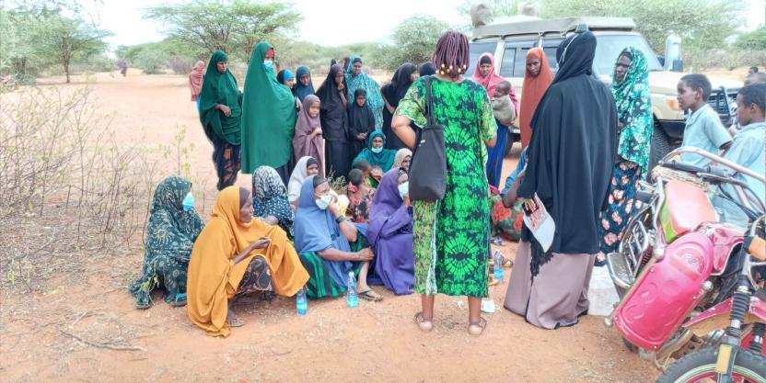

b) Focus group discussion with the youth
The youth were also invited to a separate discussion. Joseline (REREC) explained to the youth that they are also key to the decisions that are made in the community and so discussion with them was necessary so that they have opportunity to express themselves. He explained the agenda of the visit by the KOSAP team from national government and county government was to undertake an environmental and social screening of the proposed site to check suitability in terms of environmental, technical, social and health requirements. The need to undertake community engagement to sensitize the community on the project. The third objective was to explain the land requirements for the project, rights of the community members and the need for a project grievance redress mechanism and committee. She then gave a summary of the project in terms of its positive and negative impacts and their mitigation measures and their rights and requirements for identifying land. She told the youth to select a representative to the project committee who would represent their views/issues to the committee for redress. She explained to the youth that they would benefit from the project in terms of job opportunities, ability to set up shops or enhance their businesses due to power supply, entertainment, use of ICT while those in school could benefit from better lighting and ability to access e-learning opportunities through radios and T.V for reading among others.
Plenary Session
She asked the youth to feel free to air their opinions on the project. The youth said they support the project. The youth were then allowed to ask questions.
Name of Person making the contribution (e.g. comment or question) | Question, Comment, Suggestion | Feedback/Responses by project team | Response by agency on how feedback will be used or acted upon
 | No question was asked by the youth

Photo of the youth in focus group discussion
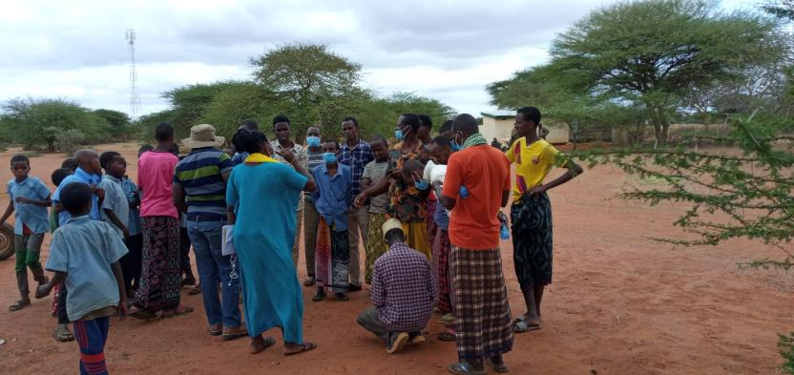

c) Elders/men discussions
Koech explained to the men that it was important to hold separate discussion so that the community get enough opportunities to be informed of the project and be free to ask questions. He told the men that public participation in projects is crucial as it helps build consensus and enables people to make informed choices regarding projects. He repeated the agenda of the visit by the officers was to; undertake an environmental and social screening of the proposed site to check suitability in terms of environmental, technical, social and health requirements. The second objective was to undertake community engagement to sensitize the community on the project. The third objective was to explain the land requirements for the project, rights of the community in regard to the project and the need for a project grievance redress mechanism. Wilfred (KPLC) then gave a summary of the project in terms of its positive and negative impacts and their mitigation measures and the requirements for identifying land for the project. He also explained the need for the men to select representatives to the project committee who would represent their views/issues to the committee for redress.
The elders said they welcome the project and that they had already agreed on the portion of land where the project would be implemented i.e. part of the land which had already been set aside by the community for public utilities and one of the utilities under construction was a dispensary. The discussion was then opened up for questions.

Plenary Session
Question, Suggestions, feedback and response for focus group discussion with Men
Name of Person making the contribution (e.g. comment or question) | Question, Comment, Suggestion | Feedback/Responses by project team | Response by agency on how feedback will be used or acted upon
 | No questions raised

Photo of the elders in the focus group discussion
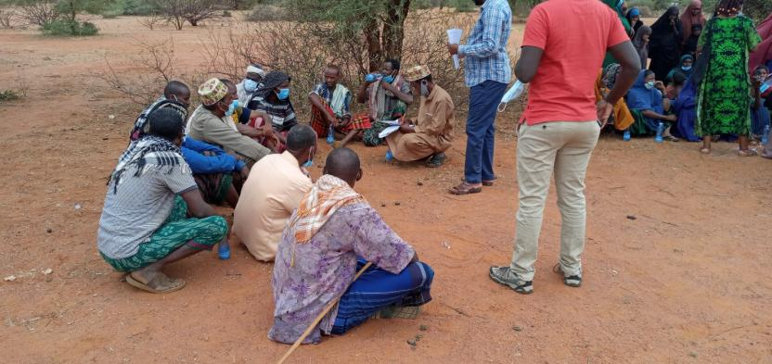

Minute 10 /KOSAP/2021: Environmental and social screening of the site
The project team and the community members visited the identified site. The objective was to screen the site to check whether it was technically, environmentally and socially suitable for the project. The site was found to be appropriate for the project.

CONCLUSION
- The community welcomed the project and is in support of the project.
- Land identified belong to the community and is communally owned, representatives of the community signed the land forms as a sign of commitment
- No residential houses and no economic activity or business premises were on site during the site visit
- There will be no physical or economic displacement because the land was already set aside for community social projects by the community
- In terms of consultations one public meeting was held with the residents of Dasheeg. In addition, focus group discussions were held separately with the men, the women and the youth to enhance the stakeholder engagements. The engagements were fruitful and the community identified land for the proposed Mini-grid.
- The need for a grievance redress mechanism (GRM) was explained to the community including the need and roles of a grievance redress committee (GRC). A GRC was chosen with representatives from the men, women, youth and special needs group.
- The need for advance possession of the land as the process of survey and registration progresses was explained to the community and the community agreed to the same.
- It was explained to the community that it will be their responsibility to pay for connection to power , wiring of their premises and to pay for power consumed
The community in Dasheeg agreed to set aside land for Minigrid construction. A Land Identification form was signed by the representative of the community, the county government and the Implementing Agencies summarizing the process of land identification and the agreements reached with the community.
The meeting ended at 11.47 a.m.

Recommendations
1. Environmental Social Impact Assessment to be progressed for the site

Appendix 4: List of Participants - Land Acquisition
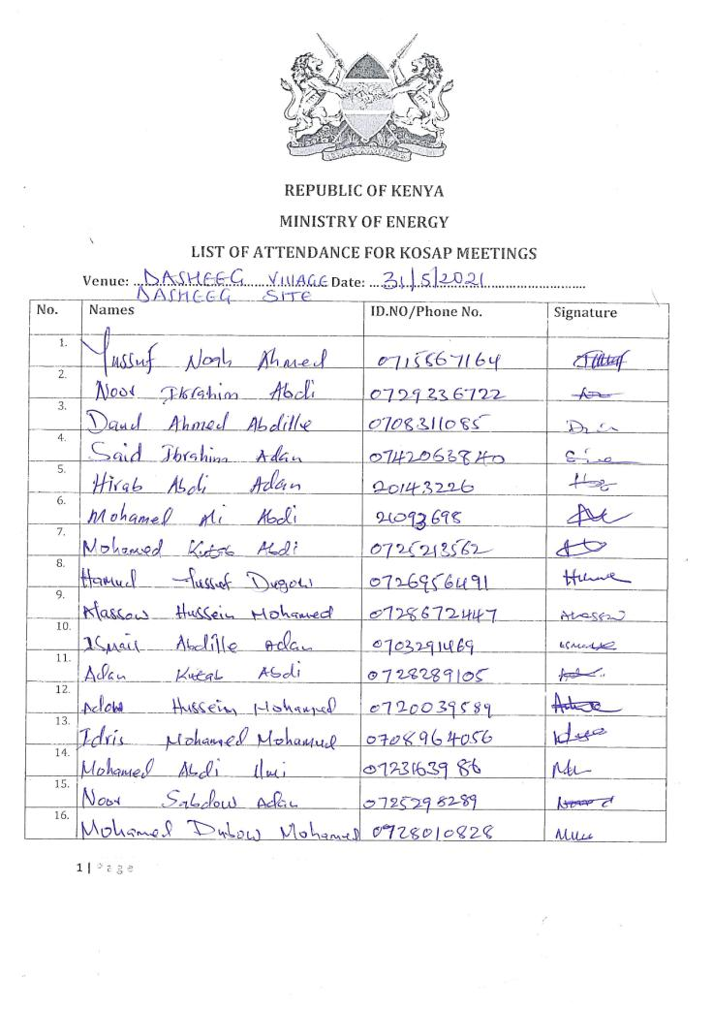
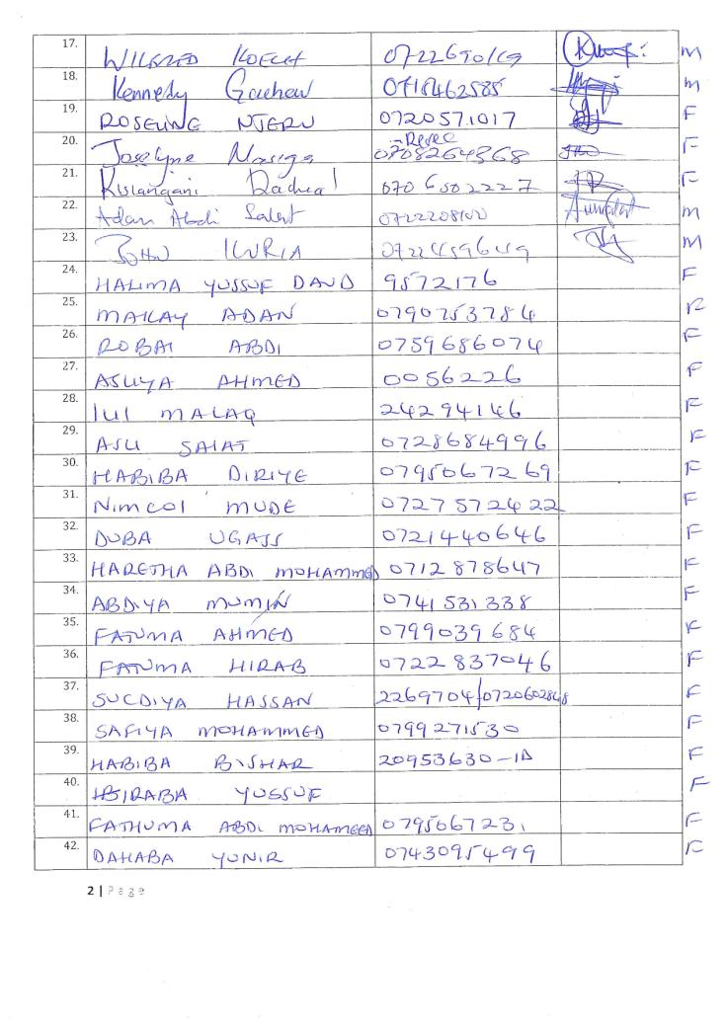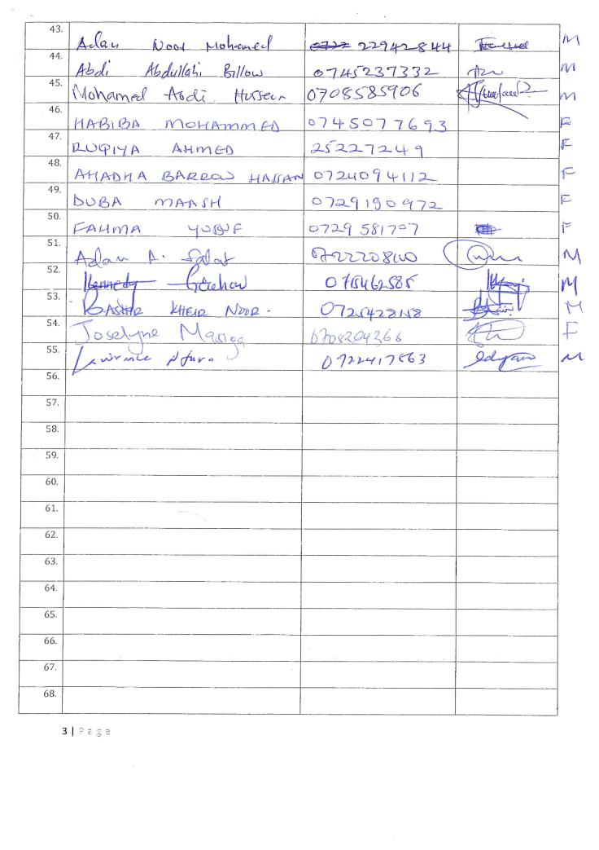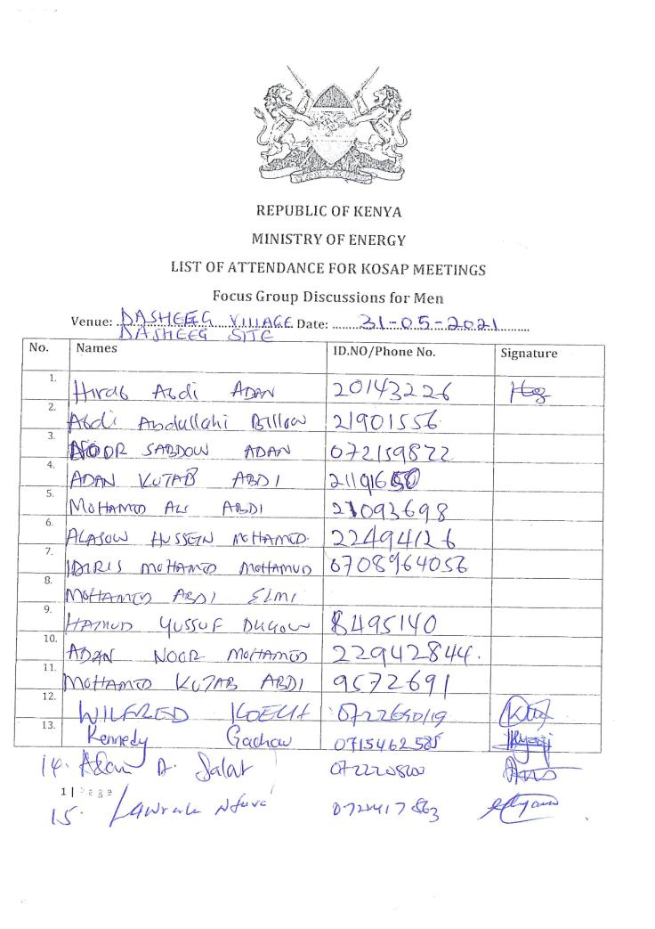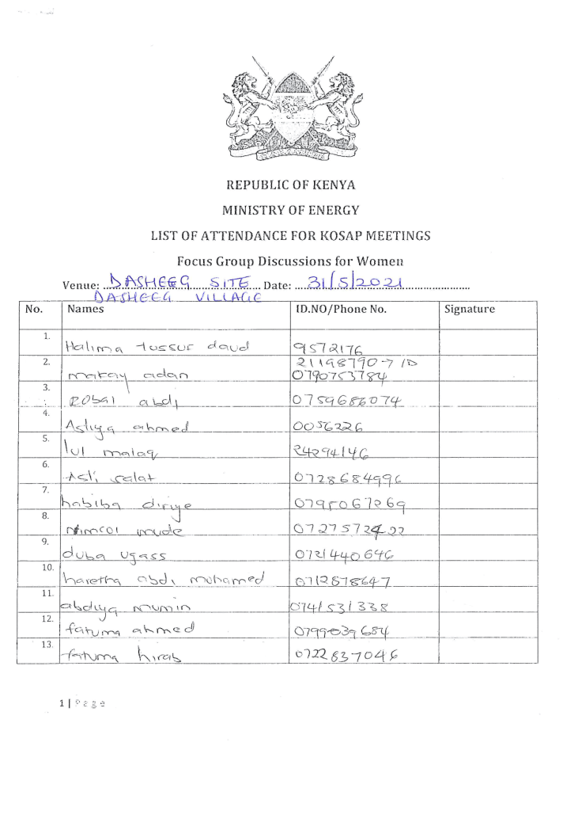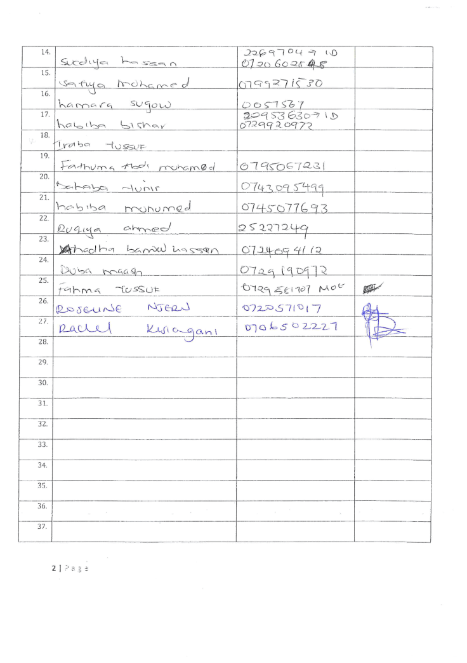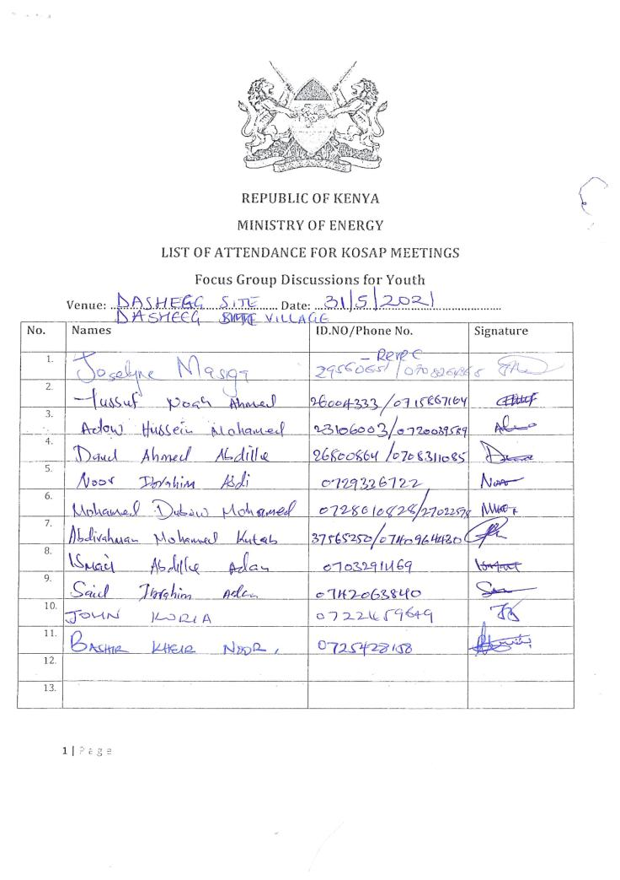

Appendix 5: Abbreviated Resettlement Action Plan (A-RAP)

- Dasheeg Sub-project Site
The Dasheeg sub-project site is on unregistered community land and held in trust by the County Government of Mandera on behalf of the community, in line with the Community Land Act 2016. The proposed site is uninhabited, has no structures, community facilities, or encumbrances, and is part of the land owned by the Dasheeg community for grazing. Consultations leading to the identification and selection of the sub-project site are captured in the Environmental and Social Screening report for Quimbiso. Refer to Chapter 4 of the ESIA for the comprehensive socio-economic profile.

- Actual Census Survey of PAPs and Valuation of Affected Assets
The number of project-affected persons (PAPs) is 4000 approximately 550 households). The land acquisition-related impacts are loss of land and pasture. Mitigation measures include in-kind compensation for loss of land and pasture, and designing power distribution lines to avoid impacting trees, crops, structures, and community facilities. No physical displacement is anticipated; however, there is minimal loss of pasture occasioned by the acquisition of land utilized by the community for grazing. The 1.11 Hectares identified for the sub-project will be acquired compulsorily by the National Land Commission (NLC). The proposed site will be valued and compensated in line with the provisions of the Resettlement Policy Framework (RPF) prepared under KOSAP. Refer to section 2.2 of the ESIA for the sketch map of the site.

- Compensation Measures Agreed with the PAPs and other Resettlement Assistance to be Provided
The proponent requested the community identify three priority projects, whereby one out of the three would be provided as in-kind compensation for loss of land and pasture. The Dasheeg community requested for fencing of Dasheeg waterpan/small dam and additionally install water distribution lines from the water pan to settlement areas. The value of the priority community project will be proportional to or higher than the value of land under acquisition. In addition, loss or damage to crops, trees, structures, and community facilities will be compensated in line with the provisions of the RPF, and as summarized in the entitlement matrix below.

3.1 Entitlement Matrix

Types of Impact | Person(s) Affected/Eligible for Compensation | Compensation/Entitlement/Benefits | Responsible organization
- Loss of Land
Loss of unregistered community land. | Community. | Compensation in-kind as prioritized by the community. | KPLC
Loss of land in unregistered group ranches. | Group ranch members. | Compensation in-kind as prioritized by the community. | KPLC
Loss of land in registered group ranches. | Group ranch members. | Compensation in-kind as prioritized by the community. | KPLC
Loss of land owned by the National Police, county governments and the Ministry of Interior | Government agencies. | No compensation for public land allocated to another government body. | KPLC
Loss of land owned by the Kenya Forest Service (KFS) and Kenya Wildlife Service (KWS). | Government agencies. | No compensation for public land allocated to another government body. However, payment of conservation fees to KWS and KFS as stipulated under their respective regulations is foreseen. | KPLC
- Loss of Use on Land
Loss of use on public land (e.g., grazing, farming etc.). | Communities utilizing public land. | Communities do not own public land; however, they utilize public land with consent from the relevant agencies. The project will implement the infrastructure project prioritized by the community as compensation for the loss of public land use. | KPLC
Loss of use on unregistered community land, unregistered group ranches and registered group ranches ( e.g., grazing, farming etc.). | Communities utilizing unregistered community land, unregistered group ranches, and registered group ranches. | Compensation in-kind as prioritized by the community. | KPLC
- Loss of /Damage to Assets on Land
Trees | Community members on unregistered community land; community members utilizing public land; members of registered and unregistered group ranches and government entities. | During detailed design for power distribution lines and construction of the mini grid and community project, any crops, structures, trees, and community facilities shall be avoided to the extent possible. However, loss or damage to the above will be compensated/restored at full replacement cost, in line with the provisions of the RPF. | KPLC
Crops |  |  | KPLC
Structures |  |  | KPLC
Community facilities e.g., water sources (earth pans, boreholes etc.). | Community members on unregistered community land, community members utilizing public land, and members of registered and unregistered group ranches. |  | KPLC

4. Consultations with PAPs About Acceptable Compensation Options and Alternatives that have been Considered
Detailed consultations with PAPs on land acquisition and compensation, including the modalities of acquiring land and compensation options, were undertaken during the Environmental and Social Screening, Environmental and Social Impact Assessment, and the NLC land valuation process. The following sections provide a summary of the consultations.

4.1 Engagement of Project -Affected Persons (PAPs)
Local administration and County Renewable Energy Officers (CREOs) supported the proponent and implementing agency (IA) to mobilize community members and other stakeholders for public consultations and engagement activities. National and county government entities, community segments (men, women, youth, elders, persons with disability, vulnerable and marginalized groups, etc.), NGOs, and local leaders were engaged through key informant interviews, community meetings, and focus-group discussions. The proponent and IA implemented appropriate measures to ensure PAPs effectively participated in the consultations. Refer to Chapter 5 of the ESIA on public consultation and engagement.
Once the compensation award and Bill of Quantities (BoQs) are known, the Implementing Agency (IA) will engage the community and agree on the community project to be executed as in-kind compensation. During these consultations, the IA and the community will define the roles and responsibilities of the community in monitoring the implementation of in-kind compensation and maintenance once the IA hands it over to the community. Thus, the IA and the community will effect an agreement to be signed by the local leadership; representatives of the Grievance Redress Committees at the locational, county, and national levels; A-RAP Implementation Committee, and Implementing Agencies.

4.2 Identification of Community Representatives
The Dasheeg Locational Grievance Redress Committee (LGRC), constituting a chairperson, secretary, and three members, was formed through community consensus. The committee’s membership comprises men, women, youth, persons with disabilities, and ethnic minorities. The LGRC is responsible for engaging PAPs and resolving complaints. Refer to Chapter 6 of the ESIA on the Grievance Redress Committees. Further, the community will constitute the A-RAP Implementation Committee responsible for coordinating community engagements on the A-RAP and monitoring the implementation and closure of the A-RAP. The representation of the committee will consider gender, vulnerability, and intergenerational sensitivities.

4.3 Summary of Consultations on Land Acquisition and Compensation Options
Date | Objective | Implementing  Entities | Land Acquisition and Compensation Aspects  Discussed | Key Issues Raised | Responses  Given
May 31st 2021 | Environmental and Social Screening.  Voluntary land donation (VLD).  Constitution of the Locational Grievance Redress Committee (GRC). | Ministry of Energy (MoE)  Kenya Power (KPLC)  Rural Electrification and Renewable Energy Corporation (REREC) | Site identification and land allocation for the sub-project.  Criteria for VLD.  Community entitlements (forms of compensation and implications for each). | None. | None.
November 24th 2021 | Environmental and Social Impact Assessment. | Consultants  MoE  KPLC  REREC | Land acquisition through compulsory acquisition (not voluntary land donation).  Selection of three priority community projects, whereby one is to be implemented as in-kind compensation for land. | The Dasheeg community requested for fencing of Dasheeg waterpan/small dam and additionally install water distribution lines from the water pan to settlement areas. as in-kind compensation. | The proponent has set aside KES 1 million to implement the priority in-kind compensation project.  The value of the project will be proportional to or greater than the value of land.  NLC will determine the value of land.
May 2023 | Compulsory Land Acquisition. | NLC | Site inspection and inquiries.  Land valuation.  Award of compensation.

5. Institutional Responsibility for Implementation of the ARAP
Entity | Role
Ministry of Energy | - Coordinate A-RAP implementation and provide budget for in-kind compensation.
National Land Commission | - Implement the statutory process for compulsorily land acquisition, including site gazettement and inspections, inquiries, valuation, and award of compensation.
Kenya Power | - Monitor all land acquisition and compensation aspects (including A-RAP closure), complemented by a third-party monitor.  - Provide budgets for stakeholder engagement, grievance management, and monitoring, including the facilitation of the Land Acquisition and Compensation Implementation Committee, and the Grievance Redress Committee.
Mini-grid Contractor | - Implement in-kind compensation concurrently with the solar mini-grid project.
Supervising Consultant | - Monitor and report on implementation of in-kind compensation, and overall project compliance with social safeguards.
Grievance Redress Committees | - Formed at the locational, county, and national levels, and responsible for resolving complaints, including A-RAP related grievances.
A-RAP Implementation Committee | - Coordinate A-RAP engagements at the community level, monitoring A-RAP implementation and closure.
Affected Community | - Responsible for the operation and maintenance (O&M) of in-kind compensation project. An agreement stipulating the O&M roles and responsibilities of the community will be effected.

6. Procedures for Grievance Redress
The Project procedures for grievance redress were established through a public consultation process and informed by the existing conflict resolution structures in the community. The Grievance Redress Mechanism (GRM) comprises tiers at the project, county, and national levels. Refer to Chapter 5 of the ESIA for a detailed GRM.

7. Implementation Timetable and Budget for the ARAP Implementation

7.1 Timelines
The proponent will commission the community project by May 25th, 2025, before operationalizing the mini-grid. The mini-grid contractor will implement the mini-grid and the community project simultaneously. The Supervision Consultant and IAs will implement a commitment register to ensure the mini-grid contractor can achieve the agreed-upon milestones. The register will be complete with clear and practical timebound indicators, which can be monitored by all parties – the PAPs, IAs, the Ministry, third-party monitor, and the Bank.

7.2 Budget
The proponent has set aside KES 1 million for the community project (budget captured in the ESMP). The compensation award from NLC and the Bill of Quantities will inform the final cost of the community project. The costs for in-kind compensation, stakeholder engagement, grievance management (including the facilitation of the GRCs and the A-RAP Implementation Committee), and monitoring are covered under the project.

Appendix 6: Project Design
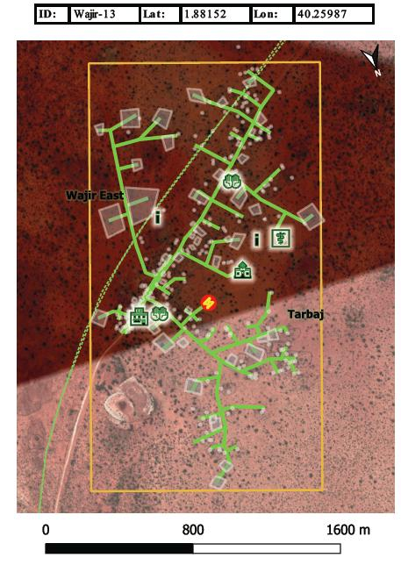

Appendix 7: Lead Expert’s Practicing Licence
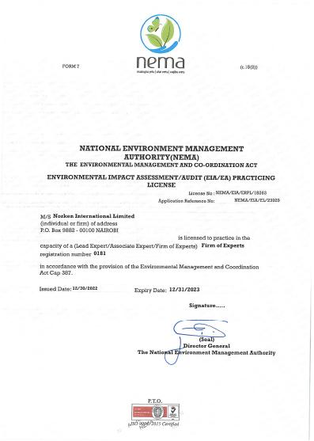
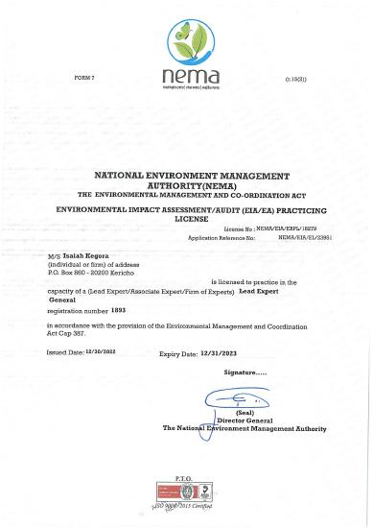

A cost basis that will yield compensation sufficient to replace assets, plus necessary transaction costs associated with asset replacement).

